|  |  |  |  |
| --- | --- | --- | --- |
| Indium Seal Ring Removal | | | |
| **Document Number:** | CP-P1-TUNHT-FLNG-DISA | **Approval Date:** | 16-Dec-2020 |
| **Revision Number:** | Rev - | **Periodic Review Date:** | 17-Dec-2022 |
| **Document Owner:** | T. Ganey |  |  |

## 

# Purpose and Scope

Remove the indium seal ring from the P1 cavities, including the FPC, FP, and HOM flanges.

|  |  |
| --- | --- |
| FPC Flange with Ring | HOM Flange with Ring |

# References

* 115120-1014C: SRF LINAC/CRYOMODULE 1998 WAVEGUIDE WAVEGUIDE SEAL SPACER DETAIL, REV -
* 115130-1037C: SRF LINAC/CRYOMODULE 1998 HOM SEAL SPACER DETAIL, REV -
* 115110-1014C: SRF LINAC/CRYOMODULE 1998 FPC BEAMLINE SEAL SPACER DETAIL, REV -

# Terms and Definitions

1. **Indium Seal Ring** – Stainless steel ring with indium seal on both sides of the ring.
2. **Flange Groove** – Groove containing indium and the indium seal ring that is cut into the flange surface.

# Process Details

1. **Safety / PPE**: Wear heat resistant gloves, safety glasses, and proper work clothes while operating the heat gun, working with the heated flange, and removing the seal ring.
2. **Tools Needed**:
   1. Heat gun that can maintain a temperature of at least 200 degrees C (Leister heat gun recommended)
   2. Infrared thermometer and/or thermocouples
   3. Cooper tool(s) for removing ring from FPC flange [Figure 1]
   4. Pliers for removing ring from HOM and FP flanges

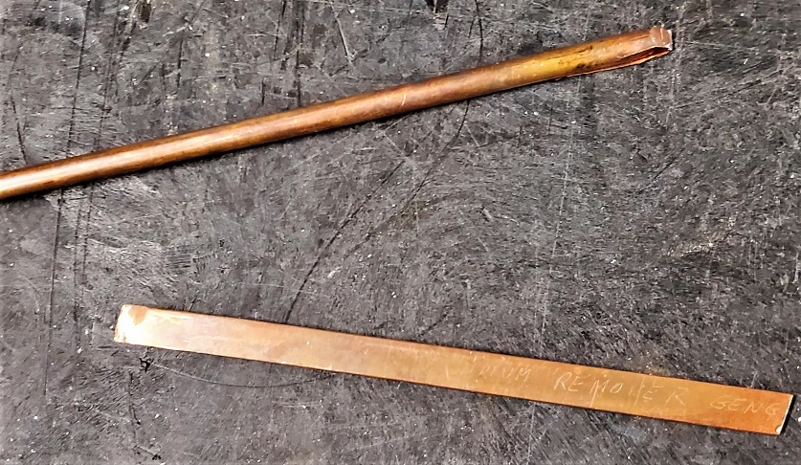

Figure 1: Copper tools with angled edges

1. **Setup**:
   1. Setup for FPC flange: [Figure 2]

|  |  |
| --- | --- |
| * Protect nearby surfaces from heat. * Position the FPC flange facing downward. * Aim the heat gun at the flange. * Place a container under the flange to capture the ring and indium when removed. * If thermocouples will be used to monitor the flange temperature, attach thermocouples to the flange near the corner to be heated. | C:\Users\ganey\AppData\Local\Microsoft\Windows\INetCache\Content.MSO\B7548CE3.tmp  Figure 2: Setup for FPC flange |

* 1. Setup for FP and HOM flanges: [Figure 3]
     + Protect nearby surfaces from heat.
     + Support the FP or HOM flange so that the flange can be held in place and rotated.
     + Position the FP or HOM flange to face the heat gun.
     + Aim the heat gun at the flange.

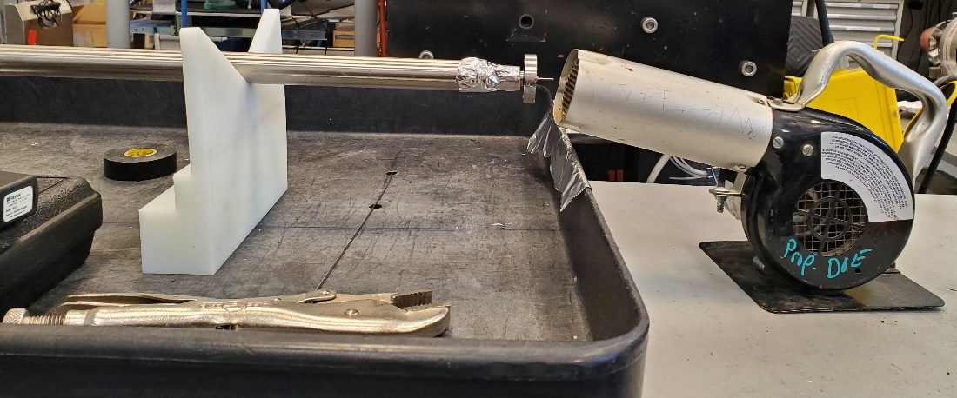

Figure 3: Setup for FP and HOM flanges

1. **Heat**:

Note: A temperature of 80 – 90 degrees C is typically sufficient to soften the indium for ring removal. The melting point of indium is 157 degrees C.

* 1. If heating the FPC flange, focus the heat on a single corner of the ring. Heating the FPC flange to allow for the ring removal will typically take 20 – 30 minutes.
  2. If heating a FP or HOM flange, rotate the flange to apply heat evenly.
  3. Check the flange and ring temperature using the infrared thermometer (or thermocouples if used).

1. **Remove**:
   1. If removing from the FPC flange:
      * Starting at the heated flange corner, use the copper tool(s) to lift the ring out of the flange groove. Once the ring starts to pull away from the flange, the entire ring can typically be removed.
   2. If removing the FP or HOM flange:
      * Use the pliers on the thickest part of the ring and pull the ring away from the flange.
2. **Cool**:
   1. Place the ring on a heat resistant surface to cool.
   2. Switch the heat gun to cool off the flange.

# **Revision History**

|  |  |  |
| --- | --- | --- |
| Rev # | Revision or update: | Effective: |
| Release | Initial Release | 12/16/2020 |
|  |  |  |

# **Approvals**

|  |  |  |
| --- | --- | --- |
| Approved by: | Signature: | Date: |
| **Document Owner: T. Ganey** |  |  |
| **Reviewer 1: R. Overton** |  |  |
| **Reviewer** 2: K. Davis |  |  |