Traveler Title | SNSPPU Cavity String Assembly Traveler
Traveler Abstract | SNSPPU Cavity string assembly traveler
Traveler ID | SNSPPU-CLNRM-CST-ASSY
Traveler Revision | R1
Traveler Author | D. Forehand
Traveler Date | 13-Mar-2021
NCR Informative Emails | Edaly,dreyfuss
NCR Dispositioners | kdavis,macha,forehand
D3 Emails | forehand,Dreyfuss,edaly,kdavis,macha
Approval Names | Danny Forehand | Kurt Macha | Kirk Davis | Ed Daly
Approval Signatures
Approval Dates
Approval Title | Author | Reviewer | Reviewer | Project Manager

References | List and Hyperlink all documents related to this traveler. This includes, but is not limited to: safety (THAs, SOPs, etc.), drawings, procedures, and facility related documents.
Coupler Installation Picture | String Assembly Legend | SNSPPU Cavity String Drawing | SNSPPU Coupler Installation Procedure | Ionized Nitrogen Cleaning Procedure
Return warm to cold beam pipe tooling picture | Supply warm to cold beam pipe tooling picture | Bellows restraint and ion pump support tooling picture | SNSPPU Clean Room StringTooling Drawing

Revision Note
R1 | Initial release of this Traveler.

Step No. | Instructions | Data Input
1 | Record the cavity string serial number.  Ensure the string tooling is cleaned and assembled on rail.  Note:  Ensure four cavities with helium vessel have been tested and qualified ready for string assembly.  One of the four cavities must have liquid level probes. This cavity will be located at position #1.  Ensure all components including couplers, beam line components, Ion pump manifold and hardware are staged and ready for assembly. | [[CSTSN]] <<CSTSN>>  [[StringPrepTech]] <<SRFCVP>>  [[InitiateDate]] <<TIMESTAMP>>  [[PrepComment]] <<COMMENT>>

Step No. | Instructions | Data Input
2 | Cavity 1 Prep:  The following components shall be sprayed with ionized nitrogen IAW Ionized Nitrogen Cleaning Procedure:  - Beam-line bellows, bellows stiffeners and hardware  - 1 beam-line gasket  - 3 beam-line dust covers with gaskets  - After individually spraying bellows, stiffeners shall be attached and dust cover clamped on using two glove covered spring clamps. The entire assembly shall then be sprayed with ionized nitrogen again.  - FPC alignment blank and gasket  - 8 glove-covered spring clamps  - 4 beam-line fasteners with nuts and washers  - 1 FPC assembly  - 1 FPC gasket  - 4 FPC fasteners with nuts and washers  - FPC alignment tool  - Wrenches for beam-line fasteners and FPC fasteners | [[CAVSN1]] <<CAVSN>>  [[Cav1LiquidLevelProbeInstalled]] <<YESNO>>  [[Cav1PrepTech]] <<SRFCVP>>  [[Cav1FPCPrepTech]] <<SRFCVP>>  [[Cav1PrepComment]] <<COMMENT>>
 | Note: The cavity must dry for a minimum of twelve hours between HPR and assembly. Ensure the cavity has a liquid level probe installed.  Approach the cavity slowly and install a gasketed dust cover on the lower beam-line flange with two glove covered spring clamps.  Slowly install FPC alignment blank with two glove covered spring clamps.  Slowly remove gasketed dust cover from bottom beam-line flange and install bellows assembly. A second technician shall install the four beam-line fasteners to attach the assembly to the cavity flange while the first technician holds the bellows in place. Snug the nuts with the open end of the wrench.  Lower the cavity with the back tech and slowly install the upper beam-line flange gasketed dust cover. | [[Cav1BellowsInstalltech1]] <<SRFCVP>>  [[Cav1BellowsInstalltech2]] <<SRFCVP>>  [[Cav1_2BLBPSN]] <<BLBPSN>>  [[Cav1BellowsComment]] <<COMMENT>>
 | Note: Cavity can now be rotated ninety degrees with the FPC flange facing down and placed on the FPC installation tooling rail.  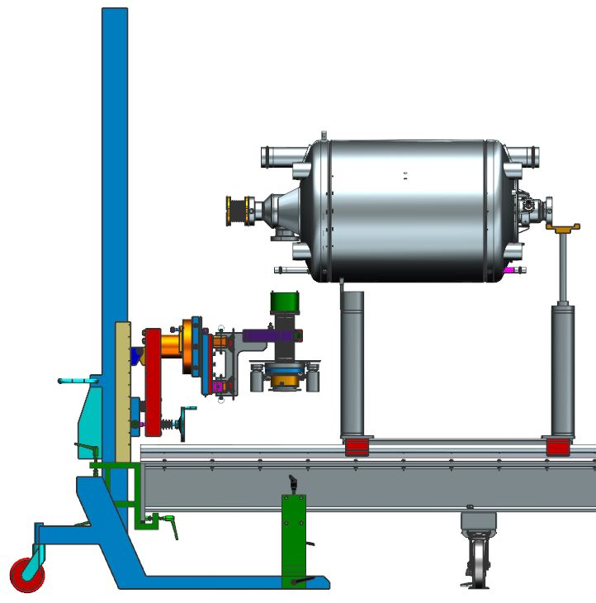  Install the FPC coupler onto the cavity IAW SNSPPU Coupler Installation Procedure  After all fasteners are installed and snugged, torque fasteners using the standard torque pattern for round flanges starting at 12 pound feet. Torque again at 20 pound feet and finish at 31 pound feet. | [[Cav1FPCInstallTech1]] <<SRFCVP>>  [[Cav1FPCInstallTech2]] <<SRFCVP>>  [[Cav1FPCSN]] <<FPCSN>>  [[Cav1FPCFlangeTorqueValue]] <<FLOAT>> ft/lbs
 | The cavity can now be moved to location 1 on the string rail, using the back tech and lifting fixture. The position 1 cavity will be supported on both ends at the cavity beam-line flange. Secure the flanges on the lollipops using the two bolts at the top mounts. The cavity alignment will be self-aligning due to the lollipop tooling design. Use the following string legend for cavity orientation.  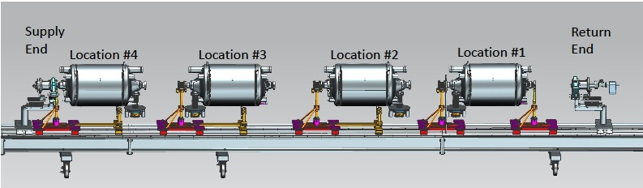  Lock the lollipops at the rail to prevent the cavity from sliding on the rail. | [[Cavity1OnRail]] <<TIMESTAMP>>
3 | Return warm to cold beam pipe sub-assembly:  Refer to following picture to assist in this sub-assembly.  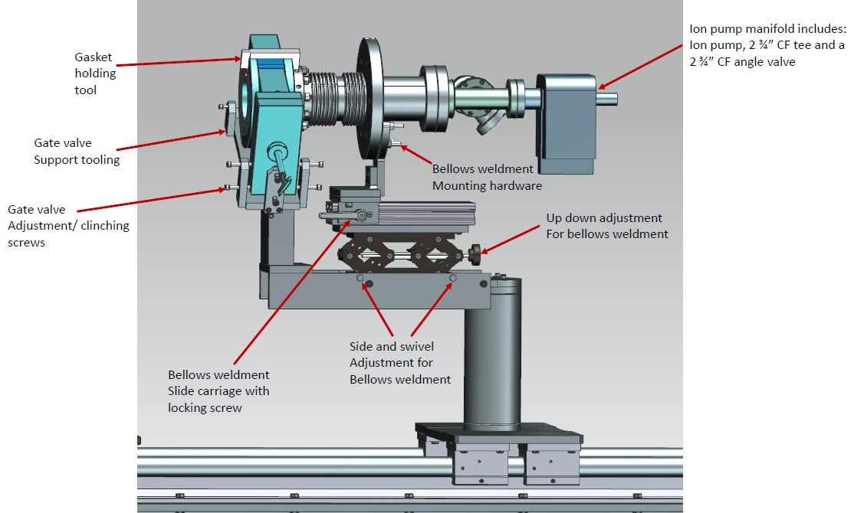  Clean all components IAW Ionized Nitrogen Cleaning Procedure  Prepare the upstream gate valve for assembly:  - Install the gate valve onto the return warm to cold beam line tooling and align properly. Alignment shall include rotating the valve to the proper assembly angle. Align the valve to the cavity beam line flange at location #4.  - Clean with ionized nitrogen IAW Ionized Nitrogen Cleaning Procedure and cycle the valve while cleaning.  Install the bellows weldment onto the tooling. Ensure the tooling slide track is set to leave an opening between the bellows flange and the gate valve.  Using the tooling adjustment, rough align the large flange of the bellows sub-assembly to be centered with the gate valve flanges (At beam center). The only alignment feature important is the large flange bolt orientation in relation to the mating cavity beam line flange. This should be self-aligning due to the design of the tooling. Alignment should be verified using a level and bolt hole pins. The alignment features on the tooling are used to help make the bellows flange easy to assemble to the valve.  Caution: The rotation of the large flange in relation to the valve is important. Make sure the rotation is as pictured below. Use the tooling to support the bellows as per the string tooling drawing.  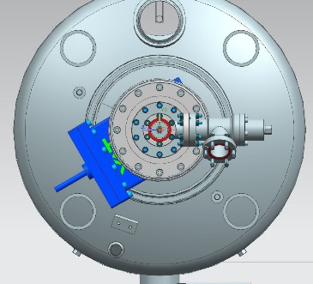  Install the copper gasket and mate the bellows flange to the gate valve. The slide track on the tooling will allow the bellows weldment to be moved in place. Install all hardware and snug the bolts so the flanges are secure. Do not tighten to ensure the valve stays in alignment. After this step is complete double check the valve alignment. | [[ReturnBeamPipePrepTech]] <<SRFCVP>>  [[ReturnBeamPipePrepDate]] <<TIMESTAMP>>  [[RTBPSN]] <<RTBPSN>>  [[UpAMGVSN]] <<AMGVSN>>  [[RTBPComment]] <<COMMENT>>
4 | Return warm to cold beam line assembly to the first cavity:  Install the metal seal gasket in the valve and hold it in place using the gasket holding tool.  Remove the cavity beam-line cover and slide the return beam-line sub-assembly into place. After all fasteners are installed and snugged, torque fasteners using the standard torque pattern for round flanges starting at 12 pound feet. Torque again at 20 pound feet and finish at 31 pound feet.  Tighten all hardware on the return warm to cold beam pipe assembly.  Install the ion pump sub-assembly and tighten all flanges. | [[Cav1UpstreamFlangeTorqueValue]] <<FLOAT>> ft/lbs  [[Cav1UpstreamFlangeTorqueTech]] <<SRFCVP>>  [[Cav1UpFlangeTorqueComment]] <<COMMENT>>

Step No. | Instructions | Data Input
5 | Cavity 2 Prep:  The following components shall be sprayed with ionized nitrogen IAW Ionized Nitrogen Cleaning Procedure:  - Beam-line bellows, bellows stiffeners and hardware  - 1 beam-line gasket  - 3 beam-line dust covers with gaskets  - After individually spraying bellows, stiffeners shall be attached and dust cover clamped on using two glove covered spring clamps. The entire assembly shall then be sprayed with ionized nitrogen again.  - FPC alignment blank and gasket  - 8 glove-covered spring clamps  - 8 beam-line fasteners with nuts and washers  - 1 FPC assembly  - 1 FPC gasket  - 4 FPC fasteners with nuts and washers  - FPC alignment tool  - Wrenches for beam-line fasteners and FPC fasteners | [[CAVSN2]] <<CAVSN>>  [[Cav2LiquidLevelProbeInstalled]] <<YESNO>>  [[Cav2PrepTech]] <<SRFCVP>>  [[Cav2FPCPrepTech]] <<SRFCVP>>  [[Cav2PrepComment]] <<COMMENT>>
 | Note: The cavity must dry for a minimum of twelve hours between HPR and assembly. Bellows is installed on the field probe end beam-line flange for cavity 2.  Approach the cavity slowly and install a gasketed dust cover on the lower beam-line flange with two glove covered spring clamps.  Slowly install FPC alignment blank with two glove covered spring clamps.  Lower the cavity with the back tech and slowly install the upper beam-line flange gasketed dust cover. Rotate the cavity 180 degrees to allow for bellows installation.  Slowly remove gasketed dust cover from bottom beam-line flange and install bellows assembly. A second technician shall install the four beam-line fasteners to attach the assembly to the cavity flange while the first technician holds the bellows in place. Snug the nuts with the open end of the wrench. | [[Cav2BellowsInstallTech1]] <<SRFCVP>>  [[Cav2BellowsInstallTech2]] <<SRFCVP>>  [[Cav2_3BLBPSN]] <<BLBPSN>>  [[Cav2BellowsComment]] <<COMMENT>>
 | Note: Cavity can now be rotated ninety degrees with the FPC flange facing down and placed on the FPC installation tooling rail.  Install the FPC coupler onto the cavity IAW SNSPPU Coupler Installation Procedure  After all fasteners are installed and snugged, torque fasteners using the standard torque pattern for round flanges starting at 12 pound feet. Torque again at 20 pound feet and finish at 31 pound feet. | [[Cav2FPCInstallTech1]] <<SRFCVP>>  [[Cav2FPCInstallTech2]] <<SRFCVP>>  [[Cav2FPCSN]] <<FPCSN>>  [[Cav2FPCFlangeTorqueValue]] <<FLOAT>>ft/lbs
 | The cavity can now be moved to location 2 on the string rail, using the back tech and lifting fixture. The position 2 cavity will be supported with the downstream (supply) beam-line flange bolted to the lollipop and the upstream (return) end of the cavity resting on the tooling at the helium vessel (this allows for clean beam-line connection). Refer to location #2 on the following string legend. One side of the cavity will be self-aligning due to the lollipop tooling design. | [[Cavity2OnRail]] <<TIMESTAMP>>
6 | Cavity 2 Installation:  Measure the location of the cavity 1 downstream beam-line flange, in reference to the rail, using the cavity flange alignment tooling. Record the X and Y dimensions on the dial indicators for this flange. Move the dial indicator tooling to the helium vessel supported beam-line flange on cavity 2 and position the cavity to match the reference flange.  Remove the cavity cover flanges and install the gasket. Hold the gasket using the gasket holding tools.  Slowly slide cavity 2 in place and install the four ionized nitrogen sprayed fasteners. Snug fasteners with wrench on the cavity side of the flange (to prevent bellows damage). The remaining fasteners can now be installed on both flanges. These fasteners do not need to be sprayed with ionized nitrogen. After all fasteners are installed and snugged, torque fasteners using the standard torque pattern for round flanges starting at 12 pound feet. Torque again at 20 pound feet and finish at 31 pound feet.  Install the second half of the lollipop fork section. Remove the bellows stiffeners and install the bottom bolt into cavity 2 beam line flange.  Remove the helium vessel support tooling. | [[Cav1RefLocationY]] <<FLOAT>>  [[Cav1RefLocationX]] <<FLOAT>>  [[Cav2InstallTech1]] <<SRFCVP>>  [[Cav2InstallTech2]] <<SRFCVP>>  [[Cav1DwnstrmFlangeTorqueValue]] <<FLOAT>> ft/lbs  [[Cav2UpstrmFlangeTorqueValue]] <<FLOAT>> ft/lbs  [[Cav1toCav2InstallComments]] <<COMMENT>>

Step No. | Instructions | Data Input
7 | Cavity 3 Prep:  The following components shall be sprayed with ionized nitrogen IAW Ionized Nitrogen Cleaning Procedure:  - Beam-line bellows, bellows stiffeners and hardware  - 1 beam-line gasket  - 3 beam-line dust covers with gaskets  - After individually spraying bellows, stiffeners shall be attached and dust cover clamped on using two glove covered spring clamps. The entire assembly shall then be sprayed with ionized nitrogen again.  - FPC alignment blank and gasket  - 8 glove-covered spring clamps  - 4 beam-line fasteners with nuts and washers  - 1 FPC assembly  - 1 FPC gasket  - 4 FPC fasteners with nuts and washers  - FPC alignment tool  - Wrenches for beam-line fasteners and FPC fasteners | [[CAVSN3]] <<CAVSN>>  [[Cav3LiquidLevelProbeInstalled]] <<YESNO>>  [[Cav3PrepTech]] <<SRFCVP>>  [[Cav3FPCPrepTech]] <<SRFCVP>>  [[Cav3PrepComment]] <<COMMENT>>
 | Note: The cavity must dry for a minimum of twelve hours between HPR and assembly.  Approach the cavity slowly and install a gasketed dust cover on the lower beam-line flange with two glove covered spring clamps.  Slowly install FPC alignment blank with two glove covered spring clamps.  Slowly remove gasketed dust cover from bottom beam-line flange and install bellows assembly. A second technician shall install the four beam-line fasteners to attach the assembly to the cavity flange while the first technician holds the bellows in place. Snug the nuts with the open end of the wrench.  Lower the cavity with the back tech and slowly install the upper beam-line flange gasketed dust cover. | [[Cav3BellowsInstalltech1]] <<SRFCVP>>  [[Cav3BellowsInstalltech2]] <<SRFCVP>>  [[Cav3_4BLBPSN]] <<BLBPSN>>  [[Cav3BellowsComment]] <<COMMENT>>
 | Note: Cavity can now be rotated ninety degrees with the FPC flange facing down and placed on the FPC installation tooling rail.  Install the FPC coupler onto the cavity IAW SNSPPU Coupler Installation Procedure  After all fasteners are installed and snugged, torque fasteners using the standard torque pattern for round flanges starting at 12 pound feet. Torque again at 20 pound feet and finish at 31 pound feet. | [[Cav3FPCInstallTech1]] <<SRFCVP>>  [[Cav3FPCInstallTech2]] <<SRFCVP>>  [[Cav3FPCSN]] <<FPCSN>>  [[Cav3FPCFlangeTorqueValue]] <<FLOAT>> ft/lbs
 | The cavity can now be moved to location 3 on the string rail, using the back tech and lifting fixture. The position 3 cavity will be supported with the downstream (supply) beam-line flange bolted to the lollipop and the upstream (return) end of the cavity resting on the tooling at the helium vessel (this allows for clean beam-line connection). Refer to location #3 on the following string legend. The cavity alignment will be self-aligning due to the lollipop tooling design. | [[Cavity3OnRail]] <<TIMESTAMP>>
8 | Cavity 3 Installation:  Measure the location of the cavity 2 downstream beam-line flange, in reference to the rail, using the cavity flange alignment tooling. Record the X and Y dimensions on the dial indicators for this flange. Move the dial indicator tooling to the helium vessel supported beam line flange on cavity 3 and position the cavity to match the reference flange.  Remove the cavity cover flanges and install the gasket. Hold the gasket using the gasket holding tools.  Slowly slide cavity 3 in place and install the four ionized nitrogen sprayed fasteners. Snug fasteners with wrench on the cavity side of the flange (to prevent bellows damage). The remaining fasteners can now be installed on both flanges. These fasteners do not need to be sprayed with ionized nitrogen. After all fasteners are installed and snugged, torque fasteners using the standard torque pattern for round flanges starting at 12 pound feet. Torque again at 20 pound feet and finish at 31 pound feet.  Install the second half of the lollipop fork section. Remove the bellows stiffeners and install the bottom bolt into cavity 3 beam line flange.  Remove the helium vessel support tooling. | [[Cav2RefLocationY]] <<FLOAT>>  [[Cav2RefLocationX]] <<FLOAT>>  [[Cav3InstallTech1]] <<SRFCVP>>  [[Cav3InstallTech2]] <<SRFCVP>>  [[Cav2DwnstrmFlangeTorqueValue]] <<FLOAT>>ft/lbs  [[Cav3UpstrmFlangeTorqueValue]] <<FLOAT>>ft/lbs  [[Cav2toCav3InstallComments]] <<COMMENT>>

Step No. | Instructions | Data Input
9 | Cavity 4 Prep:  The following components shall be sprayed with ionized nitrogen IAW Ionized Nitrogen Cleaning Procedure:  - 2 beam-line dust covers with gaskets  - FPC alignment blank and gasket  - 8 glove-covered spring clamps  - 8 beam-line fasteners with nuts and washers  - 1 FPC assembly  - 1 FPC gasket  - 4 FPC fasteners with nuts and washers  - FPC alignment tool  - Wrenches for beam-line fasteners and FPC fasteners | [[CAVSN4]] <<CAVSN>>  [[Cav4LiquidLevelProbeInstalled]] <<YESNO>>  [[Cav4PrepTech]] <<SRFCVP>>  [[Cav4FPCPrepTech]] <<SRFCVP>>  [[Cav4PrepComment]] <<COMMENT>>
Note: The cavity must dry for a minimum of twelve hours between HPR and assembly. Cavity 4 will not have a bellows installed.

Approach the cavity slowly and install a gasketed dust cover on the lower beam-line flange with two glove covered spring clamps.

Slowly install FPC alignment blank with two glove covered spring clamps.

Lower the cavity with the back tech and slowly install the upper beam-line flange gasketed dust cover. Rotate the cavity 180 degrees to allow for bellows installation.
 | Note: Cavity can now be rotated ninety degrees with the FPC flange facing down and placed on the FPC installation tooling rail.  Install the FPC coupler onto the cavity IAW SNSPPU Coupler Installation Procedure  After all fasteners are installed and snugged, torque fasteners using the standard torque pattern for round flanges starting at 12 pound feet. Torque again at 20 pound feet and finish at 31 pound feet. | [[Cav4FPCInstallTech1]] <<SRFCVP>>  [[Cav4FPCInstallTech2]] <<SRFCVP>>  [[Cav4FPCSN]] <<FPCSN>>  [[Cav4FPCFlangeTorqueValue]] <<FLOAT>> ft/lbs
 | The cavity can now be moved to location 4 on the string rail, using the back tech and lifting fixture. The position 4 cavity will be supported with the downstream (supply) beam-line flange bolted to the lollipop and the upstream (return) end of the cavity resting on the tooling at the helium vessel (this allows for clean beam-line connection). Refer to location #4 on the following string legend. The cavity alignment will be self-aligning due to the lollipop tooling design. | [[Cavity4OnRail]] <<TIMESTAMP>>
10 | Cavity 4 Installation:  Measure the location of the cavity 3 downstream beam-line flange, in reference to the rail, using the cavity flange alignment tooling. Record the X and Y dimensions on the dial indicators for this flange. Move the dial indicator tooling to the helium vessel supported beam-line flange on cavity 4 and position the cavity to match the reference flange.  Remove the cavity cover flanges and install the gasket. Hold the gasket using the gasket holding tools.  Slowly slide cavity 4 in place and install the four ionized nitrogen sprayed fasteners. Snug fasteners with wrench on the cavity side of the flange (to prevent bellows damage). The remaining fasteners can now be installed on both flanges. These fasteners do not need to be sprayed with ionized nitrogen. After all fasteners are installed and snugged, torque fasteners using the standard torque pattern for round flanges starting at 12 pound feet. Torque again at 20 pound feet and finish at 31 pound feet.  Install the second half of the lollipop fork section. Remove the bellows stiffeners and install the bottom bolt into cavity 4 beam line flange.  Remove the helium vessel support tooling. | [[Cav3RefLocationY]] <<FLOAT>>  [[Cav3RefLocationX]] <<FLOAT>>  [[Cav4InstallTech1]] <<SRFCVP>>  [[Cav4InstallTech2]] <<SRFCVP>>  [[Cav3DwnstrmFlangeTorqueValue]] <<FLOAT>> ft/lbs  [[Cav4UpstrmFlangeTorqueValue]] <<FLOAT>> ft/lbs  [[Cav3toCav4InstallComments]] <<COMMENT>>

Step No. | Instructions | Data Input
11 | Supply warm to cold beam pipe sub-assembly:  Refer to following picture to assist in this sub-assembly.  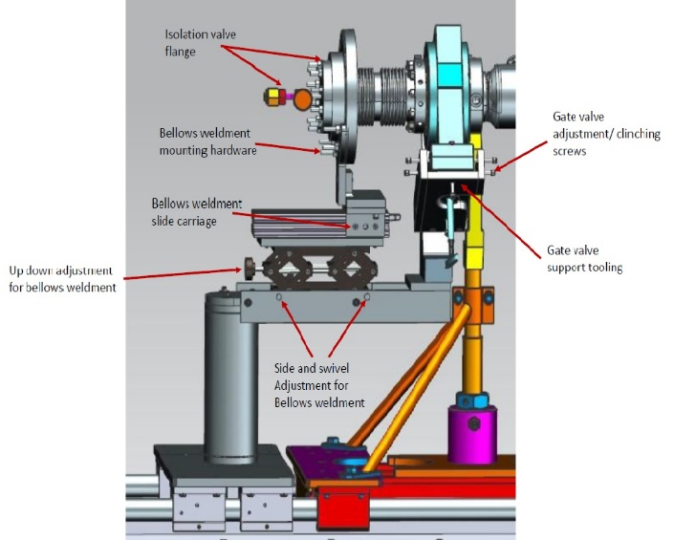  Clean all components IAW Ionized Nitrogen Cleaning Procedure | [[SupplyBeamPipePrepTech]] <<SRFCVP>>  [[SupplyBeamPipePrepDate]] <<TIMESTAMP>>
 | Prepare the downstream gate valve for assembly:  - Install the gate valve onto the supply warm to cold beam line tooling and align properly. Alignment shall include rotating the valve to the proper assembly angle. Align the valve to the cavity beam line flange at location #4.  - Clean with ionized nitrogen IAW Ionized Nitrogen Cleaning Procedure and cycle the valve while cleaning.  Install the bellows weldment onto the tooling. Ensure the tooling slide track is set to leave an opening between the bellows flange and the gate valve.  Using the tooling adjustment, rough align the large flange of the bellows sub-assembly to be centered with the gate valve flanges (At beam center). The only alignment feature important is the large flange bolt orientation in relation to the mating cavity beam line flange. This should be self-aligning due to the design of the tooling. Alignment should be verified using a level and bolt hole pins. The alignment features on the tooling are used to help make the bellows flange easy to assemble to the valve.  Caution: The rotation of the large flange in relation to the valve is important. Make sure the rotation is as pictured below. Use the tooling to support the bellows as per the string tooling drawing.  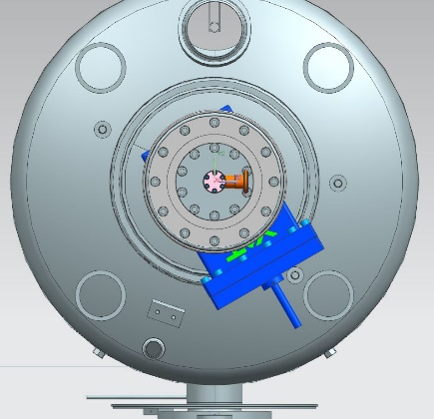  Install the copper gasket and mate the bellows flange to the gate valve. The slide track on the tooling will allow the bellows weldment to be moved in place. Install all hardware and snug the bolts so the flanges are secure. Do not tighten to ensure the valve stays in alignment. After this step is complete double check the valve alignment.  Assemble the isolation valve flange onto the bellows weldment and tighten all fasteners. | [[SUBPSN]] <<SUBPSN>>  [[DnAMGVSN]] <<AMGVSN>>  [[SUBPPrepComment]] <<COMMENT>>
12 | Supply warm to cold beam line assembly to the fourth cavity:  Install the metal seal gasket in the valve and hold it in place using the gasket holding tool.  Remove the cavity beam-line cover and slide the supply beam-pipe sub-assembly into place. Bolt and torque the two flanges.  Torque all hardware on the supply warm to cold beam pipe assembly. |  | [[Cav4DwnFlangeTorqueValue]] <<FLOAT>> ft/lbs  [[Cav4DwnFlangeTorqueTech]] <<SRFCVP>>  [[Cav4DwnFlangeTorqueComment]] <<COMMENT>>

Step No. | Instructions | Data Input
13 | String Prep for Evacuation:  Re-torque all flanges on cavity string, including the field probe fasteners.  -Field probes: 40 in/lbs  -Beam line flanges 31 foot lbs  -Conflat flanges as standard hand tightening  Remove the temporary bellows support tooling and install the transfer bellows supports at both warm to cold beam line assemblies. Remove the warm to cold beam pipe assembly tooling at each end of the cavity string.  Install the locking bars to tie the lollipops together.  Install the ion pump support tool by bolting it to the end lollipop and adjust the tooling to fix the 1 ½” tee located on the ion pump assembly.  The cavity string should be configured as per the top view on the cavity string tooling drawing.  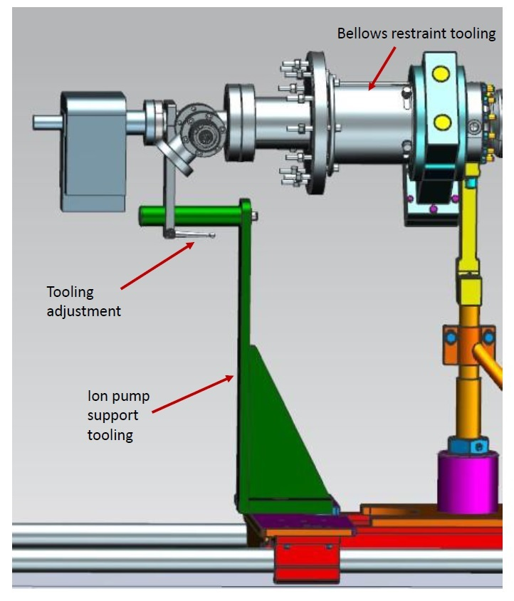  **Cavity string is now ready to be evacuated. | [[StringRetorqueTech1Tech]] <<SRFCVP>>  [[StringRetorqueTech2Tech]] <<SRFCVP>>
14 | String Completion | [[StringCompletionDate]] <<TIMESTAMP>>  [[StringCompleteComment]] <<COMMENT>>

