**Shipping plan**

1. Due to the insufficient support strength of the lower legs of the cold mass assembly, it is easy to cause the lower legs deformation in the transportation. Therefore, we will bend 4mm stainless steel plates into angles and weld to part of the supporting legs, corresponding to the supporting legs on the HGR PIPE-LSLC-II MACHINED tubes. And put a 6mm rubber plate at the connecting position of the supporting leg to achieve shock absorption. 由于冷质量组件下部的支腿支撑强度不够，在运输过程中极易造成下部支腿变形。因此我们是用4mm的不锈钢板折弯成角钢，并在部分支腿的位置焊上螺柱，对应HGR PIPE-LSLC-II MACHINED管上的支撑腿。并且在螺柱与支腿的连接位置安放6mm 的橡胶板，起到减震的作用。

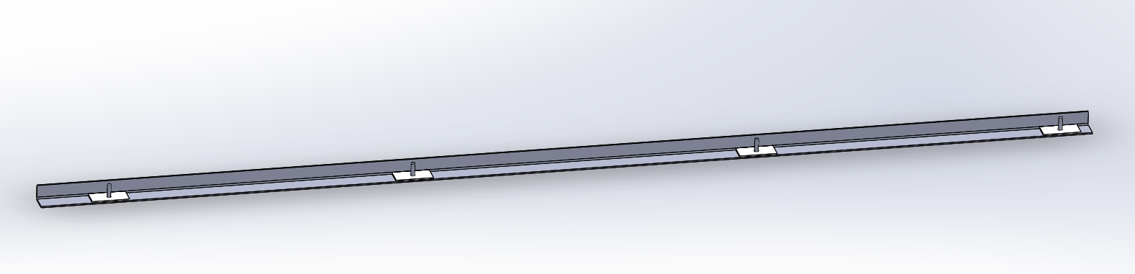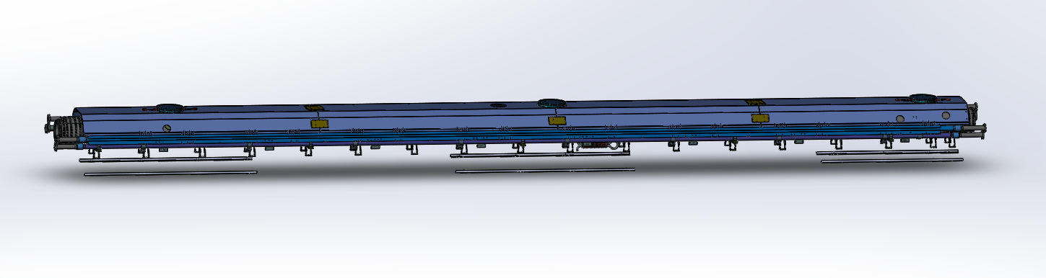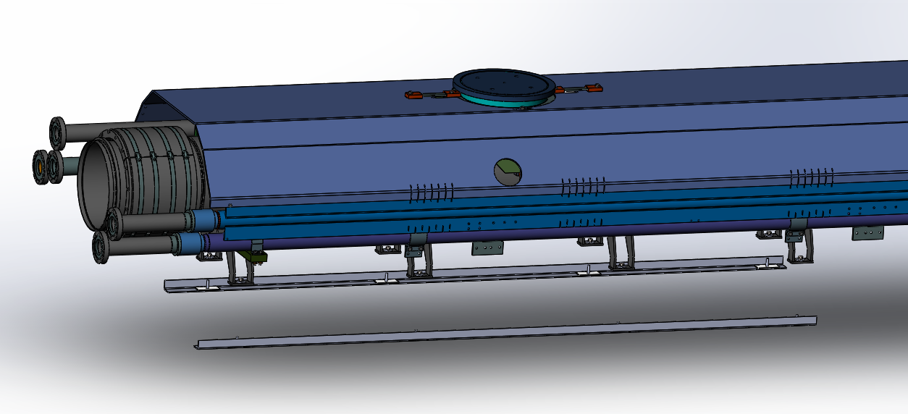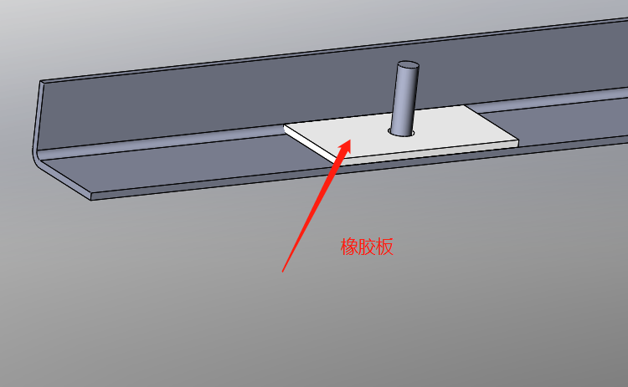

2. Screw the angle iron to the supporting legs bottom plate with nuts, spring washers and large flat pads用螺母，弹垫垫圈，大平垫把角钢拧紧在支撑腿的底板上。

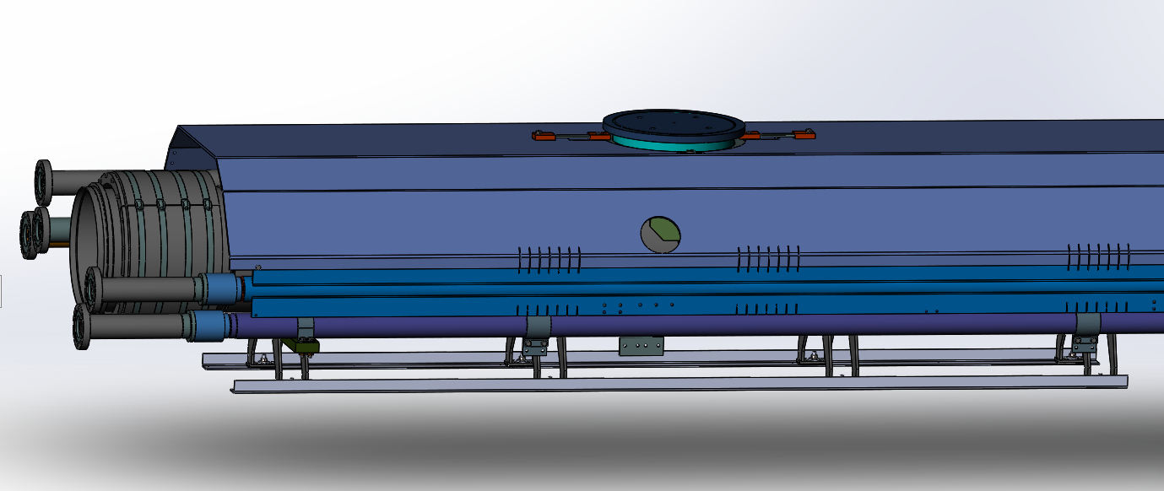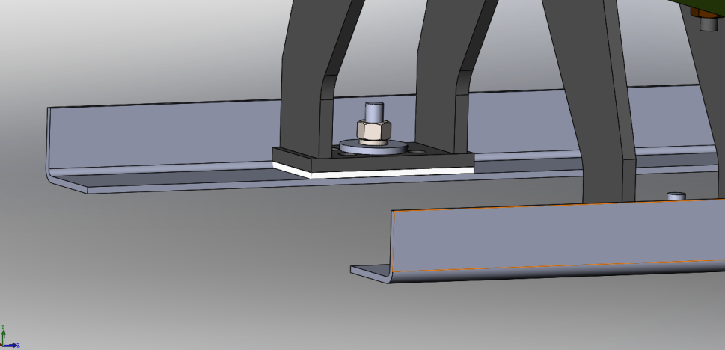

3. Place the cold mass assembly on the wooden frame将内管道安放在木架上

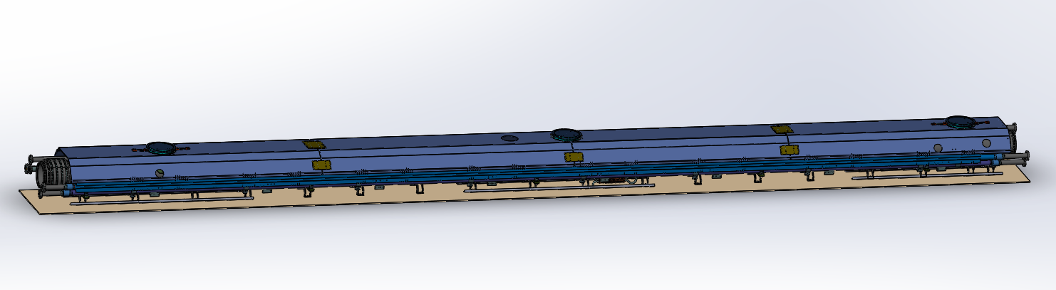

4. Fix the two ends of the Angle steel with boards to prevent the cold mass assembly from moving left and right inside the crate.用木板固定角钢的两头，防止内管道在木箱里面左右移动。

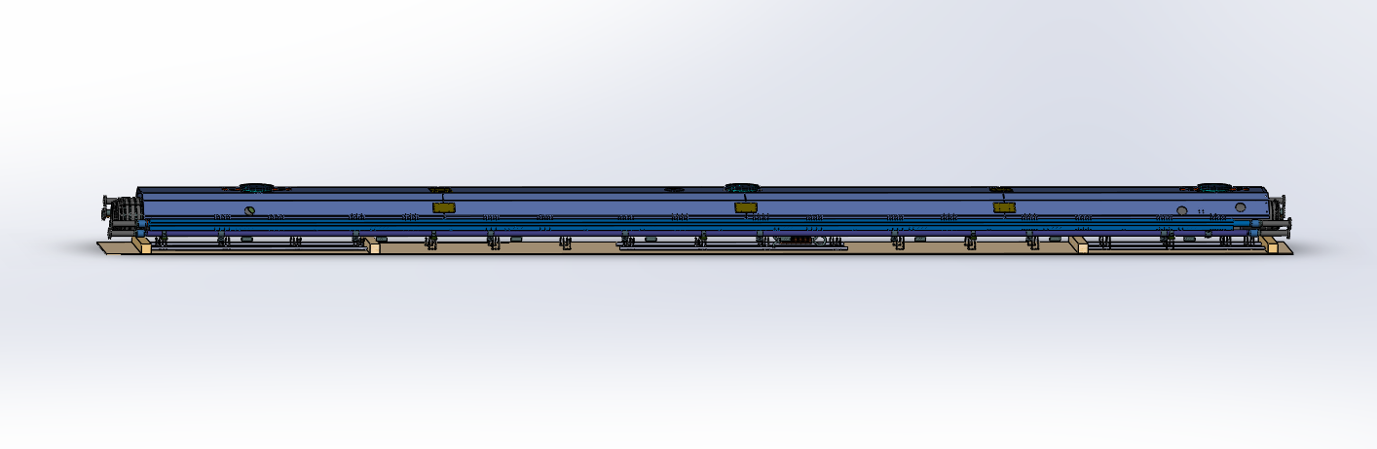

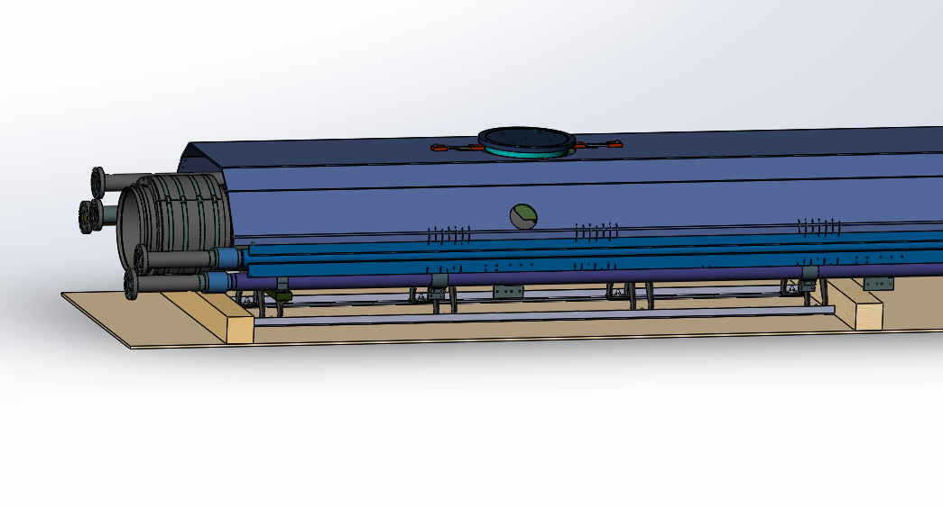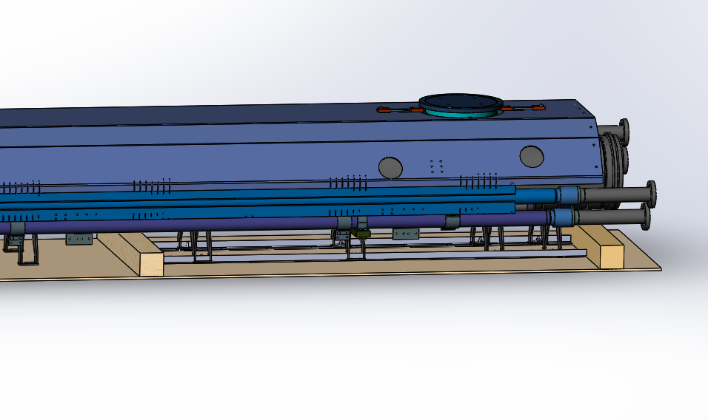

5. Both ends of the pipes are padded on CF flanges with 6mm rubber sheets

在内管道的两端用6mm的橡胶板垫在CF法兰上

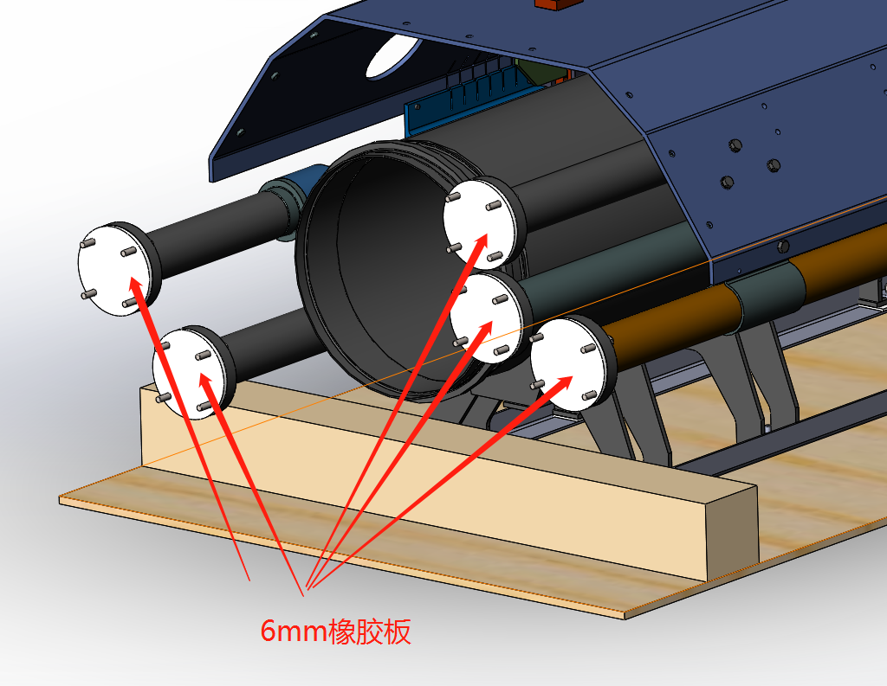

6. Fix the formwork on the 5 pipes with bolts, the formwork is made of 4mm stainless steel plate. Since the 50K RETURN TURE pipe is fixed and cannot be moved, we can fix the other 4 pipes with this tube to prevent them from moving.用4mm的不锈钢板做成模板，用螺栓固定在5根管道上。由于50K RETURN TURE管是固定不能移动的，以此来固定其余4根管道，防止其左右移动。

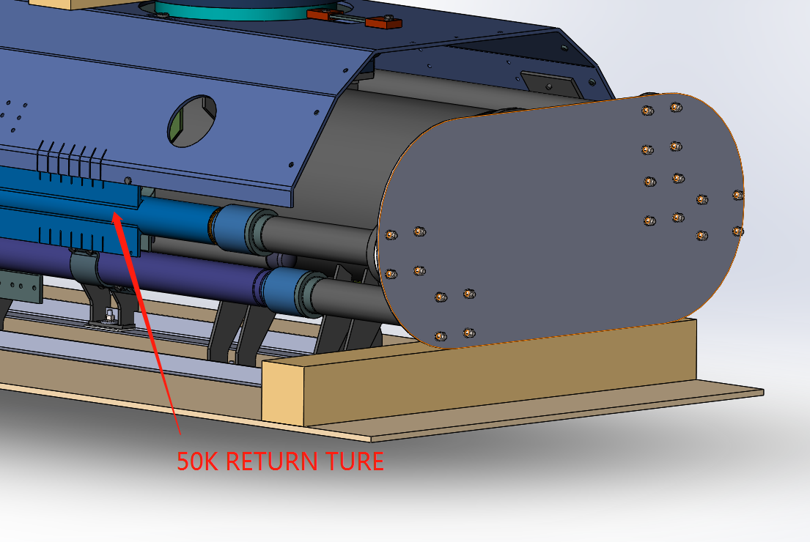

7. Fix the POST with boards to prevent the cold mass assembly from jumping up and down inside the crate用木板固定POST，防止内管道在木箱里面上下跳动

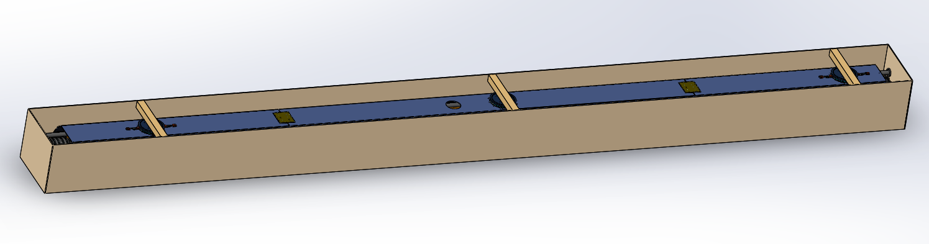

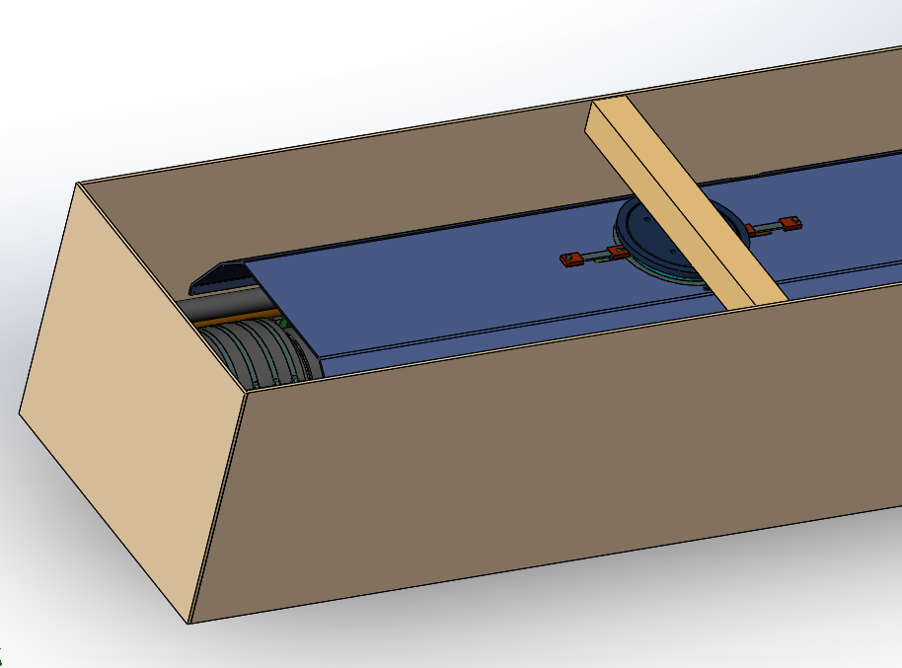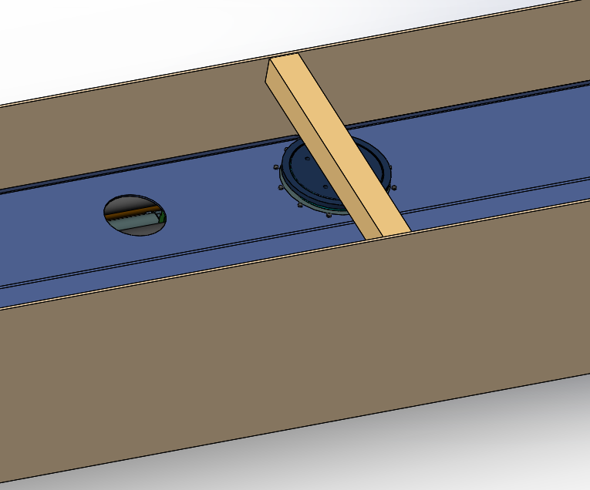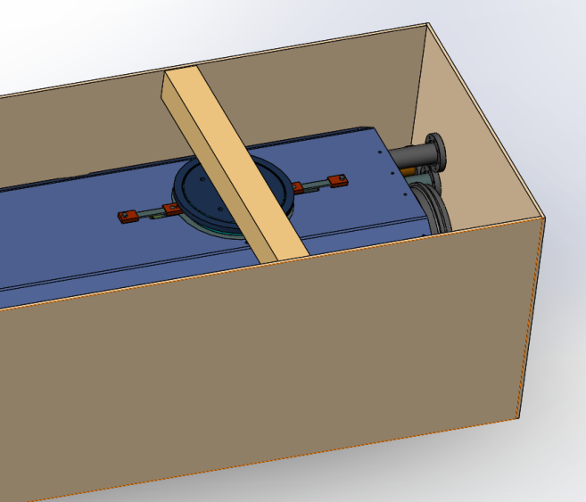

8. Close the crate.盖好木箱盖。

