Traveler Title | C100R Cavity HOM Feedthru Receiving Inspection
Traveler Abstract | This traveler covers incoming inspection for the C100R Cavity HOM feedthrus, both re-use and spares from Kyocera
Traveler ID | C100-INSP-HMFT
Traveler Revision | R3
Traveler Author | HyeKyoung Park
Traveler Date | 24-Mar-21
NCR Informative Emails | Georged,areilly
NCR Dispositioners | Hkpark,kdavis
D3 Emails | Hkpark,kdavis,areilly
Approval Names | HyeKyoung Park | Kirk Davis | Tony Reilly
Approval Signatures
Approval Dates
Approval Title | Author | Reviewer | Project Manager

References | List and Hyperlink all documents related to this traveler. This includes, but is not limited to: safety (THAs, SOPs, etc), drawings, procedures, and facility related documents.
CRM-120-7014-0020 rev A | CRM-120-7014-0022 rev - | Leak check spec 11141-S-0029 | CRM-120-7000-S-1017 rev A
JL0070606

Revision Note
R1 | Initial release of this Traveler. Modified from C100-CAV-INSP-HMFT-R6
R2 | Modifications by HKPark to apply to C100R
R3 | Added inspection steps for the Spare HMFTs from Kyocera

Step No. | Instructions | Data Input
HOM feedthru is an ultra high vacuum component. Wear talc free latex or Nitrile gloves at all times when handling this component.
1 | Enter part serial number.  Serial number may not be in the same format since there were multiple vendors.  Select if this HMFT is a re-use or Kyocera HMFT. | [[HMFTSN]] <<HMFTSN>>  [[HMFT_type]] {{RE-USE,KYOCERA}} <<RADIO>>
2 | Visual inspection:  - Is part clean, free from dust, oil, finger prints, or brazing residue?  - Is the gasket seating surface smooth, free from burrs or nicks?  - Is sapphire insert free from cracks?  - Examine the electrical pin. If the pin is damaged, bent, or showing any irregularity, generate NCR and upload pictures  If the part does not pass visual inspection take pictures and upload the file. | [[INSP1_TechnicianSRF]] <<SRF>>  [[DateTime]] <<TIMESTAMP>>  [[VisualClean]] <<YESNO>>  [[VisualSurfacePass]] <<YESNO>>  [[VisualSapphirePass]] <<YESNO>>  [[VisualPinPass]] <<YESNO>>  [[VisualPics]] <<FILEUPLOAD>>  [[VisualCmnt]] <<COMMENT>>
For C100R Re-Use HMFTs see Page 2 for Inspection Steps
For Kyocera HMFTs see Page 3 for Inspection Steps

Step No. | Instructions | Data Input
Inspection Steps for C100R HOM Feedthrus: RE-USE
3 | Gauge checks  - Check thread fit with a standard N type connector.  - Check the pins braze strength with tweezers. There should be no rotation or axial movement but lateral flexibility is acceptable. If the pin is not flexible at all generate NCR because it indicates there is no gap between the pin and the sapphire surface. Provide comments, if any (i.e., the connection too resistant or loose, flimsy pin, etc.) | [[ThreadFit]] <<YESNO>>  [[ConnCheckComment]] <<COMMENT>>  [[BrazePresent]] <<YESNO>>  [[TorquePass]] <<YESNO>>  [[TorqueComment]] <<COMMENT>>
4 | Perform leak test per 11141-S-0029 rev.A and upload file  Minimum Detectable Leak 1×10^-10 std cc of He/sec  Part passed leak test? | [[LC1_TechnicianSRF]] <<SRF>> [[LC1_Date]] <<TIMESTAMP>>  [[LeakTestInitial]] <<YESNO>>  [[LeakInitialFile]] <<FILEUPLOAD>>
5 | QC Review  Determine production release after reviewing traveler record and NCRs.  If all NCRs are closed and the feedthru is accepted store it at the inventory area (contact srfinv@jlab.org). | [[QCReviewTech]] <<SRF>>  [[QCReviewDate]] <<TIMESTAMP>>  [[ProductionRelease]] <<YESNO>>  [[AdditionalComments]] <<COMMENT>>

Step No | Instructions | Data Inputs
Inspection Steps for HOM Feedthrus: KYOCERA
3 | Gauge checks:  - Check connector thread fit with a standard N type connector. Select “yes” if the fit is OK. | [[Conn_Fit]] <<YESNO>>
4 | Dimensions (CMM):  Unit in inches.  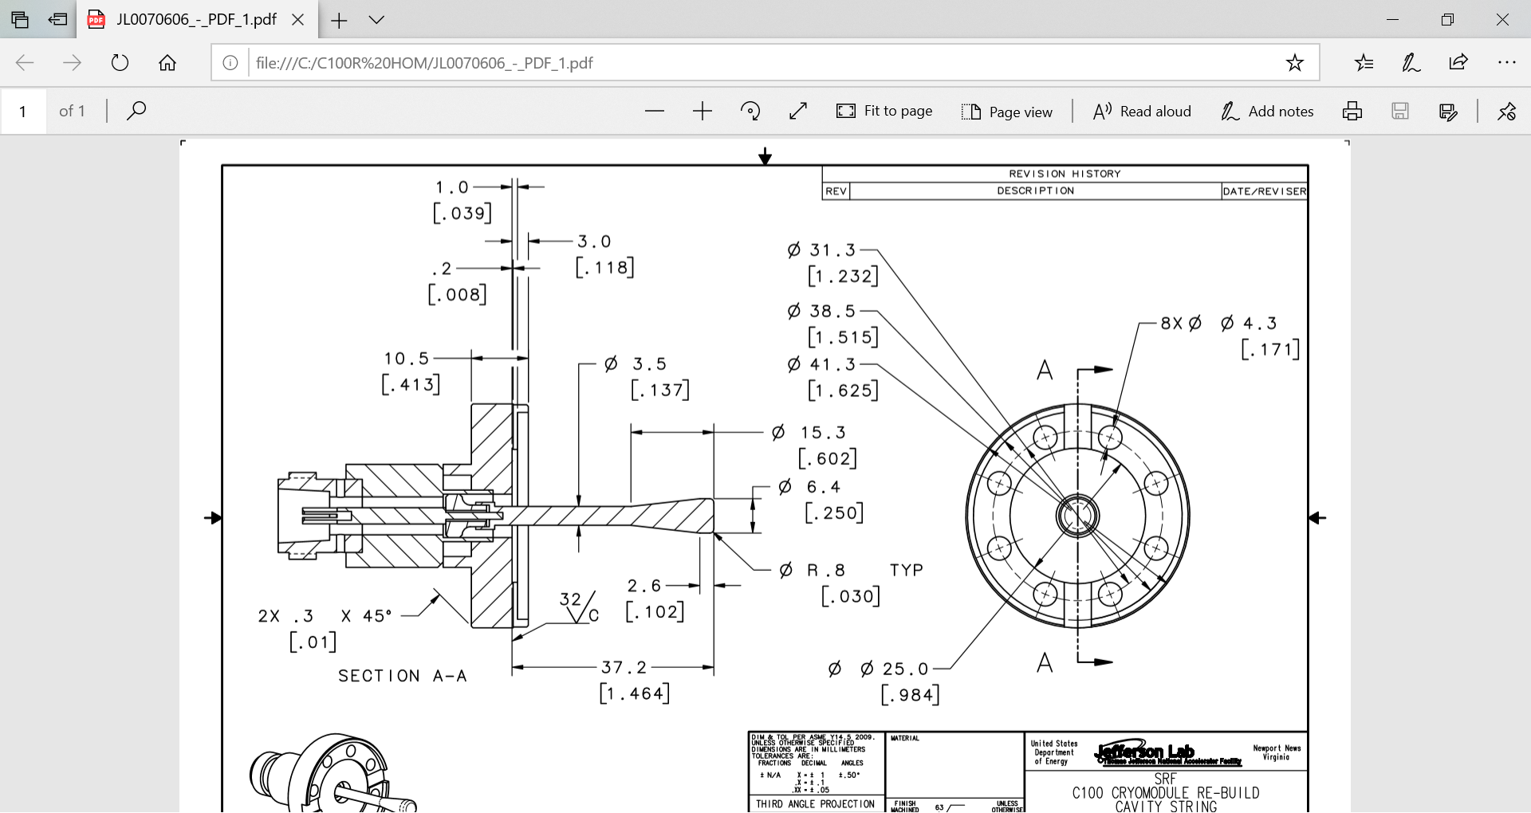  Flange seal surface to probe tip (1.459/1.469)  Probe angle  (Datum is the sealing surface, should be less than .5 deg) | [[Probe_Length]] <<FLOAT>>  [[Probe_Angle]] <<FLOAT>>
After visual and dimensional inspection, send the part to cleanroom group to have mounted in the test stand for cold cycle.
The part will be back after final leak test.
5 | Final visual inspection:  Perform quick visual inspection whether there is no damage during cold cycle and leak test.  Provide comments and upload picture if necessary.  Is part released for production?  Send the part to the storage area (contact srfinv@jlab.org) | [[Final_Comm]] <<COMMENT>>  [[Final_Pics]] <<FILEUPLOAD>>  [[Prod_Release]] <<YESNO>>

