Traveler Title | LCLS-II HE SPQA Magnet Current Lead Flange Assembly Inspection Traveler
Traveler Abstract | This traveler covers the necessary steps to perform incoming inspection and acceptance tests of LCLS-II HE SPQA magnet current lead flange assembly at JLab. This item is a Fermilab procurement and drop-shipped to JLab.
Traveler ID | L2HE INSP-CFL
Traveler Revision | R1
Traveler Author | Seetha-Lakshmi Lalitha
Traveler Date | 29-Mar-21
NCR Informative Emails | kwilson,Hogan
NCR Dispositioners | lalitha,king
D3 Emails | lalitha,king,fisher
Approval Names | Seetha-Lakshmi Lalitha | Larry King | Michael Morrone | John Hogan
Approval Signatures
Approval Dates
Approval Title | Author, SOTR | Reviewer | Reviewer | Project Manager

References | List and Hyperlink all documents related to this traveler. This includes, but is not limited to: safety (THAs, SOPs, etc), drawings, procedures, and facility related documents.
 | F10022642-Rev G.pdf | F10046761-Rev A.pdf | F10046899.pdf

Revision Note
R1 | Initial release of this Traveler.

Notes
- The current lead flange assembly is fabricated according to the FNAL drawing, #F10022642-Rev G.
- The assembly contains delicate components. Wear nitrile gloves while handling and follow extreme care.
- Protect the ceramic feedthroughs and feed through flags from damage.
- Protect the knife edge sealing surface of the flange from scratches.
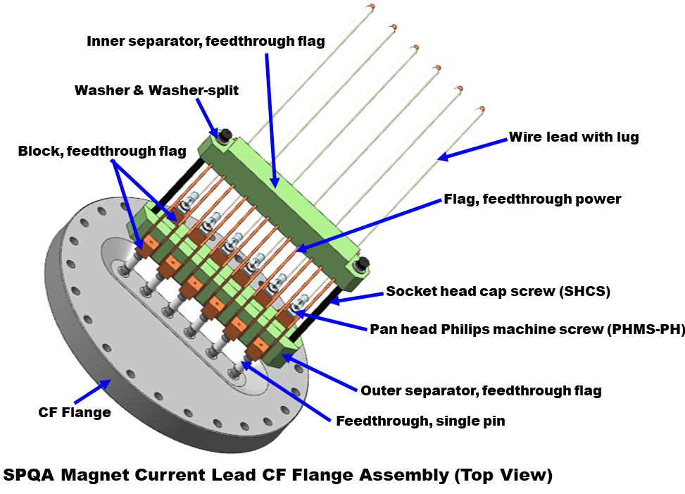 |  |  | 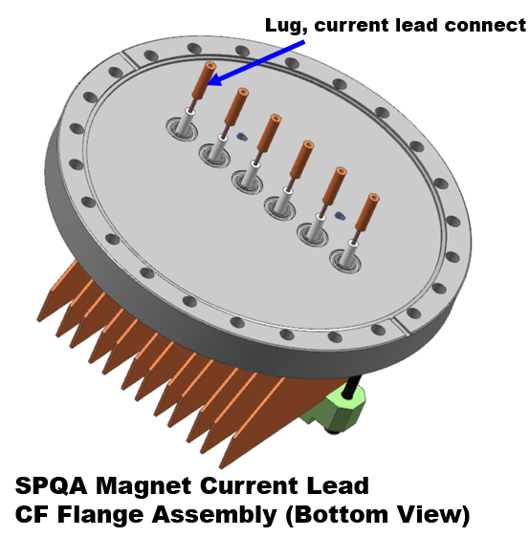
Figure 1: Top view (left panel) and bottom view (right panel) of the SPQA magnet current lead flange assembly (3D CAD model #F10022642).
Step No. | Instructions | Data Input
 | Create inventory
 | - Inventory preparer name. | [[Insp_Name_SRF]] <<SRF>>
 | - Received date of the shipment. | [[RecDate]] <<TIMESTAMP>>
 | - Manufacturer. | [[Manufacturer]] <<TEXT>>
 | - Assembly drawing number. | [[Assembly Drawing Number]] <<TEXT>>
 | - Assign the serial number of the current lead flange assembly  Note: labeling format F10022642-G-NNNN where the last four digits indicate the serial number starting from 0001. | [[CFLSN]] <<CFLSN>>
 | - Mark the corresponding serial number on the outer side of the CF flange. | [[Mark_SN]] <<YESNO>>
 | - Add comments, if any. | [[Comment1]] <<COMMENT>>
 | - The date of completion of the inventory. | [[CompDate]] <<TIMESTAMP>>

 | EBOM inspection
 | Note; Refer to Figure 1 and Table 1 of this document and attached CAD drawings for the details.
 | - Inspector name and date. | [[EBOM_Insp_Name]] <<SRF>>  [[EBOM_Insp_Date]] <<TIMESTAMP>>
 | - Are all components listed in the Table.1 present in the assembly?  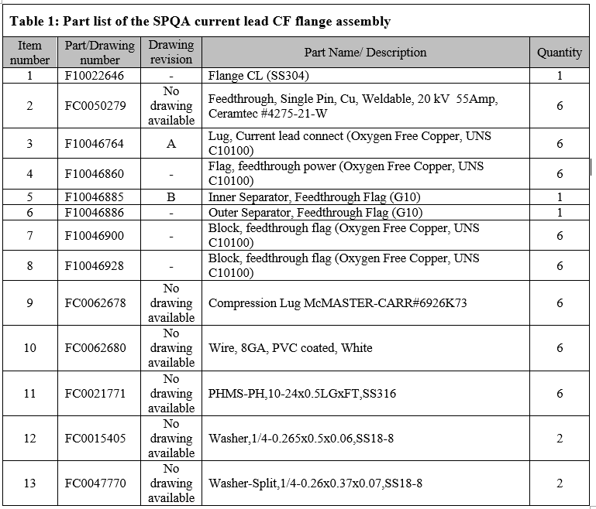 | [[EBOM_Tally]] <<YESNO>>  [[EBOM_Comment]] <<COMMENT>>
 | - Note non-conformances, if any. Provide a short description and upload pictures. | [[[Vis_NCR]] <<YESNO>>  [[EBOM_NCR_Comment]] <<COMMENT>>  [[EBOM_Photos]] <<FILEUPLOAD>>
 | - Date of completion of EBOM inspection. | [[EBOM_COMP_Date]] <<TIMESTAMP>>
 | Visual inspection
 | - Inspector name and date. | [[Insp_Name3]] <<SRF>>  [[Date5]] <<TIMESTAMP>>
 | - Are all components of the assembly free of dirt, grease, oil, or chip? | [[Vis_Pass_1]] <<YESNO>>  [[Vis_Pass_1_Comment]] <<COMMENT>>
 | - Are all parts free of sharp edges, corners, and burrs? | [[Vis_Pass_2]] <<YESNO>>  [[Vis_Pass_2_Comment]] <<COMMENT>>
 | - Are the sealing surface of the flange and knife edges free of scratches? | [[Vis_Pass_3]] <<YESNO>>  [[Vis_Pass_3_Comment]] <<COMMENT>>
 | - Check for the signs of damage on weldments on the assembly. Refer to the drawings for the current lead flange weldment (drawing no: F10046761-Rev A), feedthrough flag weldment (drawing no: F10046899) for details. | [[Vis_Pass_4]] <<YESNO>>  [[Vis_Pass_4_Comment]] <<COMMENT>>
 | - Are feedthrough flags held firmly in place by G-10 inner and outer separators? | [[Vis_Pass_5]] <<YESNO>>  [[Vis_Pass_5_Comment]] <<COMMENT>>
 | - Are vaccum-side of all feedthrough pins straight? | [[Vis_Pass_6]] <<YESNO>>  [[Vis_Pass_6_Comment]] <<COMMENT>>
 | - Check the quality of brazing (solder quantity and appearance of the joint) between the feedthrough pins and copper lugs on the bottom surface of the flange. | [[Vis_Pass_7]] <<YESNO>>  [[Vis_Pass_7_Comment]] <<COMMENT>>
 | - Does the lead wire length match the specification in drawing #F10022642-Rev G? | [[Vis_Pass_8]] <<YESNO>>  [[Vis_Pass_8_Comment]] <<COMMENT>>
 | - Check the quality of the crimped cable and report the signs of defects or damage, if any. | [[Vis_Pass_9]] <<YESNO>>  [[Vis_Pass_9_Comment]] <<COMMENT>>
 | - Note non-conformance if any from the visual inspection. Leave comments and upload photos. | [[Vis_insp_NCR]] <<YESNO>>  [[Vis_Insp_Comment]] <<COMMENT>>  [[Vis_Insp_photos]] <<FILEUPLOAD>>
 | - Date of completion of visual inspection. | [[Date6]] <<TIMESTAMP>>
 | Electrical inspection
 | - Electrical technician and date. | [[Elect_Insp_Name]] <<SRF>>  [[Elect_Insp_Date]] <<TIMESTAMP>>
 | - Measure isolation of each feedthrough pin to the body with a hand-held DMM ( qualification criterion: Resistance >= 60 MΩ.) | [[Pin1_Iso_R]] <<FLOAT>>  [[Pin2_Iso_R]] <<FLOAT>>  [[Pin3_Iso_R]] <<FLOAT>>  [[Pin4_Iso_R]] <<FLOAT>>  [[Pin5_Iso_R]] <<FLOAT>>  [[Pin6_Iso_R]] <<FLOAT>>  [[Pin1_Iso_R_Pass]] <<YESNO>>  [[Pin2_Iso_R_Pass]] <<YESNO>>  [[Pin3_Iso_R_Pass]] <<YESNO>>  [[Pin4_Iso_R_Pass]] <<YESNO>>  [[Pin5_Iso_R_Pass]] <<YESNO>>  [[Pin6_Iso_R_Pass]] <<YESNO>>
 | - Measure continuity of each feedthrough pin at the bottom of the flange to feedthrough flag surface using a hand-held DMM (qualification criterion: Resistance <= 2Ω.).  Note: The lug current lead connect is soldered onto the feedthrough pin at the bottom (the vacuum side) of the CF flange. | [[Pin1_CT_R]] <<FLOAT>>  [[Pin2_CT_R]] <<FLOAT>>  [[Pin3_CT_R]] <<FLOAT>>  [[Pin4_CT_R]] <<FLOAT>>  [[Pin5_CT_R]] <<FLOAT>>  [[Pin6_CT_R]] <<FLOAT>>  [[Pin1_CT_R_Pass]] <<YESNO>>  [[Pin2_CT_R_Pass]] <<YESNO>>  [[Pin3_CT_R_Pass]] <<YESNO>>  [[Pin4_CT_R_Pass]] <<YESNO>>  [[Pin5_CT_R_Pass]] <<YESNO>>  [[Pin6_CT_R_Pass]] <<YESNO>>
 | - Report non-conformance, if any. | [[Elect_NCR]] <<YESNO>>  [[Elect_NCR]] <<FILEUPLOAD>>  [[Elect_Insp_Comment]] <<COMMENT>>
 | - Date of completion of the electrical inspection. | [[Elec_Comp_Date]] <<TIMESTAMP>>
 | Vacuum leak
 | - Inspector name and date. | [[Inp_Name5]] <<SRF>>  [[Date9]] <<TIMESTAMP>>
 | - Perform the vacuum leak according to the specifications on drawing #F10022642-Rev G. The specifications are:  - No leak shall be detectable on the most sensitive scale of a helium leak detector with a minimum sensitivity of 2 x10⁻⁹ mbar x L / sec.  - The vacuum level during the leak check shall be less than 1 x 10⁻⁴ Torr. | [[LkChkFile]] <<FILEUPLOAD>>  [[LkChkVacLevel]] <<FLOAT>> Torr  [[LeakChkGood]] <<YESNO>>  [[LkChkComment]] <<COMMENT>>
 | - Date of completion of the inspection. | [[Date10]] <<TIMESTAMP>>
 | Re-pack the current lead flange assembly. Send to inventory area until use. | [[Inp_Name6]] <<SRF>>  [[Date11]] <<TIMESTAMP>>

