SNS-PPU Cavity Tuner Installation Procedure

Document Number: | PPU-SP-104211400-M8U-8200-A001 | Approval Date: | 4/6/2021
Revision Number: | - | Periodic Review Date:
Document Owner: | Naeem Huque | Department Owner: | SRF Ops

Purpose and Scope

This procedure outlines the steps for installing cavity tuners on SNS-PPU cryomodules

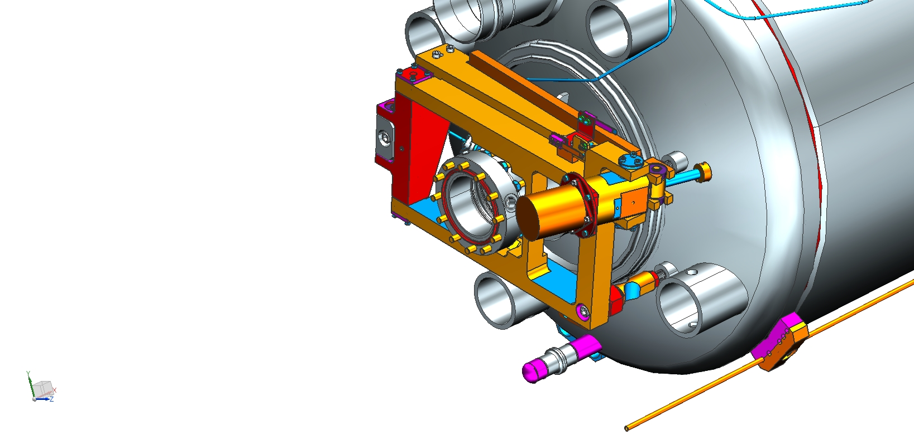

References
These are hyperlinked documents which will be used for reference and calculation as this Procedure is performed.
104211400-M8U-8200-A001

Terms and Definitions

NWA – Network Analyzer
SNS – Spallation Neutron Source
PPU – Proton Power Upgrade
HV – Helium Vessel
SHCS – Socket Head Cap Screw

Roles and Responsibilities

The following roles have responsibilities described in this document. The following actions are to be performed by knowledgeable, authorized Technicians only. Consult the Group Lead for details.

Procedure

- Prior to starting tuner installation, install neoprene bellows protector on helium vessel bellows
- Frame Installation

  - Separate frame (Item 1) from lever assembly by removing primary lever (Item 2), secondary lever (Item 3) and associated components. The connectors (Item 7) should be attached to the frame with four #10-32 hex heads (Item 28).
  - Install ½-13 jam nuts (Item 32) onto tuner mounting studs on HV head. Bottom them out.

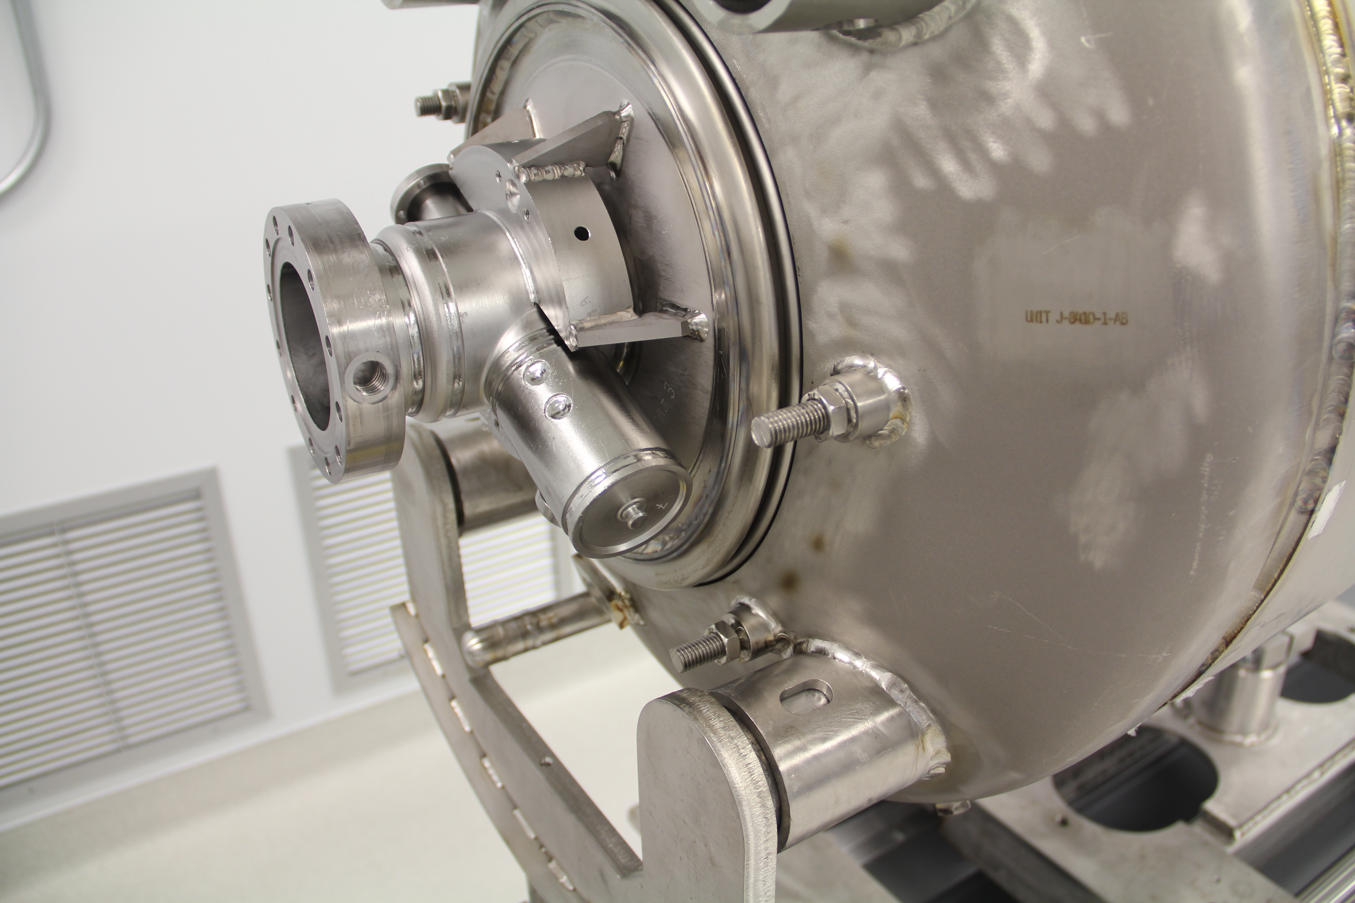
  - Install adjusting standoffs (Item 9) and 7/8-14 hex nuts (Item 38) onto other two studs. Bottom out standoffs on studs. About two threads should be visible between hex nuts and shoulder on standoffs.
    - Flexures should be in a vertical orientation as shown in the image below

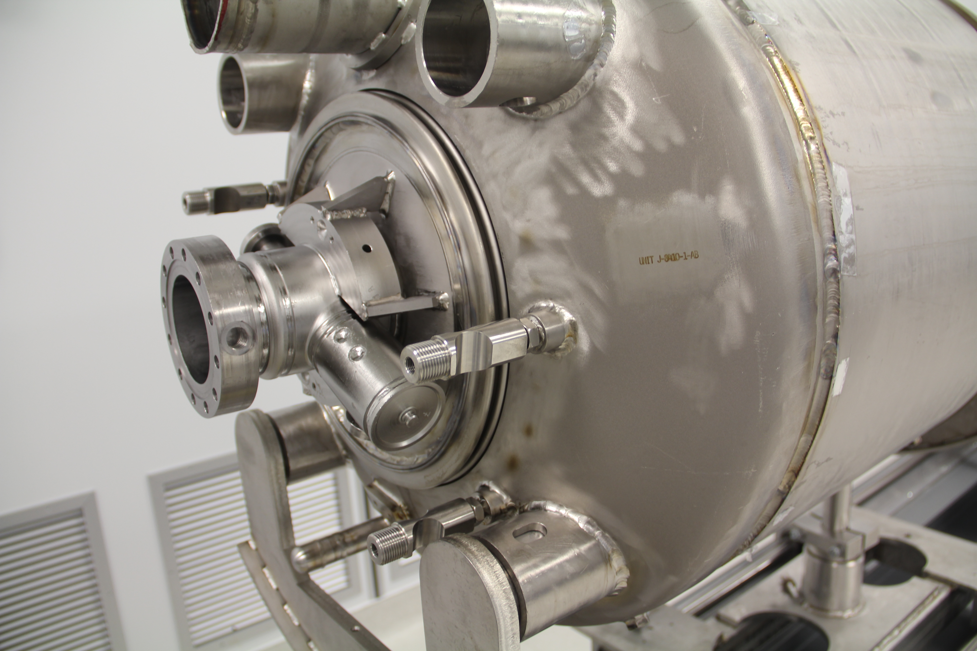

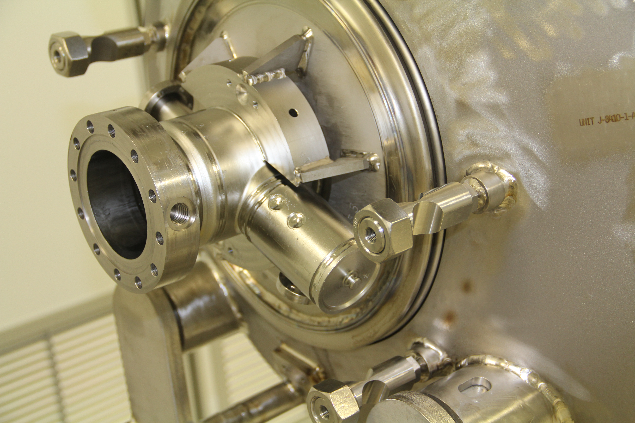

  - Position frame on cavity blocks and insert two 3/8-24 x 1.5” SHCS (Item 30) and washers (Item 37) to loosely attach frame to standoffs.
    - Adjust mounting studs as required using a jam nut
  - Attach frame to cavity using four #10-32 hex heads (Item 28). Frame should be parallel (by eye) to cavity beamline flange.

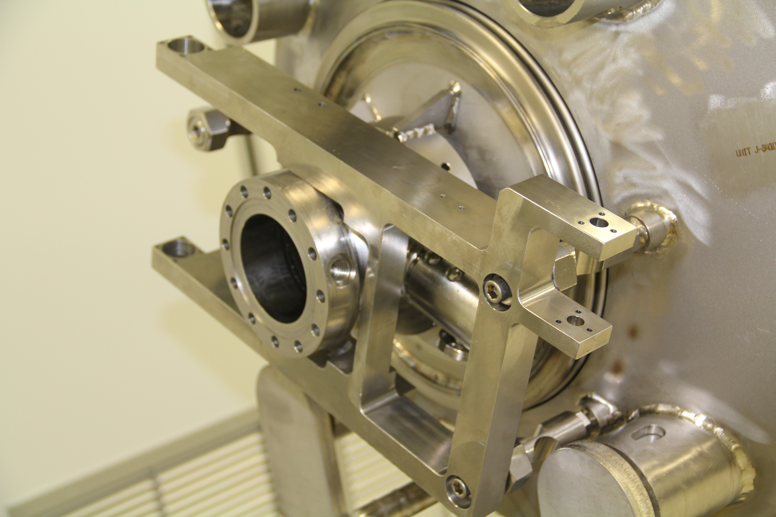

  - Reinstall primary and secondary levers onto frame. Clevis axle (Item 12) should be snug against stop collar (Item 13) nearest drive housing (Item 17).

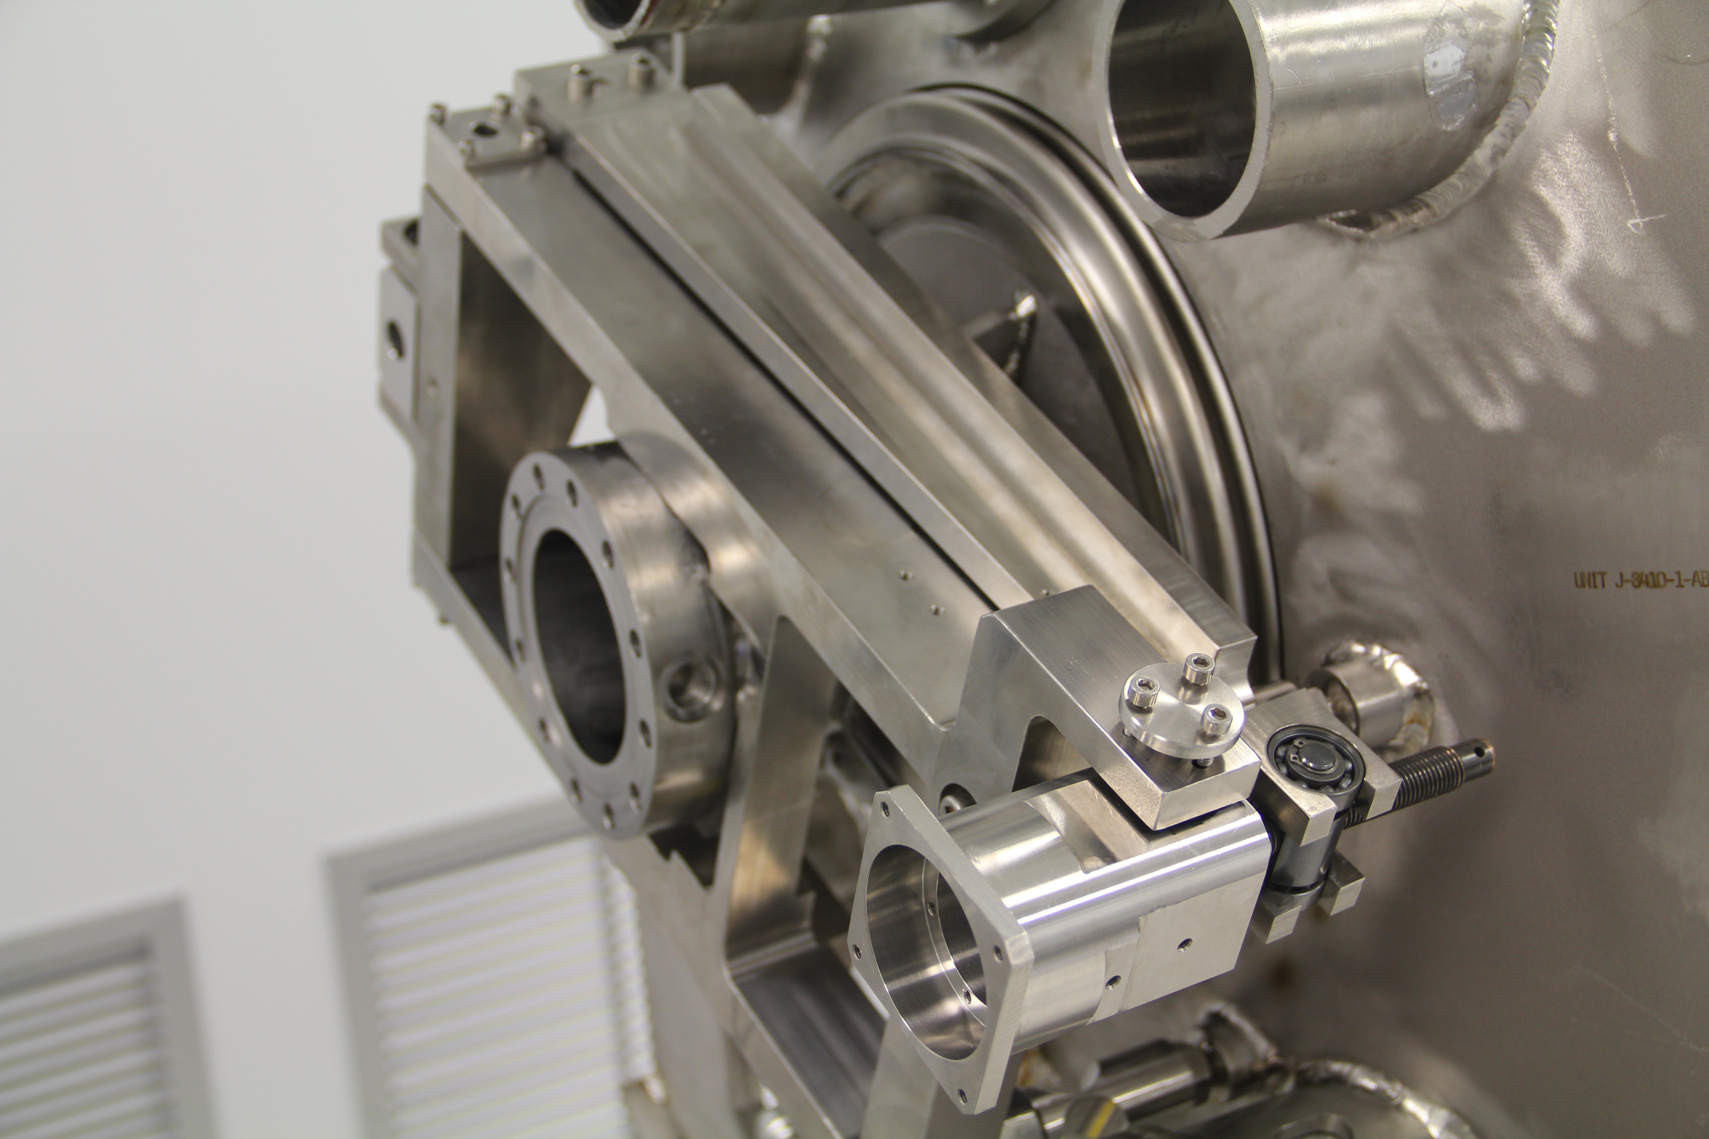
  - Ensure that long lever axle (Item 4) is centered by tightening hex socket set screw (Item 39).

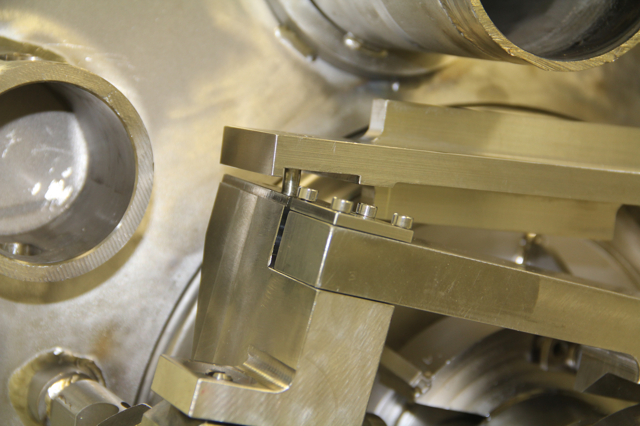

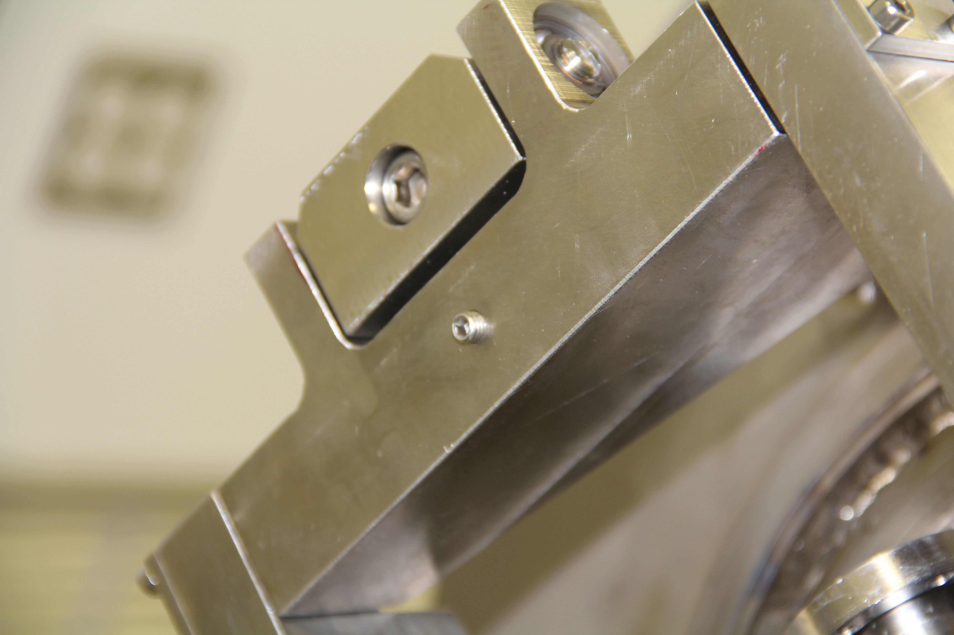

- Cavity Frequency Setting
  - Adjust standoffs so that standoff flexures are aligned and hex nuts are snug to frame. Tighten jam nut beneath standoffs
  - Use network analyzer and coaxial adapter to measure pi-mode frequency. Refer to traveler SNSPPU-CMA-CMASS
  - Using 7/8-14 hex nuts and 3/8-24 SHCS uniformly, adjust position of frame until cavity frequency is achieved. Tighten hex nuts and SHCS. Reconfirm that flexures are aligned properly.

- Limit Switch Installation and Adjustment
  - Install forward and reverse limit switch hardware (Items 31, 40 – 47). Forward limit switch is nearest the primary lever. Reverse limit switch is nearest the frame.

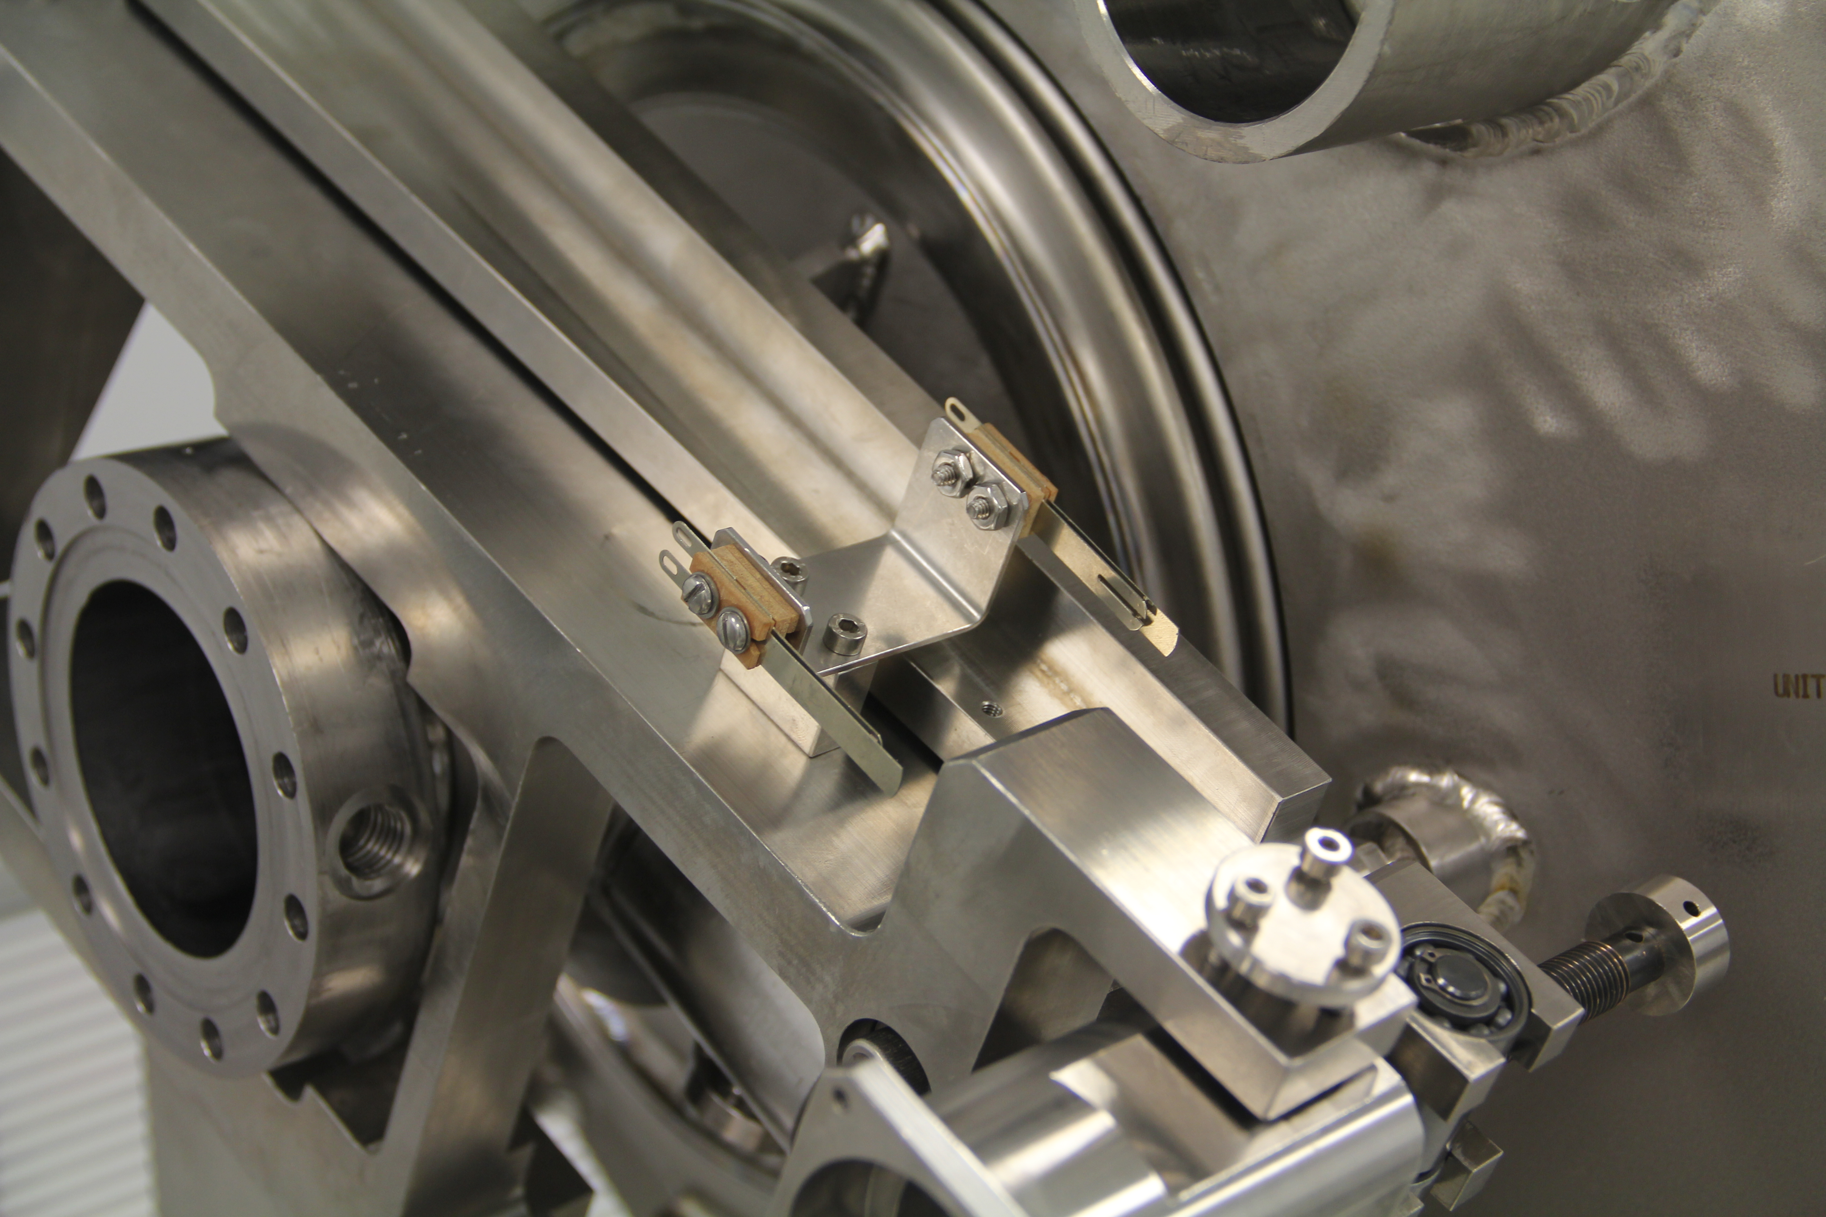

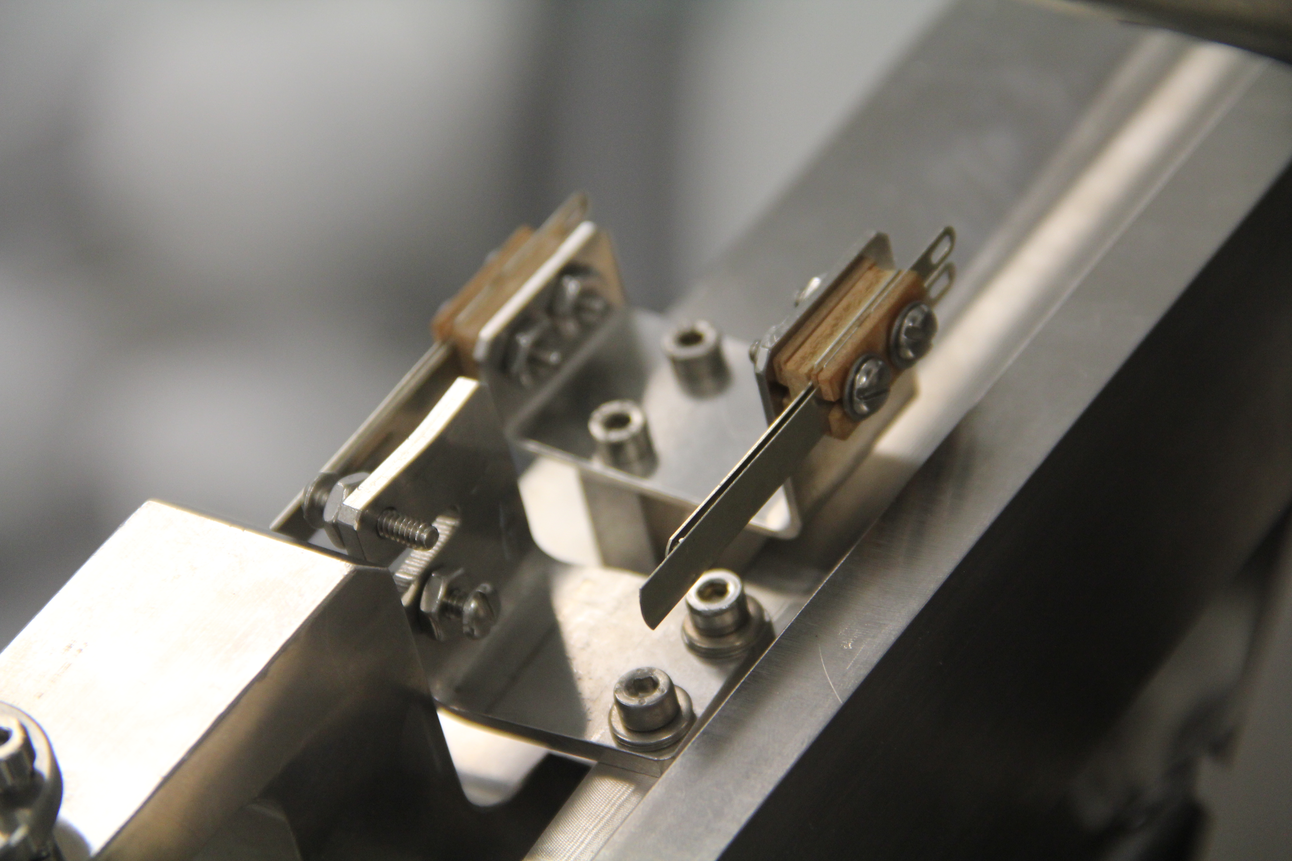

  - Confirm that clevis is against stop collar on drive housing. Turn drive screw (Item 15) approximately 1 revolution forward. Set reverse limit switch to open in this position.
  - Turn drive screw to set primary lever at the other end of travel so that it stops against stop collar at end of drive screw. Turn drive screw (Item 15) approximately 1 revolution backward. Set forward limit switch to open in this position.
  - Turn drive screw (Item 15) until reverse limit switch opens. Leave tuner in this position.

- Stepper Motor and Harmonic Drive Installation

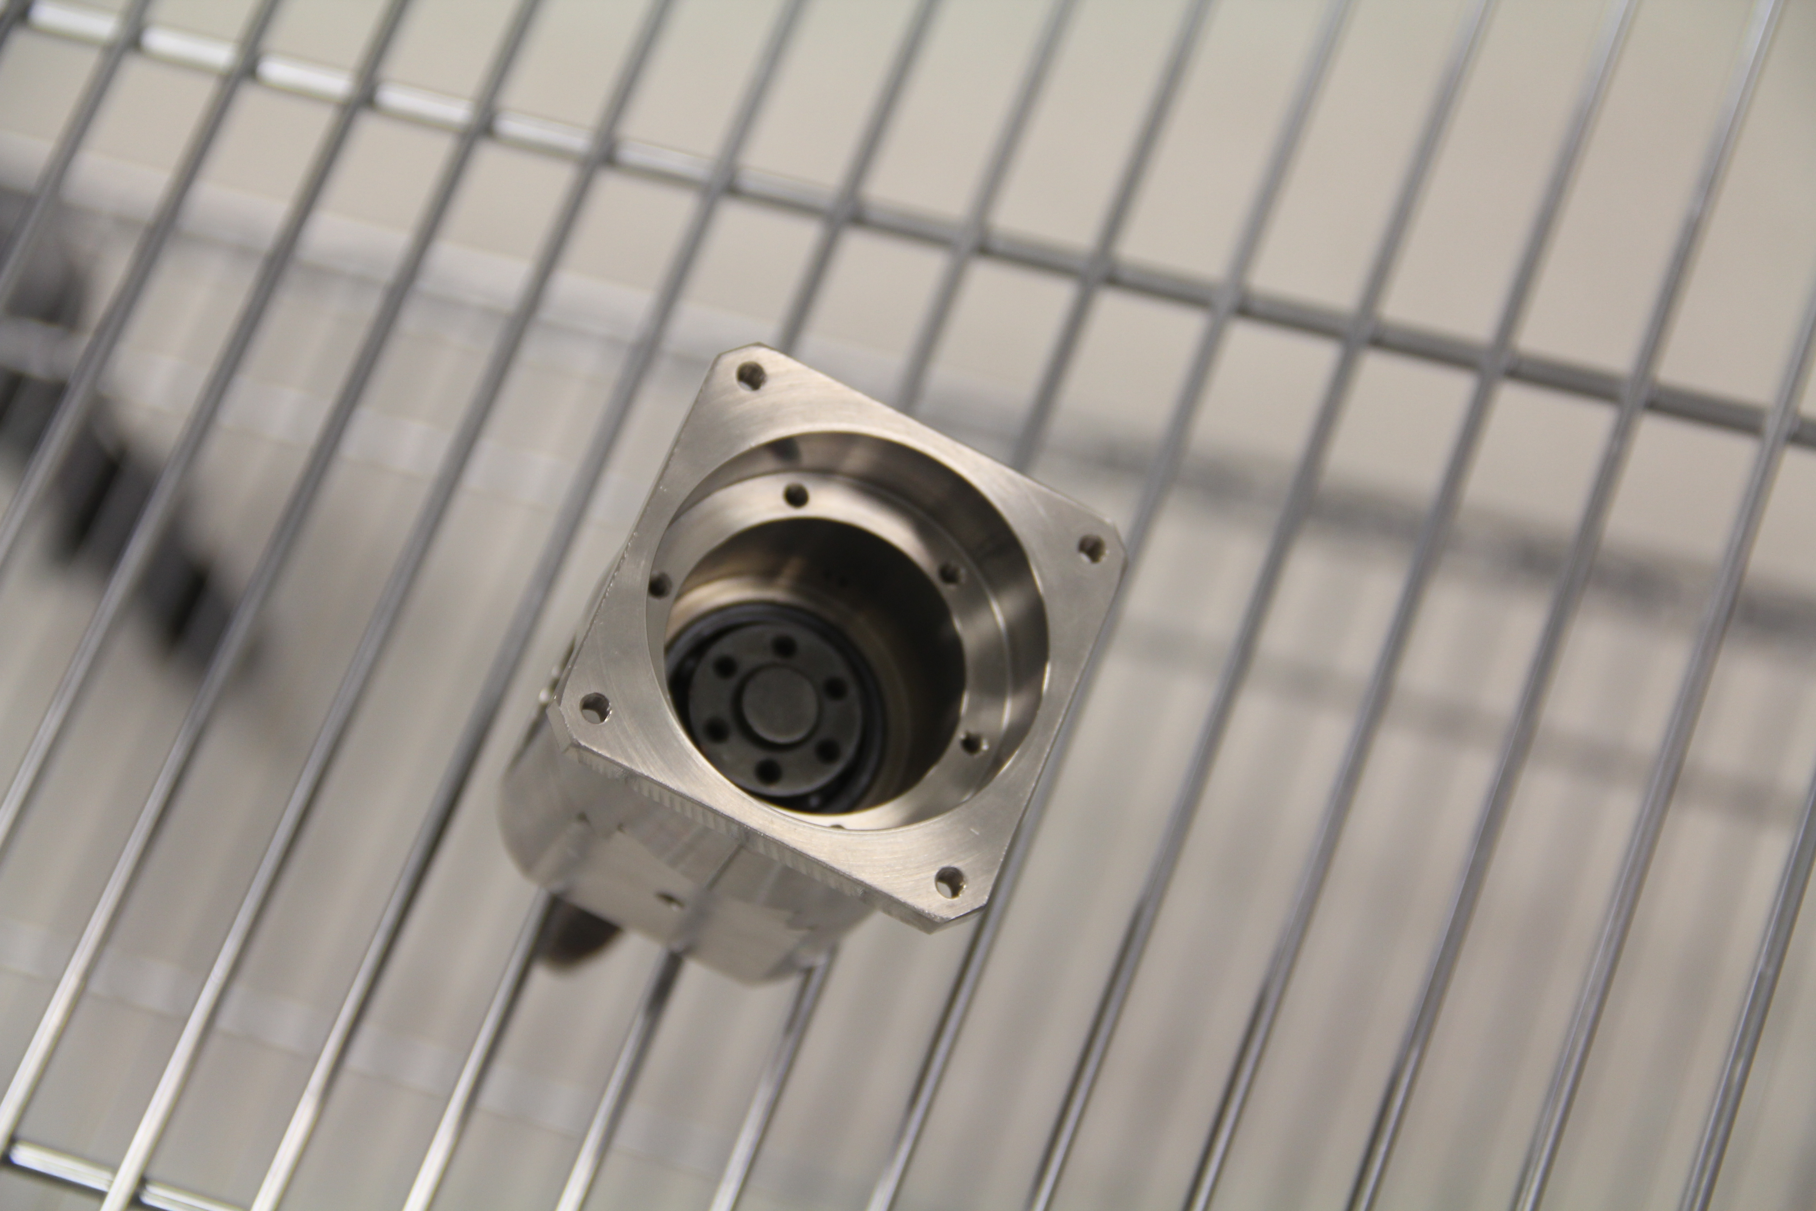

  - Install harmonic drive gear ring using 6 ea M3 x 0.5 x 16 mm SHCS (Item 50).
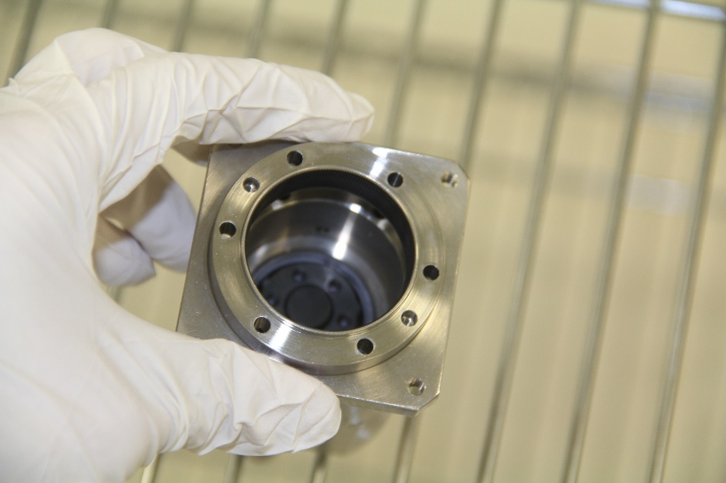
  - Install harmonic drive spline cup using 6 ea M3 x 0.5 x 16 mm SHCS.

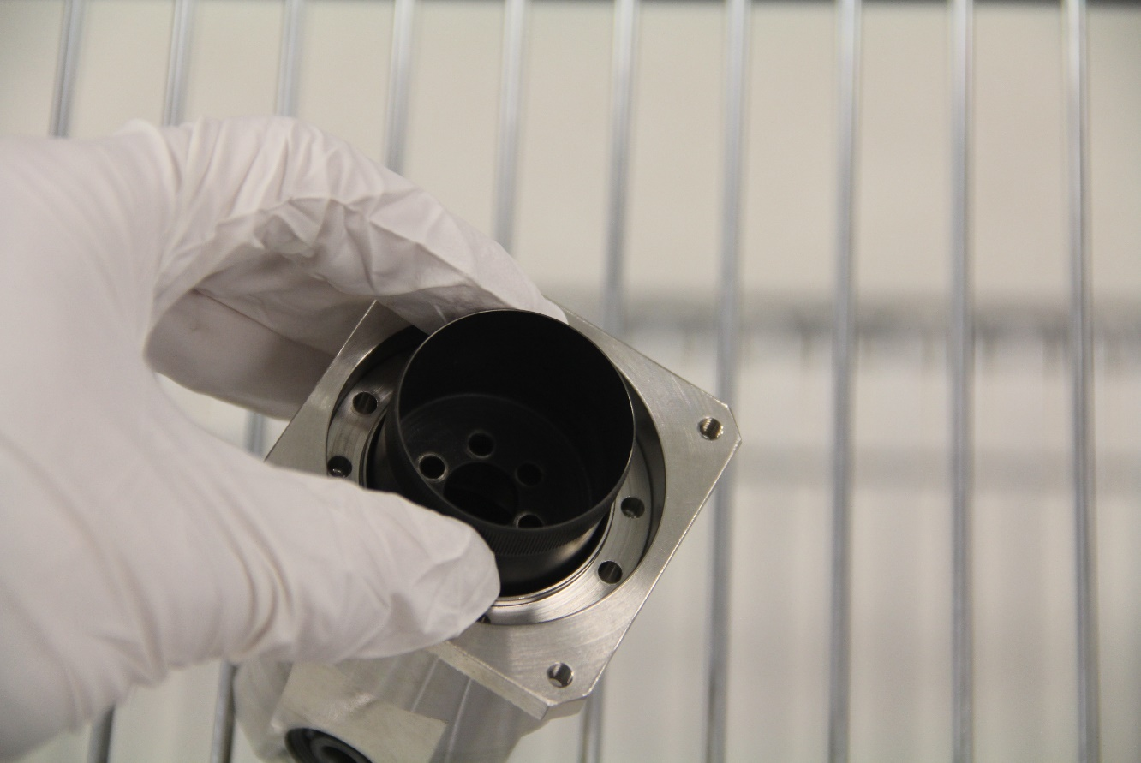
  - Install adapter plate (Item 18) onto stepper motor using 4 ea M4 x 0.7 x 8 mm (Item 8).
  - Install harmonic drive wave generator onto motor subassembly using 4 ea M4 x 0.7 x 12 mm (Item 31). Check that distance from bottom of wave generator to adapter plate is 17.5 mm.

  - Confirm that positive steps drive the motor counterclockwise after motor is wired.

Release and Revision History

Rev # | Revision or update: | Effective:
- |  | 4/6/2021

Approvals

Approved by: | Signature: | Date:
Document Owner | Naeem Huque
Production Group Lead | John Fischer
Project Manager | Ed Daly

