|  |  |  |  |
| --- | --- | --- | --- |
| L2HE Production Cavity Vertical Testing | | | |
| **Document Number:** | CP-L2HE-VTA-CAV-CTRF | **Approval Date:** | 22- Feb-2018 |
| **Revision Number:** | R1 | **Periodic Review Date:** | 18-Feb-2022 |
| **Document Owner:** | E.A. McEwen |  |  |

## 

# Purpose and Scope

This procedure describes the steps of testing 1300MHz L2HE 9-cell production cavities at VTA. Refer to CP-C1100-CAV-VTRF for detailed description if needed

# References

[VTA SOP](https://jlabdoc.jlab.org/docushare/dsweb/Get/Document-109940/VTA%20OSP%202015.docx)

[Excel spreadsheet template for VTA](https://jlabdoc.jlab.org/docushare/dsweb/Get/Document-125560/SpreadsheetTemplate%20for%20L2PRD-CAV-VTRF_30Aug2016.xlsm) [RF measurements](https://jlabdoc.jlab.org/docushare/dsweb/Get/Document-125560/SpreadsheetTemplate%20for%20L2PRD-CAV-VTRF_30Aug2016.xlsm)

[CP-C100-CAV-VTRF (C100](https://jlabdoc.jlab.org/docushare/dsweb/Get/Document-27848/CP-C100-CAV-VTRF%20R4.pdf) [1497MHz Vertical Testing](https://jlabdoc.jlab.org/docushare/dsweb/Get/Document-27848/CP-C100-CAV-VTRF%20R4.pdf) [Procedure)](https://jlabdoc.jlab.org/docushare/dsweb/Get/Document-27848/CP-C100-CAV-VTRF%20R4.pdf)

[Excel File for 9-Cell Pass Band](https://jlabdoc.jlab.org/docushare/dsweb/Get/Document-126149/Mode%20Analysis%20AES034%20d7%20aug%2026%202014.xlsx) [Mode Analysis](https://jlabdoc.jlab.org/docushare/dsweb/Get/Document-126149/Mode%20Analysis%20AES034%20d7%20aug%2026%202014.xlsx)

[Theory and Practice of Cavity RF Test](https://jlabdoc.jlab.org/docushare/dsweb/Get/Document-27850/Theory%20and%20practice%20of%20cavity%20RF%20test%20systems.pdf) [Systems](https://jlabdoc.jlab.org/docushare/dsweb/Get/Document-27850/Theory%20and%20practice%20of%20cavity%20RF%20test%20systems.pdf)

An Automated RF Data Acquisition System for Testing Superconducting RF Cavities

# Terms and Definitions

1. **Term1** – Definition of term1.
2. **Term2** – Definition of term2.

# Process Details

# Preparation: Assume dewar is at 2K, HOM survey has been done, and pass band has been found. Open previous testing traveler if available. Remove water and dust from inside cable connectors on top of test stand using air can.

* 1. **Write down:** He level (cm), Dewar pressure (Torr), cavity pressure (mBar). Cavity SN, Dewar#, test stand#, network analyzer and reference power meter used. Date & Time.

# Find cavity π mode frequency using network analyzer

Recall C100 setup: “recall” and select “VTA1300MHz”, “Marker” and the screen will show the cavity frequency. “Output” ->”CW”. Set input power frequency at π mode cavity frequency ±50~100 kHz (write down detuned frequency used).

Example: pass band frequencies for CAV0005:

|  |  |  |
| --- | --- | --- |
| π/9 | 1276.34 MHz |  |
| 2π/9 | 1278.49 MHz |  |
| 3π/9 | 1281.75 MHz |  |
| 4π/9 | 1285.71 MHz |  |
| 5π/9 | 1289.98 MHz |  |
| 6π/9 | 1293.98 MHz |  |
| 7π/9 | 1297.31 MHz |  |
| 8π/9 | 1299.46 MHz |  |
| π | 1300.22 MHz |  |

# Hook up cables on control room rack and at dewar:

## *Cable connection at control room rack:*

Use 1300MHz system, blue cable A,B,C,D connect to D7 or D8 A,B,C,D.

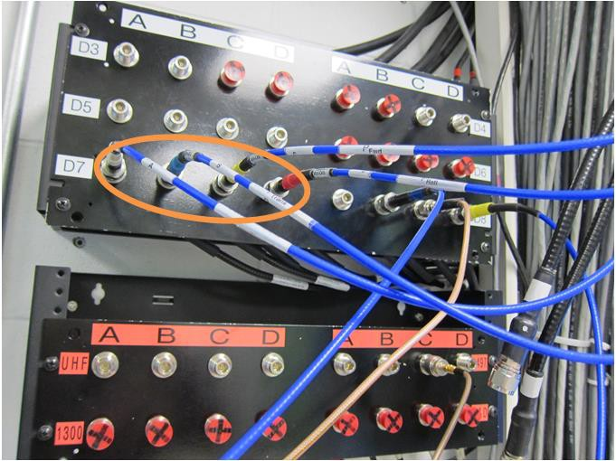

Figure 1. Cable connection at control room rack if testing in dewar 7 using 1300MHz system.

## *Cable connection at dewar (Dewar7 shown in picture):*

Make sure cable from the correct amplifier is connected to the input of the circulator.

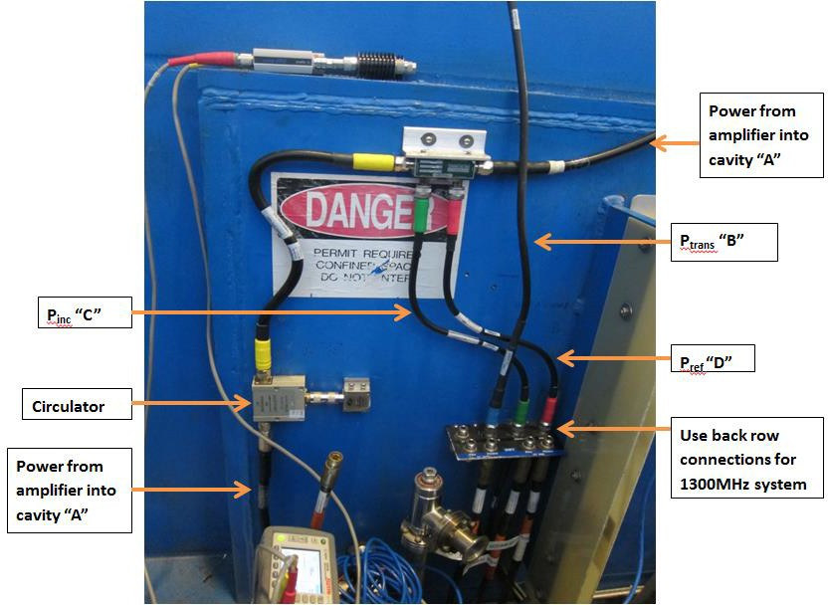

Figure 2. Cable connection at dewar if testing in dewar 7.

## *Amplifier cable connection:*

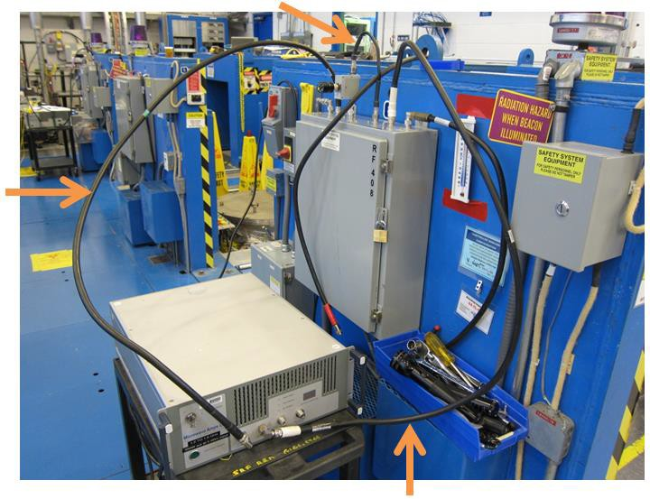

Figure 3. Amplifier cable connection.

Need two circulators (UTE Microwave Inc, CT-2334N, 1.0~1.5GHz), one for lower power amplifier, and one for cable calibration. Roll-up amplifier has its own protection all built-in.

# Cable calibration:

Yellow colored numbers are the values need to be written down during calibration, existing numbers are for reference.

# Prepare power meters and start LabVIEW program:

Select the right frequency (1.3GHz) before using power meters.

***Reference power meter (at dewar):*** Need “Cal” and then “Zero” before calibrating cables.

***HOM power meter (at dewar):*** Power cord plugged in and started. Ethernet cable connected for data communication. HOM power meter does not need “Cal” but need “Zero” before opening LabVIEW program in control room. To zero HOM power meter, connect power head A and B (with 20dB attenuator attached) to the calibration port on the power meter individually and press “Zero”.

Open LabVIEW program in control room: “7_VTA_main”. Fill out cavity information. Zero meters (three of them, on the rack above). Pull out previous traveler of the same cavity to check that frequency and probe calibration numbers are not significantly deviated.

Check position of knobs in control room: Loop “open”, RF “off”, AMP switched “off”.

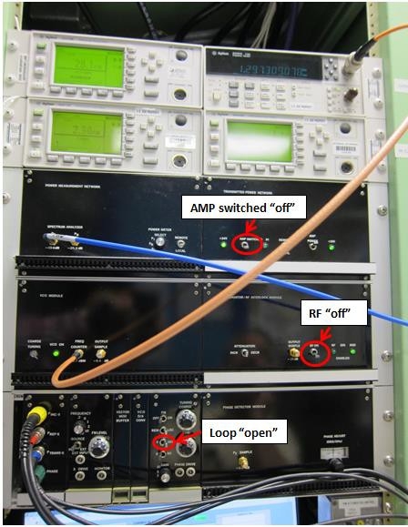

Figure 4. Knob positions in control room when start LabVIEW program.

# Send power from network analyzer Port 1 to control room (aka. Power into control room measurements):

Port 1 cable connect to power meter, aka. Power out from network analyzer (measure output power from network analyzer), ~30mW measure power for 15dB attenuation setting of power output from network analyzer (directional coupler loss is 30dB);

Port 1 cable connect to cable Pin “A”, aka. Reflected power from VTA. In control room, (Pi, Pt should be zero, or nW, pW scale; Pr should read a few µW scale) put the network analyzer power out in the yellow field in LabVIEW;

Port 1 cable connect to cable Ptrans “B”, aka. Transmitted power into control room. In control room, (Pi, Pr should be zero, Pt should read hundreds of µW scale, should have less loss because no directional coupler on the route) put the network analyzer power out in the yellow field in LabVIEW;

Port 1 cable connect to HOM A, aka. HOMA power into control room. In control room, (Pi,Pr,Pt should read zero) put the network analyzer power out in the yellow field in LabVIEW;

Port 1 cable connect to HOM B, aka. HOMB power into control room. In control room, (Pi,Pr,Pt should read zero) put the network analyzer power out in the yellow field in LabVIEW;

# Send power from control room to dewar reference power meter (aka. Incident power (Pin) at dewar):

Cable Pin “A” connect to reference power meter head. In control room, adjust Labview attenuator control from 40dB to 20dB, RF “ON”, frequency set to detuned frequency (π mode frequency ±50~100 kHz). At dewar record power meter reading (~25.2 mW) (in control room, Pin should read ~1.06 µW, Pr,Pt should read zero, Pr may read 10 nW because of crosstalk from 20dB directional coupler)

RF “OFF” when done.

# Send power from network analyzer Port 1 to cavity (aka. Cold cable return losses):

Port 1 cable connect to circulator “1”, power meter head connect to circulator “3”, adjust connector on circulator “2”.

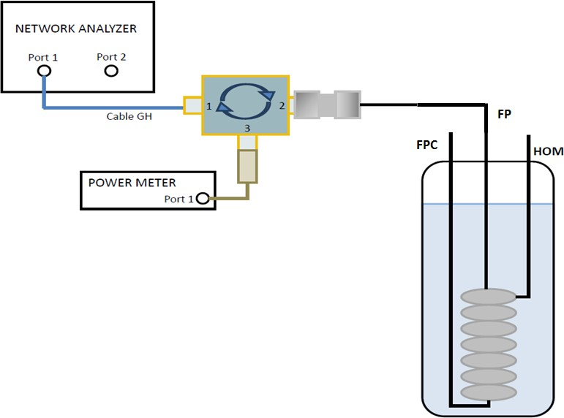

Figure 5. Cable connection when measure cold cable return losses on field probe.

Circulator “2” near Field Probe port on test stand, record reading on reference power meter (~27.5mW) (aka. Calibrated open measurement); circulator “2” connected to Field Probe port on test stand, record reading on reference power meter (~11.96 mW) (aka. Transmitted cable return loss);

Circulator “2” near HOM A port on test stand, record “open” (28.1 mW) and “connected” (20.16 mW) values, aka. HOMA cable return loss;

Circulator “2” near HOM B port on test stand, record “open” (27.71 mW) and “connected” (21.1 mW) values, aka. HOMB cable return loss;

# Forward power into a detuned cavity:

Check calibrations with previous test before closing lead door. If good, choose “replace”. Write down PCAV (Torr), PDewar (Torr) (23Torr for 2.0K), LHe level (cm)

Connect all cables at dewar. Close lead door. Post area per VTA RWP. Check high power amplifier is on. Enable RF (purple beacon will flash at the dewar).

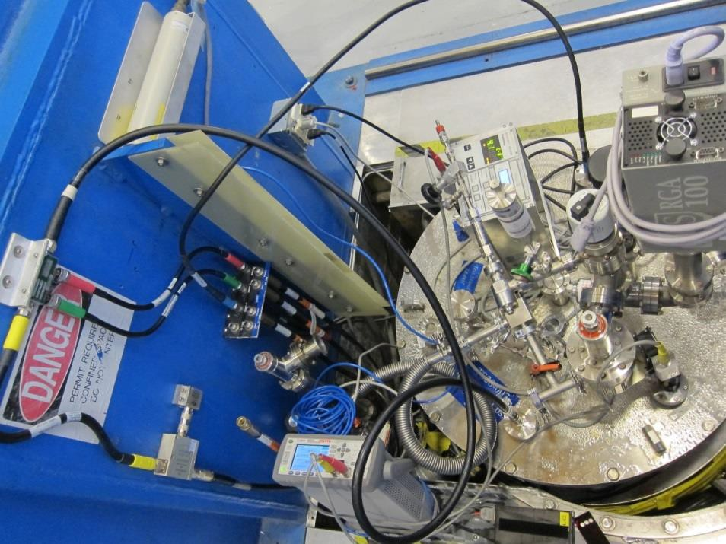

Figure 6. All cables connected before closing lead door.

In control room, check: loop “open”, RF “ON”, Attenuation on LabVIEW program at 35 dB, frequency OFF resonance, Pt power should read zero, Pin and Pr should be about the same magnitude.

Click “Forward Power into Detuned Cavity” button on LabVIEW. Note the scale of numbers that flash briefly on the screen?

Finish with calibration on LabVIEW. If good, choose “replace”.

Reset the Labview attenuator to 35dB, the magnitude (absolute value) of Ploss/Pinc should be <0.003. Repeat FPDC if not. RF “OFF” when done.

# High power testing

* 1. **Find cavity lock frequency and check cable calibration**

Close loop. RF “ON”. Attenuation at 35 dB. Find π mode frequency around known number and actual lock frequency might be slightly different. Write down current resonant (lock) frequency, attenuation used for decay measurement (35 dB). Dial phase in LabVIEW to maximize Pt on oscilloscope, adjust crystal to 600mV, then optimize phase with fine tune knob.

* 1. **Measure coupling β** (refer to CP-C100-CAV-VTRF)

Turn off RF. Wait until first reflected peak reach the middle of the screen, turn on RF power. When both peaks are on the screen, pause the scope. Open oscilloscope screen shot LabVIEW program. Take a

screen shot of scope data, save, and write down file name. Select coupling on the testing LabVIEW program as measured.

# Decay measurement

Set Qext2 at a number between 0 and 100. Attenuation at 35 dB. Same attenuation repeat 3~5 times and make sure data have good consistency. Write down important numbers.

2K:

|  |  |  |  |  |  |  |  |  |  |
| --- | --- | --- | --- | --- | --- | --- | --- | --- | --- |
| Dwell  time, sec | Eacc , MV/m | Q0 | Qext1 | Qext2 | Error, % | τ, sec | QHOMA | QHOMB | Rad, mR/hr |
|  |  |  |  |  |  |  |  |  |  |
|  |  |  |  |  |  |  |  |  |  |
|  |  |  |  |  |  |  |  |  |  |
|  |  |  |  |  |  |  |  |  |  |
|  |  |  |  |  |  |  |  |  |  |

|  |  |  |  |  |
| --- | --- | --- | --- | --- |
| Ci | Cr | Ct | CHOMA | CHOMB |
|  |  |  |  |  |

Enter the chosen Qext2 and Error% value from decay measurement. Start recording CW Q0-Eacc curve. For each measurement point:

Adjust attenuation on LabVIEW to obtain the desired Eacc, adjust phase, adjust “PIN attenuator control knob” until Pr (blue curve on oscilloscope) is at 600mV.

**Start initial 2K power rise.** Start from 40 dB attenuation and take 0.5 MV/m step. Stop at 18 MV/m if there is no early quench or out-of-limit radiation.

# Cool down to 1.8K, 1.6K, and lower temperature testing:

At dewar control panel: Change set point to 12.5Torr (1.8K) or 5.7Torr (1.6K). Make sure CTF pump (Kinney pump) is isolated (Close EV920) and pair pump(s) is running. It takes ~20 minutes to cool from 2K to 1.8K. (If you leave control room, disarm RF to your dewar.) When at target temperature, make decay measurement and record numbers.

1.8K:

|  |  |  |  |  |  |  |  |  |  |
| --- | --- | --- | --- | --- | --- | --- | --- | --- | --- |
| Dwell  time, sec | Eacc , MV/m | Q0 | Qext1 | Qext2 | Error, % | τ, sec | QHOMA | QHOMB | Rad, mR/hr |
|  |  |  |  |  |  |  |  |  |  |

1.6K:

|  |  |  |  |  |  |  |  |  |  |
| --- | --- | --- | --- | --- | --- | --- | --- | --- | --- |
| Dwell time,  sec | Eacc , MV/m | Q0 | Qext1 | Qext2 | Error, % | τ, sec | QHOMA | QHOMB | Rad, mR/hr |
|  |  |  |  |  |  |  |  |  |  |

Take at least one decay measurement at 1.8K and 1.6K. Q0 and Eacc should go up. Others should stay the same. Use 2K Qe2 for all testing unless error is significantly smaller using new numbers due to better input coupling factor (Beta closer to unity).

When rising power, start from 40 dB attenuation and take 1 MV/m step. Go up to 18 MV/m or previous stop gradient.

# Decay measurement

At dewar control panel: Change set point to 23Torr. Turn on heater, power 150 W. Wait ~15 minutes until at dewar pressure reach 23 Torr. Turn off heater. Wait until dewar pressure is stable at 23 Torr.

Start from 40 dB attenuation and take 1 MV/m step. Use 0.5 MV/m steps once you get close to previous quench gradient or unexplored gradient range. Stop at 24 MV/m unless limited by quench, high radiation (>1 R/hr), or cable breakdown.

# Finish testing

Disarm your dewar, If other tests are not using PSS, then disarm PSS and un-post area. Fill out traveler.

# Options during testing:

Turn on Lorenz detuning live in LabVIEW program;

RF “OFF” to check cables, ratio Ploss/Pinc <0.003; if not, forward power into detuned cavity and replace last part of calibration;

# **Revision History**

|  |  |  |
| --- | --- | --- |
| Rev # | Revision or update: | Effective: |
| R1 | Initial Release | 14-Apr-2021 |

# **Approvals**

|  |  |  |
| --- | --- | --- |
| Approved by: | Signature: | Date: |
| **Document Owner** | K. Davis |  |
| **Reviewer** | A. Palczewski |  |
| **Project Manager** | J. Hogan |  |