|  |  |  |  |
| --- | --- | --- | --- |
| **Vertical Plasma Processing Cable Calibrations** | | | |
| Document Number: | PLACLN-PR-VSA-CAV-CCAL | Approval Date: | Mmm DD, YYYY |
| Revision Number: | 1 | Periodic Review Date: | Mmm DD, YYYY |
| Process Owner: | Ganey, Tiffany | Department Owner: | SRF Ops |

**Table of Contents**

1 Purpose and Scope 3

2 Safety 3

3 Terms and Definitions 4

4 Roles and Responsibilities 5

5 Tools and Equipment Needed 5

6 Pre-Requisites 6

7 PFwd to Cable End 8

8 Power at End of Test Cable 10

9 PRef from Cable End 11

10 PTrans from Cable End 13

11 Incident Power to Detuned Cavity 15

12 Verify Cable Calibrations 17

13 Calibrate RF PWR 18

14 References 19

15 Release and Revision History 19

16 Approvals 19

**Table of Figures**

Figure 6‑a: HOM Couplers and Cell Numbers 6

Figure 6‑b: RF System as connected for Vertical Plasma Processing 7

Figure 7‑a: PFwd to Cable End Connections 8

Figure 7‑b: Example data for PFwd calibration 8

Figure 7‑c: Example Pfwd Calibration Change values 9

Figure 8‑a: Power at End of Test Cable Connection 10

Figure 8‑b: Example power meter reading 10

Figure 8‑c: Example data from power meter calibration 10

Figure 9‑a: PRef from Cable End Connection 11

Figure 9‑b: Example directivity and calibration values for PRef 11

Figure 9‑c: Example data from PRef calibration 12

Figure 10‑a: PTrans from Cable End Connections 13

Figure 10‑b: Example Calibration value for PTrans 13

Figure 10‑c: Example data from PTrans calibration 14

Figure 11‑a: Incident Power to Detuned Cavity Connections 15

Figure 11‑b: Example HOM one way loss value 15

Figure 11‑c: Example HOM 1-way loss calibration values 16

Figure 12‑a: Calibration Factor Comparison shown when calibration is complete 17

Figure 13‑a: Calibrate RF PWR Connection 18

# Purpose and Scope

This procedure provides instructions for performing cable calibrations for plasma processing of a C100 cavity in the Vertical Staging Area (VSA). The cable calibration process for vertical plasma processing consists of calibrating the forward, reflected, and transmitted power cables; forward power to a detuned cavity, and RF power.

The C100 cavity shall use the plasma processing test stand (TS28-006). The test stand shall be staged in the southwest corner of the VSA after being removed from the Dewar.

# Safety

Individuals must keep safety as the first priority in the process; before beginning any job, the user must assure they have the correct PPE for the individual job. Maintaining the level of safety and secure nature of the work area is paramount. Assure personal safety by using caution in movement and taking necessary steps to avoid unnecessary personnel in the immediate area.

Refer to the work-center OSP for specifics.

## The VSA is a Radiologically Controlled Area, and dosimetry must be worn at all times while in the VSA.

### Refer to the Vertical Testing Area (VTA) OSP for specific guidance for working in the VSA.

## The VTA / VSA is a radiation area when high power tests are being performed. In addition to flip signs indicating a change in state, the magenta beacons each shield lid are an indication that high power operation is enabled. Individuals who are not approved to be in the VTA / VSA during high power operation as per the VTA RWP are required to leave the area during high power testing.

## Test stands are frequently lowered into and raised out of the VSA. The location of equipment and test stands in the VSA changes frequently. Be mindful of the current conditions and stay out of the way of any movement of equipment.

## Frequent crane moves between the Vertical Attachment Area (VAA), VSA, and VTA. Prior to entering or exiting the VSA, observe the crane location and if there is an active lift occurring.

# Terms and Definitions

The following terms have specific meanings within this procedure.

|  |  |
| --- | --- |
| Term | Definition |
| Computer / RF Cart | Cart with computer, signal generator, power meters, amplifier, etc. and RF components (directional coupler, circulator, power sensors, cables, etc.) used for plasma processing. |
| PlasmaMain | The LabVIEW software that runs the plasma processing program; located in the D:\Labview VIs folder. |
| PFwd | Forward Power, from the RF source(s) to the HOM(s) |
| PRef | Reflected Power, from the HOM(s) |
| PTrans | Transmitted Power, from the FPC |
| Test Cable | RF Source 1 Cable, from Signal Generator (Freq1) |
| Verify | If an instruction specifies to “verify” and the item is not true then stop and seek help unless additional instructions are provided in the procedure. |
| Vertical Staging Area (VSA) | Area adjacent to the Vertical Test Area (VTA), where test stands are staged prior to and after vertical testing in the VTA. |

A list of general terms and definitions can be found in the Quality Manual QML-001.

# Roles and Responsibilities

The following roles have responsibilities described in this document.

|  |  |
| --- | --- |
| Role | Responsibility |
| Plasma Processing Worker | Personnel trained to set up the plasma processing carts and to perform plasma processing. |
| Plasma Processing Subject Mater Expert (SME) | Personnel knowledgeable on plasma processing techniques and requirements, available to assist during plasma processing treatments. |

# Tools and Equipment Needed

|  |  |  |
| --- | --- | --- |
| Tool / Equipment | Quantity | Where / When Needed |
| 100 Watt Load | 1 | For cable calibrations |
| N-type cables, connectors, attenuators, etc. | As needed | RF connections between Computer / RF cart and cavity |
| N-type elbow connector | 1 or 2 | To be connected to the HOM(s) to be used for plasma processing |
| Plasma Computer / RF Cart | 1 | In the VSA lower level |

# Pre-Requisites

## If not done, open the PlasmaMain software and press the run arrow to start the program.

### Name the data file in the format "[Cavity ID]_HOM[&]", where [Cavity ID] is replaced with the cavity ID and [&] is replaced with the HOM(s) used for plasma processing. For example, "C100-RI-086_HOMB" is the data file for processing the cavity C100-RI-086 with HOM port B.

### Turn off the auto capture of images and network analyzer traces by clicking the "Timed Write ON" button. The timed write button will turn yellow and display "Timed Write OFF".

**NOTES:**

* See Figure 6‑a to determine HOM nomenclature.
* PlasmaMain will append the current date to the file name and save the file to the appropriate directory on the computer's D drive.

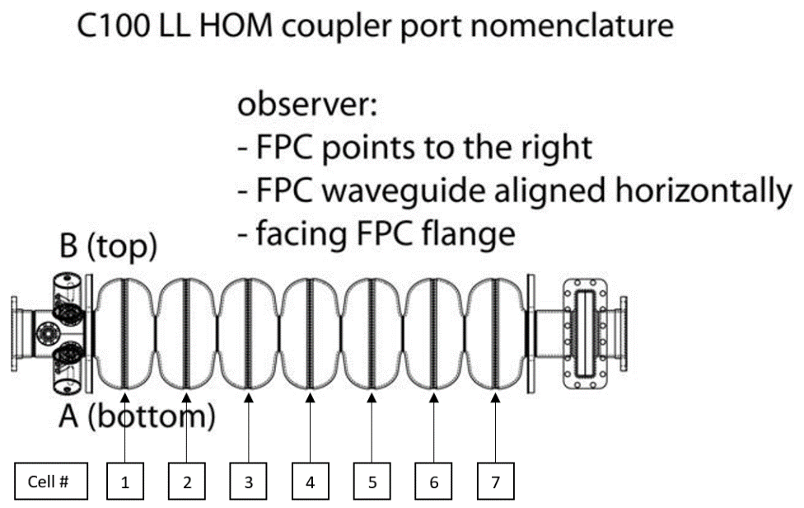

Figure 6‑a: HOM Couplers and Cell Numbers

## Add N-type RF elbow to the HOM(s) to be used for plasma processing. See Figure 6‑a to determine HOM nomenclature.

## Verify / turn off RF amplifier.



Figure 6‑b: RF System as connected for Vertical Plasma Processing

## Disconnect RF source 1 cable (Signal Generator Freq 1) from the combiner. This cable will be used for most of the steps of this procedure as the "test cable"

## Disconnect amplifier output from circulator. The amplifier and combiner only be used for the last section of this procedure (Section 13, Calibrate RF PWD).

## Disconnect Ptrans power meter from splitter. This power meter sensor will be used for many of the steps of this procedure.

## From the PlasmaMain home screen, click the Calibrate Cables button.

## In the popup window, verify the initial conditions listed have been set, and press "Click to return".

# PFwd to Cable End

## Press the “PFwd to Cable End” button.

## Connect the RF source 1 cable (Signal Generator Freq 1) to the input of the circulator. See the dash line on Figure 7‑a.

## Connect the PTrans power meter to the cable that is normally connected to the cavity HOM port. See the dash-dot line on Figure 7‑a.



Figure 7‑a: PFwd to Cable End Connections

## Verify that the directivity is about -20 dB and that the calibration factor is about 35 dB.

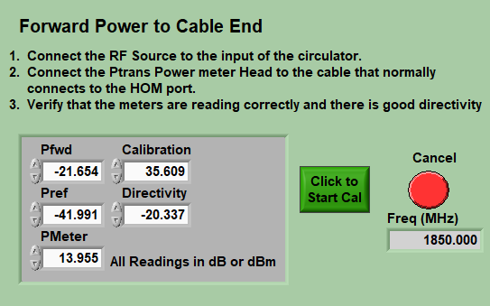

Figure 7‑b: Example data for PFwd calibration

## Click the green Start Calibration Button.

.

## In the blue popup window, verify that the Change column values are within a few tenths of a dB as a function of frequency and click Done.

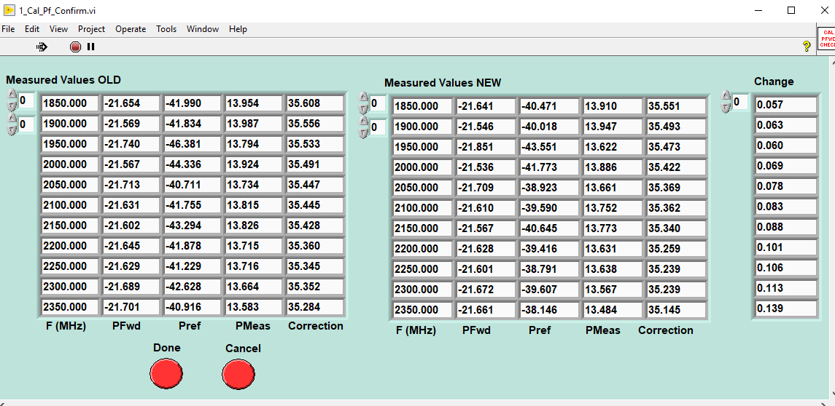

Figure 7‑c: Example Pfwd Calibration Change values

# Power at End of Test Cable

## Press the “Power at End of Test Cable” button.

## Connect the RF source 1 cable (Signal Generator Freq 1) to the PTrans power meter, as shown in Figure 8‑a



Figure 8‑a: Power at End of Test Cable Connection

## Verify that PMeter is approximately 1 dB less than the Source Pwr.

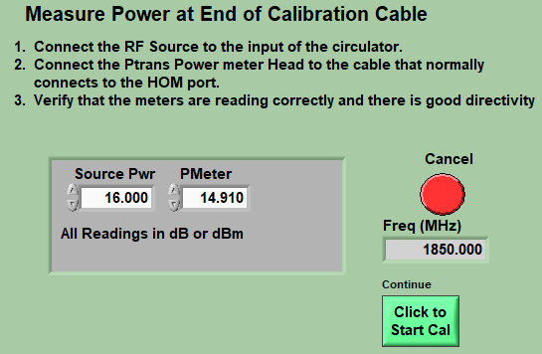

Figure 8‑b: Example power meter reading

## Click the green Start Calibration button.

## In the green popup window, verify that the PM Data values are roughly the same for each frequency.

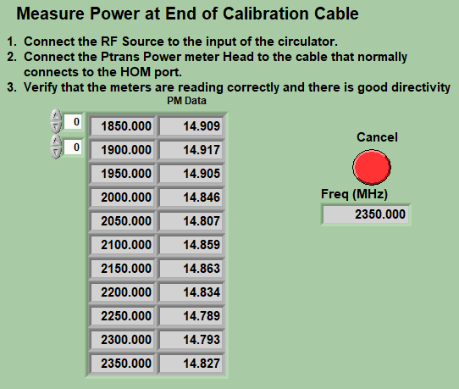

Figure 8‑c: Example data from power meter calibration

## In the blue popup window, verify that the Change values are correct and click Done.

# PRef from Cable End

## Press the “PRef From Cable End” button.

## Connect the RF source 1 cable (Signal Generator Freq 1) to the cable that is normally connected to the cavity HOM port.



Figure 9‑a: PRef from Cable End Connection

## Verify that the power meters are reading and that the directivity is about -20 dB and that the calibration factor is about 35 dB. Note the Calibration value on this screen.

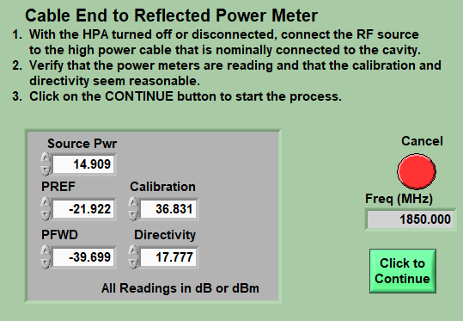

Figure 9‑b: Example directivity and calibration values for PRef

## Click the green Continue button.

## In the green popup window, verify that the PR_Cal values are within a few tenths of a dB from the Calibration value noted in step 9.3.

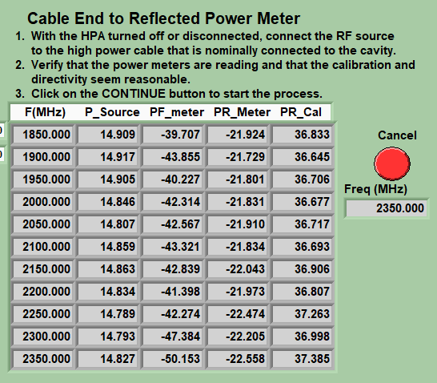

Figure 9‑c: Example data from PRef calibration

## In the blue popup window, verify that the Change values are correct and click Done.

# PTrans from Cable End

## Press the “Ptrans from Cable End” button.

## Connect the RF source 1 cable (Signal Generator Freq 1) to cable connected to the splitter input. See dash line in Figure 10‑a.

## Connect the Ptrans power meter to the 2-way splitter, where it is normally connected. See dash-dot line in Figure 10‑a.



Figure 10‑a: PTrans from Cable End Connections

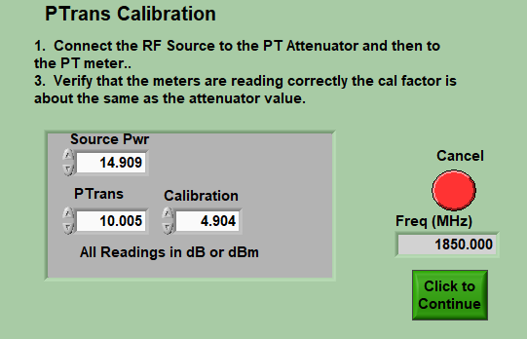

Figure 10‑b: Example Calibration value for PTrans

## Click the green Continue button.

## In the green popup window, verify that the ‘PT_Cal” values are roughly the same for each frequency.

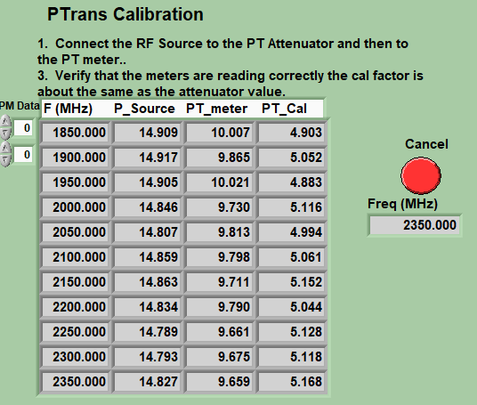

Figure 10‑c: Example data from PTrans calibration

## In the blue popup window, verify that the Change values are within a few hundredths of a dB if no changes to the RF cables or components have been made since the last cable calibration. Click Done.

# Incident Power to Detuned Cavity

## Press the “Incident Power to Detuned Cavity” button.

## Connect the RF source 1 cable (Signal Generator Freq 1) to the input of the circulator. See dash line in Figure 11‑a.

## Connect Pinc cable to the appropriate cavity HOM (be sure that an elbow is already on the cavity). See dash-dot line in Figure 11‑a.

## Leave the Ptrans power meter connected to the 2-way splitter, where it is normally connected.

## Connect the splitter input to the FPC or to the FPC extension cable if installed. See dot line in Figure 11‑a.



Figure 11‑a: Incident Power to Detuned Cavity Connections

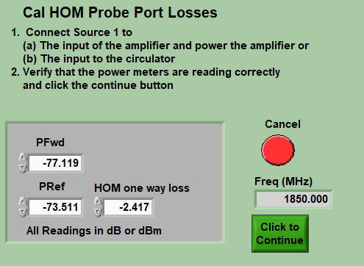

Figure 11‑b: Example HOM one way loss value

## Press the green Continue button.

## In the popup window, verify that the 1-Way Loss values are roughly the same for each frequency.

### If not, set the deltaF to +/- 1-2 MHz, and then click the Recaluclate button on any frequencies that have a higher 1-Way Loss until the 1-Way Loss value is as small as possible.

### Click Done.

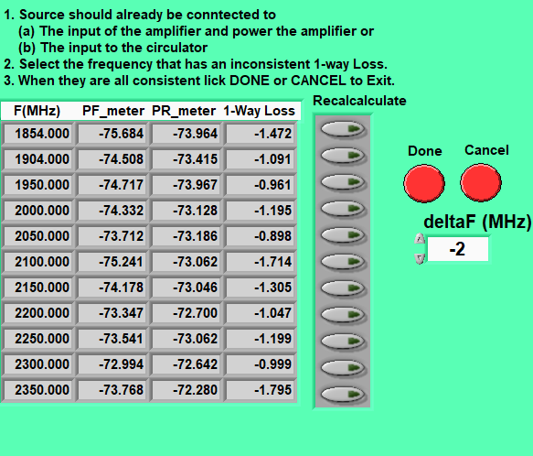

Figure 11‑c: Example HOM 1-way loss calibration values

## Click the Done on the 1_Cal_confirm_Detune screen.

# Verify Cable Calibrations

## On the Cal Cable screen, if all calibration steps have been performed, the indicators will all be light green. If any calibration steps have been missed, go to the appropriate step and perform the calibration.

## Once all of the Cable Calibrations on the “Calibrate Cables” screen have been completed, click Done to view the Calibration Factor Comparison. Pay attention to the Delta values (HOM, CpFWD, CpRef, and CpTrans). These values should be close to 0, unless a known change to the RF cables or components has occurred since the last calibration.

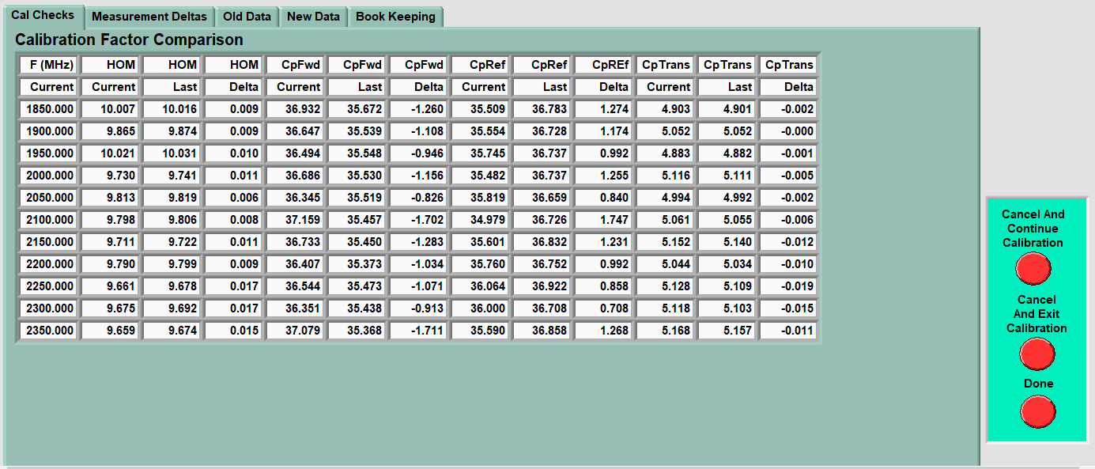

Figure 12‑a: Calibration Factor Comparison shown when calibration is complete

## If the data on the Calibration Factor Comparison screen is correct, click Done. Otherwise, exit the calibration by clicking "Cancel and Exit Calibration", correct any cable or component problems, and attempt the calibration sequence again.

## On the PlasmaMain screen, select the tab “Last Data”.

## Verify the Pi, Pr, and Pt values listed under the Cable Cals (dB) header.

* Example data: Pi = 35.450, Pr = 36.832, Pt = 5.410.

## Disconnect the cable connected to the HOM to prepare for calibrating RF power in the next section.

# Calibrate RF PWR

## Return to the PlasmaMain Main tab.

## Connect the RF source 1 cable (Signal Generator Freq 1) to the combiner.

## Connect the amplifier output to the circulator input.

## Disconnect the cable connected to the HOM port.

## Connect a 50 – 100 W load to the cable that is normally connected to the cavity HOM port.



Figure 13‑a: Calibrate RF PWR Connection

## Turn on the amplifier.

## From the Plasma Main home screen, click the Calibrate RF PWR button. A Calibrate Output Power window will appear and show for a minute or two. This window will close on its own.

## A new window with 4 graphs will open. Click Save and Exit.

## Turn off the amplifier.

## Disconnect the cable from the 100 W load.

# References

|  |  |
| --- | --- |
| Document No. | Title |
| QML-001 | SRF Ops Quality Manual |
| PLACLN-PR-VSA-CAV-VCON | Vertical Plasma Processing – Clean Connect Vacuum Cart |
| PLACLN-PR-VSA-CAV-MODE | Create HOM Modes File for Vertical Plasma Processing |
| PLACLN-PR-VSA-CAV-PREP | Vertical Plasma Processing – Prepare Vacuum and Gas Carts |
| PLACLN-PR-VSA-CAV-PROC | Vertical Plasma Processing |
| PLACLN-VSA-CAV-PROC | Vertical Plasma Processing Traveler |

# Release and Revision History

|  |  |  |
| --- | --- | --- |
| Rev # | Major Changes | Approval Date: |
| 1 | Initial version | Mmm DD, YYYY |

# Approvals

|  |  |  |  |
| --- | --- | --- | --- |
| Approved by: | Name: | Signature: | Date: |
| Procedure Author | Tiffany Ganey | DocuShare E-sign | Mmm DD, YYYY |
| Reviewer | Natalie Brock | DocuShare E-sign | Mmm DD, YYYY |
| Process Owner | Tom Powers | DocuShare E-sign | Mmm DD, YYYY |
| Department Head | Tony Reilly | DocuShare E-sign | Mmm DD, YYYY |