Traveler Title | Hook and Tee Weldment
Traveler Abstract | Outlines the welding of the Hook and Tee
Traveler ID | AUP-ASSY-DAMP-HKTEE
Traveler Revision | R1
Traveler Author | Matthew Weaks
Traveler Date | 6-Apr-20
NCR Informative Emails | jharris
NCR Dispositioners | Huque
D3 Emails | Huque
Approval Names | Matthew Weaks | George Dekerlegand | Naeem Huque
Approval Signatures
Approval Dates
Approval Title | Author | Reviewer | Project Manager

References | List and Hyperlink all documents related to this traveler. This includes, but is not limited to: safety (THAs, SOPs, etc), drawings, procedures, and facility related documents.
JL0083868 | JL0086021 | CP-STP-CAV-CHEM-ACID | CP-STP-CAV-CHEM-DEGR
JL0088266 | JL0088272 | CERN EDMS No. 1389669 | JL0088266_CMM

Revision Note
R1 | Initial release of this Traveler.

Step No. | Instructions | Data Input
1 | Serial Number of Completed Part | [[HKTEESN]] <<HKTEESN>>
 | Ensure all components have relevant Material Certification.  Upload Material Certifications | [[Ins1Tech]] <<SRF>>  [[Ins1Time]] <<TIMESTAMP>>  [[Ins1Comm]] <<COMMENT>>  [[Ins1File]] <<FILEUPLOAD>>
CHEMISTRY
2 | JL0083868: Etch 30 microns as per JLab Procedure CP-STP-CAV-CHEM-ACID.  Upload any relevant photos and/or comments. | [[TEESN]]<<TEESN>>  [[BCP1Tech]] <<SRF>>  [[BCP1Time]] <<TIMESTAMP>>  [[BCP1Comm]] <<COMMENT>>  [[BCP1File]] <<FILEUPLOAD>>
3 | JL0086021: Etch 30 microns as per JLab Procedure CP-STP-CAV-CHEM-ACID.  Upload any relevant photos and/or comments. | [[HOOKSN]]<<HOOKSN>>  [[BCP2Tech]] <<SRF>>  [[BCP2Time]] <<TIMESTAMP>>  [[BCP2Comm]] <<COMMENT>>  [[BCP2File]] <<FILEUPLOAD>>
4 | JL0088272: Etch 15 microns as per JLab Procedure CP-STP-CAV-CHEM-ACID. Protect the brazing surfaces  Upload any relevant photos and/or comments. | [[FLGMCHSN]]<<FLGMCHSN>>  [[BCP3Tech]] <<SRF>>  [[BCP3Time]] <<TIMESTAMP>>  [[BCP3Comm]] <<COMMENT>>  [[BCP3File]] <<FILEUPLOAD>>

Step No. | Instructions | Data Input
ELECTRON BEAM WELDER
5 | EBW  Weld as per drawing JL0088266, following CERN EDMS No. 1389669  Upload relevant WPS and WPQR, as well as any photos and/or comments. | [[EBWTech]] <<SRF>>  [[EBWTime]] <<TIMESTAMP>>  [[EBWComm]] <<COMMENT>>  [[EBWFile]] <<FILEUPLOAD>>
 | Visually inspect the weldment in accordance with EN ISO 13919-2 Level B, as defined in CERN EDMS No. 1389669 – Section 4.2.7.3  Upload inspection report. | [[Ins2Tech]] <<SRF>>  [[Ins2Time]] <<TIMESTAMP>>  [[Ins2Comm]] <<COMMENT>>  [[Ins2File]] <<FILEUPLOAD>>
TESTING
6 | Leak check the assembly in accordance with EN 13185 as defined in CERN EDMS No. 1389669 – Section 4.5 | [[LC1Tech]] <<SRF>>  [[LC1Time]] <<TIMESTAMP>>  [[LC1Comm]] <<COMMENT>>  [[LC1File]] <<FILEUPLOAD>>

Step No. | Instructions | Data Input
INSPECTION
7 | Verify Dimensions marked on JL0088266_CMM.  Upload inspection report.  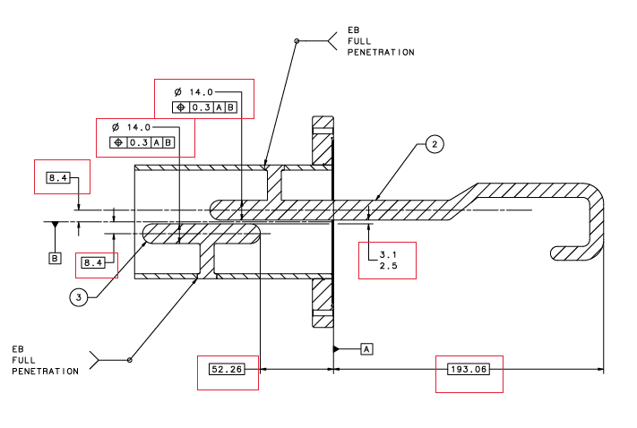 | [[Ins3Tech]] <<SRF>>  [[Ins3Time]] <<TIMESTAMP>>  [[Ins3Comm]] <<COMMENT>>  [[Ins3File]] <<FILEUPLOAD>>
CHEMISTRY
8 | Degrease JL0088266 as per CP-STP-CAV-CHEM-DEGR | [[DG4Tech]] <<SRF>>  [[DG4Time]] <<TIMESTAMP>>  [[DG4Comm]] <<COMMENT>>  [[DG4File]] <<FILEUPLOAD>>

