|  |  |  |  |
| --- | --- | --- | --- |
| **Inspection Procedure for LCLS-II-HE Cold Fundamental Power Coupler** | | | |
| **Document Number:** | L2HE-PR-INSP-FPCC | **Approval Date:** | 5/12/2021 |
| **Revision Number:** | - | **Periodic Review Date:** |  |
| **Document Owner:** | Naeem Huque | **Department Owner:** | SRF Ops |
|  | | | |

# Purpose and Scope

This procedure outlines the steps for performing incoming inspections on cold Fundamental Power Coupler pairs

# References

These are hyperlinked documents which will be used for reference and calculation as this Procedure is performed.

[CP-L2PRD-CLN-PUMP](https://jlabdoc.jlab.org/docushare/dsweb/Get/Document-243280/CP-L2PRD-CLN-PUMP.docx)

[CP-L2PRO-CST-CHEM-CLN-ION-R1](https://jlabdoc.jlab.org/docushare/dsweb/Get/Document-243279/CP-L2PRO-CST-CHEM-CLN-ION-R1.pdf)

[CP-C100-CAV-LKTS](https://jlabdoc.jlab.org/docushare/dsweb/Get/Document-243278/CP-C100-CAV-LKTS.pdf)

[CP-L2PRD-CM-SLBUP-R2](https://jlabdoc.jlab.org/docushare/dsweb/Get/Document-242793/CP-L2PRD-CM-SLBUP-R2.pdf)

[Vacuum-005-2008](https://jlabdoc.jlab.org/docushare/dsweb/Get/Document-242791/Vacuum-005-2008%20Guidelines%20for%20UHV-Components%20at%20DESY.pdf)

[CP-STP-CAV-CHEM-DEGR](https://jlabdoc.jlab.org/docushare/dsweb/Get/Document-242796/CP-STP-CAV-CHEM-DEGR-R3.pdf)

[Solair 3100 Gen E Manual](https://jlabdoc.jlab.org/docushare/dsweb/Get/Document-242790/Solair%203100%20Gen%20E%20Manual.pdf)

[LCLSII-HE-1.2-ES-0059](https://jlabdoc.jlab.org/docushare/dsweb/Get/Document-242797/LCLSII-HE-1.2-ES-0059.pdf)

# Terms and Definitions

LCLS-II-HE – Linear Coherent Light Source-II High Energy

FPC – Fundamental Power Coupler

SLAC – Stanford Linear Accelerator Center

CM – Cryomodule

RF – Radiofrequency

SSA – Solid State Amplifier

RAV – Right-Angle Valve

UHV – Ultra-High Vacuum

TWG – Test Waveguide

# Roles and Responsibilities

The following roles have responsibilities described in this document. The following actions are to be performed by knowledgeable, authorized Technicians only. Consult the Group Lead for details.

# Procedure

1. Introduction

The LCLS-II-HE FPCs are UHV components which are designed to transmit RF power from SSAs to cavities, within a CM. The FPC assembly is made up of three parts: the warm FPC (FPCW), cold FPC (FPCC) and the FPC Push Rod (FPPR); this procedure covers the incoming inspection steps for the FPCCs.

FPCCs (Figure 1.1) are delivered to partner labs from the vendor, CPI. A pair of FPCCs are installed on a Test Waveguide (TWG) box (Figure 1.2). The internal space of the FPCCs and the waveguide box are under UHV. Each of the pair and waveguide box assemblies are packed within two bags made from MIL-PRF-131K, Class 1 (>4mils thick) bagging material.

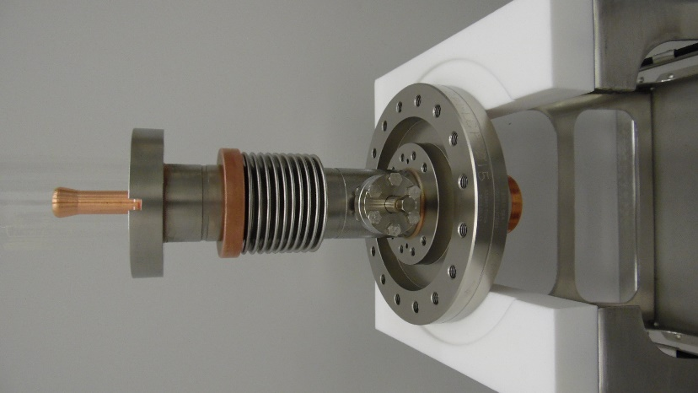

**Figure 1.1: FPCC**

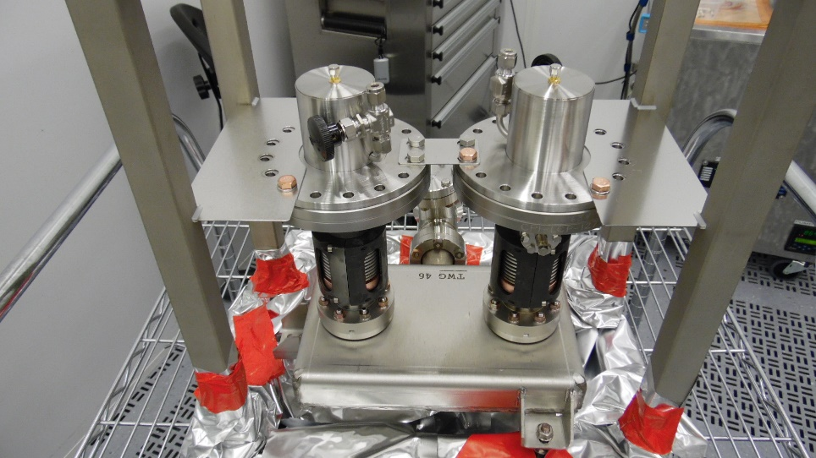

**Figure 1.2: Two FPCCs on a TWG**

1. Pre-Inspection
   1. The following tasks are to be carried out prior to the FPCC/TWG assemblies being taken into the chemistry area. Applicable information should be recorded in L2HE-CLNRM-FPCC-INSP
      1. Record the inspection date and technician name in the traveler
      2. Visually inspect the outer plastic bag
      3. Check that all kit parts are present
      4. Record the Pair number and FPCC serial numbers in the traveler
2. Chemistry
   1. Remove the FPCC pair from the crate and place on a cart; the weight of the assembly requires a two-person lift. Move the cart into the chemistry room.
      1. Record the chemistry room admission date and technician name in the traveler
      2. Wipe down the outer plastic bag with isopropyl alcohol
      3. Push the cart into the pass-thru area
      4. Remove and discard the outer plastic bag
      5. Wipe inner plastic bag down with isopropyl alcohol and spray with dry nitrogen
      6. Push the cart into the cleanroom vacuum pumping area
3. Vacuum leak check and rga scan
   1. Prior to starting the bag leak check, the following tools and hardware will be required:

* Pump cart
* Filtered, de-ionized N2 source
* 2-3/4 CF gasket
* 2-3/4 CF Flange hardware
* Wrenches
* Scissors
  1. Move the cart into the particulate counter area. Prepare the area as per CP-L2PRO-CST-CHEM-CLN-ION-R1
     1. Blow down the bag with nitrogen until 0.3μm counts are below 1000, or 15 minutes (whichever comes first).
  2. Vacuum Leak Check
     1. Record the date and the vacuum leak check technician in the traveler
     2. Clean vacuum components as per CP-L2PRO-CST-CHEM-CLN-ION-R1
     3. Cut the plastic in front of the RAV and attach the hose for the vacuum pumping system (Figure 4.1)

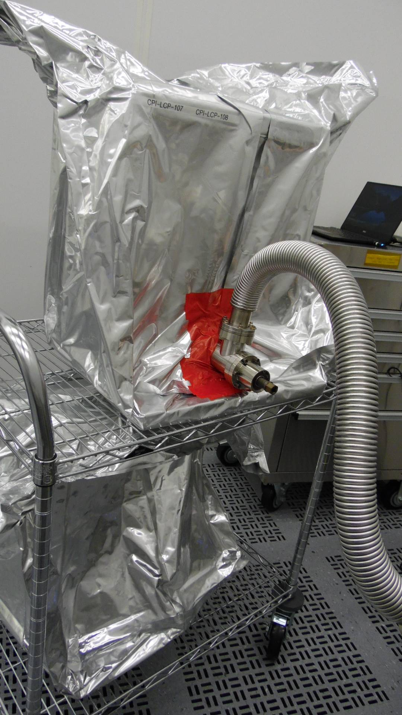

Figure 4.1: Pumping line installed on RAV

* + 1. Open the RAV and record the static vacuum in the traveler
    2. Pump down the FPCC and TWG assembly as per CP-L2PRD-CLN-PUMP
    3. Check the CF joints on the RAV and vacuum line by spraying He gas as per CP-L2PRD-CLN-PUMP
    4. Seal the plastic bag using cleanroom tape as shown in Figure 4.1
    5. Perform the bag leak check as per CP-C100-CAV-LKTS. Upload the data file into the traveler and generate an NCR if a leak higher than 2x10-10 mbar-l/sec He is found
    6. Record analog RGA data in the traveler. Generate an NCR if the RGA spectrum does not meet the specifications in Table 4.1

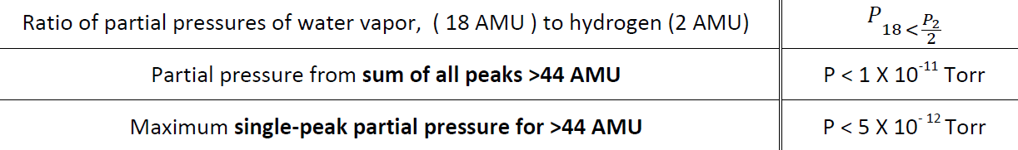

Table 4.1

* + 1. Remove the plastic bag from the assembly

1. Electrical Checks
   1. Check that the electron probes are properly installed using a multimeter
      1. Connect the multimeter cable to each FPCC in turn. The resistance value should read infinity (Figure 5.1). Otherwise, generate an NCR

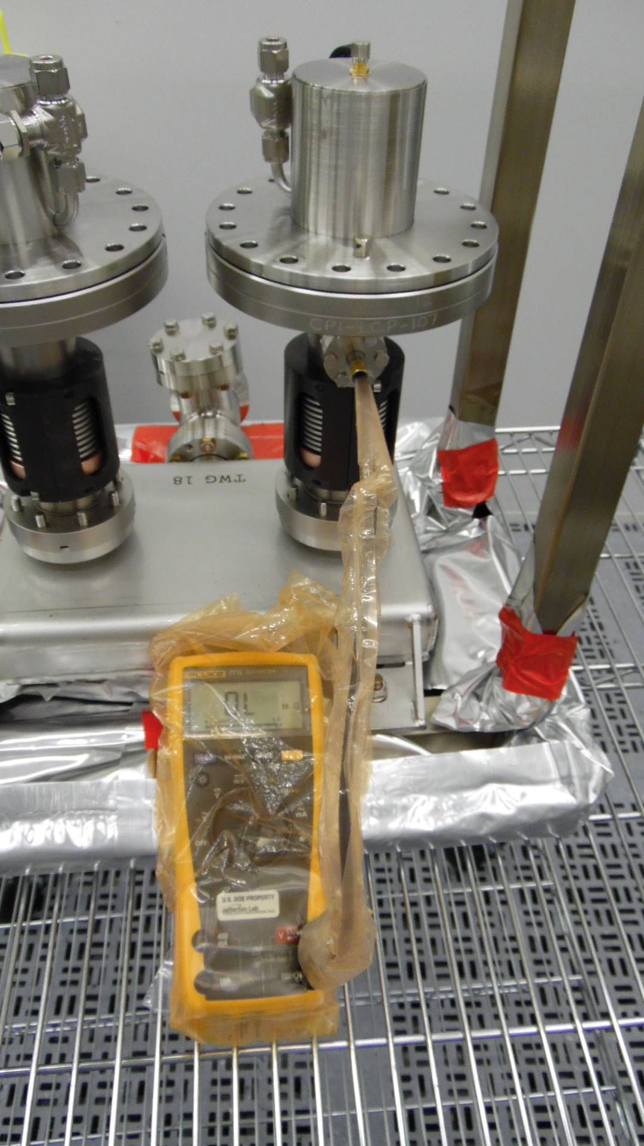

Figure 5.1: Multimeter reading of Electron Probe

1. Visual inspection after removing protection caps
   1. Remove the ceramic protection caps on each FPCC (Figure 6.1). The space is under positive nitrogen pressure and there should be a hissing sound when the gasket seal is broken.

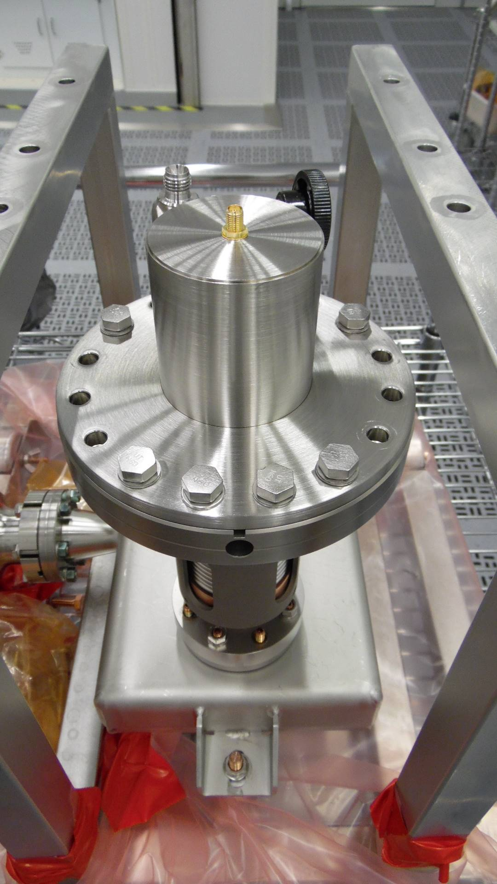

Figure 6.1: Ceramic Protection Cap

* + 1. Visually inspect the ceramics (Figure 6.2). Generate an NCR if there are any scratches, dark spots, chips, or stains

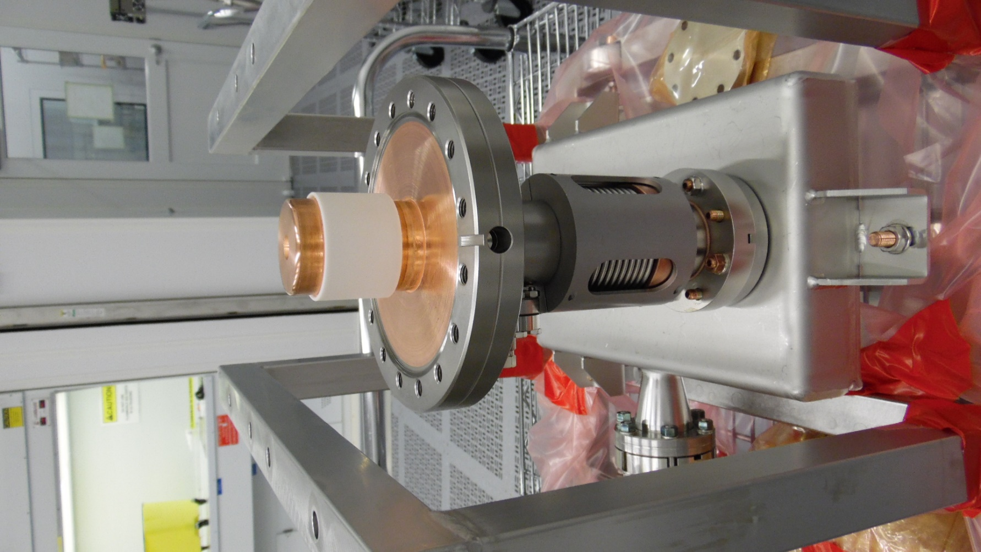

Figure 6.2: FPCC Ceramic

* + 1. Visually inspect the knife edges on the CF100 flanges on each FPC (Figure 6.3). Generate an NCR if there are any defects on the knife edges

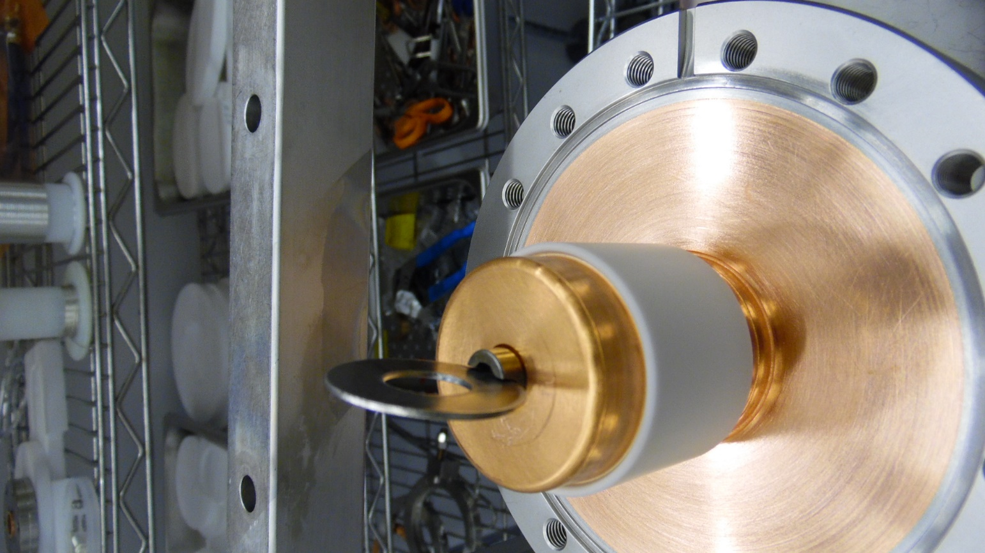

Figure 6.3: CF100 Flange Knife Edge

* + 1. Visually inspect the copper plating on the flange surface (Figure 6.4). Generate an NCR if there are any pits, blisters, or flaking copper. Generate an NCR if there is any Viton residue on the copper.

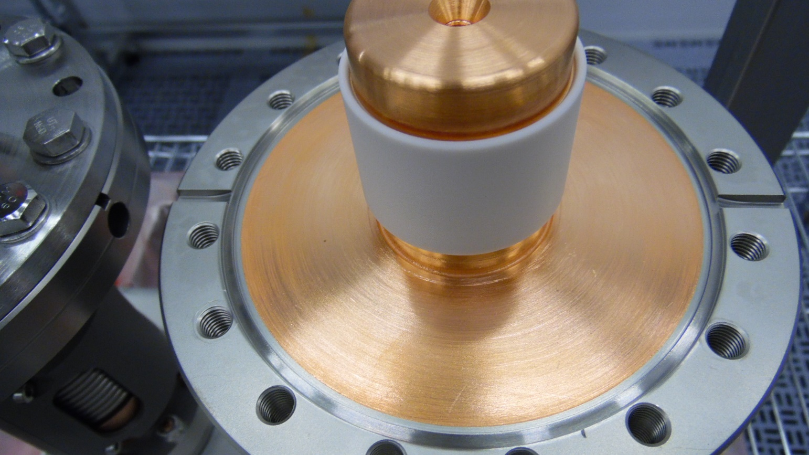

Figure 6.4: Copper plating on CF100 Flange

* + 1. Visually inspect the RF contact surface above the ceramic (Figure 6.5). Generate an NCR if there are any dents or scratches on the surface

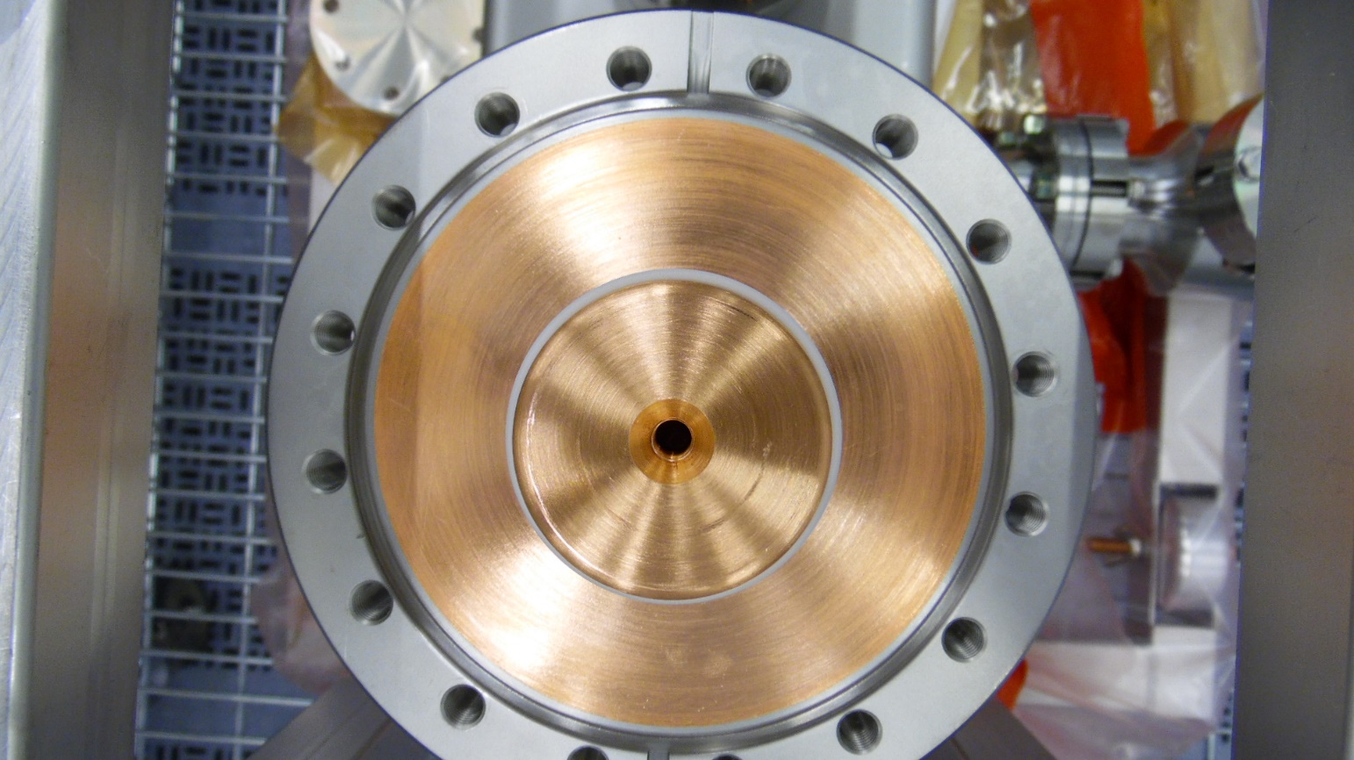

Figure 6.5: RF Contact Surface

* + 1. Remove the RF pin and check that the threads are clean and intact (Figure 6.6). Generate an NCR if there is damage to the threads or if there is excessive dirt or oil.

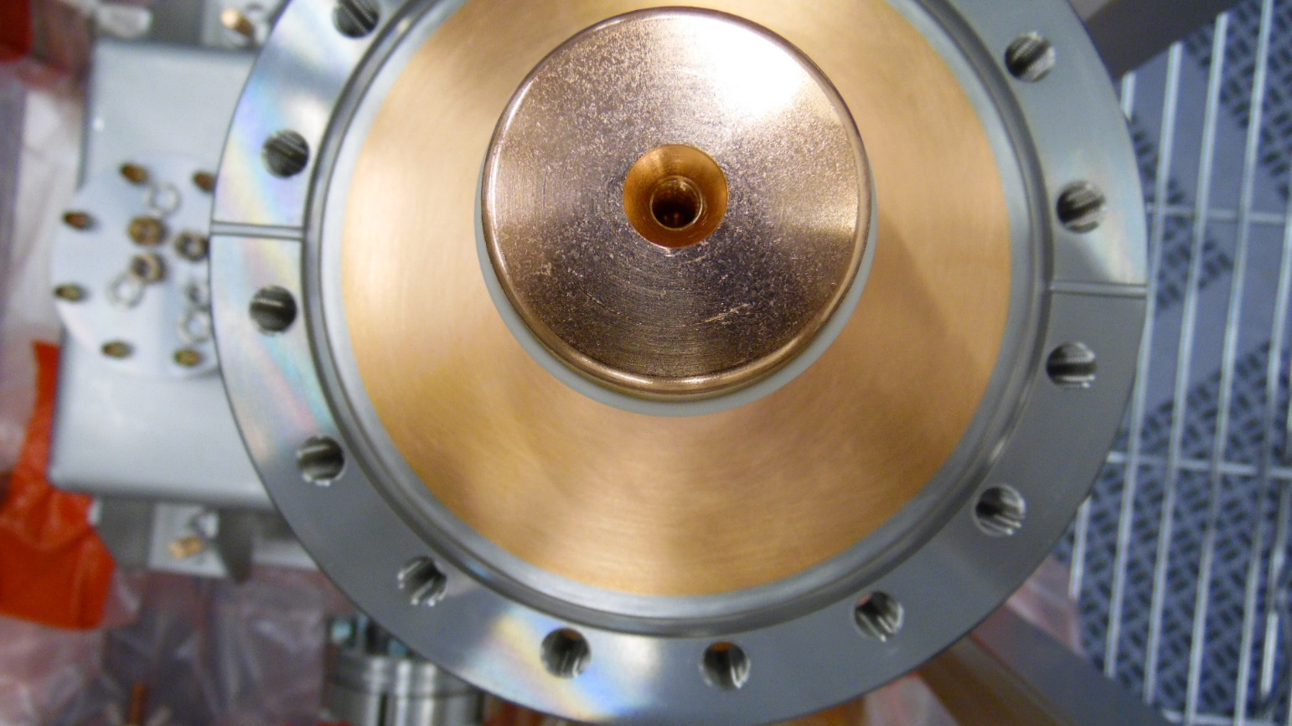

Figure 6.6: RF Pin threaded hole

* + 1. Reinstall the two ceramic protection caps
    2. Slightly unscrew the SMA connector (Figure 6.7) and back-fill the space under the caps with dry, filtered nitrogen.

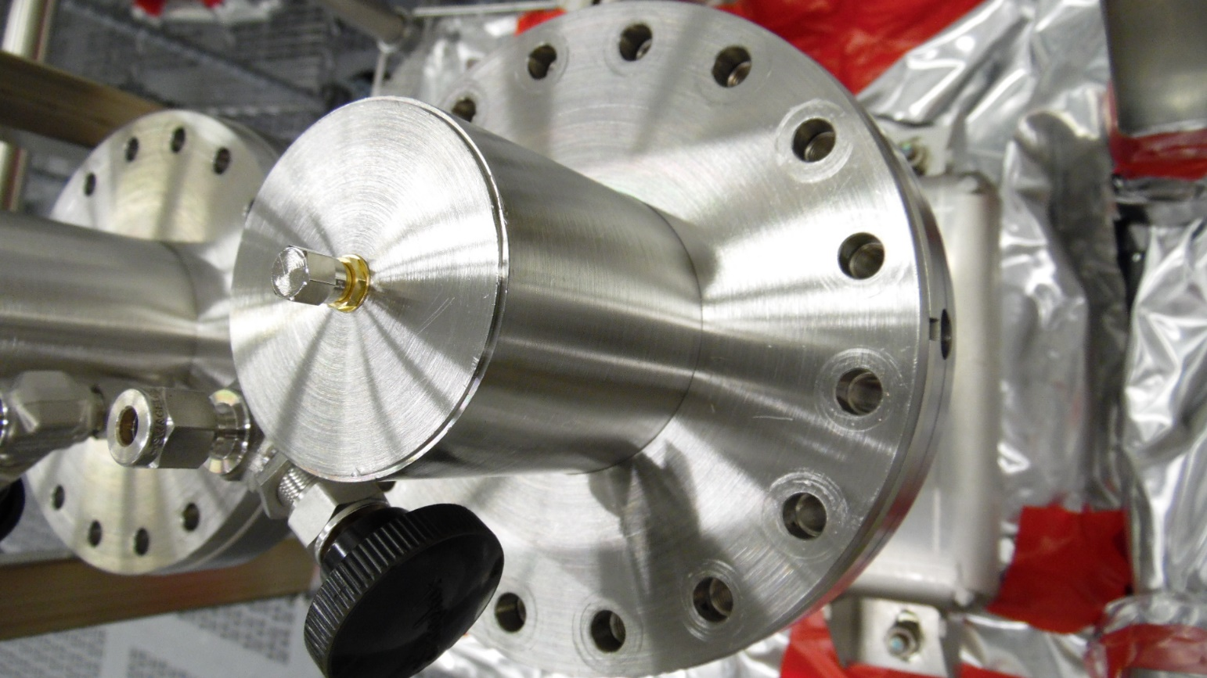

Figure 6.7: SMA connector on ceramic protection cap

* + 1. Tighten the SMA connector to seal the space

1. Individual FPCC Visual Inspections
   1. Bleed up the test box with dry, filtered nitrogen with the following steps:
      1. Close the RAV
      2. Connect the controlled bleed-up device to the pumping system
      3. Pump down the bleed-up hose
      4. Open the RAV
      5. Start pumping down the assembly and controlled bleed-up system
      6. Close valve on the pumping system
      7. Start controlled bleed-up process
   2. Remove FPCC-1 from the TWG using the following steps:
      1. Remove all bolts from the FPCC cavity flange (Figure 7.1)

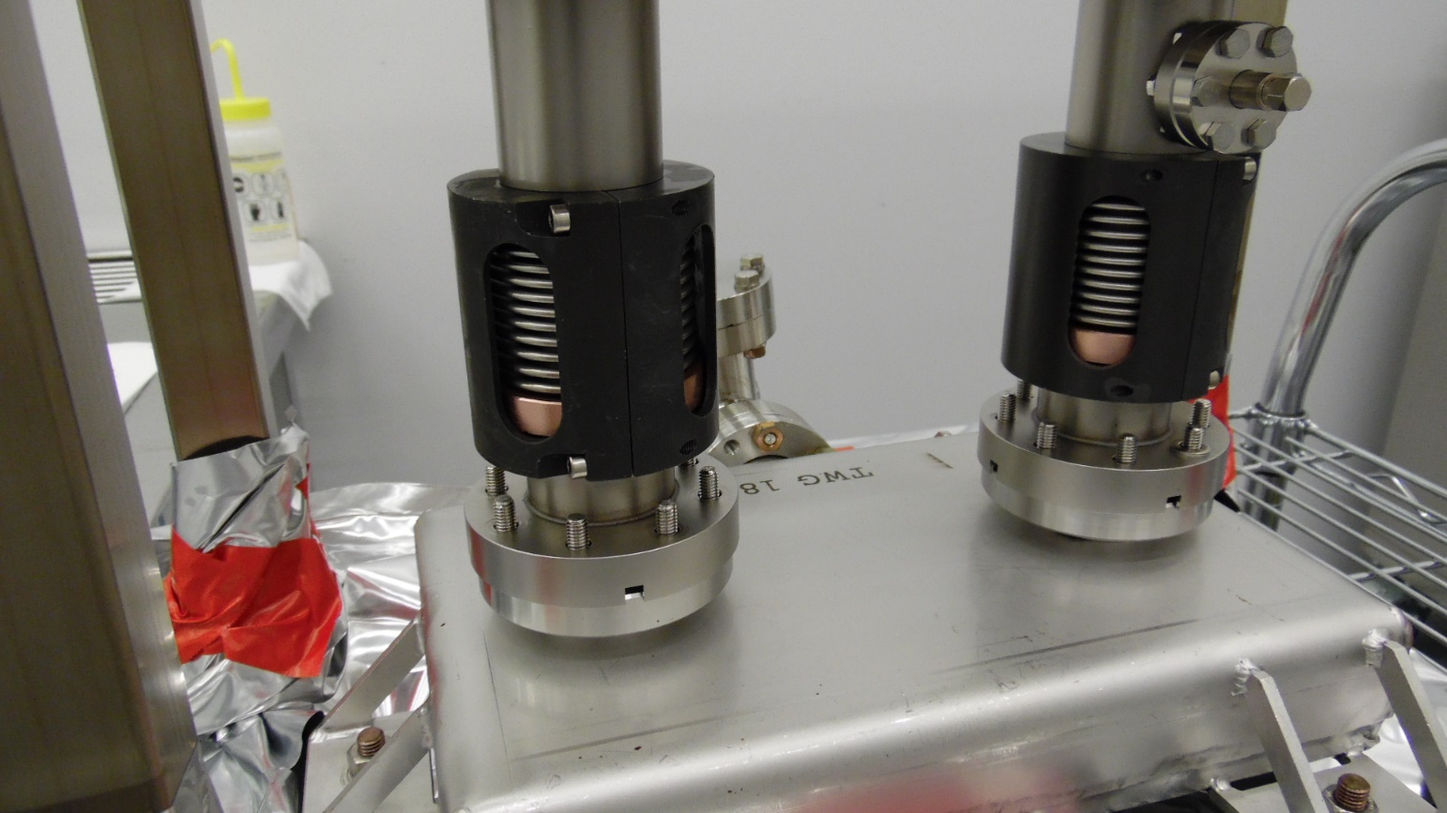

Figure 7.1: Removing hardware from Cavity Flange

* + 1. Wipe down the external surface of the cavity flange with isopropyl alcohol
    2. Dry the surfaces using dry, filtered nitrogen
    3. Perform a particulate count of the FPCC-1 external surfaces. Generate an NCR if the 0.3μm count cannot be brought below 1000 counts after 15 minutes of spraying
    4. With the TWG under continuous positive nitrogen flow, remove FPCC-1 from the TWG and place it on the inspection stand
  1. Visually inspect the FPCC-1 and record the findings in the traveler:
     1. Remove the bellows protection bracket (Figure 7.3) and inspect the bellows convolutions. Generate an NCR if there are any dents of scratches larger than 1/16”, or any other signs of damage. Reinstall the protection bracket once finished

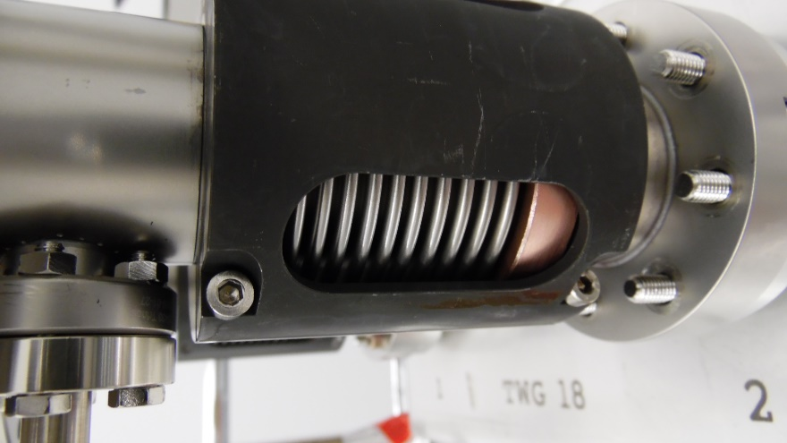

Figure 7.3: Bellows protection bracket

* + 1. Visually inspect the cavity flange sealing surface (Figure 7.4). Generate and NCR if there are any traces of the AlMg seal or any scratches or residue

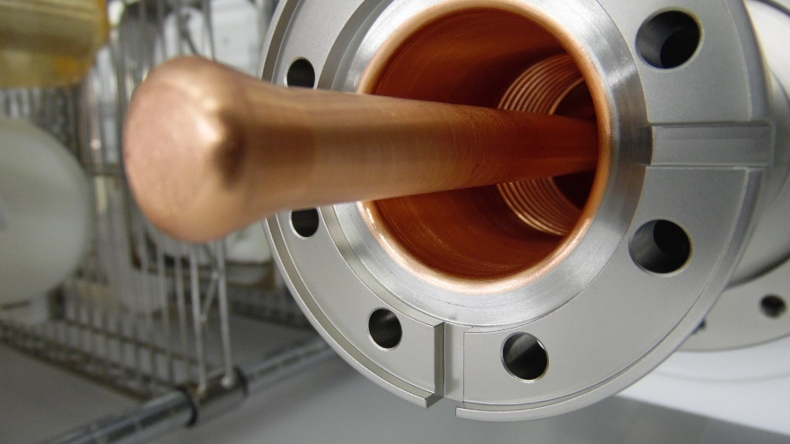

Figure 7.4: Sealing surface of the FPCC cavity flange

* + 1. Visually inspect the regions of copper plating on the inside of the FPCC (Figure 7.5) which are visible through the cavity flange. Generate and NCR if there are any scratches, pits, blisters, or flaking copper.

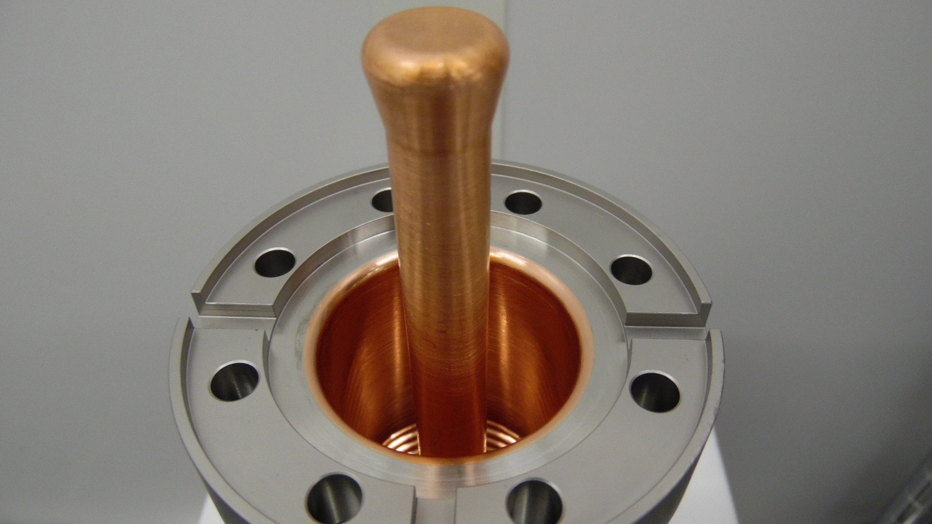

Figure 7.5: Inner copper plating of FPCC

* + 1. Visually inspect the end of the copper antenna (Figure 7.6). Generate an NCR if there any scratches, chemical residue or erosion spots.

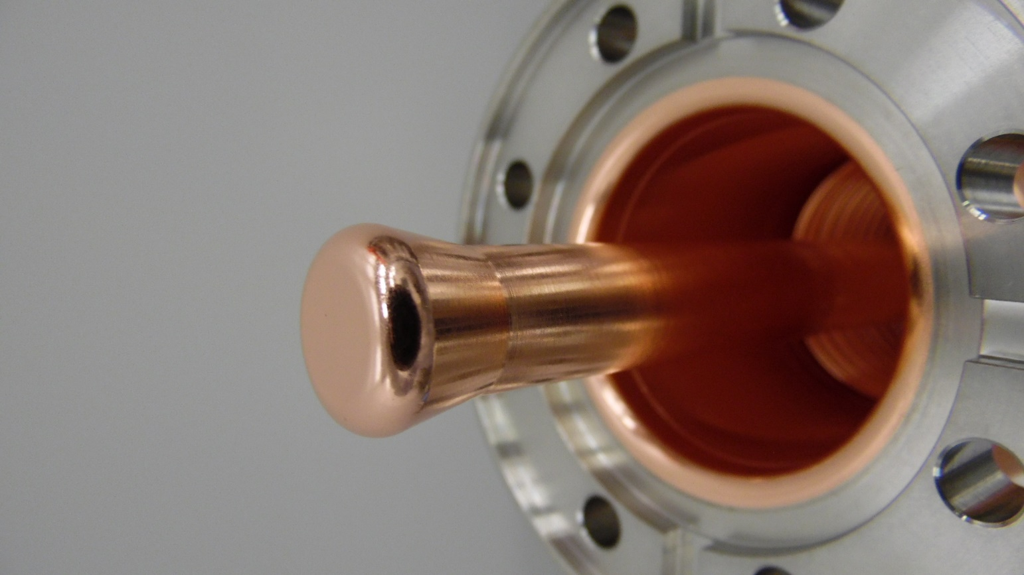

Figure 7.6: Copper antenna tip

* 1. Perform a particulate count on the internal surfaces of FPCC-1
     1. Generate an NCR if the 0.3μm count cannot be brought below 10 counts after 15 minutes of spraying.
     2. Record the results in the traveler
  2. Reinstall FPCC-1 into the TWG
     1. Use the old NW40 aluminum seal and Nitronic-60 hardware
  3. Repeat Steps 7.2 – 7.5 for FPCC-2

1. Storage
   1. The FPCC pair will be stored in the cleanroom in preparation of string assembly
      1. Disconnect the pumping and bleed-up systems
      2. Close the RAV
      3. Blank off the RAV
      4. Move the assembly to the storage area in the cleanroom
      5. Record the storage date in the traveler

# **Release and Revision History**

|  |  |  |
| --- | --- | --- |
| Rev # | Revision or update: | Effective: |
| - |  | 5/10/2021 |
|  |  |  |

# **Approvals**

|  |  |  |
| --- | --- | --- |
| Approved by: | Signature: | Date: |
| **Document Owner** | Naeem Huque |  |
| **Production Team Lead** | Danny Forehand |  |
| **Production Group Lead** | Kirk Davis |  |
| **Reviewer** | Chris Dreyfus |  |
| **Reviewer** | Mircea Stirbet |  |
| **CAM** | Katherine Wilson |  |