Traveler Title | LCLS-II-HE Cold FPC Inspection Traveler
Traveler Abstract | Incoming inspection process for the cold part of L2HE FPCs (FPCCs)
Traveler ID | L2HE-CLNRM-FPCC-INSP
Traveler Revision | R1
Traveler Author | huque
Traveler Date | 6-May-21
NCR Informative Emails | jharris
NCR Dispositioners | Huque, kwilson
D3 Emails | Huque, kwilson
Approval Names | Naeem Huque | Danny Forehand | Mircea Stirbet | Wilson/Hogan
Approval Signatures
Approval Dates
Approval Title | Author | Reviewer | Reviewer | Project Manager

References | List and Hyperlink all documents related to this traveler. This includes, but is not limited to: safety (THAs, SOPs, etc), drawings, procedures, and facility related documents.
LCLSII-HE-1.2-ES-0059 | CP-L2PRD-CLN-PUMP | CP-C100-CAV-LKTS | Solair 3100 Gen E Manual
CP-STP-CAV-CHEM-DEGR-R3 | CP-L2PRD-CM-SLBUP-R2 | CP-L2PRO-CST-CHEM-CLN-ION | Vacuum-005-2008

Revision Note
R1 | Initial release of this Traveler.

Step No. | Instructions | Data Input
1 | Inspection Start Date  Technician Name  Visually inspect the outer plastic bag. Comment on any damage.  Check whether kitted parts are present. | [[StartDate]] <<TIMESTAMP>>  [[InspTech1_SRFCVP]] <<SRFCVP>>  [[BagComm]] <<COMMENT>>  [[KitParts]] <<YESNO>>  [[KitPartsComm]] <<COMMENT>>
2 | Enter the serial number of the FPC pair (label on outer bag, in the form PA#-XX)  Enter the serial numbers for the two FPCCs as per the image below (label on outer bag).  Add any relevant comments.  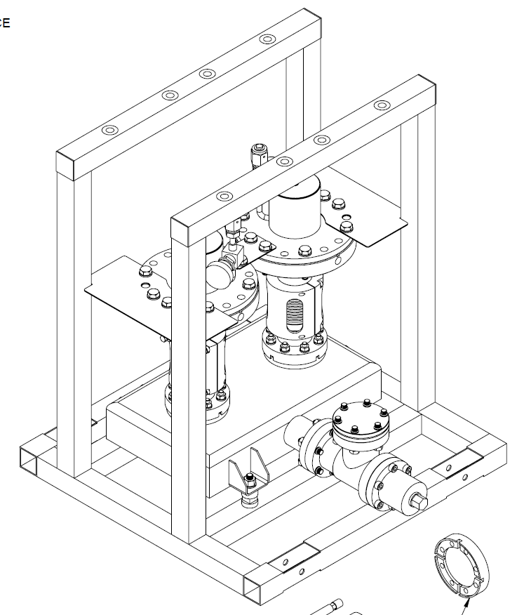  FPCC-2  FPCC-1 | [[PAIRSN]] <<PAIRSN>>  [[FPCC-1_SN]] <<FPCCSN>>  [[FPCC-2_SN]] <<FPCCSN>>  [[SerialComm]] <<COMMENT>>
3 | Cleanroom Test Date  Cleanroom Technician  Cleanroom Admission Comments | [[CRTest]] <<TIMESTAMP>>  [[CRTech_SRFCVP]] <<SRFCVP>>  [[CRComm]] <<COMMENT>>
4 | RGA Scan and Leak Check  RGA/Leak Test Date  Technician  Record Static Vacuum (in torr)  Perform bag Leak Check and upload data file. If leak rate is above 2.76x10⁻¹⁰ torr-l/sec He, generate an NCR.  Assembly passes Leak Check?  Collect RGA data and upload file. Generate NCR if the RGA spectra does not conform to the specification below:  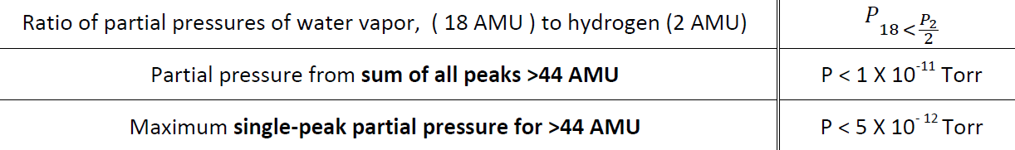  Assembly passes RGA Scan? | [[RGALeakDate]] <<TIMESTAMP>>  [[RGALeakTech_SRFCVP]] <<SRFCVP>>  [[StatVac]] <<SCINOT>>  [[StatVacUpload]] <<FILEUPLOAD>>  [[StatVacComm]] <<COMMENT>>  [[LC1Rate]] <<SCINOT>>  [[LC1Upload]] <<FILEUPLOAD>>  [[LC1Comm]] <<COMMENT>>  [[LC1YesNo]] <<YESNO>>  [[RGAUpload]] <<FILEUPLOAD>>  [[RGAComm]] <<COMMENT>>  [[RGAYesNo]] <<YESNO>>
5 | Electrical Checks  Check that the resistance of the electron probes read infinity with the multimeter. Generate an NCR for any probes that fail.  FPC-1 Probe Ok?  FPC-2 Probe Ok? | [[FPC1PRobe]] <<YESNO>>  [[FPC2PRobe]] <<YESNO>>  [[FPCProbeComm]] <<COMMENT>>
7 | Visual Inspection – After Removal of Protection Caps  Visually inspect the cold ceramics. Generate an NCR for any scratches, chips, spots or stains. Upload photos of any areas of interest  Visually inspect the CF100 knife edges. Generate an NCR if there are any defects or if there are any copper deposits on the knife edge. Upload photos of any areas of interest  Visually inspect the copper plating on the CF100 flanges: should be uniform, without pits, scratches, peeling off, blisters and should stop at ~3 mm from the knife edge. There should be no Viton residue on the copper. If any issues are found, document findings and generate NCR. Upload photos of any areas of interest  Visually inspect the RF contact surfaces above the ceramic. Generate an NCR if there are any scratches or other defects. Upload photos of any areas of interest  Remove the RF pin and check that the threads are intact and that there is no dirt or oil inside the tapped hole. Generate an NCR if any issues are found. Upload photos of any areas of interest | [[FPC1CeramicOk]] <<YESNO>>  [[FPC2CeramicOk]] <<YESNO>>  [[CeramicComm]] <<COMMENT>>  [[CeramicPhoto]] <<FILEUPLOAD>>  [[FPC1CFKnifeOk]] <<YESNO>>  [[FPC2CFKnifeOk]] <<YESNO>>  [[CF100Comm]] <<COMMENT>>  [[CF100Photo]] <<FILEUPLOAD>>  [[FPC1FlangePltOk]] <<YESNO>>  [[FPC2FlangePltOk]] <<YESNO>>  [[FlgPltComm]] <<COMMENT>>  [[FlgPltPhoto]] <<FILEUPLOAD>>  [[FPC1RFConOk]] <<YESNO>>  [[FPC2RFConOk]] <<YESNO>>  [[RFConComm]] <<COMMENT>>  [[RFConPhoto]] <<FILEUPLOAD>>  [[FPC1RFHoleOk]] <<YESNO>>  [[FPC2RFHoleOk]] <<YESNO>>  [[RFHoleComm]] <<COMMENT>>  [[RFHolePhoto]] <<FILEUPLOAD>>
8 | FPCC-1 External Particulate Count  Record and upload (optional) particulate counts on the external volume of FPCC-1. If particulate count for 0.3μm particles size does not reach 1000 counts in about 15 minutes of nitrogen spraying, comment and generate an NCR. | [[FPC1ExtCountOk]] <<YESNO>>  [[FPC1ExtCountUpload]] <<FILEUPLOAD>>  [[FPC1ExtCountComm]] <<COMMENT>>
9 | Visual Inspections after Removing FPCC-1 from Shipping Stand  Inspect the FPCC-1 bellows for any dents or scratches. Generate an NCR if any defects are found. Upload photos of any areas of interest  Visually inspect the sealing surface of the FPCC-1 Cavity Flange sealing surface. It should be free of AlMg traces, scratches, and chemical residue. Generate an NCR if any issues are found. Upload photos of any areas of interest  Inspect the visible regions of copper plating on the inner surface of FPCC-1. Generate an NCR if there are any blisters, pits, scratches, stains, or flaking copper. Upload photos of any areas of interest  Visually inspect the FPCC-1 copper antenna. It should be free of scratches, chemical residue, erosion spots or mechanical cleaning marks. If any issues are identified, document and generate NCR. Upload photos of any areas of interest | [[FPC1BellowsOk]] <<YESNO>>  [[FPC1BellowsComm]] <<COMMENT>>  [[FPC1BellowsPhoto]] <<FILEUPLOAD>>  [[FPC1CavSealOk]] <<YESNO>>  [[FPC1CavSealComm]] <<COMMENT>>  [[FPC1CavSealPhoto]] <<FILEUPLOAD>>  [[FPC1CopperOk]] <<YESNO>>  [[FPC1CopperComm]] <<COMMENT>>  [[FPC1CopperPhoto]] <<FILEUPLOAD>>  [[FPC1AntennaOk]] <<YESNO>>  [[FPC1AntennaComm]] <<COMMENT>>  [[FPC1AntennaPhoto]] <<FILEUPLOAD>>
10 | FPCC-1 Internal Particulate Count  Record and upload (optional) particulate counts on the internal volume of FPCC-1. If particulate count for 0.3μm particles size does not reach 10 counts in about 10 minutes of nitrogen spraying, comment and generate an NCR. | [[FPC1IntCountOk]] <<YESNO>>  [[FPC1IntCountUpload]] <<FILEUPLOAD>>  [[FPC1IntCountComm]] <<COMMENT>>
11 | Visual Inspections after Removing FPCC-2 from Shipping Stand  Inspect the FPCC-2 bellows for any dents or scratches. Generate an NCR if any defects are found. Upload photos of any areas of interest  Visually inspect the sealing surface of the FPCC-2 Cavity Flange sealing surface. It should be free of AlMg traces, scratches, and chemical residue. Generate an NCR if any issues are found. Upload photos of any areas of interest  Inspect the visible regions of copper plating on the inner surface of FPCC-2. Generate an NCR if there are any blisters, pits, scratches, stains, or flaking copper. Upload photos of any areas of interest  Visually inspect the FPCC-2 copper antenna. It should be free of scratches, chemical residue, erosion spots or mechanical cleaning marks. If any issues are identified, document and generate NCR. Upload photos of any areas of interest | [[FPC2BellowsOk]] <<YESNO>>  [[FPC2BellowsComm]] <<COMMENT>>  [[FPC2BellowsPhoto]] <<FILEUPLOAD>>  [[FPC2CavSealOk]] <<YESNO>>  [[FPC2CavSealComm]] <<COMMENT>>  [[FPC1CavSealPhoto]] <<FILEUPLOAD>>  [[FPC2CopperOk]] <<YESNO>>  [[FPC2CopperComm]] <<COMMENT>>  [[FPC2CopperPhoto]] <<FILEUPLOAD>>  [[FPC2AntennaOk]] <<YESNO>>  [[FPC2AntennaComm]] <<COMMENT>>  [[FPC2AntennaPhoto]] <<FILEUPLOAD>>
12 | FPCC-2 Particulate Count  Record and upload (optional) particulate counts on the internal volume of FPCC-2. If particulate count for 0.3μm particles size does not reach 10 counts in about 10 minutes of nitrogen spraying, comment and generate an NCR. | [[FPC2IntCountOk]] <<YESNO>>  [[FPC2IntCountUpload]] <<FILEUPLOAD>>  [[FPC2IntCountComm]] <<COMMENT>>
13 | Storage  Move the test frame with the two FPCCs in the Clean room class 10 dedicated storage areas. Record the date when the test stand was moved in storage area. | [[FPCStoreDate]] <<TIMESTAMP>>

