Traveler Title | Outer Tube Assembly
Traveler Abstract | Outlines the assembly of the RFD Outer Tube
Traveler ID | AUP-ASSY-DAMP-TBASSY
Traveler Revision | R2
Traveler Author | Matthew Weaks
Traveler Date | 7-Apr-20
NCR Informative Emails | Weaksmc
NCR Dispositioners | Huque,scott
D3 Emails | Huque,scott,weaksmc
Approval Names | Matthew Weaks | John Fischer | Naeem Huque
Approval Signatures
Approval Dates
Approval Title | Author | Reviewer | Project Manager

References | List and Hyperlink all documents related to this traveler. This includes, but is not limited to: safety (THAs, SOPs, etc), drawings, procedures, and facility related documents.
CERN EDMS No. 1389321 | CERN EDMS No. 1389669 | JL0088268_CMM
JL0088268 | JL0086009 | JL0088598

Revision Note
R1 | Initial release of this Traveler.
R2 | Added serial numbers. Added drawing in Step 5

Step No. | Instructions | Data Input
1 | Serial Number of Parts | [[TBASSYSN]] <<TBASSYSN>>  [[OTUBESN]] <<OTUBESN>>  [[EXPIPESN]] <<EXPIPESN>>
CHEMISTRY
1a | Degrease JL0086009 as per CP-STP-CAV-CHEM-ACID  Upload any relevant photos and/or comments. | [[DG1Tech]] <<SRF>>  [[DG1Time]] <<TIMESTAMP>>  [[DG1Comm]] <<COMMENT>>  [[DG1File]] <<FILEUPLOAD>>
 | Degrease JL0088598 as per CP-STP-CAV-CHEM-ACID  Upload any relevant photos and/or comments. | [[DG2Tech]] <<SRF>>  [[DG2Time]] <<TIMESTAMP>>  [[DG2Comm]] <<COMMENT>>  [[DG2File]] <<FILEUPLOAD>>
WELDING
2 | TIG Weld the assembly together as per drawing JL0088268 following ASME BPVC Section IX as described in CERN EDMS No. 1389669 – Section 11.4.6.  Upload relevant WPS and WPQR along with any photos and/or comments. | [[WeldTech]] <<SRF>>  [[WeldTime]] <<TIMESTAMP>>  [[WeldComm]] <<COMMENT>>  [[WeldFile]] <<FILEUPLOAD>>

Step No. | Instructions | Data Input
INSPECTION
2a | Visually inspect the weld following EN ISO 13919-2 Level B as described in CERN EDMS No. 1389669 Section 5.2.4.3.  Upload Inspection Report. | [[Ins1Tech]] <<SRF>>  [[Ins1Comm]] <<COMMENT>>  [[Ins1File]] <<FILEUPLOAD>>
2b | Inspect the assembly radiographically following EN ISO 13919-2 Level B as described in CERN EDMS 1389669 – Section 5.2.4.55.  Upload Inspection Report | [[Ins2Tech]] <<SRF>>  [[Ins2Time]] <<TIMESTAMP>>  [[Ins2Comm]] <<COMMENT>>  [[Ins2File]] <<FILEUPLOAD>>
TESTING
3 | Leak check the assembly following EN 13185 as described in CERN EDMS No. 1389669 – Section 4.3.5  Upload leak check chart. | [[LCTech]] <<SRF>>  [[LCTime]] <<TIMESTAMP>>  [[LCComm]] <<COMMENT>>  [[LCFile]] <<FILEUPLOAD>>
4 | Pressure test the assembly following EN 13445-5:2014 as described in CERN EDMS No. 1389669 – Section 11.5.8  Upload any relevant photos and/or comments. | [[PTTech]] <<SRF>>  [[PTTime]] <<TIMESTAMP>>  [[PTComm]] <<COMMENT>>  [[PTFile]] <<FILEUPLOAD>>

Step No. | Instructions | Data Input
INSPECTION
5 | Verify dimensions marked on JL0088268_CMM.  Upload inspection report  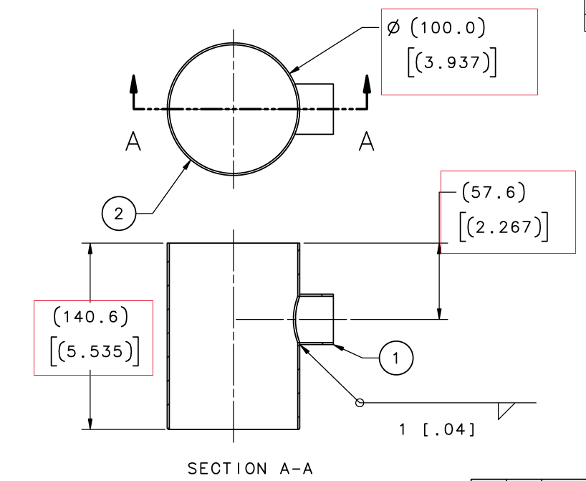 | [[Ins3Tech]] <<SRF>>  [[Ins3Time]] <<TIMESTAMP>>  [[Ins3Comm]] <<COMMENT>>  [[Ins3File]] <<FILEUPLOAD>>
CHEMISTRY
6 | Degrease the assembly as per CERN EDMS No. 1389321  Upload any relevant photos and/or comments. | [[DG3Tech]] <<SRF>>  [[DG3Time]] <<TIMESTAMP>>  [[DG3Comm]] <<COMMENT>>  [[DG3File]] <<FILEUPLOAD>>

