Traveler Title | LCLS-II HE Split-Quad Clamp Kit Inspection Traveler
Traveler Abstract | This traveler covers the necessary steps to perform incoming inspection and acceptance of split-quad clamp kit at JLab. This item is a Fermilab procurement and drop-shipped to JLab.
Traveler ID | L2HE-INSP-CLMPSQ
Traveler Revision | R1
Traveler Author | Seetha-Lakshmi Lalitha
Traveler Date | 3-Jun-21
NCR Informative Emails | kwilson,hogan
NCR Dispositioners | lalitha,king
D3 Emails | lalitha,king,fischer
Approval Names | Seetha-Lakshmi Lalitha | Larry King | John Fischer | John Hogan
Approval Signatures
Approval Dates
Approval Title | Author, SOTR | Reviewer | Reviewer | Project Manager

References | List and Hyperlink all documents related to this traveler. This includes, but is not limited to: safety (THAs, SOPs, etc), drawings, procedures, and facility-related documents.
 | F10042265-Rev B.pdf | F10042073-Rev B.pdf

Revision Note
R1 | The initial release of this Traveler.

Notes
- The split-quad clamp assembly drawing- F10042265-RevB.pdf.
- Wear nitrile gloves while handling the parts.
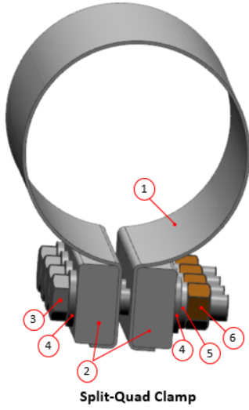 |  | 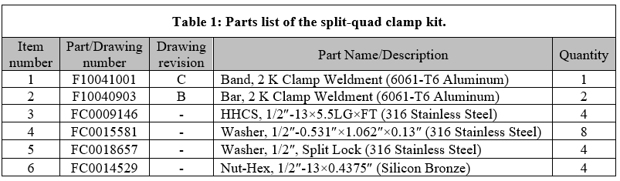
Figure 1: Front view of the split-quad clamp (3D CAD model number: F10042265-Rev B).
Step No. | Instructions |  | Data Input
 | Note: See Figure 1 and Table 1 of this document and attached CAD drawings for the details.
 | Serialization of the split-quad clamp
 | - Preparer name. |  | [[Ser_Preparer_Name_SRF]] <<SRF>>
 | - Assign serial number for the split-quad clamp.  Note: The labeling format is F10042265BSN where the last two digits indicate the serial number starting from 01. |  | [[CLMPSQ]] << CLMPSQSN >>
 | - Mark the serial number on the 2 K clamp weldment bars (label 2 in Figure 1). |  | [[Mark_CLMPSQSN]] <<YESNO>>
 | - Add comments, if any. |  | [[Ser_Comment]] <<COMMENT>>
 | - Date of completion. |  | [[Ser_Comp_Date]] <<TIMESTAMP>>
 | EBOM inspection
 | - Inspector name and date. |  | [[EBOMI_Inspector_Name_SRF]] <<SRF>>  [[EBOMI_Date]] <<TIMESTAMP>>
 | - Are all components listed in Table.1 present? |  | [[EBOMI_Tally]] <<YESNO>>  [[EBOMI_Comment]] <<COMMENT>>
 | - If the answer is NO to step #2.2, then generate NCR.

 | - Date of completion of EBOM inspection. | [[EBOMI_Comp_Date]] <<TIMESTAMP>>
 | Visual inspection
 | - Inspector name and date. | [[VI_Inspector_Name_SRF]] <<SRF>>  [[VI_Date]] <<TIMESTAMP>>
 | - Are all components of the assembly free of dirt, grease, oil, or chip? | [[VI_Pass_1]] <<YESNO>>  [[VI_Pass_1_Comment]] <<COMMENT>>
 | - Are all parts free of sharp edges, corners, and burrs? | [[VI_Pass_2]] <<YESNO>>  [[VI_Pass_2_Comment]] <<COMMENT>>
 | - Check for the signs of damage on weldments. Refer to the drawing for the 2 K split-quad clamp weldment (drawing no: F10042073-Rev B) for details. | [[VI_Pass_3]] <<YESNO>>  [[VI_Pass_3_Comment]] <<COMMENT>>
 | - If the answer is NO to steps #3.2 and/or #3.3 and/or #3.4, then generate NCR.
 | - Date of completion of visual inspection. | [[VI_Comp_Date]] <<TIMESTAMP>>
 | Re-pack the split-quad clamp kit. Send to inventory area until use. | [[Repack_Inspector_Name_SRF]] <<SRF>>  [[Repack_Comp_Date]] <<TIMESTAMP>>

