Traveler Title | LCLS-II HE Cavity Incoming Inspection
Traveler Abstract | Incoming Inspection of Dressed LCLS-II HE Production Cavities
Traveler ID | L2HE-INSP-CAV
Traveler Revision | R2
Traveler Author | T. Ganey
Traveler Date | 5-Aug-21
NCR Informative Emails | forehand,overtonr,hogan,ganey
NCR Dispositioners | hannesv,kwilson
D3 Emails | hannesv,ganey,kwilson,forehand,overtonr,hogan,areilly
Approval Names | T. Ganey | A. DeKerlegand | J. Vennekate | J. Hogan
Approval Signatures
Approval Dates
Approval Title | Author | Reviewer | Reviewer | Project Manager

References | List and Hyperlink all documents related to this traveler. This includes, but is not limited to: safety (THAs, SOPs, etc), drawings, procedures, and facility related documents.
Cavity Drawing Package F10023864_rev_M

Revision Note
R1 | Initial release of this Traveler.
R2 | Added hyperlink to Cavity Drawing Package, updated images under Incoming Inspection Goals, and added a note on how to measure step 4 Distance between Tuner Blocks.

Incoming Inspection Goals:

This traveler covers all steps required to visually and dimensionally (CMM measurements) accept incoming LCLS-II HE dressed cavities.
Careful handling of the cavity is mandatory at all times. This includes transferring the cavity to another work station during or after the inspections. The goals of this inspection covers:

- Visual inspections of the dressed LCLS-II HE cavity
- CMM inspections (restricted to accessible components on the exterior)

Nomenclature: The sketch below defines the nomenclature for the cavity coupler ports highlighting the bare cavity only.

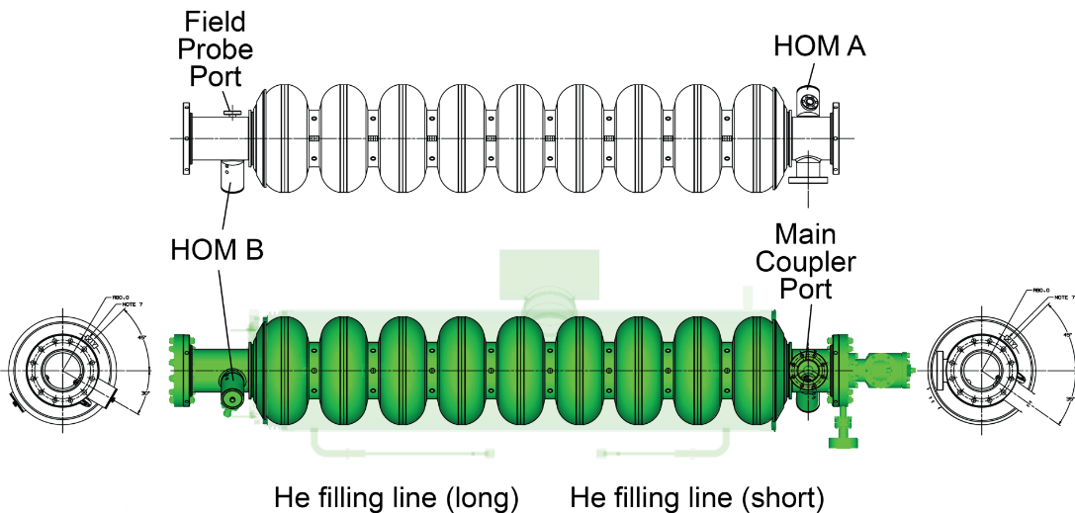

Note that LCLS-II HE remediation cavities were produced by Zanon Research & Innovation SRL (short: EZ) and RI Research Instruments, GmbH (short: RI), and production cavities are produced by RI. Each LCLS-II HE production cavity is delivered with a helium vessel under vacuum and at this point has passed 3 acceptance levels (hold points) at the vendor site permitting shipment to JLab (or our partner institute at FNAL). At JLab the cavity must have passed receipt inspection and RF inspection to allow visual and CMM inspection. Vendor drawings of the dressed cavity assembly reflecting the condition at delivery are shown below.

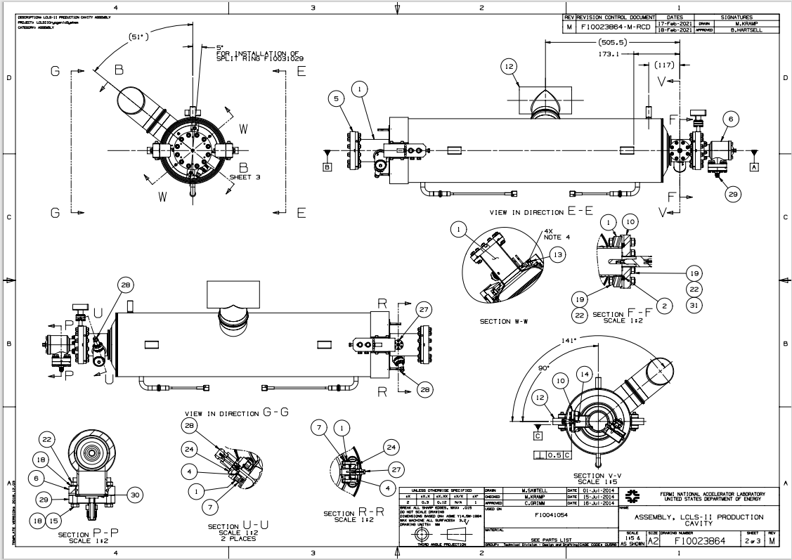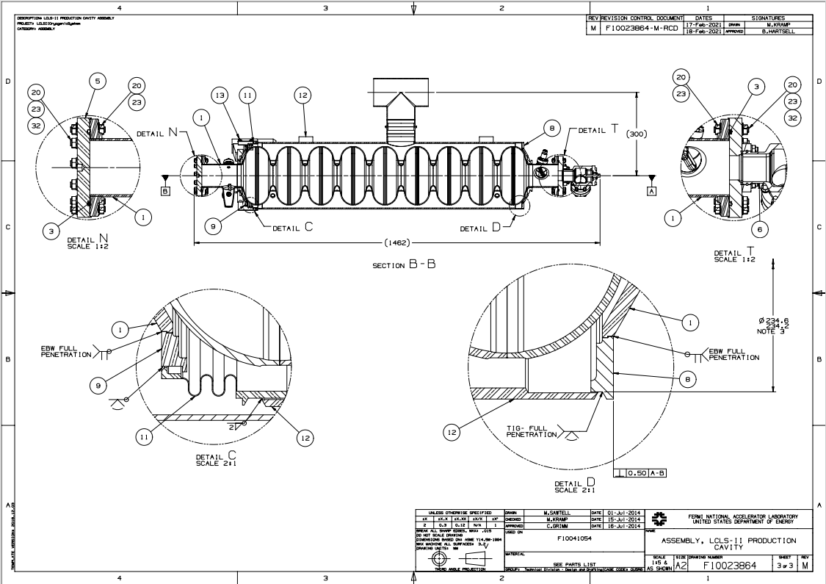

The cavity is mechanically restrained to the helium tank with bellows brackets (two arms) mounted between the tank and the cavity connection flange via the tuner split ring (figure below) on the long beam tube side (bellows side). These brackets are required for pressure testing and whenever the cavity and helium vessel are not under atmospheric pressure (e.g. vacuum leak check, VTA testing), The bellows bracket arms shall not be removed and remain with the cavity until string assembly.

The cavity has been welded to its helium vessel such that the bare cavity cells are not accessible for dimensional control. The cavity and helium vessel were dimensionally and optically inspected by the vendor before shipment to JLab. Upon arrival obvious damages of the shipping box and the cavity are to be checked visually and recorded. The dimensional inspections foreseen as part of this traveler serve as a verification of the vendor data restricted to externally accessible parts.

Note that temporary protection brackets – when installed by vendors - for both the rather thin bellows convolutions as well as both He filling lines may be removed to check the integrity of the components.

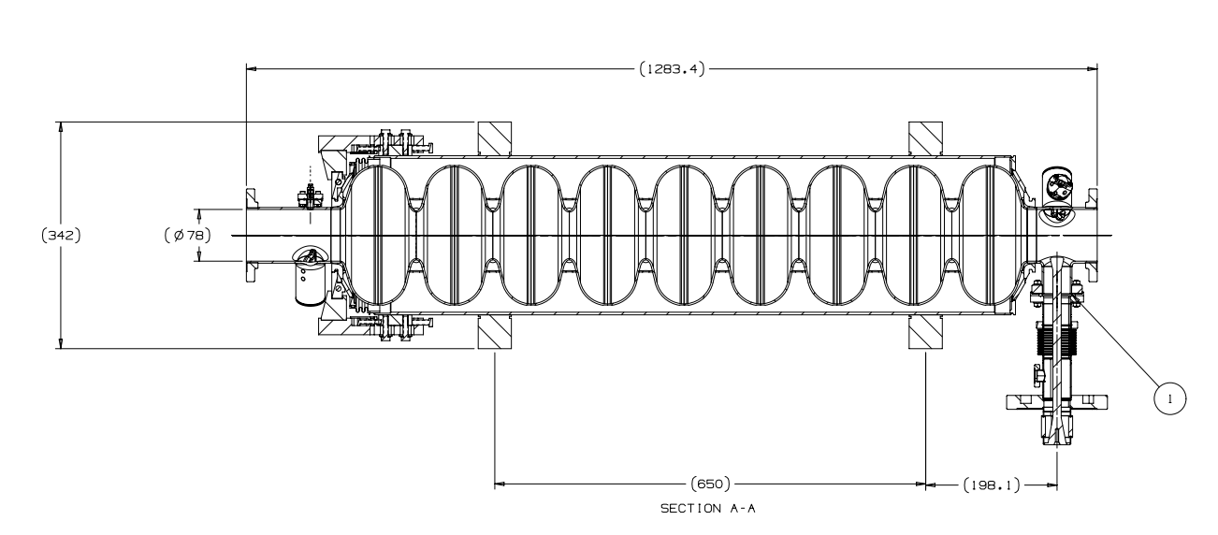
Brace Arms
Split Ring

Step No | Instructions | Data Inputs
1 | Record serial numbers  Inspector Name  Cavity Serial Number  Date of Inspection | [[InspTech]] <<SRFCVP>>  [[InspDateTime]] <<TIMESTAMP>>  [[SerialNumComment]] <<COMMENT>>  [[InspFileUpload]] <<FILEUPLOAD>>
 | Cavity | [[CAVSN]] <<CAVSN>>
 | Helium Vessel | [[HELVSN]] <<HELVSN>>
 | Valve | [[AV15SN]] <<AV15SN>>
 | Beam tube flange adapter – short | [[FlangeShortSN]] <<SN>>
 | Beam tube flange adapter - long | [[FlangeLongSN]] <<SN>>
 | Bellows brace arms | [[BellowsBrace1SN]] <<SN>>  [[BellowsBrace2SN]] <<SN>>
 | Split ring | [[SplitRingSN]] <<SN>>
 | Burst Disk | [[PBDSN]] <<PBDSN>>
 | Field Probe | [[FPFTSN]] <<FPFTSN>>
 | HOM Probe A – short | [[HMFTASN]] <<HMFTASN>>
 | HOM Probe B – long | [[HMFTBSN]] <<HMFTBSN>>
 | Input Coupler | [[NTFTSN]] <<NTFTSN>>

Step No | Instructions | Data Inputs
2 | Configuration Check. Are the following components installed? | [[CMMTechInstall]] <<SRFCVP>>  [[CMMDateTimeInstall]] <<TIMESTAMP>>  [[CMMCommentInstall]] <<COMMENT>>  [[CMMUploadInstall]] <<FILEUPLOAD>>
 | Protective caps on TEE | [[ProtectCapsTEE]] <<YESNO>>
 | Protective caps on helium fill lines | [[ProtectCapsHelFill]] <<YESNO>>
 | Covers on helium lines | [[HeliumLineCovers]] <<YESNO>>
 | Tuner ring | [[TunerRing]] <<YESNO>>
 | Support blocks (4) (F10018181) | [[SupportBlocks1]] <<YESNO>>
 | Clamp Pin (F10018180) | [[ClampPin]] <<YESNO>>
 | Bellows restraint brackets (Brace Arms) | [[BellowRestraintBracket]] <<YESNO>>
 | Bellows covers | [[BellowCovers]] <<YESNO>>
 | Right Angle Valve in closed position, exposed stem length is approximately 8mm. Measure and record length. | [[RightAngleValve]] <<YESNO>>  [[ValveBoltLength]] <<FLOAT>>

Step No | Instructions | Data Inputs
3 | Damage Check. Are the following components damaged? | [[CMMTechDammage]] <<SRFCVP>>  [[CMMDateTimeDammage]] <<TIMESTAMP>>  [[CMMCommentDammage]] <<COMMENT>>  [[CMMUploadDammage]] <<FILEUPLOAD>>
 | Helium Vessel shell and Tee | [[HELVShell]] <<YESNO>>
 | Helium Vessel Bellows | [[HELVBellows]] <<YESNO>>
 | Helium Vessel Fill line - short | [[HELVFillShort]] <<YESNO>>
 | Helium Vessel Fill line - long | [[HELVFillLong]] <<YESNO>>
 | Support blocks (4) No scratches allowed on top, bottom, or outboard side. | [[SupportBlocks2]] <<YESNO>>
 | Field Probe Pin | [[FieldProbePin]] <<YESNO>>
 | HOM Probe Pin and Can - short | [[HOMPinShort]] <<YESNO>>
 | HOM Probe Pin and Can - long | [[HOMPinLong]] <<YESNO>>
 | Burst Disc | [[BurstDisc]] <<YESNO>>
 | Any other damage | [[OtherDamages]] <<YESNO>>  [[DamageComment]] <<COMMENT>>

Step No | Instructions |  | Data Inputs
4 | CMM Inspections  Perform dimensional inspections on CMM. Fill out NCR for any out of tolerance measurements. |  | [[CMMTech]] <<SRFCVP>>  [[CMMDateTime]] <<TIMESTAMP>>  [[CMMComment]] <<COMMENT>>
Drawing number | Description | Drawing Value (mm or as noted) | Measured Value | Within Tolerance
F10015802  (Weldment, Helium Vessel) | Distance of cavity center line to center line of 2-phase header pipe | 300.0 +0.5 – 1.5 | [[DIM1]] <<FLOAT>> | [[DIMTOL1]] <<YESNO>>
F10015802  (Weldment, Helium Vessel) | Parallelism of 2-phase TEE | 1.0 | [[DIM2]] <<FLOAT>> | [[DIMTOL2]] <<YESNO>>
F10023864  (Assembly, LCLS-II Production Cavity) | Perpendicularity of main coupler port to helium vessel lugs (support face C) (ref. to F10018181, "PAD, ROLLING") | 0.5 degrees | [[DIM3]] <<FLOAT>> | [[DIMTOL3]] <<YESNO>>
F10015802  (Weldment, Helium Vessel) | Distance between helium vessel lugs (ref. to F10018181, "PAD, ROLLING"), face to face, axially (2x) | 650 +/- 1.0 | [[DIM4]] <<FLOAT>> | [[DIMTOL4]] <<YESNO>>
F10015802  (Weldment, Helium Vessel) |  | 650 +/- 1.0 | [[DIM5]] <<FLOAT>> | [[DIMTOL5]] <<YESNO>>
F10015802  (Weldment, Helium Vessel) | Distance between helium vessel lugs (ref. to F10018181, "PAD, ROLLING"), face to face, radially (2x) | 342 +0.35 – 0.65 | [[DIM6]] <<FLOAT>> | [[DIMTOL6]] <<YESNO>>
F10015802  (Weldment, Helium Vessel) |  | 342 +0.35 – 0.65 | [[DIM7]] <<FLOAT>> | [[DIMTOL7]] <<YESNO>>
F10015802  (Weldment, Helium Vessel) | Angle of helium vessel lug #1 surface to center plane of 2-phase header pipe | 39 +/- 1.0 degrees | [[DIM8]] <<FLOAT>> | [[DIMTOL8]] <<YESNO>>
F10015802  (Weldment, Helium Vessel) | Angle of helium vessel lug #2 surface to center plane of 2-phase header pipe | 39 +/- 1.0  degrees | [[DIM9]] <<FLOAT>> | [[DIMTOL9]] <<YESNO>>
F10015802  (Weldment, Helium Vessel) | Angle of helium vessel lug #3 surface to center plane of 2-phase header pipe | 39 +/- 1.0  degrees | [[DIM10]] <<FLOAT>> | [[DIMTOL10]] <<YESNO>>
F10015802  (Weldment, Helium Vessel) | Angle of helium vessel lug #4 surface to center plane of 2-phase header pipe | 39 +/- 1.0  degrees | [[DIM11]] <<FLOAT>> | [[DIMTOL11]] <<YESNO>>
F10023864  (Assembly, LCLS-II Production Cavity) | Location of tuner ring (split ring) circle | 5 +/- 1.0  degrees | [[DIM12]] <<FLOAT>> | [[DIMTOL12]] <<YESNO>>
F10015802  (Weldment, Helium Vessel) | Distance between tuner blocks.  Note: to measure this distance, remove one of the brace arm bolts and insert CMM probe to measure a single point | 272 +0.35 – 0.65 | [[DIM13]] <<FLOAT>> | [[DIMTOL13]] <<YESNO>>

Step No | Instructions |  | Data Inputs
5 | Magnetic Hygiene Control  Magnetic hygiene check of the helium vessel shall be conducted in a region with relatively stable ambient field. TLA high bay and rm 1012 are the expected locations to do this. This nominal field is 0.5G in those areas. Follow the following steps:  - The preferred magnetometer used for cavity magnetic field survey is AlphaLab model VGM. Refer to the manual for this type of magnetometer. When using this type of magnetometer:  - Important: make sure that the magnetometer is displaying "Magnitude" not any of the three axes. Press "View" button to adjust if necessary.  - Unit is Gauss. Measured field is DC magnetic field.  - The probe is preferred to be kept perpendicular to the measured surface.  - To reduce the probe tip wear due to friction, either keep the probe tip at a tiny gap from the measured surface or add an insulation layer, such as plastic tape, to the probe tip.  - The wire that connects to the probe may break after repeated use. Add protection sleeve or make a strain relief loop.  - Turn on the magnetometer.  - Before surveying a component, the magnetometer's reading inside the equipped Zero Field Chamber (ZFC) shall be checked. Insert the probe into the ZFC to check if the reading is zero. If not, perform "offsets" procedure per VGM's manual. Note that the ZFC might need to be degaussed if it was placed in a >5 Gauss field. Follow the instruction on the ZFC box.  - Determine background in the area of measurements by sampling at least three locations along the line where the inspected cavity's axis will be, record the average as the background magnetic field. Note if the ambient field varies more than 50 mG among the sampling points, change the location of cavity inspection.  - Pull a dressed cavity into the inspection area. Prepare to demagnetize the cavity using a Helmholtz coil and follow OSP SRF-17-68342-OSP.  - Perform a preliminary measurement to all locations listed at the end of this step and record.  - The following components will be de-magnetized irreguardless of the results of the preliminary measurements taken as mentioned above: Tee, fill lines, and bellows restraint brackets.  - Place the coil to be concentric to the 2-phase Ti-SS transition joint so that the joint will see axisymmetric demagnetization field. The coil needs to be firmly supported during demagnetization. Then demagnetize (1 cycle) this joint per Section 11 of OSP SRF-17-68342-OSP.  - Move the coil slightly to be over the stainless steel weld joint that is adjacent to the 2-phase Ti-SS joint. Weld joint and coil shall be concentric. Then demagnetize (1 cycle) this weld joint per Section 11 of OSP SRF-17-68342-OSP.  - Place the coil on one of the two helium fill line Ti-SS joints. Note that the inner surface of the coil has the highest demagnetization strength, which shall be utilized to demagnetize the fill line joints. Then demagnetize (1 cycle) this Ti-SS joint per procedure in OSP SRF-17-68342-OSP.  - Apply Step 10) to the other helium fill line Ti-SS joint.  - Place the coil over the bellows restraint brackets. Then demagnetize (1 cycle) this bracket per procedure in OSP SRF-17-68342-OSP.  - Note that on the tee and fill line Ti-SS joints (Tee and fill lines), the magnetic field threshold is < 250 mG + background.  - Two-phase Ti-SS field survey: move the probe along the circumference of the joint. Pay attention to the variation of the reading and locate the "hot spots" where the field is high. If the measured field magnitude exceeds the threshold set at the bottom of this step, mark the spots with measured magnitudes. Then prepare to rerun demagnetization(s). Position the Helmholtz coil so that its inner edge is on contact with the "hot spot" to be demagnetized.  - Run at least one demagnetization cycle. Demagnetize all "hot spots" in this manner. A longer than 4-second demagnetization cycle may be needed. Observe OSP SRF-17-68342-OSP for safety regulations, especially the coil temperature shall never exceed 60 °C. Survey the magnetic field after demagnetization. If repeated demagnetization cannot reduce the field level to be under the criterion, generate a NCR.  - Helium fill line Ti-SS joints field survey: move the magnetometer's probe around a joint as much as accessible. Take peak reading and check against criterion set in Step 13). If the threshold is exceeded, execute Step 15). This step shall be applied to both fill line Ti-SS joints.  - Continue to survey other items per the list below. On demagnetization and NCR generation, observe Step 13).  - For bolts on the right-angle valve bonnet and attaching studs:  - If fields >2.5 Gauss + beackground on contact, demagnetize.  - If fields <2.5 Gauss + background, accept as-is.  - For studs on tuner end beamline flange:  - If fields >1.5 Gauss + background on contact, demagnetize.  - If fields <1.5 Gauss + background, accept as-is.  - For studs on coupler end beamline flange:  - If fields >0.5 Gauss + background on contact, demagnetize.  - If fields <0.5 Gauss + background, accept as-is.  - For studs on coupler flange:  - If fields >0.5 Gauss + background on contact, demagnetize.  - If fields <0.5 Gauss + background, accept as-is.  - For transition welds and adjacent stainless to stainless welds:  - If fields >0.25 Gauss + background on contact, demagnetize.  - If fields <0.25 Gauss + background, accept as-is.  - For bellows restraint brackets:  - If fields >0.20 Gauss + background on contact, demagnetize.  - If fields <0.20 Gauss + background, accept as-is. |  | [[MagCheckTech]] <<SRF>>  [[MagCheckDate]] <<TIMESTAMP>>  [[Demagnetized]] <<YESNO>>  [[Background]] <<FLOAT>>  [[MagNotes]] <<COMMENT>>
Instructions - Record out of spec readings after all de-mag cycles
 |  | Maximum allowable fields incorporating background. |  | Enter in Gauss
Tee-transition joint |  | [[MaxAllowable1]] <<FLOAT>> |  | [[MagTeeTrans]] <<FLOAT>>
Tee- ss joint |  | [[MaxAllowable2]] <<FLOAT>> |  | [[MagTeeSS]] <<FLOAT>>
Short fill line-transition joint |  | [[MaxAllowable3]] <<FLOAT>> |  | [[MagShortTrans]] <<FLOAT>>
Short fill line-ss joint |  | [[MaxAllowable4]] <<FLOAT>> |  | [[MagShortSS]] <<FLOAT>>
Long fill line-transition joint |  | [[MaxAllowable5]] <<FLOAT>> |  | [[MagLongTrans]] <<FLOAT>>
Long fill line-ss joint |  | [[MaxAllowable6]] <<FLOAT>> |  | [[MagLongSS]] <<FLOAT>>
Beamline flange studs- Coupler end |  | [[MaxAllowable7]] <<FLOAT>> |  | [[MagBLFPC]] <<FLOAT>>
Beamline flange studs-tuner end |  | [[MaxAllowable8]] <<FLOAT>> |  | [[MagBLTuner]] <<FLOAT>>
Valve bonnet bolts |  | [[MaxAllowable9]] <<FLOAT>> |  | [[MagValveB]] <<FLOAT>>
Valve flange studs |  | [[MaxAllowable10]] <<FLOAT>> |  | [[MagValveF]] <<FLOAT>>
Coupler flange studs |  | [[MaxAllowable11]] <<FLOAT>> |  | [[MagCoupler]] <<FLOAT>>
Bellows Restraint Bracket – FPC Side |  | [[MaxAllowable12]] <<FLOAT>> |  | [[BelResFPC]] <<FLOAT>>
Bellows Restraint Bracket |  | [[MaxAllowable13]] <<FLOAT>> |  | [[BelRes]] <<FLOAT>>

