Traveler Title | DN100 Braze Assembly
Traveler Abstract | Outlines the brazing assembly of the DN100 Flange
Traveler ID | AUP-ASSY-DAMP-FLGBRZ
Traveler Revision | R2
Traveler Author | Matthew Weaks
Traveler Date | 3-Apr-20
NCR Informative Emails | jharris
NCR Dispositioners | Huque,scott
D3 Emails | Huque
Approval Names | Matthew Weaks | Scott Williams | Naeem Huque
Approval Signatures
Approval Dates
Approval Title | Author | Reviewer | Project Manager

References | List and Hyperlink all documents related to this traveler. This includes, but is not limited to: safety (THAs, SOPs, etc), drawings, procedures, and facility related documents.
JL0086026 | JL0088274 | CERN EDMS No. 1389669 | CP-STP-CAV-CHEM-DEGR | JL0088272
JL0086025 | JL0088274_CMM | CP-STP-CAV-CHEM-ACID | JL0088272_CMM

Revision Note
R1 | Initial release of this Traveler.
R2 | Removed document check. Changed order of steps. Added machining and post-machining inspection steps

Step No. | Instructions | Data Input
1 | Serial Number of Assembly  Serial Number of JL0086026  Serial Number of JL0086025 | [[FLGBRZSN]] << FLGBRZSN>>  [[ITUBESN]<<ITUBESN>>  [[DN100SN]]<<DN100SN>>
CHEMISTRY
2 | Degrease JL0086026 as per CP-STP-CAV-CHEM-ACID.  Upload any relevant photos and/or comments. | [[DG1Tech]] <<SRF>>  [[DG1Time]] <<TIMESTAMP>>  [[DG1Comm]] <<COMMENT>>  [[DG1File]] <<FILEUPLOAD>>
 | Degrease JL0086025 as per CP-STP-CAV-CHEM-ACID.  Upload any relevant photos and/or comments. | [[DG2Tech]] <<SRF>>  [[DG2Time]] <<TIMESTAMP>>  [[DG2Comm]] <<COMMENT>>  [[DG2File]] <<FILEUPLOAD>>

Step No. | Instructions | Data Input
BRAZING
3a | Visually inspect both JL0086026 and JL0086025 for any cracks, damage, or any other abnormalities that may affect brazing.  Upload any relevant photos and/or comments. | [[Ins2Tech]] <<SRF>>  [[Ins2Comm]] <<COMMENT>>  [[Ins2File]] <<FILEUPLOAD>>
3b | Braze components as per drawing JL0088274 and CERN EDMS No. 1389669 – Section 2.4.6.  Upload BPS and BPQR | [[BrazTech]] <<SRF>>  [[BrazTime]] <<TIMESTAMP>>  [[BrazComm]] <<COMMENT>>  [[BrazFile]] <<FILEUPLOAD>>
INSPECTION
4 | Visually inspect the braze in accordance with EN 12799 & EN ISO 18279 as defined in CERN EDMS No. 1389669 - Section 4.2.7.  Upload Inspection Report | [[Ins3Tech]] <<SRF>>  [[Ins3Comm]] <<COMMENT>>  [[Ins3File]] <<FILEUPLOAD>>

Step No. | Instructions | Data Input
LEAK CHECK
5a | Thermal shock the assembly by immersing it into LN2 five times, while allowing the assembly to reach room temperature between immersions.  Upload any relevant photos and/or comments | [[LN2Tech]] <<SRF>>  [[LN2Time]] <<TIMESTAMP>>  [[LN2Comm]] <<COMMENT>>  [[LN2File]] <<FILEUPLOAD>>
5b | Leak check the assembly in accordance with EN 13185 as defined in CERN EDMS No. 1389669 – Section 4.5  Upload leak check chart. | [[LC1Tech]] <<SRF>>  [[LC1Time]] <<TIMESTAMP>>  [[LC1Comm]] <<COMMENT>>  [[LC1File]] <<FILEUPLOAD>>
ULTRASONIC TESTING
6 | Inspect the assembly ultrasonically in accordance EN 12799 as per CERN EDMS No.1389669 – Section 4.2.6.4.  Upload Inspection Report | [[US1Tech]] <<SRF>>  [[US1Comm]] <<COMMENT>>  [[US1File]] <<FILEUPLOAD>>
INSPECTION
7 | Verify dimensions marked on drawing JL0088274_CMM.  Upload inspection report.  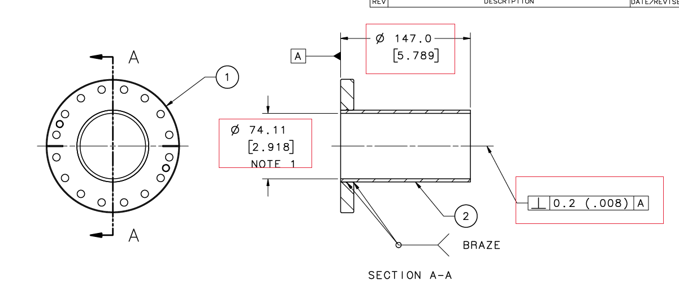 | [[Ins4Tech]] <<SRF>>  [[Ins4Time]] <<TIMESTAMP>>  [[Ins4Comm]] <<COMMENT>>  [[Ins4File]] <<FILEUPLOAD>>
MACHINING
8 | Machine the knife edge as per JL0088272.  Note the new serial number of the part  Upload any relevant photos and files | [[FLMCHSN]] << FLMCHSN >>  [[MachTech]] <<SRF>>  [[MachTime]] <<TIMESTAMP>>  [[MachComm]] <<COMMENT>>  [[MachFile]] <<FILEUPLOAD>>
LEAK CHECK
9 | Leak check the assembly (checking the knife edge in particular) in accordance with EN 13185 as defined in CERN EDMS No. 1389669 – Section 4.5  Upload leak check chart. | [[LC2Tech]] <<SRF>>  [[LC2Time]] <<TIMESTAMP>>  [[LC2Comm]] <<COMMENT>>  [[LC2File]] <<FILEUPLOAD>>
INSPECTION
10 | Verify dimensions marked on drawing JL0088272_CMM.  Upload inspection report.  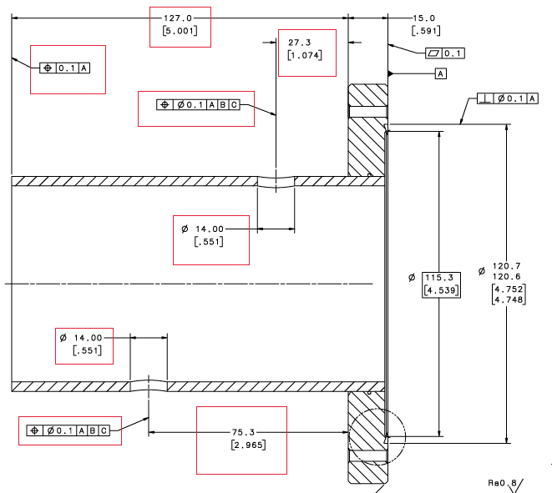 | [[Ins5Tech]] <<SRF>>  [[Ins5Time]] <<TIMESTAMP>>  [[Ins5Comm]] <<COMMENT>>  [[Ins5File]] <<FILEUPLOAD>>

