Traveler Title | SNSPPU High Beta Cold Mass Assembly Traveler
Traveler Abstract | This traveler details the steps required to complete the Cold Mass assembly outside of the cleanroom, including the welding of the coupler process tubing, installation of the inner magnetic shielding and installation of MLI. This subassembly makes up the cold mass inside of the SNS PPU high beta cryomodule.
Traveler ID | SNSPPU-CMA-CMASS-ASSY
Traveler Revision | R2
Traveler Author | G.Cheng
Traveler Date | 30-Aug-21
NCR Informative Emails | edaly,wiseman,jharris
NCR Dispositioners | fischer,cheng,huque,jared
D3 Emails | fischer,cheng,edaly,areilly
Approval Names | G. Cheng | J.Martin | N.Huque | J.Fischer
Approval Signatures
Approval Dates
Approval Title | Author | Reviewer | CA Manager | CMA Group Lead

References | List and Hyperlink all documents related to this traveler. This includes, but is not limited to: safety (THAs, SOPs, etc), drawings, procedures, and facility related documents.
104211500-M8U-8200-A002 Cold Mass Assembly Dwg | 104211300-M8U-8200-A009-MLI Dwg | 104211200-M8U-8200-A001-INNER Magnetic Shielding | 104211400-M8U-8200-A001_TUNER Assembly | 104211500-M8U-8200-A001_Cleanroom Assembly
SNS Tuner Installation Procedure | 11141S0029 Rev B Leak Check Procedure | CP-SNSPPU-CM-INST-MLI.docx | Cold Mass Assembly Kit Lists | Indium Installation Procedure

Revision Note
R1 | Initial release of this Traveler.
R2 | Traveler revision after first Assembly. Many changes

Step No. | Instructions | Data Input
Cold Mass Assembly |  | [[CMSN]] <<CMSN>>
1 | Identify the serial number of the cavity string assembly (HXX) and enter in data input box | [[CSTSN]] <<CSTSN>>  [[CSTTech]] <<SRF>>  [[CSTDate]] <<TIMESTAMP>>  [[CSTComments]] <<COMMENT>>

Step No | Instructions | Data Inputs
2 | Move cavity string assembly from clean room to CM assembly bench using transfer bench.  Procedure:  - Mate up cavity string bench and CM transfer bench.  - Tie benches together.  - Install lockdowns onto transfer bench.  - Record vacuum pressure, close the beamline valve, isolating the ion pump, and then turn off ion pump.  - Ensure links and lockdowns installed BEFORE moving cavity string (lollipops tight, lockdowns tight, benches tied together tight).  - Move cavity string from clean room onto transfer bench.  - Install additional lockdowns.  - Move transfer bench to CM assembly area.  - Mate the benches and tie together.  - Transfer cavity string onto assembly rails.  - Align coupler #1 over target and lockdown string.  - Install additional lockdowns.  - Re-establish cavity vacuum by turning on the ion pump, once vacuum is established, open the beamline valve.  - Record vacuum pressure level.  - Install bellows protectors over beam line bellows  - Compare the Cavity String major dimensions against 104211500-M8U-8200-A001_Cleanroom Assembly, comment on findings. | [[MoveTech]] <<SRF>>  [[MoveDate]] <<TIMESTAMP>>  [[MoveComment]] <<COMMENT>>  [[BeforeVac]] <<SCINOT>>  [[AfterVac]] <<SCINOT>>

Step No | Instructions |  |  |  |  |  | Data Inputs
3 | Record caviy serial numbers:  North (Supply End Can) 4 – 3 – 2 – 1LLP South (Return End Can)  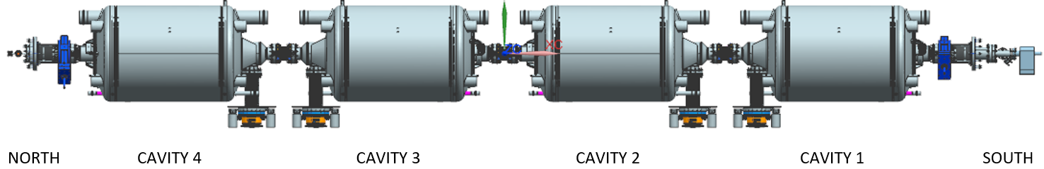 |  |  |  |  |  | [[CAVSN1]] <<CAVSN>>  [[CAVSN2]] <<CAVSN>>  [[CAVSN3]] <<CAVSN>>  [[CAVSN4]] <<CAVSN>>  [[CMATech]] <<SRF>>  [[CAVDate]] <<TIMESTAMP>>  [[CAVComment]] <<COMMENT>>
4 | Install the 2K circuit – weld 3" helium return line bellows (2x 104211500-A017, 1x 104211500-A026), 3" supply and return headers (1x 104211500-A018 & 1x 104211500-A019) , crossover flex lines (104211500-A027), and 3/4" end caps. In this traveler, drawing number in ORNL’s format typically omits the "-M8U-8200" portion for brevity.  Procedure:  - Pull wires through wire loop inside He vessel heads.  - Install bellows/pull heater wires through separate feedthru ports in double tophat bridging areas.  - Add bellows protectors to the 2 phase bellows  - Pull liquid level wires through the 3" return header.  - Install G10 standoffs to protect wires during welding.  - Weld all components using appropriate procedure and Cu cooling block.  - Verify header to header length of cavity string as per drawing number 104211500-A002 = 227.37", record the dimension. If these values are significantly off (+/- 1”) consult a Supervisor.  - Verify gate valve to gate valve length = 220.18"  - Upload the completed 2 phase In-Process weld examination documentation.  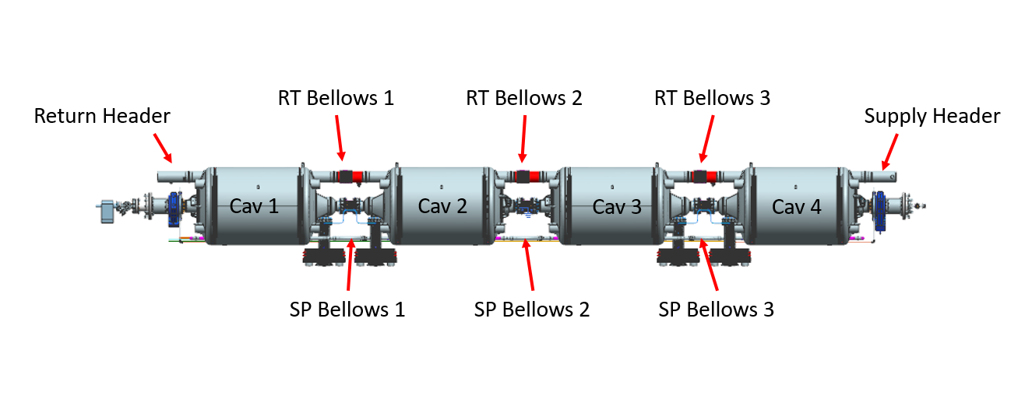 |  |  |  |  |  | [[Welder2KC]] <<SRF>>  [[Weld2KCDate]] <<TIMESTAMP>>  [[Weld2KCComment]] <<COMMENT>>  [[WeldDocumentation]] <<FILEUPLOAD>>  [[CMMPSN]] <<CMMPSN>>  [[ReturnHeader]] <<SN>>  [[HOBCBSN]] <<HOBCBSN>>  [[RtBellow1]] <<SN>>  [[RtBellow2]] <<SN>>  [[RtBellow3]] <<SN>>  [[EQFHSN]] <<EQFHSN>>  [[SpBellow1]] <<SN>>  [[SpBellow2]] <<SN>>  [[SpBellow3]] <<SN>>  [[SupplyHeader]] <<SN>>  [[Header2HeaderDist]] <<FLOAT>>  [[Valve2VavleDist]] <<FLOAT>>
5 | Wire and install the cryogenic feedthrus (x3) as per 104212000-M8U-8200-A001 |  |  |  |  |  | [[InstFTTech]] <<SRF>>  [[InstFTDate]] <<TIMESTAMP>>  [[InstFTComment]] <<COMMENT>>  [[FT08PSNSupplyEnd]] <<FT08PSN>>  [[FT08PSNCav4]] <<FT08PSN>>  [[FT08PSNCav1]] <<FT08PSN>>
6 | Cold shock all weld-joints, explosion joints, and cryogenic feedthrus 3 times each. |  |  |  |  |  | [[ColdShockTech]] <<SRF>>  [[ColdShockDate]] <<TIMESTAMP>>  [[ColdShockComment]] <<COMMENT>>
7 | Install the tuner frames, heat stationing straps with indium, and motor housings. Do not install harmonic assy at this time.  104211400-M8U-8200-A001  SNS Tuner Installation Procedure, Indium Installation Procedure  Note: Leave tuner frames loose for frequency setting.  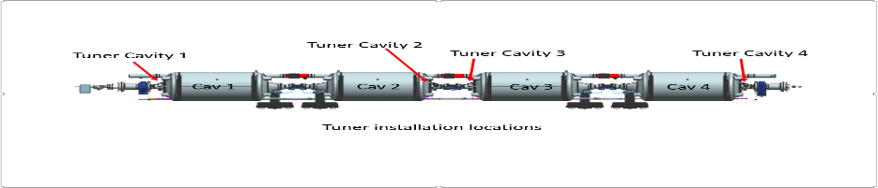  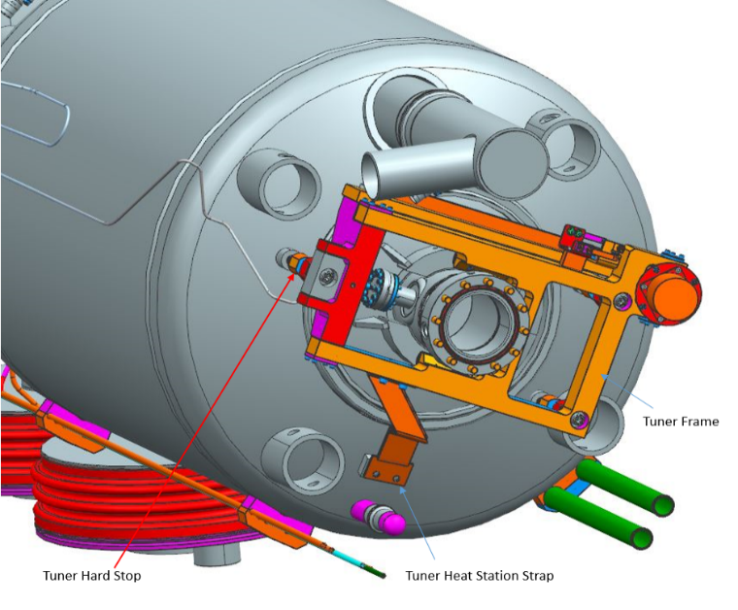 |  |  |  |  |  | [[TUNCSN1]] <<TUNCSN>>  [[TUNCSN2]] <<TUNCSN>>  [[TUNCSN3]] <<TUNCSN>>  [[TUNCSN4]] <<TUNCSN>>  [[TuneTech1]] <<SRF>>  [[TuneDate1]] <<TIMESTAMP>>  [[TuneComment1]] <<COMMENT>>
8 | Measure as received cavity frequencies (passbands) and record.  Acceptable range: 803.950 to 804.060 MHz  **NOTE: When naming the files, use letters and numbers only, no symbols, no spaces. In place of a space, you may use a dash or underscore.**  Note: Cavities are under vacuum and helium vessels are at atmosphere. |  |  |  |  |  | [[FreqTech]] <<SRF>>  [[FreqDate]] <<TIMESTAMP>>  [[FreqFile]] <<FILEUPLOAD>>  [[FreqComment]] <<COMMENT>>
9 | Set the tuner hard stops on the helium vessel head to 803.9 + 0.05 MHz using the network analyzer. |  |  |  |  |  | [[TunStpTech]] <<SRF>>  [[TunStpDate]] <<TIMESTAMP>>  [[TunStpComment]] <<COMMENT>>
10 | Record and install the harmonic drives, stepper motors, motor Mu metal covers, and hose clamps on all cavities  Note: Wave generators to be set 11/16" from the adapter plate to the outer face on the generator. |  |  |  |  |  | [[HMDRSN1]] <<HMDRSN>>  [[HMDRSN2]] <<HMDRSN>>  [[HMDRSN3]] <<HMDRSN>>  [[HMDRSN4]] <<HMDRSN>>  [[SMSN1]] <<SMSN>>  [[SMSN2]] <<SMSN>>  [[SMSN3]] <<SMSN>>  [[SMSN4]] <<SMSN>>  [[TuneTech2]] <<SRF>>  [[TuneDate2]] <<TIMESTAMP>>  [[TuneComment2]] <<COMMENT>>
11 | Install and set the limit switches with the additional G-10 bumpers. Switches to open one revolution from either hard stop. Leave the high frequency switch on. |  |  |  |  |  | [[SwtchTech]] <<SRF>>  [[SwtchDate]] <<TIMESTAMP>>  [[SwtchComment]] <<COMMENT>>
12 | Leak check 2K circuit.  Bag all joints to be leak checked.  Use calibrated equipment, record the machine S/N and leak rate calibration date.  **NOTE: When naming the file, use letters and numbers only, no symbols, no spaces. In place of a space, you may use a dash or underscore.** |  |  |  |  |  | [[LkChk2KCTech]] <<SRF>>  [[LkChk2KCDate]] <<TIMESTAMP>>  [[LkChk2KCFile]] <<FILEUPLOAD>>  [[LkChk2KCComment]] <<COMMENT>>  [[LDSN]] <<SN>>  [[LRCalDate]] <<TEXT>>
13 | Install 24 Cernox sensors onto helium vessels, beampipe flanges, coupler flanges and coupler outer conductor bodies, as per schematic. Record serial numbers by location as installed. Sensors shall be securely attached with indium foil and screw. Heat-station all wires to the same surface the sensor is mounted on, and route remaining wire to hole in the primary magnetic shielding.  After installation, measure the sensor resistances and compare with allowables. Upload the electrical data.  **Note-beampipe diode leads need to be ran to allow the flange cooling rings clear access when installed, without interference**  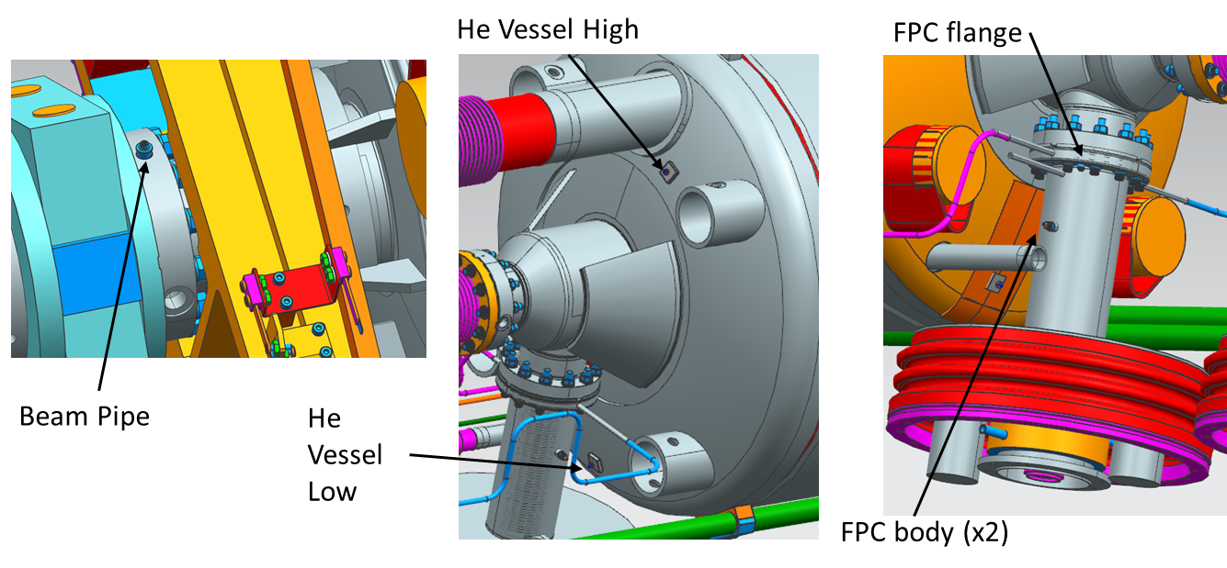 |  |  |  |  |  | [[CernoxTech]] <<SRF>>  [[CernoxDate]] <<TIMESTAMP>>  [[CernoxComment]] <<COMMENT>>  [[ElectricalUpload]] <<FILEUPLOAD>>
 |  |  | Helium Vessel_Low | [[DCXCUSN123]] <<DCXCUSN>> | [[DCXCUSN223]] <<DCXCUSN>> | [[DCXCUSN323]] <<DCXCUSN>> |  | [[DCXCUSN423]] <<DCXCUSN>>
 |  |  | Helium Vessel_High | [[DCXCUSN122]] <<DCXCUSN>> | [[DCXCUSN222]] <<DCXCUSN>> | [[DCXCUSN322]] <<DCXCUSN>> |  | [[DCXCUSN422]] <<DCXCUSN>>
 |  |  | FPC Flange | [[DCXCUSN121]] <<DCXCUSN>> | [[DCXCUSN221]] <<DCXCUSN>> | [[DCXCUSN321]] <<DCXCUSN>> |  | [[DCXCUSN421]] <<DCXCUSN>>
 |  |  | Beam Pipe | [[DCXCUSN124]] <<DCXCUSN>> | [[DCXCUSN224]] <<DCXCUSN>> | [[DCXCUSN324]] <<DCXCUSN>> |  | [[DCXCUSN424]] <<DCXCUSN>>
 |  |  | Coupler_A | [[DCXCUSN137A]] <<DCXCUSN>> | [[DCXCUSN237A]] <<DCXCUSN>> | [[DCXCUSN337A]] <<DCXCUSN>> |  | [[DCXCUSN437A]] <<DCXCUSN>>
 |  |  | Coupler_B | [[DCXCUSN137B]] <<DCXCUSN>> | [[DCXCUSN237B]] <<DCXCUSN>> | [[DCXCUSN337B]] <<DCXCUSN>> |  | [[DCXCUSN437B]] <<DCXCUSN>>
14 |  | Install the MLI Blankets (CRM9007000-1060, -1061, -1062, & -1063) onto the helium vessel ends and under the tuner mounting area.  CP-SNSPPU-CM-INST-MLI.docx will be used for all MLI work outlined in this Traveler. |  |  |  |  | [[HVMLITech]] <<SRF>>  [[HVMLIDate]] <<TIMESTAMP>>  [[HVMLIComment]] <<COMMENT>>
15 |  | Fabricate and place MLI over the beam line bellows, and cones.  - 15 layers  - Remove bellows protectors  - Mark location of bellows on the exterior layer of MLI  NOTE: Leave access for the alignment arms. |  |  |  |  | [[SpprtsMLITech]] <<SRF>>  [[SpprtsMLIDate]] <<TIMESTAMP>>  [[SpprtsMLIComment]] <<COMMENT>>
16 |  | Apply MLI to crossovers, FPC bodies, beamline bellows and 3" helium return bellows (15 layers).  - Remove bellows protectors  - Mark location of bellows on the exterior layer of MLI  All 2K areas should now be covered. |  |  |  |  | [[BLMLITech]] <<SRF>>  [[BLMLIDate]] <<TIMESTAMP>>  [[BLMLIComment]] <<COMMENT>>
17 |  | Install the inner magnetic shields, 104211200-M8U-8200-A001-Inner Magnetic Shielding, onto the helium vessels, ensure a tight fit.  **Visually inspect the magnetic shield pieces prior to installation for deformation or damage. If issues are found consult the Supervisor or Cold Mass Engineer.**  Install reducing rings first, keeping them straight and square. Tape in place using Mylar tape. Test fit nitronic rods, but do not install them at this time.  **Note: Take caution when working around the headers bellows that are wrapped with MLI.**  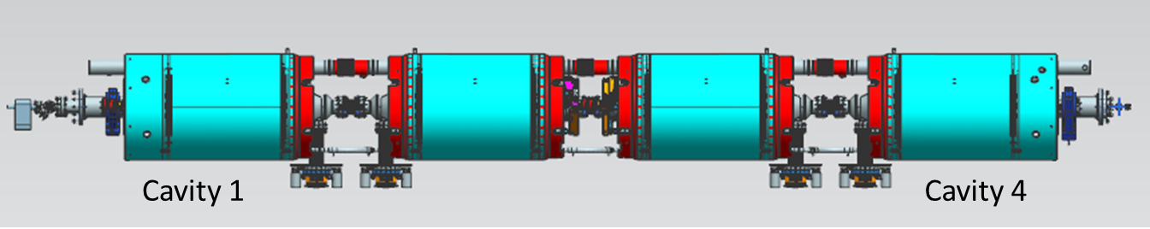 |  |  |  |  | [[IMAGSN]] <<IMAGSN>>  [[IMAGTech]] <<SRF>>  [[FieldName]] {{fischer,jared,cheng}} <<HOLDPOINT>>  [[IMAGDate]] <<TIMESTAMP>>  [[IMAGComment]] <<COMMENT>>
18 |  | Install, label and weld 1/4" coupler cooling lines with G10 supports to the helium vessel. Form the exhaust lines to ensure the bridging areas are clearly accessible after thermal shield and space frame are installed. Upload the In-Process welding documentation.  **Following views have circuits color coded to ease proper installation**  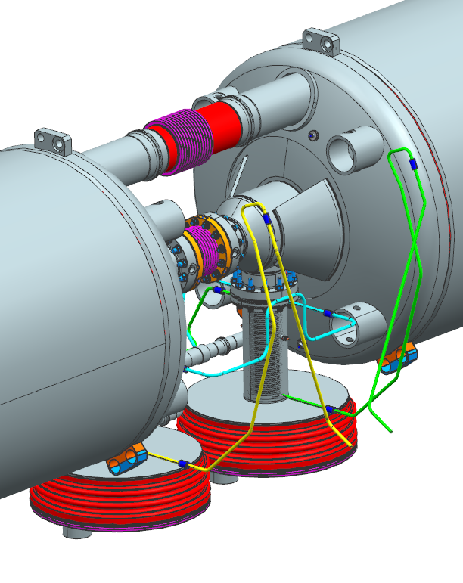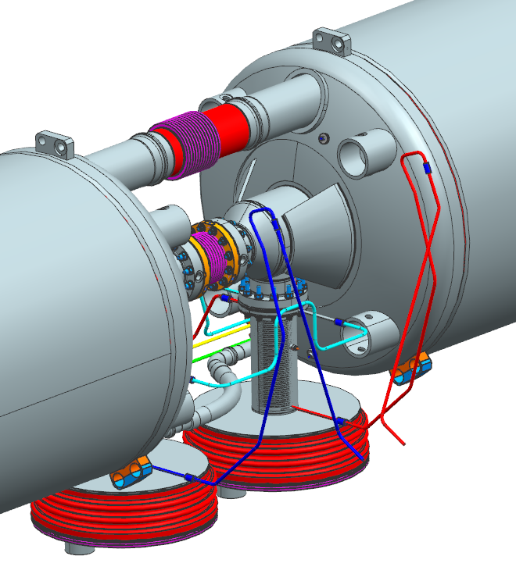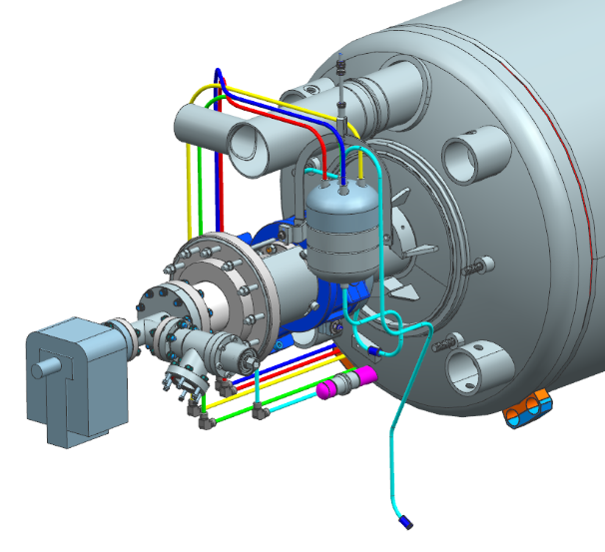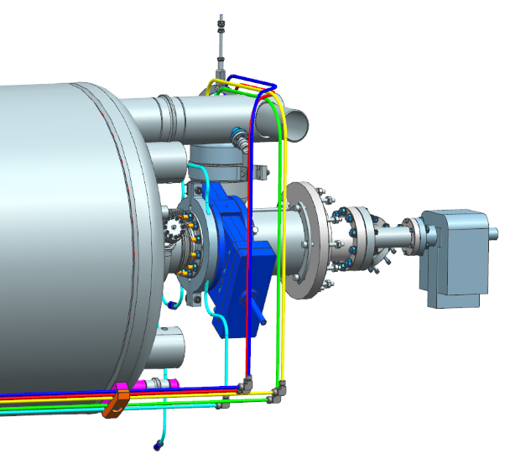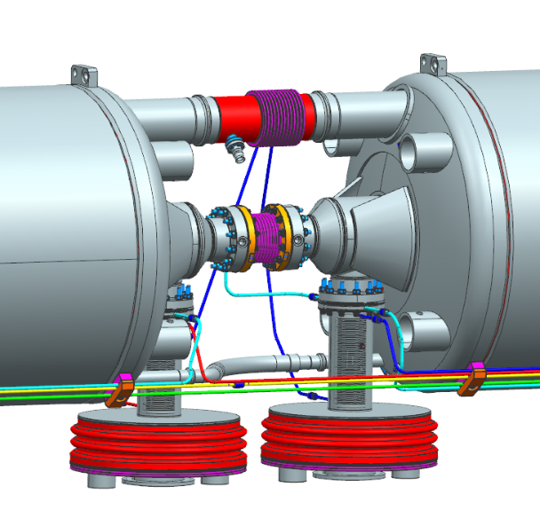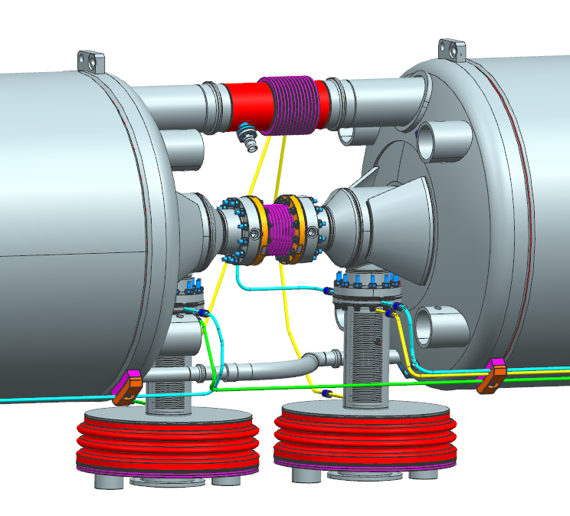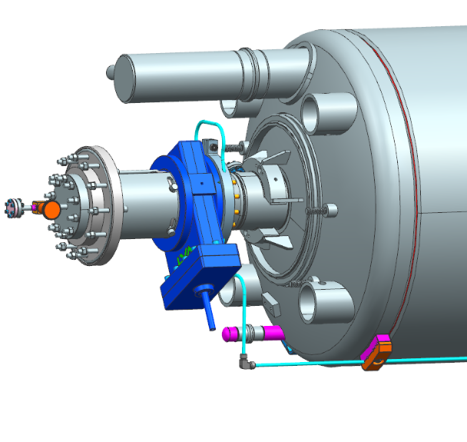 |  |  |  |  | [[WelderCplr]] <<SRF>>  [[WeldCplrDate]] <<TIMESTAMP>>  [[WeldCplrComment]] <<COMMENT>>  [[WeldDocumentation]] <<FILEUPLOAD>>  [[VerifyCplr]] {{fischer,jared,cheng}} <<HOLDPOINT>>
19 |  | Leak check 1/4" coupler lines – five circuits.  Use calibrated equipment, record the machine S/N and leak rate calibration date.  **NOTE: When naming the file, use letters and numbers only, no symbols, no spaces. In place of a space, you may use a dash or underscore.** |  |  |  |  | [[LkChkCplrTech]] <<SRF>>  [[LkChkCplrDate]] <<TIMESTAMP>>  [[LkChkCplrC1File]] <<FILEUPLOAD>>  [[LkChkCplrC2File]] <<FILEUPLOAD>>  [[LkChkCplrC3File]] <<FILEUPLOAD>>  [[LkChkCplrC4File]] <<FILEUPLOAD>>  [[LkChkCplrFlng]] <<FILEUPLOAD>>  [[LkChkCplrComment]] <<COMMENT>>  [[LDSNCplr]] <<SN>>  [[LRCalDateCplr]] <<TEXT>>
20 |  | Weld the four coupler bellows to the FPC flanges.  Install bellows protectors to the FPC Bellows after welding.  Upload the In-Process weld documentation  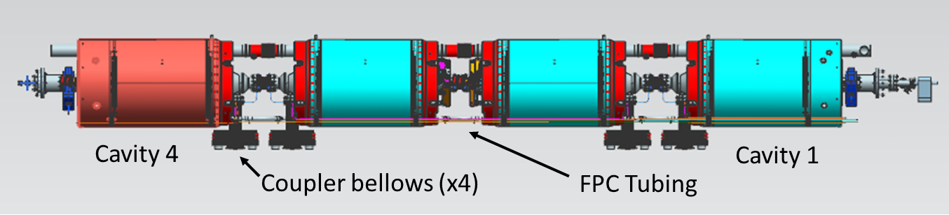 |  |  |  |  | [[WelderFPC]] <<SRF>>  [[WeldFPCDate]] <<TIMESTAMP>>  [[WeldFPCComment]] <<COMMENT>>  [[Cav1CPBellows]] <<TPHTBSN>>  [[Cav2CPBellows]] <<TPHTBSN>>  [[Cav3CPBellows]] <<TPHTBSN>>  [[Cav4CPBellows]] <<TPHTBSN>>  [[BellowProtectors]] <<YESNO>>  [[WeldCPDocumentation]] <<FILEUPLOAD>>
21 |  | Leak check the four coupler bellows and record.  Use calibrated equipment, record the machine S/N and leak rate calibration date.  **NOTE: When naming the file, use letters and numbers only, no symbols, no spaces. In place of a space, you may use a dash or underscore.** |  |  |  |  | [[LkChkCplrBLTech]] <<SRF>>  [[LkChkCplrBLDate]] <<TIMESTAMP>>  [[LkChkCplrBLCav1File]] <<FILEUPLOAD>>  [[LkChkCplrBLCav2File]] <<FILEUPLOAD>>  [[LkChkCplrBLCav3File]] <<FILEUPLOAD>>  [[LkChkCplrBLCav4File]] <<FILEUPLOAD>>  [[LkChkCplrBLComment]] <<COMMENT>>  [[LDSNBel]] <<SN>>  [[LRCalDateBel]] <<TEXT>>
22 |  | Install the two 3/4" IPS heat exchange lines onto helium vessels using G-10 supports. Position them axially as per 104211500-M8U-8200-A002  Note: Ensure clamps allow movement axially for alignment, add washers as spacers. After alignment the pipes should be anchored in one location, non-tuner side of cavity 2.  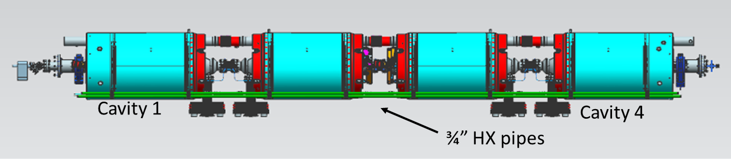 |  |  |  |  | [[IPSTech]] <<SRF>>  [[IPSDate]] <<TIMESTAMP>>  [[IPSComment]] <<COMMENT>>
23 |  | Install the Field probe flex cables. Be sure to maintain clearance between the tuner frame and heat stationing Cu strap.  **Cable ends to be torqued to 15in/lbs and verified by the Electrical Technician.** |  |  |  |  | [[FPTech]] <<SRF>>  [[CableEndTorqued]] <<YESNO>>  [[FPDate]] <<TIMESTAMP>>  [[FPComment]] <<COMMENT>>
25 |  | Perform TDR and record findings. |  |  |  |  | [[TDRTech]] <<SRF>>  [[TDRDate]] <<TIMESTAMP>>  [[TDRFile]] <<FILEUPLOAD>>  [[TDRComment]] <<COMMENT>>
26 |  | Install the remaining inner magnetic shielding, 104211200-M8U-8200-A001  Route the field probe cables and instrumentation wires out through holes in magnetic shield as required. Protect the wires from sharp edges.  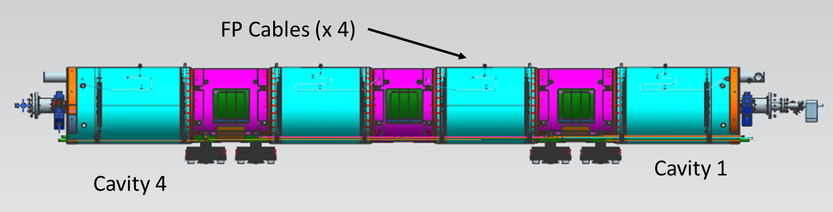 |  |  |  |  | [[MagTech]] <<SRF>>  [[MagDate]] <<TIMESTAMP>>  [[MagComment]] <<COMMENT>>
27 |  | Install the 2K MLI over the cavity string assembly.  104211300-M8U-8200-A009-MLI Dwg |  |  |  |  | [[MLI2KTech]] <<SRF>>  [[MLI2KDate]] <<TIMESTAMP>>  [[MLI2KComment]] <<COMMENT>>
28 |  | Confirm the SNSPPU Cold Mass Assembly is complete and acceptable for the next step of assembly. Assembly completed as per 104211500-M8U-8200-A002. Record assembly drawing number and revision.  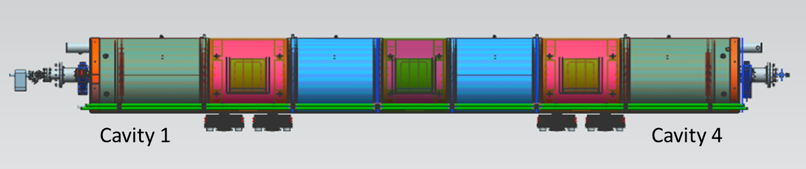 |  |  |  |  | [[CMassComplTech]] <<SRF>>  [[CMassComplDate]] <<TIMESTAMP>>  [[CMassDrawing]] <<FILEUPLOAD>>  [[CMassComment]] <<COMMENT>>  [[CompletionChecklist]] <<FILEUPLOAD>>  [[ReviewDataHoldpoint]] {{Fischer,cheng,jared}} <<HOLDPOINT>>

