Traveler Title | Vertical HOM Damper
Traveler Abstract | Outlines the final inspection and fabrication for the final assembly of the VHOM Damper for the RFD Cavity
Traveler ID | AUP-ASSY-VHOM-VCASSY
Traveler Revision | R1
Traveler Author | Naeem Huque
Traveler Date | 25-Sep-21
NCR Informative Emails
NCR Dispositioners | Huque,obrien
D3 Emails | Huque
Approval Names | Naeem Huque | Adam O’Brien | Naeem Huque
Approval Signatures
Approval Dates
Approval Title | Author | Work Center Lead | Project Manager

References | List and Hyperlink all documents related to this traveler. This includes, but is not limited to: safety (THAs, SOPs, etc), drawings, procedures, and facility related documents.
CP-AUP-CAV-CHEM-DEGR | CP-AUP-CAV-CHEM-ACID | CERN EDMS No. 1389669 | JL0090121 | JL0089940
JL0118832 | JL0101223 | JL0090122 | JL0089940_CMM

Revision Note
R1 | Initial release of this Traveler.

Step No. | Instructions | Data Input
1 | Serial Number of Assembly.  Serial Number of JL0090121  Serial Numbet of JL0090122  Serial Number of JL0101223 | [[VCASSYSN]] <<VCASSYSN>>  [[BRZASSN]] <<BRZASSN>>  [[VH25HSN]]<<VH25HSN>>  [[FTPINSN]]<<FTPINSN>>
CHEMISTRY
2a | Degrease/Etch JL0090121 as per JLab spec CP-AUP-CAV-CHEM-ACID  Upload any relevant photos and/or comments. | [[DG1Tech]] <<SRF>>  [[DG1Time]] <<TIMESTAMP>>  [[DG1Comm]] <<COMMENT>>  [[DG1File]] <<FILEUPLOAD>>
2b | Degrease/Etch JL0101223as per JLab spec CP-AUP-CAV-CHEM-ACID  Upload any relevant photos and/or comments. | [[DG2Tech]] <<SRF>>  [[DG2Time]] <<TIMESTAMP>>  [[DG2Comm]] <<COMMENT>>  [[DG2File]] <<FILEUPLOAD>>
2c | Degrease/Etch JL090122 as per JLab spec CP-AUP-CAV-CHEM-ACID  Upload any relevant photos and/or comments. | [[DG3Tech]] <<SRF>>  [[DG3Time]] <<TIMESTAMP>>  [[DG3Comm]] <<COMMENT>>  [[DG3File]] <<FILEUPLOAD>>
 | Hold to review inspection reports, travelers, NCRs, WPS, and WPQR to verify parts are ready for EBW. | [[HoldPoint1]] {{huque}} <<HOLDPOINT>>
ELECTRON BEAM WELD
3a | EBW assembly as per drawing JL0089940  Upload relevant WPS and WPQR. | [[Weld1Tech]] <<SRF>>  [[Weld1Time]] <<TIMESTAMP>>  [[Weld1Comm]] <<COMMENT>>  [[Weld1File]] <<FILEUPLOAD>>
3a | Visually inspect the welds following EN ISO 13919-2 Level B as defined in CERN EDMS No. 1389669 - Section 4.2.7  Upload inspection report. | [[Ins1Tech]] <<SRF>>  [[Ins1Time]] <<TIMESTAMP>>  [[Ins1Comm]] <<COMMENT>>  [[Ins1File]] <<FILEUPLOAD>>
LEAK CHECK AND THERMAL SHOCK
4 | Leak check the assembly following EN 13185 as defined in CERN EDMS No. 1389669 - Section 4.5  Upload any relevant photos and/or comments. | [[LC1Tech]] <<SRF>>  [[LC1Time]] <<TIMESTAMP>>  [[LC1Comm]] <<COMMENT>>  [[LC1File]] <<FILEUPLOAD>>
RADIOGRAPHIC TESTING
5 | Inspect the welds radiographically following EN ISO 13919-2 Level B as defined in CERN EDMS No. 1389669 - Section 4.2.7  Upload inspection report. | [[RT1Tech]] <<SRF>>  [[RT1Time]] <<TIMESTAMP>>  [[RT1Comm]] <<COMMENT>>  [[RT1File]] <<FILEUPLOAD>>
INSPECTION
6 | Verify dimensions marked on drawing JL0089940_CMM  Upload inspection report.  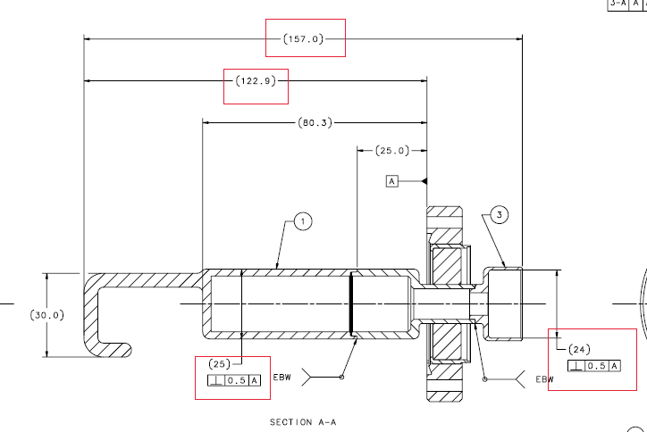 | [[Ins2Tech]] <<SRF>>  [[Ins2Time]] <<TIMESTAMP>>  [[Ins2Comm]] <<COMMENT>>  [[Ins2File]] <<FILEUPLOAD>>
CHEMISTRY
7 | Degrease/Etch the assembly as per JLab spec CP-STP-CAV-CHEM-DEGR and CP-STP-CAV-CHEM-ACID.  Upload any relevant photos and/or comments. | [[DG5Tech]] <<SRF>>  [[DG5Time]] <<TIMESTAMP>>  [[DG5Comm]] <<COMMENT>>  [[DG5File]] <<FILEUPLOAD>>
ASSEMBLY
8 | Complete assembly as per drawing JL0118832.  Upload any relevant photos and/or omments. | [[AssyTech]] <<SRF>>  [[AssyTime]] <<TIMESTAMP>>  [[AssyComm]] <<COMMENT>>  [[AssyFile]] <<FILEUPLOAD>>
9 | Close all travelers and NCRs. | [[TravCHK]] <<SRF>>  [[TravCHK]] <<TIMESTAMP>>

