Traveler Title | SNSPPU Cryomodule Final Assembly Traveler
Traveler Abstract | This traveler specifies the assembly steps for the SNS cryomodule after the space frame-thermal shield assembly traveler has been completed. These assembly steps include the vacuum vessel, space frame-thermal shield assembly, thermal and mag shield end extensions, end cans, warm-to-cold beampipes and all final leak checks.
Traveler ID | SNSPPU-CMA-FNL-ASSY
Traveler Revision | R1
Traveler Author | Jared Martin
Traveler Date | 22-Oct-21
NCR Informative Emails | Jharris,areilly
NCR Dispositioners | fischer,marchlik,cheng,jared,edaly
D3 Emails | fischer,cheng,marchlik,edaly,areilly
Approval Names | Jared Martin | John Fischer | Matt Marchlik | Naeem Huque
Approval Signatures
Approval Dates
Approval Title | Author | CMA Group Lead | Engineering TR | CA Manager

References | List and Hyperlink all documents related to this traveler. This includes, but is not limited to: safety (THAs, SOPs, etc), drawings, procedures, and facility related documents.
104210200-M8U-8200-A001_-_SNS PPU CM Top Assy | 104210200-M8U-8200-A002_A_SPACEFRAME-THERMAL SHIELD Assy | 104210700-M8U-8200-A001- RETURN END CAN Assy | 104210600-M8U-8200-A001-SUPPLY END CAN Assy | 104210200-M8U-8200-A011- SUPPLY END PIPING Assy
104210200-M8U-8200-A012- RETURN END PIPING Assy | 104210300-M8U-8200-A200_-_RETURN WARM BEAM TUBE Assy | 104210300-M8U-8200-A001_-_SUPPLY WARM BEAM TUBE Assy | 104211100-M8U-8200-A014_A_RETURN END THERMAL SHIELD Assy | 104211100-M8U-8200-A025_A_SUPPLY END THERMAL SHIELD Assy
104210800-M8U-8200-A001_A_VACUUM VESSEL Assy | 104210200-M8U-8200-A010-D- COUPLER RETURN PIPING Assy | 104211000-M8U-8200-A013- SUPPLY OUTER MAG SHIELD Assy | 104211000-M8U-8200-A022-RETURN OUTER MAG SHIELD Assy | 104211300-M8U-8200-A002- MLI Dwgs
104211300-M8U-8200-A003- MLI Dwgs 1 | 104211300-M8U-8200-A006- MLI Dwgs 2 | 104211300-M8U-8200-A011- MLI Dwgs 3 | SNS Cryomodule Assembly/Alignment ,  SNS Final Assy Alignment Procedure | 11141S0029 Rev B High Sensitivity Vacuum Leak Check
CP-CM-INST-MLI Procedure

Revision Note
R1 | Initial release of this Traveler.

Step No. | Instructions | Data Input
1 | Record the Vacuum Vessel and Crymoodule serial number. | [[RecDate]]: <<Date>>  [[RecTech]]: <<Username>>  [[VVSN]] <<VVSN>>  [[CMSN]] <<CMSN>>  [[RecComment]] <<COMMENT>>
2 | Thermal shield/spaceframe assembly traveler signed off, assembly is ready for installation.  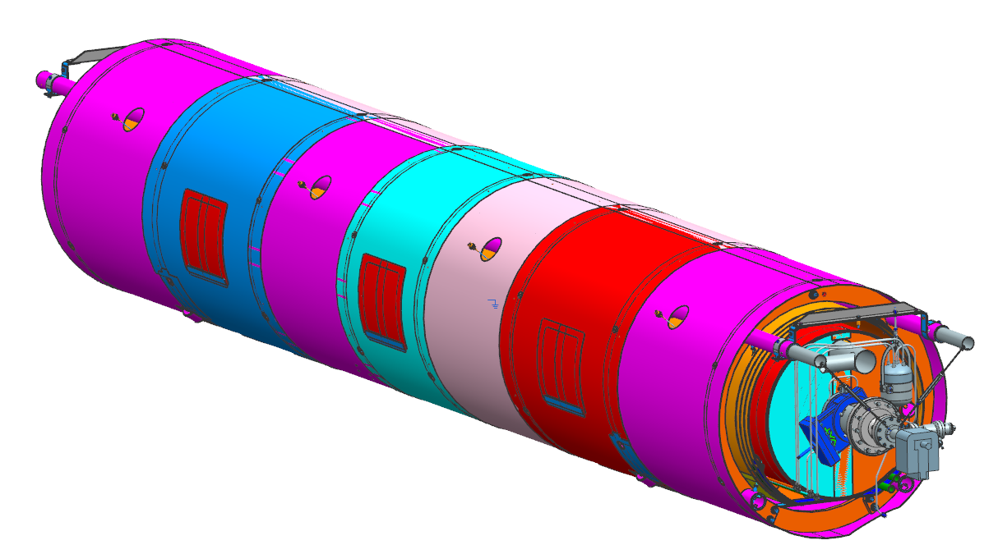 | [[SODate]]: <<Date>>  [[SOName]]: <<Username>>  [[SOComment]]: <<Comment>>
3 | Install the vacuum vessel onto the transfer bench into the carriages, set roll and elevation, lockdown, stage next to spaceframe. 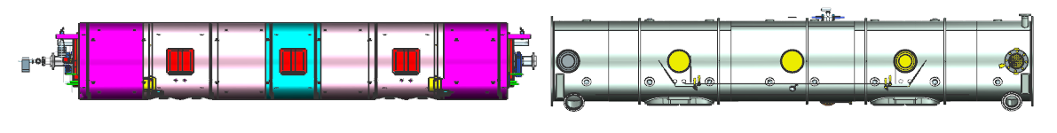  Adjust the carriages to align the VV guide rail to the SF grooved wheel.  Install the VV tooling, will temporarily replace the missing section of the guide rail.  Remove the coupler blanks from couplers to provide extra clearance during SF/TS installation into VV. | [[InstDate]]: <<Date>>  [[InstName]]: <<Username>>  [[InstComment]]: <<Comment>>
4 | Slowly roll the spaceframe assembly into the vacuum vessel  - Remove the spaceframe supports as the wheels engage the vacuum vessel.  - Verify nothing is exceeding the O.D. of the outer magnetic shielding that may interfere during insertion. Coupler cooling exhaust lines will need to be inside the shield.  - **Tie the Cold Mass and VV together to prevent disengagement of wheels as you install the assembly.**  - Install the Outer Mu shielding patches over the lollipop and SF tooling holes as installation allows.  - Roughly align the tophats and spaceframe lockdown points.  - Remove the previously installed guide rail replacement tooling  - Pull the ¼” coupler exhaust lines through the VV weldments (x4)  - Re install the coupler aluminum covers.  - Install the lockdowns to secure the assembly prior to moving.  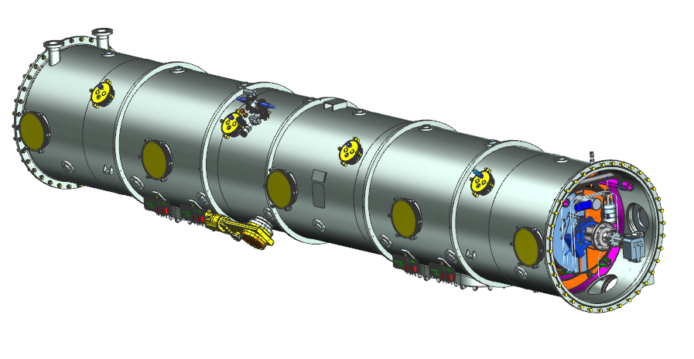 | [[RollDate]]: <<Date>>  [[RollTech]]: <<Username>>  [[RollComment]]: <<Comment>>
5 | Verify the assembly is ready to be moved to the final work station | [[VerifyLead]] <<SRFCMP>>  [[VerifyDate]] <<TIMESTAMP>>  [[VerifyComment]] <<COMMENT>>  [[Ready2Move]] {{fischer,jared,jjcamp }} <<HOLDPOINT>>
6 | Move the assembly to the final work station, align the VV Assembly and reference to the building control system.  **CGV will need to be closed and ionpump powered down for the move, then re-established once move is complete. Record pre and post move vacuum recordings**  Upload findings.  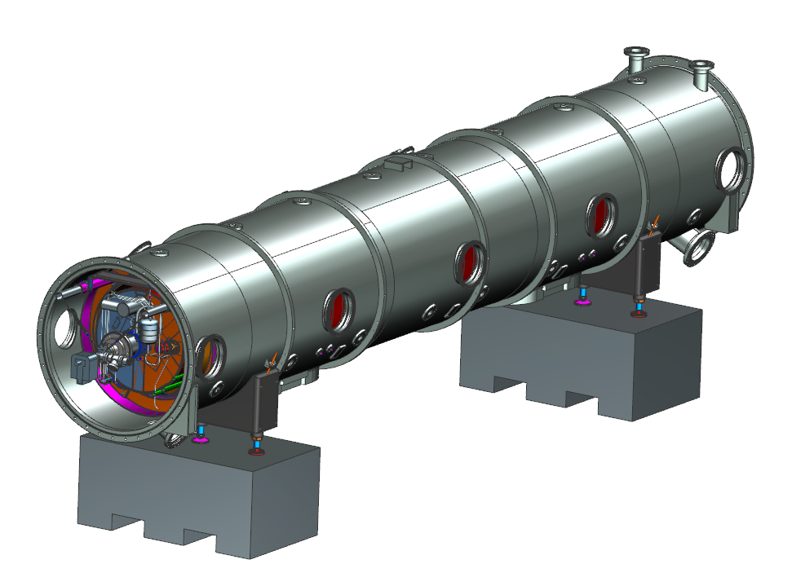 | [[AlignTech]] <<SRFCMP>>  [[ATDate]] <<TIMESTAMP>>  [[ATComment]] <<COMMENT>>  [[MoveBLPreVac]] <<SCINOT>>  [[MoveBLPostVac]] <<SCINOT>>
7 | Align the Cold Mass inside the VV to within +/- 1mm X, Y, and Z using the OHC, lockdowns, and lockdown centering tooling. The JLAB Alignment crew will assist in this operation. Upload findings. | [[Locktech]] <<SRFCMP>>  [[LockDate]] <<TIMESTAMP>>  [[LockComment]] <<COMMENT>>  [[LockData]] <<FILEUPLOAD>>
8 | Tack, then weld the lockdowns. Skip weld to minimize string movement. Use SNSPPU Lockdown Welding Procedure | [[LDWelder]] <<SRFCMP>>  [[LDWDate]] <<TIMESTAMP>>  [[LDWComment]] <<COMMENT>>
9 | Install both Supply and Return end cans into the VV ports, leaving the interface flanges loose.  Record the End Can serial numbers  - Test fit/add the G-10 thermal shield supports into the end can bridge tubes  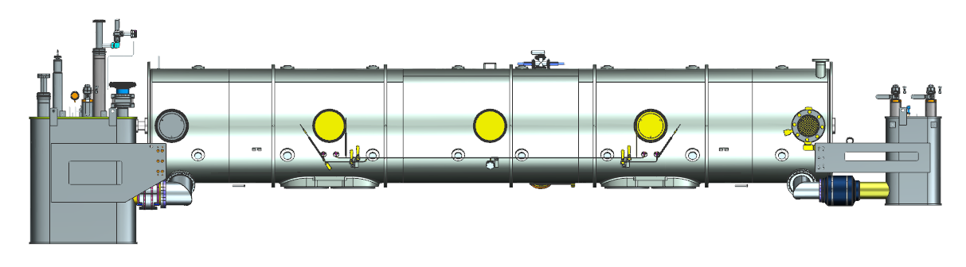 | [[ECTech]] <<SRFCMP>>  [[ECDate]] <<TIMESTAMP>>  [[ECComment]] <<COMMENT>>  [[SECSN]] <<SECSN>>  [[RECSN]] <<RECSN>>
10 | Align the bayonets of both end cans to the VV as referenced in dwgs 104210200-M8U-8200-A001_-_SNS PPU CM Top Assy, 104210700-M8U-8200-A001- RETURN END CAN Assy, 104210600-M8U-8200-A001-SUPPLY END CAN Assy. | [[BayTech]] <<SRFCMP>>  [[BayDate]] <<TIMESTAMP>>  [[BayComment]] <<COMMENT>>  [[BayData]] <<FILEUPLOAD>>
11 | Verify the OAL of the CM is less than or equal to 309.8” Record findings.  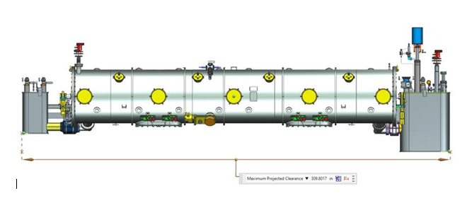 | [[OALTech]] <<SRFCMP>>  [[OALDate]] <<TIMESTAMP>>  [[OALComment]] <<COMMENT>>  [[OAL]] <<TEXT>>
12 | While monitoring the bayonet positions, tack, then weld, both interface blocks between the EC’s and VV. Record the final bayonet positions. The JLAB Alignment crew will perform this work.  Final bayonet positions shall be recorded with the tooling carts loosened and not influencing measurements. | [[POSTech]] <<SRFCMP>>  [[POSDate]] <<TIMESTAMP>>  [[POSComment]] <<COMMENT>>  [[POSData]] <<FILEUPLOAD>>
13 | Verify the EC installations are complete, then remove the installation tooling carts  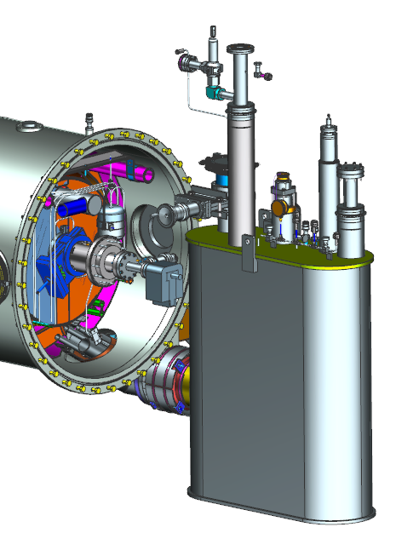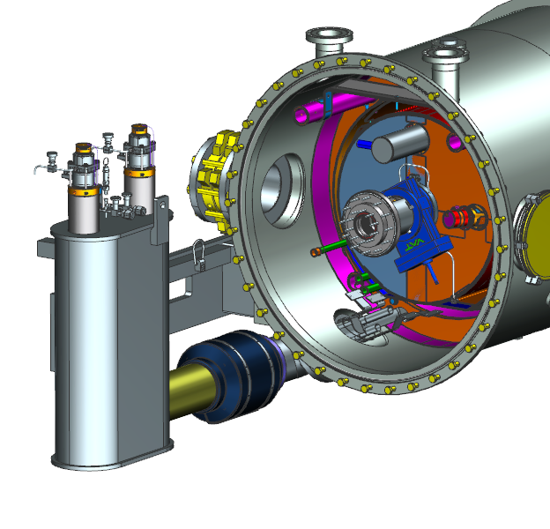 | [[ECCompTech]] <<SRFCMP>>  [[ECCompDate]] <<TIMESTAMP>>  [[ECCompComment]] <<COMMENT>>  [[ECCompHPoint]] {{fischer,jared,jjcamp }} <<HOLDPOINT>>
14 | Complete the bridge tube bellows flange installation to the VV at both interface regions. Verify minimal thermal shorts if possible. Record any findings. | [[BTTech]] <<SRFCMP>>  [[BTDate]] <<TIMESTAMP>>  [[BTComment]] <<COMMENT>>
15 | Install the process piping in the Supply end of the assembly. This will include 2k, 50k, beamline cooling ring, JT’s, and surge tank tap. Add the G-10 pipe supports as required to separate pipes and reduce thermal shorts.  Use 104210200-M8U-8200-A011- SUPPLY END PIPING Assy  Upload welding documents as required.  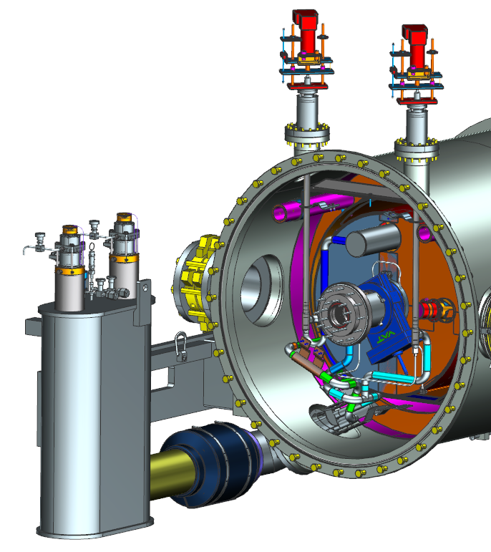 | [[SECPPTech]] <<SRFCMP>>  [[SECPPWelder]] <<SRFCMP>>  [[SECPPDate]] <<TIMESTAMP>>  [[SECPPComment]] <<COMMENT>>  [[SECPPWeldDocs]] <<FILEUPLOAD>>  [[VerifyPiping]] {{fischer,jared,jjcamp }} <<HOLDPOINT>>
16 | Leak check all added lines to 11141S0029 Rev B High Sensitivity Vacuum Leak Check . Record findings.  Use and record calibrated Leak Detector information. | [[SECPPLCTech]] <<SRFCMP>>  [[SECPPLCDate]] <<TIMESTAMP>>  [[SECPPLCComment]] <<COMMENT>>  [[SECPPLDSN]] <<TEXT>>  [[SECPPLDLR]] <<TEXT>>
17 | Install MLI onto all required surfaces, using CP-CM-INST-MLI Procedure | [[SECMLITech]] <<SRFCMP>>  [[SECMLIDATE]] <<TIMESTAMP>>  [[SECMLIComment]] <<COMMENT>>
18 | Install SEC 50k shield panels and heat stationing straps. Apply indium to interface regions of strapping and follow Indium Installation Procedure.  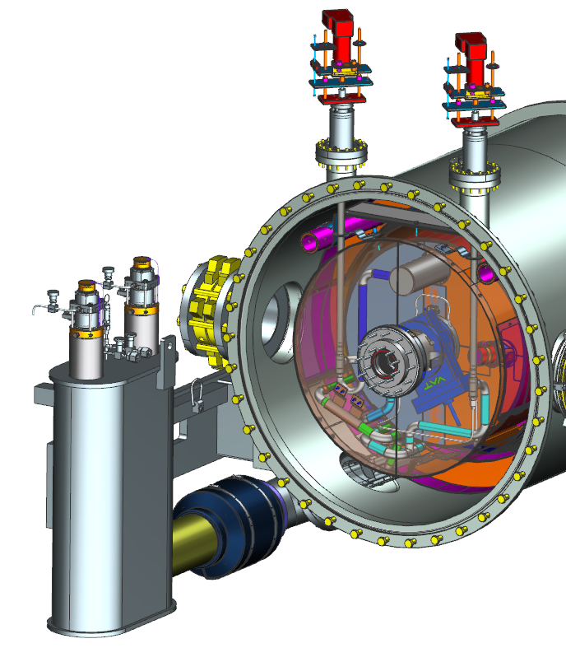 | [[SEC50KTech]] <<SRFCMP>>  [[SEC50KDate]] <<TIMESTAMP>>  [[SEC50KComment]] <<COMMENT>>
19 | Add the SEC 50k MLI using CP-CM-INST-MLI Procedure, 104211300-M8U-8200-A002- MLI Dwgs, 104211300-M8U-8200-A003- MLI Dwgs 1, 104211300-M8U-8200-A006- MLI Dwgs 2 | [[SEC50KMLITech]] <<SRFCMP>>  [[SEC50KMLIDate]] <<TIMESTAMP>>  [[SEC50KMLIComment]] <<COMMENT>>
20 | Install the SEC outer magnetic shielding cap. Handle the material properly, do not compromise the shielding quality.  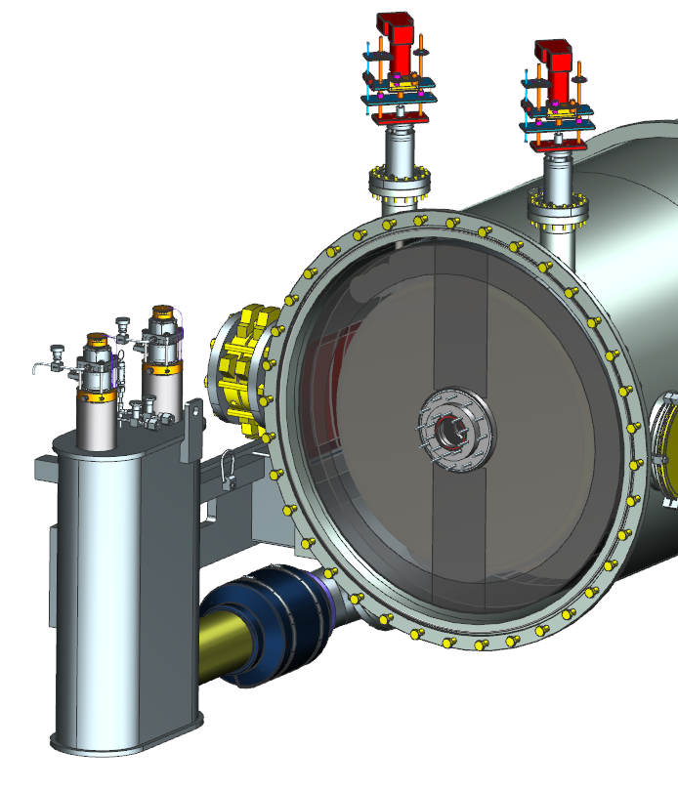 | [[SECOMTech]] <<SRFCMP>>  [[SECOMDate]] <<TIMESTAMP>>  [[SECOMComment]] <<COMMENT>>  [[OMAGSN]] <<OMAGSN>>
21 | Install the SEC VV end plate.  Clean and install the o-rings in both flanges  Wipe down mating surfaces  Align and install the fasteners, leaving the fasteners to the beam pipe hand tight for now.  Record the end plate s/n, it must match the VV for pressure system compliance  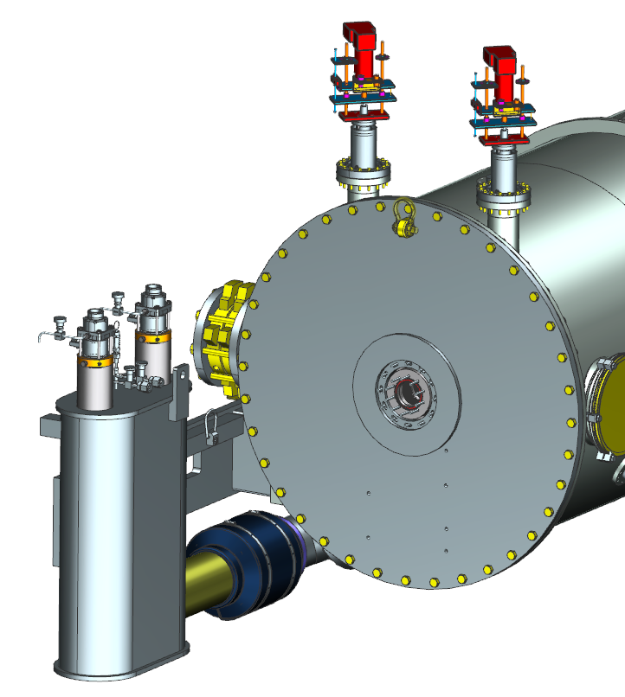 | [[SECVVEPTech]] <<SRFCMP>>  [[SECVVEPDate]] <<TIMESTAMP>>  [[SECVVEPComment]] <<COMMENT>>  [[SECEPSN]] <<TEXT>>
22 | Remove the bellows protectors  Reaching through the VV access ports, carefully remove the fasteners releasing the bellows protectors. This needs to be done carefully and by knowledgeable trained technicians only.  Record the beam line vacuum level prior to and after the work is completed.  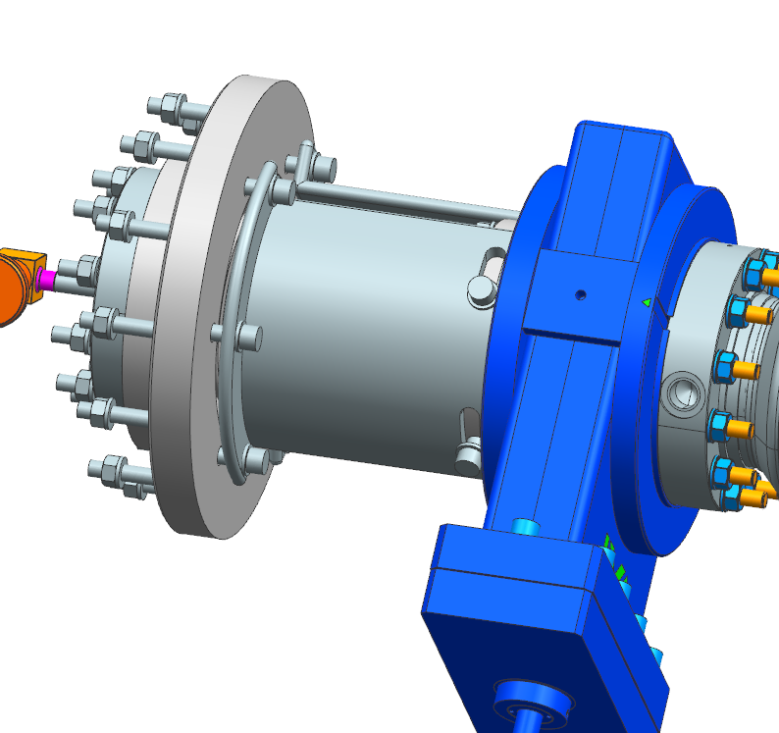  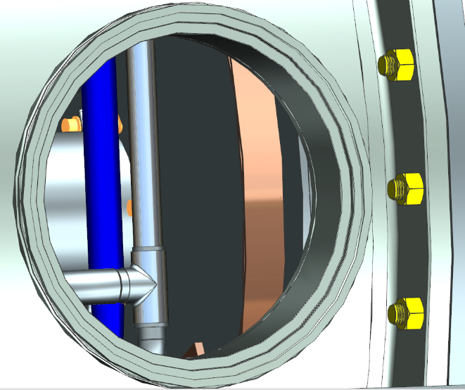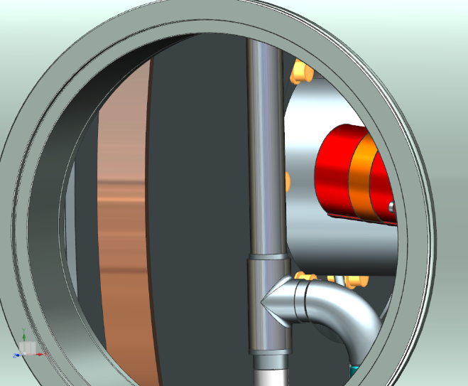  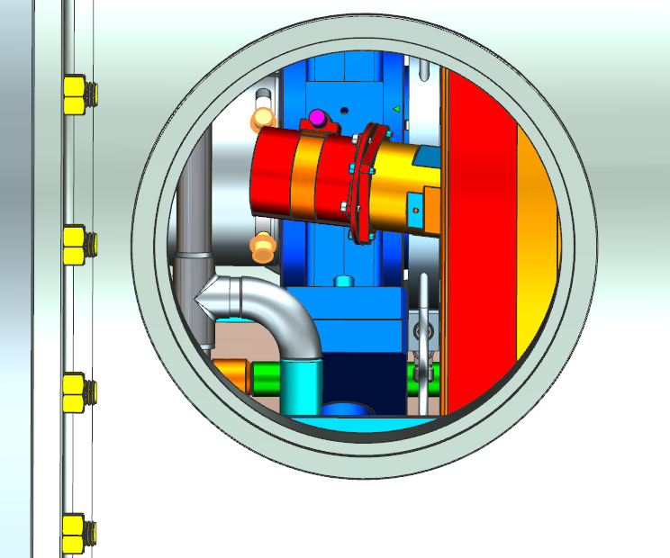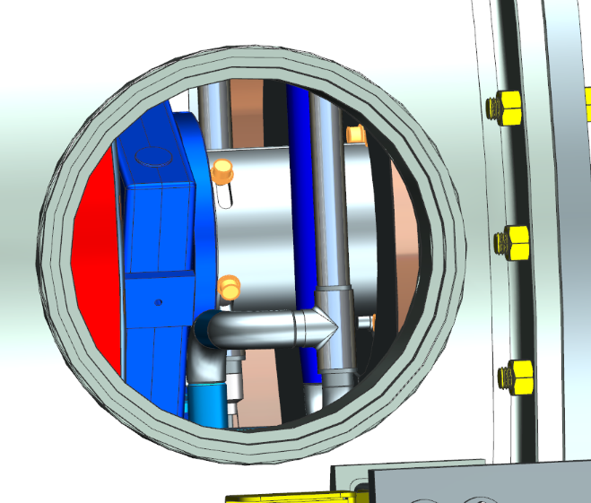 | [[SECBPLeadTech]] <<SRFCMP>>  [[SECBPSuper]] <<SRFCMP>>  [[SECBPDate]] <<TIMESTAMP>>  [[SECBPComment]] <<COMMENT>>  [[SECBPReviewprior]] {{fischer,jared,jjcamp }} <<HOLDPOINT>>  [[BLVacPrior]] <<SCINOT>>  [[BLVacPost]] <<SCINOT>>
23 | Verify all protection pieces have been removed, then tighten the beam line fasteners on the SEC VV end plate. | [[SECFastTech]] <<SRFCMP>>  [[SECFastDate]] <<TIMESTAMP>>  [[SECFastComment]] <<COMMENT>>
24 | Install bellows protection, apply indium to the clamp i.d.,then install the 50k clamp and torque. Use Indium Installation Procedure. Record the beam line vac before and after installation.  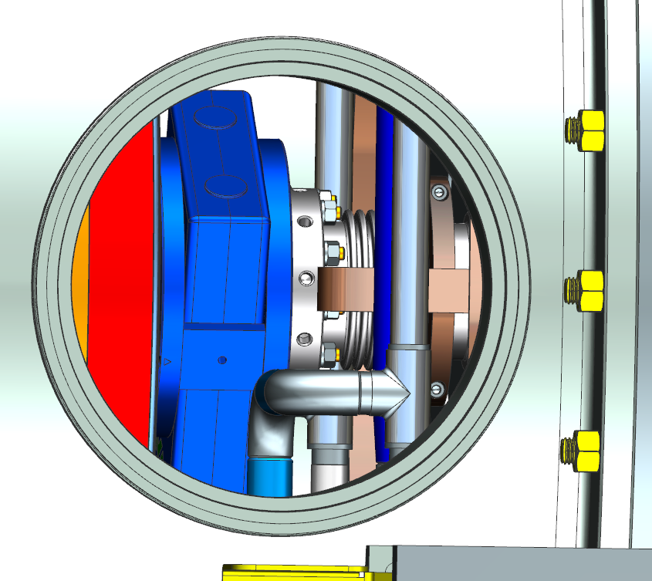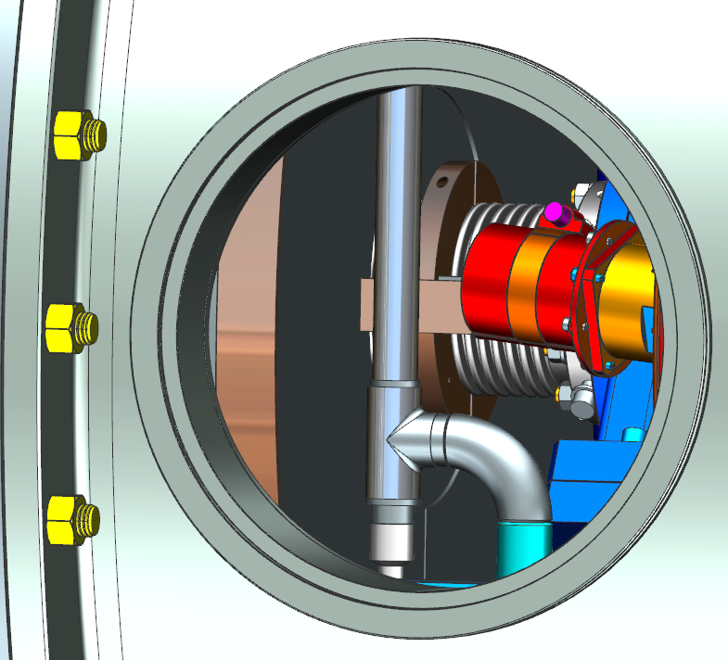 | [[SECCLPTech]] <<SRFCMP>>  [[SECCLPDate]] <<TIMESTAMP>>  [[SECCLPComment]] <<COMMENT>>  [[BLCLPPrior]] <<SCINOT>>  [[BLCLPPost]] <<SCINOT>>
25 | Cleanly install the pump drop assembly and soft shut valve. Use SNSPPU SEC Pump Drop Installation Procedure  Record the SEC Pump drop and valve s/n  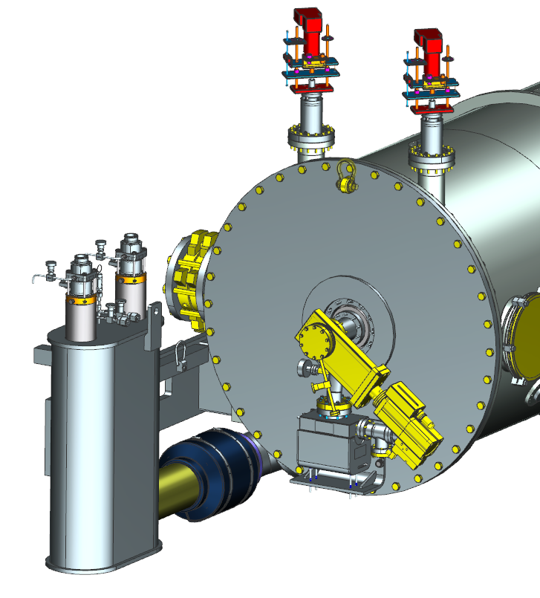 | [[SECCLNTech]] <<SRFCMP>>  [[SECCLNDate]] <<TIMESTAMP>>  [[SECCLNComment]] <<COMMENT>>  [[SECSoftShutValve SN]] <<SUBPSN>>[[FieldName]] <<TEXT>>
26 | Leak check the added beam line components from the above step. 11141S0029 Rev B High Sensitivity Vacuum Leak Check Record findings.  Use calibrated equipment to perform work. | [[SECPDLCTech]] <<SRFCMP>>  [[SECPDLCDate]] <<TIMESTAMP>>  [[SECPDLCComment]] <<COMMENT>>  [[SECPDLC]] <<FILEUPLOAD>>  [[SECPDLDSN]] <<TEXT>>  [[SECPDLDCal]] <<TEXT>>
27 | Turn on the ion pump while pumping on the Pump Drop assy, establish vacuum. Isolate the turbo. When within 1 decade of string beam line pressure, slowly open the SEC cold GV making vacuum regions common. Record vacuum when stable. | [[PDTech]] <<SRFCMP>>  [[PDDate]] <<TIMESTAMP>>  [[PDComment]] <<COMMENT>>  [[PDVac]] <<SCINOT>>
28 | Once vacuum is stable and recovered, close the REC CGV isolating it from the cavity string. Record vacuum. | [[RECVacTech]] <<SRFCMP>>  [[RECVacDate]] <<TIMESTAMP>>  [[RECVacComment]] <<COMMENT>>
29 | Install the process piping in the Return end of the assembly. This will include 2k, 50k, beamline cooling ring, and surge tank lines. Add the end can G-10 pipe supports as required to minimize thermal shorts.  Use 104210200-M8U-8200-A012- RETURN END PIPING Assy  Upload welding documentation as required  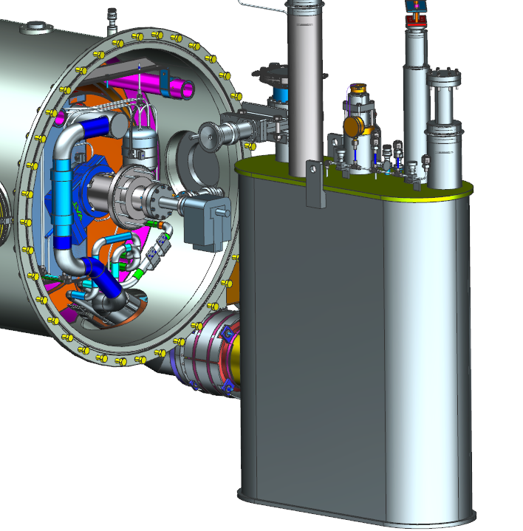 | [[RECPPTech]] <<SRFCMP>>  [[RECPPWelder]] <<SRFCMP>>  [[RECPPDate]] <<TIMESTAMP>>  [[RECPPComment]] <<COMMENT>>  [[RECPPWeldDocs]] <<FILEUPLOAD>>
30 | Leak check all added lines to 11141S0029 Rev B High Sensitivity Vacuum Leak Check . Record findings.  Use and record calibrated Leak Detector information. | [[RECPPLCTech]] <<SRFCMP>>  [[RECPPLCDate]] <<TIMESTAMP>>  [[RECPPLCComment]] <<COMMENT>>  [[RECPPLDSN]] <<TEXT>>  [[RECPPLDLR]] <<TEXT>>
31 | Install MLI onto all required surfaces, using CP-CM-INST-MLI Procedure | [[RECMLITech]] <<SRFCMP>>  [[RECMLIDATE]] <<TIMESTAMP>>  [[RECMLIComment]] <<COMMENT>>
32 | Install REC 50k shield panels and heat stationing straps. Apply indium to interface regions of strapping and follow Indium Installation Procedure.  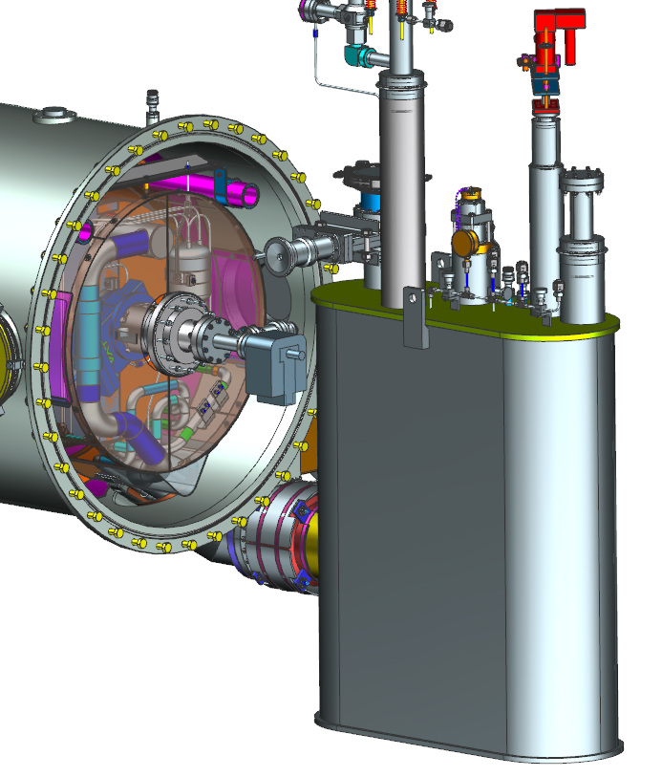 | [[REC50KTech]] <<SRFCMP>>  [[REC50KDate]] <<TIMESTAMP>>  [[REC50KComment]] <<COMMENT>>
33 | Add the REC 50k MLI using CP-CM-INST-MLI Procedure, 104211300-M8U-8200-A002- MLI Dwgs, 104211300-M8U-8200-A003- MLI Dwgs 1, 104211300-M8U-8200-A006- MLI Dwgs 2 | [[REC50KMLITech]] <<SRFCMP>>  [[REC50KMLIDate]] <<TIMESTAMP>>  [[REC50KMLIComment]] <<COMMENT>>
34 | Install the REC outer magnetic shielding cap. Handle the material properly, do not compromise the shielding quality.  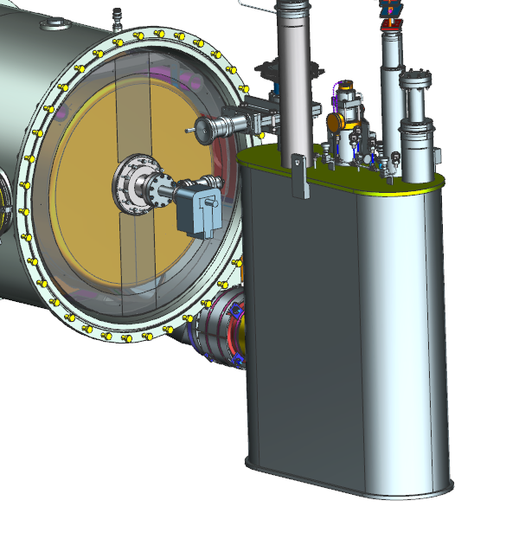 | [[RECOMTech]] <<SRFCMP>>  [[RECOMDate]] <<TIMESTAMP>>  [[RECOMComment]] <<COMMENT>>
35 | While monitoring the beamline pressure (to verify the REC CGV is closed) bleed up the vacuum spool and cleanly remove the 15 L/S ion pump, then blank off the beam pipe end. Record the beam line vacuum. | [[RECBPTech]] <<SRFCMP>>  [[RECBPDate]] <<TIMESTAMP>>  [[RECBPComment]] <<COMMENT>>  [[RECBPVac]] <<SCINOT>>
36 | Install the REC VV end plate.  Clean and install the o-rings in both flanges  Wipe down mating surfaces  Align and install the fasteners, leaving the fasteners to the beam pipe hand tight for now.  Record the end plate s/n, it must match the VV for pressure system compliance  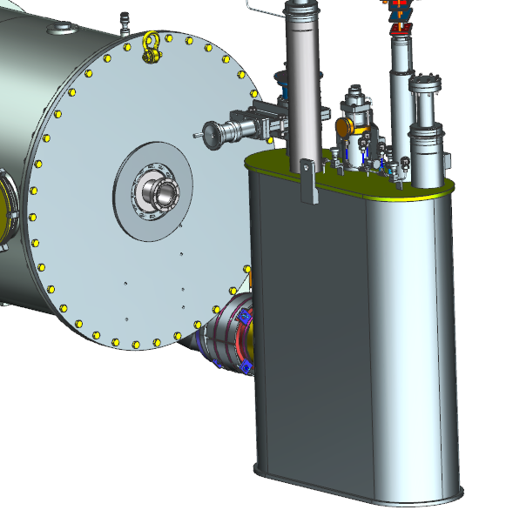 | [[RECVVEPTech]] <<SRFCMP>>  [[RECVVEPDate]] <<TIMESTAMP>>  [[RECVVEPComment]] <<COMMENT>>  [[RECEPSN]] <<TEXT>>
37 | Remove the bellows protectors  Reaching through the VV access ports, carefully remove the fasteners releasing the bellows protectors. This needs to be done carefully and by knowledgeable trained technicians only.  Record the beam line vacuum level prior to and after the work is completed.  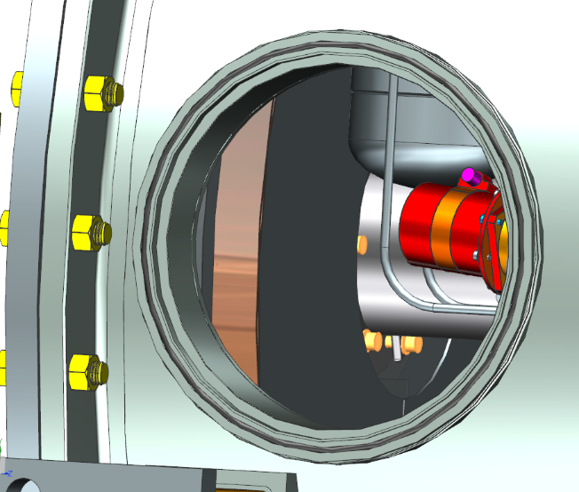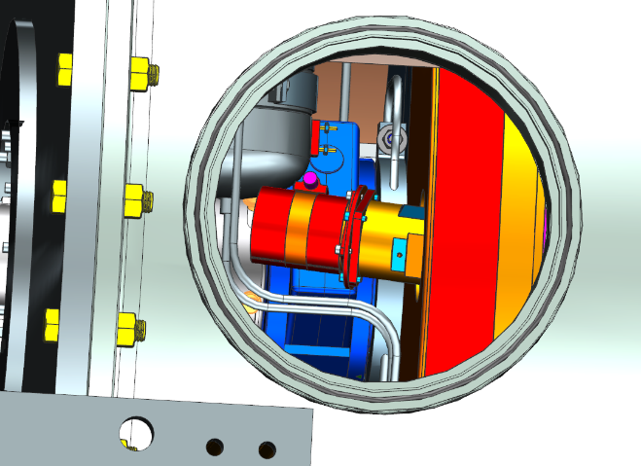  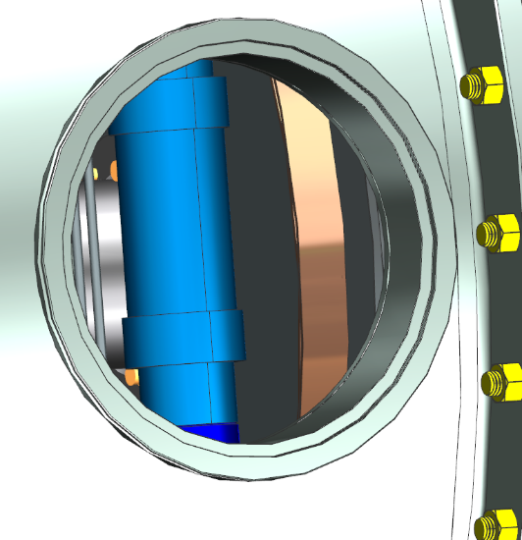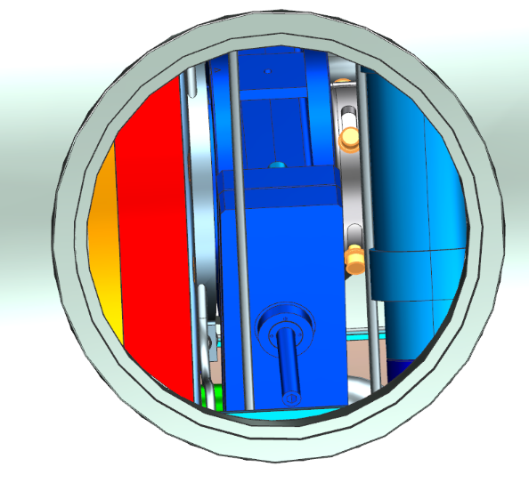 | [[RECBPLeadTech]] <<SRFCMP>>  [[RECBPSuper]] <<SRFCMP>>  [[RECBPDate]] <<TIMESTAMP>>  [[RECBPComment]] <<COMMENT>>  [[RECBPReviewprior]] {{fischer,jared,jjcamp }} <<HOLDPOINT>>  [[RECBLVacPrior]] <<SCINOT>>  [[RECBLVacPost]] <<SCINOT>>
38 | Verify all protection pieces have been removed, then tighten the beam line fasteners on the REC VV end plate. | [[RECFastTech]] <<SRFCMP>>  [[RECFastDate]] <<TIMESTAMP>>  [[RECFastComment]] <<COMMENT>>
39 | Install bellows protection, apply indium to the clamp i.d.,then install the 50k clamp and torque. Use Indium Installation Procedure. Record the beam line vac before and after installation.  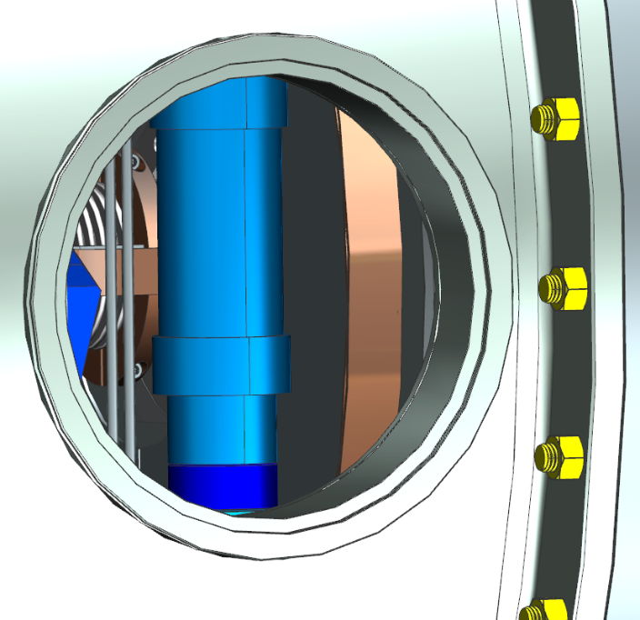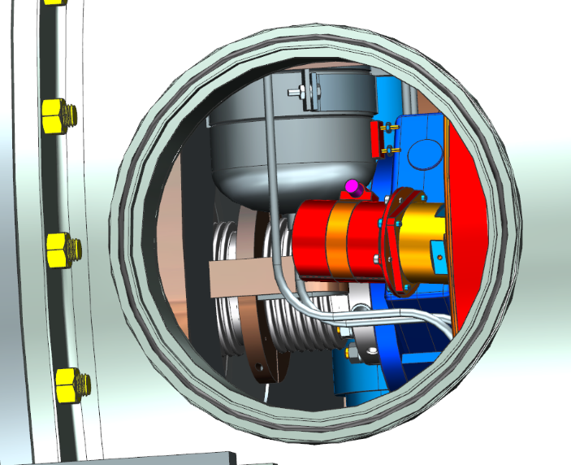 | [[RECCLPTech]] <<SRFCMP>>  [[RECCLPDate]] <<TIMESTAMP>>  [[RECCLPComment]] <<COMMENT>>  [[RECBLCLPPrior]] <<SCINOT>>  [[RECBLCLPPost]] <<SCINOT>>
40 | Cleanly install the beam line spool and soft shut valve. Use SNSPPU REC Beam Pipe Installation Procedure  Record the REC spool and valve s/n | [[RECCLNTech]] <<SRFCMP>>  [[RECCLNDate]] <<TIMESTAMP>>  [[RECCLNComment]] <<COMMENT>>  [[RECBPSN]] <<SUBPSN>>  [[SoftShutValveSN]] <<TEXT>>
41 | Leak check the added beam line components from the above step. 11141S0029 Rev B High Sensitivity Vacuum Leak Check Record findings.  Use calibrated equipment to perform work. | [[RECPDLCTech]] <<SRFCMP>>  [[RECPDLCDate]] <<TIMESTAMP>>  [[RECPDLCComment]] <<COMMENT>>  [[RECPDLC]] <<FILEUPLOAD>>  [[RECPDLDSN]] <<TEXT>>  [[RECPDLDCal]] <<TEXT>>
42 | Establish similar vacuum as the cavity string, then open the REC CGV making the entire beam line common. Record vacuum. | [[SimVacTech]] <<SRFCMP>>  [[SimVacDate]] <<TIMESTAMP>>  [[SimVacComment]] <<COMMENT>>  [[SimVac]] <<SCINOT>>
43 | Install the VV peripherals, see 104210200-M8U-8200-A001_-_SNS PPU CM Top Assy, with the relative part numbers  - Instrumentation flanges- Items 1,7,11,36,39  - JT actuators- may be added in the CMTF- Item 37  - Coupler tophats- Items  - Ins Vac gauge and manifold- Item 21  - Instrumentation bulkhead plates- Item 32  - Coupler exhaust manifold- Item 17  - Ins vac burst disc- Item 28  - Ins vac gate valve- Item 4  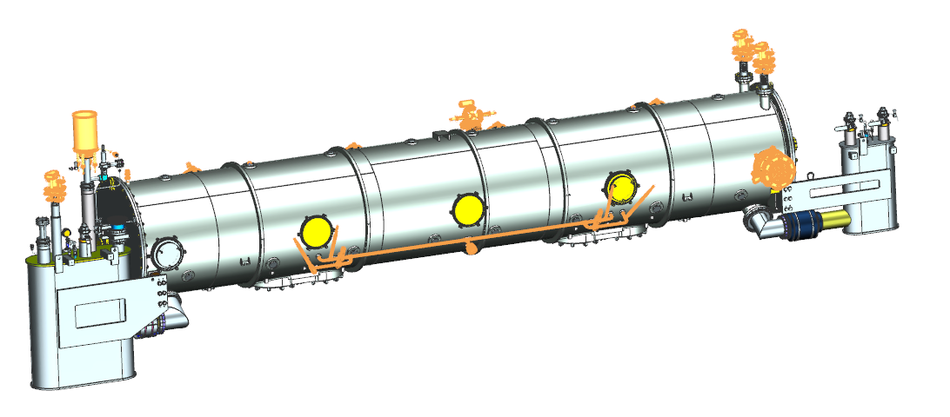  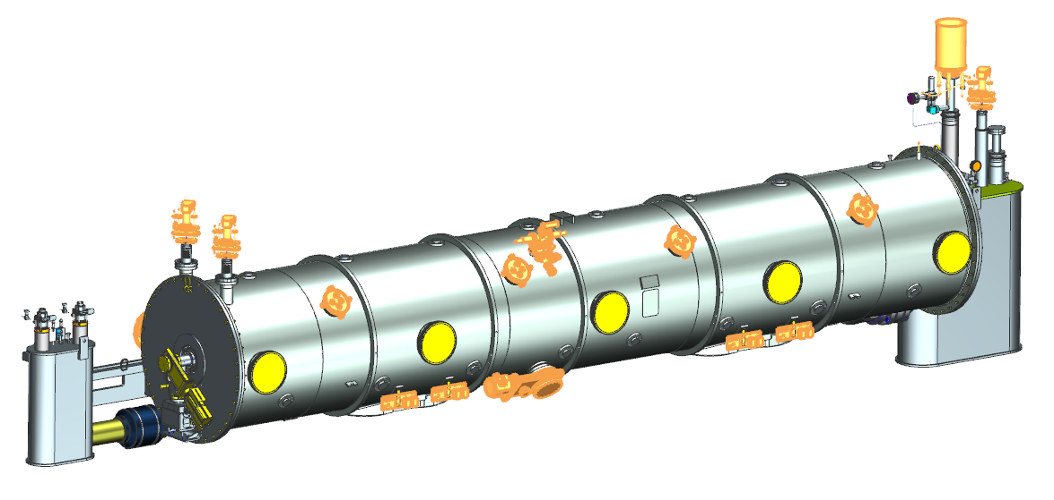 | [[VVPerTech]] <<SRFCMP>>  [[VVPerDate]] <<TIMESTAMP>>  [[VVPerComment]] <<COMMENT>>  [[AllInsted]] <<YESNO>>
44 | Weld the coupler exhaust manifold in place. Upload the supporting welding documentation  104210200-M8U-8200-A010-C- COUPLER RETURN PIPING Assy | [[CplManWelder]] <<SRFCMP>>  [[CplManDate]] <<TIMESTAMP>>  [[CplManComment]] <<COMMENT>>  [[CplManWeldDocs]] <<FILEUPLOAD>>
45 | Leak check the coupler exhaust manifold. Use, 11141S0029 Rev B High Sensitivity Vacuum Leak Check  Use calibrated equipment to perform work.  Record findings | [[CplManLC]] <<SRFCMP>>  [[CplManLCDate]] <<TIMESTAMP>>  [[CplManLCComment]] <<COMMENT>>  [[CplManLCData]] <<FILEUPLOAD>>  [[CplManLDSN]] <<TEXT>>  [[CplManLDCal]] <<TEXT>>
46 | Perform final measurements on all instrumentation. Record findings  104211500-M8U-8200-A002_A_COLD MASS ASSY  CRYOMODULE WIRING DIAGRAM  END CAN WIRING DIAGRAM | [[FnlElecTech]] <<SRFCMP>>  [[FnlElecDate]] <<TIMESTAMP>>  [[FnlElecComment]] <<COMMENT>>  [[FnlElecUpload]] <<FILEUPLOAD>>
47 | Leak check the insulating vacuum. Use 11141S0033 LARGE ITEM LEAK CHECK 1E-9  Use calibrated equipment to perform work.  Record findings. | [[IVLCTech]] <<SRFCMP>>  [[IVLCDate]] <<TIMESTAMP>>  [[IVLCComment]] <<COMMENT>>  [[IVLCData]] <<FILEUPLOAD>>  [[IVLCLDSN]] <<TEXT>>  [[IVLCLDCal]] <<TEXT>>
 | Pressure test the Cryomodule internal cryogenic circuits using CMTF P&ID Dwg, SOP-SNSCMPressureTestingRevB  Use calibrated equipment, record findings. | [[PTTech]] <<SRFCMP>>  [[PTDate]] <<TIMESTAMP>>  [[PTComment]] <<COMMENT>>  [[PTUpload]] <<FILEUPLOAD>>
48 | Perform final alignment, record findings | [[FnlAlignTech]] <<SRFCMP>>  [[FnlAlignDate]] <<TIMESTAMP>>  [[FnlAlignComment]] <<COMMENT>>  [[FAUpload]] <<FILEUPLOAD>>
49 | Add the soft shut valve supports prior to shipping the CM, 104210200-M8U-8200-A063_-_SUPPLY GV Bracket, 104210200-M8U-8200-A065_-_RETURN GV Bracket  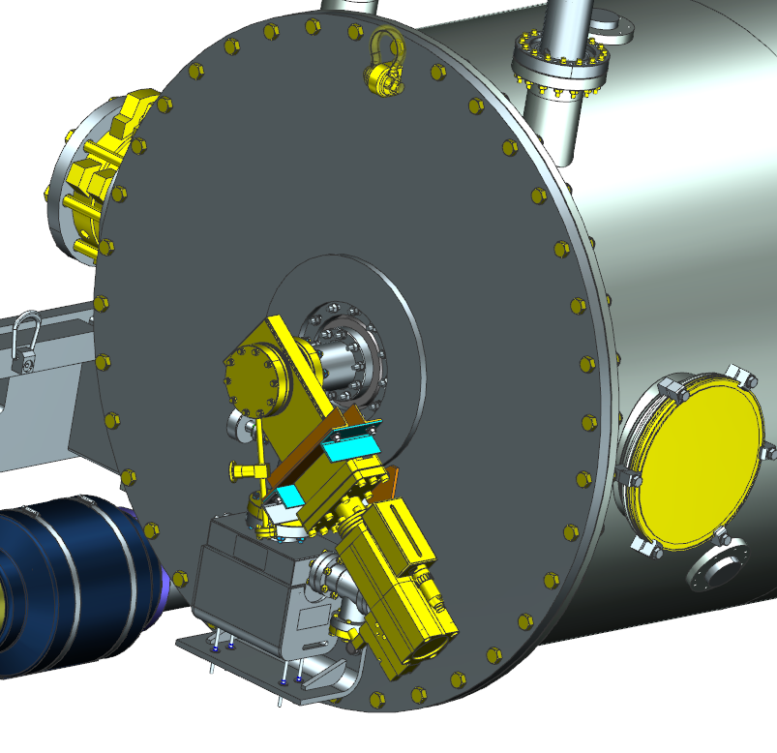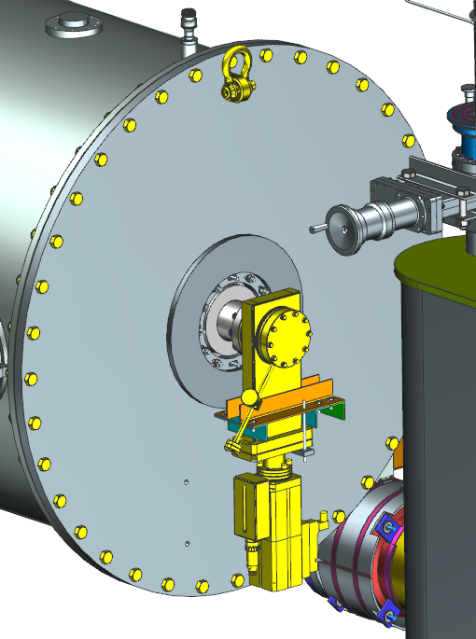 | [[SSTech]] <<SRFCMP>>  [[SSDate]] <<TIMESTAMP>>  [[SSComment]] <<COMMENT>>
50 | Verify the final assembly is complete.  Conduct the Technical Review and PS6 form, upload comments. | [[FnlAssyTech]] <<SRFCMP>>  [[FnlAssyLead]] <<SRF>>  [[FnlAssyDate]] <<TIMESTAMP>>  [[FnlAssyComment]] <<COMMENT>>  [[FnlAssyUpload]] <<FILEUPLOAD>>  [[FnlAssyPS6]] <<FILEUPLOAD>>  [[FnlAssyLead]] {{fischer,jared,jjcamp}} <<HOLDPOINT>>
51 | Install the Cryomodule into the Test cave for the verification testing.  - Move the CM from the final workstation onto the transport tooling  - Slowly roll into the CMTF  - Set to dimensions shown on the below views.  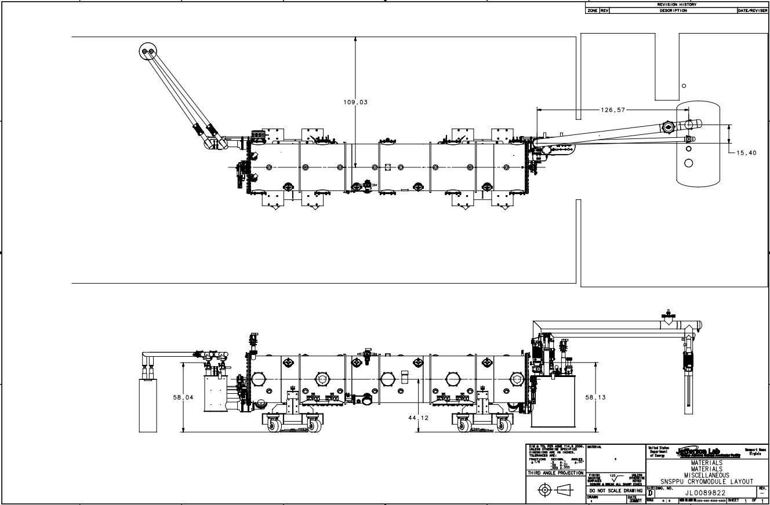 | [[MoveCMTFTech]] <<SRFCMP>>  [[MoveCMTFDate]] <<TIMESTAMP>>  [[MoveCMTFComment]] <<COMMENT>>

