|  |  |  |  |
| --- | --- | --- | --- |
| **SNSPPU LOCKDOWN WELDING PROCEDURE** | | | |
| **Document Number:** | CP-SNSPPU-CMA-WELD-LKDWN | **Approval Date:** | TBD |
| **Revision Number:** | Rev 1a | **Periodic Review Date:** | TBD |
| **Document Owner:** | Aaron Auston | **Department Owner:** | SRF Ops |
|  | | | |

# Purpose and Scope

The purpose of this procedure is to document the process to be used when welding the lockdowns on the SNSPPU High Beta Cryomodule. This work occurs once the Spaceframe/Thermal shield has been installed and aligned into the vacuum vessel. The welding of the lockdowns is a crucial step during the assembly process. Incorrect welding can compromise the cavity string alignment if done incorrectly.

# Terms and Definitions

**Spaceframe/Thermal shield**- Intermediate part of the Cryomodule assembly which acts as both the cavity support structure and the thermal 50k break.

**Lockdown-** The threaded connector between the SF/TS and vacuum vessel, that establishes and maintains alignment between the two

# Roles and Responsibilities

The roles and responsibilities for the actions in the Document are managed by the CMA Group or Welding Lead or their designee.

# Procedure

## Procedure

Once the cold mass has been aligned and the lockdowns installed, welding will begin. The position of the lockdown, as well as the amount of weld applied will be described in an effort to minimize cavity string alignment changes. There are 24 lockdowns in total, 8 at each 120 degree interval. See dwg [104210200-M8U-8200-A001_-_SNS PPU CM Top Assy](https://jlabdoc.jlab.org/docushare/dsweb/Get/Document-246843/104210200-M8U-8200-A001_-_SNS%20PPU%20CRYOMODULE%20ASSY.pdf)- for welding detail and code identification. Notes 1, 2, and 3. Image below is an example of that dwg including weld size.

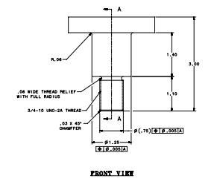

Picture of lockdown stud

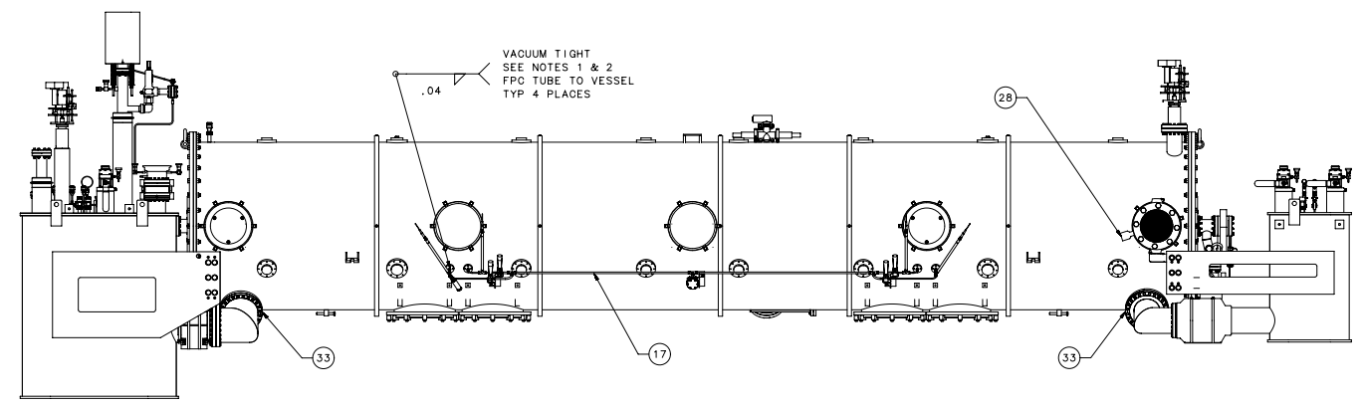

* Begin by tacking all of the top lockdowns (x8). Start at the middle, apply three 1/8” tacks about 120 degrees apart.
* Repeat the above on the side lockdowns alternating sides as you go. Complete tacking all 24 lockdowns.
* Return to the top lockdowns, again start in the middle, and add three ½” long welds 120 degrees apart.
* Repeat this process on the remaining side lockdowns, alternating sides.
* Repeat the above ½” welding steps until all lockdowns are completely welded.
* Visually inspect, make any necessary repairs.

Lock down welding is complete.

The SME may choose to verify the alignment by rechecking the beamline flange locations utilizing the JLAB Alignment Crew.

Welding in-process inspection may be required

The final insulating vacuum leak check will verify the lockdowns are leak tight to specification [11141S0033 LARGE ITEM LEAK CHECK 1E-9](https://jlabdoc.jlab.org/docushare/dsweb/Get/Document-249682/11141S0033%201e9%20Leak%20Check%20Final.pdf).

# **Release and Revision History**

|  |  |  |
| --- | --- | --- |
| Rev # | Revision or update: | Effective: |
| A | Initial version | 10/22/2021 |
|  |  |  |

# **Approvals**

|  |  |  |
| --- | --- | --- |
| Approved by: | Signature: | Date: |
| **SNSPPU CAM** | Naeem Huque |  |
| **SRF CMA Weld Lead** | Aaron Auston |  |
| **SRF CMA Group Lead** | John W. Fischer |  |