|  |  |  |  |
| --- | --- | --- | --- |
| **<Procedure Title>** | | | |
| **Document Number:** | SRFOPS-PR-CLNRM-LEAK | **Effective Date:** | DD Mmm YYYY |
| **Revision Number:** | 1 | **Periodic Review Date:** | DD Mmm YYYY |
| **Document Owner:** | David Savransky | **Department Owner:** | SRF Operations |

# Purpose

The following procedures define the steps to conduct a leak test with a RGA. This procedure will outline the equipment needed to conduct a leak test with a RGA along with the steps that must be followed to complete one.

# Scope

This procedure will outline what to do if a leak is found along with the ways to calculate the size of the leak.

**It is expected that users following this procedure must be knowledgeable and experienced in leak testing before beginning this procedure.**

# Terms and Definitions

The following terms have specific meanings within this procedure.

|  |  |
| --- | --- |
| **Term** | **Definition** |
| RGA | Residual Gas Analyze |
| UHV | Ultra High Vacuum |
| He | Helium |

# Roles and Responsibilities

The following roles have responsibilities described in this document.

|  |  |
| --- | --- |
| **Role** | **Responsibility** |
| <Job Title> | <Very short summary of activities this job title performs in this procedure.> |
|  |  |
|  |  |
|  |  |

# Required Equipment

The following is a complete list of all the necessary equipment required to perform a leak check with a RGA:

* Clean UHV pump station with a Residual Gas Analyzer (RGA)
* Computer with RGA software
* Serial cable to connect RGA to computer
* Calibrated helium gas leak rate unit
  + The calibrated helium leak rate unit should be suitable for the ongoing test
  + Check testing specific documentation to determine what helium gas leak rate unit should be used
* Helium leak test wand
* Helium source (< 20 psi)
* Appropriately sized cleanroom bag for final leak test
  + The cleanroom bag is only necessary if the assembly is leaking and the leak size needs to be determined or if the final leak check is taking place in the clean room i.e. cavity strings or cavity pairs.

# Procedure

## Before starting this procedure the following conditions must be met:

* The system must be under vacuum with the UHV pumping station on the components that are about to be leak checked (isolation valves open).
* The RGA must be under vacuum and be part of the evacuated system to be leak tested (RGA isolation valve open).
* **The total system pressure at the UHV pumping station must be at or below 3.0E-6 mbar.**

## Setup the RGA for leak testing:

* Ensure that the serial port communications cable is plugged into the correct receptacle on the back of the RGA
* Ensure that the valve to the calibrated helium gas leak rate unit on the pump station is open
  + If the valve is closed, open the valve.
* Turn on the RGA
* Start up the RGA software on the computer and connect to the RGA.
* Turn on the filament and run the analog scan.
* Turn on the total pressure reading on the software.
* When the RGA total pressure is at or below 3e-6 Torr turn on UHV pumping station proceed to next step.
  + **Under no circumstance should the pressure on the RGA be used as a measurement for total pressure**
* Ensure that the settings on the RGA are as follows
  + The RGA software mode should be “Leak Test Mode”
  + The settings under the scan parameters should be set to:
    - Name: Helium
    - Speed: 3
    - The settings can be access by moussing over the scan tab and selecting the “scan parameters” option
  + A pictorial aid can be found in the Appendix
* The following are a series of recommended settings that can ensure an easier RGA test but are not required to be set:
  + For settings under the scan parameters:
    - Autoscale: off
    - Automatic Time Axis: On
  + For the Y-axis parameters:
    - Change the Y-axis scale from linear to logarithmic
    - Turn on the micro tics
    - This settings tab can be opened up by double clicking the Y-axis

## Initialization of Leak Test

* Start the RGA scan and allow the scan to run for at least ten minutes before proceeding to the next step.
  + This will allow the RGA to warm up and stabilize
* Verify that the trace on the leak test scan has stabilized and is flat.
  + **If the trace is not flat, stop and inform he supervisor.**
  + Note the He partial pressure with the calibrated helium gas leak rate unit valve open.
* Close the valve to the calibrated helium gas leak rate on the RGA.
  + Watch the scan for a noticeable drop when the valve is closed.
  + **If a noticeable drop in the trace cannot be seen, stop and inform he supervisor.**
* Allow the scan to run for a minimum of ten minutes or until the trace is flat again.
  + Note the He partial pressure with the leak calibrated helium gas leak rate unit valve closed
  + **If the trace is not flat, stop and inform he supervisor.**

# Leak Check Procedures

All the following subsections are meant as a guide for different steps during the leak check process and might not all be used for a specific procedure. Refer back to the procedure that requested the leak check to verify which subsections need to be conducted. For every leak test that is conducted, the information that needs to be saved can be found in section 6.7.

## Rough Leak Test:

* Generously spray the component(s) to be tested with helium, using the helium leak test wand.
* Be sure to spray all connections and welds associated with the component.
* Monitor the helium trace on the chart for any increases in helium partial pressure; any increase in the trace would be associated with a leak.
* Proceed to section 6.2 if the leak needs to be isolated

## Rough Leak Test Leak Isolation

* If a leak is found during a rough leak test, use the following steps to locate the leak:
* Start by spraying a “small flow” of helium at the area where the helium rise was first noticed on the graph.
* Slowly move backwards, and retrace the original helium spray path until a partial pressure increase is seen again on the graph.
* Continue isolating the leak by allowing the trace to return to its previous baseline and spraying different areas until the leak is identified to be at a certain location.

## Bagged Leak Test:

* If a rough leak check was performed before starting the bagged leak test, perform the steps in section 6.6.
* Bag the components or area to be leak tested and generously fill the bag with helium.
  + Allow a small trickle of helium to continue filling the bag through the leak test.
* Seal the bag with vinyl tape to retain the helium.
  + Monitor for a helium rise in the trace.
* The component is leak tight if no change in helium partial pressure was seen with-in 10 minutes after the helium was sprayed into the bag.
* If the component is not leak tight because a helium rise was seen and a leak size is necessary proceed to section 6.4 and locate and size the leak.
  + Ensure to note down the helium partial pressure when it has reached it plateau

## Bagged Leak Test Leak Isolation:

* If multiple components are being leak check within a single bag, the first step to isolating the leak is to put separate bags around each of the components or groups of components and attempt section 6.3 again for each bag.
  + Perform the steps in section 6.6 before performing the next set of leak check on the separate bags.
* If there is only a single component inside the bag, that component can be identified as leaking and the leak size can be identified by using section 6.5

## Sizing a Leak

* The leak sizing can only be done if the leak test was done on a component that was bagged in 100% helium.
* Open the link to the calculation excel file found in section 2.0
* Input the pressured that were gathered during the leak test thus far
* Save the value of the size of leak in Torr L/sec

## Reset RGA Plateau

* Open the valve to the calibrated helium gas leak rate on the pump station.
* Start a scan and allow the scan to run for 10 minutes.
  + Verify that the trace on the leak test scan has stabilized and is flat.
  + Note the He partial pressure with the calibrated helium gas leak rate unit valve open
* Close the valve to the calibrated helium gas leak rate on the pump station.
  + Watch the trace for a noticeable drop when the valve is closed.
* Allow the scan to run for another 10 minutes
  + Note the He partial pressure with the calibrated helium gas leak rate unit valve closed
  + The trace must again be flat to continue.

## Information to be saved for Each Scan

* Save the scan and document the following information in the appropriate location:
* Fills to be saved:
  + ASCII data file of leak test
  + Metafile or screen capture of leak test
  + RGA data file of leak test
* To be included in Title of RGA program:
  + Calibrated leak size (if one is found)
  + Component that is being leak checked
  + Date and time of test
* Other information that is useful to save:
  + When the valve to the calibrated helium gas leak rate was closed
  + When the component was sprayed
* An example can be found in the Appendix of an save metafile of a leak test

# Appendix

## Help with utilization of RGA software

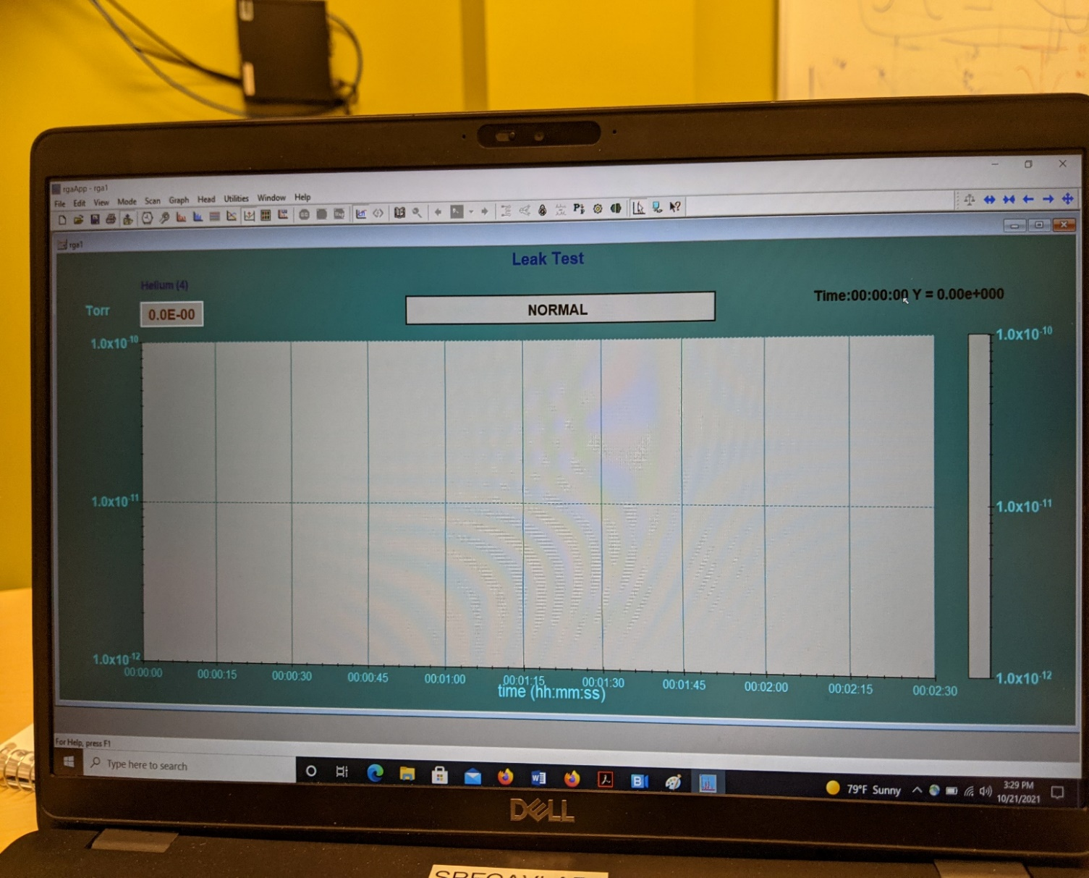

**Mode: Leak Test Button**

Figure 1: Example Leak Test Main Page

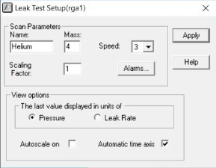

Figure 2: Example of Scan Parameter Screen

## Example of Leak Test Chart

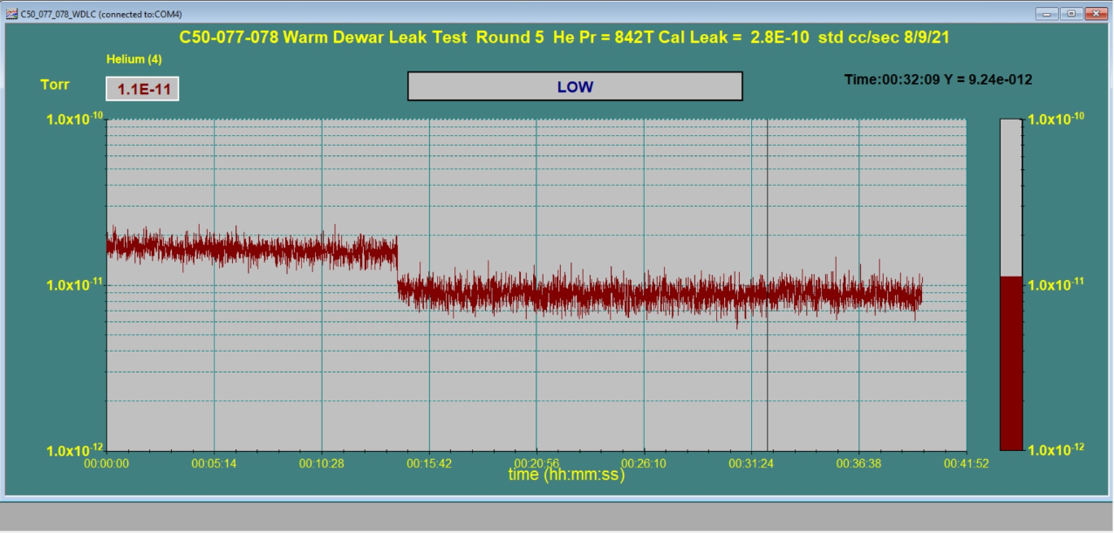

Valve to the calibrated helium gas leak rate on the RGA is closed

Figure 3: Example of RGA software readback without a leak detected.

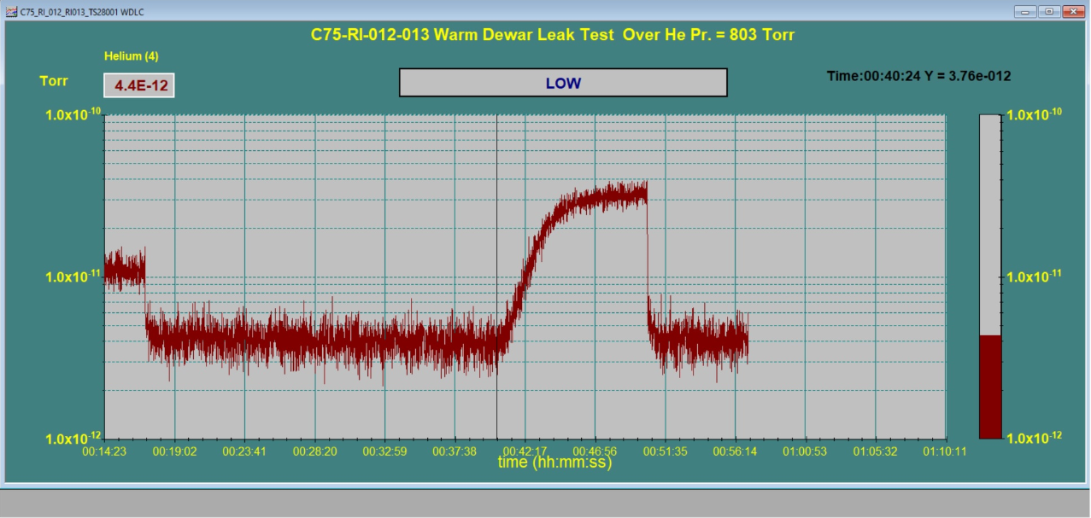

Valve to the calibrated helium gas leak rate on the RGA is closed

Leaky part is sprayed with helium

Figure 4: Example of RGA software readback with a leak detected

# References

|  |  |
| --- | --- |
| **Document No.** | **Title** |
| SRF-01-ML-001 | SRF Quality Manual |
| [Leak Check Calculation](https://jlabdoc.jlab.org/docushare/dsweb/Get/Document-248733/LEAK%20SIZING%20FOR%20RGA_S(1).xlsx) | This document describes the way to calculate the size of a leak if one is found |
|  |  |

# Release and Revision History

|  |  |  |
| --- | --- | --- |
| **Rev #** | **Major Changes** | **Effective Date:** |
| 1 | Initial version | DD Mmm YYY |
|  |  |  |
|  |  |  |
|  |  |  |

# Approvals

|  |  |  |  |
| --- | --- | --- | --- |
| **Approved by:** | **Name:** | **Signature:** | **Date:** |
| Document Owner | David Savransky |  | DD Mmm YYY |
| Subject Matter Expert | Danny Forehand |  | DD Mmm YYY |
| Work Center Lead | Kirk Davis |  | DD Mmm YYY |
| Project Leader | Tony Reilly |  | DD Mmm YYY |