|  |  |  |  |
| --- | --- | --- | --- |
| **Clean Room Production Pump System Operation** | | | |
| **Document Number:** | SRF-MSPR-CLN-PUMP | **Effective Date:** | DD Mmm YYYY |
| **Revision Number:** | R1 | **Periodic Review Date:** | DD Mmm YYYY |
| **Document Owner:** | Kurt Macha | **Department Owner:** | SRF Operations |

# Purpose

The purpose of this document is to for guiding you through the slow pump procedure as well as slow bleed.

# Scope

This procedure applies to general operation of the cavity production pump cart.

# Terms and Definitions

The following terms have specific meanings within this procedure.

|  |  |
| --- | --- |
| **Term** | **Definition** |
| <Term 1> | <Definition> |
| <Term 2> | <Definition> |
|  |  |

# Roles and Responsibilities

The following roles have responsibilities described in this document.

|  |  |
| --- | --- |
| **Role** | **Responsibility** |
| <Job Title> | <Very short summary of activities this job title performs in this procedure.> |
|  |  |
|  |  |
|  |  |

# Procedure

## Clean Room Production Pump System Operation

This procedure is divided into sections to cover general pump operation, slow pump and slow bleed-up.

This pump is used solely for clean pumping such as production cavities that require a clean surface for proper performance. This pump is not to be used on items that have not been cleaned properly that can compromise the cleanliness of the system.

This system will be maintained as needed to ensure the cleanliness of items that use this system. A periodic cleaning of this system will be performed as needed.

## General use without slow pump or slow bleed-up:

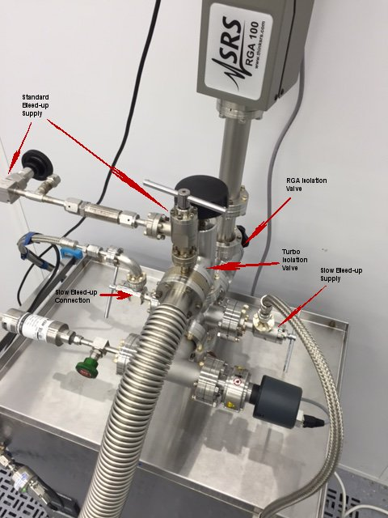

Figure 1

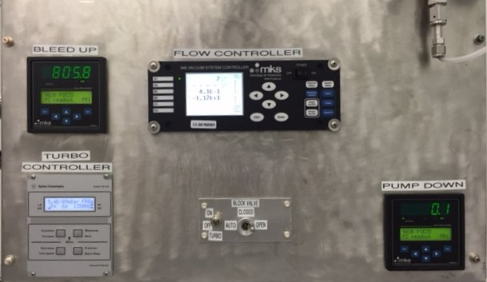

Figure 2

This system is designed to operate as any typical turbo pump system.

When the block valve is switched to the open position and the turbo pump switch in the on position the turbo system can be used as any standard system.

This means the manual scroll pump valve at the wall controls the scroll pump pumping and the turbo controller will allow you to turn on the turbo pump as needed.

Keep in mind the **Pump Down** MKS controller will need to be on because the turbo pump is still not to come on until the 1 torr interlock is satisfied. This interlock can be changed in this controller.

When using in general operation mode verify the **Slow Bleed-up Supply** and the **Slow Bleed-up Connection** valves are closed. (Figure 2)

## Slow Pump Operation

### Assumptions

* The system is bleed-up.
* The main flex hose in connected to the cavity or volume that is desired to pump.
* Typically an isolation valve is installed between the pumping volume and the pump flex line. This is called the cavity isolation valve. This valve can be optional for some instances.
* The 946 vacuum system controller is already programed and ready for the slow pump process. (See: 946 vacuum controller setup in this procedure)
* Power is supplied to all items on the pump cart.

### Procedure

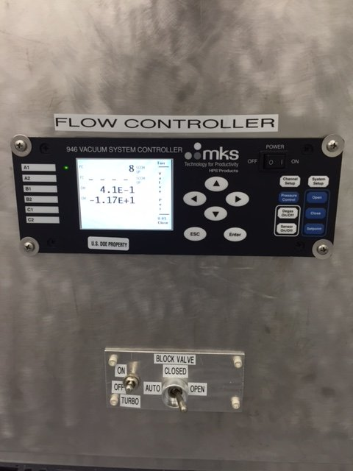

Figure 3

* Switch the block valve to the auto position.
* Switch the turbo to the on position.
* Click the start button on the turbo pump controller. Verify the turbo pump controller says waiting for interlock to be satisfied.
* Ensure the manual valve in the scroll pump line is open and the scroll pump is on.
* Verify the cavity isolation valve is open.
* Close the slow pump metering valve by using the 946 vacuum system controller.
  + Press the pressure control button 2 times.
  + Change the PID control to the on position.
    - Ensure the OFF in PID control is highlighted. Press enter, using the up or down arrow change the control to ON, press enter to complete the change. (Figure 4)
    - Press the pressure control button 2 times and verify the Op Mode has changes to PID. (Figure 5)
    - Press the ESC button to view the metering valve position and verify its operation. (Figure 6)

The slow pump is automatic from this point on. The volume will pump at the rate entered in the 946 vacuum system controller. When the first set point coming from the MKS gauge controller is satisfied the block valve will open allowing for full scroll pumping speed. When the second set point coming from the MKS gauge controller is satisfied the turbo pump will come on allowing full pumping.

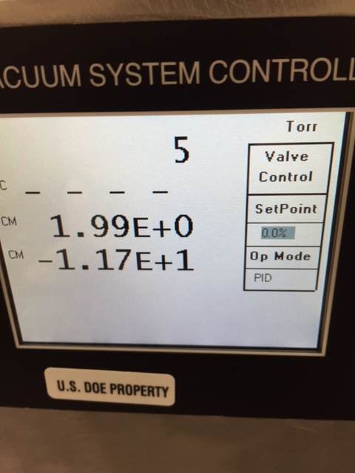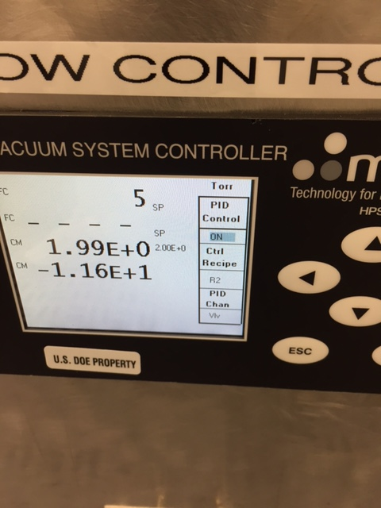

Figure 4 Figure 5

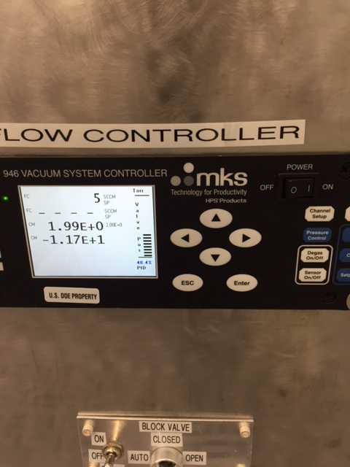

Figure 6

After the pump down is complete and the turbo pump has been activated the metering valve is no longer required. The metering valve PID loop should be stopped.

* On the 946 vacuum system controller, Press the pressure control button Once. (Figure 5) Using the up and down arrow highlight the PID and hit enter. Using the up or down arrow change the PID to read closed. Hit Enter to confirm this change. Press ESC button to go back to the main screen. Verify instead of reading PID under the valve position it now reads closed. The valve bar graph should now read 0%.

## Slow Bleed-up Operation

### Assumptions

* The cavity isolation valve is closed and the cavity or volume to be bleed-up is under vacuum.
* There is no turbo pump connected to the cavity isolation valve.
* The production pump system is vented entirely including the slow pump bleed-up connection line.

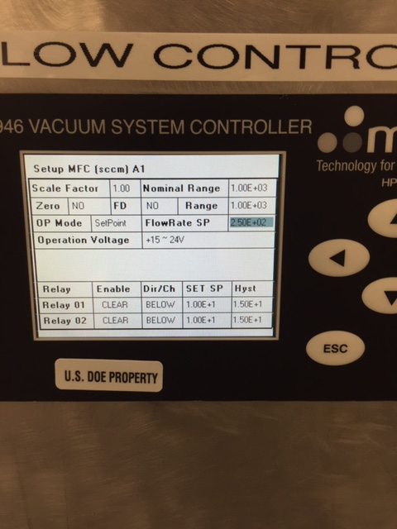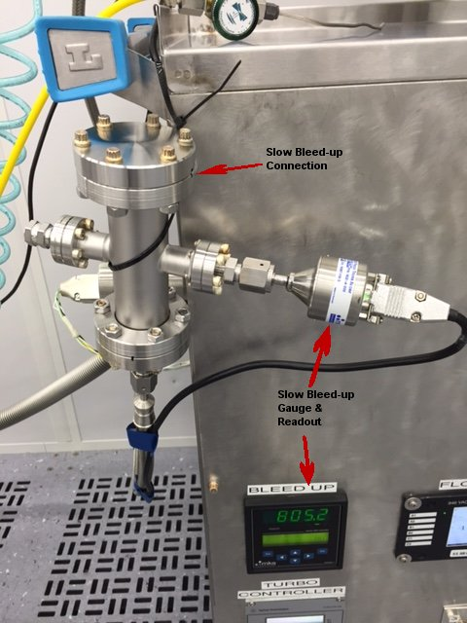

Figure 7 Figure ?

### Procedure:

#### Set-up:

* Using standard clean assembly practices connect the slow bleed-up connection to the cavity isolation valve. Use a new gasket and tighten for a leak tight seal.
* Ensure the standard bleed-up valve is closed.
* Close the turbo isolation valve.
* Set the MFC valve to the closed position.
  + Press the close button, close will flash in red and press enter to confirm. (Figure 3)
  + Verify the 946 vacuum system controller says close at the SCCM status. (Figure ?)
* Open the slow bleed-up connection and the slow bleed-up supply mini valves.
* Plug in the nitrogen supply to the MFC and set the regulator to 20PSIG.

You are now properly set-up and ready to pump the turbo system. This will allow you to ultimately open the cavity isolation valve with a vacuum on both sides and then slow pump the system.

#### Pumping and getting the cavity isolation valve open:

* Set the turbo system to general operation.
  + Switch the turbo to the on position.
  + Turn the turbo controller to the start position and verify the turbo says waiting for interlock to be satisfied.
  + Switch the block valve to the open position
  + Verify the manual valve in the scroll pump line is open and the scroll pump is on.

The scroll pump will pump the slow bleed-up lines up to the cavity isolation valve. The turbo pump will come on when the turbo interlock is satisfied. When the main system Cold Cathode gauge is at the low e-4 torr the cavity isolation valve can be open.

* Open the cavity isolation valve when the system pressure is in the low e-4 torr range.
* Ensure the FlowRate SP entered is correct in the 946 vacuum system controller. (See: 946 Vacuum Controller Setup in this procedure)
* Turn the turbo pump off.
  + Turn off the turbo pump at the turbo controller by hitting the stop button. You may also want to switch the turbo to the off position at the manual switch panel.
* Open the MFC to the setpoint value.
  + On the 946 vacuum system controller press the setpoint button. The SP will flash in red and press Enter to confirm the change.

The cavity will bleed-up at the rate programed into the 946 vacuum system controller. The time will vary depending on the FlowRate SP entered and the volume of the cavity that is being bleed-up. The cavity vacuum can be monitored by the slow bleed-up gauge readout (Figure 7)

At atmosphere the MFC should be set to the closed position to stop the MFC form operating.

* Set the MFC valve to the closed position.
  + Press the close button, close will flash in red and press enter to confirm. (Figure 3)
  + Verify the 946 vacuum system controller says close at the SCCM status. (Figure ?)

## 946 Vacuum Controller Setup

### Setup for slow pump operation

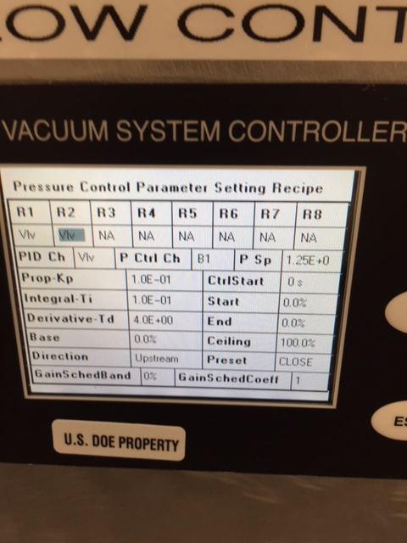Figure 9 shows standard setup for the slow pump operation:

* Prop-Kp: 1.0E-1
* Integral-Ti : 1.0E-1
* Derivative-Td: 4.0E+00
* Direction: Upstream
* Preset: Close
* Ceiling: 100.0%
* P Sp 2.0E+0 (This is the one field you change to control the speed of the pump-down.)

Figure 9

Various parameters control the smooth operation of the metering valve during slow pump-down. The standard slow pump parameters are indicated above next to Figure 9. The P Sp value can be changed for various applications. The standard set point is 2.0E+0. The Pressure Control Parameter Setting Recipe can be changed by:

* From the main screen Press the System Setup button.
* Using the arrows select the proper Recipe in Figure 9 R2 is selected.
* Press Enter and use the arrows to move to the field you want to change.
* After the proper field is highlighted press enter to bold highlight. Us the up or down arrows to change to the desired value. Press enter to confirm the change.
* After the desired fields have been changed press ESC to take you back to the main screen.

### Setup for Slow Bleed-up operation

The Flow Rate setpoint can be changed as desired for various applications. The typical setpoint for cavity slow bleed-ups is 2.5e+2.

Setup the MFC flow rate:

* Press the channel setup button.
* Change the A1 MFC FlowRate SP.
  + Press enter to allow access to fields to be changed.
  + Using the arrows highlight the FlowRate SP field.
  + Press enter and use the up or down arrow to change the value in the FlowRate SP field.
  + Press enter to confirm the change.
  + ESC will take you back to the home page.

Figure 10

# References

|  |  |
| --- | --- |
| **Document No.** | **Title** |
| SRF-01-ML-001 | SRF Quality Manual |
| <SRF-FM-###> | <Document Title> |
|  |  |

# Release and Revision History

|  |  |  |
| --- | --- | --- |
| **Rev #** | **Major Changes** | **Effective Date:** |
| 1 | Initial version | DD Mmm YYY |
| <2> | <brief description of major changes> | DD Mmm YYY |
|  |  |  |
|  |  |  |

# Approvals

|  |  |  |  |
| --- | --- | --- | --- |
| **Approved by:** | **Name:** | **Signature:** | **Date:** |
| Document Owner | Kurt Macha |  | DD Mmm YYY |
| Subject Matter Expert | Chris Dreyfuss |  | DD Mmm YYY |
| Work Center Lead | <First Last Name> |  | DD Mmm YYY |
| Project Leader | <First Last Name> |  | DD Mmm YYY |