Traveler Title | SNSPPU Cyromodule Shipping
Traveler Abstract | Outlines the preparation of an SNSPPU style cryomodule for its shipping cradle for shipping, and the loading of the cradle and cryomodule onto a flatbed trailer for transport.
Traveler ID | SNSPPU-CMA-CM-SHIP
Traveler Revision | R1
Traveler Author | Matthew Weaks
Traveler Date | 31-Jan-22
NCR Informative Emails | edaly
NCR Dispositioners | Huque,fischer
D3 Emails | Weaksmc
Approval Names | Matthew Weaks | John Fischer | Naeem Huque
Approval Signatures
Approval Dates
Approval Title | Author | Reviewer | Project Manager

References | List and Hyperlink all documents related to this traveler. This includes, but is not limited to: safety (THAs, SOPs, etc), drawings, procedures, and facility related documents.
SNSPPU-PR-CMA-CM-SHIP-R1 | JL0078591 - Shipping Fixture

Revision Note
R1 | Initial release of this Traveler.

Step No. | Instructions | Data Input
1 | Ensure that the traveler for CM testing has been completed | [[CMSerialNumber]] <<CMSN>>  [[AcceptanceTravComplete]] <<CHECKBOX>>
2 | Cap off/Apply protective foil to exposed End Can connections.  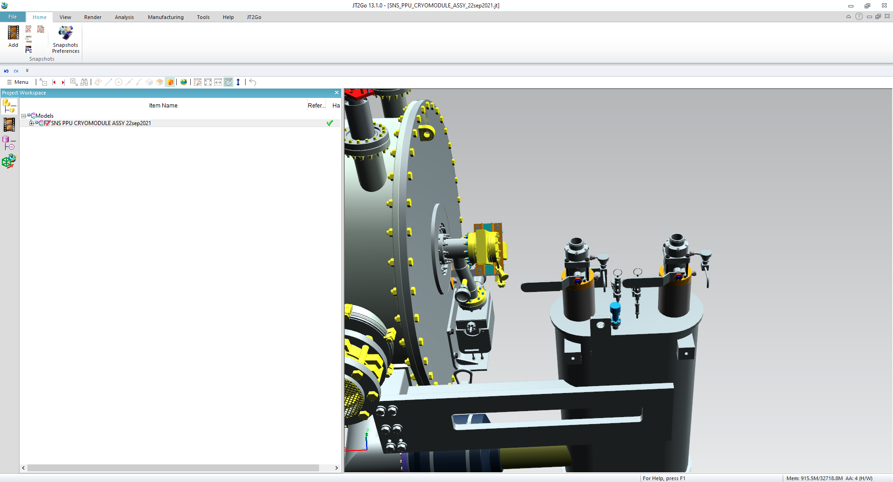 | [[EndCanCapTech]] <<SRF>>  [[EndCanCapTime]] <<TIMESTAMP>>  [[EndCanCapComments]] <<COMMENT>>
3 | Record beamline vacuum.  Beamline Vacuum should be <10⁻⁸ torr before disconnecting any pumping devices. | [[BLVacTech]] <<SRF>>  [[BLVacTime]] <<TIMESTAMP>>  [[BLVac]] <<SCINOT>> (Torr)

Step No. | Instructions | Data Input
4 | Pressurize the Primary Helium Circuit (1 psig)  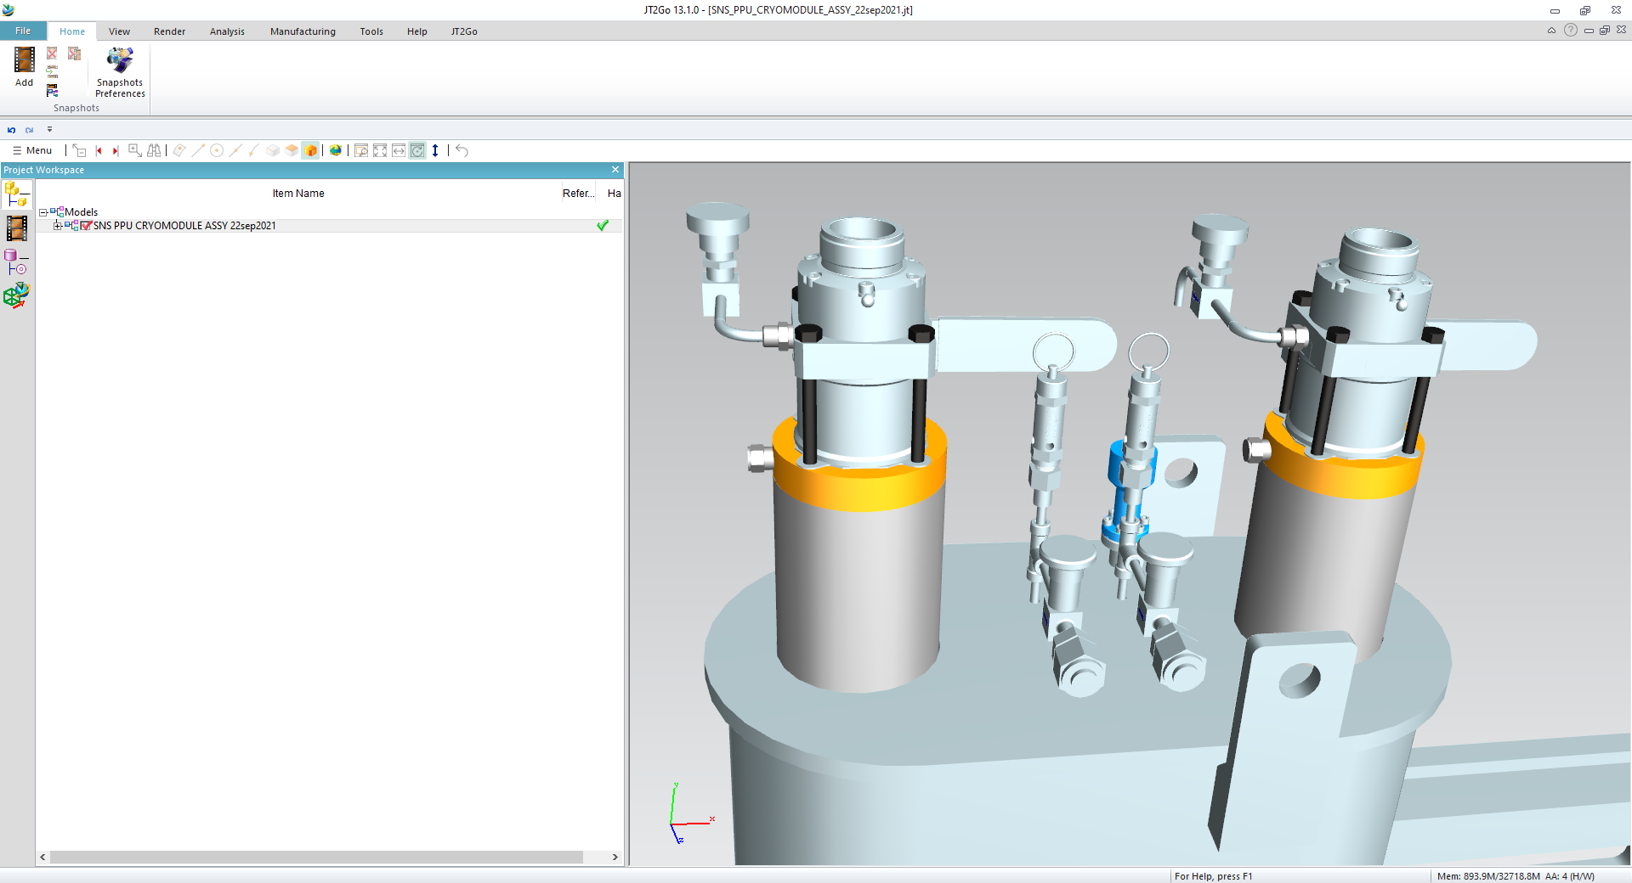  Figure 1: Primary Connection on RIGHT, nearest CM | [[PrimaryPressurized]] <<CHECKBOX>>  [[PrimaryPressTech]] <<SRF>>  [[PrimaryPressTime]] <<TIMESTAMP>>  [[PrimaryPressComments]] <<COMMENT>>
5 | Pressurize the Shield Circuit (1 psig)  Figure 2: Shield Connection on LEFT, furthest from CM | [[ShieldPressurized]] <<CHECKBOX>>  [[ShieldPressTech]] <<SRF>>  [[ShieldPressTime]] <<TIMESTAMP>>  [[ShieldPressComments]] <<COMMENT>>
6 | Label all valves with “Circuit under 1 psig pressure” notice tags. | [[AllValvesLabeled]] <<CHECKBOX>>  [[ValveLabelTech]] <<SRF>>  [[ValveLabelTime]] <<TIMESTAMP>>

Step No. | Instructions | Data Input
7 | Confirm that all tuners have been parked such that the high-frequency limit switch is open. If any of the tuners are not parked on the high-frequency limit switch, use a local tuner box to run the stepper motors until they are parked with the high-frequency limit switch open. | [[Tuner1Parked]] <<CHECKBOX>>  [[Tuner2Parked]] <<CHECKBOX>>  [[Tuner3Parked]] <<CHECKBOX>>  [[Tuner4Parked]] <<CHECKBOX>>  [[TunerParkTech]] <<SRF>>  [[TunerParkTime]] <<TIMESTAMP>>  [[TunerParkComments]] <<COMMENT>>
8 | Confirm that warm Passband frequencies have been recorded. If warm Passband frequencies have not been recorded, check and record the passband frequencies with a network analyzer, and upload a spreadsheet containing the data. | [[FrequenciesRecorded]] <<CHECKBOX>>  [[FrequencyCheckTime]] <<TIMESTAMP>>  [[FrequencyCheckTech]] <<SRF>>  [[FrequencyCheckComments]] <<COMMENT>>  [[PassbandFrequencies]] <<FILEUPLOAD>>

Step No. | Instructions | Data Inputs
9 | Perform electrical pin check out and attach spreadsheet. | [[PinCheckTime]] <<TIMESTAMP>>  [[PinCheckTech]] <<SRF>>  [[PinCheckComments]] <<COMMENT>>  [[PinCheckSpreadsheet]] <<FILEUPLOAD>>
10 | Disconnect all vacuum pumps and power supplies from the Cryomodule.  Ensure all isolation valves are tightly closed, and vacuum pumps turned off before breaking any vacuum connection. | [[PumpAndPowerDCTech]] <<SRF>>  [[PumpAndPowerDCTime]] <<TIMESTAMP>>
11 | Prepare the cryomodule for shipping as per procedure SNSPPU-PR-SHIP | [[CMPrepped]] <<CHECKBOX>>  [[CMPrepTech]] <<SRF>>  [[CMPrepTime]] <<TIMESTAMP>>  [[CMPrepComments]] <<COMMENT>>
12 | Record insulating vacuum.  Insulating Vacuum should be <10⁻⁴ torr before disconnecting any pumping devices. | [[InsVacTech]] <<SRF>>  [[InsVacTime]] <<TIMESTAMP>>  [[InsVac]] <<SCINOT>> (Torr)
13 | Install Cryomodule on Shipping Cradle as per SNSPPU-PR-SHIP  Back Trailer into High Bay area  Lift CM with Shipping Frame and secure Shipping Frame to Trailer  **Refer to Lift Plan when moving/lifting the Cryomodule and/or Shipping Cradle** | [[CMtoCradleTech]] <<SRF>>  [[CMtoCradleTime]] <<TIMESTAMP>>  [[CMtoCradleComments]] <<COMMENT>>  [[CradleToTrailerTech]] <<SRF>>  [[CradleToTrailerTime]] <<TIMESTAMP>>  [[CradleToTrailerComments]] <<COMMENT>>

Step No | Instructions | Data Inputs
14 | Install shock recorders (SSX and Lansmont) as per SNSPPU-PR-SHIP | [[ShockLogTech]] <<SRF>>  [[ShockLogTime]] <<TIMESTAMP>>  [[ShockLogComments]] <<COMMENT>>
15 | Strap the cryomodule to the upper frame of the shipping cradle in the vicinity of the vacuum vessel main cradles  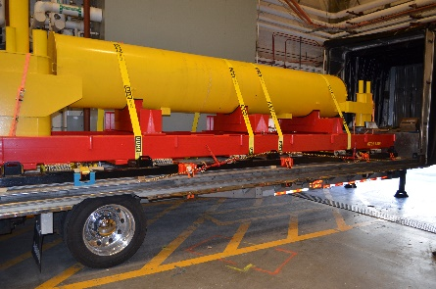  Raise the End Can Cradles until they are supporting part of the weight of the End Cans. This can be determined by monitoring the position of the can with a dial indicator (Stopping then the End Can begins to lift).  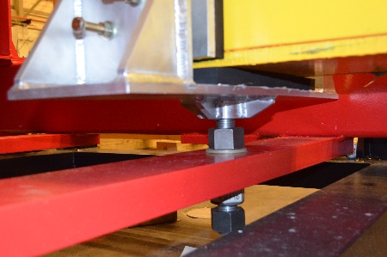  Strap the End Cans to the Upper Frame | [[CMStrapTech]] <<SRF>>  [[CMStrapTime]] <<TIMESTAMP>>  [[CMStrapComments]] <<COMMENT>>  [[ECStrapTech]] <<SRF>>  [[ECStrapTime]] <<TIMESTAMP>>  [[ECStrapComments]] <<COMMENT>>  [[ShipCoverTech]] <<SRF>>  [[ShipCoverTime]] <<TIMESTAMP>>  [[ShipCoverComments]] <<COMMENT>>

Step No | Instructions | Data Inputs
16 | Reconnect the ion pump power supply to the beamline and leave it connected until just before the trailer leaves the high bay area. | [[IonPumpConnected]] <<CHECKBOX>>  [[IonPumpConnectedTime]] <<TIMESTAMP>>  [[ConnectTech]] <<SRF>>  [[IonPumpDisconnected]] <<CHECKBOX>>  [[IonPumpDisconnectedTime]] <<TIMESTAMP>>  [[DisconnectTech]] <<SRF>>
17 | Pack the Actuators in their crate and record serial numbers | [[ValvesWrapped]] <<CHECKBOX>>  [[ValvesPacked]] <<CHECKBOX>>  [[ValvePackTime]] <<TIMESTAMP>>  [[ValvePackTech]] <<SRF>>  [[JTEVASN1]] <<EVASN>>  [[JTEVASN2]] <<EVASN>>  [[CDEVASN]] <<EVASN>>
18 | Pack the CCGs in their crates and record the serial numbers | [[CCGsWrapped]] <<CHECKBOX>>  [[CCGsPacked]] <<CHECKBOX>>  [[CCGPackTime]] <<TIMESTAMP>>  [[CCGPackTech]] <<SRF>>  [[CCGSerial1]] <<SN>>  [[CCGSerial2]] <<SN>>  [[CCGSerial3]] <<SN>>  [[CCGSerial4]] <<SN>>  [[CCGSerial5]] <<SN>>  [[CCGSerial6]] <<SN>>  [[CCGSerial7]] <<SN>>  [[CCGSerial8]] <<SN>>

Step No | Instructions | Data Inputs
19 | Have the driver check all tie-downs, and confirm they are satisfied.  Fill out any shipping paperwork, and ensure the driver has all necessary information, Bill of Lading, etc.  Upload copies of all relevant paperwork. | [[DriverCheckedTieDowns]] <<CHECKBOX>>  [[PaperworkGiven]] <<CHECKBOX>>  [[ShippingTech]] <<SRF>>  [[ShippingTime]] <<TIMESTAMP>>  [[ShippingPaperWork]] <<FILEUPLOAD>>
20 | Before allowing the truck to depart, an independent reviewer (Someone with relevant knowledge/experience with lifting and loading, who was NOT involved in the initial loading of the module/shipping cradle) must check all tie-downs, straps, and securing devices. | [[IndependentReviewer]]{{fischer, jared,jjcamp,huque}}<<HOLDPOINT>>
21 | Confirm that all necessary data has been entered in the traveler, and that requested data has been made available to relevant parties. | [[FinalHold]] {{fischer,huque,edaly}} <<HOLDPOINT>>

