Girder Particulate Sampling Procedure
Document Number: |  | Approval Date: | 06-JUNE-2020
Revision Number: | Initial Release | Periodic Review Date: | 09-JUNE-2022
Document Owner: | Anne-Marie Valente-Feliciano

Purpose and Scope

This procedure covers the sampling for particulate and disassembly of a warm region girder. In 2 locations: in the Tunnel, in the main SRF cleanroom.

STP- Standard Traveler/Procedure:
This Standard Procedure is intended to be generalized such that it could apply to most girder types at JLab. The PI/PM is encouraged to provide project specific instructions to supplement this procedure, which are to be attached to the applicable Traveler.
If at any time the project specific instructions change or modify the content of this procedure, then a new procedure will be required, to be approved through the normal processes at SRF and JLab.

SAFETY:
Individuals must keep safety as the first priority in the process; before beginning any job, the user must assure they have the correct PPE for the individual job. Maintaining the level of safety and secure nature of the work area is paramount. Assure personal safety by using caution in movement and taking necessary steps to avoid unnecessary personnel in the immediate area.
Refer to the work-center OSP for specifics.

During the girder re-work process, there will be some items labeled as “Radioactive Material”. Radioactive Material (RAM) is defined in the RadCon manual as any activated material, equipment or system component with radiation levels distinguishable from background. The following guidelines are to be adhered to when handling RAM in order to follow Radcon requirements:
- There are no requirements for dosimetry for Radioactive Material Areas unless otherwise notified by a member of the RCD.
- Persons must be Radiation Worker I qualified to handle RAM.
- The RAM tag must accompany the item at all times with the following exceptions. Cleaning, heating or any process in which the tag will impede that process or the tag could be potentially damaged or destroyed.
- When performing processes listed above, the tag is to be removed by personnel performing the task and placed on the RAM tag board located in the area.
- Each component removed from the cavity pair needs to be tagged with a Radcon coupon, recorded on the dedicated list.
- All hardware (bolts, nuts, gaskets…) needs to be gathered in a Rad waste bag.
- Once task is complete, the tag is to be placed back on the material/equipment.
- Eating, drinking or smoking is not permitted in Radioactive Material Areas
Remove all tags prior to installation of cryomodule in the Accelerator
Tasks associated with this procedure will be performed in the designated area of the clean room.
Each re-location of the assembly or its components requires Radcon authorization.

CAUTION:
Take great care of the items disassembled. Some are extremely sensitive and/or delicate. Limited or no spares may be available for replacement.

The girder needs to be maintained upright in the same orientation it had on the beamline. Do not flip over, topple, …

References

SRF-XXXX-OSP - OSP for Safe Operations in the Clean room
Cleanroom protocols for clean and particulate free work

Terms and Definitions

- N₂ / Nitrogen: filtered nitrogen.
- PI/PM/SOTR: Principal Investigator, Project Manager, Subcontracting Officer Technical Representative. Someone otherwise in charge of the project or item in question. A supervisor may also be utilized if needed.
- GSR: gun shot residue

- Items used in this procedure:
Solvents: | Wipers:
Acetone, Clean Room Quality Isopropyl (Isopropanol) | TX1009B Alpha Wipes, pre-wetted Alpha Wipes, pre-cut wetted wipes
Supplies: | Tools:
GSR samples, collection bags, cleanroom paper, pen | Trays, tweezers, scissors, wrenches, disassembly tools, assembly layout and positions

Process Details

Prior to Start

Insure that an initial measurement has been performed on the BPMs as a baseline for the measurements that will be performed after cleaning, following “BPM antennas following the BPM Cavity Acceptance Test” (EES-PR-02-002). The point of contact for these measurements is Pete Francis (x7528 / francis@jlab.org).
The girder assembly will be blown off prior entry in the Production chemroom, wiped down with Isopropyl and blown off again with nitrogen prior entry in the cleanroom via the Production chemroom path-thru.

- ***Get authorization from RADCON to move girder to the Production chemroom***
- Print the Girder Drawing or picture with sampling locations identified. Print the part list and record all existing component data. Any component that has been tagged as RAM shall be noted in the last column.
Girder assemblies may slightly vary from one to another. Identify ahead of time the preset positions to be sampled. It is critical for post-analysis to maintain the nomenclature as consistent as possible from one assembly to another at the time of sample collection.
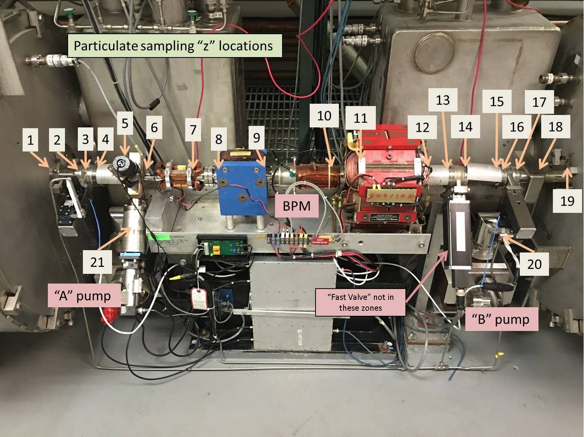
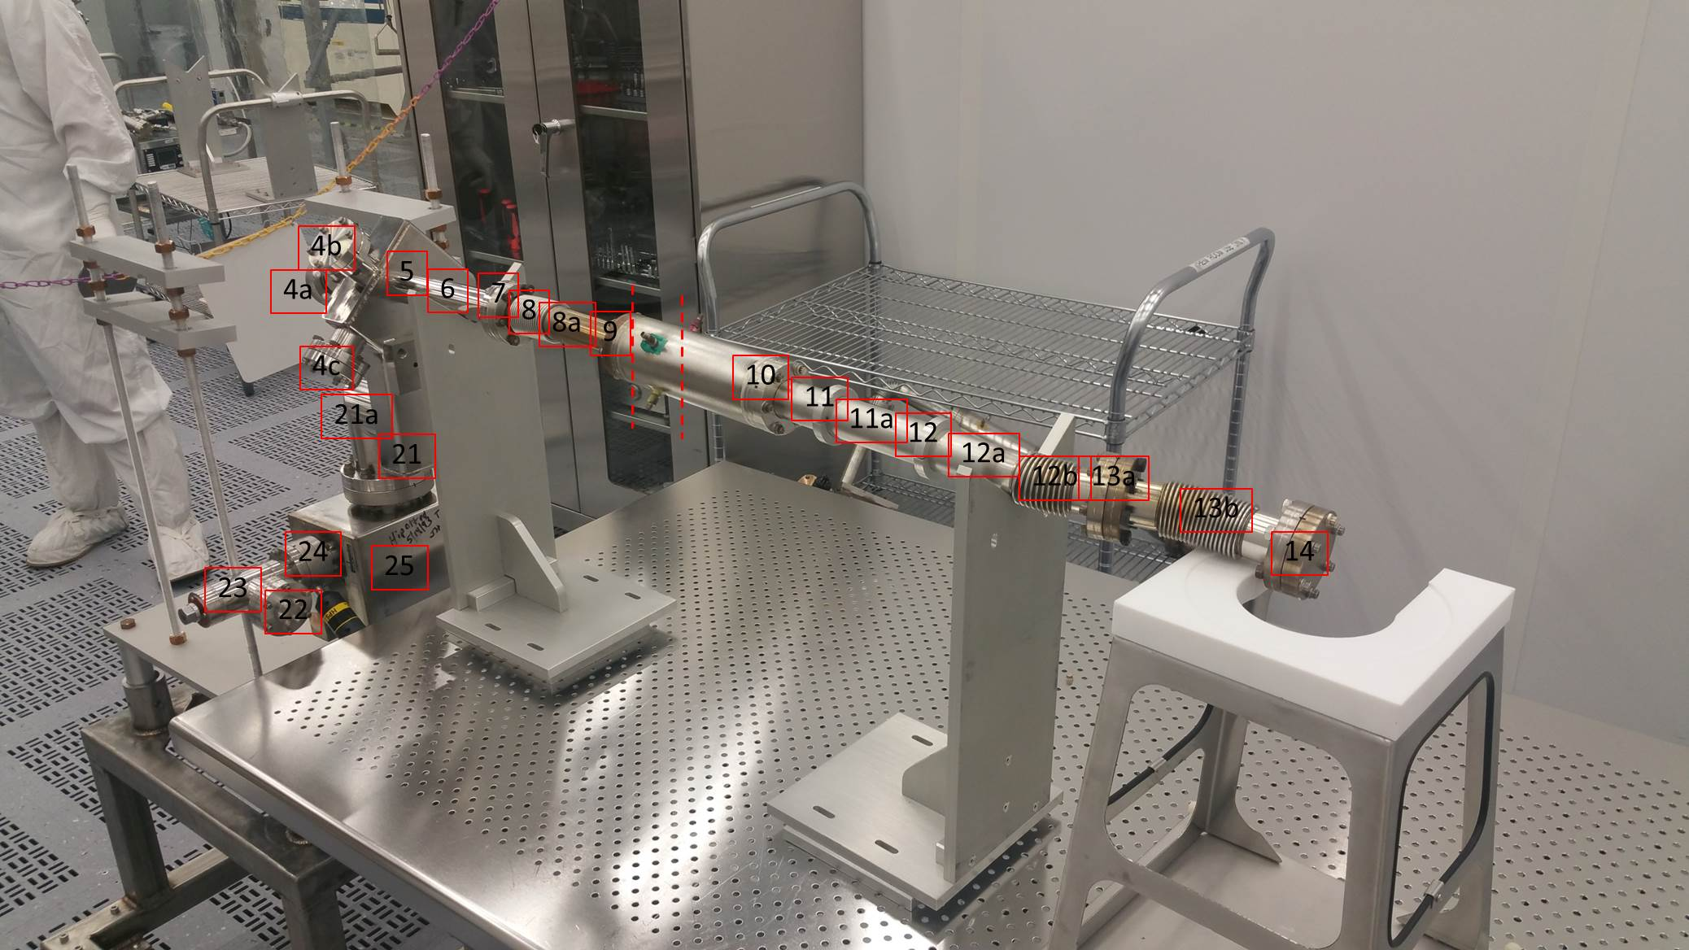
Girder in the Tunnel and in the cleanroom with identified sampling locations

- Bag the drawings/lists in cleanroom bag and transfer to the cleanroom pass-thru
- Check the availability of GSR samples
- Ensure the workspace is clean and tidy.
- Don appropriate PPE.
  - Gloves should be worn whenever handling items and changed after cleaning and as needed to maintain cleanliness.
  - TLD badge
- Inspect item(s) for damage (dents, scratches, dings, , etc).
  - If an item has pre-existing impairment, notify the PI/PM or a supervisor.
  - Do not proceed until written acknowledgement of previous damage presence has been received.
  - Take pictures
- Use only pre-approved tooling.
- Pre-cut wetted wipes
- Store delicate items in dedicated sealed plastic boxes
- Take great care of the items disassembled. Some are extremely sensitive and/or delicate and limited or no spares may be available for replacement.
- Insure that all tooling necessary is available, cleaned and transferred to the cleanroom

Wipes preparation

Two types of wipes are used to collect particulates. Pre-cut wetted (30%IPA, Iso3) Alpha wipes and dry Alpha wipes.
Enough pre-cut wipes should be prepared in advance to complete the work.
- Prepare dedicated scissors, sealed plastic boxes, bag of wetted (30%IPA, Iso3) Alphawipes.
- Stage by nitrogen blow off station with a particle counter
- Wipe the cutting area.
- Blow-off the scissors, plastic boxes and covers to 0 count.
- Use a stack of wet wipes (needed number + 2)
- Cut the wet wipes in 9 pieces
- Discard top and bottom pieces on each stack and pile up as you go in the dedicated plastic boxes
- Seal the boxes and transfer to collection area,

Staging
- Set the girder in the cleanroom designated area.
- Ensure the area and the girder are adequately clean.
- Prepare disassembly tooling, sampling tooling, supplies & samples, vial trays, storage containers for delicate components on cleanroom carts (typically at least 2 carts are needed).
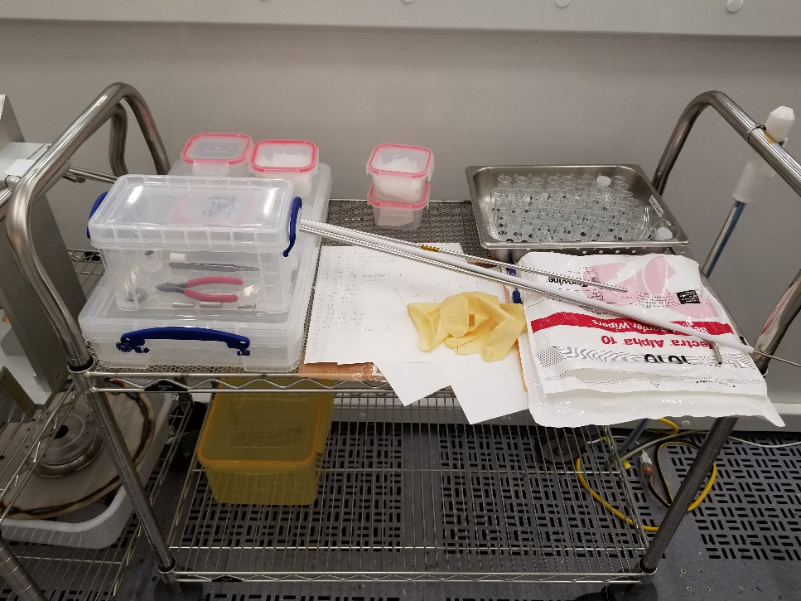
Sampling tooling and supplies

- Prepare and stage recording lists for particulate samples generated, assembly components and Radcon coupons
- Let the cleanroom area recover
- Prepare disassembly tooling, sampling tooling, supplies & samples, storage container for delicate components such as HOM loads.
- Prepare recording lists for particulate samples generated, cavity pair components and Radcon coupons
- Let the cleanroom area recover

Sampling
- Use dedicated stainless steel/ptfe tool with wet wipes for collection in the assembly

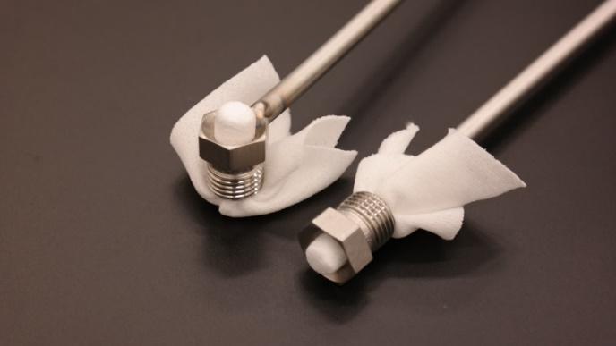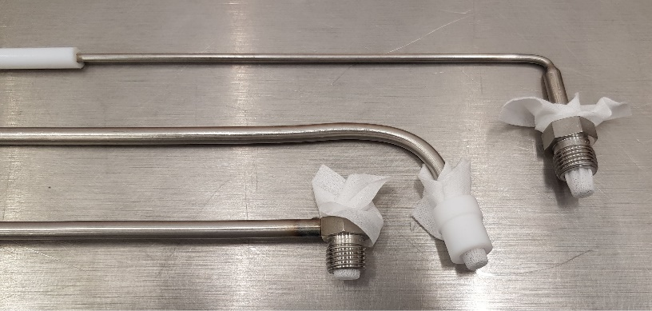
Pre-cut wetted wipe set in sampling tooling

- Use dry wipes to collect particle from dismounted and shaken parts
- Remove protective film from sample and replace in vial keeping sample "face down" to avoid potential cross-contamination from environment.
- Store samples “face up” once re-encapsulated in glass vial.

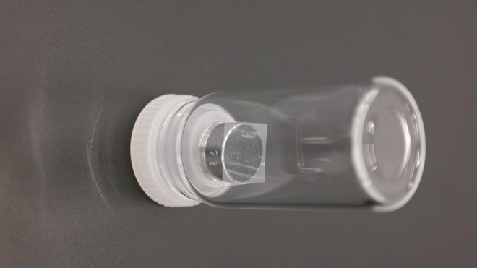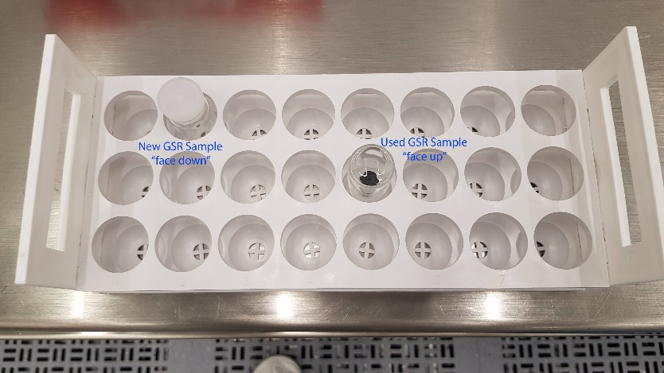
GSR sample

- Assemblies are sampled working from one end towards the center and then from the other end towards the center. This is required to avoid cross-contamination of the areas to be sampled.
- Any GSR sample that falls on a table or touches any surface but the collection wipe or area to be sampled becomes an “environmental sample” or “witness” sample. It has been cross-contaminated and is not representative of the assembly.
- Gloves should be changed as often as necessary, particularly between disassembly and sampling.

- Set an environmental witness sample prior starting disassembly and sampling tasks
- Remove all but 2 bolts on the blank 2.75” conflat flanges at #4b and #4a
- Blow off the flange holes to 0 counts
- Prepare a sample
- Remove the blank CF(4b) at the end of the assembly
- Sample the flange with a pre-cut wet wipe and set aside
- Discard the used wetted wipe in the dedicated waste bag
- Record the sample number and sampling location
- Prepare a sample
- Remove the blank CF(4a)
- Sample the flange with a pre-cut wet wipe and set aside
- Discard the used wetted wipe in the dedicated waste bag
- Record the sample number and sampling location
- Prepare a sample
- Set a wetted wipe on the collection tool
- Sample location at 4b
- Discard the used wetted wipe in the dedicated waste bag
- Record the sample number and sampling location
- Repeat steps 14 to 18, working towards the center of the assembly from location #4 to #9
- Stay away from BPM of at least 1"
- Repeat steps 2 to 13 from the other end of the assembly at #14 working towards #10
- Stay away from BPM of at least 1"
- Remove all but 2 bolts on parts from #13 to # 21
- Discard hardware in dedicated Rad waste bag
- Blow off the flange holes to 0 count, taking care to stay away from the open flanges at each end of the assemblies
- Prepare a dry Alpha wipe on one of the side stations
- Slowly separate the first component from the assembly, removing the remaining bolts and taking care to produce the minimum possible particulates.
- Discard hardware in dedicated bag (Radcon tagged if RMA)
- Gently shake the part above the prepared Alpha wipe
- Collect particles from the inner component on the dry Alpha wipe with a GSR sample
- Record the sample number and component sampled
- Tag the component with a Radcon coupon if required
- Record the Tag number on the parts list
- Discard the dry Alpha wipe
- Repeat steps 26 to 34, working your way through the assembly until all parts are disassembled, from #13 to #21
- Retrieve, record and store the environmental sample (from step1).

Wrap-up
- Insure all parts are appropriately tagged and recorded
- Insure all parts are secured on a cart
- Return the sampling tooling and remaining unused supplies, samples in the Clean analytical cabinets
- Store the GSR samples collected in the indicated area in the Clean analytical Lab
- Clean the work area
- Return tooling, carts to their respective storage areas.
- Contact Radcon to schedule components survey
- Exit the cleanroom
- Record the sample and component list electronically (excel catalog, database, traveller…)

Sampling in the Tunnel
Preparation
- Prepare in the cleanroom tooling, trays, GSR samples (4 per girder), wipes needed
- Double bag required tooling (tweezers) and supplies
- Double bag cleanroom PPE (bouffant, mask, shoe covers, gloves, cleanroom garment)
- Prepare location/sample list

In the Tunnel
The work area in the Tunnel is extremely tight
Work slowly and carefully
Take care to NOT cross-contaminate supplies, tooling, PPE…

- Take a picture of each sampling location
- Set the supplies and PPE in each portable cleanroom, up beam and down beam
- Enter cleanroom staging area
- Don PPE
- Stage tooling and samples
- All but 2 bolts should have been removed from the 2^{3/4}” CF flange linking the girder with the adjacent cryomodule
- The Bolt holes should be blown off until particulate count is down
- Orient the particulate counter sensor towards the area of interest
- Set 2 samples (remove plastic tabs, keep face down)
- Slowly remove the 2 remaining bolts
- Carefully separate the flanges
- Sample Cryomodule side on valve A
- Sample Girder side on Valve A
- Secure the samples
- Blank the Cryomodule flange
- Blank the girder flange and tighten bolts
- Exit to the cleanroom staging area
- Store the samples (face up) and tools and return to double bags
- Record the samples
- Repeat steps 3 to 19, sampling Cryomodule side on valve B and then Girder side on Valve B.

Q&A Sample collection
These samples are witness of various tasks accomplished in the cleanroom

- Procure the required number of GSR samples
- Open the vial, keeping the GSR sample face down and remove the plastic tab
- Set the GSR sample in the work area in a location where it can stay undisturbed while being exposed to the task at hand (assembly, disassembly, …)
- Once the task completed, retrieve the GSR sample and re-encapsulate it in its vial
- Store the GSR samples face up

Revision History

Rev # | Revision or update: | Effective:
Release | Initial Release | 6/9/20

Approvals

Approved by: | Signature: | Date:
Document Owner
SRF Operations Department Head
SRF R&D Department Head

