Traveler Title | C100R Thermal Shield and Spaceframe Assembly
Traveler Abstract | This traveler details the assembly and in-process quality control inspection of the C100 Spaceframe and Thermal Shield. All work from this section on will be performed in the Cryomodule assembly area. Furthermore, it is assumed the Cold Mass Assembly Traveler has been completed. The scope of work begins with a completed Cold Mass Assembly and ends with a partial assembly of the Cryomodule including Spaceframe, Thermal Shield, and Outer Magnetic shield.  Work within this Traveler is to be performed by trained and authorized Assembly Technicians ONLY.  All Cryomodule RAM materials shall be kept inside the established RADCON barriers, and all protocals outlined in the attached RADCON Control Memorandum will be maintained.  ** Radiation surveys shall be performed and information recorded at traveler hold points.**
Traveler ID | C100R-CM-ASSY-SFR
Traveler Revision | R2
Traveler Author | John Fischer
Traveler Date | 10-Feb-2022
NCR Emails | fischer,areilly,jjcamp
Approval Names | John Fischer | Tony Reilly | Jeff Campbell | Dave Hamlette
Approval Signatures
Approval Dates
Approval Title | CM Group Lead | SRF Dept. Head | Technical Reviewer | RADCON Rep.

References | List and Hyperlink all documents related to this traveler. This includes, but is not limited to: safety (THAs, SOPs, etc), drawings, procedures, and facility related documents.
11141S0030 Rev A  GTAW Specification S/S | JLAB Specification 11141S0029, Rev. A  Small item Leak Check Procedure | JLAB specification 11141S0035  General Cleaning Procedure | CP-C100-CM-ALGN  Cavity String Alignment Procedure | 50k Shield dwg sh 1
JLAB Specification  11141S0034  S/S Cleaning and Handling | Spaceframe dwg 2 | Spaceframe dwg 1 | Interface dwg- 50k shield, spaceframe, and outer mag. | 50KShield dwg 2
JLAB Specification  11141S0033 Rev A  Leak Check of Large Items | Outer mag shield 1 | Outer mag shield 2 | CP-C100-CM-INST-MLI  MLI Installation Procedure | Shield and Spaceframe Installation Procedure
Radcon RAM Control Doc 2019_C100r

Revision Note
R1 | Initial release of this Traveler.
R2 | Modified approval names and signatures, changed a few steps

Step No. | Instructions | Data Input
1 | Verify the Cold Mass Assembly Traveler is complete and enter the Cryomodule Assembly serial no. | [[CMSN]] <<CMSN>>  [[UCMLeadTech]] <<SRF>>  [[UCMComplete]] <<YESNO>>  [[CMDate]] <<TIMESTAMP>>
2 | Prepare and Install the 50 k shield, MLI, and Spaceframe. Follow CP-C100-CM-ASSY-SFR to complete this work.  - Ensure that .010" indium layer is placed between heat station blocks, all braided thermal straps, and shield outer surface.  - Identify, match mark the shield sections and disassemble for reassembly into the spaceframe.  - Once shield and spaceframe is in its final position over the cavity string, proceed below.  - Attach the thermal straps to all (64) radial rods and axial (4) rods - all straps and blocks must be inside the shield. Hold required dimensions.  - Attach the waveguide thermal straps - Extreme care is needed so as NOT to put any load on the waveguide.  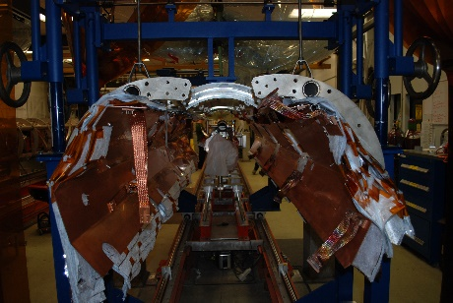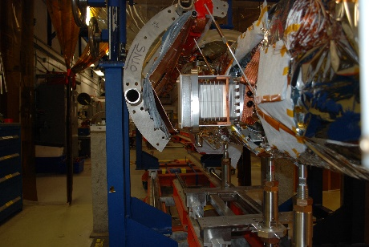 | [[SFRSN]] <<SFRSN>>  [[SFRInstallLeadTech]] <<SRF>>  [[SFRInstallDate]] <<TIMESTAMP>>  [[SFRInstallComment]] <<COMMENT>>
3 | Weld the bellows between the shield sections  - Open the MLI accessing the bellows areas  - Install fire blanket material around the weld area  - Designate and Institute a Firewatch  - Install and weld the bellows assemblies between the shield sections, using ASME B31.3 "Process Piping" as the standard. | [[ShieldWelder]] <<SRF>>  [[WeldMapAndInspectionUpload]] <<FILEUPLOAD>>  [[ShieldWeldDate]] <<TIMESTAMP>>  [[ShieldWeldComment]] <<COMMENT>>
4 | Leak check the 50 K thermal shield helium circuit. Bag all joints. JLAB Specification 1114S0029 Rev A, and 1114S0033 Rev A. | [[LeakCheckTech]] <<SRF>>  [[LeakCheckDate]] <<TIMESTAMP>>  [[LeakCheckGood]] <<YESNO>>  [[UploadStripChartFile]]  <<FILEUPLOAD>>  [[LeakCheckComment]] <<COMMENT>>

Step No. | Instructions | Data Input
5 | Install, then anchor the HOM and FPC cables to the 50 K thermal shield intercept blocks. Install .010" Indium foil between the cables and the 50K heat intercept blocks. Torque indium joints a minimum of 3 times. Perform TDR measurements of all cables. Record findings.  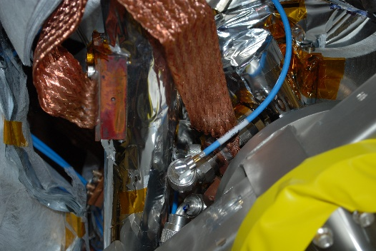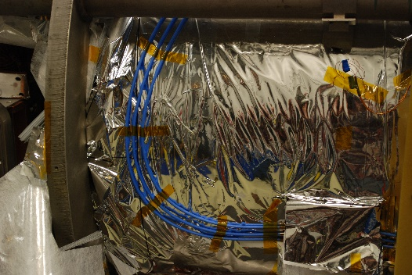 | [[THRMSN]] <<THRMSN>>  [[AnchorTech]] <<SRF>>  [[AnchorDate]] <<TIMESTAMP>>  [[AnchorComment]] <<COMMENT>>  [[AnchorElectricalTech]] <<SRF>>  [[TDRfiles]] <<FILEUPLOAD>>
6 | Transfer the cavity string to the space frame  - Connect all (64 radial, 4 axial) nitronic rods to the space frame.  - Verify the spaceframe is centered, torque the axial rods (4x) to 20 in/lbs. Use dwg. CRM1207001-0500 as a reference.  - Torque the remaining 64 rods to 20 in-lbs, tops first - alternating side to side to minimize the roll.  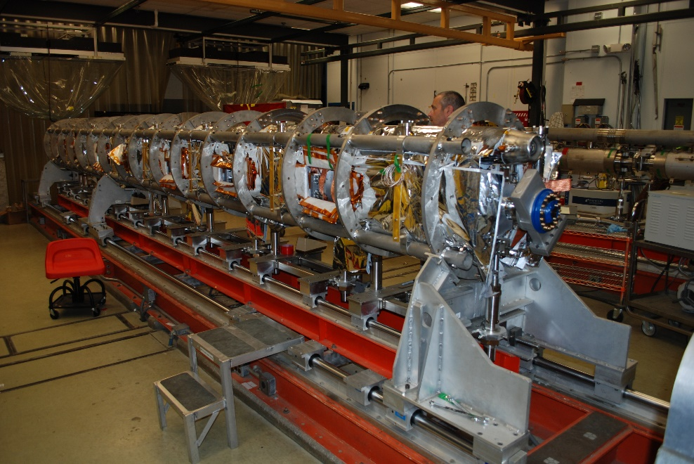 | [[TransferLeadTech]] <<SRF>>  [[TransferDate]] <<TIMESTAMP>>  [[TransferComment]] <<COMMENT>>
7 | Remove the cleanroom cavity string assembly supports  - Beam line vacuum shall be monitored during entire process to ensure reliability and integrity of all vacuum seals. Record vacuum before and after.  Dial indicators can be used to monitor the beam line movement during the tooling weight transfer. | [[BeamlineVacBefore]] <<SCINOT>>  [[BeamlineVacAfter]] <<SCINOT>>  [[ElevationSEC]] <<FLOAT>>  [[ElevationCenter]] <<FLOAT>>  [[ElevationREC]] <<FLOAT>>  [[BeanlineTech]] <<SRF>>  [[BeamlineDate]] <<TIMESTAMP>>  [[BeamlineComment]] <<COMMENT>>
8 | Align the cavity string to +/- 0.010 inches with respect to the monuments. Using the double arm alignment fixture, measure and record the cold valve flange positions at each end. This information will be used after the spaceframe is installed into the vacuum vessel. Use the alignment spreadsheet to record all values. Refer to CP-C100-CM-ALGN  Alignment yoke dwgs CRM1207014-0160, CRM1207014-0161 | [[AlignTech]] <<SRF>>  [[AlignDate]] <<TIMESTAMP>>  [[AlignComment]] <<COMMENT>>  [[AlignmentSS]] <<FILEUPLOAD>>  [[AlignBefore]] <<SCINOT>>  [[AlignAfter]] <<SCINOT>>
9 | Perform RF measurements, record passbands, and upload findings | [[RFTech]] <<SRF>>  [[RFDate]] <<TIMESTAMP>>  [[RFComment]] <<COMMENT>>  [[RFUpload]] <<FILEUPLOAD>>

Step No. | Instructions | Data Input
10 | Perform a wire check, verifying values and read-back. Record findings. | [[WireElectricalTech]] <<SRF>>  [[WireDate]] <<TIMESTAMP>>  [[WireValue]] <<FILEUPLOAD>>  [[WireComment]] <<COMMENT>>
11 | Install the outer magnetic shielding around the exterior of the space frame. Band clamp the shielding prior to installing the fasteners for secure fit to space frame.  Outer Magnetic Shield dwg 1, Outer Magnetic Shield dwg 2  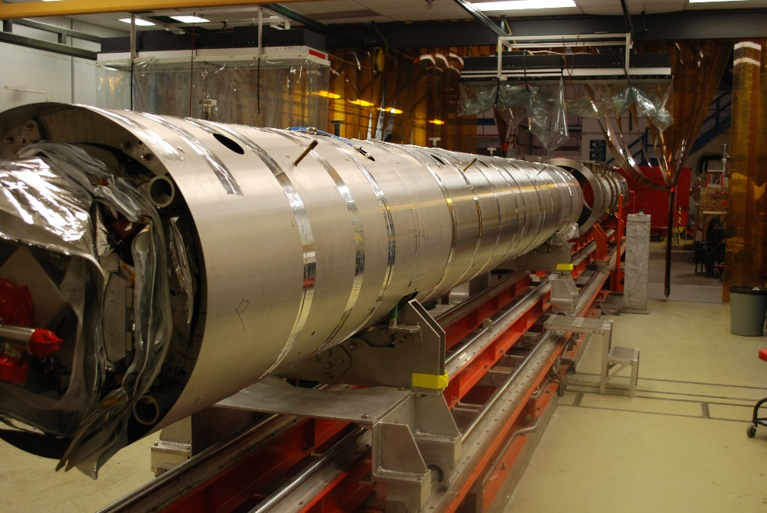 | [[OMAGSN]] <<OMAGSN>>  [[OMAGTech]] <<SRF>>  [[OMAGDate]] <<TIMESTAMP>>  [[OMAGComment]] <<COMMENT>>
12 | Preparation for Fiducialization  - Survey and Alignment group shall measure and record the space frame tooling markers and cold valve locations. | [[PrepTech]] <<SRF>>  [[PrepDate]] <<TIMESTAMP>>  [[PrepComment]] <<COMMENT>>  [[FiducialData]] <<FILEUPLOAD>>
13 | Complete the Space Frame/Thermal Shield checklist, then upload. | [[CheckSupervisor]] <<SRFCMP>>  [[CheckDate]] <<TIMESTAMP>>  [[CheckComment]] <<COMMENT>>  [[CheckList]] <<FILEUPLOAD>>
14 | C100R Spaceframe and Shield Traveler complete. | [[TravCompleteSupervisor]] <<USERNAME>>  [[TravCompleteDate]] <<TIMESTAMP>>  [[TravCompleteComment]] <<COMMENT>>

