Traveler Title | C100R COLD MASS ASSEMBLY
Traveler Abstract | This traveler details the assembly and in-process quality control inspection of the C100R Outside Cleanroom Cavity String. All work from this section on will be performed in the Cryomodule assembly area. Furthermore, it is assumed a completed and inspected cavity string assembly has been delivered through the clean room door. The scope of work begins with a cursory inspection of the cavity string and ends with a partial assembly of the cryomodule internal components prior to thermal shield installation. Work within this Traveler is to be performed by trained and authorized Assembly Technicians ONLY.  All Cryomodule RAM materials shall be kept inside the established RADCON barriers, and all protocals outlined in the attached RADCON Control Memorandum will be maintained.  ** Radiation surveys shall be performed and information recorded at traveler hold points.**
Traveler ID | C100R-CM-ASSY-COLD
Traveler Revision | R2
Traveler Author | John Fischer
Traveler Date | 10-Feb-2022
NCR Emails | fischer,areilly,jjcamp
Approval Names | John Fischer | Tony Reilly | Jeff Campbell | Dave Hamlette
Approval Date
Approval Signatures
Approval Title | CM Group Lead | SRF Dept. Head | Technical Reviewer | RADCON Rep.

References | List and Hyperlink all documents related to this traveler. This includes, but is not limited to: safety (THAs, SOPs, etc), drawings, procedures, and facility related documents.
CRM1207014-0001 Outside Cleanroom Assy | CRM1207014-0002 Cavity String | CRM1207080-1000 Cryogenic Piping | CRM1207050-0000 Cold Tuner Assembly | CRM120-7042-0000 Inner Magnetic Shield
11141S0029 Small item Leak Check Spec | 11141S0030 GTAW Spec for S/S | 11141S0033 Large Item Leak Check | 11141S0034 S/S Cleaning and Handling | 11141S0035 General Cleaning and Handling
WPS017 Welding Procedure  Doc. | WPS015/PQR015  Welding Procedure and Qualification  Doc. | Radcon RAM Control Doc 2019_C100r | C100 Cold Tuner Installation Procedure  Doc. | 12 GEV Cold Mass Kit

Revision Note
R1 | Initial release of this Traveler.
R2 | Modified approval names and signatures, changed a few steps

Step No. | Instructions | Data Input
1 | Record the Cryomodule Assembly serial number. | [[CMTech]] <<SRFCMP>>  [[CMDate]] <<TIMESTAMP>>  [[CMSN]] <<CMSN>>
2 | Notify RADCON that the Cavity string will be moved from the Clean Room to the Cryomodule Assembly Area. RAM identification tags shall be combined to a single tag at this time as well. Record tag info. | [[NotifyTech]] <<SRFCMP>>  [[RADCONRep]] <<RAD>>  [[NotifyDate]] <<TIMESTAMP>>  [[NotifyComment]] <<COMMENT>>  [[RAMTag]] <<FILEUPLOAD>>
3 | Move the cavity string from the clean room to the CM assembly bench using the mobile transfer bench. Safety Shoes are required.  Procedure:  - Mate up cavity string bench and CM transfer bench.  - Tie benches together.  - Install lockdowns onto end of the transfer bench.  - Record vacuum pressure, close the beamline valve isolating the ion pump, then turn off the ion pump.  - Move the cavity string from clean room onto the transfer bench.  - Install additional rail lockdowns.  - Disengage from the cleanroom rail.  - Move the transfer bench to the CM assembly area.  - Mate the benches and tie together.  - Slowly transfer the cavity string onto the fixed assembly rails, position over the alignment marks on floor.  - Install additional locks, both side of each cart, 16 total.  - Install additional lockdowns.  - Re-establish cavity vacuum by turning on the ion pump, once vacuum is established, open the beamline valve.  Record vacuum pressure level.  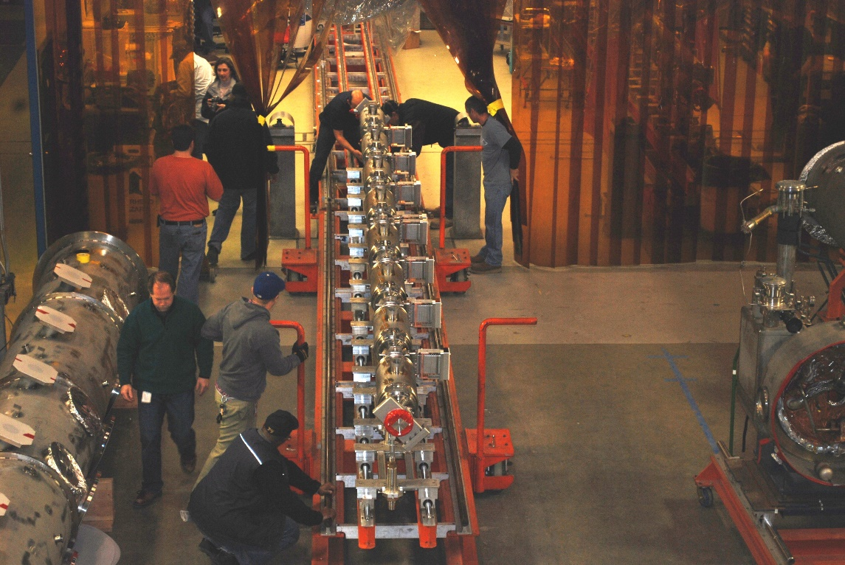 | [[TransferLeadTech]] <<SRF>>  [[TransferDate]] <<TIMESTAMP>>  [[TransferComment]] <<COMMENT>>
[[VacuumBeforeMove]] <<SCINOT>>
[[VacuumBeforeMoveTech]] <<SRF>>
[[VacuumAfterMove]] <<SCINOT>>
[[AllRailLocksInstalled]] <<YESNO>>
[[VacuumAfterMoveTech]] <<SRF>>
[[VacuumAfterMoveDate]] <<TIMESTAMP>>
[[VacuumAfterMoveComment]] <<COMMENT>>
4 | Record cavity serial numbers. Number cavities according to beam direction South (#1) to North (#8). | [[CAVSN1]] <<CAVSN>>  [[CAVSN2]] <<CAVSN>>  [[CAVSN3]] <<CAVSN>>  [[CAVSN4]] <<CAVSN>>  [[CAVSN5]] <<CAVSN>>  [[CAVSN6]] <<CAVSN>>  [[CAVSN7]] <<CAVSN>>  [[CAVSN8]] <<CAVSN>>  [[CavTech]] <<USERNAME>>  [[CavDate]] <<TIMESTAMP>>  [[CavComment]] <<COMMENT>>
5 | Install the helium vessel and waveguide bellows covers and "bellows " identification tape.  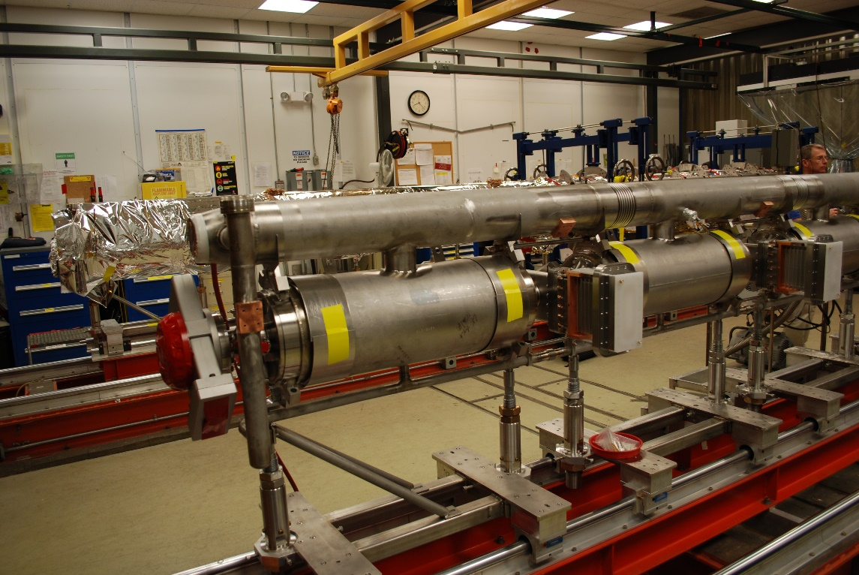 | [[CoverTech]] <<SRF>>  [[CoverDate]] <<TIMESTAMP>>  [[CoverComment]] <<COMMENT>>
6 | Verify the "as built " alignment of the Cavity string. This will verify roll, beamline, and waveguide flange positions. | [[AlignTech]] <<SRF>>  [[AlignDate]] <<TIMESTAMP>>  [[AlignComment]] <<COMMENT>>  [[AlignData]] <<FILEUPLOAD>>

Step No. | Instructions | Data Input
7 | Measure the cavity frequencies (passbands) and HOM modes, tune if necessary, record values. Note any significant variance.  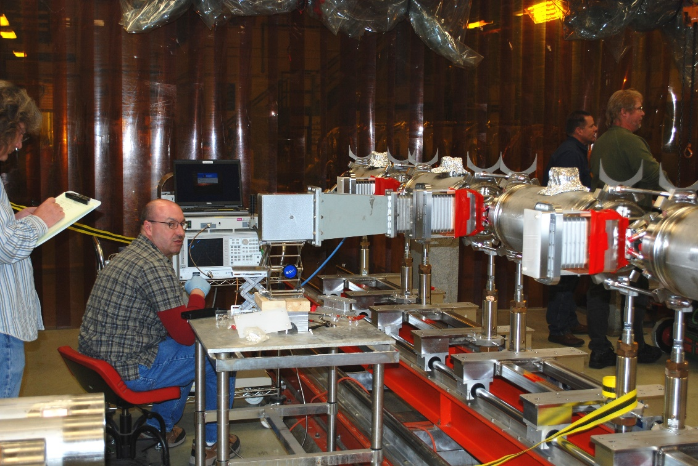 | [[RFTech]] <<SRF>>  [[RFDate]] <<TIMESTAMP>>  [[RFComment]] <<COMMENT>>  [[RFUpload]] <<FILEUPLOAD>>

Step No. | Instructions | Data Input
8 | Assemble, then weld the 2K helium supply and return piping (CRM-120-7080-1000). Work to be completed to ASME B31.3 standards.  **Consult with RADCON on guidelines for prepping RAM materials.**  Following schematic, extend wires as necessary to reach 2k feedthrus.  **Protect heater wires during the welding process**  CRM1207030-1000 SH 1  CRM1207030-1000 SH 2  CRM1207030-1001 SH 1  CRM1207030-1001 SH 2  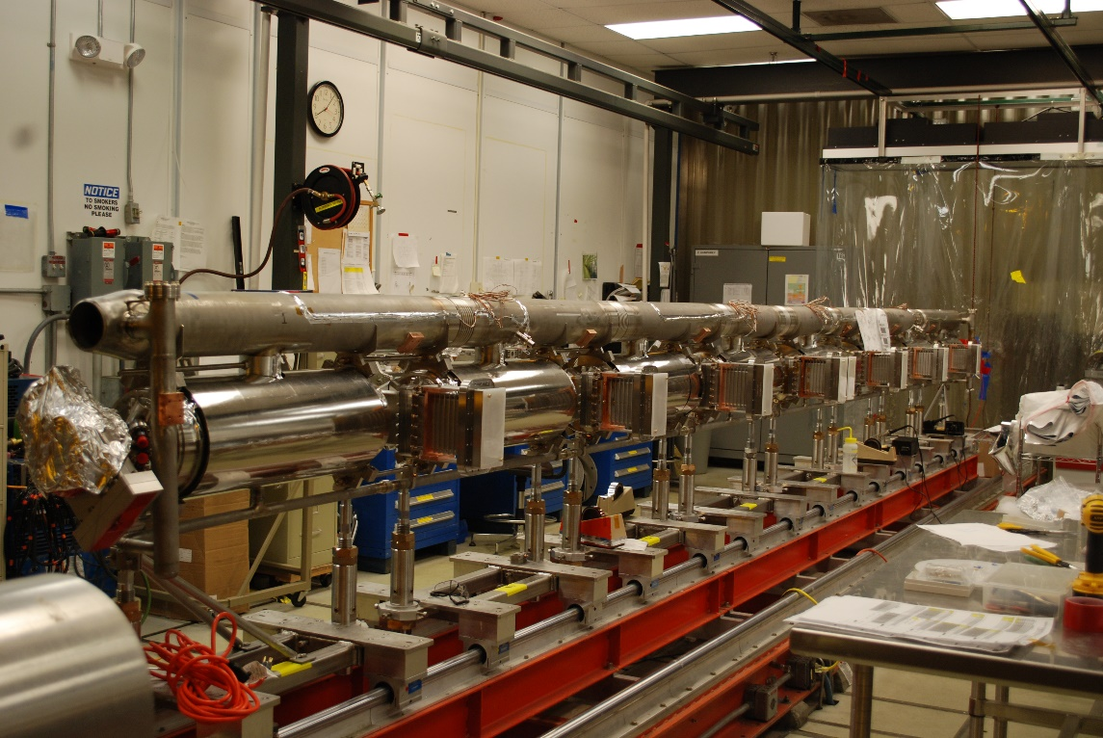 | [[Welder]] <<SRF>>  [[WeldDate]] <<TIMESTAMP>>  [[WeldDocumentation]] <<FILEUPLOAD>>  [[ElectricalTechnician]] <<SRF>>  [[WeldComment]] <<COMMENT>>
9 | Wire and install the cryogenic 8 pin feedthrus for heaters and liquid levels. (CRM-120-7014-0001). Record the Cryogenic 8 pin feedthru serial numbers and Manufacturer. Feedthrus are recorded from south (SEC) to north (REC). (4x's)  Verify all HOM "connector savers" are in place. (qnty 16)  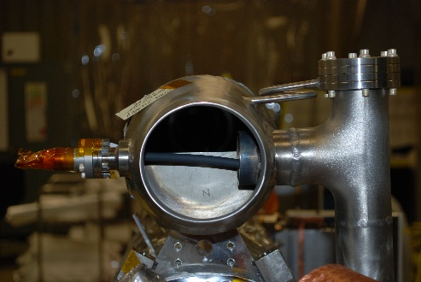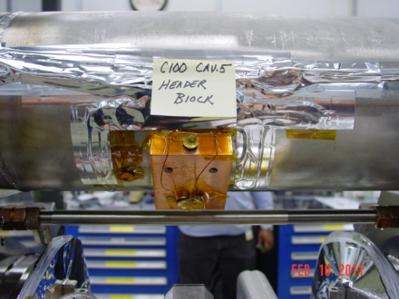  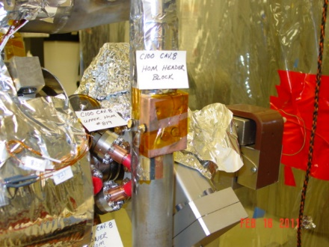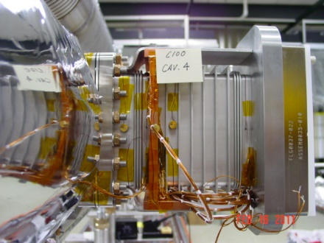 | [[FTElectricalTechnician]] <<SRF>>  [[FTDate]] <<TIMESTAMP>>  [[FTManufacturer]] <<FILEUPLOAD>>  [[FT08PSN1]] <<FT08PSN>>  [[FT08PSN2]] <<FT08PSN>>  [[FT08PSN3]] <<FT08PSN>>  [[FT08PSN4]] <<FT08PSN>>  [[ConnectorSaversPresent]] <<YESNO>>  [[FTComment]] <<COMMENT>>
10 | Install all hardware to negate the vacuum load during the 2 phase piping pumpdown. This includes the lollipop 45's, lollipop lockdown washer, spanner from hv port to head, and additional rail locks on inside of carts 1 & 8.  - Upper support brace- Install from HV head tab to HV return pipe, Cavs 1 and 8 only  - Lower support brace- Install 45 degree brace to upper side of lollipop with clamp and lower side of brace to the transfer cart. Cavs 1 and 8 only  - Lollipop washer assembly- Install jam nut and extended stub to existing lollipop assembly, add heavy washer and nut, tighten. Cavs 1 and 8 only.  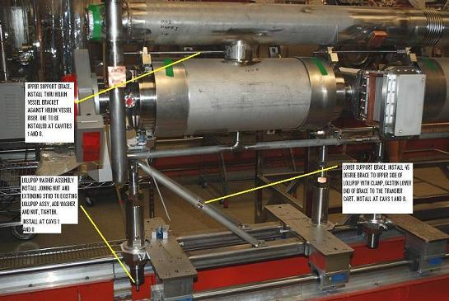 | [[HardwareTech]] <<SRF>>  [[HardwareDate]] <<TIMESTAMP>>  [[HardwareComment]] <<COMMENT>>
11 | Leak check 2K circuit as per Leak Check Procedure  Bag all joints to be leak checked.  11141S0030revA- UHV Leak Check - Large Items  11141S0029- UHV Leak Check - Small Items | [[LeakTech]] <<SRF>>  [[LeakDate]] <<TIMESTAMP>>  [[PassLeakCheck]] <<YESNO>>  [[LeakCheckDoc]] <<FILEUPLOAD>>  [[LeakComment]] <<COMMENT>>
12 | Review the weld documentation, and leak checks before proceeding with assembly. If additions to forementioned QC docs is needed do not procede with assembly, make necessary changes prior. | [[SupervisorSignoff]] {{fischer,jjcamp}} <<HOLDPOINT>>  [[ReviewDate]] <<TIMESTAMP>>  [[ReviewComment]] <<COMMENT>>

Step No. | Instructions | Data Input
13 | Install the wire harnesses and diodes, then heat station to the 2K circuit. Dwgs links are located in step 8 of this Traveler. (CRM1207030-1001) | [[WireElectricalTech]] <<SRF>>  [[WireTech]] <<SRFCMP>>  [[WireDate]] <<TIMESTAMP>>  [[WireComment]] <<COMMENT>>
14 | Install the inner magnetic shielding over each helium vessel (CRM-120-7042-0000), Nitronic rods openings in Mu head caps should measure 1.25" wide x 2.5" tall.  Wear appropriate gloves during application to prevent cuts or abrasions. Secure with Mylar tape.  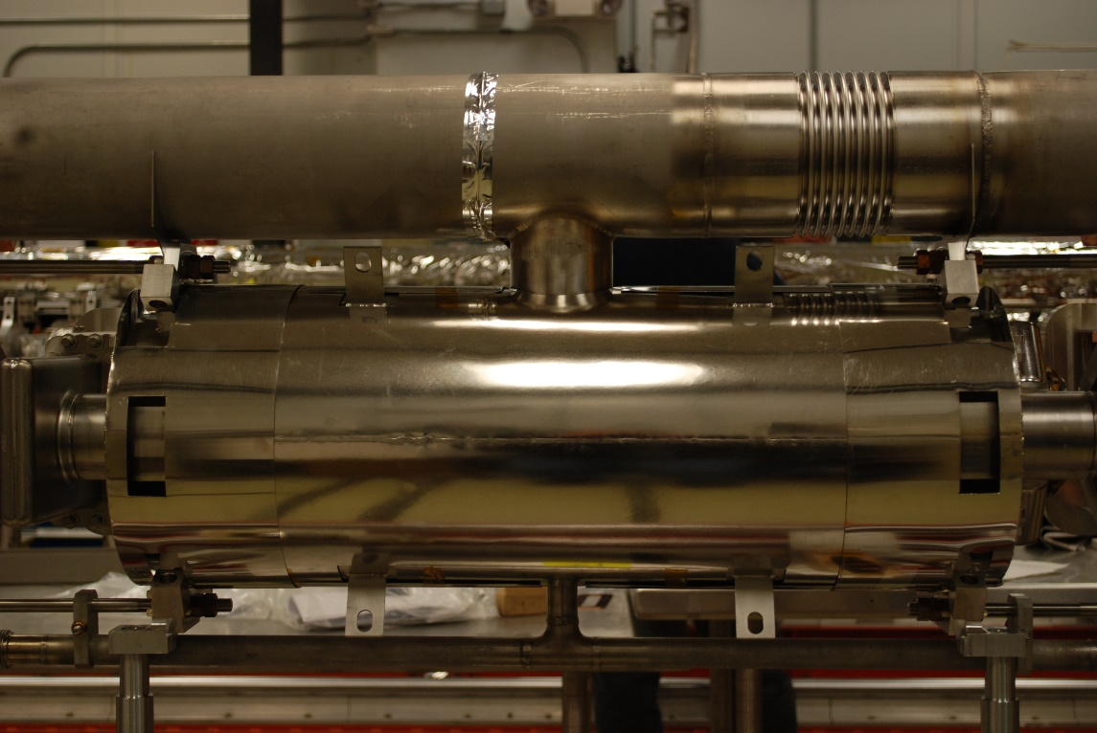 | [[MagTech]] <<SRF>>  [[MagDate]] <<TIMESTAMP>>  [[MagComment]] <<COMMENT>>

Step No. | Instructions | Data Input
15 | Adjust the Ti rods between the helium vessels to achieve 0.010" gap between double nuts and vessel head brackets. | [[TiTech]] <<USERNAME>>  [[TiDate]] <<TIMESTAMP>>  [[TiComment]] <<COMMENT>>
16 | Install first 10 layers of MLI, 2 blankets containing 5 layers onto 2k surfaces. Use proper installation techniques and gloves. Surfaces include; Supply and Return headers, Helium Vessels, and surrounding Beampipe areas.  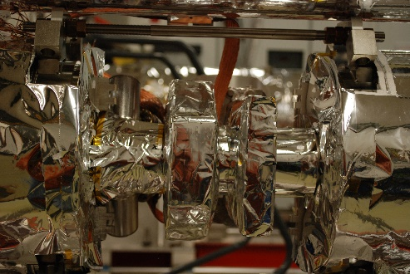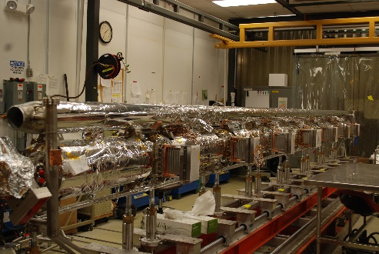 | [[MLILeadTech]] <<USERNAME>>  [[MLIDate]] <<TIMESTAMP>>  [[MLIComment]] <<COMMENT>>
17 | Install tuners onto each helium vessel using "C100 Tuner Installation Procedure". (CRM-120-7050-0000). Record Tuner Assy serial numbers. Set the distance between the Jack blocks using the 3.818 " tooling block. This sets the inner and outer tuning shafts to their ideal location.  Determine if cold tuner will be used to pre-tune any cavities low in frequency, record findings in comment box.  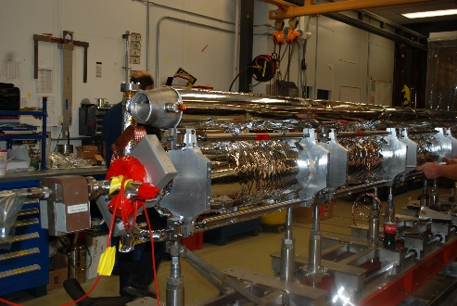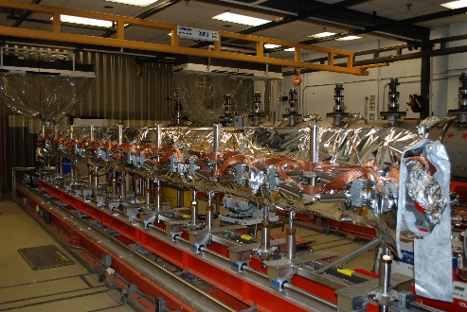 | [[TunerTech]] <<SRF>>  [[TunerDate]] <<TIMESTAMP>>  [[TUNCSN1]] <<TUNCSN>>  [[TUNCSN2]] <<TUNCSN>>  [[TUNCSN3]] <<TUNCSN>>  [[TUNCSN4]] <<TUNCSN>>  [[TUNCSN5]] <<TUNCSN>>  [[TUNCSN6]] <<TUNCSN>>  [[TUNCSN7]] <<TUNCSN>>  [[TUNCSN8]] <<TUNCSN>>  [[TunerComment]] <<COMMENT>>
18 | Install the heat-stationing clamps from the HOM'S to the return header (CRM1207014-0150), use .010" indium foil at all interface points. Torque fasteners to 30 in/lbs a minimum of 3 times.  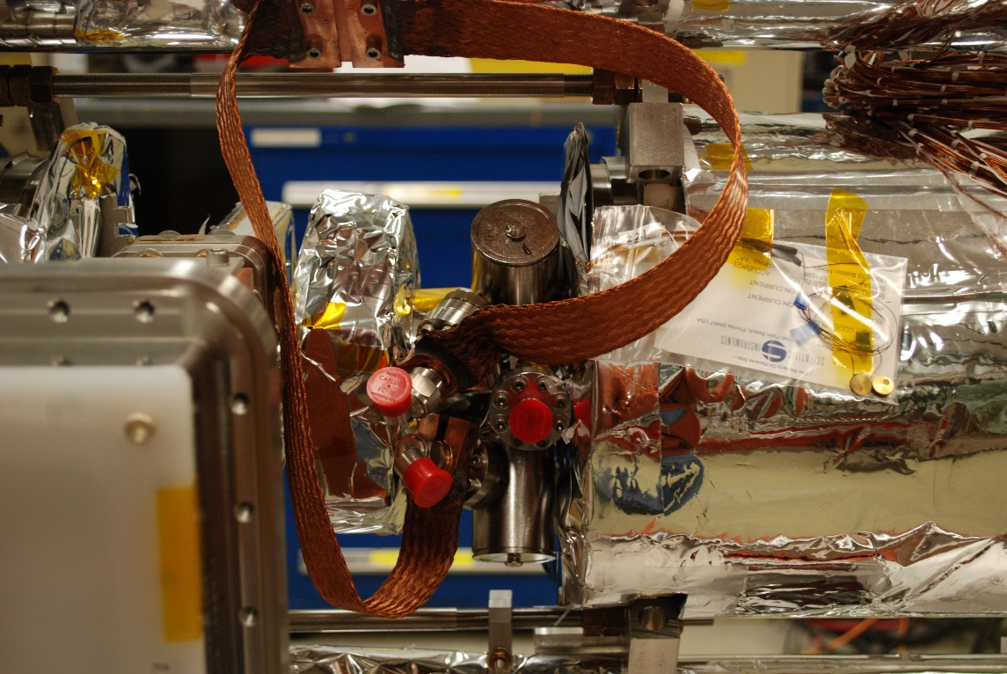 | [[HeatClampTech]] <<SRF>>  [[HeatClampDate]] <<TIMESTAMP>>  [[HeatClampComment]] <<COMMENT>>

Step No. | Instructions | Data Input
19 | Install the upper Nitronic rods (32) and (4) axial rods, and swivels, use CRM1207095-1000 to complete this work. Be sure to thread nuts until they touch lug on hv head bracket.  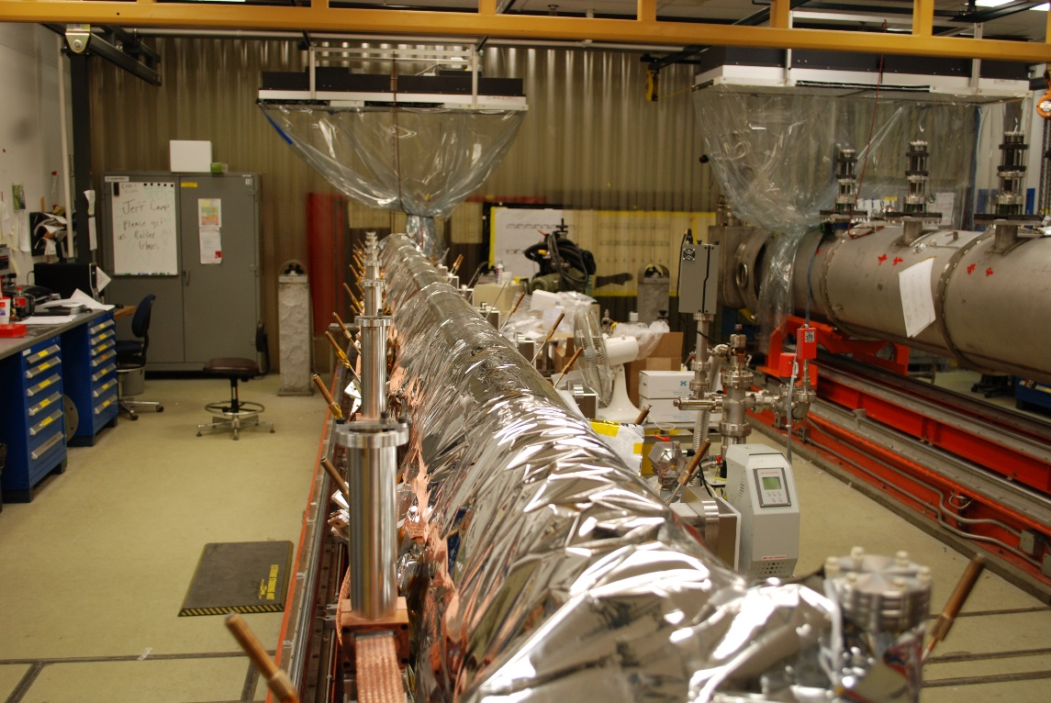 | [[RodTech]] <<SRF>>  [[RodDate]] <<TIMESTAMP>>  [[RodComment]] <<COMMENT>>
20 | Install the outer 2k MLI, 2 blankets of 5 layers each, encompassing the entire string. Use gloves and proper techniques. (CRM1207014-0300)  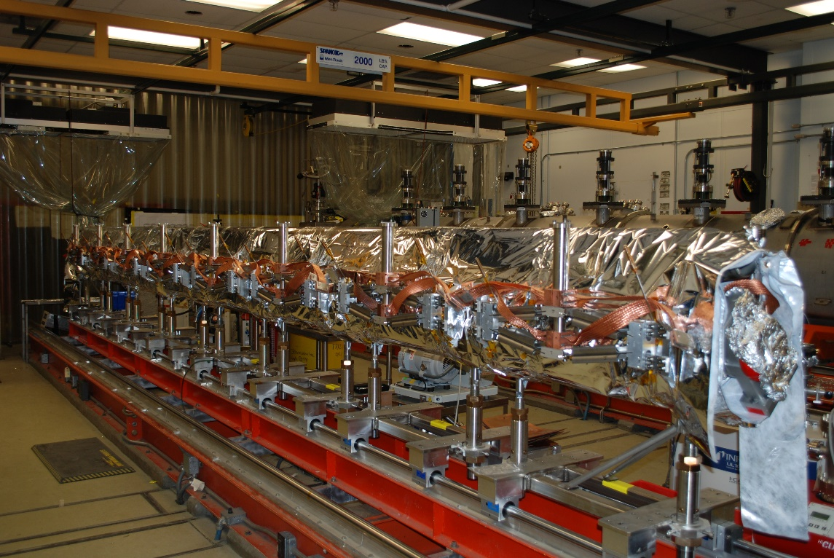 | [[OuterTech]] <<SRF>>  [[OuterDate]] <<TIMESTAMP>>  [[OuterComment]] <<COMMENT>>
21 | Perform the final instrumentation check, and record values. Use the dwgs from step 8 for reference. | [[InstElectricalTech]] <<SRF>>  [[InstrumentationDate]] <<TIMESTAMP>>  [[WireValues]] <<FILEUPLOAD>>  [[InstrumentationComment]] <<COMMENT>>
22 | Review the assembly and documentation for completeness and that Radcon criteria have been met. Upload the checklist. | [[FinalReviewSupervisor]] <<SRFCMP>>  [[RADReviewer]] <<RAD>>  [[FinalReviewDate]] <<TIMESTAMP>>  [[FinalReviewComment]] <<COMMENT>>  [[FinalReviewChecklist]] <<FILEUPLOAD>>
23 | Outside Cleanroom Assembly String Assembly Complete and ready for next level.  Hold point for sign off. | [[FinalSupervisorSignOff]] {{fischer,jjcamp}} <<HOLDPOINT>>  [[SignOffDate]] <<TIMESTAMP>>  [[SignOffComment]] <<COMMENT>>

