Preparation, Installation, and Initiation of Slam Sticks for SNS-PPU Cryomodule Shipments
Document Number: | SNSPPU-PR-CMA-SHIP-SSX | Approval Date: | 23 Feb 2022
Revision Number: | 1 | Periodic Review Date: | N/A
Document Owner: | Peter Owen | Department Owner: | SRF Operations

Purpose

This document describes the steps to prepare enDAQ shock recorders, also called Slam Sticks (SSX) for SNS-PPU cryomodule (CM) shipments from Jefferson Lab to Oak Ridge National Laboratory

Scope

This procedure defines the following instructions to prepare SSXs for use on SNS-PPU CM shipments
- Programming SSXs
- Installation on CM and Shipping Frame
- Starting SSXs prior to shipment

Terms and Definitions

Term | Definition
SNS-PPU | Spallation Neutron Source Proton Power Upgrade
CM | Cryomodule
SSX | enDAQ shock recorders, also called Slam Sticks

Roles and Responsibilities

Role | Responsibility
CM Assembly Group Lead | Ensure staff follow this procedure in a safe and correct manner
CM Assembly Technician | Follow this procedure as per Group and Shipping Lead’s directions
SNS-PPU Shipping Lead | Ensure that this procedure is carried out correctly
SNS-PPU Project Manager | Review procedure and approve CM to ship

SSX Preparation Process

Requirements
- CM on the trailer
- Eight SSXs
- Double sided table (green peel, any thickness)
- USB cables:
  - USB cables – Type A to Micro-B
  - USB hub
  - ~30 ft of USB extensions, various lengths
- A laptop with enDAQ LAB Software installed, LabView software is optional

Preparation

Configure Software

Plug each SSX into the laptop, these can be done one at a time or connected all at once

Apply the following settings (Figures 1-3):
- Recording time limit = 36000 seconds (10 hours, or long enough for the drive to ORNL)
- Ch 32: all axes turned on, record at 800 Hz
- All other recording channels turned off

Delete data from the SSXs using one of the two methods below. This does not affect the settings applied in step 5.2.1.2.
- From the LabVIEW software run the ‘Delete SSX data’ program
- Open the ‘DATA’ folder of each drive and delete any files/folders inside

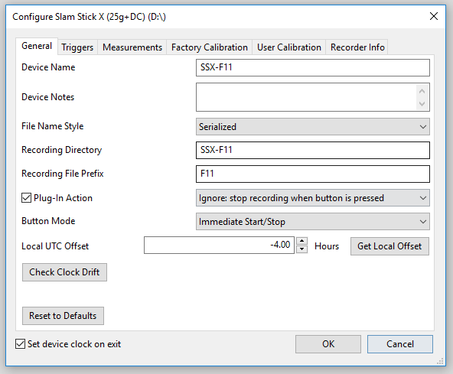
Figure 1: SSX Configuration Screen
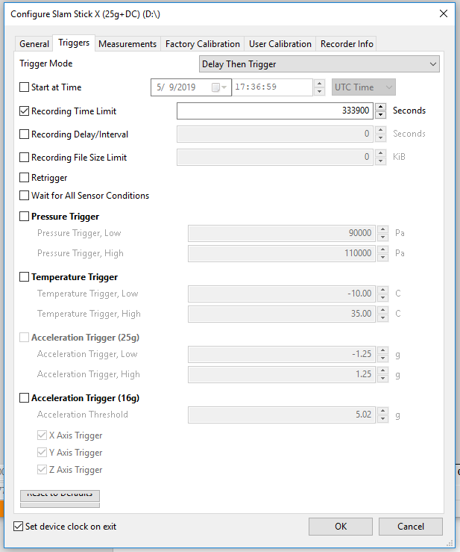
Figure 2: SSX Configuration Screen
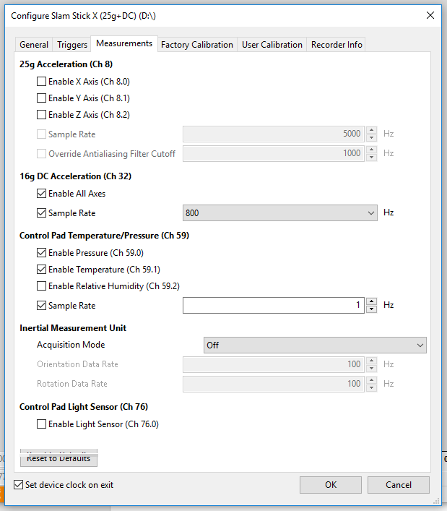
Figure 3: SSX Configuration Screen

Install on the CM

Install SSXs on the CM as per SNSPPU-PR-CMA-CM-SHIP.

Start the SSXs

Start SSXs in Software (Option 1)

Using the extensions and hubs, plug all SSXs into the laptop.

Verify all 8 are connected in Windows Explorer, they will appear like flash drives.

If some are not connecting, unplug and re-plug their cable.

Once all SSXs show their recording time set, press Set All Clocks.

Start SSXs remotely.

NOTE this cannot be undone from the laptop. Once the SSXs are started, the button on the SSX must be pressed to stop them before the timer.

LabVIEW: Run the ‘Remote Start SSX’ program.

OR: press ‘Start Recording’ for each SSX from the Ctrl + D menu in the enDAQ LAB Software.

If any SSX fails to start, unplug, re-plug, and try again.

When the SSXs are running, they will disappear from Windows Explorer and their green light will blink.

Unplug all USB cables from the laptop and SSXs.

Start SSX Manually (Option 2)

Go to each SSX and press the white button with the enDAQ logo. The green light will blink.

Try to start all the SSXs in less than 2 minutes.

Once all SSXs are running, impart a shock on the trailer to produce a calibrating event. This can be achieved by jumping on the trailer or hitting the red frame with a mallet.

Release and Revision History

Rev # | Major Changes | Approval Date:
1 | Initial version | 23 Feb 2022

Approvals

Approved by: | Name: | Signature: | Date:
Document Owner | Peter Owen | Approval and date in DocuShare. | 23 Feb 2022
SRF Quality Engineer | Jacob Harris | Approval and date in DocuShare. | 23 Feb 2022
Project Manager | Ed Daly | Approval and date in DocuShare. | 23 Feb 2022

