|  |  |  |  |
| --- | --- | --- | --- |
| **JT Actuator Calibration** | | | |
| **Document Number:** | SRF-MSPR-CM-CAL-JTAT | **Effective Date:** | DD Mmm YYYY |
| **Revision Number:** | R1 | **Periodic Review Date:** | DD Mmm YYYY |
| **Document Owner:** | John Fischer | **Department Owner:** | SRF Operations |

# Purpose

The purpose of this document is to <enter text>.

# Scope

This procedure contains the information needed to install, calibrate and test the JT Actuator and stem. The units will be installed on the Cryomodule Supply end cans during the receiving inspection process and during the Final Cryomodule Assembly work

This procedure does not apply to <enter text>.

# Terms and Definitions

The following terms have specific meanings within this procedure.

|  |  |
| --- | --- |
| **Term** | **Definition** |
| <Term 1> | <Definition> |
| <Term 2> | <Definition> |
|  |  |

# Roles and Responsibilities

The following roles have responsibilities described in this document.

|  |  |
| --- | --- |
| **Role** | **Responsibility** |
| <Job Title> | <Very short summary of activities this job title performs in this procedure.> |
|  |  |
|  |  |
|  |  |

# Procedure

## JT Actuator Calibration

Tools Needed

0-250/lb force gauge with 3/16 ball

Dial indicator with clamping attachment

3/8,9/16,and 1"wrenches

JT actuator power supply

LVDT readout screwdriver 1/16 allen wrench

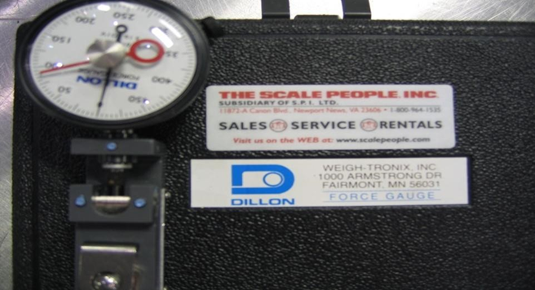

## Procedure

Actuator must first be set to provide a 200-pound seating force

### Screw down the actuator stud and move the movable plate up to allow clearance for the force gauge.

### Place force gauge with 3/16 ball under the actuator stud and actuate to provide 200 pounds of downward force.

### Adjust spring tension and actuator until snap rings under the top plate (2 places) have a 1/16 gap above the snap rings, keeping the 200 pounds of force.

### Setting the limit switch; turn the top 10-32 screw limit switch screw until it triggers the limit switch and lock screw in place. Actuate the cylinder up and then down. The cylinder should shut off near 200 pounds of force. Fine tune the limit switch until it shuts off at 200 pounds, keeping the lock nut tight.

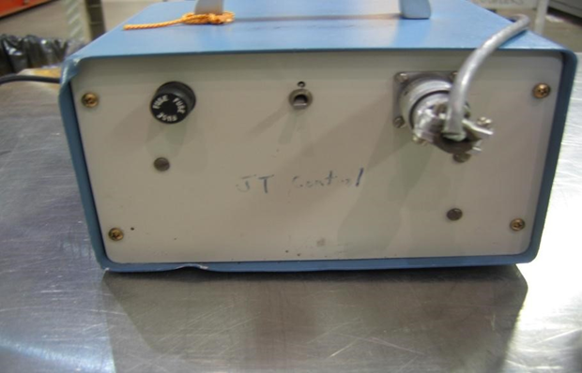

## Installing on JT valve:

### Adjusting the actuator stud; Drive the actuator to the fully closed position (the gears will stop the motion); by hand, push the JT valve closed. Set the actuator on top of the JT valve. (JT Stem already installed into end can) Adjust the actuator stud until the actuator sits flat and the stud touches the top of the closed JT stem.

### Mounting the actuator; Connect the JT stem to the actuator using a 9/16-long 10-32 stud and 10-32 kep nut. When assembling, be careful not to twist the JT stem bellows. Drive the actuator up until the actuator sits flat on the JT flange. Install the actuator mounting screws.

### Setting the actuator stroke and over travel limit; Drive the actuator to the fully closed position. (The 200 pound limit switch should turn off the actuator and the “C" clips should have a 1/16 gap above them). Install a dial indicator to measure movable plate stroke. Open the JT value to .562". Adjust the position of the middle plate so it about 1/8" from hitting the “C" clips and lock in place. BE CAREFUL NOT TO ROTATE THE ACTUATOR TUBE

### Setting the bottom limit switch; Adjust the bottom 10-32 limit switch screw until it triggers the limit switch and lock in place. Check the actuator travel and adjust the limit switch screw until the actuator has a .562" travel.

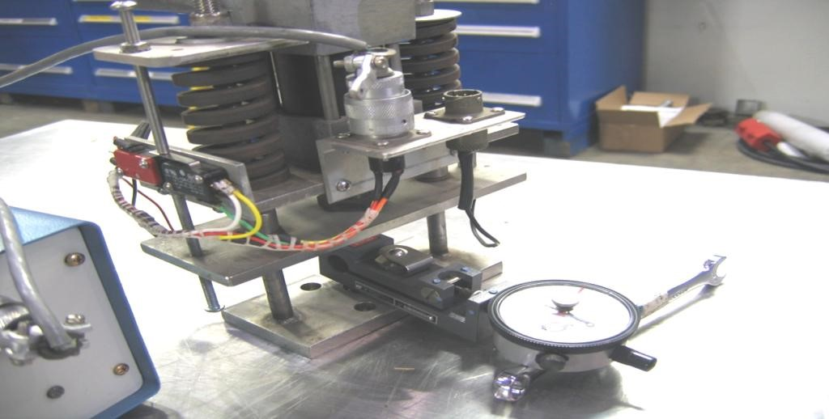

## JT Actuator installed onto a Supply End Can

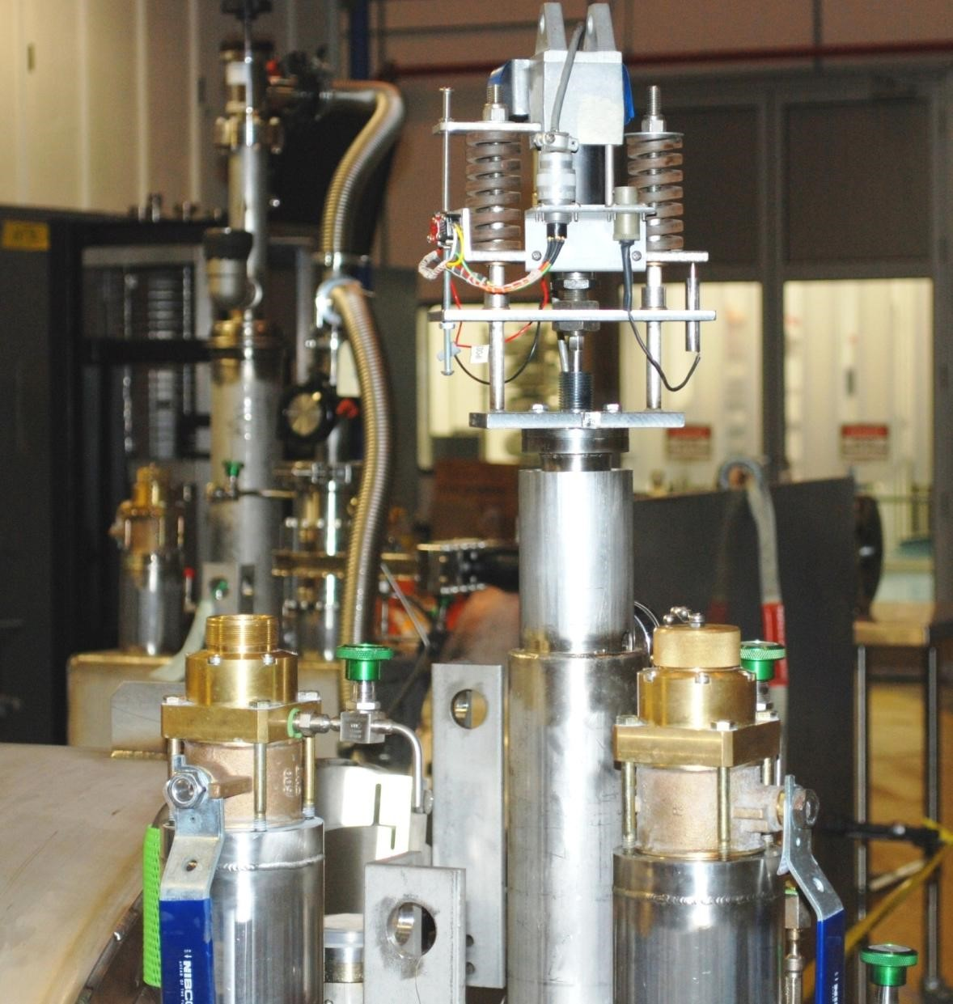

## Verify the JT bullet seals in the end can seat.

Using the most current End Can or Cryomodule Pressure Testing OSP, verify the stem seals.

### Close the JT valve, verify snap rings are off the seats.

### Install the high pressure manifold with the appropriate gauge onto the peanut relief spigot for the primary circuit.

### Pressurize the inlet side of the JT valve to 200 psig, valve off the supply, snoop connections to verify there are no leaks.

### Record pressure every 15 minutes for a duration of 2 hours.

### If pressure change is >2 psig, seat and/or bullet shall be reworked.

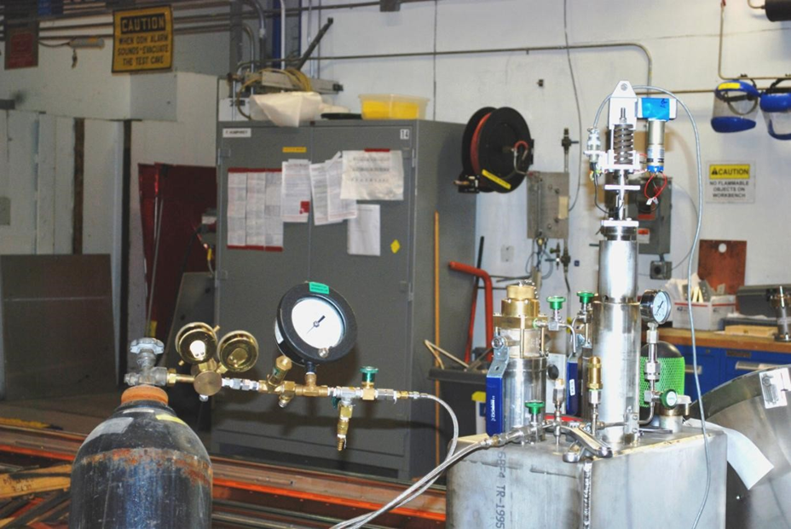

Supply End Can Pressure Test Setup

## Setting of the JT Actuator

### Purpose

##### The purpose of his Procedure is to ensure a proper setting of the JT Valve Actuator on the Cryomodule.

### Scope

#### This Procedure is used for individuals responsible for setting the Actuator. Setting stroke, seating force, limit switches, and mounting.

### Equipment Required

* 0-250/lbs force gauge with 3/16” ball
* Dial indicator with clamping attachment
* 3/8”, 9/16” and 1” wrenches
* JT actuator power supply
* LVDT readout
* Screwdriver
* 1/16” allen wrench

### Procedure

When tightening or loosening the stud lock nuts be careful to not rotate the valve stem. This could compromise the internal bellows.

#### Screw down the actuator stud and move the movable plate up to provide clearance for the force gauge.

#### Place the force gauge with the 3/16” ball under the actuator stud and actuate to provide 200 pounds of downward force. Do not exceed force on the force gauge.

#### Adjust the spring tension and actuator until the snap rings undor the top plate (2 places) have 1/16” gap above the snap rings with 200 lbs of force.

#### Setting the limit: turn the top 10-32 limit switch screw until it triggers the limit switch open and lock in place. Actuate the cylinder up and then down. The cylinder should shut off near the 200 lbs of force. Fine tune as needed locking the screw jamb nut when done.

#### The actuator is now set to provide 200 lbs of seating force.

#### After the seating force has been set it can be installed onto a JT stem.

#### Adjust he actuator stud: Drive the actuator fully closed position, by hand push the JT stem closed. Set the actuator on top of the JT Valve. Adjust the stud until the actuator sit flat and the stud touches the top of the closed JT stem.

#### Mounting the actuator: Connect the JT stem to the actuator using a 9/16” long 10-32 stud and kep nut. When assembling, be careful not to twist the JT stem. Drive the actuator up until the actuator sits flat on the JT flange. Install the actuator mounting screws.

#### Setting the actuator stroke and limit switches: Drive the actuator to the fully closed position. The 200lb limit switch should stop the actuator and the snap rings should be off the above plate. Install a dial indicator to measure the plate stroke. Open the JT valve to .562”. Adjust the position of the middle plate so it is about 1/8” from hitting the “c” clips and lock in place. Again be careful to not rotate the JT stem.

#### Setting the bottom limit switch: Adjust the bottom 10-32 limit switch screw until it triggers the limit switch and lock in place. Check the actuator travel and adjust the limit switch screw until the actuator has .562” travel.

#### Calibrating the LVDT

* Plug in the LVDT readout
* Close the JT valve then open it slightly unti the gap above the 2 snap rings is eliminated
* Loosen the LVDT set screw and adjust until it reads “zero” on the readout. Tighten the set screw to lock the LVDT in place. Do not over tighten.
* Checking the LVDT readback: In the fully closed position (200 lbs of seating force) the readback should indicate ~10%, and in the fully open position the readback should indicate 100% or better.

# References

|  |  |
| --- | --- |
| **Document No.** | **Title** |
| SRF-01-ML-001 | SRF Quality Manual |
| CRM1208010-  0000 SHTS 13 | Supply End Can |
| 75600-0005 | JT Actuator Assy |
| 75600-0165 | JT Valve Assy |

# Release and Revision History

|  |  |  |
| --- | --- | --- |
| **Rev #** | **Major Changes** | **Effective Date:** |
| 1 | Initial version | DD Mmm YYY |
| <2> | <brief description of major changes> | DD Mmm YYY |
|  |  |  |
|  |  |  |

# Approvals

|  |  |  |  |
| --- | --- | --- | --- |
| **Approved by:** | **Name:** | **Signature:** | **Date:** |
| Document Owner | J. Campbell |  | DD Mmm YYY |
| Subject Matter Expert | F. Humphry |  | DD Mmm YYY |
| Work Center Lead | <First Last Name> |  | DD Mmm YYY |
| Project Leader | <First Last Name> |  | DD Mmm YYY |