**Step by step, illustrated and updated procedure for HOM survey**

Peter Owen

powen@jlab.org

January 2019

This procedure details the use of the VTA HOM survey LabView program. It reflects mainly the preparation of an Excel file to be used by Mathematica to extract Qloaded values.

**A. Connect the network analyzer to the cavity and laptop**

1. Connect a 4-port E5071C network analyzer as follows
2. Port 1 connected to the FPC adapter
3. Port 2 connected to HOM A
4. Port 3 connected to HOM B
5. Port 4 connected to FP adapter (field probe), it may be useful to attach port 4 to the output of a RF preamp
6. Connect the network analyzer to the srfvtalap laptop using the GPIB – USB adapter.

**B. Use LabVIEW program for HOM survey data acquisition**

1. Login to VTA laptop as srs-ee (use the PASSWORD).
2. Open the LabVIEW shortcut on the desktop called “VTA HOM Survey.vi”.
3. Under the ‘README’ tab, a short description of the program’s function as well as the options available to the user are listed.
4. Under the ‘Setup Inst’, fill in the information about the test: Tester’s Name, Dewar #, etc.
5. 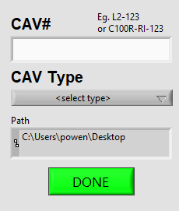Make sure to select the VISA instrument as connected
6. Run the program by clicking the white arrow. (Fig. 1)
7. A popup window will appear asking where to save the collected data, and important information about the cavity. (Fig. 2)
8. 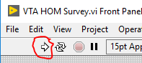Fill in the information and click ‘Done’.

Fig 2 Cavity information popup

Fig 1. White run arrow

3 White run arrow

1. 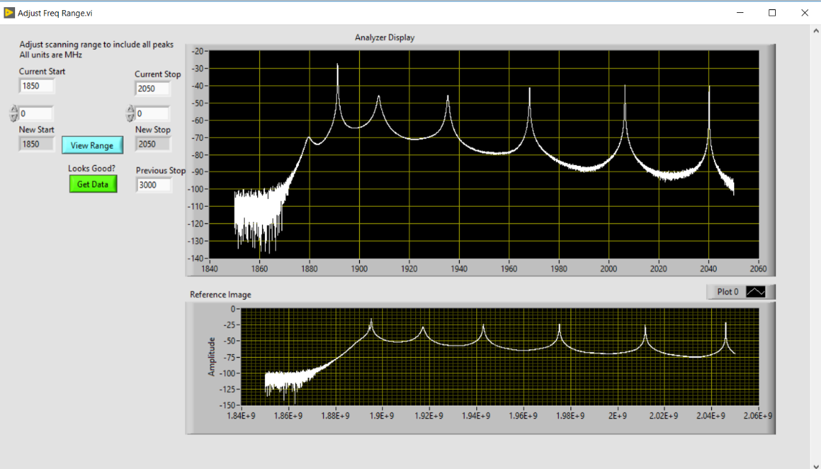The program will take data for the full range of HOM bands, then prompt the user to refine the next range of data. Sample data is provided to show what the trace(s) should look like, most notably the number of peaks in the range. Adjust the start and stop frequency from the program to reduce the amount of noise floor captured.
2. Repeat step (9) as prompted by the program.
3. After a few prompts, the program will begin taking an S41 measurement of the passbands. This measurement will take some time due to the small bandwidth resolution.
4. Once the scan has completed, the program will export the data from each scan as well as an image of each range to an Excel spreadsheet. Double check that all ranges are exported properly (two sheets per range for C100 surveys) and ensure the file has been saved in the selected folder
5. Now that the data has been saved, send the spreadsheet to the person analyzing or follow the next steps of the procedure.
6. It may be useful at this stage to identify the Pi mode of the cavity to help whoever is running the RF test

This concludes the parts of HOM survey process that need to be performed at the cavity. Save and send the spreadsheet file for analysis. The analysis to extract Q values can be performed by another person at another time.