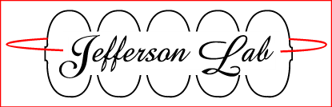

**Accelerator Division**

**Institute for SRF Science & Technology**

**Common Procedure**

## *C100 Cryomodule Beam pipe Assembly and Installation*

## *Procedure ID # CP-C100-CM-ASSY-BPIP*

*This procedure describes the supply and return beam pipe preparation and installation onto the C100 Cryomodule. This work is to be performed as per this procedure by knowledgeable and trained staff only. Adverse effects to the Cryomodule performance can result otherwise. It assumes the beam pipes have been properly assembled and are ready for use.*

|  |  |  |  |  |  |  |
| --- | --- | --- | --- | --- | --- | --- |
| Author : | | Dave Bigelow | | Date : | | 8-2-2013 |
| Name: Authors name | |
| Reviewer: | | John Fischer | | Date : | | 8-2-2013 |
| Name: Reviewers name | |
| Version | | 1.0 | | | | |
| Approval Date | |  | | | | |
| References | | List and Hyperlink all documents related to this traveler. | | | | |
|  | |  | |  | |  |
|  | |  | |  | |  |
|  |  | |  | |
|  | |  | |  | |  |  |
|  | |  | |  | |  |  |

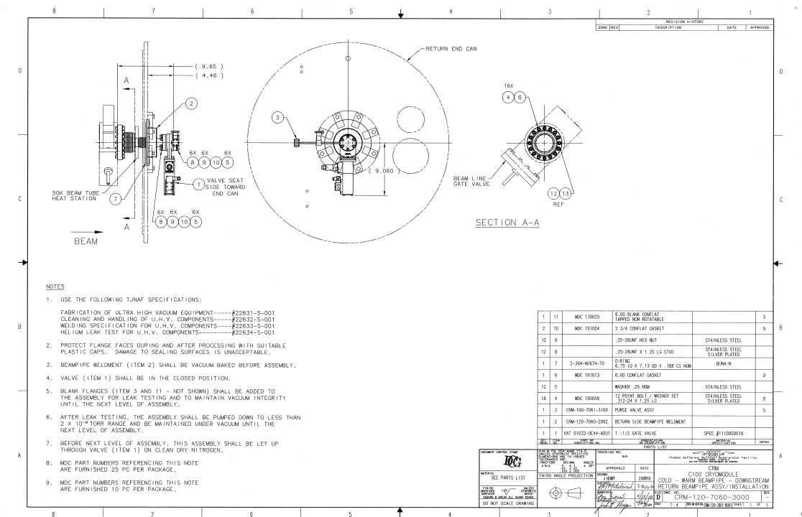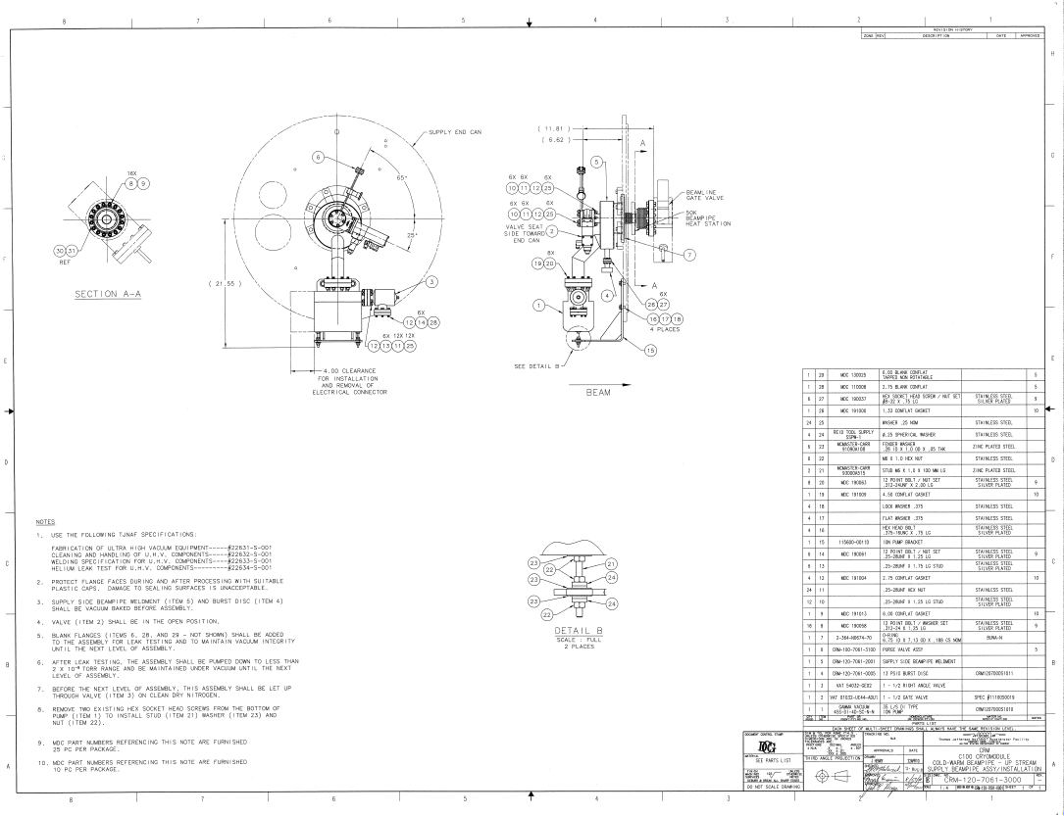

|  |  |
| --- | --- |
| **Step No.** | **Instructions** |
| Prior to the beam pipes being installed the following steps must be completed.   * End cans are aligned and verified. * Bridging o-ring groove cleaned ,inspected, and o-ring installed * End can beam pipe o-ring surface cleaned * Beam pipe flange dogs, hardware, and o-rings are positioned and ready for use   **\*\*\* During clean beam pipe work the following steps are to be followed \*\*\***   * Wipe down and blow off all surfaces to be inside the flow hood. * Position the laminar flow hood over the work area. * Tape the curtains to eliminate leaks into the hooded area. * Cover the other exposed surfaces in the flow hood with aluminum foil. * Allow the flow hood to run for 20 minutes. * Set up the particle counter and begin monitoring the particle count. * Don clean room garments, hair net, gloves, and smock to perform all clean vacuum work. * Stage all supplies and tools inside the flow hood, on the perforated work surface. * Once the count is stabilized at zero (.05 micron scale), you are ready perform work. | |
| 1 | **Supply Beam pipe Installation**  Clean and grease the beam pipe o-ring.  Install the beam pipe o-ring into the beam pipe flange groove.  Carefully raise the pump drop to the height of opening in the end can.  Gently insert the flange and bellows through the end can opening until the o-ring is flush with end can mating surface.  Secure the pump drop to the surface using the dogs provided.  Using the alignment arm and scopes align the beampipe within .010”.  Install the pump drop bracket, affix pump hardware. |
| 2 | **Turbo Hook Up**  Wipe down and blow off all surfaces between the end can and the cryomodule.  Position the laminar flow hood over the beam pipe area.  Tape the curtain around the flanges about to be connected.  Cover the other exposed surfaces in the flow hood with aluminum foil.  Allow the flow hood to run for 20 minutes.  Set up the particle counter and begin monitoring the particle count.  Stage all supplies and tools inside the flow hood, on the perforated work surface.  Once the count is stabilized at zero (.05 micron scale), you are ready to hook up a beam line turbo pump to the pump drop.  Bleed up the pump using clean, dry, filtered nitrogen.  Don clean room garments, hair net, gloves, and smock to perform all clean vacuum work.  Once the hose is bled up, remove the blanking flanges on the turbo’s hose and the right angle valve on the pump drop assembly.  Install a clean copper gasket, connect the two flanges and torque down.  Once all of the bolts have been tightened to a uniform distance, pump and purges may begin.  Pump and purge the turbo line 3 times.  After the third time, maintain vacuum on the pump up to the right angle valve. |
| **3** | **Leak Check the connection**  Using the RGA, ensure that the connection is leak tight.  Upon confirmation of being leak tight, open the right angle valve making a common vacuum.  Valve off RGA.  Once the pressure has stabilized, begin backfilling the pump drop with clean, dry, filtered nitrogen. Allow it to purge for five minutes. |
| **4** | **Beam pipe Hook Up**  Record the Cavity string beam line pressure.  Verify the Cavity string cold valve is closed.  Monitor the beam line pressure throughout the procedure. If vacuum fluctuates during bleed up, stop purge and pump down. Consult a Supervisor to discuss further actions.  Follow clean work procedure described above.  Remove the blanking flanges from the beam pipe and cavity string.  Ensure that the particle counter remains at zero.  Using a clean copper gasket, make the conflat connection and uniformly tighten the bolts.  Install the 50K heat stationing clamp.  Position the end can and lock down. |
| **5** | **Leak Check Connection, Establish Vacuum**  Begin the first of three pump back fills. After the third pump down leave the pump drop under vacuum.  Once pressure is into the e-6 range leak checking may begin using the RGA.  Upon confirmation of being leak tight, record the leak check.  Start the pump drop ion pump.  Valve off RGA.  Once the beam pipe pressure is within 1 decade of the Cavity string pressure, the string cold valve can be opened, making beam pipe vacuums common.  Close the Return end Cavity string cold valve.  Cavity string vacuum is now on Supply pump drop only. |
| **6** | **Return Ion Pump Manifold Removal**  Verify the Cavity string cold valve is shut.  Follow clean work procedure described above.  Bleed up the pump using clean, dry, filtered nitrogen.  Once the hose is bled up, remove the blanking flanges on the turbo’s hose and the right angle valve on the ion pump manifold.  Install a clean copper gasket, connect the two flanges and torque down.  Once all of the bolts have been tightened to a uniform distance, pump and purges may begin.  Pump and purge the turbo line 3 times.  After the third time, maintain vacuum on the pump up to the right angle valve. |
| **7** | **Leak Check the connection**  Using the RGA, ensure that the connection is leak tight.  Upon confirmation of being leak tight, open the right angle valve making a common vacuum.  Valve off RGA.  Record and monitor the Cavity string beam line vacuum. If vacuum fluctuates during bleed up, stop the purge and pump down the manifold. Consult a Supervisor to discuss further actions.  Once the pressure has stabilized, begin backfilling the pump drop with clean, dry, filtered nitrogen. |
| **8** | **Remove the Return Manifold**  While monitoring the Cavity string vacuum, remove the hardware.  Remove the manifold assy, be careful not to compromise the Cold valve knife edge.  Install a clean gasket and temporary 6” blank CFF onto the Cold valve, snug the hardware.  Disconnect the manifold from the beam line turbo, cover all open ports. |
| **9** | **Position the Return End Can**  Carefully install the Return beam pipe into the Return end can.  Secure with the dog clamps.  Using the alignment arm and scopes align the beampipe within .010”.  Slide the end can into position and lock down.  Follow the clean work procedure described above. |
| **10** | **Hook up Return Beam Pipe**  Record the Cavity string beam line pressure.  Verify the Cavity string cold valve is closed.  Monitor the beam line pressure throughout the procedure. If vacuum fluctuates during the activity, stop work. Consult a Supervisor to discuss further actions.  Follow clean work procedure described above.  Remove the blanking flanges from the beam pipe and cavity string.  Ensure that the particle counter remains at zero.  Using a clean copper gasket, make the conflat connection and uniformly tighten the bolts.  Install the 50K heat stationing clamp.  Reposition the end can and lock down.  Install the beamline turbo to the manifold on outside of the Return end plate. |
| **11** | **Leak Check the connections**  Using the RGA, ensure that the connection is leak tight.  Upon confirmation of being leak tight, open the right angle valve on the manifold, evacuating the Return beam pipe.  Leak Check the Return beam pipe, record findings.  Start the manifold ion pump.  Valve off RGA.  Once the beam pipe pressure is within 1 decade of the Cavity string pressure, the string cold valve can be opened, making the beam pipe vacuums common. |
| **12** | **Close Return Warm VAT Valve**  Follow the clean work procedure described above.  Hook 80 psi Nitrogen supply to warm valve.  Attach the valve control box to the valve solenoid.  Cycle the valve shut.  While monitoring the beam line pressure slowly bleed up the backside of the VAT valve. If the vacuum fluctuates during the activity, stop work. Consult a Supervisor to discuss further actions.  Remove the Return manifold.  Install a clean lollipop assembly.  Install a beam line turbo to the pump out port on the lollipop.  Evacuate.  Leak check the connection.  Close the Nupro valve.  Valve off the RGA.  Bleed up the turbo pump, and remove.  Blank off the pump out port. |
| **Beam line should be on the Supply Ion Pump, with both warm VAT valves shut and lollipops installed. All work shall be recorded in the Assembly Travelers and necessary documents generated.** | |

