|  |  |  |  |
| --- | --- | --- | --- |
| **SNS-PPU Cryomodule Shipping Procedure** | | | |
| **Document Number:** | SNSPPU-PR-CMA-CM-SHIP | **Approval Date:** | 23 Feb 2022 |
| **Revision Number:** | 3 | **Periodic Review Date:** | N/A |
| **Document Owner:** | Naeem Huque | **Department Owner:** | SRF Operations |

# Purpose

This document describes the steps to prepare an SNS-PPU cryomodule (CM) for over-the-road shipping from Jefferson Lab to Oak Ridge National Laboratory.

# Scope

This procedure defines the shipping preparations for an SNS-PPU CM after the completion of testing in the CMTF:

* Preparation of CM and other deliverables
* Loading/Securing CM on the trailer
* Installing shipping instrumentation
* Verifying documentation

# Terms and Definitions

|  |  |
| --- | --- |
| **Term** | **Definition** |
| SNS-PPU | Spallation Neutron Source Proton Power Upgrade |
| CMTF | Cryomodule Testing Facility |
| CM | Cryomodule |
| SHCS | Socket-Head Cap Screw |
| HHCS | Hex-Head Cap Screw |
| FPC | Fundamental Power Coupler |
| DoT | (US) Department of Transportation |
| SSX | enDAQ shock recorders, also called Slam Sticks |

# Roles and Responsibilities

|  |  |
| --- | --- |
| **Role** | **Responsibility** |
| CM Assembly Group Lead | Ensure staff follow this procedure in a safe and correct manner |
| Assembly Technicians | Follow this procedure as per Group and Shipping Lead’s directions |
| SNS-PPU Shipping Lead | Ensure that this procedure is carried out correctly |
| SNS-PPU Project Manager | Review procedure and approve CM to ship |

# Shipping Preparation Process

## Remove testing hardware

#### Remove the three Baratron gauges from the end can piping. These will remain in the CMTF

#### Install caps on open pipe outlets (pipes, bayonets, cooldown line outlet)

#### Detach coupler exhaust line (stays in CMTF)

#### Unhook instrumentation cables (stays in CMTF)

#### Turn off and disconnect vacuum pumps

#### Roll out of the test cave. The CM will remain on the orange transport carts.

## Prepare Process Piping

#### Pressurize process piping to 1psig as per the manifold’s pressure testing SOP

#### Label each line as pressurized

## Electrical Checks

### Cavity Checks

#### Perform the cavity tuner position checks and the passband frequency measurements

### Electrical Checkout

#### Contact the Instrumentation Group to perform the final electric pin checkout

## Cryomodule Preparation

These steps are carried out prior to the CM being loaded on to the shipping frame. The work can happen before or after the CM is removed from the CMTF.

### Remove Actuators

#### Uninstall the three actuators on the end cans and pack them in the dedicated cases

#### Install the Joule-Thompson valve restraint (JL0122843) with the valves in an open position using the #10-32 hex nuts and ¼-20 SHCS as shown in JL0122842

#### Torque hex nuts to 33 in-lbs

### Install FPC Shipping Cover

#### Install the FPC Shipping Cover (JL0123683, Item 6 on JL0078591) on all four FPCs.

#### Install the cover using the fasteners and washers (Items 10, 11, and 12), and the brass ¼-28 SHCS (Item 14) in the center positon. Finger tighten only at this stage.

#### Torque the eight ¼-20 Stainless Steel SHCS to 65 in-lbs.

#### Tighten the center SHCS until snug (do not over torque). Add tape to secure screw.

### Remove lift plate Shroud, if installed.

#### Take out the #10-32 HHCS and remove the shroud on top of the Return End Can lift plate (Figure 5.4.4).

#### Pack the cover in its dedicated case.

#### Install the #10-32 HHCS back into the same holes and tighten.

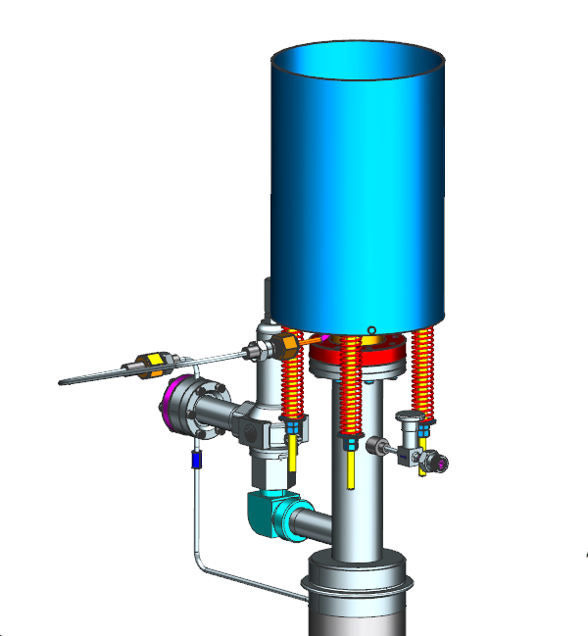

Figure 5.4.4: Lift Plate Shroud

### Remove coupler magnets

#### Carefully remove the cold cathode gauge magnets from each of the FPCs (eight in total). Take care not to damage bellows.

#### Pack the magnets and hardware in the dedicated case

## Loading Cryomodule onto the Trailer

### Load Shipping Frame onto the Trailer

#### Inspect all trailer tires for damage.

#### Back the trailer in to the High Bay loading dock.

#### While the trailer is being backed, there should be four spotters at each corner of the tractor/trailer, all within vocal communication range.

#### The trailer must be in a position to allow the loading bay door to be closed.

#### After the trailer is positioned, close the loading bay door, chock the wheels, lower the landing legs, and disengage the tractor.

#### Open the sliding roof and secure it at the fifth-wheel end of the trailer.

#### Position 5 wooden 4x4 supports along under the area where the frame will sit.

#### Load the shipping frame on to the trailer, with the Return End Can support positioned at the rear of the trailer. The Supply End Can side of the shipping frame must be ~1 – 3ft from the drop on the trailer.

### Strap Shipping Frame to Trailer

#### Print out copies of Figures 5.5.2.1-4 on a D size paper and hang it in a visible location near the work area

#### Strap the shipping frame’s outer frame (black structure) to the trailer using five 4” wide DoT rated straps and chafe protection (Figure 5.5.2.1), in the positions shown in Figures 5.5.2.1-4 Check that there are no twists in the strap.

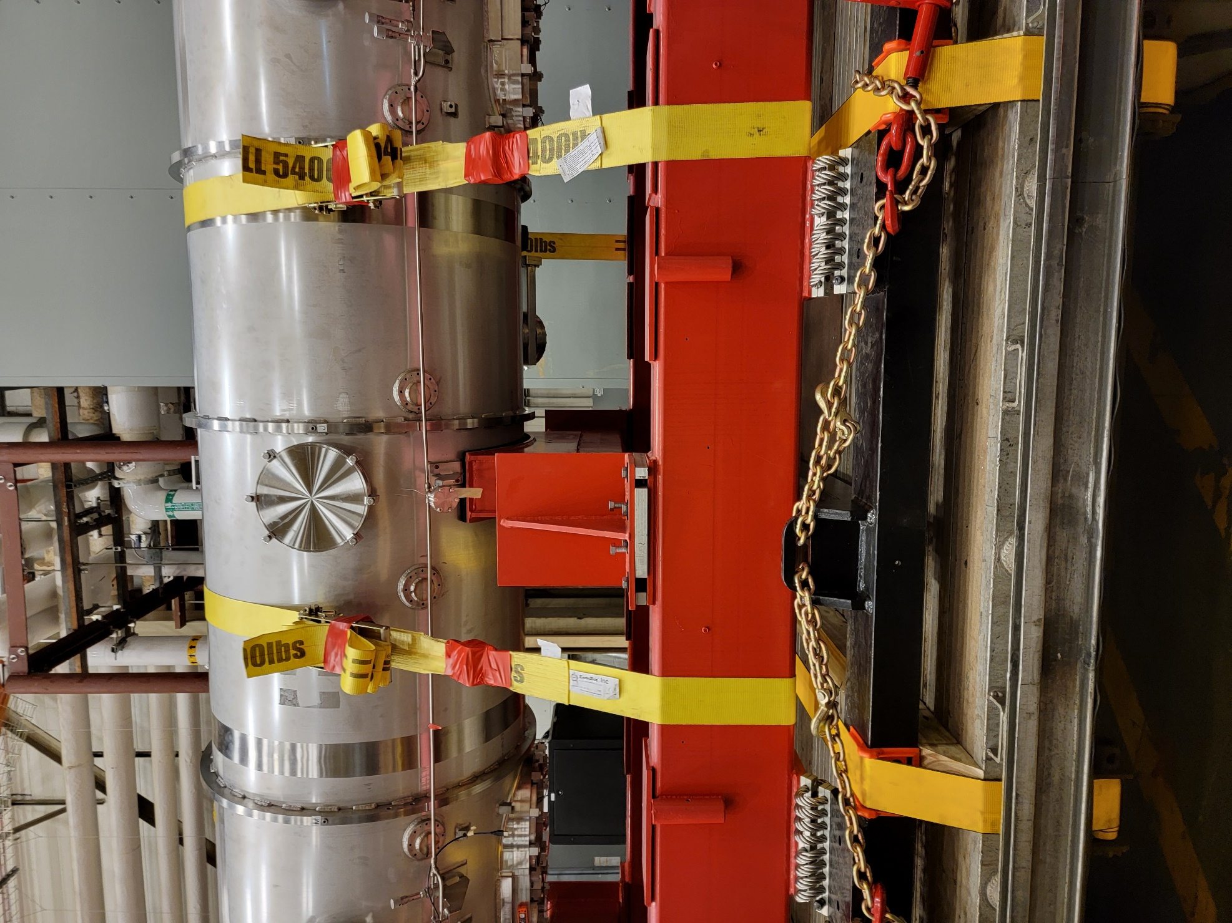

**Figure 5.5.2.1: DoT 4” strap and protector, with chain**

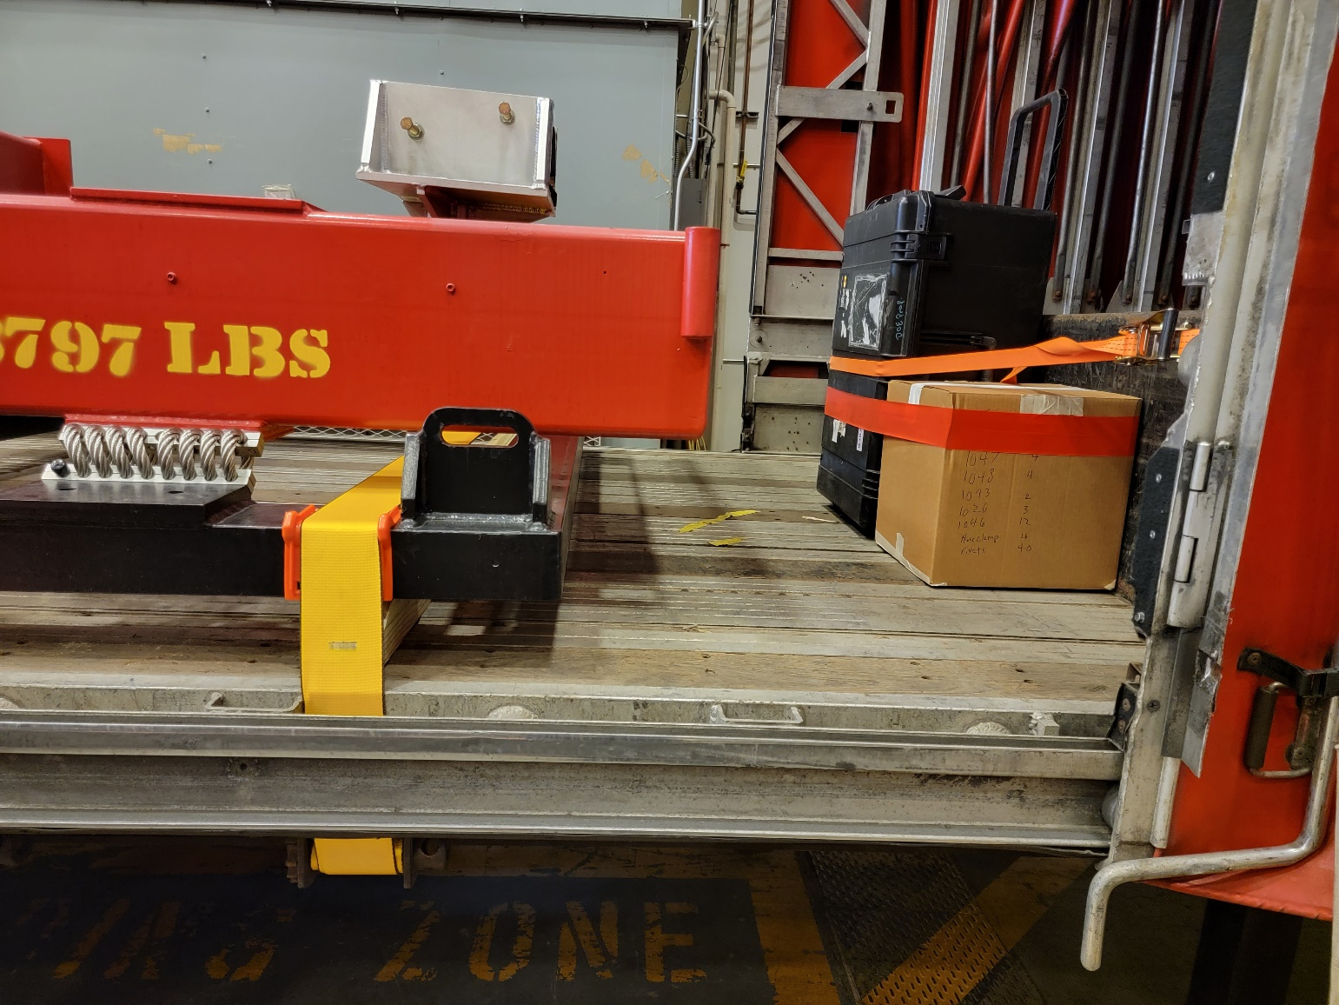

**Figure 5.5.2.2: Location of strap**

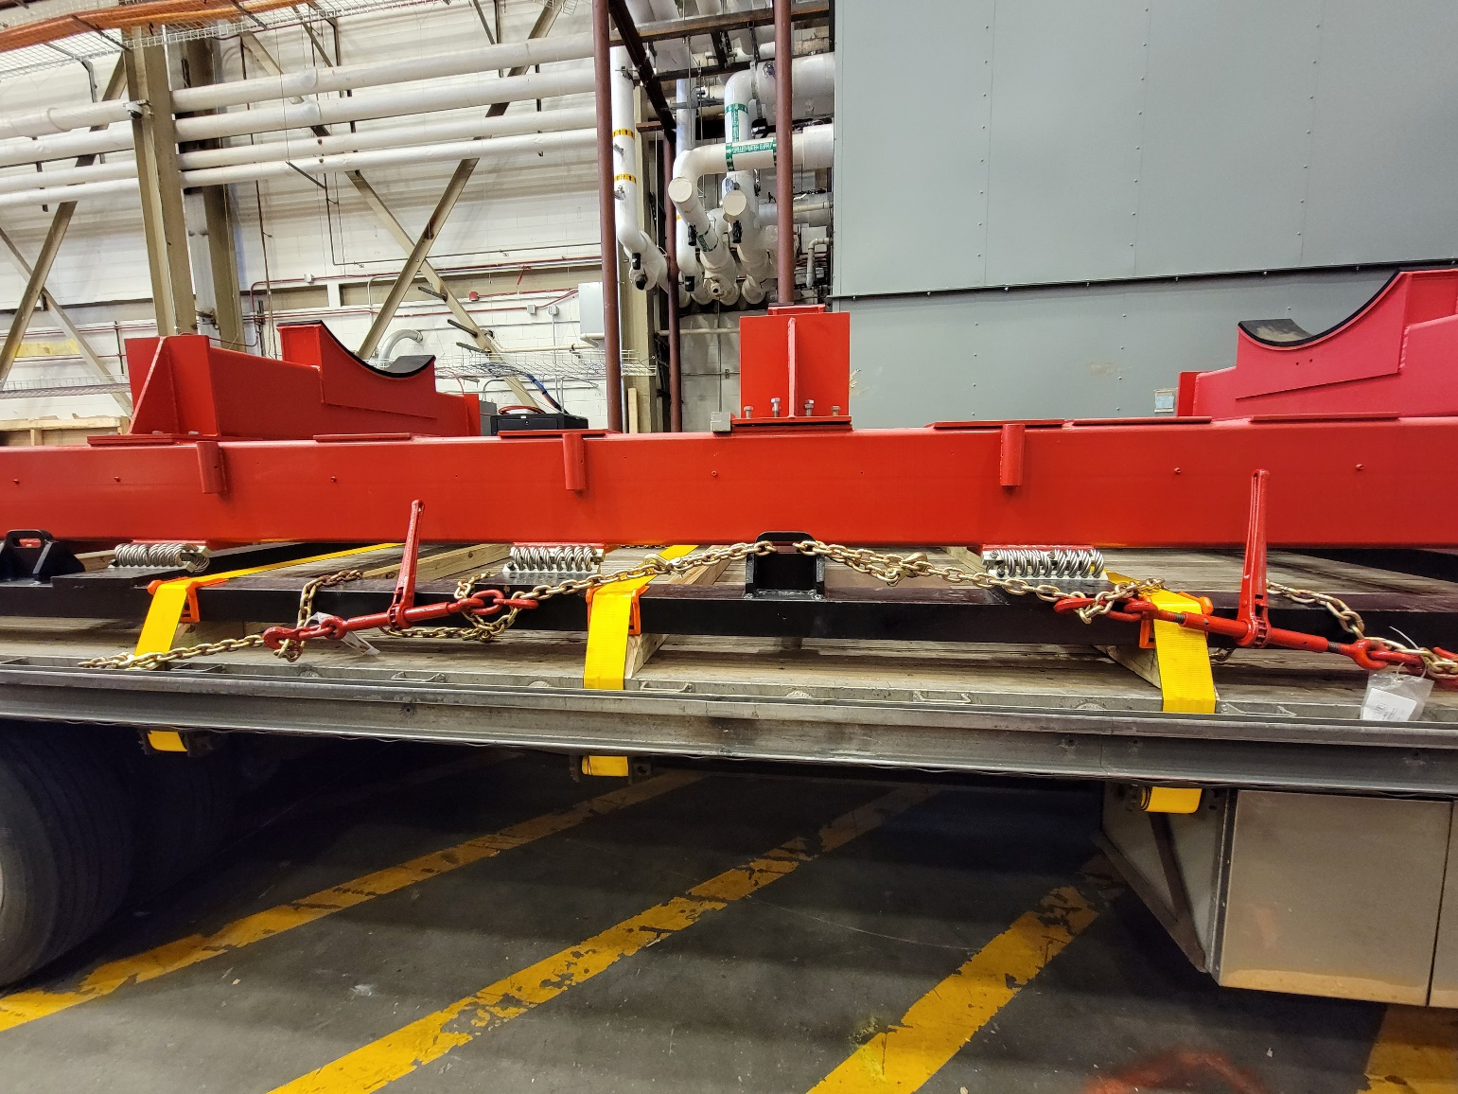

**Figure 5.5.2.3: Location of straps**

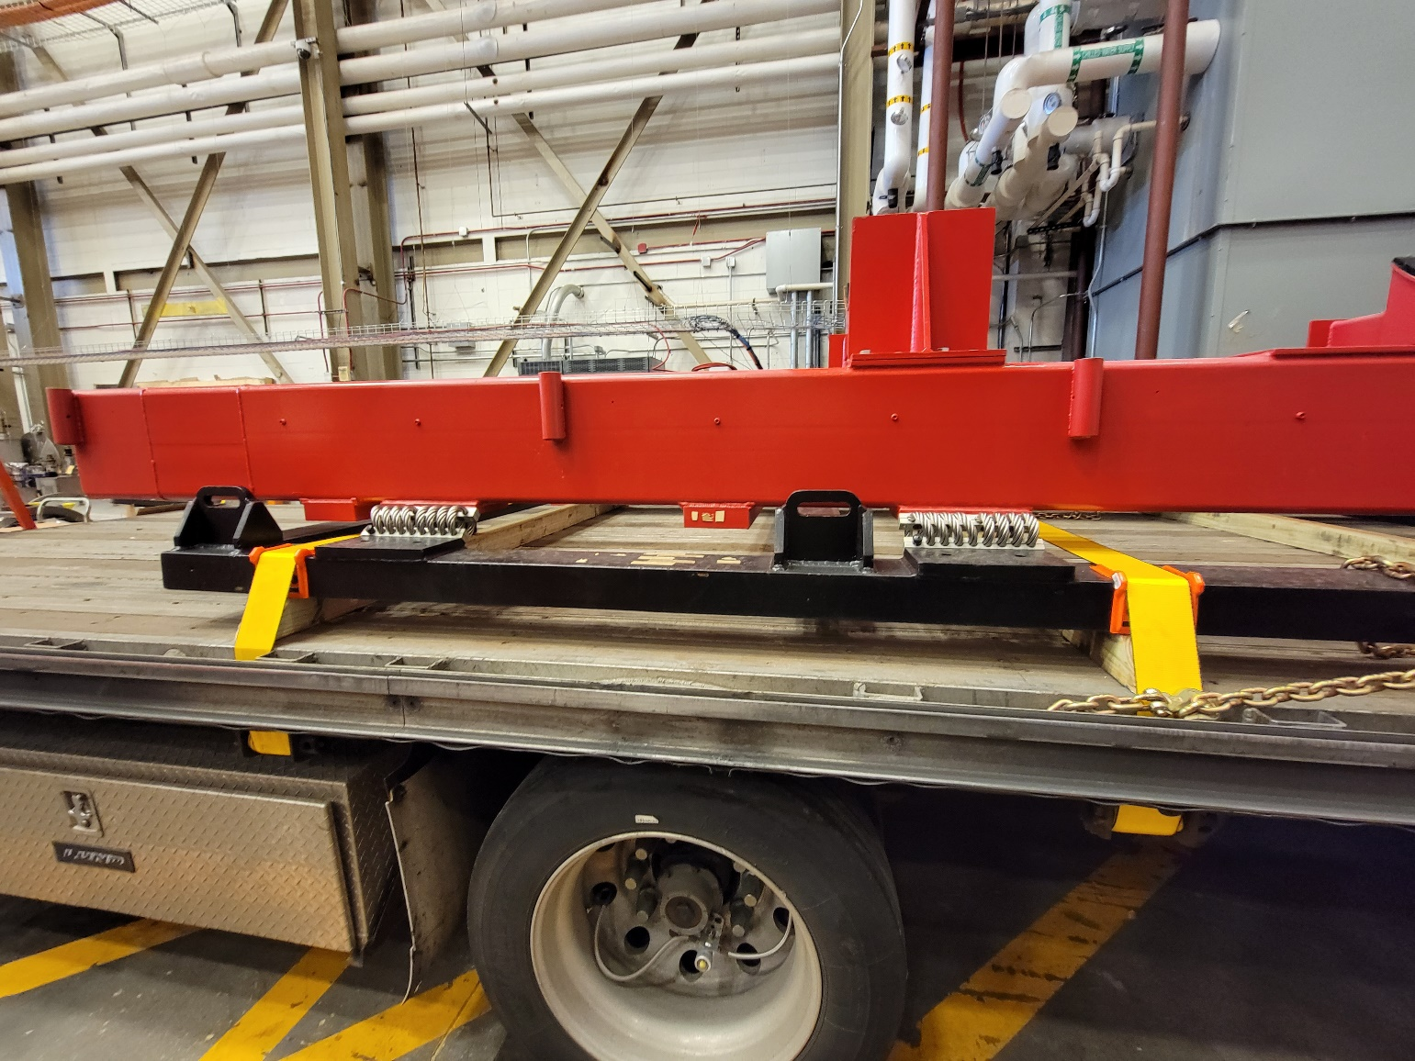

**Figure 5.5.2.4: Location of straps**

#### Install and tighten chains.

#### The allowable fixture positions for straps and chains may be different for different trailers.

#### Tighten all the straps and chains.

#### An experienced team member not involved in the loading should inspect the straps and clear the hold point in the traveler

### Loading CM into Shipping Frame

#### Lower the two end can supports on the shipping frame.

#### Remove the shims from the central support and lower the support.

#### Load the CM into the Shipping Frame using the Lift Plan “SNS Cryomodule and Shipping Frame Lift to Trailer”.

#### Level the CM using the Primary Return bayonet flange as reference

#### Raise the central support until it comes in contact with the vacuum vessel using the jacking screws.

##### Tighten the jacking screws until there is additional resistance, implying that there is contact between the center support and the vacuum vessel.

##### Turn the jacking screws half a turn to ensure contact.

##### There should be 3/16” clearance between the edge of the center support and the coupler line support on the vacuum vessel (Figure 5.5.3.1)

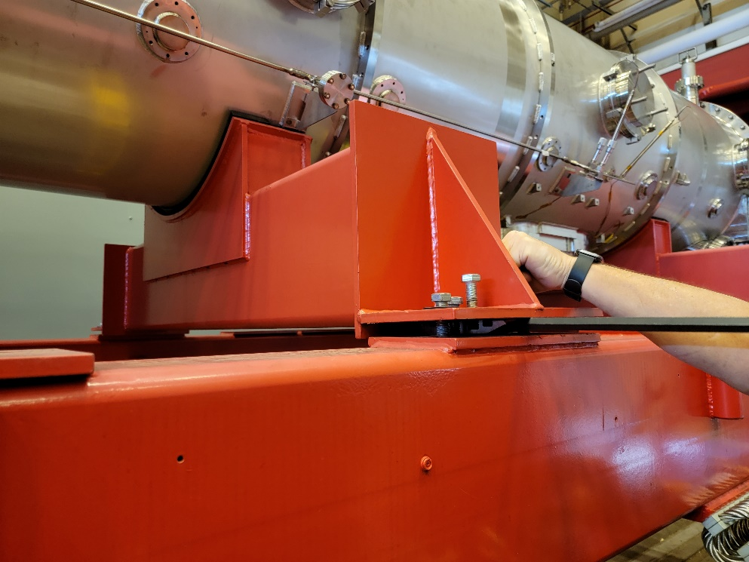

**Figure 5.5.3.1: Raised center support**

#### Install shims under the center support (Figure 5.5.3.2).

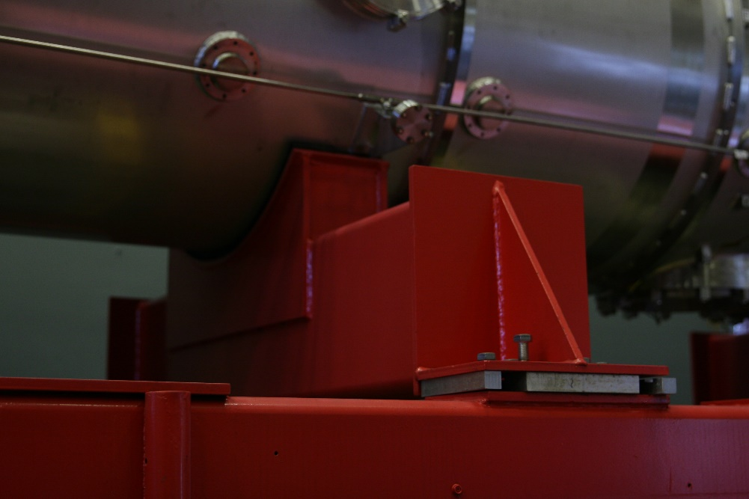

**Figure 5.5.3.2: Shims under center support**

#### Use 4 DoT rated 4” wide straps (U-Line or other) to fix the CM on to the shipping frame (Figure 5.5.3.3).

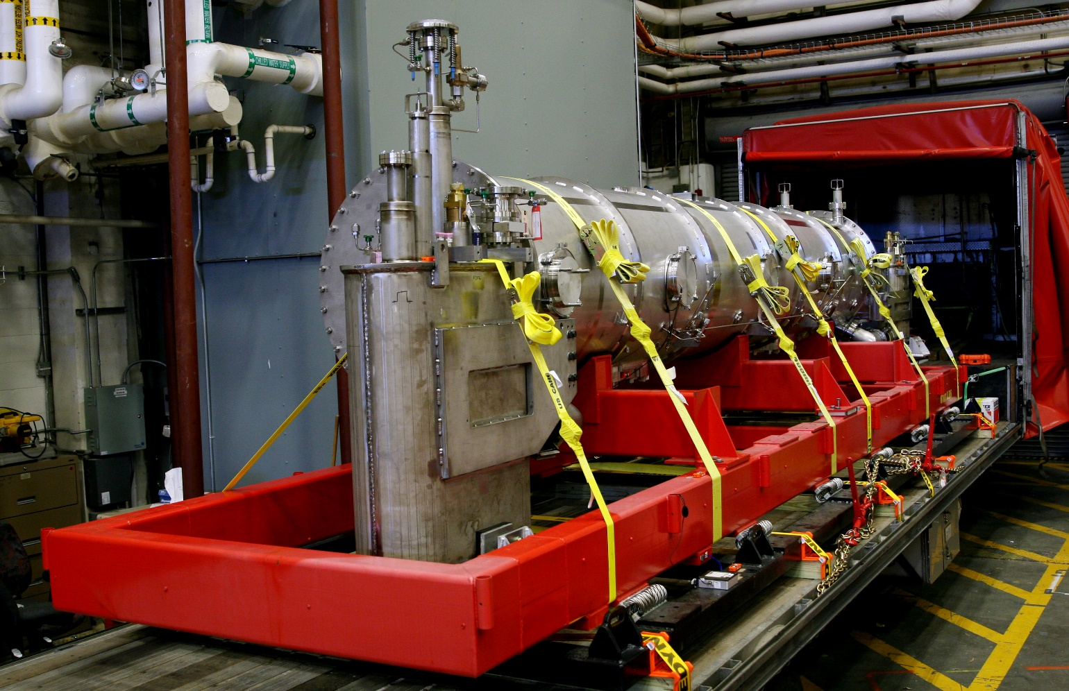

Figure 5.5.3.3: Shipping Frame and CM secured on the trailer

### End Can Supports

#### Start at the Return End Can

#### Install a dial indicator on the underside of the End Can to measure vertical motion (Figure 5.5.4.1).

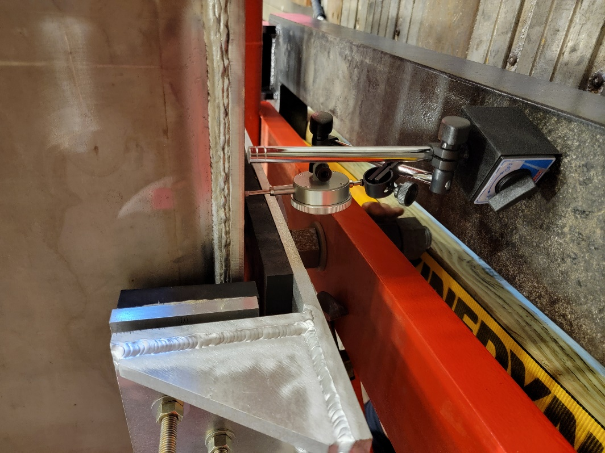

**Figure 5.5.4.1: Dial indicator installed under End Can Support**

#### Raise the support by turning the adjustment 1.5-10 UNC Hex Nut (Figure 5.5.4.2).

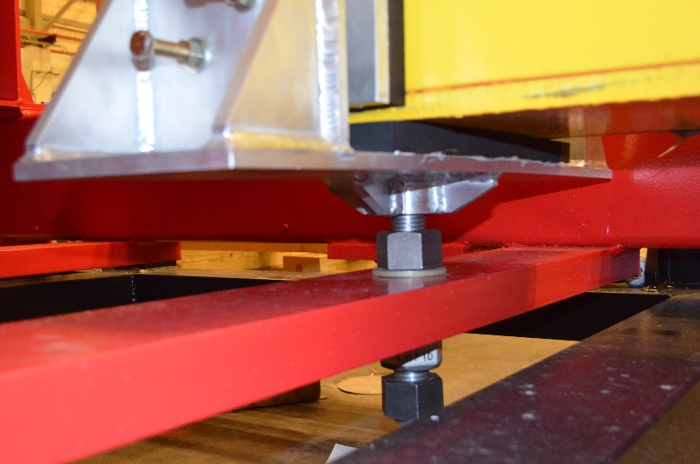

**Adjustment Nut**

**Locking Nut**

Figure 5.5.4.2: Vertical support nuts

#### Stop when the dial indicator starts to show upward motion of the End Can.

#### Lock the vertical position using the locking nut.

#### Loosen the locking nuts on the side support

#### Move the side support until it fits over the End Can lip and touches the End Can’s side (Figure 5.5.4.3).

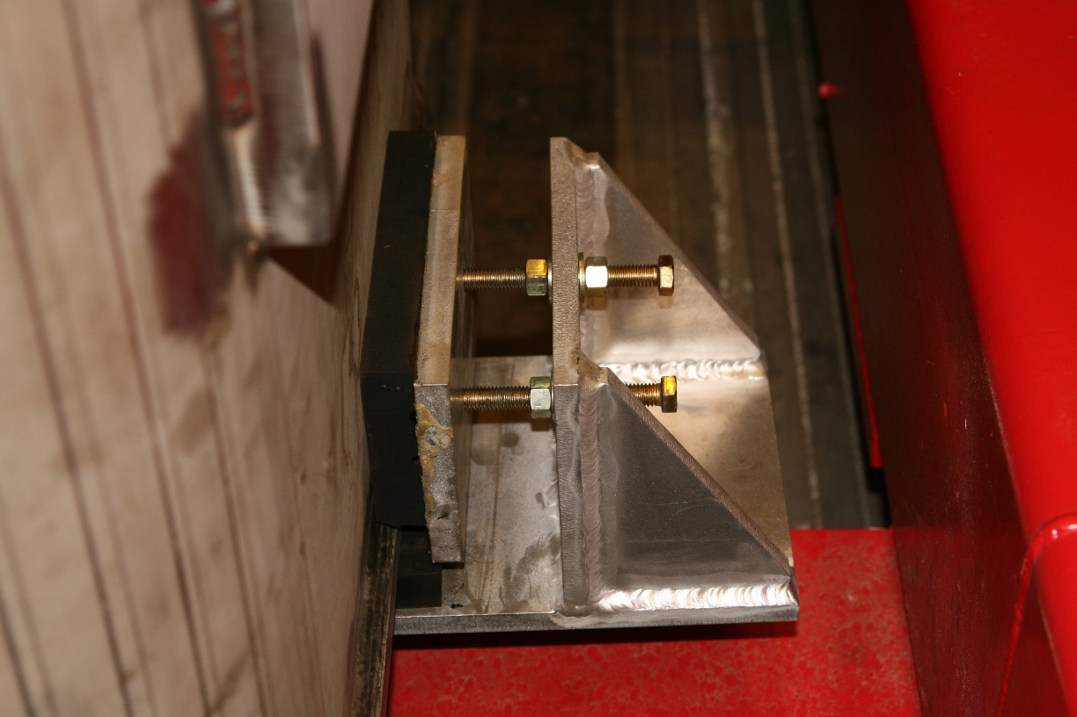

**Locking Nut**

**Locking Nut**

Figure 5.5.4.3: Side Support

#### Adjust the ½-13 HHCS (alternating on both side supports) until the supports are in contact with the End Can’s side.

#### Repeat steps 5.5.4.2 – 5.5.4.9 for the Supply End Can

#### Tighten the adjustment nuts on the Supply and Return End Can side supports in an alternating pattern until they are all at 15 ft-lbs (Figure 5.5.4.4).

#### Install two additional straps on to the End Cans (Figure 5.5.3.3).

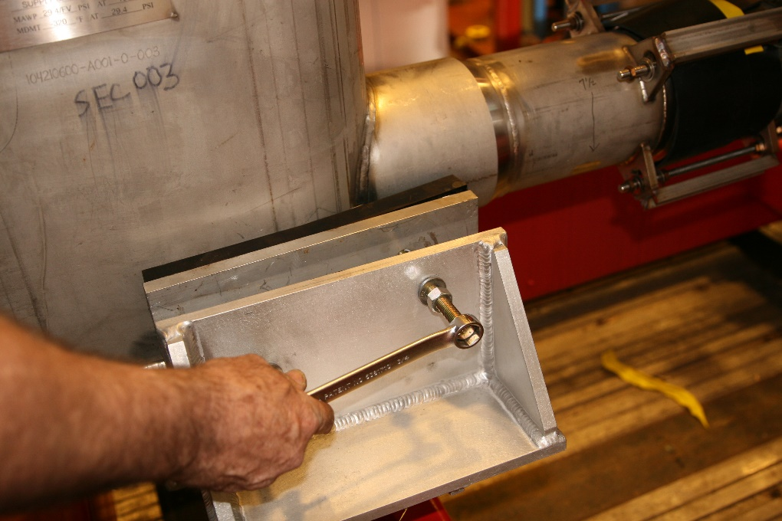

**Figure 5.5.4.4: Adjusting end can supports**

### Install Additional Boxes on Trailer

#### Boxes containing the following components should be loaded and strapped on to the trailer:

* Cold Cathode Gauge magnets
* Baratron Gauges
* Lift Plate Shroud
* Actuators

## Install Instrumentation

### Accelerometers

#### Prepare Slam Sticks (SSXs) for installation as per SNSPPU-PR-CMA-SHIP-SSX.

#### Cut a strip of double-sided tape, about 1.5” to 2” long and apply to the back of the SSXs. Keep the green backing of the tape on for now.

#### At the cryomodule locations indicated on Figure 5.6.1.1 (Orange), remove the green backing from the tape and install SSXs in the following orientation:

* + - * + SSX X: Pointing towards the back of the trailer, away from the tractor
        + SSX Y: Pointing to the side away from the CM
        + SSX Z: Pointing upwards

#### Install the Lansmont SAVER9X and the satellite triaxial accelerometers in the positions shown in Figure 5.6.1.1 (Green)

|  |
| --- |
|  |

**Figure 5.6.1.1: Instrumentation Locations**

### GPS Transmitter

#### Install the transmitter on the shipping frame in the position shown in Figure 5.6.1.1 (Blue) using zip ties.

### Data Transmitter

#### Install the Digi-connect transmitter (Red) and its batteries on the shipping frame as shown in Figure 6)

#### Transfer the power to the ion pump from the power cables to the onboard battery

#### Ensure the local controller is reading back, and the Digi-Connect is transmitting the correct voltage

## Documentation Review

### Travelers

#### Ensure the shipping traveler is filled out and is ready to close

### Property Forms

#### Ensure that the following forms are filled out and signed

* Shipping Form (including JLab Radiation Control survey form)
* Bill of Lading (three copies signed by the Technical Representative and driver)

## Final Checks

### Start SSX Manually

#### Go to each SSX and press the white button with the enDAQ logo. The green light will blink.

#### Try to start all the SSXs in less than 2 minutes.

#### Once all SSXs are running, impart a shock on the trailer to produce a calibrating event. This can be achieved by jumping on the trailer or hitting the red frame with a mallet.

### Start SAVER9X

#### Press the blue button for 5 seconds. The green light will blink every 5 seconds.

#### The SAVER9X will now calibrate. Do not touch the CM or the trailer while calibration is in progress.

#### In about one minute, the blinking green light will slow to once every 30 seconds. This indicates that the calibration is complete and the unit is recording.

### Tractor Attachment and Driver Pre-Check

#### Allow the driver to check the straps, chains, and tires

#### Allow the driver to back the tractor in to attach to the trailer

#### Allow the driver to retighten straps and chains where necessary

#### Close and secure the sliding roof

#### Give the driver two copies of the signed Bill of Lading forms.

### Release for Shipment

#### Post spotters at the four corners of the tractor/trailer. This is in addition to any second driver also assisting.

#### Signal the driver to exit the loading bay and begin the trip to Oak Ridge National Lab.

# Release and Revision History

|  |  |  |
| --- | --- | --- |
| **Rev #** | **Major Changes** | **Approval Date:** |
| 1 | Initial version | 23 Feb 2022 |
| 2 | Changed procedure to lift shipping frame on to trailer first. Updated and added images. Added steps to adjust center support (5.5.3.3 – 5.5.3.6). Changed End Can Support torque to 15 ft.lbs. Trailer cribbing changed to 4x4 wooden beams. | 05 May, 2022 |
| 3 | Added note to 5.4 that work may be done in or outside the CMTF. Updated all figure numbers. Added instructions for adjusting center support (section 5.5.3.5). Added/updated images to show strap positions (section 5.5.2). Updated Figure 5.6.1.1. Removed step to remove Burst Disc assembly (originally 5.4.2) and updated list in 5.5.5.1 |  |
|  |  |  |

# Approvals

|  |  |  |  |
| --- | --- | --- | --- |
| **Approved by:** | **Name:** | **Signature:** | **Date:** |
| Document Owner | Naeem Huque | Approval and date in DocuShare. | 23 Feb 2022 |
| SRF Quality Engineer | Jacob Harris | Approval and date in DocuShare. | 23 Feb 2022 |
| CM Production Lead | John Fischer | Approval and date in DocuShare. | 23 Feb 2022 |
| Project Manager | Ed Daly | Approval and date in DocuShare. | 23 Feb 2022 |