|  |  |  |  |
| --- | --- | --- | --- |
| **Inspection Procedure for LCLS-II-HE Cold Fundamental Power Coupler** | | | |
| **Document Number:** | L2HE-PR-INSP-FPCC | **Approval Date:** | 5/12/2021 |
| **Revision Number:** | R5 | **Periodic Review Date:** |  |
| **Document Owner:** | Naeem Huque | **Department Owner:** | SRF Ops |
|  | | | |

# Purpose and Scope

This procedure outlines the steps for performing incoming inspections on Fundamental Power Coupler Cold pairs

# References

These hyperlinked documents will be used for reference and calculation as this Procedure is performed.

[CP-L2PRD-CLN-PUMP](https://jlabdoc.jlab.org/docushare/dsweb/Get/Document-243280/CP-L2PRD-CLN-PUMP.docx)

[CP-L2PRO-CST-CHEM-CLN-ION-R1](https://jlabdoc.jlab.org/docushare/dsweb/Get/Document-243279/CP-L2PRO-CST-CHEM-CLN-ION-R1.pdf)

[CP-C100-CAV-LKTS](https://jlabdoc.jlab.org/docushare/dsweb/Get/Document-243278/CP-C100-CAV-LKTS.pdf)

[CP-L2PRD-CM-SLBUP-R2](https://jlabdoc.jlab.org/docushare/dsweb/Get/Document-242793/CP-L2PRD-CM-SLBUP-R2.pdf)

[Vacuum-005-2008](https://jlabdoc.jlab.org/docushare/dsweb/Get/Document-242791/Vacuum-005-2008%20Guidelines%20for%20UHV-Components%20at%20DESY.pdf)

[CP-STP-CAV-CHEM-DEGR](https://jlabdoc.jlab.org/docushare/dsweb/Get/Document-242796/CP-STP-CAV-CHEM-DEGR-R3.pdf)

[Solair 3100 Gen E Manual](https://jlabdoc.jlab.org/docushare/dsweb/Get/Document-242790/Solair%203100%20Gen%20E%20Manual.pdf)

[LCLSII-HE-1.2-ES-0059](https://jlabdoc.jlab.org/docushare/dsweb/Get/Document-242797/LCLSII-HE-1.2-ES-0059.pdf)

# Terms and Definitions

LCLS-II-HE – Linear Coherent Light Source-II High Energy

FPC – Fundamental Power Coupler

SLAC – Stanford Linear Accelerator Center

CM – Cryomodule

RF – Radiofrequency

SSA – Solid State Amplifier

RAV – Right-Angle Valve

UHV – Ultra-High Vacuum

TWG – Test Waveguide

CF - ConFlat

# Roles and Responsibilities

Assembly Technicians – Knowledgeable persons authorized by the Group Lead to inspect FPCs

# Procedure

1. Introduction

The LCLS-II-HE FPCs are UHV components which are designed to transmit RF power from SSAs to cavities, within a CM. The FPC assembly is made up of three parts: the warm FPC (FPCW), cold FPC (FPCC) and the FPC Push Rod (FPPR); this procedure covers the incoming inspection steps for the FPCCs.

FPCCs (Figure 1.1) are delivered to partner labs from the vendor, CPI. A pair of FPCCs are installed on a Test Waveguide (TWG) box (Figure 1.2). The internal space of the FPCCs and the waveguide box are under UHV. Each of the pair and waveguide box assemblies are packed within two bags made from MIL-PRF-131K, Class 1 (>4mils thick) bagging material.

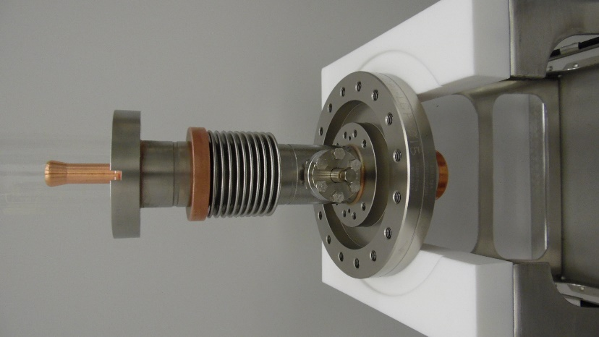

**Figure 1.1: FPCC**

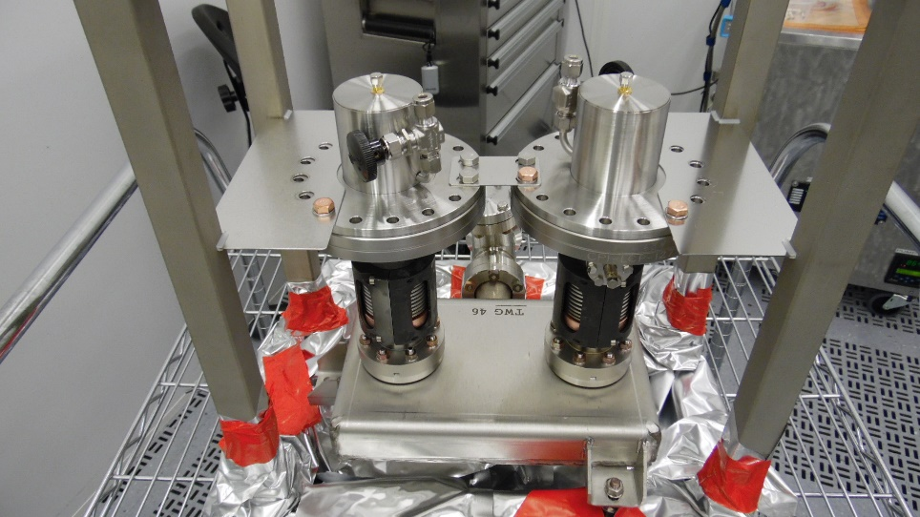

**Figure 1.2: Two FPCCs on a TWG**

1. Pre-Inspection
   1. Perform the following tasks prior to the FPCC/TWG assemblies being taken into the chemistry area. Record the applicable information in L2HE-CLNRM-FPCC-INSP
      1. Record the inspection date and technician name in the traveler
      2. Visually inspect the outer plastic bag
      3. Record the Pair number and FPCC serial numbers in the traveler
2. Chemistry
   1. Remove the FPCC pair from the crate and place on a cart; the weight of the assembly requires a two-person lift. Move the cart into the chemistry room.
      1. Record the chemistry room admission date and technician name in the traveler
      2. Wipe down the outer plastic bag with isopropyl alcohol
      3. Push the cart into the pass-thru area
      4. Remove and discard the outer plastic bag
      5. Wipe inner plastic bag down with isopropyl alcohol and spray with dry nitrogen
      6. Push the cart into the cleanroom vacuum pumping area
3. Vacuum leak check and rga scan
   1. Prior to starting the bag leak check, the following tools and hardware will be required:

* Pump cart
* Filtered, de-ionized N2 source
* 2-3/4 CF gasket
* 2-3/4 CF Flange hardware
* Wrenches
* Scissors
  1. Move the cart into the particulate counter area. Prepare the area as per CP-L2PRO-CST-CHEM-CLN-ION-R1.
     1. Blow down the bag with nitrogen until 0.3μm counts are below 1000, or for 15 minutes (whichever comes first).
  2. Vacuum Leak Check
     1. Record the date and the vacuum leak check technician in the traveler.
     2. Clean vacuum components as per CP-L2PRO-CST-CHEM-CLN-ION-R1.
     3. Cut the plastic in front of the RAV and attach the hose for the vacuum pumping system (Figure 4.1).

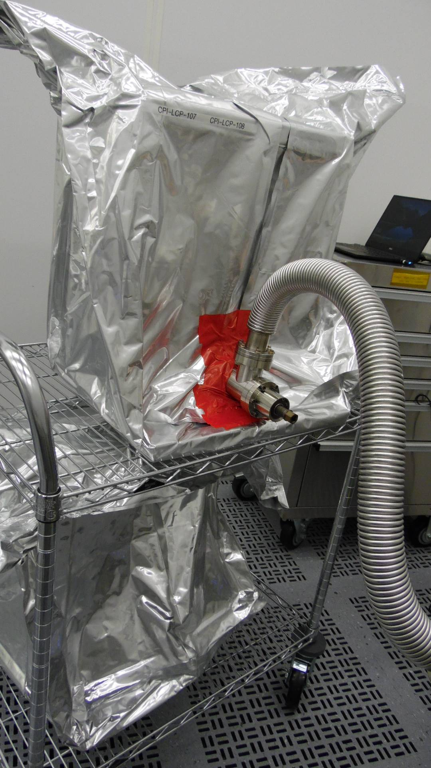

Figure 4.1: Pumping line installed on RAV

* + 1. Open the RAV and record the static vacuum in the traveler.
    2. Pump down the FPCC and TWG assembly as per CP-L2PRD-CLN-PUMP.
    3. Check the CF joints on the RAV and vacuum line by spraying He gas as per CP-L2PRD-CLN-PUMP.
    4. Open the N2 valve on the ceramic protection cap.
    5. Seal the plastic bag using cleanroom tape as shown in Figure 4.1.
    6. Perform the bag leak check as per CP-C100-CAV-LKTS. Upload the data file into the traveler and generate an NCR if a leak higher than 2.76x10-10 torr-l/sec He is found.
       1. If a leak is found, remove the bag and conduct a He spray leak test to identify the leak location, then inspection work on the pair.
    7. Record analog RGA data in the traveler.
    8. Remove the plastic bag from the assembly.

1. Electrical Checks
   1. Check that the electron probes are properly installed using a multimeter.
      1. Connect the multimeter cable to each FPCC in turn. The resistance value should indicate an Open Loop (Figure 5.1). Otherwise, generate an NCR.

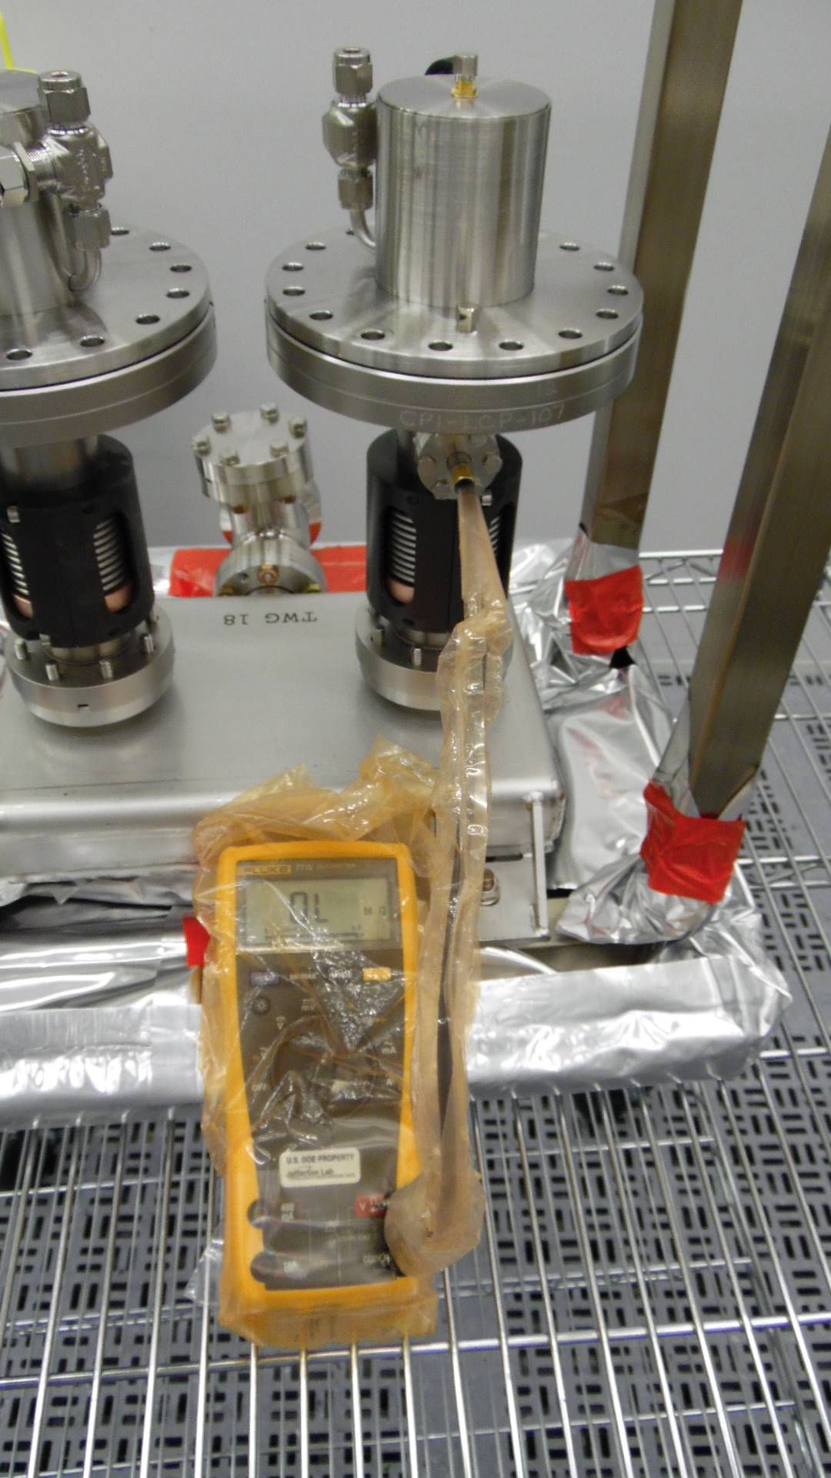

Figure 5.1: Multimeter reading of Electron Probe

1. Visual inspection after removing protection caps
   1. Perform a particulate count of the FPCC-1 external surfaces. Generate an NCR if the 0.3μm count cannot be brought below 1000 counts after 15 minutes of spraying.
   2. Wipe down the assembly.
   3. Remove the ceramic protection caps on each FPCC (Figure 6.1) using the following steps:
      1. Remove only the M8 HHCSs holding the Support Bracket on to CF100 flange. Remove the support bracket, but do not replace the M8 HHCSs.
      2. Install a minimum of four FPC Tophat Alignment Rods (JL0128795) into the empty M8 threaded holes on the DN100 flange (evenly spaced).
         1. If the alignment of the cap holes do not allow the alignment rods to be threaded in, then loosen (but do not remove) the HHCSs and adjust the position of the protective cap laterally.
      3. Loosen the M8 x 1.25 HHCSs holding down the protective cap
      4. Remove the M8 HHCSs.
      5. Lift the protective cover upwards using the Alignment Rods as guides, while minimizing contact between the rods and the IDs of the cover’s clearance holes.
         1. If the cap is stuck on to the flange, pry it at the leak check groove. Do not try to force or twist the cap.
      6. Once the cap is clear of the FPC ceramic, remove the alignment rods from the threaded holes.

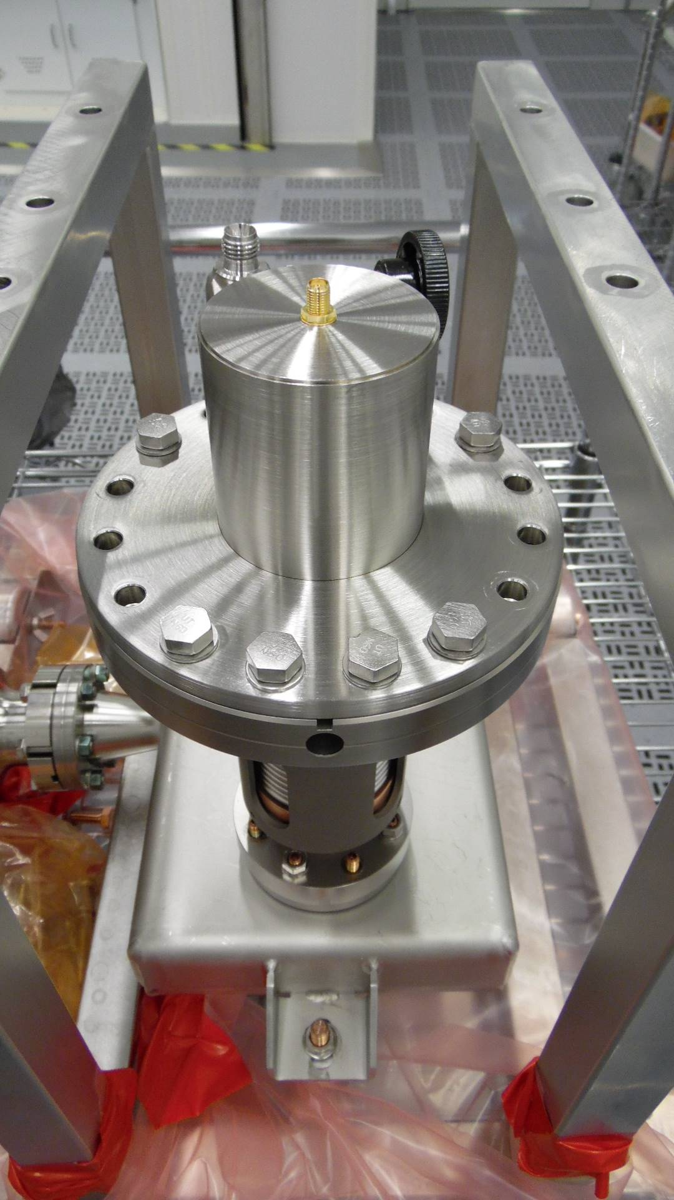

Figure 6.1: Ceramic Protection Cap

* 1. Visually inspect and photograph the ceramics (Figure 6.2). Generate an NCR if there are any scratches, dark spots, chips, or stains
     1. Photos should be taken on all sides at 90-degree rotations.
     2. Take additional close-up images of the upper and lower edges of the ceramic.

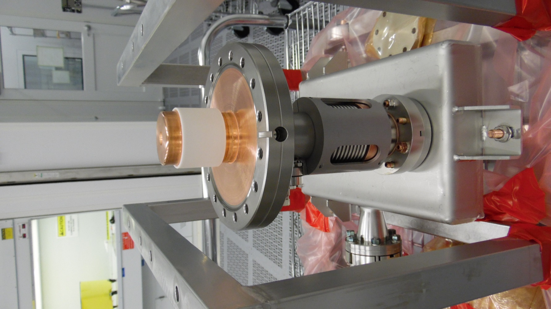

Figure 6.2: FPCC Ceramic

* 1. Visually inspect and photograph the knife edges on the CF100 flanges on each FPC (Figure 6.3). Generate an NCR if there are any defects on the knife edges

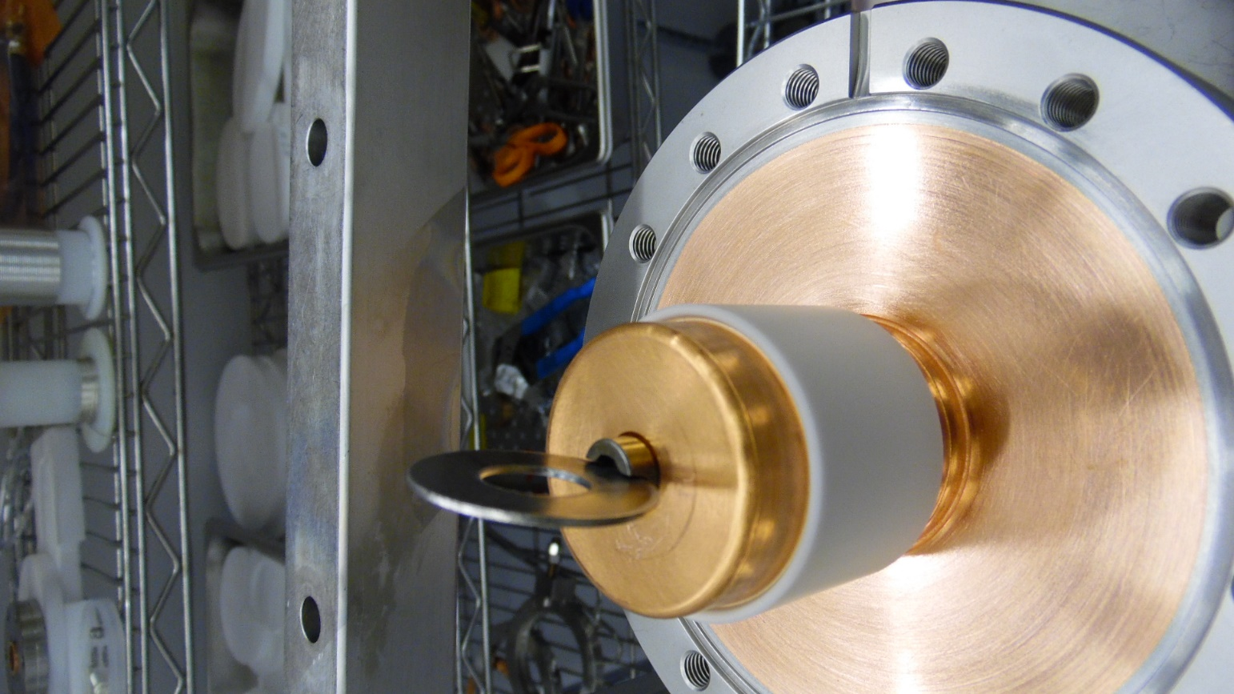

Figure 6.3: CF100 Flange Knife Edge

* + 1. Visually inspect and photograph the copper plating on the flange surface (Figure 6.4). Generate an NCR if there are any pits, blisters, or flaking copper. Generate an NCR if there is any Viton residue on the copper.

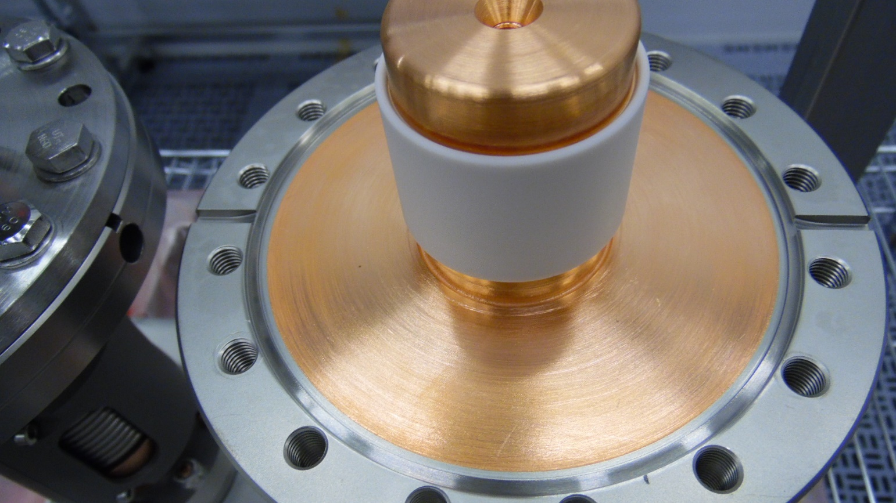

Figure 6.4: Copper plating on CF100 Flange

* + 1. Visually inspect and photograph the RF contact surface above the ceramic (Figure 6.5). Generate an NCR if there are any dents or scratches on the surface.

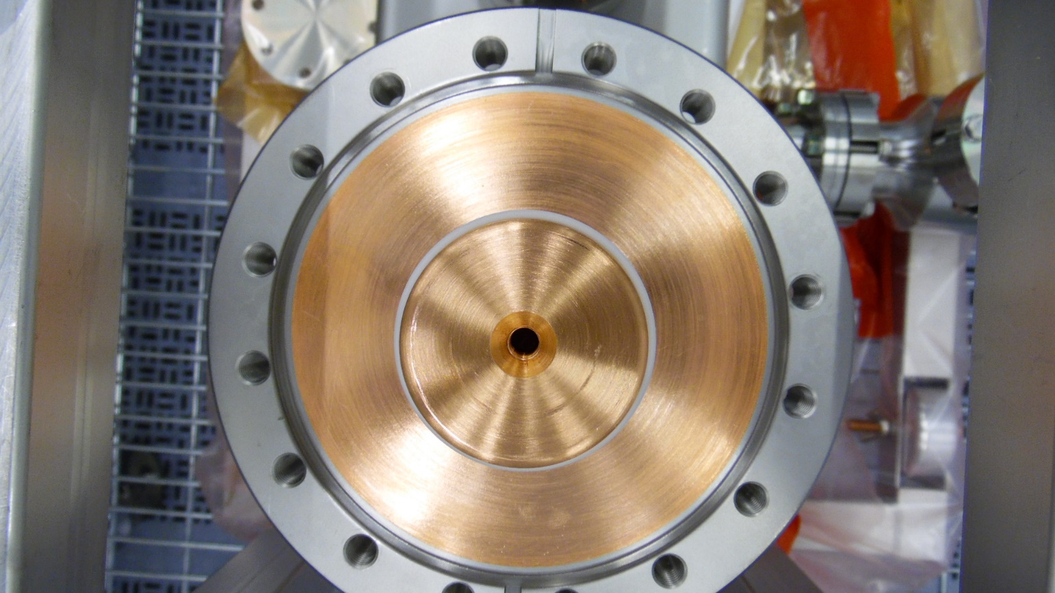

Figure 6.5: RF Contact Surface

* + 1. Remove the RF pin and check that the threads are clean and intact (Figure 6.6), and take photos. Generate an NCR if there is damage to the threads or if there is excessive dirt or oil.

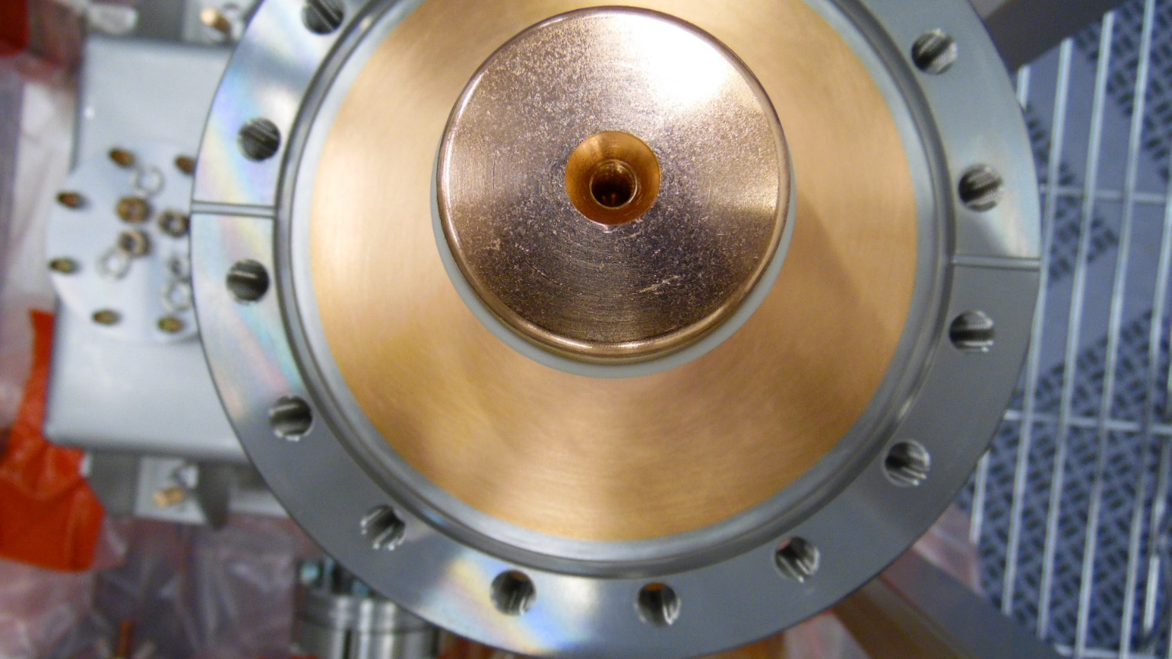

Figure 6.6: RF Pin threaded hole

* 1. Reinstall the two ceramic protection caps and RF pins using the following steps:
     1. Install the RF Pin in the center hole of the conductor.
     2. Install four Alignment Rods (JL0125795) in the threaded holes on the first FPCC, in the positions shown in Figure 6.7
     3. Position the o-ring on the CF100 Flange
     4. Clock the protective cap in the final position for installation on the string (Figure 6.8). The location of the probe must be used as a reference.

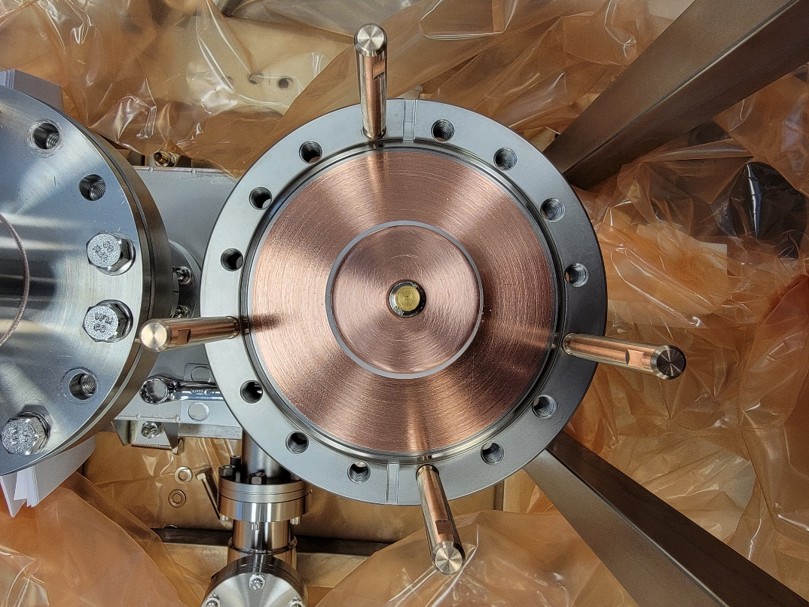

Direction of Electron Probe

Figure 6.7: Positions of Alignment Rods

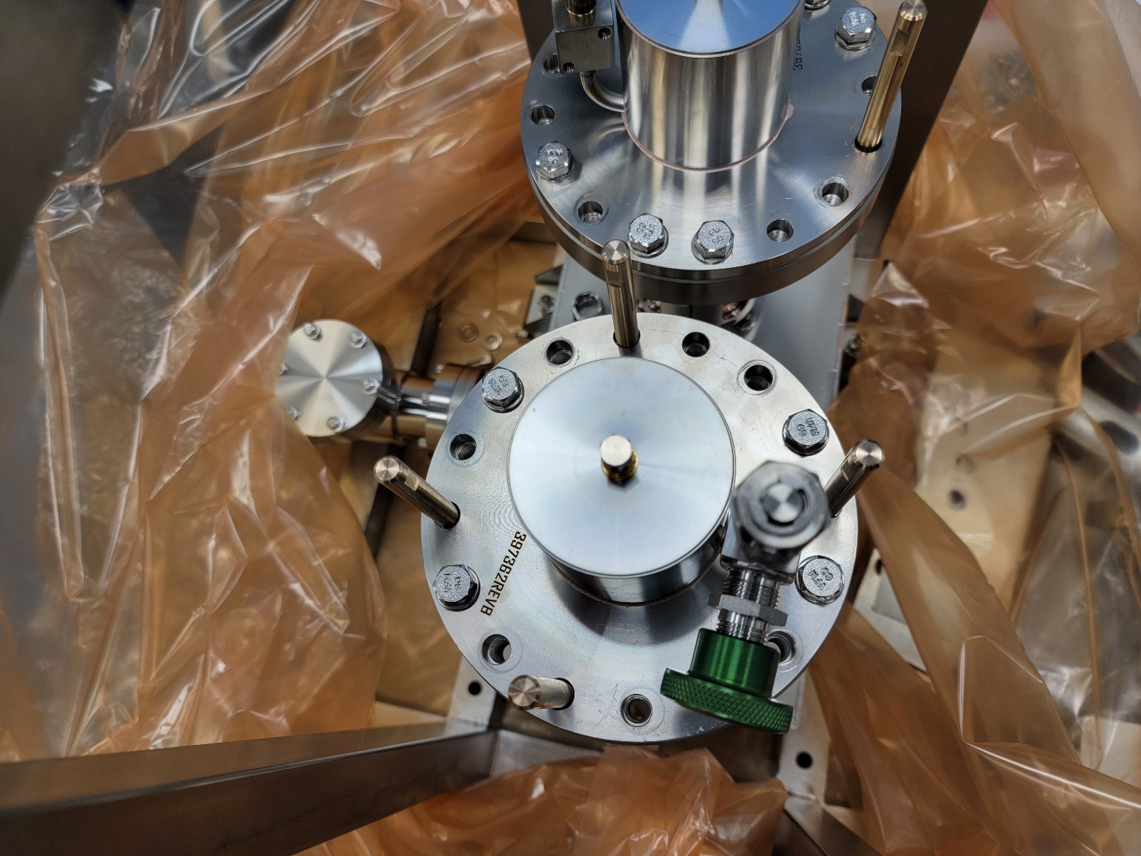

Direction of Electron Probe

Figure 6.8: Clocking of the protective cap and valve

* + 1. Slowly lower the cap down to the CF100 flange using the Rods as guides; minimize contact between the Rods and the clearance hole IDs.
    2. Once the cap is sitting on the flange, start threading the shorter M8 x 1.25 HHCSs and washers in the positions shown in Figure 6.8.
    3. Remove the Alignment Rods.
    4. Finger tighten the four HHCSs
    5. Torque the four HHCSs to 10 in.lbs. Do not overtighten.
    6. Repeat the process for the other FPCC
  1. Slightly unscrew the SMA connector (Figure 6.9) and back-fill the space under the caps with dry, filtered nitrogen.

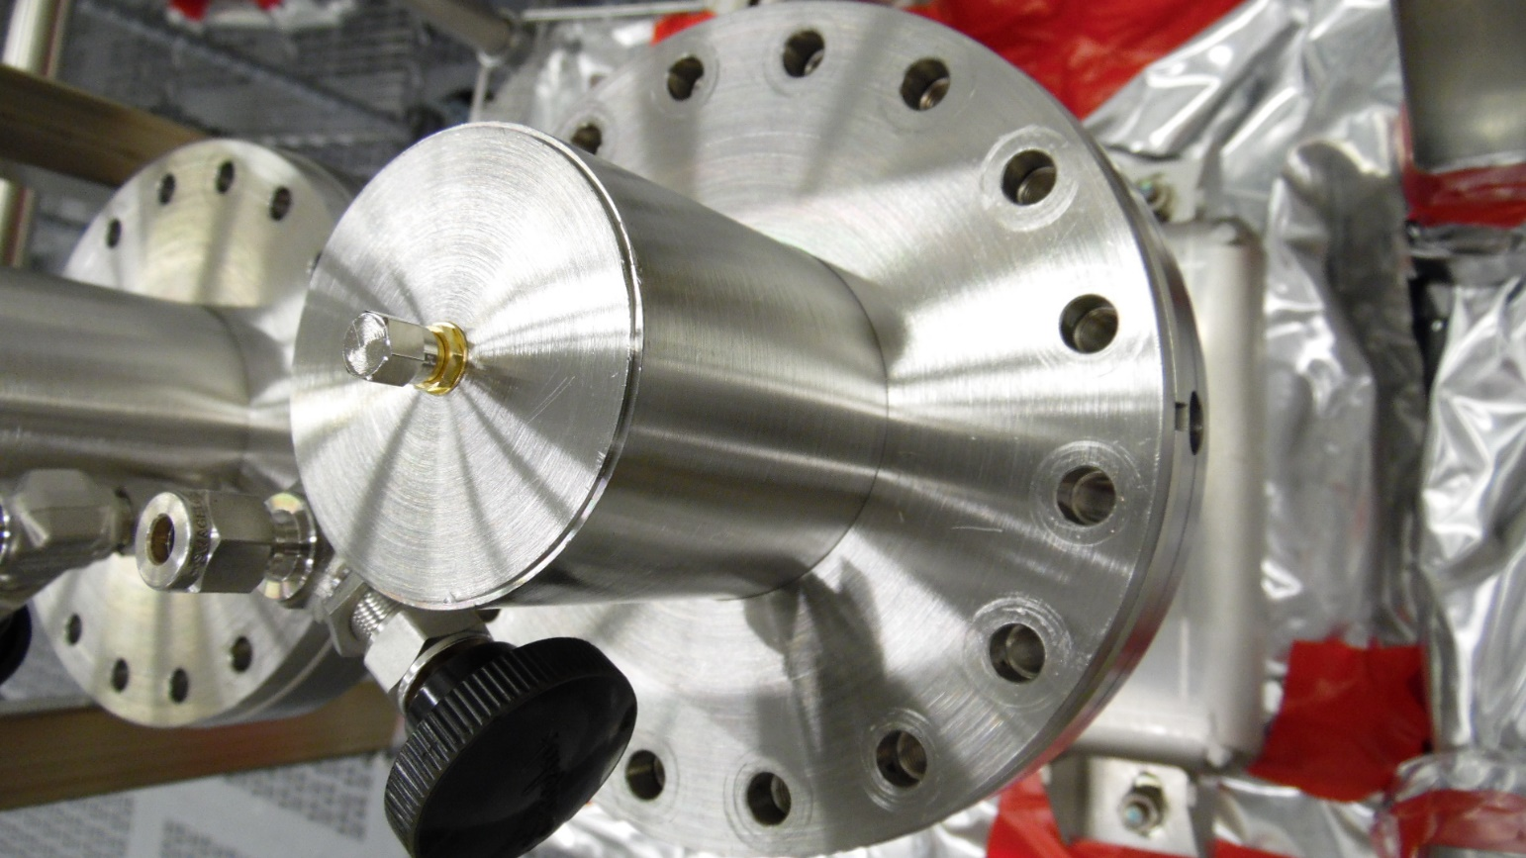

Figure 6.9: SMA connector on ceramic protection cap

* 1. Tighten the SMA connector to seal the space

1. Individual FPCC Visual Inspections
   1. Bleed up the test box with dry, filtered nitrogen with the following steps:
      1. Close the RAV.
      2. Connect the controlled bleed-up device to the pumping system.
      3. Pump down the bleed-up hose.
      4. Open the RAV.
      5. Start pumping down the assembly and controlled bleed-up system.
      6. Close valve on the pumping system.
      7. Start controlled bleed-up process.
   2. Remove FPCC-1 from the TWG using the following steps:
      1. Remove all bolts from the FPCC cavity flange (Figure 7.1).

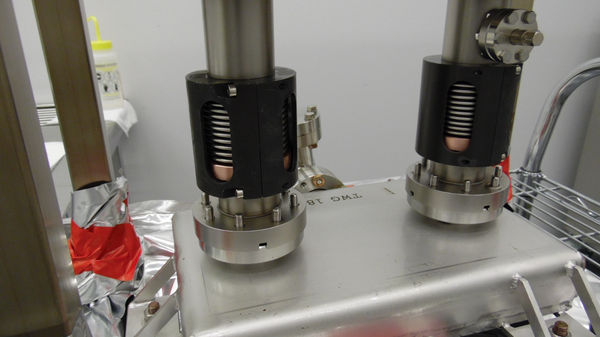

Figure 7.1: Removing hardware from Cavity Flange

* + 1. Wipe down the external surface of the cavity flange with isopropyl alcohol.
    2. Dry the surfaces using dry, filtered nitrogen.
    3. With the TWG under continuous positive nitrogen flow, remove FPCC-1 from the TWG and place it on the inspection stand.
  1. Visually inspect the FPCC-1 and record the findings in the traveler.
     1. Remove the bellows protection bracket (Figure 7.3) and inspect the bellows convolutions. Photograph the O.D. of the bellows with a (maximum) 90 degree separation. Generate an NCR if there are any dents or scratches larger than 1/16”, or any other signs of damage.
     2. Wipe down and reinstall the protection bracket once finished

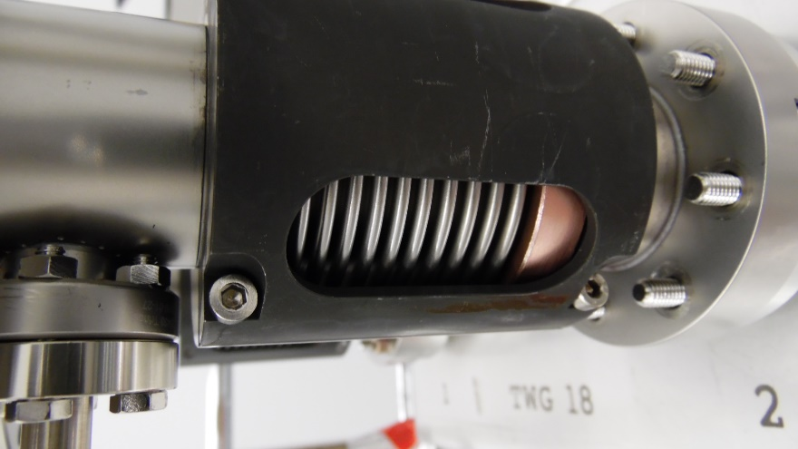

Figure 7.3: Bellows protection bracket

* + 1. Visually inspect and photograph the cavity flange sealing surface (Figure 7.4). Generate an NCR if there are any traces of the AlMg seal or any scratches or residue

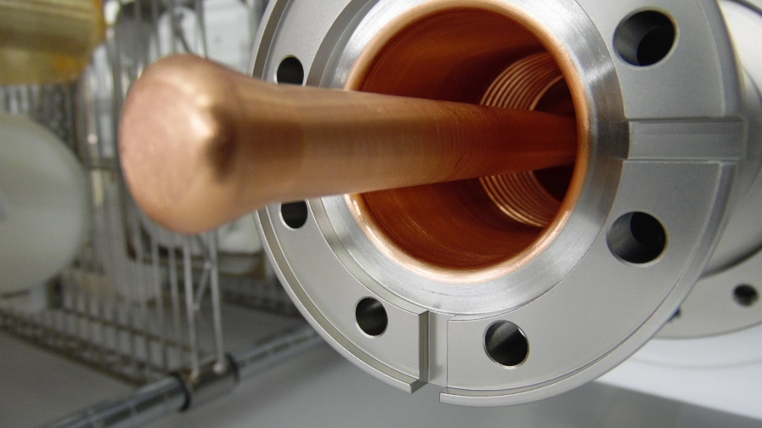

Figure 7.4: Sealing surface of the FPCC cavity flange

* + 1. Visually inspect and photograph the regions of copper plating on the inside of the FPCC (Figure 7.5) which are visible through the cavity flange. Generate an NCR if there are any scratches, pits, blisters, or flaking copper.

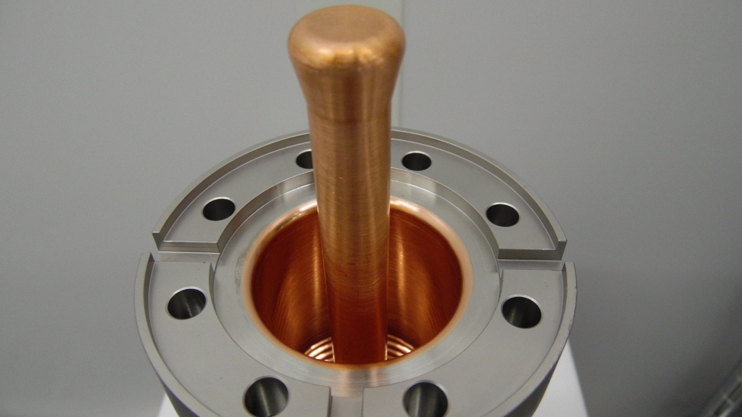

Figure 7.5: Inner copper plating of FPCC

* + 1. Visually inspect and photograph the end of the copper antenna (Figure 7.6). Generate an NCR if there are any scratches, chemical residue or erosion spots.

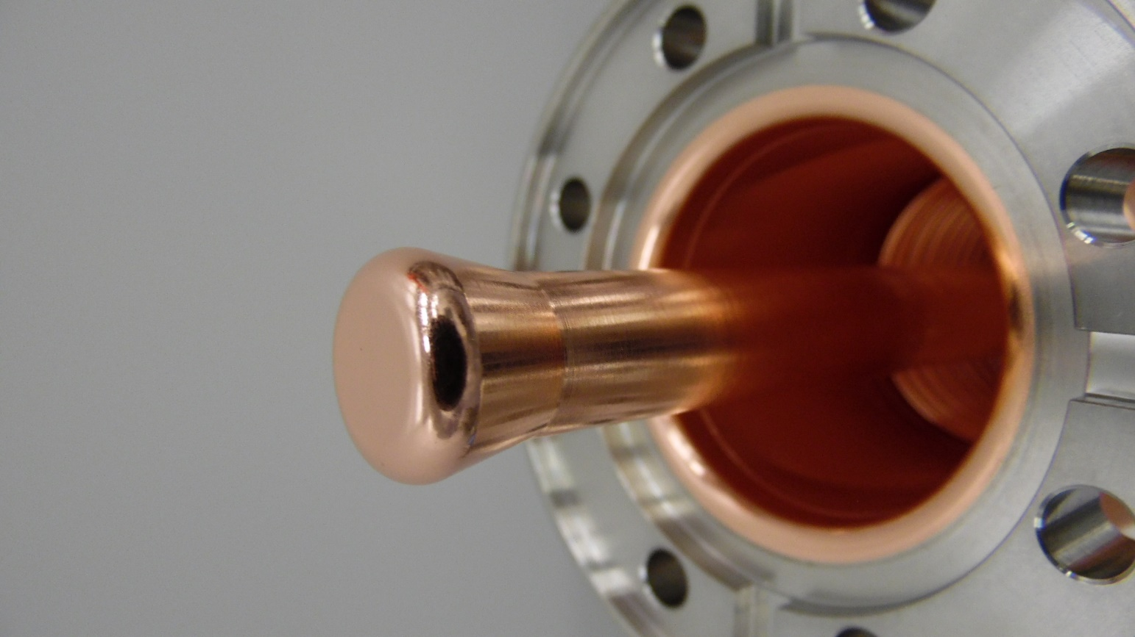

Figure 7.6: Copper antenna tip

* 1. Perform a particulate count on the internal surfaces of FPCC-1
     1. Generate an NCR if the 0.3μm count cannot be brought below 10 counts after 15 minutes of spraying.
     2. Record the results in the traveler.
  2. Reinstall FPCC-1 into the TWG.
     1. Use the same NW40 aluminum seal and Nitronic-60 hardware.
  3. Repeat Steps 7.2 – 7.5 for FPCC-2

1. Storage
   1. Store the FPCC pair in the cleanroom in preparation of string assembly
      1. Disconnect the pumping and bleed-up systems.
      2. Pressurize the internal space with filtered N2.
      3. Close the RAV.
      4. Blank off the RAV.
      5. Move the assembly to the storage area in the cleanroom.
      6. Record the storage date in the traveler.

# **Release and Revision History**

|  |  |  |
| --- | --- | --- |
| Rev # | Revision or update: | Effective: |
| R1 | Initial | 5/10/2021 |
| R2 | Removed kit parts and RGA criteria | 7/23/2021 |
| R3 | Added instructions to upload photographs at multiple steps, regardless of whether defects are present. | 9/26/2021 |
| R4 | Added instructions for removing and installing Protective Cap using Alignment Rods (6.3 and 6.6). Added ceramic photo requirements (6.4). Shorter M8 HHCSs are used to replace caps instead of the original long ones (6.6.6) | 5/13/2022 |
| R5 | Section 6.3.2 changed three rods to a minimum of four rods. Added locations for installing alignment rods (section 6.6.2). Updated Figure 6.7 as per 6.6.2. Added locations of M8 HHCSs (section 6.6.6). Updated Figure 6.8 as per 6.6.6. Removed specific number of alignment rods in 6.6.7. | 5/26/2022 |

# **Approvals**

|  |  |  |
| --- | --- | --- |
| Approved by: | Signature: | Date: |
| **Document Owner** | Naeem Huque |  |
| **Production Team Lead** | Danny Forehand |  |
| **Production Group Lead** | Kirk Davis |  |
| **Reviewer** | Chris Dreyfuss |  |
| **CAM** | Adam Grabowski |  |