To ReOpen a Traveler when Requested

1. Select ADMIN MENU
2. Under EDIT Travelers, select OWNERS
3. Find the Sequence Number to be reopened
   1. Change 'y' to 'n' in the "Complete" column
   2. Remove name from "Closed By" column
   3. Remove date from "Closed Date" column
   4. Add a Comment which includes:
      1. Name of Requestor
      2. Date of Request
      3. And mode in which request was made (email,phone, etc)
4. Check the box for that sequence number in the "Update?" column
5. Submit edits by clicking the "Update" button at bottom of page

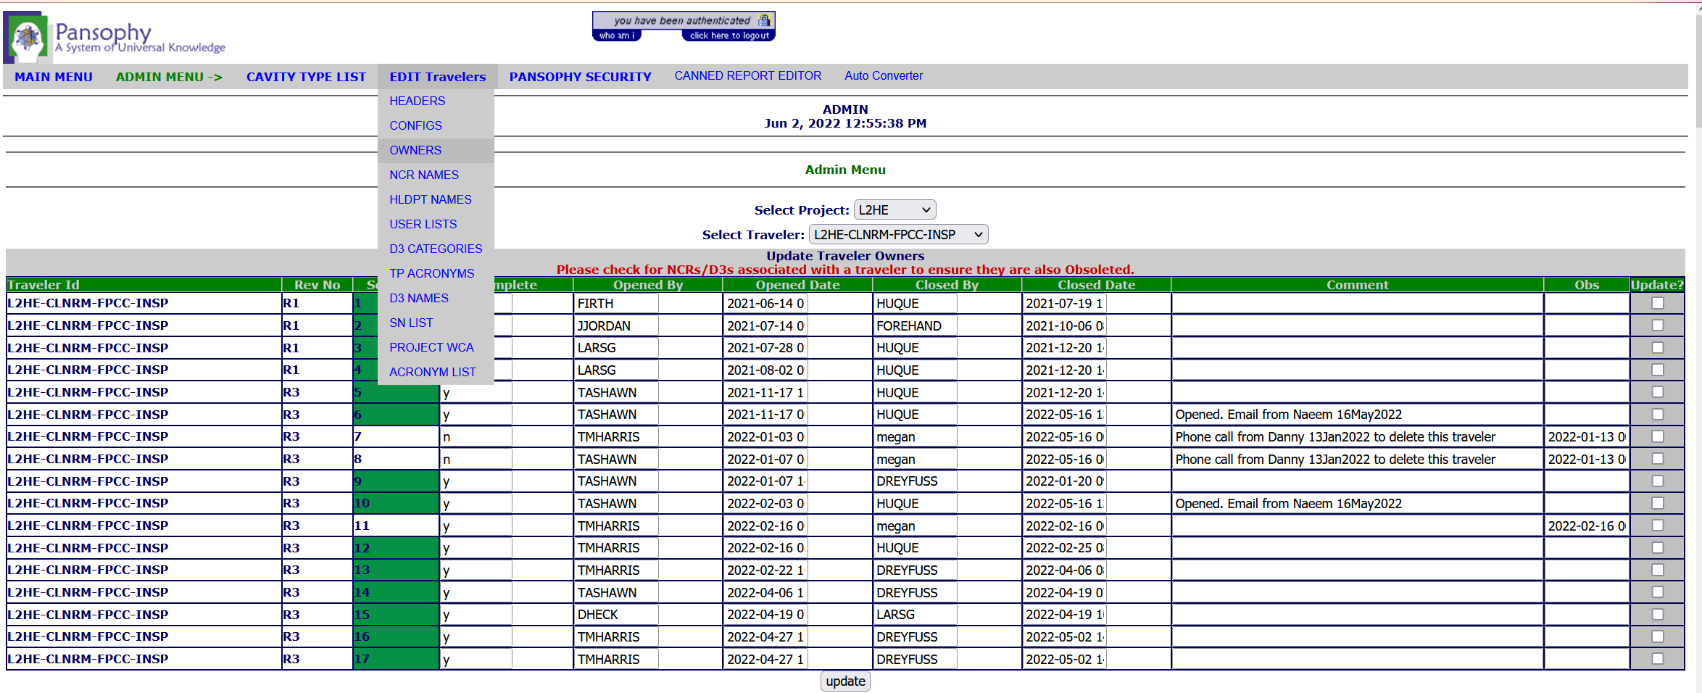

To Verify

Below is an example of the TRAV_OWNERS table found in the TRAVELERS database. It show modified records with dates and comments.

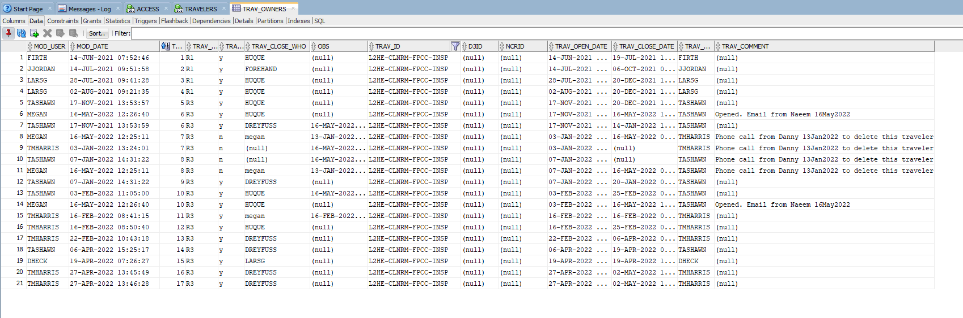

To View from Pansophy

1. Select Travelers menu
2. Under USER TOOLS select OWNERS
3. Select Project
4. Select Traveler from the Project
5. A list of all travelers with comments/dates/names is displayed

