|  |  |  |  |
| --- | --- | --- | --- |
| **CMA Indium Installation Procedure** | | | |
| **Document Number:** | SRF-MSPR-CMA-THERM-IND | **Approval Date:** | TBD |
| **Revision Number:** | Rev 1 | **Periodic Review Date:** | TBD |
| **Document Owner:** | Jared Martin | **Department Owner:** | SRF Ops |
|  | | | |

# Purpose and Scope

The purpose of this document is to explain the appropriate procedure for installing Indium when used to improve thermal connectivity in heat stationing applications.

This document applies to indium installation within the cryomodule assembly group.

# Terms and Definitions

**Indium:** the chemical element of atomic number 49, a soft silvery-white metal occurring naturally in association with zinc and some other metals.

# Roles and Responsibilities

The Roles and Responsibilities are defined by the CMA group Lead or Designee for the work to be performed by trained and authorized staff.

# Procedure

## 

Safety: When using/handling indium make sure to wear the appropriate PPE which includes the use of gloves and safety glasses. When you are finished handling indium be sure to wash hands thoroughly.

Uses: The main use of indium in the cryomodule assembly group is thermal conductivity. Indium when installed and torqued correctly conforms to each mating surface allowing it to absorb any differences in the mating material. Indium will also fill any gaps created by the mating materials difference during thermal expansion or contraction.

Installation: When preparing to install indium to a surface you will first need to make sure the surface is clean and free of contaminants. Using a lint free wipe along with isopropanol, clean the surface you intend to apply the indium to.

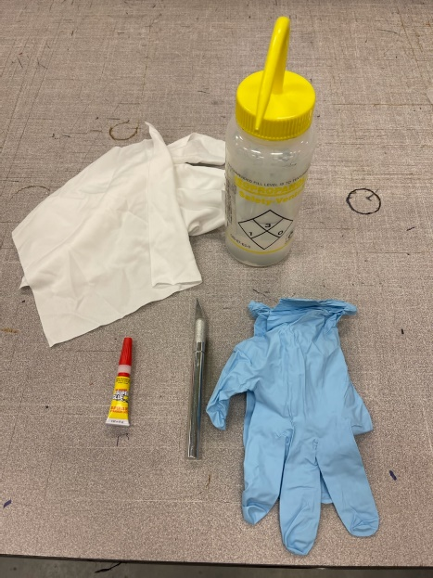

Once the surface is clean you will apply several small drops of super glue (non-gel) to the surface. Do not completely cover the surface with super glue, a few drops on the corners and along the center will hold the indium in place while the part is installed. (as seen in the image below)

Install the indium onto the prepared surface

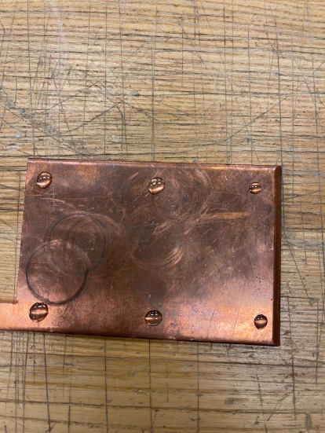

After the glue has dried, the part is ready to be installed. When installing the part, it is critical to follow the correct torque sequence. All indium layered pieces will need to be torqued a total of three times with a minimum of eight hours between torques. After each torque sequence use a marker and make a tick mark on each bolt head. When the final torque has been applied each bolt head should have three tick marks on it indicating that all three torque sequences have been completed. Torque values are dependent on fasteners size and material.(as seen below)

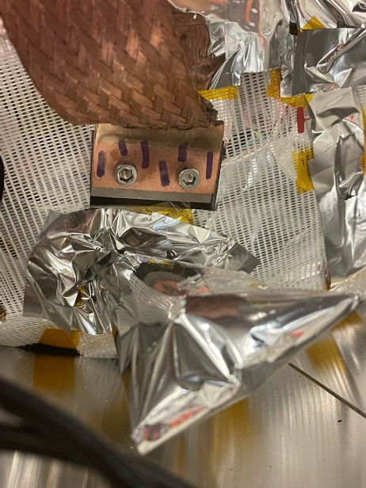

Any scrap indium should be properly disposed of in one of the indium scrap bags that are placed throughout the cryomodule assembly area. (see below)

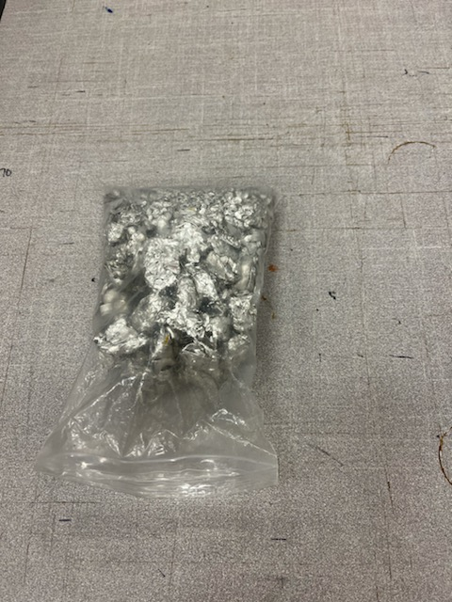

# **Release and Revision History**

|  |  |  |
| --- | --- | --- |
| Rev # | Revision or update: | Effective: |
| 1 | Initial version | 8/31/2021 |
|  |  |  |

# **Approvals**

|  |  |  |
| --- | --- | --- |
| Approved by: | Signature: | Date: |
| **Document Owner** | Jared Martin |  |
| **CMA Group Leader** | John Fischer |  |
| **Technical Reviewer** | Gary Cheng |  |