**How to Download and Upload Shared Files to Docushare**

1. Find the document you want to edit. Click the three dots on the right side of the screen to open the drop-down menu.
2. Check out the document from Docushare. Checking out a document should ensure that no one else can edit it or upload a new version while you have it.
   1. If you just want to look at the document and not edit it, clicking the file name will open a read-only document without checking it out.

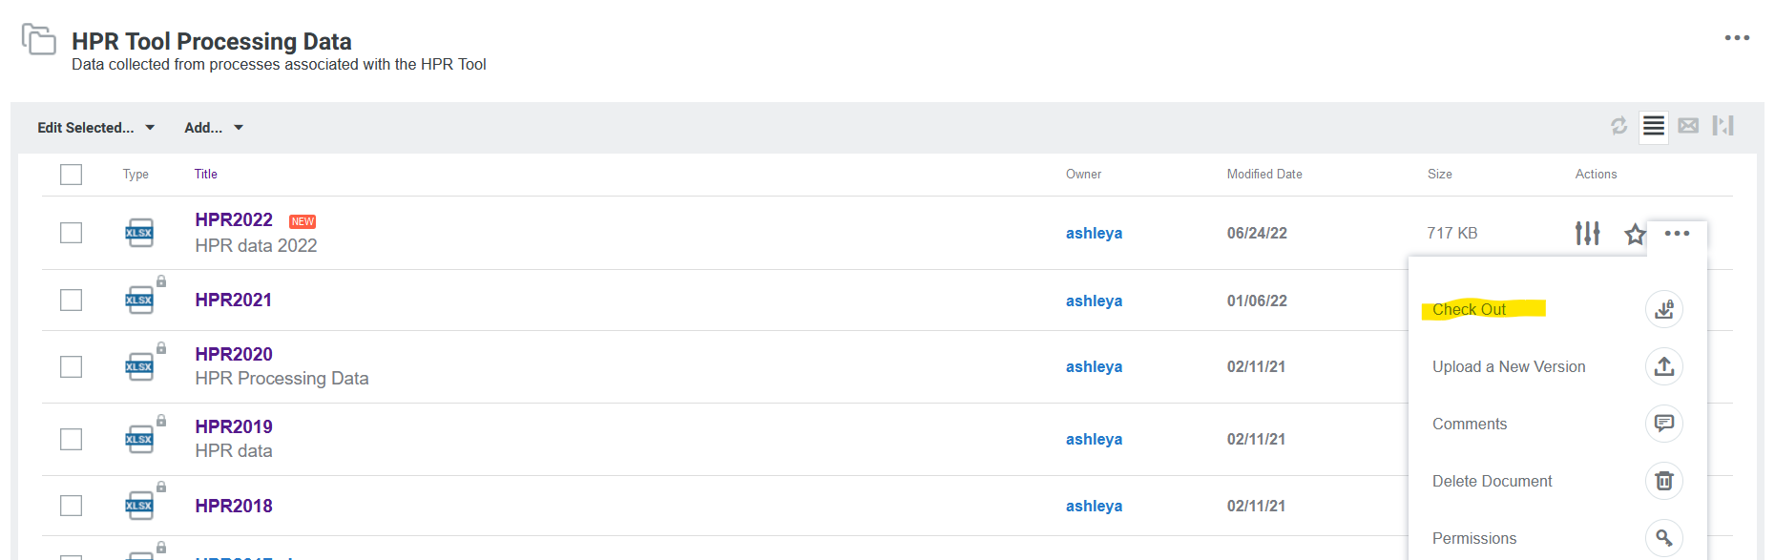

1. Open the file.
   1. Sometimes it takes a moment for the OK button to be clickable.

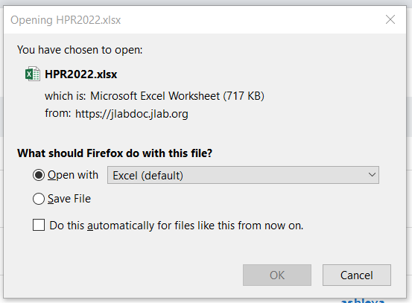

* 1. It will open as a read-only document.



1. If you refresh the page, the file will show it is locked by putting a lock icon next to the file type.
   1. If someone else has the document locked, do not edit the document until it has been returned. This ensures the most recent document is in Docushare and being edited.
   2. If you hover over the lock, it will show who has the document checked out. If you need the document quickly, or if they have it checked out for a long time, you can contact the person and ask them to unlock the document.

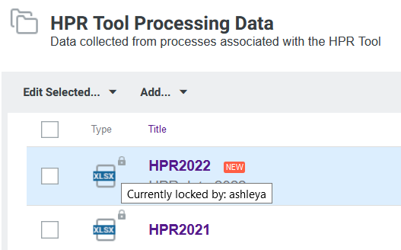

1. To save the document, click File, Save As, then Browse.

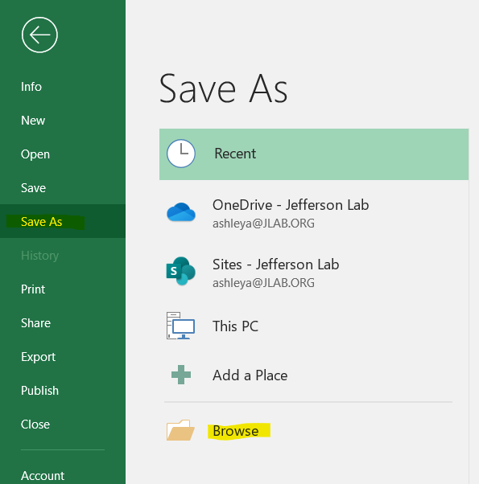

1. Choose a location to save the file.
   1. In this example, the file is being saved to the desktop.
   2. Notice the file name defaults to a copy of the original file.
      1. If there are multiple versions already saved, it will add a number to the end of the file name too.
   3. If you want to save a copy of the file, skip the next step.
   4. If you want to overwrite the file and save it as the same name, proceed to the next step.

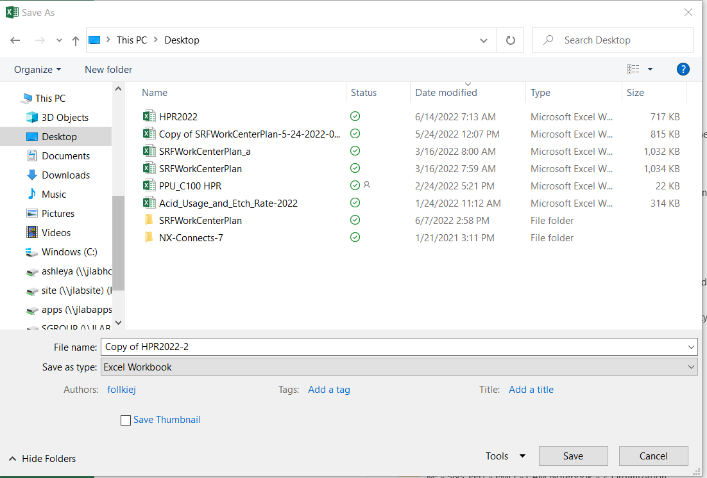

1. Click the file you want to overwrite with the new file.
   1. In this example, it is the HPR2022 Excel file.
   2. This will populate the File name field.
   3. Notice the file name is the same as the existing file.
   4. Click Save.

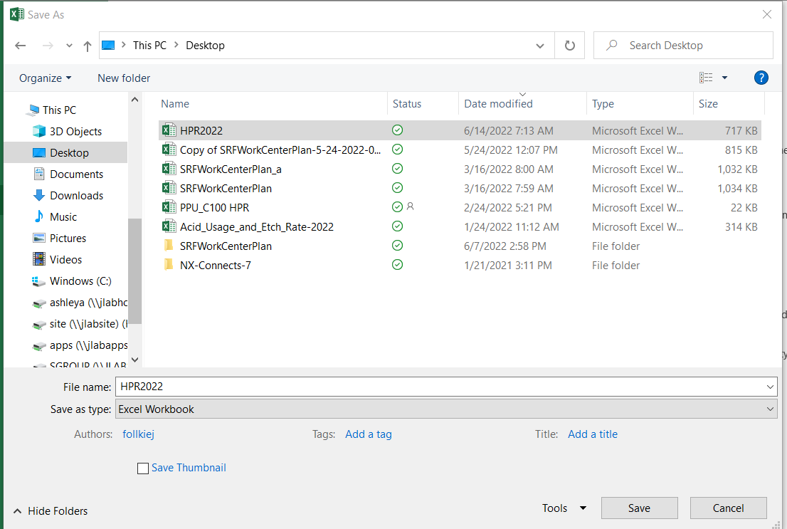

1. A message will pop-up asking if you want to replace the file.
   1. Click Yes.

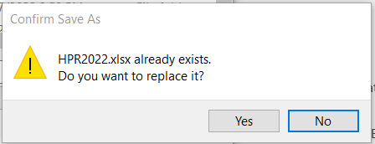

1. Edit the document.
2. Once you’re done editing the document and ready to return it to Docushare, click the three dots on the right and click Upload a New Version.

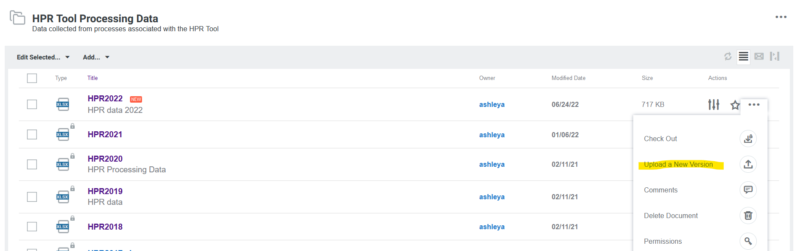

1. A new page will open to add a new version.

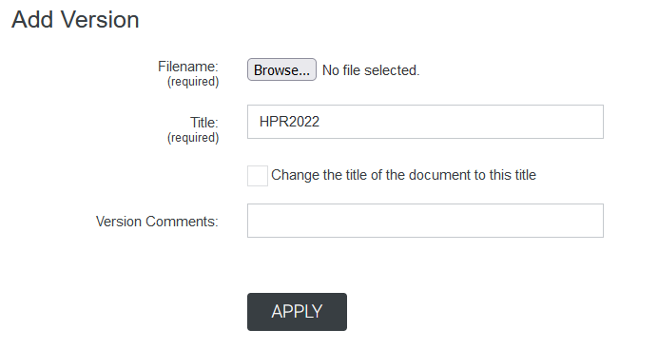

1. Click Browse
   1. Select the file.

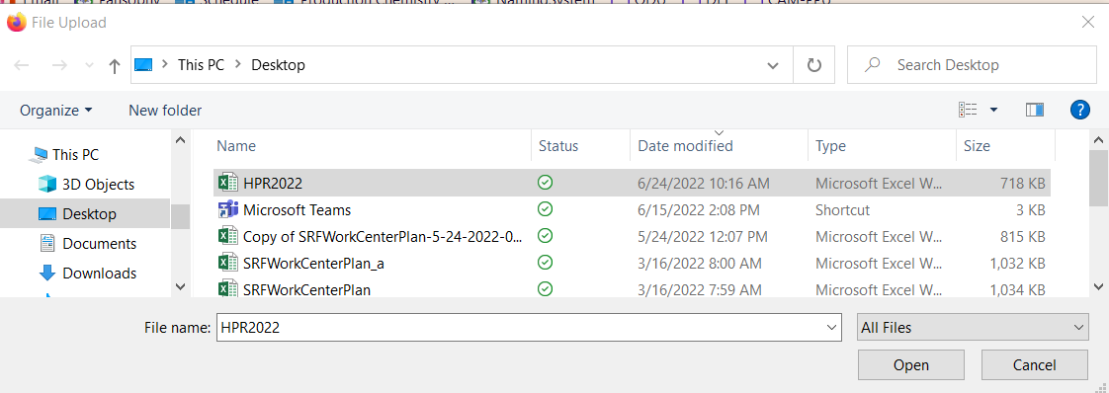

* 1. The file name will show next to browse

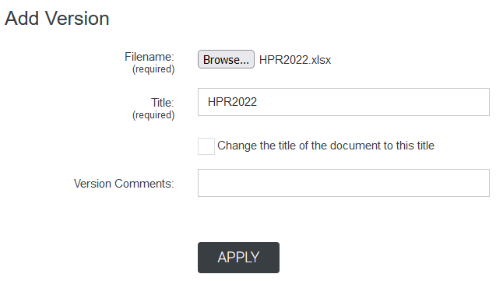

1. Click Apply, the page will refresh to View Properties

