Traveler Title | LCLS-II-HE Cold FPC Inspection Traveler
Traveler Abstract | Incoming inspection process for the cold part of L2HE FPCs (FPCCs)
Traveler ID | L2HE-CLNRM-FPCC-INSP
Traveler Revision | R5
Traveler Author | N. huque
Traveler Date | 13-Jul-22
NCR Informative Emails | jharris
NCR Dispositioners | Huque,adamg
D3 Emails | Huque,adamg
Approval Names | Naeem Huque | Danny Forehand | Kirk Davis | John Hogan
Approval Signatures
Approval Dates
Approval Title | Author | Work Center Lead | Reviewer | Project Manager

References | List and Hyperlink all documents related to this traveler. This includes, but is not limited to: safety (THAs, SOPs, etc), drawings, procedures, and facility related documents.
LCLSII-HE-1.2-ES-0059 | CP-L2PRD-CLN-PUMP | CP-C100-CAV-LKTS | Solair 3100 Gen E Manual | L2HE-PR-INSP-FPCC-R4
CP-STP-CAV-CHEM-DEGR-R3 | CP-L2PRD-CM-SLBUP-R2 | CP-L2PRO-CST-CHEM-CLN-ION | Vacuum-005-2008

Revision Note
R1 | Initial release of this Traveler.
R2 | Removed kit parts and RGA criteria
R3 | Added instructions to photograph parts (multiple steps) regardless of defects
R4 | Changed NCR dispositioner and D3 informative emails. Changed inspection procedure revision to R4
R5 | Change traveler format to one serial number per traveler.

Step No. | Instructions | Data Input
1 | Inspection Start Date  Technician Name  Visually inspect the outer plastic bag. Comment on any damage. | [[StartDate]] <<TIMESTAMP>>  [[InspTech1_SRFCVP]] <<SRFCVP>>  [[BagComm]] <<COMMENT>>
2 | Enter the serial number of the FPC being inspected (label on outer bag, in the form PA#-XX) and note the postion on the stand as per the image below.  Enter the serial number for the second FPCC for reference (label on outer bag) CPI-FPCC-HE-XXX, along with any other relevant comments.  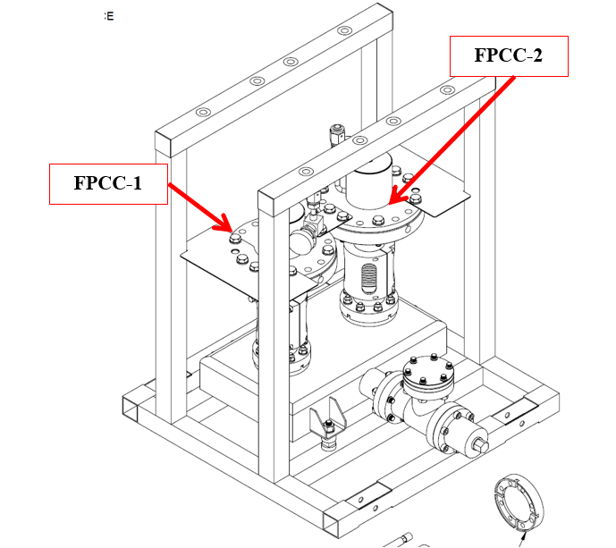 | [[FPCCSN]] <<FPCCSN>>  [[Position 1or 2]] <<POSITION>>  [[PairFPCSerialNumber]] <<COMMENT>>
3 | Cleanroom Test Date  Cleanroom Technician  Cleanroom Admission Comments | [[CRTest]] <<TIMESTAMP>>  [[CRTech_SRFCVP]] <<SRFCVP>>  [[CRComm]] <<COMMENT>>
4 | RGA Scan and Leak Check  RGA/Leak Test Date  Technician  Record Static Vacuum (in torr)  Perform bag Leak Check and upload data file. If leak rate is above 2.76x10⁻¹⁰ torr-l/sec He, generate an NCR.  Assembly passes Leak Check?  Collect RGA data and upload file. Do not generate an NCR | [[RGALeakDate]] <<TIMESTAMP>>  [[RGALeakTech_SRFCVP]] <<SRFCVP>>  [[StatVac]] <<SCINOT>>  [[StatVacUpload]] <<FILEUPLOAD>>  [[StatVacComm]] <<COMMENT>>  [[LCRate]] <<SCINOT>>  [[LCUpload]] <<FILEUPLOAD>>  [[LCComm]] <<COMMENT>>  [[LCYesNo]] <<YESNO>>  [[RGAUpload]] <<FILEUPLOAD>>  [[RGAComm]] <<COMMENT>>
5 | Electrical Checks  Check that the resistance of the electron probes read infinity with the multimeter. Generate an NCR for any probes that fail.  FPC Probe Ok? | [[FPCPRobe]] <<YESNO>>  [[FPCProbeComm]] <<COMMENT>>
6 | External Particulate Count  Record and upload (optional) particulate counts on the external volume of the assembly. If particulate count for 0.3μm particles size does not reach 1000 counts in about 15 minutes of nitrogen spraying, comment and generate an NCR and upload the final file. | [[ExtCountOk]] <<YESNO>>  [[ExtCountUpload]] <<FILEUPLOAD>>  [[ExtCountComm]] <<COMMENT>>
7 | Visual Inspection – After Removal of Protection Caps  Visually inspect the cold ceramics. Upload photos of the cold ceramics. Generate an NCR for any scratches, chips, spots or stains.  Visually inspect the CF100 knife edges; upload photos. Generate an NCR if there are any defects or if there are any copper deposits on the knife edge.  Visually inspect the copper plating on the CF100 flanges and upload photos. The plating should be uniform, without pits, scratches, peeling off, blisters and should stop at ~3 mm from the knife edge. There should be no Viton residue on the copper. If any issues are found, document findings and generate NCR.  Visually inspect the RF contact surfaces above the ceramic; upload photos Generate an NCR if there are any scratches or other defects.  Remove the RF pin and check that the threads are intact and that there is no dirt or oil inside the tapped hole; upload photos. Generate an NCR if any issues are found. | [[FPCCeramicOk]] <<YESNO>>  [[CeramicComm]] <<COMMENT>>  [[CeramicPhoto]] <<FILEUPLOAD>>  [[FPCCFKnifeOk]] <<YESNO>>  [[CF100Comm]] <<COMMENT>>  [[CF100Photo]] <<FILEUPLOAD>>  [[FPCFlangePltOk]] <<YESNO>>  [[FlgPltComm]] <<COMMENT>>  [[FlgPltPhoto]] <<FILEUPLOAD>>  [[FPCRFConOk]] <<YESNO>>  [[RFConComm]] <<COMMENT>>  [[RFConPhoto]] <<FILEUPLOAD>>  [[FPCRFHoleOk]] <<YESNO>>  [[RFHoleComm]] <<COMMENT>>  [[RFHolePhoto]] <<FILEUPLOAD>>
8 | Visual Inspections after Removing FPCC from Shipping Stand  Inspect the FPCC bellows for any dents or scratches. Upload photos of the bellows; at least 4 images with 90 degrees of rotation between them. Generate an NCR if any defects are found.  Visually inspect the sealing surface of the FPCC Cavity Flange sealing surface; upload photos. It should be free of AlMg traces, scratches, and chemical residue. Generate an NCR if any issues are found.  Inspect the visible regions of copper plating on the inner surface of FPCC; upload photos. Generate an NCR if there are any blisters, pits, scratches, stains, or flaking copper.  Visually inspect the FPCC copper antenna and upload photos. It should be free of scratches, chemical residue, erosion spots or mechanical cleaning marks. If any issues are identified, document and generate NCR. | [[FPCBellowsOk]] <<YESNO>>  [[FPCBellowsComm]] <<COMMENT>>  [[FPCBellowsPhoto]] <<FILEUPLOAD>>  [[FPCCavSealOk]] <<YESNO>>  [[FPCCavSealComm]] <<COMMENT>>  [[FPCCavSealPhoto]] <<FILEUPLOAD>>  [[FPCCopperOk]] <<YESNO>>  [[FPCCopperComm]] <<COMMENT>>  [[FPCCopperPhoto]] <<FILEUPLOAD>>  [[FPCAntennaOk]] <<YESNO>>  [[FPCAntennaComm]] <<COMMENT>>  [[FPCAntennaPhoto]] <<FILEUPLOAD>>
9 | FPCC Internal Particulate Count  Record and upload (optional) particulate counts on the internal volume of FPCC. If particulate count for 0.3μm particles size does not reach 10 counts in about 15 minutes of nitrogen spraying, comment and generate an NCR and upload the final file. | [[FPCIntCountOk]] <<YESNO>>  [[FPCIntCountUpload]] <<FILEUPLOAD>>  [[FPCIntCountComm]] <<COMMENT>>
12 | Storage  Move the test frame with the two FPCCs in the Clean room class 10 dedicated storage areas. Record the date when the test stand was moved into the storage area or into the N2 cabinet. | [[FPCStoreDate]] <<TIMESTAMP>>

