|  |  |  |  |
| --- | --- | --- | --- |
| **Acid Etch Rate Measurement** | | | |
| **Document Number:** | SRF-MSPR-CHEM-BCP-CAV | **Effective Date:** | DD Mmm YYYY |
| **Revision Number:** | R1 | **Periodic Review Date:** | DD Mmm YYYY |
| **Document Owner:** | Ashley Mitchell | **Department Owner:** | SRF Operations |

# Purpose

The purpose of this procedure is to determine the etch rate of Nb in BCP solution

# Scope

**This procedure applies to <enter text>.**

**This procedure does not apply to <enter text>.**

# Terms and Definitions

The following terms have specific meanings within this procedure.

|  |  |
| --- | --- |
| **Term** | **Definition** |
| **<Term 1>** | **<Definition>** |
| **<Term 2>** | **<Definition>** |
|  |  |

# Roles and Responsibilities

The following roles have responsibilities described in this document.

|  |  |
| --- | --- |
| **Role** | **Responsibility** |
| **<Job Title>** | **<Very short summary of activities this job title performs in this procedure.>** |
|  |  |
|  |  |
|  |  |

# Procedure

## ACID ETCH RATE MEASUREMENT

This procedure describe the methods to determine the etch rate of niobium in BCP solution. The etch rate changes significantly depending on:

* Acid flow
* Acid temperature
* Amount of Nb dissolved in the acid

The following dependencies can be used as a guide:

1. The etch rate of Nb in BCP 1:1:2 at 20 °C (68 °F) with moderate agitation depends on the amount of Nb dissolved as: ER = 3.6871*C-0.321 where ER is the etch rate in µm/min and C is the concentration of Nb in the BCP solution in g/liter.
2. The etch rate of Nb in fresh BCP 1:1:2 with moderate agitation depends on temperature as: ER = 1.966*exp(0.031859*T) where ER is the etch rate in µm/min and T is the acid temperature in °C.
3. The etch rate of Nb in fresh BCP 1:1:1 with moderate agitation depends on temperature as: ER = 4.8472*exp(0.030417*T).

The following steps allow measuring the etch rate with two methods:

* Measure the dimensions (width, length, thickness) of the Nb sample. The sample should be cut such that the width and the length are much larger than the thickness.
* Weigh the Nb sample on the digital balance.
* Measure the thickness of the sample with a digital micrometer at a location marked on the sample, as shown in Fig. 1.
* Pre-cool the BCP solution to 15-17 °C (59-63 °F) with an ice bath, similar to Fig. 2
* Place the Nb sample in a suitable container and immerse into the container with the acid, placed into a container with chilled water (Fig. 3). The sample should be etched for **5 min for BCP 1:1:2, 2 min for BCP 1:1:1.** It is important that:
  + The acid temperature is monitored for the duration of the etching and should be maintained in the range 15-17 °C (59-63 °F). Add ice to the water bath to lower the temperature or DI water to warm it up as necessary (Fig. 4).
  + The top and bottom faces of the samples are constantly immersed and in contact with the acid so that both surfaces are equally etched.
  + Gently move the sample into the acid container
* Rinse the Nb sample in DI water and dry.
* Weigh the Nb sample on the digital balance
* Measure the thickness of the sample with a digital micrometer at a location marked on the sample, as shown in Fig. 1.
* Enter the dimensions of the sample and the weight before and after etching in the spreadsheet [Acid Usage & Etch Rate](https://jlabdoc.jlab.org/docushare/dsweb/View/Collection-29993). The etch rate is calculated as: ER1 = ∆w/(Ρ*A) where ER1 is the etch rate in µm/min, ∆w is the difference in weight before and after etching in grams, ∆ is the density of Nb (8.57 g/cm3) and A is the sample surface area in cm2.
* The other method to calculate the etch rate is given by: ER2 = ∆d*1000/2 where ER1 is the etch rate in µm/min, ∆d is the difference in thickness before and after etching measured with the micrometer in mm.
* If the values of ER1 and ER2 do not agree within **20%** the measurements should be repeated.
* Record the average value of the etch rate (ER1+ER2)/2 in the logbook
* Store the Nb sample in a sealed plastic bag.

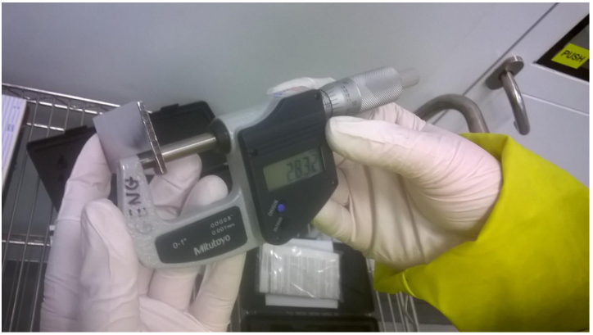

Figure 1: measurement of the thickness of the Nb sample with a digital micrometer at a fixed, marked location.

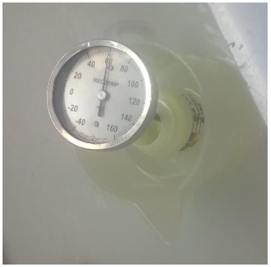

Figure 2: BCP solution pre-cooled in cold water.

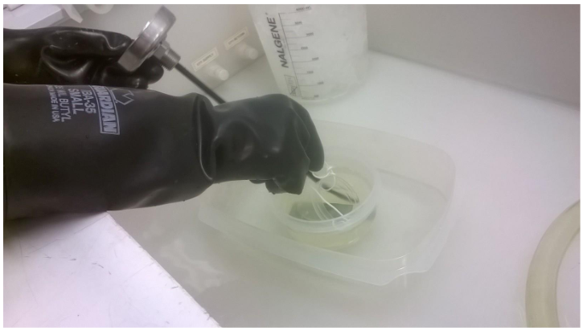

Figure 3: Nb sample in container with BCP solution, placed in a chilled water bath.

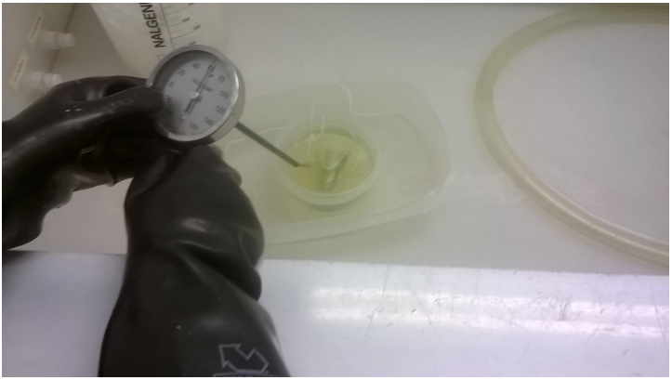

Figure 4: Assure that the acid temperature is kept between 15-17 °C (59-63 °F) during the etch rate test and that all surfaces of the sample are in contact with the acid throughout the test.

# References

|  |  |
| --- | --- |
| **Document No.** | **Title** |
| SRF-01-ML-001 | SRF Quality Manual |
| [SRF-16-58478-OSP](https://mis.jlab.org/mis/apps/mis_forms/operational_safety_procedure_form.cfm?entry_id=58478) | Production Chemistry Room  OSP |
|  |  |

# Release and Revision History

|  |  |  |
| --- | --- | --- |
| **Rev #** | **Major Changes** | **Effective Date:** |
| 1 | Initial version | DD Mmm YYY |
|  |  |  |
|  |  |  |
|  |  |  |

# Approvals

|  |  |  |  |
| --- | --- | --- | --- |
| **Approved by:** | **Name:** | **Signature:** | **Date:** |
| Document Owner | A. Mitchell |  | DD Mmm YYY |
| Subject Matter Expert | A. Wildeson |  | DD Mmm YYY |
| Work Center Lead | <First Last Name> |  | DD Mmm YYY |
| Project Leader | <First Last Name> |  | DD Mmm YYY |