**JLEIC Crab Cavity Trim Tuning Measurements and Cable Calibration Procedure**

1. **Purpose and Scope**

This procedure describes the steps to measure the frequency, and *Q*ext of the Input Probe and Pick Up Probe for the JLEIC crab cavity.

1. **References**

Coupling-cal – Spreadsheet to calculate *Q*ext

JL0127752 – JLEIC Crab Cavity Frequency Measurement Drawing

1. **Process Details**
   1. **Trim Tuning**

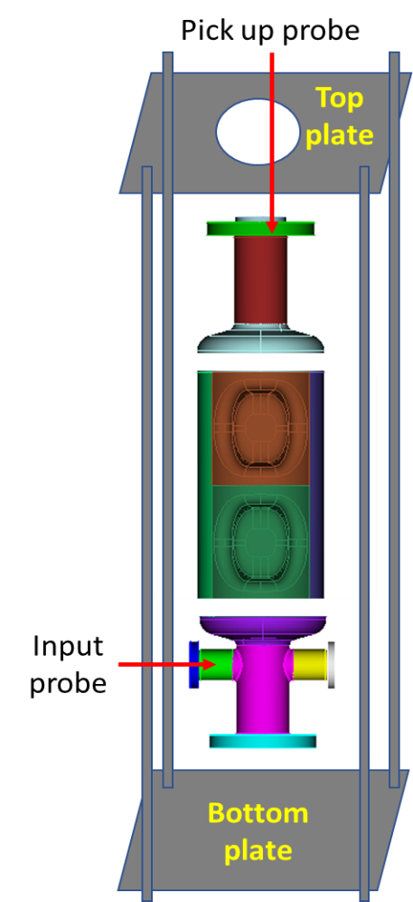

Fig. 1: Trim Tuning Set Up

**Assembly Steps:**

Fig. 2: Top and bottom plates with opening to insert auxiliary probes.

1. Assemble the 4 rods to the bottom plate. Make sure the plate is leveled (Fig. 2).
2. Assemble a 6” blank flange with a crushed 6” Cu gasket to the end cap at the bottom.
3. Stack the 3 sub-assemblies (Fig. 1).
4. Temporary blanks, auxiliary probes will supply RF power to the cavity while measuring RF frequency of the stacked assembly (Fig. 3).

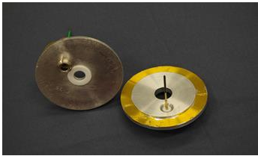

Fig. 3: Temporary blanks with auxiliary probes.

1. The threaded holes for the feed-throughs are slightly off center to couple to the fundamental mode through the beam pipe. The temporary antenna will be cut to a length that will ensure that it is under coupled and not affecting the field in the cavity (approximately 5”-6” in length).
2. Insert the temporary blank that fits on a 6” CF flange with the auxiliary probe (with an offset of 1 cm as shown in the diagram) and a 6” Cu gasket. Clamp the temporary blank to the CF flange.
3. Place the top plate and tighten the set up.
4. Use the temporary blank that fits a 2¾” CF flange with the feed-through. Use a temporary antenna of approximately 2”-3” in length. Insert the temporary blank with auxiliary probe centered on one of the 2¾” flanges. Clamp the temporary blank to the CF flange.

**Frequency Measurement Steps:**

1. Connect Vector Network Analyzer (VNA) and attach cables to the input (Port 1) and pick up (Port 2) probes.
2. Set the VNA for an *S*21 measurement, Format = Log Mag, Number of points = 1600, IF Bandwidth = 1 kHz.
3. Set the Start Frequency to 950 MHz and Stop Frequency to 960 MHz. There should be a single peak displayed corresponding to each mode to the fundamental crabbing mode.
4. Set 3dB BW *S*21 for measurement. Make sure *Q*L is > 6500 (Fig. 4). Tighten the assembly to determine the QL doesn’t vary. This verifies the good electrical contact between the sub-assemblies in the cavity.

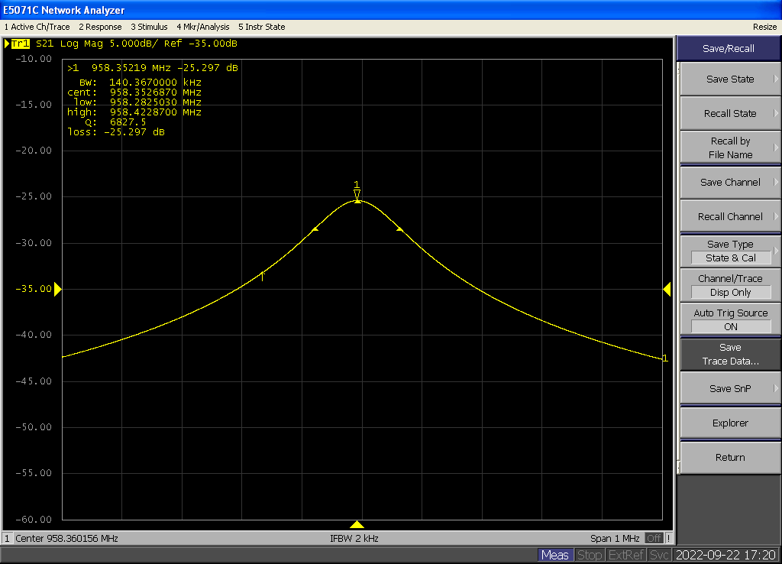

Fig. 4: VNA screenshot to measure *Q*L.

1. Set the VNA for an *S*11 and *S*22 measurement, Format = Polar 🡪 Real Imag.
2. Check that *S*11 and *S*22 to ensure it is critically coupled and not over coupled (Fig. 5).

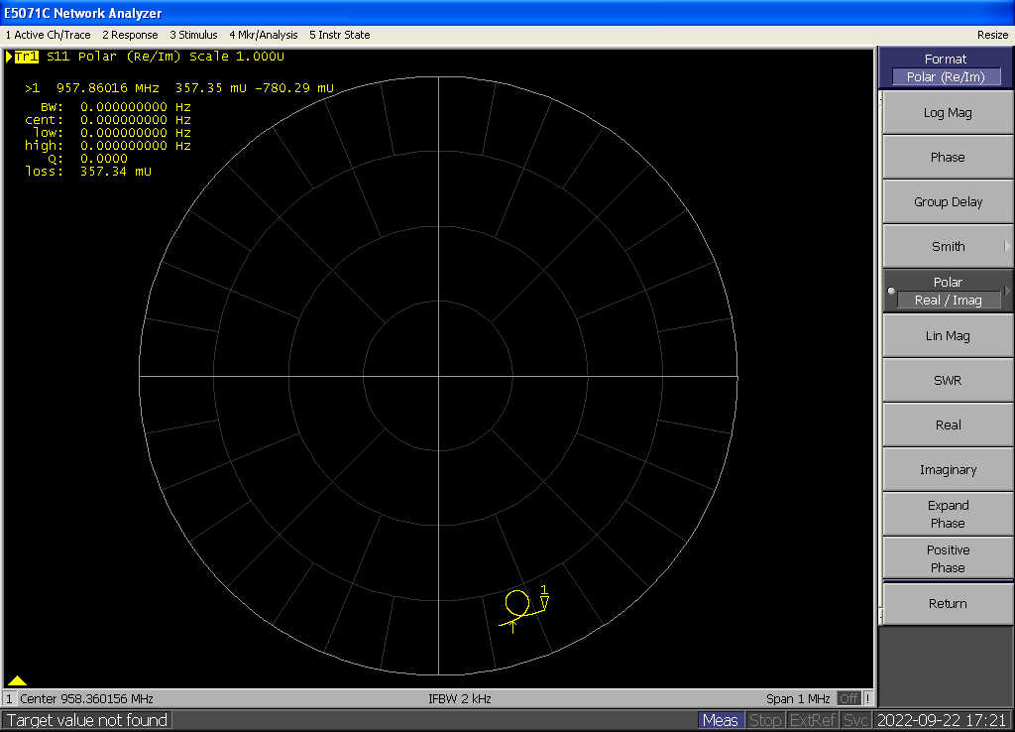

Fig. 5: VNA screenshots to check the coupling.

1. Record the frequency of the mode.
2. Follow the above steps to measure the cavity frequency at different processing steps on the cavity.
   1. **Probe Calibration**

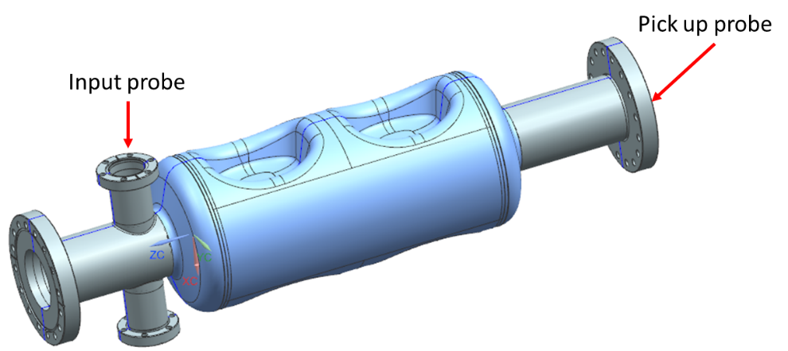

Fig. 6: Input and Pick Up Probes for VTA Test.

The JLEIC crab cavity test in VTA requires an Input Probe to couple forward power in to the cavity and a Pick Up Probe to measure the transmitted power (Fig. 6).

**Input Probe *Q*ext Measurement and Tuning Steps:**

1. Setup the VNA as follows:
   * Measure: *S*21
   * Trigger: Continuous
   * Format: Log Mag
   * Span: 1 MHz
   * Number of Points: 1601
   * IF BW: 300 Hz
   * Set the Center Frequency to be the frequency of the crabbing mode (952 MHz)
2. Calibrate the VNA: connect the cables to the Keysight N4431B electronic calibration module. Select Cal, E-CAL.
3. Verify the calibration using an *S*21 measurement with the cables connected together: the attenuation should be ≤ ±0.01dB when measuring calibrated cables.
4. A launching antenna should be inserted in a feedthrough with a temporary blank installed on the Pick Up Probe flange (Fig. 6). Connect Port 1 of the VNA to the feed-through.
5. Attach the shorter Cu probe (Fig. 7) to the 2¾” CF flange with the threaded feed-through (Fig. 8). Connect the flange to the cavity Input Probe flange with a crushed 2¾” Cu gasket. Connect Port 2 of the VNA to the feed-through.

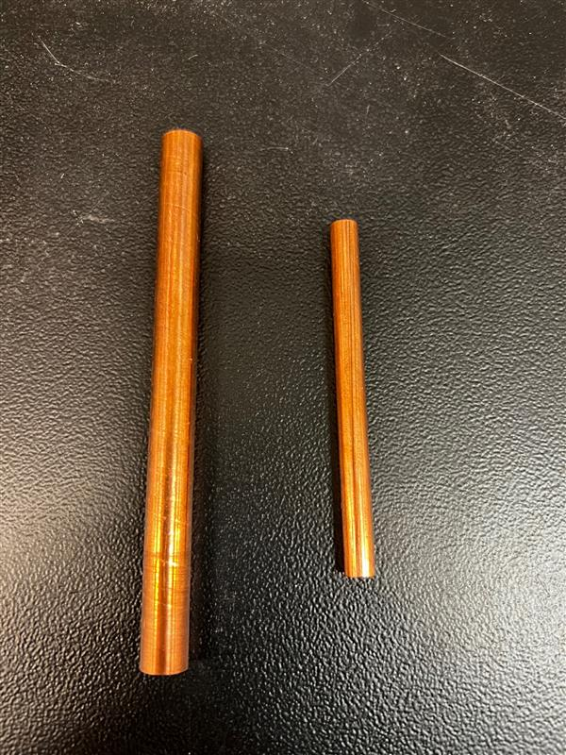

Fig. 7: Cu probes for Pick Up Probe (left) and Input Probe (right).

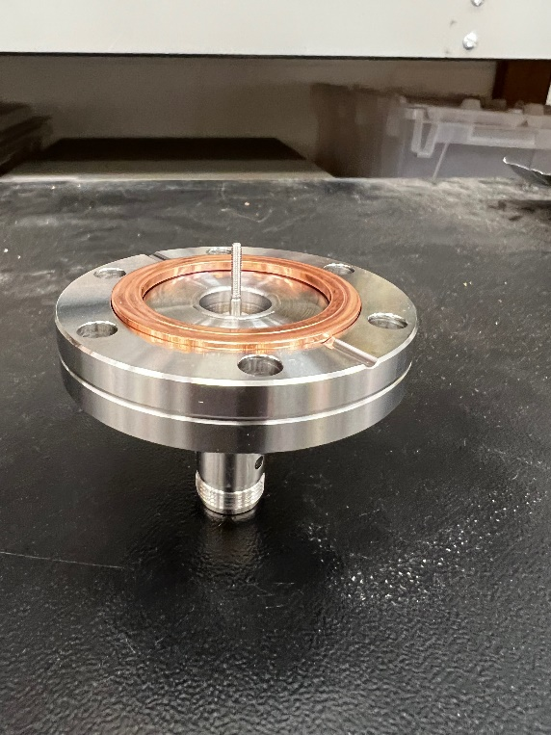 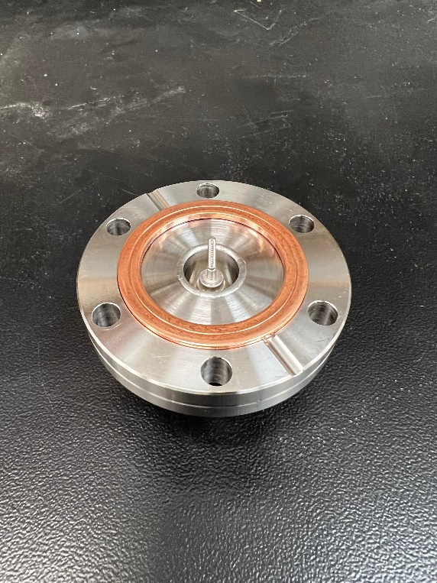

Fig. 8: 2¾” CF flange for Input Probe

1. Set the VNA to Measure *S*11, Format: Polar, to check the input antenna for coupling and reflection coefficient. The VNA screen should be similar to the one shown in Fig. 9: the signal will not include the origin if the antenna is properly under-coupled. Too short of an antenna will result in noisy signal.



Fig. 9: VNA screenshots to check the coupling.



Fig. 10: VNA screenshot to measure the reflection coefficient of the launching antenna.

1. Set marker to search for minimum. Using the Scale: Phase Offset button, roll the signal around until the point of the marker is on the positive x-axis.
2. Change the Format to Real, use the Reference Value button to roll the “off-resonance” (detuned) signal to the reference line (Fig. 10). Record the values of “*S*11_Detuned” and “*S*11_Resonant” in mU by placing the marker off resonance and on resonance (Use the Mrk Search: Min function), respectively. The length of the launching antenna should be such that *S*11_Resonant is ~ 0.8-0.9 mU.

The reflection coefficient can be calculated as: Γ = *S*11_Resonant/ *S*11_Detuned.

1. Change the measurement to *S*21, Format: Log Mag. Set Mrk Search to Max, Tracking: On, set Width: On (default setting for marker widths is -3 dB), as shown in Fig. 11. Record the values of “*Q*L” and “loss” displayed on the screen. The *Q*extcan be calculated as:



The measured quantities can be typed in the *Q*extcalculation spreadsheet to automatically calculate the *Q*ext. The *Q*extof the Input Probe needs to be set at 9.0×109 ± 15% (7.7×109 – 10.4×109).



Fig. 11: VNA screenshot of the Input Probe insertion loss measurement.

1. If the *Q*ext lower than the range mentioned above, the Input Probe is strongly coupled. Disassemble and disconnect the Cu probe from the 2¾” CF flange.
2. Trim the Cu probe by 1-3 mm. And repeat the steps 5-9 until the desired *Q*extis achieved.

**Pick Up Probe *Q*ext Measurement and Tuning Steps:**

1. Repeat steps 1-3 given above.
2. A launching antenna should be inserted in a feedthrough with a temporary blank installed on the Input Probe flange (Fig. 6). Connect Port 1 of the VNA to the feed-through.
3. Attach the longer Cu probe (Fig. 7) to the 6” CF flange with the threaded feed-through that is designed with an offset 1 cm (Fig. 12). Connect the flange to the cavity Input Probe flange with a crushed 6” Cu gasket. Connect Port 2 of the VNA to the feed-through.

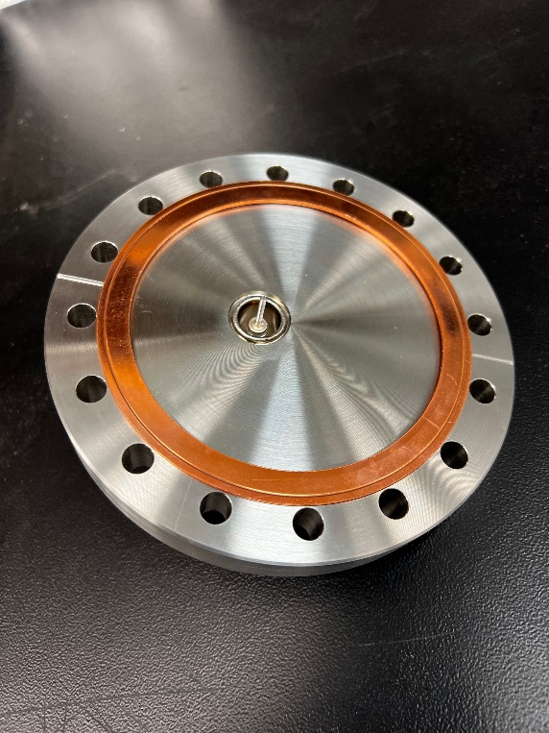 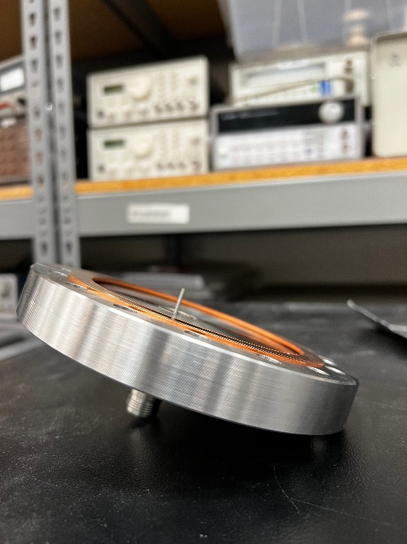

Fig. 12: 6” CF flange for Pick Up Probe.

1. The *Q*extof the Input Probe needs to be set at 5.0×1011 ± 15% (4.3×1011 – 5.8×1011).
2. Repeat steps 6-11 given above.