|  |  |  |  |
| --- | --- | --- | --- |
| **JLEIC Crab Cavity Trim Tuning Measurements and Cable Calibration Procedure** | | | |
| **Document Number:** | SRF-MSPR-TUNE-CAV | **Effective Date:** | DD Mmm YYYY |
| **Revision Number:** | R1 | **Periodic Review Date:** | DD Mmm YYYY |
| **Document Owner:** | Subashini De Silva | **Department Owner:** | SRF Operations |

# Purpose

The purpose of this document is to describe the steps to measure the frequency, and Qext of the Input Probe and Pick Up Probe for the JLEIC crab cavity.

# Scope

This procedure applies to <enter text>.

This procedure does not apply to <enter text>.

# Terms and Definitions

The following terms have specific meanings within this procedure.

|  |  |
| --- | --- |
| **Term** | **Definition** |
| <Term 1> | <Definition> |
| <Term 2> | <Definition> |
|  |  |

# Roles and Responsibilities

The following roles have responsibilities described in this document.

|  |  |
| --- | --- |
| **Role** | **Responsibility** |
| <Job Title> | <Very short summary of activities this job title performs in this procedure.> |
|  |  |
|  |  |
|  |  |

# Procedure

## Trim Tuning

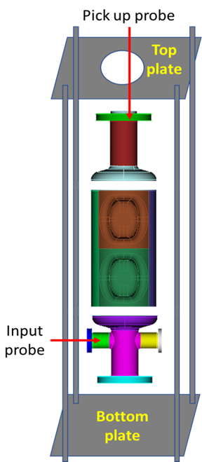

Fig. 1: Trim Tuning Set Up

## Assembly Steps:

Fig. 2: Top and bottom plates with opening to insert auxiliary probes.

1. Assemble the 4 rods to the bottom plate. Make sure the plate is leveled (Fig. 2).
2. Assemble a 6” blank flange with a crushed 6” Cu gasket to the end cap at the bottom.
3. Stack the 3 sub-assemblies (Fig. 1).
4. Temporary blanks, auxiliary probes will supply RF power to the cavity while measuring RF frequency of the stacked assembly (Fig. 3).

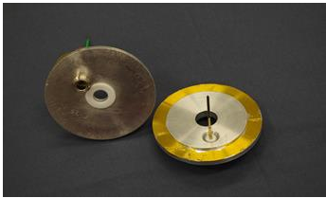

Fig. 3: Temporary blanks with auxiliary probes.

1. The threaded holes for the feed-throughs are slightly off center to couple to the fundamental mode through the beam pipe. The temporary antenna will be cut to a length that will ensure that it is under coupled and not affecting the field in the cavity (approximately 5”-6” in length).
2. Insert the temporary blank that fits on a 6” CF flange with the auxiliary probe (with an offset of 1 cm as shown in the diagram) and a 6” Cu gasket. Clamp the temporary blank to the CF flange.
3. Place the top plate and tighten the set up.
4. Use the temporary blank that fits a 2¾” CF flange with the feed-through. Use a temporary antenna of approximately 2”-3” in length. Insert the temporary blank with auxiliary probe centered on one of the 2¾” flanges. Clamp the temporary blank to the CF flange.

## Frequency Measurement Steps:

1. Connect Vector Network Analyzer (VNA) and attach cables to the input (Port 1) and pick up (Port 2) probes.
2. Set the VNA for an S21 measurement, Format = Log Mag, Number of points = 1600, IF Bandwidth = 1 kHz.
3. Set the Start Frequency to 950 MHz and Stop Frequency to 960 MHz. There should be a single peak displayed corresponding to each mode to the fundamental crabbing mode.
4. Set 3dB BW S21 for measurement. Make sure QL is > 6500 (Fig. 4). Tighten the assembly to determine the QL doesn’t vary. This verifies the good electrical contact between the sub-assemblies in the cavity.

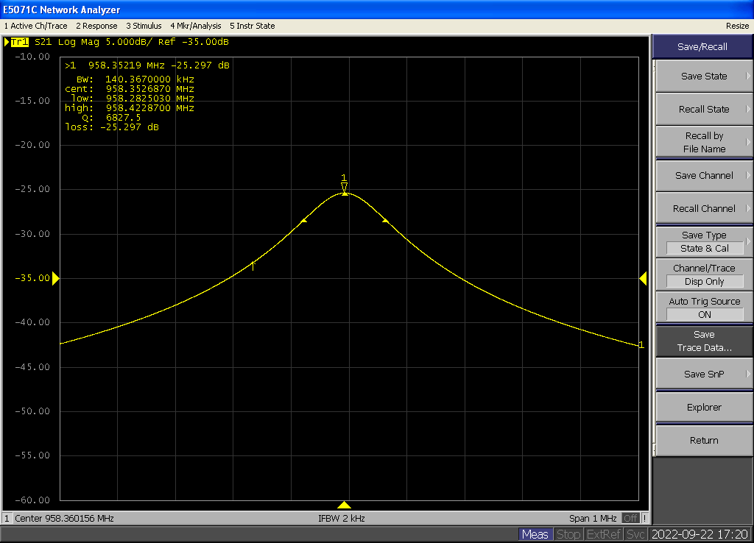

Fig. 4: VNA screenshot to measure *Q*L.

1. Set the VNA for an S11 and S22 measurement, Format = Polar → Real Imag.
2. Check that S11 and S22 to ensure it is critically coupled and not over coupled (Fig. 5).

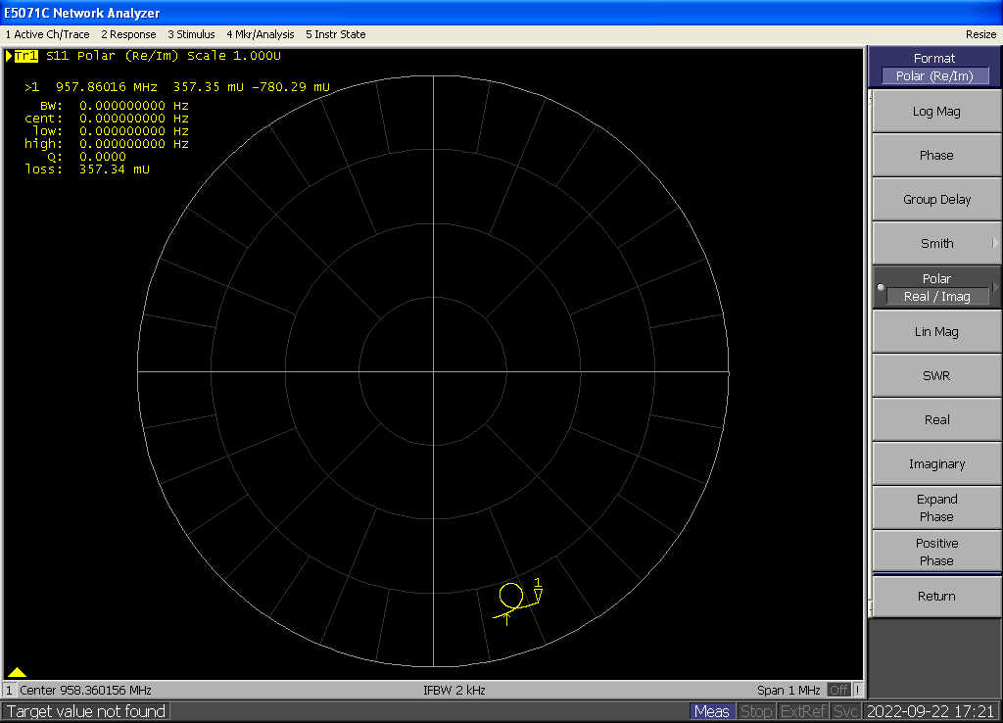

Fig. 5: VNA screenshots to check the coupling.

1. Record the frequency of the mode.
2. Follow the above steps to measure the cavity frequency at different processing steps on the cavity.

## Probe Calibration

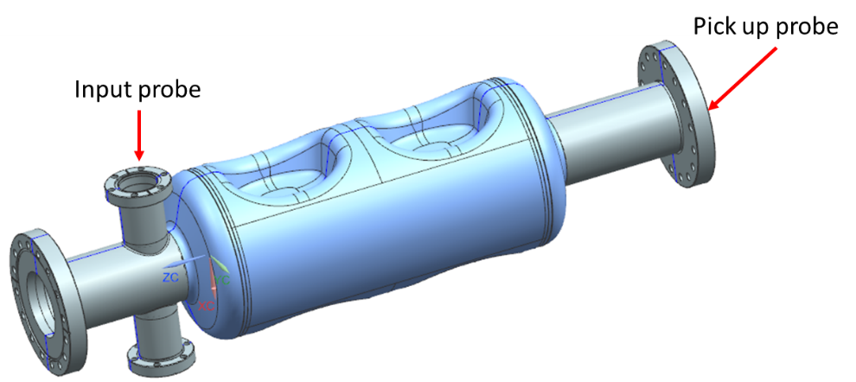

Fig. 6: Input and Pick Up Probes for VTA Test.

The JLEIC crab cavity test in VTA requires an Input Probe to couple forward power in to the cavity and a Pick Up Probe to measure the transmitted power (Fig. 6).

# References

|  |  |
| --- | --- |
| **Document No.** | **Title** |
| SRF-01-ML-001 | SRF Quality Manual |
|  | Coupling-cal – Spreadsheet to calculate Qext |
| JL0127752 | JLEIC Crab Cavity Frequency Measurement Drawing |

# Release and Revision History

|  |  |  |
| --- | --- | --- |
| **Rev #** | **Major Changes** | **Effective Date:** |
| 1 | Initial version | DD Mmm YYY |
|  |  |  |
|  |  |  |
|  |  |  |

# Approvals

|  |  |  |  |
| --- | --- | --- | --- |
| **Approved by:** | **Name:** | **Signature:** | **Date:** |
| Document Owner | <First Last Name> |  | DD Mmm YYY |
| Subject Matter Expert | <First Last Name> |  | DD Mmm YYY |
| Work Center Lead | <First Last Name> |  | DD Mmm YYY |
| Project Leader | <First Last Name> |  | DD Mmm YYY |