|  |  |  |  |
| --- | --- | --- | --- |
| **JLEIC Crab Cavity Trim Tuning Measurements and Cable Calibration Procedure** | | | |
| **Document Number:** | SRF-MSPR-TUNE-CAV | **Effective Date:** | DD Mmm YYYY |
| **Revision Number:** | R1 | **Periodic Review Date:** | NA |
| **Document Owner:** | Subashini De Silva | **Department Owner:** | SRF Operations |

# Purpose

The purpose of this document is to describe the steps to measure the frequency, and *Q*ext of the Input Probe and Pick Up Probe for the JLEIC RFD crab cavity.

# Scope

This procedure applies to RF-Dipole (RFD) style deflecting crabbing cavities.

This procedure does not apply to standard elliptical cavities.

# Terms and Definitions

The following terms have specific meanings within this procedure.

|  |  |
| --- | --- |
| **Term** | **Definition** |
| VNA | Vector Network Analyzer |
| CF | Conflat |
| BW | Bandwidth |
| RFD | Rf-Dipole |

# Roles and Responsibilities

The following roles have responsibilities described in this document.

|  |  |
| --- | --- |
| **Role** | **Responsibility** |
| <Job Title> | <Very short summary of activities this job title performs in this procedure.> |
|  |  |
|  |  |
|  |  |

# Procedure

## Trim Tuning

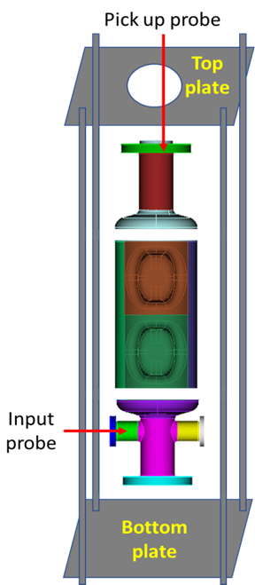

Fig. 1: Trim Tuning Set Up

### Assembly Steps:

Fig. 2: Top and bottom plates with opening to insert auxiliary probes.

1. Assemble the 4 rods to the bottom plate. Make sure the plate is leveled (Fig. 2).
2. Assemble a 6” blank flange with a crushed 6” Cu gasket to the end cap at the bottom.
3. Stack the 3 sub-assemblies (Fig. 1).
4. Temporary blanks, auxiliary probes will supply RF power to the cavity while measuring RF frequency of the stacked assembly (Fig. 3).

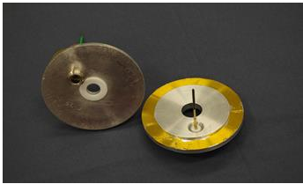

Fig. 3: Temporary blanks with auxiliary probes.

1. The threaded holes for the feed-throughs are slightly off center to couple to the fundamental mode through the beam pipe. The temporary antenna will be cut to a length that will ensure that it is under coupled and not affecting the field in the cavity (approximately 5”-6” in length).
2. Insert the temporary blank that fits on a 6” CF flange with the auxiliary probe (with an offset of 1 cm as shown in the diagram) and a 6” Cu gasket. Clamp the temporary blank to the CF flange.
3. Place the top plate and tighten the set up.
4. Use the temporary blank that fits a 2¾” CF flange with the feed-through. Use a temporary antenna of approximately 2”-3” in length. Insert the temporary blank with auxiliary probe centered on one of the 2¾” flanges. Clamp the temporary blank to the CF flange.

### Frequency Measurement Steps:

1. Connect Vector Network Analyzer (VNA) and attach cables to the input (Port 1) and pick up (Port 2) probes.
2. Set the VNA for an S21 measurement, Format = Log Mag, Number of points = 1600, IF Bandwidth = 1 kHz.
3. Set the Start Frequency to 950 MHz and Stop Frequency to 960 MHz. There should be a single peak displayed corresponding to each mode to the fundamental crabbing mode.
4. Set 3dB BW S21 for measurement. Make sure *Q*L is > 6500 (Fig. 4). Tighten the assembly to determine the *Q*L does not vary. This verifies the good electrical contact between the sub-assemblies in the cavity.

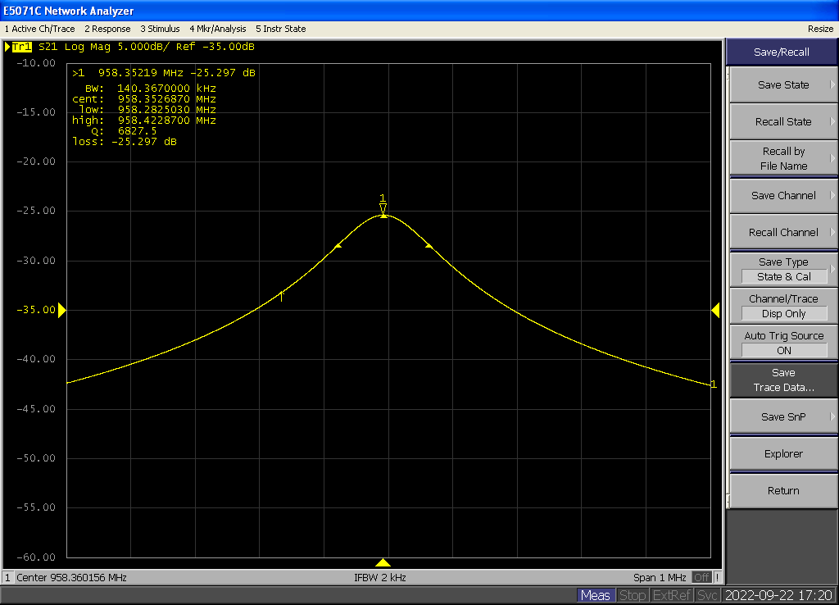

Fig. 4: VNA screenshot to measure *Q*L.

1. Set the VNA for an S11 and S22 measurement, Format = Polar 🡪 Real Imag.
2. Check that S11 and S22 to ensure it is critically coupled and not over coupled (Fig. 5).

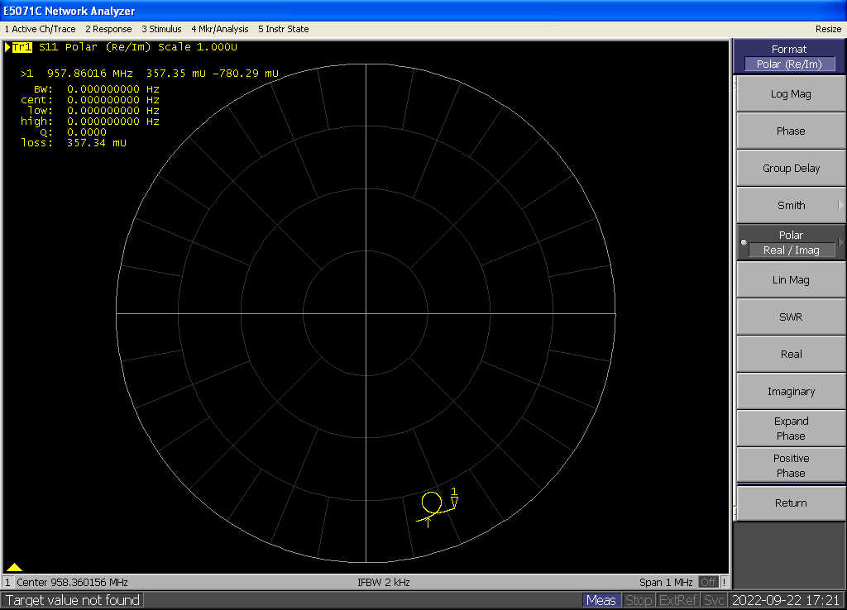

Fig. 5: VNA screenshots to check the coupling.

1. Record the frequency of the mode.
2. Follow the above steps to measure the cavity frequency at different processing steps on the cavity.

## Probe Calibration

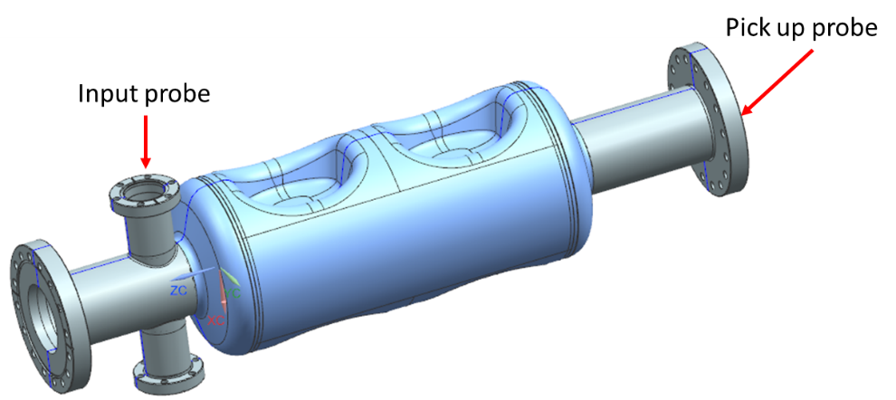

Fig. 6: Input and Pick Up Probes for VTA Test.

The JLEIC crab cavity test in VTA requires an Input Probe to couple forward power in to the cavity and a Pick Up Probe to measure the transmitted power (Fig. 6).

### Input Probe *Q*ext Measurement and Tuning Steps:

1. Setup the VNA as follows:
   * Measure: S21
   * Trigger: Continuous
   * Format: Log Mag
   * Span: 1 MHz
   * Number of Points: 1601
   * IF BW: 300 Hz
   * Set the Center Frequency to be the frequency of the crabbing mode (952 MHz)
2. Calibrate the VNA: connect the cables to the Keysight N4431B electronic calibration module. Select Cal, E-CAL.
3. Verify the calibration using an S21 measurement with the cables connected together: the attenuation should be ≤ ±0.01dB when measuring calibrated cables.
4. A launching antenna should be inserted in a feedthrough with a temporary blank installed on the Pick Up Probe flange (Fig. 6). Connect Port 1 of the VNA to the feed-through.
5. Attach the shorter Cu probe (Fig. 7) to the 2¾” CF flange with the threaded feed-through (Fig. 8). Connect the flange to the cavity Input Probe flange with a crushed 2¾” Cu gasket. Connect Port 2 of the VNA to the feed-through.

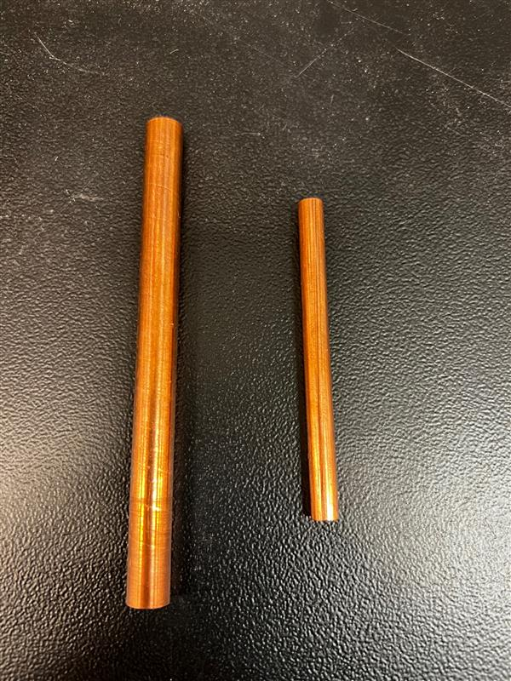

Fig. 7: Cu probes for Pick Up Probe (left) and Input Probe (right).

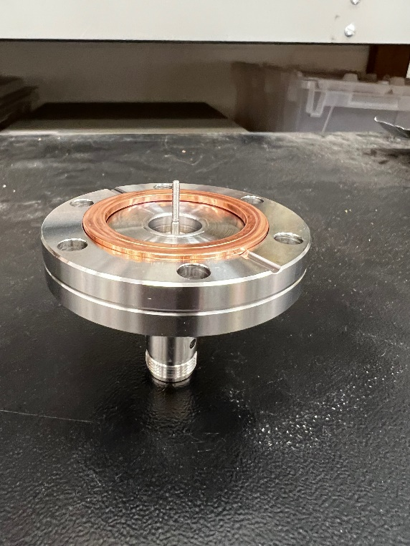 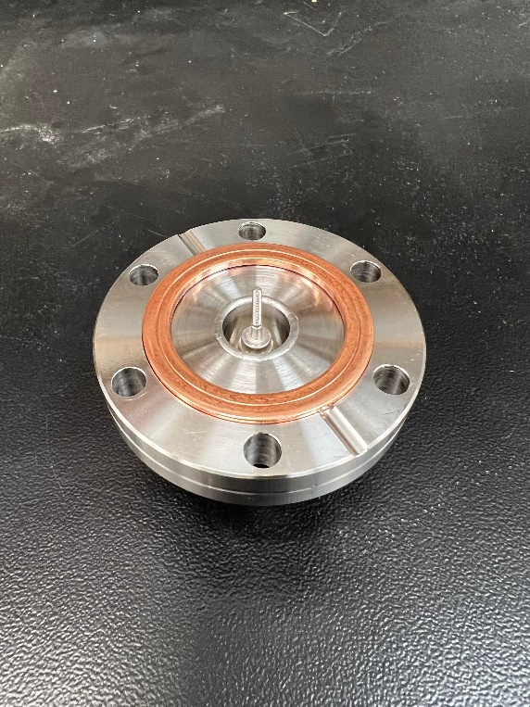

Fig. 8: 2¾” CF flange for Input Probe

1. Set the VNA to Measure S11, Format: Polar, to check the input antenna for coupling and reflection coefficient. The VNA screen should be similar to the one shown in Fig. 9: the signal will not include the origin if the antenna is properly under-coupled. Too short of an antenna will result in noisy signal.



Fig. 9: VNA screenshots to check the coupling.



Fig. 10: VNA screenshot to measure the reflection coefficient of the launching antenna.

1. Set marker to search for minimum. Using the Scale: Phase Offset button, roll the signal around until the point of the marker is on the positive x-axis.
2. Change the Format to Real, use the Reference Value button to roll the “off-resonance” (detuned) signal to the reference line (Fig. 10). Record the values of “S11_Detuned” and “S11_Resonant” in mU by placing the marker off resonance and on resonance (Use the Mrk Search: Min function), respectively. The length of the launching antenna should be such that S11_Resonant is ~ 0.8-0.9 mU.
3. The reflection coefficient can be calculated as: Γ = S11_Resonant/ S11_Detuned.
4. Change the measurement to S21, Format: Log Mag. Set Mrk Search to Max, Tracking: On, set Width: On (default setting for marker widths is -3 dB), as shown in Fig. 11. Record the values of “*Q*L” and “loss” displayed on the screen. The *Q*ext can be calculated as:

The measured quantities can be typed in the *Q*ext calculation spreadsheet to automatically calculate the *Q*ext. The *Q*ext of the Input Probe needs to be set at 9.0×109 ± 15% (7.7×109 – 10.4×109).



Fig. 11: VNA screenshot of the Input Probe insertion loss measurement.

1. If the *Q*ext lower than the range mentioned above, the Input Probe is strongly coupled. Disassemble and disconnect the Cu probe from the 2¾” CF flange.
2. Trim the Cu probe by 1-3 mm. And repeat the steps 5-9 until the desired *Q*ext is achieved.

### Pick Up Probe *Q*ext Measurement and Tuning Steps:

1. Repeat steps 1-3 given above.
2. A launching antenna should be inserted in a feedthrough with a temporary blank installed on the Input Probe flange (Fig. 6). Connect Port 1 of the VNA to the feed-through.
3. Attach the longer Cu probe (Fig. 7) to the 6” CF flange with the threaded feed-through that is designed with an offset 1 cm (Fig. 12). Connect the flange to the cavity Input Probe flange with a crushed 6” Cu gasket. Connect Port 2 of the VNA to the feed-through.

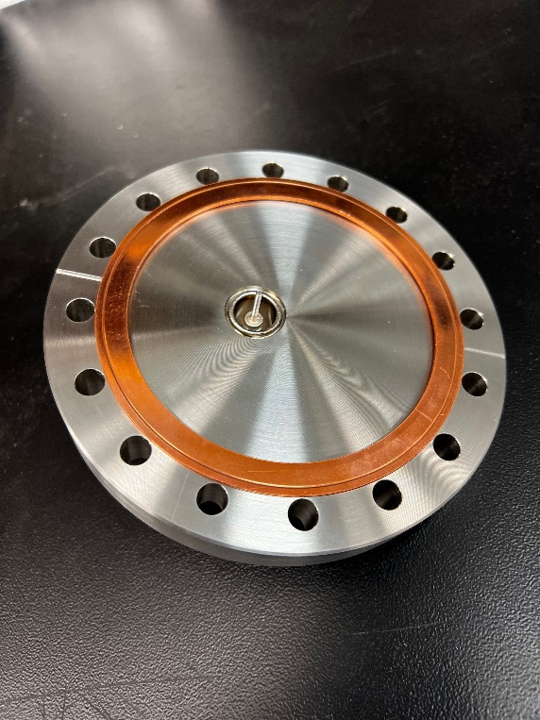 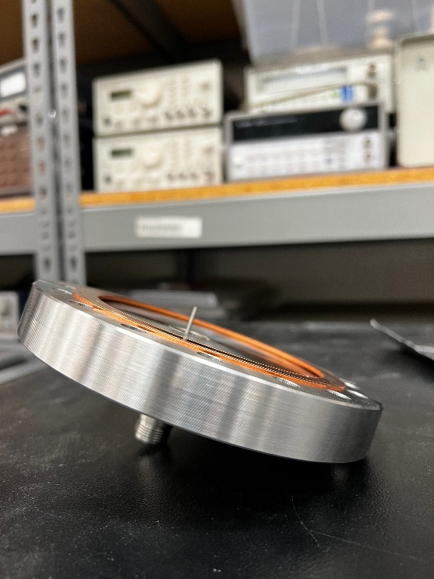

Fig. 12: 6” CF flange for Pick Up Probe.

1. The *Q*ext of the Input Probe needs to be set at 5.0×1011 ± 15% (4.3×1011 – 5.8×1011).
2. Repeat steps 6-11 given above.

# References

|  |  |
| --- | --- |
| **Document No.** | **Title** |
| SRF-01-ML-001 | SRF Quality Manual |
|  | Coupling-cal – Spreadsheet to calculate Qext |
| JL0127752 | JLEIC Crab Cavity Frequency Measurement Drawing |

# Release and Revision History

|  |  |  |
| --- | --- | --- |
| **Rev #** | **Major Changes** | **Effective Date:** |
| 1 | Initial version | DD Mmm YYY |
|  |  |  |
|  |  |  |
|  |  |  |

# Approvals

|  |  |  |  |
| --- | --- | --- | --- |
| **Approved by:** | **Name:** | **Signature:** | **Date:** |
| Document Owner | Suba |  | DD Mmm YYY |
| Subject Matter Expert | Roland? |  | DD Mmm YYY |
| Group or Work Center Lead | Kirk? |  | DD Mmm YYY |
| Project Representative | Ed or Naeem? |  | DD Mmm YYY |