Traveler Title | Receiving Inspection of LCLS-II HE SPQA Magnet
Traveler Abstract | This traveler describes the steps of incoming inspection and acceptance tests of the LCLS-II HE SPQA magnet at JLab. Fermi Lab receives the magnet from the manufacturer, conducts initial inspection in-house and acceptance before being shipped to JLab.
Traveler ID | L2HE-INSP-QUAD
Traveler Revision | R2
Traveler Author | Larry King
Traveler Date | 21-Mar-23
NCR Informative Emails | king,cheng,adamg
NCR Dispositioners | king,cheng,adamg
D3 Emails | king,cheng,adamg
Approval Names | Larry King | Michael Morrone | Gary Cheng | Mike Bevins
Approval Signatures
Approval Dates
Approval Title | Author, SOTR | Reviewer | Reviewer | Project Manager

References | List and Hyperlink all documents related to this traveler. This includes, but is not limited to: safety (THAs, SOPs, etc), drawings, procedures, and facility-related documents.
 | F10009375-RevT.pdf

Revision Note
R1 | The initial release of this Traveler.
R2 | Revised acceptance tolerances of coils’ R, L and Q measurments to better align with FNAL inspection criteria. Removed duplicate Time and Technician fields. Moved pass/fail selections closer to the relevant measurement and specification.

Overview
- The SPQA magnet has been manufactured as per the drawing package #F10009375 Rev T.
- The wooden crate contains SPQA magnet assembly wrapped in two plastic bags.
  - The inner plastic bag covers the magnet body and the RTD (Resistance Temperature Detector) leads. The RTD sensor leads are coiled and attached using masking tape to the outside surface of the magnet assembly (See Figure 1). The desiccant packets are inserted into the magnet aperture.
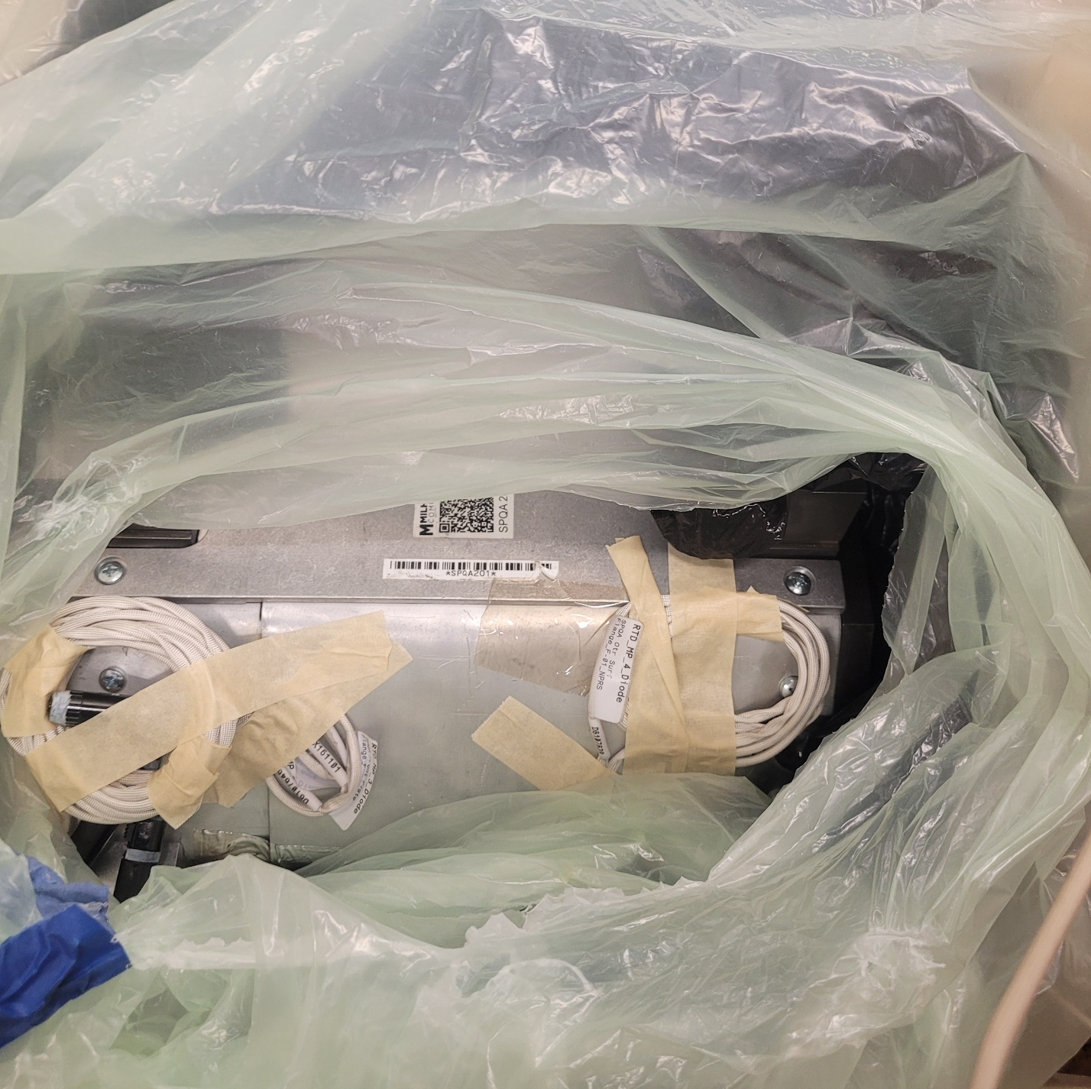
Figure 1: The SPQA magnet assembly inside the plastic bag. The RTD leads are coiled and attached to the magnet outer surface using masking tape.
  - The magnet lead wires, voltage tap wires, and heater wires are connected to the terminal strips (See Figure 2 for details). The terminal strips are fastened to a wooden block.
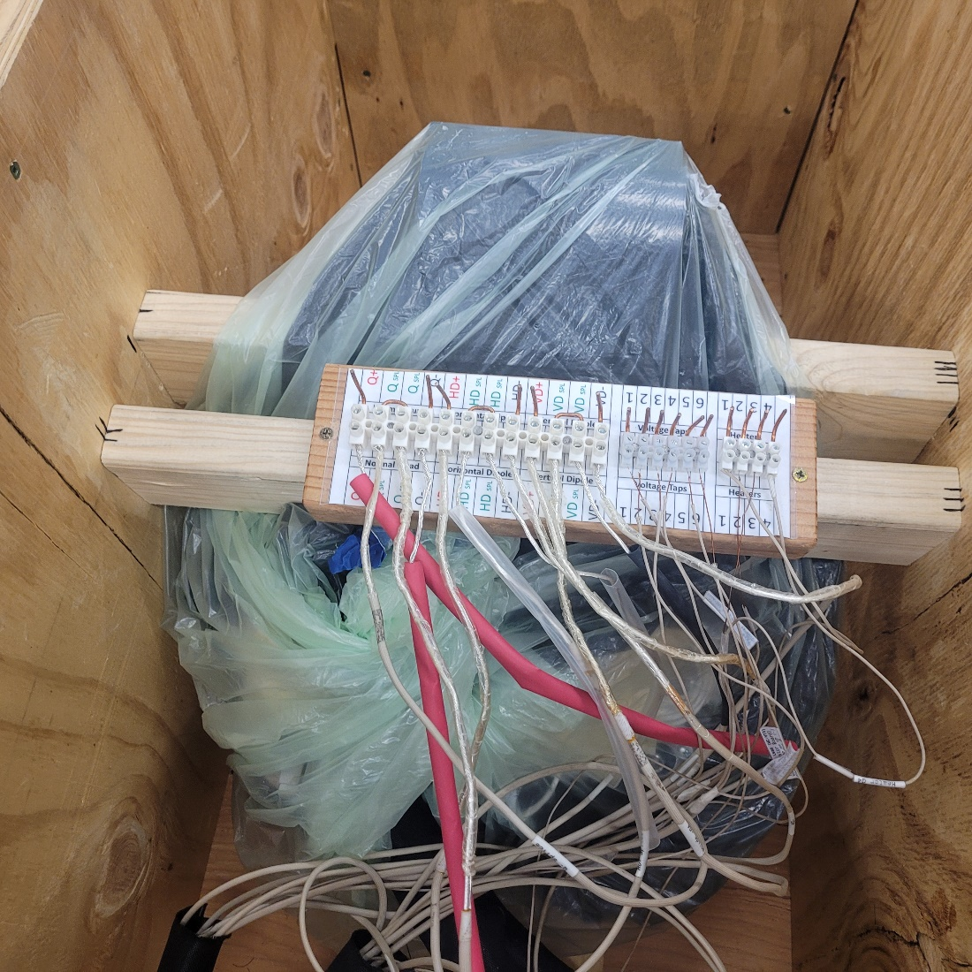
Figure 2: The terminal strip assembly of the as-received SPQA magnet from Fermi Lab.
  - The wooden block is kept outside of the inner plastic bag containing the magnet assembly and connected to two restraining bars bolted to the sides of the crate using screws (Figure 3).
  - The outer plastic bag covers the terminal strip assembly and the magnet assembly inside the inner plastic bag.
  - The core cooling strap is located between the two wooden restrain bars (See Figure 3) which also hold the magnet assembly down inside the crate.
  - The lifting eyes are not provided with the magnet assembly.
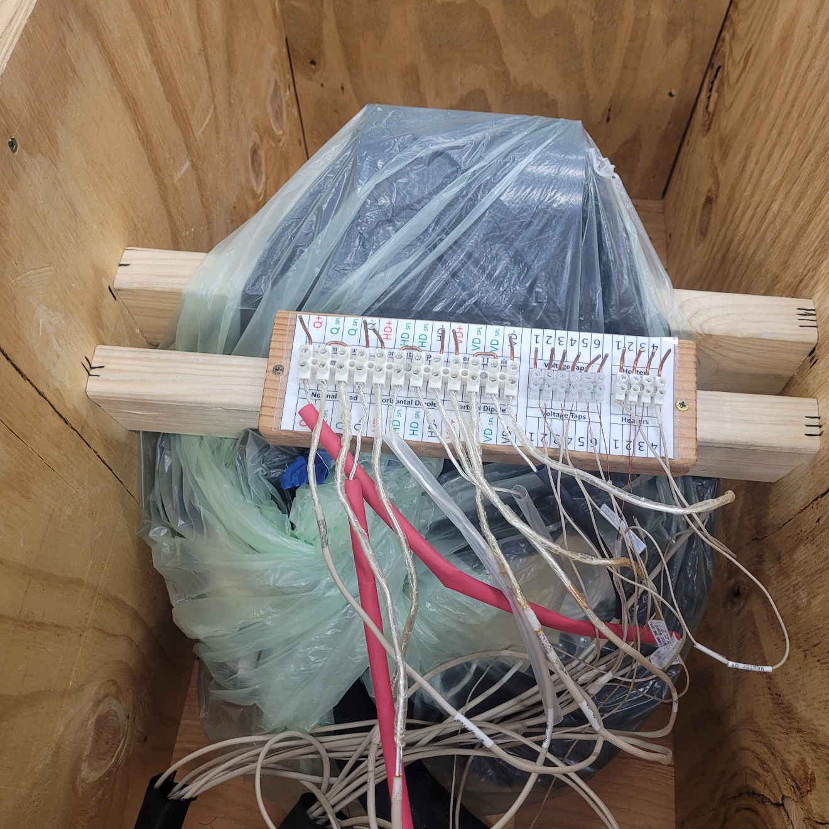
Figure 3: The SPQA magnet assembly inside the wooden crate.
Inspection and acceptance tests of the as-received SPQA magnet assembly from Fermi Lab
Notes:
  - Wear personal protective equipment (gloves, safety glasses, safety shoes) while handling and inspecting the magnet assembly.
  - Keep the fingers/hands/feet clear of any pinch hazards while handling the crate and magnet assembly.
  - Maintain a clean work area to prevent slip/ trip hazards and any contamination.
  - Perform the electrical tests under the currently applicable JLab policies and procedures.
  - The side plywood plates on the crate shall be removed before the inspection and acceptance tests of the as-received magnet.
  - The magnet lead wires and core cooling strap shall be protected from damage, kinking, and excessive flexing.
  - Ensure that magnet inventory traveler (Traveler ID: L2HE-INV-QUAD) is complete prior to the incoming inspection at JLab.
Step No. | Instructions | Data Input
 | Select the magnet serial number from the drop-down menu | [[QUADSN]] <<QUADSN>>
 | Visual Inspection
 | Visually inspect the magnet, core cooling strap, lead wires, voltage tap wires, and instrumentation wires for defects and any signs of damage from shipping and handling. Take digital pictures during the inspection and upload pictures with the traveler. Add comments if any.  Note: The digital picture filename shall follow the format QUADSN-VI-XXX. The last three letters indicate the serial number starting with 001 (e.g. SPQA201-VI-001.) | [[VI_Photos]] <<FILEUPLOAD>>  [[VI_Comment]] <<COMMENT>>
 | Did the magnet assembly pass visual inspection? If NO, generate an NCR. | [[VI_PASS]] {{YES,NO}} <<RADIO>>
 | Inspector name and date of completion of visual inspection. | [[VInspector]] <<SRF>>  [[VI_Comp_Date]] <<TIMESTAMP>>

Step No. | Instructions | Data Input
Electrical inspection
Note: Perform the electrical inspection (resistance, inductance, quality factor, hipot) of the as-received SPQA magnet, heater windings, and RTD sensors,and record the readings.
3.1 | Provide the details of all equipment (model, serial number) used for magnet R, L & Q measurements. | [[EI_Equip]] <<TEXT>>
3.2 | Quadrupole Assembly: resistance, inductance, and quality factor  Perform the electrical inspection on Q+ to Q- as per F10009375 Rev T.  Note: Q+ and Q- represent the leads of the quadrupole coil assembly (See Figure 2).  Note: Retain the jumper between the Magnet Left Half Q Splice Lead and Magnet Right Half Q Splice Lead in the as-received form.
3.2.1 | Record the external current across Q+ and Q- leads.  Note: The current must not exceed 10 mA during the coil tests. | [[QCurrent]] <<FLOAT>> milli-amperes
3.2.2 | Record resistance (R) across Q+ and Q- leads.  Note: The actual reading should fall between 132 ohm and 142 ohm  Does the resistance reading fall within the expected range?  If NO, generate an NCR. | [[QRes]] <<FLOAT>> ohm  [[EI_QRes_PASS]] {{YES,NO}} <<RADIO>>
3.2.3 | Record inductance (L) of Q+/Q- at 100 Hz.  Note: The actual reading at 100 Hz should fall between 88 mH to 98 mH.  Does the inductance at 100 Hz fall within the expected range?  Record inductance (L) of Q+/Q- at 1 kHz.  Note: The actual reading at 1 kHz should fall between 49 mH to 53 mH.  Does the inductance at 1 kHz fall within the expected range?  If either are NO, generate an NCR. | [[QInd_100Hz]] <<FLOAT>> millihenry  [[EI_QInd_100Hz_PASS]] {{YES,NO}} <<RADIO>>  [[QInd_1kHz]] <<FLOAT>> millihenry  [[EI_QInd_1kHz_PASS]] {{YES,NO}} <<RADIO>>
3.2.4 | Record quality factor (Q) of Q+/Q- at 100 Hz.  Note: The actual reading at 100 Hz should fall between 0.15 to 0.35.  Does the quality factor at 100 Hz fall within the expected range?  Record quality factor (Q) of Q+/Q- at 1 kHz.  Note: The actual reading at 1 kHz should fall between 1.0 to 1.4.  Does the quality factor at 100 Hz fall within the expected range?  If either are NO, generate an NCR. | [[QQ_100Hz]] <<FLOAT>>  [[EI_QQ_100Hz_PASS]] {{YES,NO}} <<RADIO>>  [[QQ_1kHz]] <<FLOAT>>  [[EI_QQ_1KHz_PASS]] {{YES,NO}} <<RADIO>>
3.2.5 | Test technician and date of Quadrupole (Q) R, L & Q measurements. | [[EI_QQ_Tech]] <<SRF>>  [[EI_QQ_Date]] <<TIMESTAMP>>

Step No. | Instructions | Data Input
3.3 | Vertical Dipole (VD) Assembly: resistance, inductance, and quality factor  Perform the electrical inspection on VD+ to VD- as per F10009375 Rev T.  Note: VD+ and VD- represent the leads of the vertical dipole coil assembly (See Figure 2).  Note: Retain the jumper between the Magnet Left Half VD Splice Lead and Magnet Right Half VD Splice Lead in the as-received form (See Error! Reference source not found.).
3.3.1 | Record the external current across VD+ and VD- leads.  Note: The current must not exceed 100 mA during the coil tests. | [[VDCurrent]] <<FLOAT>> milli-ampere
3.3.2 | Record resistance (R) across VD+ and VD- leads.  Note: The actual reading should fall between 11 ohm and 15 ohm.  Does the resistance reading fall within the expected range?  If NO, generate an NCR. | [[VDRes]] <<FLOAT>> ohm  [[EI_VDRes_PASS]] {{YES,NO}} <<RADIO>>
3.3.3 | Record inductance (L) of VD+/VD- at 100 Hz.  Note: The actual reading at 100 Hz should fall between 1.5 mH to 2.1 mH.  Does the inductance at 100 Hz fall within the expected range?  Record inductance (L) of VD+/VD- at 1 kHz.  Note: The actual reading at 1 kHz should fall between 0.7 mH to 1.3 mH.  Does the inductance at 1 kHz fall within the expected range?  If either are NO, generate an NCR. | [[VDInd_100Hz]] <<FLOAT>> millihenry  [[EI_VDInd_100Hz_PASS]] {{YES,NO}} <<RADIO>>  [[VDInd_1kHz]] <<FLOAT>> millihenry  [[EI_VDInd_1KHz_PASS]] {{YES,NO}} <<RADIO>>
3.3.4 | Record quality factor (Q) of VD+/VD- at 100 Hz.  Note: The actual reading at 100 Hz should fall between 0.03 to 0.13.  Does the quality factor at 100 Hz fall within the expected range?  Record quality factor (Q) of VD+/VD- at 1 kHz.  Note: The actual reading at 1 kHz should fall between 0.2 to 0.6.  Does the quality factor at 100 Hz fall within the expected range?  If either are NO, generate an NCR. | [[QVD_100Hz]] <<FLOAT>>  [[EI_QVD_100Hz_PASS]] {{YES,NO}} <<RADIO>>  [[QVD_1kHz]] <<FLOAT>>  [[EI_QVD_1kHz_PASS]] {{YES,NO}} <<RADIO>>
3.3.5 | Test technician and date of Vertical Dipole (VD) R, L & Q measurements. | [[EI_QVD_Tech]] <<SRF>>  [[EI_QVD_Date]] <<TIMESTAMP>>

Step No. | Instructions | Data Input
3.4 | Horizontal Dipole (HD) Assembly: resistance, inductance, and quality factor  Perform the electrical inspection on HD+ to HD- as per F10009375 Rev T.  Note: HD+ and HD- represent the leads of the horizontal dipole coil assembly (See Figure 2).  Note: Retain the jumper between the Magnet Left Half HD Splice Lead and Magnet Right Half HD Splice Lead in the as-received form (See Figure 2).
3.4.1 | Record the external current across HD+ and HD- leads.  Note: The current must not exceed 100 mA during the coil tests. | [[HDCurrent]] <<FLOAT>> milli-ampere
3.4.2 | Record resistance (R) across HD+ and HD- leads.  Note: The actual reading should fall between 11 ohm and 15 ohm.  Does the resistance reading fall within the expected range?  If NO, generate an NCR. | [[HDRes]] <<FLOAT>> ohm  [[EI_HDRes_PASS]] {{YES,NO}} <<RADIO>>
3.4.3 | Record inductance (L) of HD+/HD- at 100 Hz.  Note: The actual reading at 100 Hz should fall between 1.4 mH to 2.0 mH.  Does the inductance at 100 Hz fall within the expected range?  Record inductance (L) of HD+/HD- at 1 kHz.  Note: The actual reading at 1 kHz should fall between 0.6 mH to 1.2 mH.  Does the inductance at 1 kHz fall within the expected range?  If either are NO, generate an NCR. | [[HDInd_100Hz]] <<FLOAT>> millihenry  [[EI_HDInd_100Hz_PASS]] {{YES,NO}} <<RADIO>>  [[HDInd_1kHz]] <<FLOAT>> millihenry  [[EI_HDInd_1KHz_PASS]] {{YES,NO}} <<RADIO>>
3.4.4 | Record quality factor (Q) of HD+/HD- at 100 Hz.  Note: The actual reading at 100 Hz should fall between 0.02 to 0.14.  Does the quality factor at 100 Hz fall within the expected range?  Record quality factor (Q) of HD+/HD- at 1 kHz.  Note: The actual reading at 1 kHz should fall between 0.2 to 0.6.  Does the quality factor at 100 Hz fall within the expected range?  If either are NO, generate an NCR. | [[QHD_100Hz]] <<FLOAT>>  [[EI_QHD_100Hz_PASS]] {{YES,NO}} <<RADIO>>  [[QHD_1KHz]] <<FLOAT>>  [[EI_QHD_1KHz_PASS]] {{YES,NO}} <<RADIO>>
3.4.5 | Test technician and date of Horizontal Dipole (HD) R, L & Q measurements. | [[EI_QHD_Tech]] <<SRF>>  [[EI_QHD_Date]] <<TIMESTAMP>>

Step No. | Instructions | Data Input
3.5 | Perform the electrical check on the voltage tap wires from the coil windings as per F10009375 Rev T and record the readings.  Note: Figure 2 shows wiring details to the terminal strip.
3.5.1 | Record the external current across the quadrupole coil assembly leads.  Note: The current must not exceed 100 mA during the coil tests. | [[EI_VT_QCurrent]] <<FLOAT>> milli-amperes
3.5.2 | Measure the resistance (R) between each coil current leads and its voltage tap wire. Ensure all other wires and terminals are isolated from ground and each other.  Note: The actual reading should fall between 7 ohm to 17 ohm.
3.5.2.1 | Record resistance (R) between Q+ lead and VT1 voltage tap.  Does the VT1 resistance fall within the expected range? | [[Res_QPlusToV1]] <<FLOAT>> ohm  [[EC_VT_QMaxToV1_PASS]] {{YES,NO}} <<RADIO>>
3.5.2.2 | Record resistance (R) between Q- lead to the VT2 voltage tap.  Does the VT2 resistance fall within the expected range? | [[Res_QMinusToV2]] <<FLOAT>> ohm  [[EC_VT_QMinToV2_PASS]] {{YES,NO}} <<RADIO>>
3.5.2.3 | Record resistance (R) between HD- lead to the VT3 voltage tap.  Does the VT3 resistance fall within the expected range? | [[Res_HDMinusToV3]] <<FLOAT>> ohm  [[EC_VT_HDMinToV3_PASS]] {{YES,NO}} <<RADIO>>
3.5.2.4 | Record resistance (R) between HD+ leads to the VT4 voltage tap.  Does the VT4 resistance fall within the expected range? | [[Res_HDPlusToV4]] <<FLOAT>> ohm  [[EC_VT_HDMaxToV4_PASS]] {{YES,NO}} <<RADIO>>
3.5.2.5 | Record resistance (R) between VD- lead to the VT5 voltage tap.  Does the VT5 resistance fall within the expected range? | [[Res_VDMinusToV5]] <<FLOAT>> ohm  [[EC_VT_VDMinToV5_PASS]] {{YES,NO}} <<RADIO>>
3.5.2.6 | Record resistance (R) between VD+ leads to the VT6 voltage tap.  Does the VT6 resistance fall within the expected range? | [[Res_VDPlusToV6]] <<FLOAT>> ohm  [[EC_VT_VDMaxToV6_PASS]] {{YES,NO}} <<RADIO>>
3.5.3 | If any voltage tap resistances in steps #3.5.2 fall outside the expected range  , generate an NCR.
3.5.4 | Test technician and date of Voltage Tap measurements. | [[EC_VT_Tech]] <<SRF>>  [[EC_VT_Date]] <<TIMESTAMP>>

Step No. | Instructions | Data Input
3.6 | Perform the electrical resistance inspection of the heater wires.  Note:Figure 2 shows wiring details to the terminal strip.  Note: DO NOT exceed more than 10 mA of external current during the testing of the coils.
3.6.1 | Record the resistance (R) of the heater winding at the left half (LH) of the magnet assembly (Q1 to Q2).  Note: The actual reading should fall between 233 ohm to 253 ohm  Does the Q1/Q2 heater resistance fall within the expected range? | [[Res_HW_LH]] <<FLOAT>> ohm  [[EI_HW_LH_PASS]] {{YES,NO}} <<RADIO>>
3.6.2 | Record the resistance (R) of heater winding at the right half (RH) of the magnet assembly (Q3 to Q4).  Note: The actual reading should fall between 233 ohm to 253 ohm  Does the Q3/Q4 heater resistance fall within the expected range? | [[Res_HW_RH]] <<FLOAT>> ohm  [[EI_HW_RH_PASS]] {{YES,NO}} <<RADIO>>
3.6.4 | If either heater wire resistance in steps #3.6 falls outside the expected range, generate an NCR.
3.6.3 | Test technician and date of heater wire measurements. | [[EI_HW_Tech]] <<SRF>>  [[EI_HW_Date]] <<TIMESTAMP>>

Step No. |  | Instructions |  | Data Input
3.7 |  | Perform the hipot at 1kV DC on coils, steel core, and heaters and record the leakage current.  Note: qualification criterion is leakage current less than 5 microampere at 1kV DC.  Note: Use a minimum 15-second ramp rate.
- 3.7.1 |  | Model and serial number of the hipot tester. |  | [[Hipot_Equip]] <<TEXT>>
3.7.2 |  | Record the leakage current from each coil assembly to the neighboring coil assembly
3.7.2.1 |  | Q+/Q- to HD+/HD-  Do the Q to HD coils pass the hipot test? |  | [[HLC_QToHD]] <<FLOAT>> microampere  [[Hipot_Coils_QToHD]] {{PASS, FAIL}} <<RADIO>>
3.7.2.2 |  | Q+/Q- to VD+/VD-  Do the Q to VD coils pass the hipot test? |  | [[HLC_QToVD]] <<FLOAT>> microampere  [[Hipot_Coils_QToVD]] {{PASS, FAIL}} <<RADIO>>
3.7.2.3 |  | HD+/HD- to VD+/VD-  Do the HD to VD coils pass the hipot test? |  | [[HLC_HDToVD]] <<FLOAT>> microampere  [[Hipot_Coils_HDToVD]] {{PASS, FAIL}} <<RADIO>>
3.7.3 |  | Record the leakage current from each coil assembly to the steel core.  Note: qualification criterion is leakage current less than 5 microampere at 1kV DC.  Note: Use a minimum 15-second ramp rate.
3.7.3.1 |  | Q+/Q- (or jumper both) to the steel core.  Does the Q coil to the steel core pass the hipot test? |  | [[HLC_QToCore]] <<FLOAT>> microampere  [[Hipot_Coils_QToCore]] {{PASS, FAIL}} <<RADIO>>
3.7.3.2 |  | HD+/HD- (or jumper both) to the steel core.  Does the HD coil to the steel core pass the hipot test? |  | [[HLC_HDToCore]] <<FLOAT>> microampere  [[Hipot_Coils_HDToCore]] {{PASS, FAIL}} <<RADIO>>
3.7.3.3 |  | VD+/VD- (or jumper both) to the steel core.  Does the VD coil to the steel core pass the hipot test? |  | [[HLC_VDToCore]] <<FLOAT>> microampere  [[Hipot_Coils_VDToCore]] {{PASS, FAIL}} <<RADIO>>
3.7.4 |  | Record the leakage current from heater wires to each coil assembly and steel core.  Note: qualification criterion is leakage current less than 5 microampere at 1kV DC.  Note: Use a minimum 15-second ramp rate.
3.7.4.1 |  | Q (jumper Q+ and Q-) to the LH heater wires (Q1,Q2).  Does the Q coil to the LH heater wires pass the hipot test? |  | [[HLC_QToLHH]] <<FLOAT>> microampere  [[Hipot_QToLHH]] {{PASS, FAIL}} <<RADIO>>
3.7.4.2 |  | Q (jumper Q+ and Q-) to the RH heater wires (Q3,Q4).  Does the Q coil to the LH heater wires pass the hipot test? |  | [[HLC_QToRHH]] <<FLOAT>> microampere  [[Hipot_QToRHH]] {{PASS, FAIL}} <<RADIO>>
3.7.4.3 |  | HD (jumper HD+ and HD-) to the LH heater wires (Q1,Q2).  Does the HD coil to the LH heater wires pass the hipot test? |  | [[HLC_HDToLHH]] <<FLOAT>> microampere  [[Hipot_HDToLHH]] {{PASS, FAIL}} <<RADIO>>
3.7.4.4 |  | HD (jumper HD+ and HD-) to the RH heater wires (Q3,Q4).  Does the HD coil to the LH heater wires pass the hipot test? |  | [[HLC_HDToRHH]] <<FLOAT>> microampere  [[Hipot_HDToRHH]] {{PASS, FAIL}} <<RADIO>>
3.7.4.5 |  | VD (jumper VD+ and VD-) to the LH heater wires (Q1,Q2).  Does the VD coil to the LH heater wires pass the hipot test? |  | [[HLC_VDToLHH]] <<FLOAT>> microampere  [[Hipot_VDToLHH]] {{PASS, FAIL}} <<RADIO>>
3.7.4.6 |  | VD (jumper VD+ and VD-) to the RH heater wires (Q3,Q4).  Does the VD coil to the LH heater wires pass the hipot test? |  | [[HLC_VDToRHH]] <<FLOAT>> microampere  [[Hipot_VDToRHH]] {{PASS, FAIL}} <<RADIO>>
3.7.4.7 |  | Steel core to the LH heater wires (Q1,Q2).  Do the LH heater wires to the steel core pass the hipot test? |  | [[HLC_CoreToLHH]] <<FLOAT>> microampere  [[Hipot_CoreToLHH]] {{PASS, FAIL}} <<RADIO>>
3.7.4.8 |  | Steel core to the RH heater wires (Q3,Q4).  Do the RH heater wires to the steel core pass the hipot test? |  | [[HLC_CoreToRHH]] <<FLOAT>> microampere  [[Hipot_CoreToRHH]] {{PASS, FAIL}} <<RADIO>>
 | 3.7.4.9 |  | If any hipot tests in 3.7.2, 3.7.3 or 3.7.4 FAIL, generate an NCR.
3.7.5 |  | Test technician and date. |  | [[HipotTech]] <<SRF>>  [[HipotDate]] <<TIMESTAMP>>

Step No. |  | Instructions |  | Data Input
3.8 |  | Verify the performance of RTD sensors at room temperature.  Note: There are four RTD sensors installed in the magnet assembly.  Tag ID Sensor type  RTD_MP_1 Cernox CX-1030-SD-HT-1-4L  RTD_MP_2 DT-670AI-SD (Si diode)  RTD_MP_3 DT-670AI-SD (Si diode)  RTD_MP_4 DT-670AI-SD (Si diode)  Table 1: Identification tag and type of RTD installed in the SPQA magnet.
3.8.1 |  | Record the serial number of the RTD_MP_1 Cernox sensor. (e.g.“X123456”) |  | [[SN_RTDMP1]] <<TEXT>>
3.8.2 |  | Enter the value of resistance at 295 Kelvin from the above Cernox sensor’s calibration curve. |  | [[Res295K_RTDMP1]] <<FLOAT>> ohms
3.8.3 |  | Upload the calibration curve of the RTD_MP_1 Cernox sensor. |  | [[Calibdata_RTDMP1]] <<FILEUPLOAD>>
3.8.4 |  | Provide the details of temperature instrument used. |  | [[Insp_RTD_Equip]] <<TEXT>>
3.8.5 |  | Measure and record the resistance of the RTD_MP_1 Cernox sensor.  Note: Room temperature should be 22°C +/- 2°C.  Excitation voltage for the Cernox CX-1030-SD-HT-1-4L at room temperature should be 10 mV. |  | [[ResRT_RTDMP1]] <<FLOAT>> ohms
3.8.6 |  | Measure and record the forward voltage of RTD_MP_2.  Excitation current for DT-670AI-SD is 10 µA (+/- 0.1 µA).  Note: Room temperature should be 22°C +/- 2°C. |  | [[Voltage_RTDMP2]] <<FLOAT>> DC volts
3.8.7 |  | Measure and record the forward voltage of RTD_MP_3.  Note: Room temperature should be 22°C +/- 2°C. |  | [[Voltage_RTDMP3]] <<FLOAT>> DC volts
3.8.8 |  | Measure and record the forward voltage of RTD_MP_4.  Note: Room temperature should be 22°C +/- 2°C. |  | [[Voltage_RTDMP4]] <<FLOAT>> DC volts
3.8.9 |  | Did the MP1 Cernox sensor pass the test? Comments, if any.  Acceptance criterion for RTD_MP_1  The measured resistance shall be +/- 1 Ohm from the value in Ohms at 295 K obtained from the calibration curve above.  If MP1 FAILs, generate an NCR. |  | [[EI_RTDMP1]] {{PASS, FAIL}} <<RADIO>>  [[EI_RTDMP1]] <<COMMENT>>
3.8.10 |  | Did the MP2, MP3 and MP4 silicon diodes pass the tests? Comments, if any.  Acceptance criterion for MP2,_MP3, and_MP4:  The measured voltage shall between 0.561 Vdc to 0.581 Vdc.  If any FAIL, generate an NCR. |  | [[EI_RTDMP2]] {{PASS, FAIL}} <<RADIO>>  [[EI_RTDMP3]] {{PASS, FAIL}} <<RADIO>>  [[EI_RTDMP4]] {{PASS, FAIL}} <<RADIO>>  [[EI_RTDSD]] <<COMMENT>>
 | 3.8.11 |  | Test technician and date. | [[EI_RTD_Tech]] <<SRF>>  [[EI_RTD_Date]] <<TIMESTAMP>>
 |  | Note: If the as-received magnet passes all the inspections listed above, then it can be transported to another work station, as needed, to perform the following steps.

Step No. | Instructions |  | Data Input
4. | Parting plane measurements  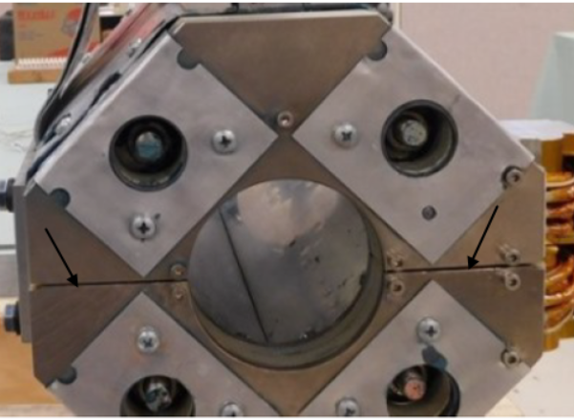  Figure 4: The (black) arrows point to the parting plane gap between the two halves of the SPQA magnet assembly.
4.1 | Verify the parting plane gap (See Figure 4) between the left half and right half of the magnet assembly using a feeler gauge. Verify at both the front and backside of the assembly. Record the maximum value. Add comments, if any. | [[Gap_PP_MagnetHalf]] <<FLOAT>> inches  [[Gap_PP_MagnetHalfComm]] <<COMMENT>>
4.2 | Test technician and date. | [[PPI_Tech]] <<SRF>>  [[PPI_Date]] <<TIMESTAMP>>
5. | Re-pack the magnet assembly. Contact SRF Inventory staff to transport and store magnet. | [[Repack_Tech_Name]] <<SRF>>  [[Repack_Comp_Date]] <<TIMESTAMP>>

