Traveler Status report (by Project) –

**Pansophy/QC Reports/Traveler reports/Traveler_status_project -** [QCREPORTS (jlab.org)](https://pansophy.jlab.org/pansophy/QCReports/TravelerReports/Traveler_Status_Project.cfm)

**Examples for ER5C**

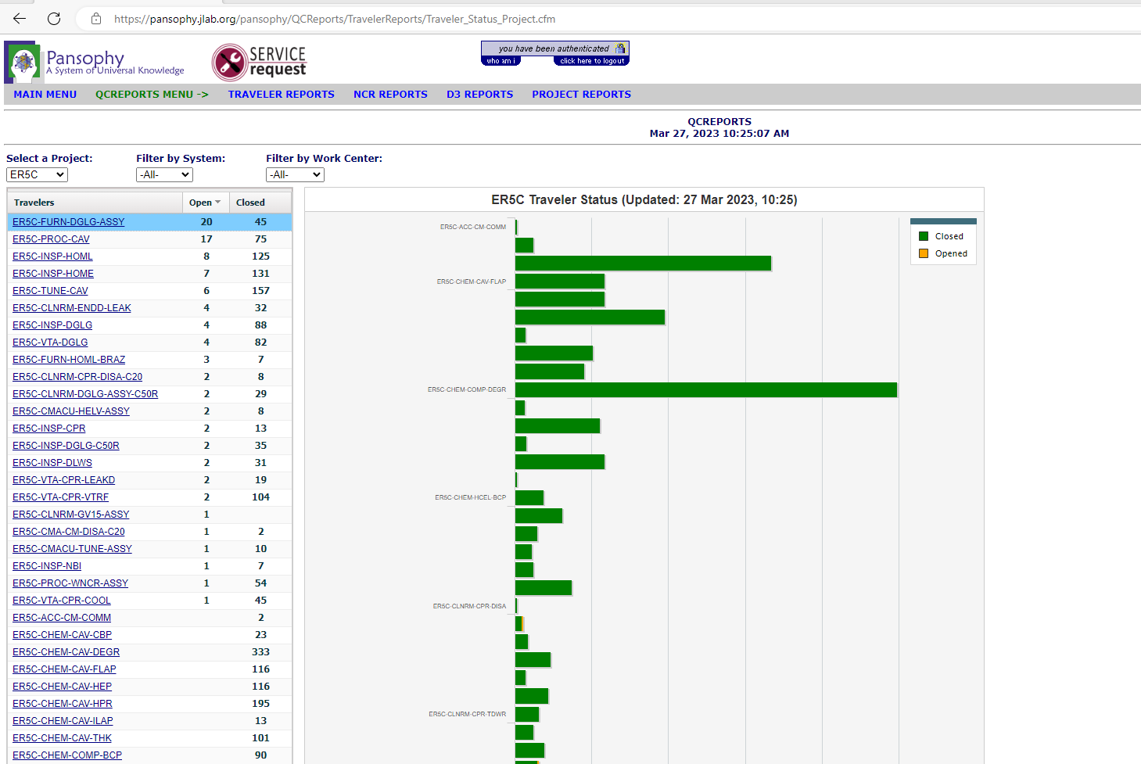

**Problems with this report (examples as of 27Mar2023)**

DL Traveler lists 5 open , summary report lists 4

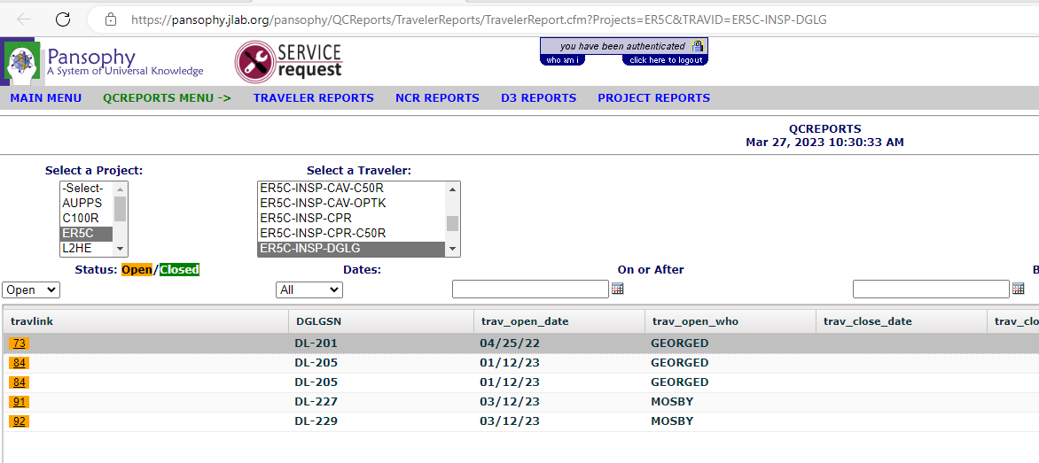

DLWS shows none open , however summary report says there are 2 open 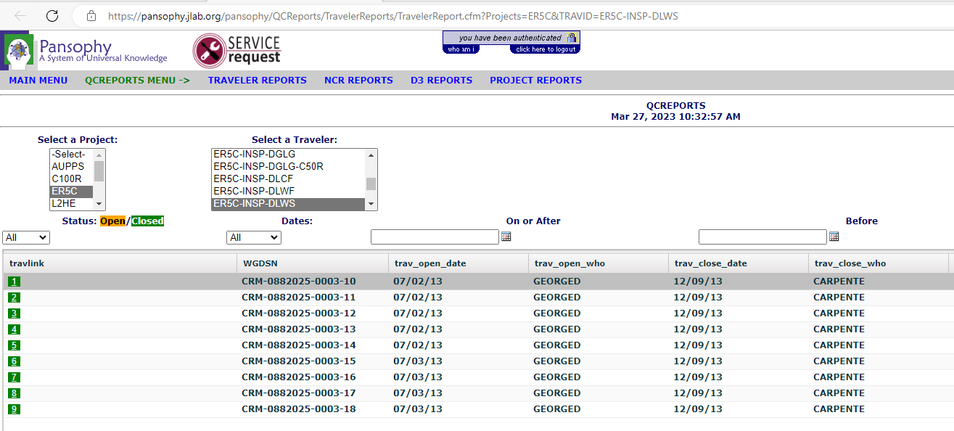

**Examples for HE**

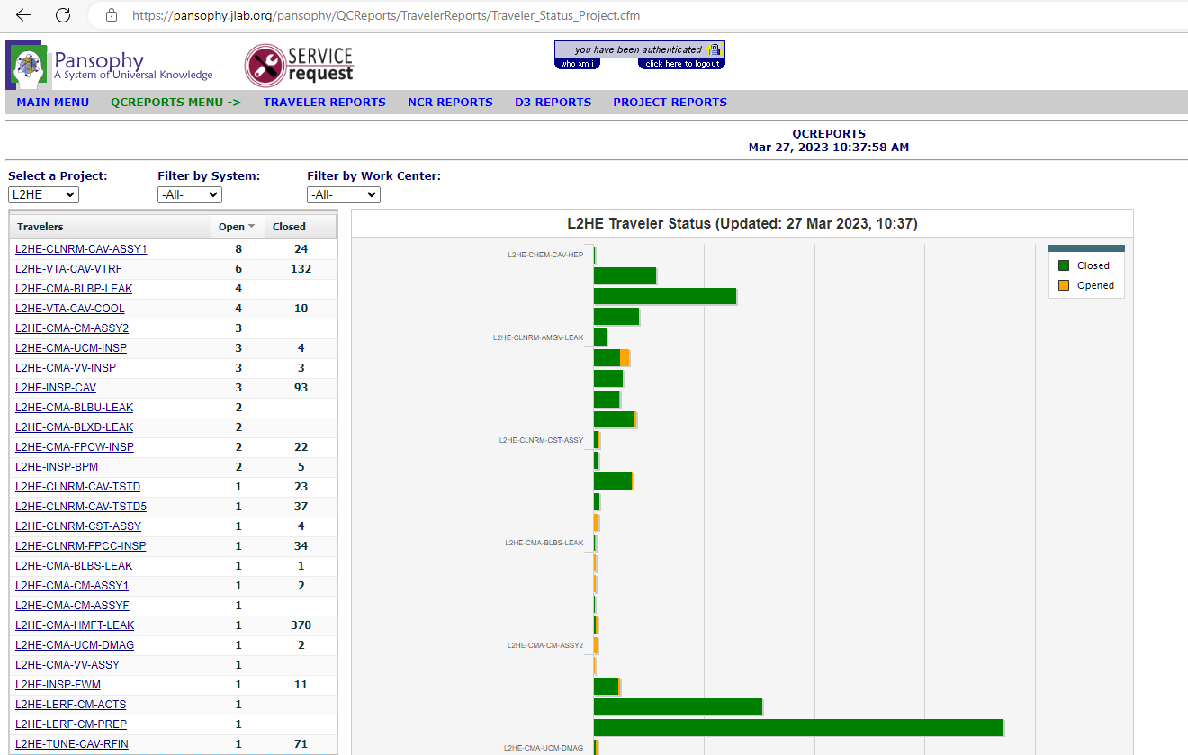

**Problems with this report (as of 27March 2023)**

Summary report says there are 8 open , but list below shows 18 open

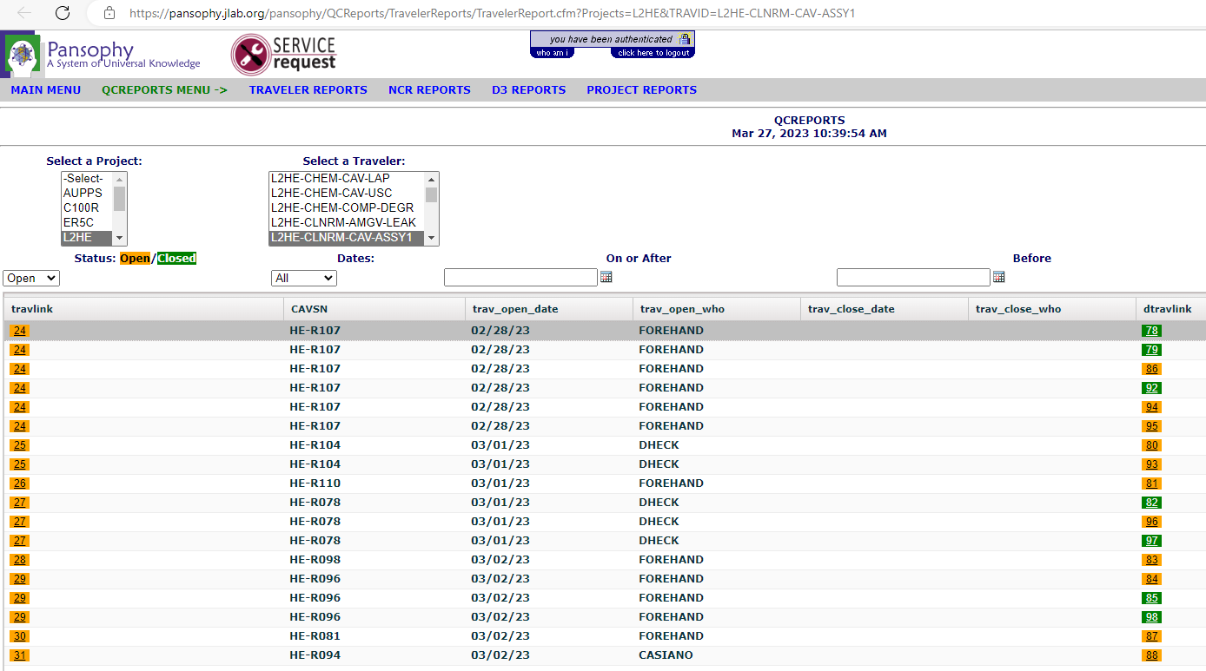

Summary report (HE) for UCM says there are 3 travelers open, but report below shows 5 open

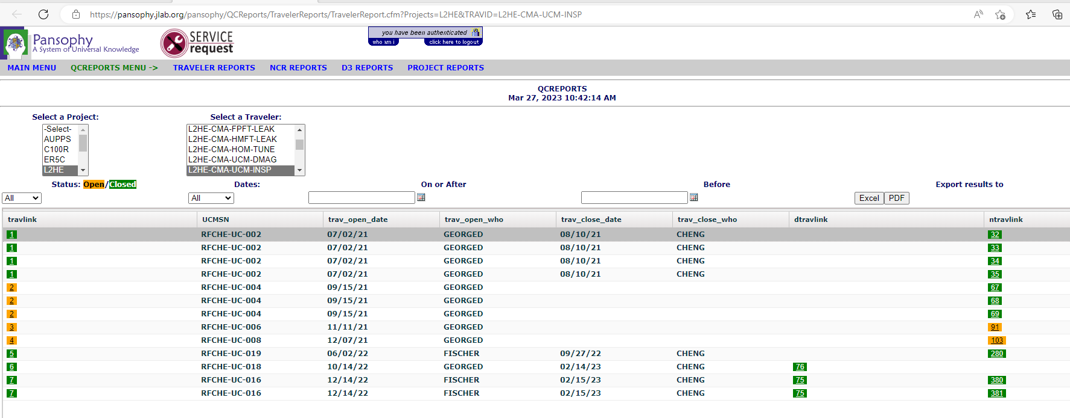

Summary report (HE) shows 2 travelers open for BPM, however report below shows 4 open

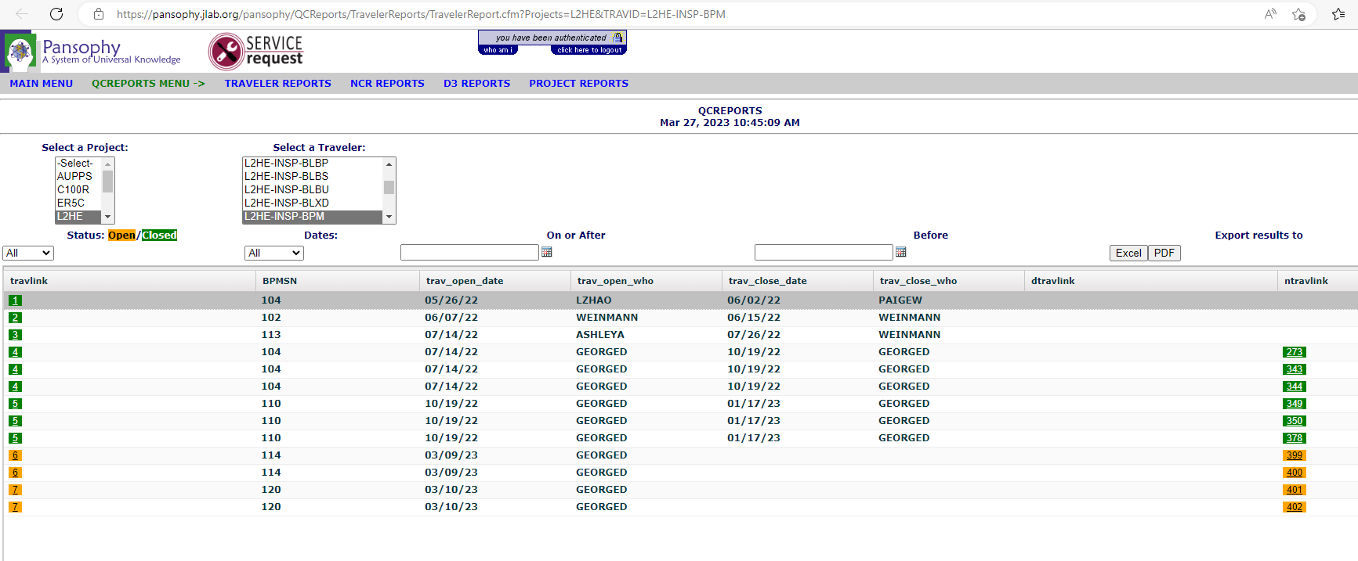

**Examples for the project SNSPPU**

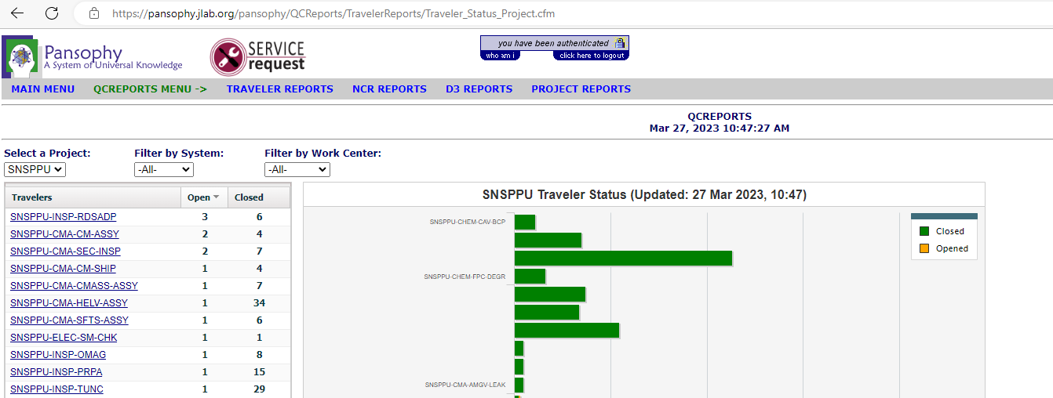

Summary report (PPU) shows 3 open travelers , however report below says there is 4 open

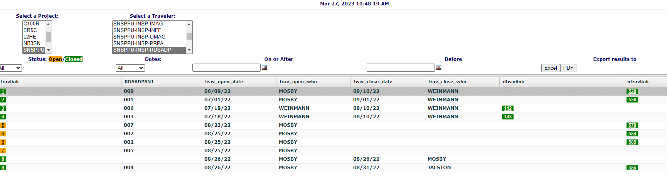

Summary report (PPU) says there is one open traveler, however report below says there is 2 open

