|  |  |  |  |
| --- | --- | --- | --- |
| **SNS-PPU General Running Procedure (CMTF)** | | | |
| **Document Number:** | SNSPPU-PR-CMTF-CM-RUN | **Effective Date:** | DD Mmm YYYY |
| **Revision Number:** | R1 | **Periodic Review Date:** | DD Mmm YYYY |
| **Document Owner:** | David Savransky | **Department Owner:** | SRF Operations |

# Purpose

The purpose of this document is to outline a procedure to keep the Spallation Neutron Source Proton Power Upgrade (SNS-PPU) Cryomodule (CM) in the Cryomodule Testing Facility (CMTF) stable at 2K along with step to be taken if a short outage occurs at the Cryogenic Test Facility (CTF) plant.

# Scope

This procedure will only outline the steps necessary to be completed by an SRF cryo operator, any steps that are to be completed by other sources will not be described.

In the procedure, the steps that are to be taken to keep the SNS-PPU CM stable at 2K in the CMTF cave along with signals to watch to ensure stability will be described.

**It is expected that the SRF Cryo Operator has read and understood the whole procedure before starting the warm-up.**

# Terms and Definitions

The following terms have specific meanings within this procedure.

|  |  |
| --- | --- |
| **Term** | **Definition** |
| CC | Cryocon |
| CD | Cooldown |
| CM | Cryomodule |
| CMTF | Cryomodule Testing Facility |
| CTF | Cryogenic Testing Facility |
| ES&H | environment, safety and health |
| EV | Electrical valve |
| GV | Guard Vacuum |
| HP | High Pressure |
| JB | Junction Box |
| JT | Joule Thomson |
| LP | Low Pressure |
| LL | Liquid Level |
| LVDT | Linear variable differential transformer |
| ODH | Oxygen Deficiency Hazard |
| SC | Subcooler |
| SME | Subject Matter Expert |
| SNS-PPU | Spallation Neutron Source- Proton Power Upgrade |
| SRF | Super Radiofrequency |
| VB | Valve Box |

# Roles and Responsibilities

The following roles have responsibilities described in this document.

|  |  |
| --- | --- |
| **Role** | **Responsibility** |
| SRF Cryo Operator | Control the valve and monitor the CM to ensure that the CM remains stable trough the testing run |
| CTF Plant Cryo Operator | Aid in maintaining a steady cryogen supply and return |

# Procedure

For any entry into the CMTF, the operator must be aware that the CMTF is an ODH area. Given this classification, the operator can use the following guidelines to determine the ODH states of the CMTF and follow the appropriate guidelines: {these are general guidelines, the operator should follow any posted signage}

* ODH0:
  + The CMTF Cave is a permanent ODH0 zone.
  + The Cave remains an ODH 0 zone when the CMTF Cave is empty or when there is a cryomodule installed but with no u-tube connections.
* ODH1:
  + Once the u-tubes are stabbed into the CM, the first floor of the Cave is designated as ODH1 area.
  + The CMTF Cave’s main equipment door must remain open.
* ODH2:
  + The mezzanine inside the CMTF Cave is always an ODH2 area.

When the CMTF Cave’s main equipment door is closed and a cryomodule is present with u-tubes connected, the entire CMTF Cave is an ODH2 zone.

# Procedure to maintain stable day to day operation at 2K

### Signals to monitor:

* All the signals in section 8 should be plotted on LivePlot to ensure stable running of the CM.
  + Most signals should be checked at least once a day to ensure that they are within their allowable range, but do not need close monitoring.
* Some signals to monitor more closely to ensure stable running are:
  + Table :
    - Motinor the CM LL and ensure their values do not drop below 85% or reach above 95%
    - Only one of the two LL signals needs to be monitored
  + Table 8:
    - Monitor the CM pressure with the 100 Torr baratron as the 5000 Torr baratron does not have the accuracy for 2K operation
    - If the CM pressure goes past lambda (34 Torr/0.044 atm), the liquid helium inside the CM will lose its superfluid properties. The liquid level (Table ) will vary weldley (i.e 2-3% jumps) if this does occur.
  + Table 7:
    - The vacuum pressurses in this section should be checked at least on a daily basis to ensure that they do not go above their operating max
    - Operating Max:
      * Insulating Vacuum: 1E-6 Torr
      * Beamline Vacuum: 1E-9 Torr
      * Couplter Vacuum: 1E-8 Torr

### Valve Operations:

* During normal 2K operation, the valves settings found in section 7 can be used for all the valve settings.
* If the junction box 4K circuit supply temperature (CTD2446) continuously stays below 6K with the listed vaporizer valve controller settings, the vaporizer valve (CEV2452) min pos. can be lowered by 5% every day. The stipulation is that the junction box 4K circuit supply temperature (CTD2446) should be monitored during this time to ensure that it does not have spikes to 20K or the vaporizer valve (CEV2452) min pos. should be set back to the previous value.
* The Primary Circuit JT Valve (CEVCMTC1/1A) is set to control both around the CM pressure (A loop) and around the CM LL (main loop). If it is found that during the CM refills the JT opens up enough to cause the CM to go over lambda (34 Torr), the Max Pos. should be lowered in 5% steps and monitored during next refill to ensure the pressure does not go above lambda.
* The Secondary Circuit JT valve (CEVCMTC2) is set to control only around the pressure of the surge tank. If it is found that the surge tank pressure (CPICMTC3) has difficulty maintain 2.6 Atm pressure with the valve fully open, attempt for slowly close the secondary circuit return manual valves in quarter turn increments until the valve begins to close down.

# Overnight Valve Positions at 4K/2K

1. Vaporizer Valve (CEV2452)

|  |  |  |  |
| --- | --- | --- | --- |
| **CEV2452** | | | |
| **Quantity** | **Value** | **Quantity** | **Value** |
| **Max Pos** | 20.00 | **ST** | 1.000 |
| **Min Pos** | 10.00 | **Gp** | -10.00 |
| **Max Chg** | 5.00 | **Gi** | -0.50 |
| **Min Chg** | 0.02 | **Gd** | 0.00 |
| **Input** | | CTD2446 | |
| **Set Value** | | 6.00 | |

1. Primary Circuit JT Valve (CEVCMTC1/1A)

|  |  |  |  |
| --- | --- | --- | --- |
| **CEVCMTC1A** | | | |
| **Quantity** | **Value** | **Quantity** | **Value** |
| **Max Pos** | 80.00 | **ST** | 5.0 |
| **Min Pos** | 10.00 | **Gp** | 300.00 |
| **Max Chg** | 2.00 | **Gi** | 2.00 |
| **Min Chg** | 0.02 | **Gd** | 0.00 |
| **Input** | | CPICMTC2 | |
| **Set Value** | | {@4K: 1.30; @2K:0.05} | |

|  |  |  |  |
| --- | --- | --- | --- |
| **CEVCMTC1** | | | |
| **Quantity** | **Value** | **Quantity** | **Value** |
| **Max Pos** | 80.00 | **ST** | 20.00 |
| **Min Pos** | 10.00 | **Gp** | 71.00 |
| **Max Chg** | 3.00 | **Gi** | 0.11 |
| **Min Chg** | 0.02 | **Gd** | -0.01 |
| **Input** | | CLLTC1 | |
| **Set Value** | | 90.00 | |

1. Secondary Circuit JT Valve (CEVCMT2/2A)

|  |  |  |  |
| --- | --- | --- | --- |
| **CEVCMTC2A** | | | |
| **Quantity** | **Value** | **Quantity** | **Value** |
| **Max Pos** | 80.00 | **ST** | 5.00 |
| **Min Pos** | 80.00 | **Gp** |  |
| **Max Chg** | 2.00 | **Gi** |  |
| **Min Chg** | 0.10 | **Gd** |  |
| **Input** | |  | |
| **Set Value** | |  | |

|  |  |  |  |
| --- | --- | --- | --- |
| **CEVCMTC2** | | | |
| **Quantity** | **Value** | **Quantity** | **Value** |
| **Max Pos** | 80.00 | **ST** | 20.00 |
| **Min Pos** | 10.00 | **Gp** |  |
| **Max Chg** | 2.00 | **Gi** |  |
| **Min Chg** | 0.10 | **Gd** |  |
| **Input** | | CPICMTC3 | |
| **Set Value** | | 2.6 | |

1. Cooldown By-pass valve (CEVCMTC3)

|  |  |  |  |
| --- | --- | --- | --- |
| **CEVCMTC3** | | | |
| **Quantity** | **Value** | **Quantity** | **Value** |
| **Max Pos** | -20.00 | **ST** | 15.00 |
| **Min Pos** | -20.00 | **Gp** | 100.00 |
| **Max Chg** | 4.00 | **Gi** | 0.01 |
| **Min Chg** | 0.20 | **Gd** | 0.00 |
| **Input** | | CPICMTC2 | |
| **Set Value** | | 1.3 | |

# **Live Plot Signals**

### CM Temperature Sensors

* All the temperature sensor listed in this section are directly tied in to the CM
* It is assumed that all sensors in this section are owned by SRF
* For some of the sensor position, there exist an A and B sensor (primary/auxiliary). Only one sensor needs to be monitored, but both should be checked out before cooldown to verify that they work.
* The temperature sensors in Table 3 are used to monitor the inlet/outlet properties of the CM and are primarily located inside the CM end-cans.

|  |  |
| --- | --- |
| Description | P&ID Name |
| HP Inlet to 2K SC Temperature | TDXX021A/B |
| HP Outlet from 2K SC Temperature | TDXX022A/B |
| He Exhaust from Cavities Temperature | TDXX023A/B |
| LP Outlet from 2K SC/ Primary Circuit Return | TDXX024A/B |
| Shield Inlet Temperature | TDXX041A/B |
| Shield Outlet Temperature | TDXX541A/B |
| Surge Tank Temperature | TDXX025A/B |

Table : Temperature Diodes inside End Cans

* The temperature sensors in Table 4 are all of the sensors that are located on the helium vessels for all 4 cavities. Since the SNS-PPU does not have any cernox directly on the cavities, these helium vessel sensors will be used as a reference to approximate the cooldown rate of the cavity.

|  |  |  |
| --- | --- | --- |
| Description | | P&ID Name |
| Cavity 1 | Top He Vessel Diodes | TDXX123 |
| Bottom He Vessel | TDXX122 |
| Cavity 2 | Top He Vessel Diodes | TDXX223 |
| Bottom He Vessel | TDXX222 |
| Cavity 3 | Top He Vessel Diodes | TDXX323 |
| Bottom He Vessel | TDXX322 |
| Cavity 4 | Top He Vessel Diodes | TDXX423 |
| Bottom He Vessel | TDXX422 |

Table : He Vessel Diodes

* The temperature sensors in Table 5 are a list of all the other sensor associated with each cavity.

|  |  |  |
| --- | --- | --- |
| Description | | P&ID Name |
| Cavity 1 | FPC Flange | TDXX121 |
| Beam Line | TDXX124 |
| FPC (x2) | TDXX137A/B |
| Cavity 2 | FPC Flange | TDXX221 |
| Beam Line | TDXX224 |
| FPC (x2) | TDXX237A/B |
| Cavity 3 | FPC Flange | TDXX321 |
| Beam Line | TDXX324 |
| FPC (x2) | TDXX337A/B |
| Cavity 4 | FPC Flange | TDXX421 |
| Beam Line | TDXX424 |
| FPC (x2) | TDXX437A/B |

Table : Other diodes inside the CM

* The temperature sensors in Table 6 are a list of all the sensors associated with the temperature of the coupler at the warm end along with the temperature sensors located on the coupler cooldown return line.

|  |  |  |
| --- | --- | --- |
| Description | | P&ID Name |
| Cavity 1 | Secondary Circuit Return Path | TEXX133 |
| Warm FPC | TEXX136A/B |
| Cavity 2 | Secondary Circuit Return Path | TEXX233 |
| Warm FPC | TEXX236A/B |
| Cavity 3 | Secondary Circuit Return Path | TEXX333 |
| Warm FPC | TEXX336A/B |
| Cavity 4 | Secondary Circuit Return Path | TEXX433 |
| Warm FPC | TEXX436A/B |

Table : Other diodes outside the CM

### Other CM signals

* The PVs in this section will cover the remainder of the CM signals that will be used during the cooldown.
* It is assumed that all sensors in this section are owned by SRF.
* Some of the EPICS signals will both have a SRF and a Cryo signal that readback from the same sensor
  + For these signals, the SRF signal name will be in parentheses
* The PVs Table 7 are used to monitor the liquid level in the CM.

|  |  |
| --- | --- |
| Description | PV Name |
| Liquid Level Sensor | CLLTC1 (SRF: SRFCMTFLLRETURN ) |
| Secondary Liquid Level Sensor | SRFCMTFLLSUPPLY |

Table : Liquid Level Sensors for CM

* The PVs in Table 8 are used to monitor the different CM pressure.

|  |  |
| --- | --- |
| Description | PV Name |
| CM Helium Pressure (0-5000 Torr) | CPICMTC2 (SRF: SRFCMTFHEPRES5000) |
| CM Helium Pressure (0-100 Torr) | CPICMTC1 (SRF: SRFCMTFHEPRES100 ) |
| Surge Tank Pressure | CPICMTC3 |

Table : CM Pressure Sensors

* The PVs in Table 9 are used to monitor the pressure of the beamline along with the CM insulating vacuum pressure

|  |  |
| --- | --- |
| Description | PV Name |
| Insulating Vacuum Pressure | SRFCMTFINSULVAC{1-3} |
| Beamline Vacuum Pressure | SRFCMTFBLVAC1 |
| Coupler Vacuum Pressure | SRFCMTFWGVAC{1-8} |

Table : CM Vacuum Sensors

### CTF Cryo Sensors

* The EPICS PVs listed in this section will cover all the signals that will be beneficial to monitor during the cooldown. Some of these PVs will not be used in any steps of the procedure.
* Unless otherwise noted, all the PVs in this section are owned by the cryogenics department
* The PVs in Table 10 are used to monitor CM inlet properties from CTF at the Junction Box.

|  |  |
| --- | --- |
| Description | PV Name |
| HP inlet to 2K SC in VB Temperature | CTD2442 |
| Inlet to JB Temperature | CTD2446 |
| CM Inlet Temperature | CTD2452 |
| Primary Supply to CM Flow Rate | CFI2452 |
| Primary Supply to VTA Flow Rate | CFI2453 |

Table : CM Inlet Properties

* The PVs in Table 11 are the pressure sensors used to monitor the return path from the CM to the recovery compressors.

|  |  |
| --- | --- |
| Description | PV Name |
| JB Pressure (100-5000 Torr) | CPI2450HR |
| JB Pressure (0-100 Torr) | CPI2450LR |
| Valve Box Pressure (0-100 Torr) | CPI2444 |
| Kinney Return Pressure (0-100 Torr) | CPI2091 |
| Purifier Line Pressure | CPI284 |

Table : Return Path Pressures

* The PVs in Table 12 are used to monitor the load on the CTF plant from all returning flows.

|  |  |
| --- | --- |
| Description | PV Name |
| Purifier Line Pressure | CPI284 |
| Purifier Line Flow | CFI282 |
| Kinney Pump Speed | CIT209 (Kinney 1) CIT219 (Kinney 2) |

Table : Recovery Characteristic

* The PVs in Table 13 are used to monitor the shield cooldown and the performance of CB1.

|  |  |
| --- | --- |
| Description | PV Name |
| Shield Flow Rate | CFI2430SU |
| CB1 Outlet Temperature | CTP2420 |
| CB1 Inlet Temperature | CTP2421 |
| CB1 Outlet Pressure | CPI2420 |

Table : Shield Line Properties

* The PVs in Table 14 are the readback value for all the valves that are critical for the CM cooldown.

|  |  |
| --- | --- |
| Description | PV |
| Primary Cooldown Valve | CEVCMTC1.ORBV |
| Secondary Cooldown Valve | CEVCMTC2.ORBV |
| Primary Circuit CD Valve | CEVCMTC3.ORBV |
| Vaporizer Valve | CEV2452.ORBV |
| Shield CD Valve | CEV243CD.ORBV |
| Shield Return Valve | CEV243RT.ORBV |
| Shield Supply Valve | CEV243SU.ORBV |
| JB CD Atmospheric Return | CEV2443.ORBV |
| JB CD Sub-Atmospheric Return | CEV2444.ORBV |
| Kinney By-pass Valve | CPV209BY.ORBV |

Table : Monitored Valves

# Appendix

## SRF Valves Additional Information

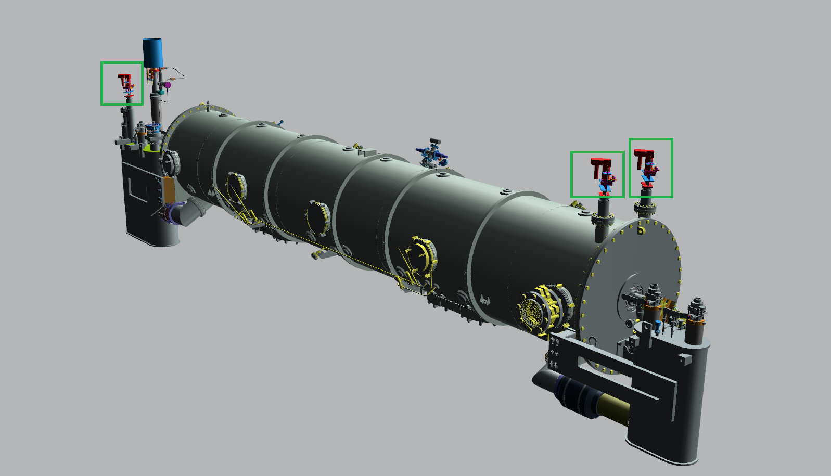

Figure : View of SRF EV on the SNS PPU CM

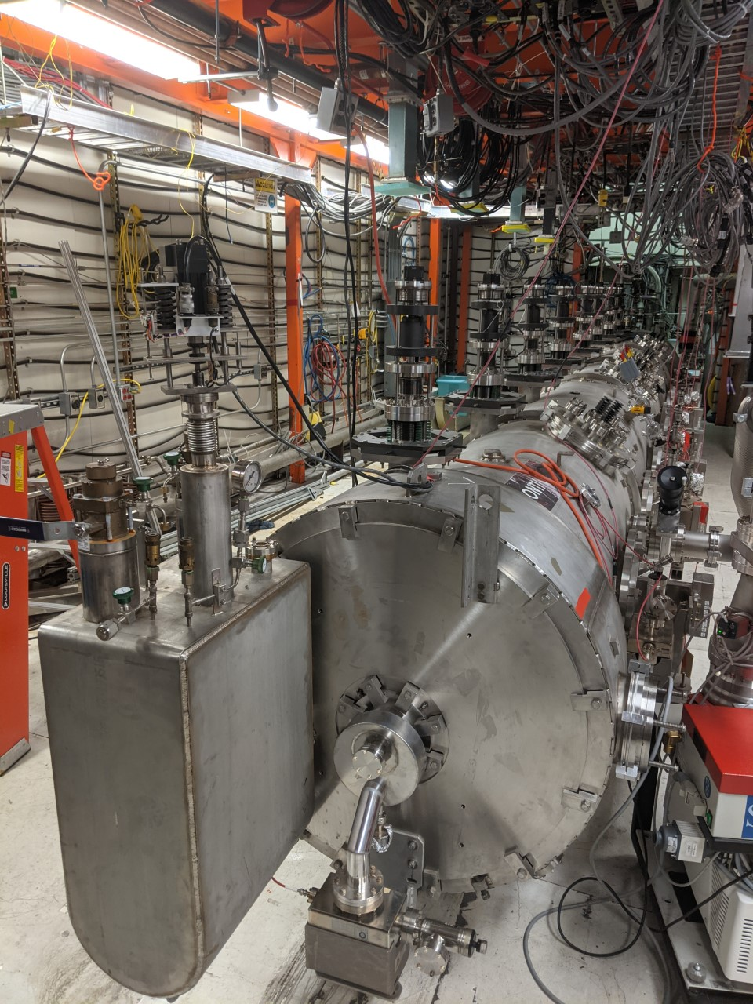

Figure : General wiring connection to EV

## CMTF LL Controller Location

* The CMTF LL controllers are located directly upon the entrance into the CMTF control room
  + Each of the controllers corresponds to a LL sensor inside the CM
  + Both LL levels are within the helium vessel for cavity 4. The Downstream LL on the left and upstream LL on the right.

Figure : CMTF LL Controllers

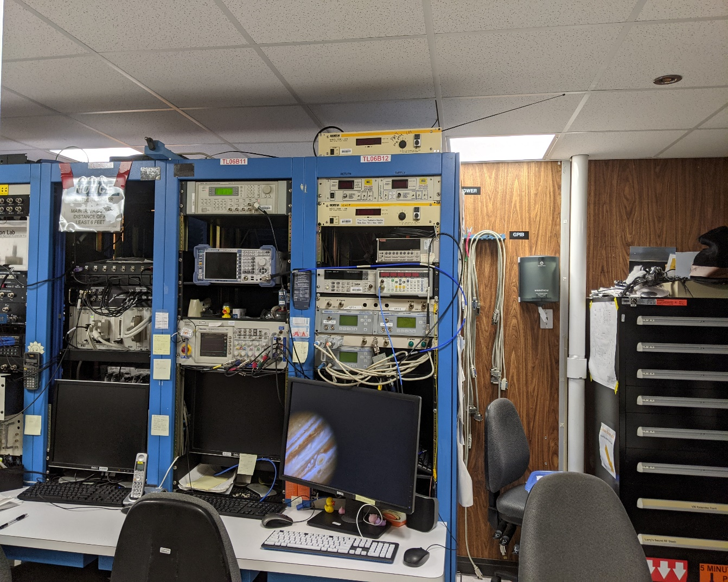

# On Call List

## Cryo Group Contact Information:

**Joe Wilson**

Extension: 7722

Cell 757-329-7576

**Thilan Wijeratne**

Extension: 7058

Cell: 954-554-6329

**Sasa Radovic**

Extension: 5157

Cell: 757-236-0684

**Aswathaman Rangharajan (Primary)**

Extension: 5956

Cell: 732-258-5365

## SRF SME Contact Information:

**Ed Daly (CTF and Cryogenics)**

Extension: 7721

Cell: 757-969-0783

**Naeem Huque (CTF and Cryogenics)**

Extension: 7485

Cell: 217-721-5422

**John Fischer (Installation)**

Extension: 7408

Cell: 757-334-2758

**Mike Drury (Testing Planning)**

Extension: 7493

Cell: 757-748-6982

## SRF SME Technical Contacts:

**Frank Humphry (Vacuum and Valves)**

Extension: 7721

Cell: 757-969-0783

**Larry King (Sensors)**

Extension: 7721

Cell: 757-969-0783

# References

|  |  |
| --- | --- |
| **Document No.** | **Title** |
| SRF-01-ML-001 | SRF Quality Manual |
| SRF-MSPR-CMTF-CM-EPICS | Utilization of Linux & EPICS for the CTF |

Table : Supporting Procedures and Documents

If any clarification is necessary on the location of sensors or the return path of any lines, please refer to the P&ID’s in the following table: {all of the P&ID can be found on [Jlab’s Document Control](https://misportal.jlab.org/jlabDocs)}

|  |  |
| --- | --- |
| **Document No.** | **Title** |
| JL0100004 | SNS-PPU CM |
| 72000-0001 | CTF Main |
| 72400-0001 | Valve Box |
| 72400-0018 | Junction Box |
| 72500-0023 | Cooldown System |
| 72500-0004 | Recovery System |
| 72800-0011 | Main Vacuum Pumps |

Table : Supporting P&ID Documentation

# Release and Revision History

|  |  |  |
| --- | --- | --- |
| **Rev #** | **Major Changes** | **Effective Date:** |
| 1 | Initial version | 31 Mar 2023 |

# Approvals

|  |  |  |  |
| --- | --- | --- | --- |
| **Approved by:** | **Name:** | **Signature:** | **Date:** |
| Document Owner | David Savransky | In Docushare | |
| Subject Matter Expert | Matt Weaks | In Docushare | |
| Work Center Lead | Mike Drury | In Docushare | |
| Project Leader | Ed Daly | In Docushare | |