|  |  |  |  |
| --- | --- | --- | --- |
| **Cryomodule Plasma Processing** | | | |
| **Document Number:** | PLACLN-PR-CM-PROC | **Approval Date:** | 5 Apr 2023 |
| **Revision Number:** | 1 | **Periodic Review Date:** | N/A |
| **Process Owner:** | Ganey, Tiffany | **Department Owner:** | SRF Ops |

**Table of Contents**

1 Purpose and Scope 1

2 Safety 2

3 Important Conditions to Monitor 2

4 Pre-Requisites to be done prior to igniting plasma in the cryomodule 3

5 Process Cell 7 5

6 Process Cells 6 and 5 8

7 Process Cells 4 and 3 10

8 Process Cells 2 and 1 12

9 End of a Plasma Processing Day 15

10 End of Cryomodule Plasma Processing 16

11 References 17

12 Release and Revision History 17

13 Approvals 17

# Purpose and Scope

This procedure provides instructions for performing plasma processing of a C100 cryomodule in either the Cryomodule Test Facility (CMTF) or in CEBAF. Adjacent cavities in a cryomodule cannot be plasma processed simultaneously. The sequence of cavity plasma processing and which RF system will be used on each cavity must be planned in advance.

Once all cavities in the cryomodule have been plasma processed, a round of plasma processing has been completed. Multiple rounds of plasma processing may be performed. Typically two rounds of plasma processing are performed with a 24 or more hour break between rounds.

Checklists for plasma processing are provided in PLACLN-FM-CM-LIST. Prior to initiating this procedure, the plasma processing vacuum and gas carts shall be set up in accordance with PLACLN-PR-CM-PREP.

# Safety

Individuals must keep safety as the first priority in the process; before beginning any job, the user must assure they have the correct PPE for the individual job. Maintaining the level of safety and secure nature of the work area is paramount. The work area may be a Radiologically Controlled Area (RCA), and dosimetry must be work at all times while in an RCA. Refer to the work-center OSP for specifics.

# Important Conditions to Monitor

**IMPORTANT:** **If a sudden increase in N2 (AMU 28) is noted in the RGA trace at any time, stop plasma processing and verify the gas line connection is leak tight. See additional information in PLACLN-PR-CM-PREP if needed.**

**IMPORTANT: An example of a coupler breakdown is shown in the images below. If a coupler breakdown occurs, click RF OFF immediately**

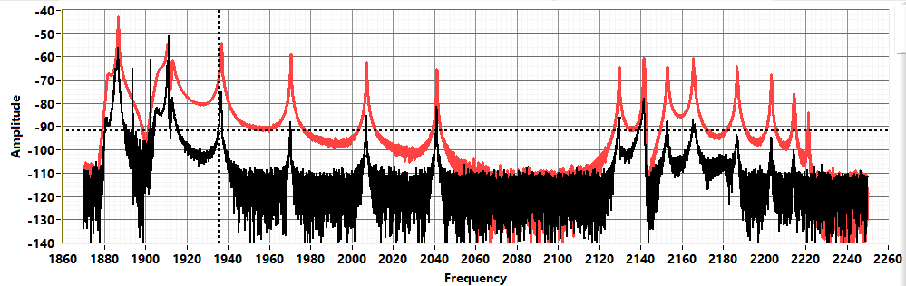

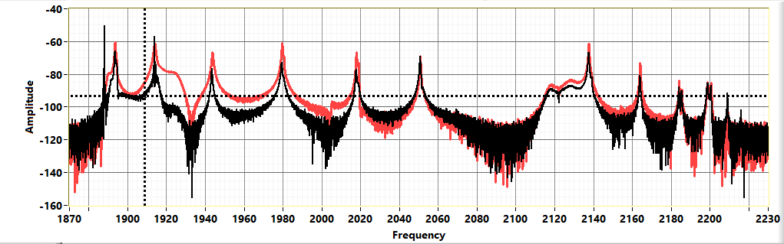

Figure 3‑a: Examples of Coupler Breakdown Network Analyzer Trace. The red line is the reference trace. The black line is live numbers.

# Pre-Requisites to be done prior to igniting plasma in the cryomodule

## Verify plasma processing carts have been connected to the cryomodule / girder in accordance with PLACLN-PR-CM-PREP.

## Verify the cryomodule is maintaining the setpoint pressure and mass flow, and that the O2% is within the target range. Use PLACLN-PR-CM-PREP if adjustments to the setpoint, mass flow, and/or O2% are required.

## Verify the phase shifter is set correctly and the cavity's modes are loaded into the PlasmaMain program in accordance with PLACLN-PR-CM-PREP and PLACLN-PR-CAV-PHASE.

## Turn on the amplifier.

## If not done, launch E5080 Network Analyzer S21 program.

* If this is the first time the E5080 Network Analyzer S21 program has been launched for plasma processing the current cavity, select “Set up Network Analyzer”. Else, select “Network Analyzer OK”.

### Click the button "Click to Save as Reference" to show a baseline S21 trace.

### Set the baseline mode frequencies.

#### Click the button "Click to Pause Acq and Find Modes".

#### Use the Manual Search function to find the peaks of the 14 modes to monitor on the Freq Shifts tab. If a frequency has multiple peaks, choose the one with the highest S21 value. See the figure below for an example of selected peaks for Frequency Shift calculation.

#### Click Save when Done to return to the main Network Analyzer screen. Click the button "Acq Paused (Click to Continue)" to restart S21 scanning.

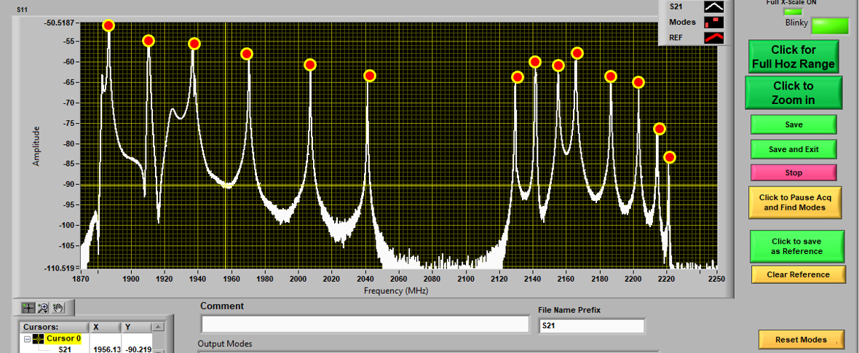

Figure 4‑a: Example of modes to select for Frequency Shift

## Set up the PlasmaMain graphs to monitor RF power, Pf/Pt (dB), and hydrocarbon residuals. Set the time scale on each graph to 1.0 hours.

* The first plot should have Incident power (Pi(W)), reflected power (Pr(W)), and percent oxygen (%O2). Monitoring this graph shows when plasma processing at full power began for each cell or cell pairs. Generally, the reflected power as compared to the incident increases when the plasma is ignited as compared to when the plasma is off.
* Pf/Pt (dB) is an indicator of state of the plasma. If Pf/Pt exceeds a certain value, based on the cell(s) with plasma ignited, it indicates that a coupler breakdown has occurred. Pf/Pt (dB) graph displays 0 when RF power is off.
* CO2 (AMU 44), CO (AMU 28), H (AMU 2) and H2O (AMU 18) are the primary components indicating that plasma processing is removing hydrocarbons from the cavity surface.

## Verify that the RGA filament has been on for at least 2 hours and the RGA scans are providing stable readings.

## Plasma process each cavity in the cryomodule at least twice, or as instructed by the Project Manager.

**NOTES:**

* The cavity frequencies used in this procedure refer to the particular cavity that was used as an example. It is not unusual for the frequencies to be different from cavity to cavity by 5 to 10 MHz. What is important is the number of peaks from the beginning of the trace. For example the 2π/7 mode typically used for igniting plasma in cell 4 is the second large peak from the left.
* An indicator stating that the interlocks are disabled should appear in the network analyzer screen when the interlocks are disabled. It should disappear when the interlocks are enabled and the band is less than 3 dB. The operator must be paying strict attention to the system to insure that there is no coupler breakdown while the interlocks are disabled.

# Process Cell 7

**CAUTION:** There is a potential for causing a coupler breakdown which is indicated by the network analyzer traces shown in Fig. 3a of this document. Operating the system with a coupler in the breakdown mode has the potential to damage the HOM coupler assembly.

**NOTE:** The starting mode / cell for igniting plasma may differ between cavities. The steps below provide options for the start mode / cell. If unable to ignite a plasma in in cell 4, try to ignite the plasma in cell 3 or 5 first. If unable to ignite plasma in cell 3/5 or cell 4, try using to ignite the plasma directly in cell 7. If still unable to ignite plasma, contact the SME for guidance.

## Disable the RF interlock so that the RF system does not trip off while igniting or making adjustments to the plasma. Disable the RF interlocks by clicking on the In Band Interlock button about half way up the Plasma main screen on the right. Caution - the operator is now the interlock in the event of a coupler breakdown.

## 

## Ignite the cell 4 mode {1911 MHz} first and jump the plasma to cell 7:

### Set an RF source to the cell 4 mode {1911 MHz}. Adjust the amplitude slider to -10 dB and turn on the RF source.

### Slowly increase the power until plasma is ignited in cell 4. This is indicated by the mode pattern of the frequency shifts for cell 4 shown in figure 5-a.

### Adjust power in cell 4 until total power is approximately 2-3 W.

### Set the other RF source to the cell 7 mode {1887 MHz}. Adjust the amplitude slider to -10 dB and turn on the RF source.

### Slowly increase power in cell 7 until total power is approximately 5 W and/or cell 7 is ignited.

### Turn off and immediately turn on cell 4 mode {1911 MHz}. When the cell 4 mode is turned back on, the plasma should be in cell 7 only. This is indicated by the mode pattern of the frequency shifts for cell 7 shown in figure 5-c.

### Turn off the cell 7 mode {1887 MHz}. Do not change the power level slider for that channel.

### Adjust the power as needed in cell 7 with the cell 4 mode {1911 MHz} to approximately 10 W.

## Ignite cell 3 or 5, walk the plasma to cell 4, and jump the plasma to cell 7:

**NOTE:** The 3π/7 mode is symmetric to cells 3 and 5; when using the 3π/7 mode, either cell 3 or 5 may ignite. In either case, using the 2π/7 mode will walk the plasma to cell 4.

### Set an RF source to the cell 3/5 mode {1937 MHz}. Adjust the amplitude slider to -10 dB and turn on the RF source.

### Slowly increase the power until plasma is ignited in either cell 3 or 5.

### Decrease the power in cell 3/5 to approximately 2-3 W.

### Set the other RF source to the cell 4 mode {1911 MHz}. Adjust the amplitude slider to -10 dB and turn on the RF source.

### Slowly increase the power until plasma is ignited in cell 4. This is indicated by the mode pattern of the frequency shifts for cell 4 shown in figure 5-a.

### Slowly decrease cell 3/5 power to -10 dB and turn off the RF for that channel. The plasma will now be in cell 4.

### Adjust power in cell 4 until total power is approximately 2-3 W.

### Set the other RF source to the cell 7 mode {1887 MHz}. Adjust the amplitude slider to -10 dB and turn on the RF source.

### Slowly increase power in cell 7 until total power is approximately 5 W and/or cell 7 is ignited.

### Turn off and immediately turn on cell 4 mode {1911 MHz}. When the cell 4 mode is turned back on, the plasma should be in cell 7 only. This is indicated by the mode pattern of the frequency shifts for cell 7 shown in figure 5-c.

### Turn off the cell 7 mode {1887 MHz}. Do not change the power level slider for that channel.

### Adjust the power as needed in cell 7 with cell 4 mode {1911 MHz} to approximately 10 W.

## If unable to ignite cell 4, ignite cell 7 first:

### Set an RF source to the cell 7 mode {1887 MHz}. Adjust the amplitude slider to -10 dB and turn on the RF source.

### Slowly increase the power until plasma is ignited in cell 7. This is indicated by the mode pattern of the frequency shifts for cell 7 shown in figure 5-c.

### Adjust the power as needed in cell 7 {1887 MHz} to approximately 10 W.

## If the interlock value is stable, set the interlock upper and lower values and enable the interlocks:

### On the plasma main program click the button marked “Set RF interlock Plasma ON” to set the upper and lower range of the plasma interlock to plus and minus 1.5 dB. The value of 1.5 dB can be adjusted by changing the value in the Plasma On Offset variable.

### Update the Pf/Pt (dB) graph y-axis to match the Interlock upper and lower values. Verify that the Pf/Pt graph is stable within the interlock band.

### Click on the In Band Interlock Enable button to enable the interlock.

## Process cell 7 for 1 hour.

#### 

Figure 5‑a: Example of the frequency mode shift pattern when there is a plasma in Cell 4 of a C100 cavity.

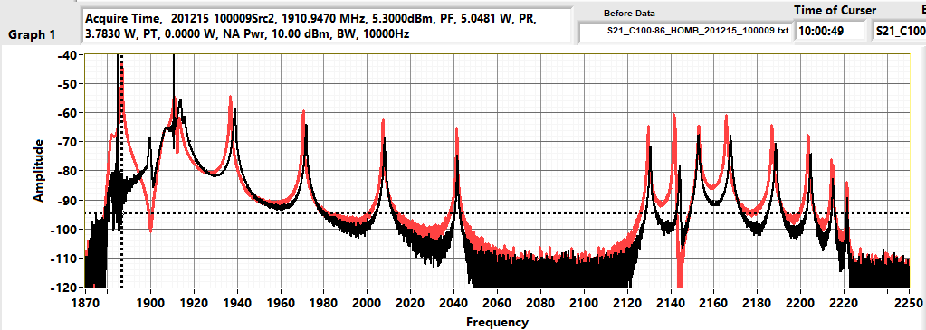

Figure 5‑b: Network Analyzer trace of Cell 7 ignited with 2π/7 mode

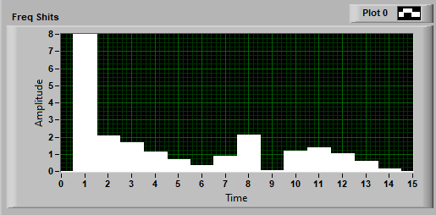

Figure 5‑c: Frequency Shifts of Cell 7 ignited with 2 π /7 mode

# Process Cells 6 and 5

## Disable the RF interlock so that the RF system does not trip off while igniting or making adjustments to the plasma. Disable the RF interlocks by clicking on the In Band Interlock button about half way up the Plasma main screen on the right. Caution - the operator is now the interlock in the event of a coupler breakdown.

## If cell 7 was processed with cell 4 mode {1911 MHz} in accordance with step 0 or 0, switch the plasma to cell 7 mode {1887 MHz}.

### Slowly decrease the power in the cell 4 mode {1911 MHz} to approximately 2-3 W.

### Turn on the RF for cell 7 mode {1887 MHz} at its previous power level.

### Turn off the RF for cell 4 mode.

## If cell 7 was processed with the cell 7 mode {1887 MHz} in accordance with step 5.4, decrease cell 7 power to approximately 2-3 W.

## Ignite plasma in cell 6 and turn off plasma in cell 7.

### Set the other RF source to the cell 6 mode {1971 MHz}. Adjust the amplitude slider to -10 dB and turn on the RF source.

### Slowly increase the power until plasma is ignited in cell 6.

### Slowly decrease cell 7 power to -10 dB or lower and turn off the RF for that channel.

### Adjust the power as needed in cell 6 to approximately 2-3 W.

## Ignite plasma in cell 5.

### Set the other RF source to the cell 5 mode {1937 MHz}. Adjust the amplitude slider to -10 dB and turn on the RF source.

### Slowly increase the power until plasma is ignited in cell 5.

## Adjust power in both cells as needed to provide a total of approximately 10 W to the cavity.

## Optional: Increment Freq 1 and/or Freq 2 by 0.1 - 0.4 MHz to increase the plasma density.

## If the interlock value is stable, set the interlock upper and lower values and enable the interlocks:

### On the plasma main program click the button marked “Set RF interlock Plasma ON” to set the upper and lower range of the plasma interlock to plus and minus 1.5 dB. The value of 1.5 dB can be adjusted by changing the value in the Plasma On Offset variable.

### Update the Pf/Pt (dB) graph y-axis to match the Interlock upper and lower values. Verify that the Pf/Pt graph is stable within the interlock band.

### Click on the In Band Interlock Enable button to enable the interlock.

## Process cell 6 and 5 for 1 hour.

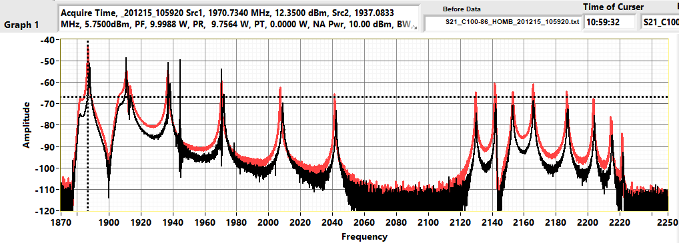

Figure 6‑a: Network Analyzer trace of Cell 6 and 5 ignited

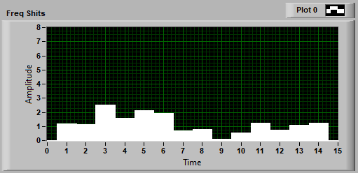

Figure 6‑b: Frequency Shifts for Cell 6 and 5 ignited

# Process Cells 4 and 3

**NOTE:** Ignite plasma in cell 4 by either turning off all RF power and igniting cell 4 directly in accordance with step 7.2 or by "walking" the plasma from cell 5 in accordance with step 7.3.

## Disable the RF interlock so that the RF system does not trip off while igniting or making adjustments to the plasma. Disable the RF interlocks by clicking on the In Band Interlock button about half way up the Plasma main screen on the right. Caution - the operator is now the interlock in the event of a coupler breakdown.

## Optional: If able to directly ignite cell 4 (step 5.2 was used), turn off all RF power and ignite cell 4.

### Click the RF off button to turn off the plasma in both cells 5 and 6.

### Set a RF source to the cell 4 mode {1911 MHz}, turn on the source, and increase power until cell 4 ignites.

### Adjust the power as needed in cell 4 to approximately 2-3 W.

## If unable to directly ignite cell 4, walk plasma to cell 4 from cell 5.

### Decrease the power in the cell 6 mode {1971 MHz} to -10 dB and turn off the RF power from that source.

### Decrease the power in cell 5 mode {1937 MHz} until it is approximately 2-3 W.

### Set the other RF source to the cell 4 mode {1911 MHz}. Adjust the amplitude slider to -10 dB and turn on the RF source.

### Slowly increase the power until plasma is ignited in cell 4.

### Slowly decrease cell 5 power to -10 dB or lower and turn off the RF for that channel.

### Adjust the power as needed in cell 4 to approximately 2-3 W.

## Ignite plasma in cell 3.

### Set the other RF source to the cell 3 mode {1937 MHz}. Adjust the amplitude slider to -10 dB and turn on the RF source.

### Slowly increase the power until plasma is ignited in cell 3.

## Adjust power in both cells as needed to a total of approximately 10 W to the cavity.

## Optional: Increment Freq 1 and/or Freq 2 by 0.1 - 0.4 MHz to increase the plasma density.

## If the interlock value is stable, set the interlock upper and lower values and enable the interlocks:

### On the plasma main program click the button marked “Set RF interlock Plasma ON” to set the upper and lower range of the plasma interlock to plus and minus 1.5 dB. The value of 1.5 dB can be adjusted by changing the value in the Plasma On Offset variable.

### Update the Pf/Pt (dB) graph y-axis to match the Interlock upper and lower values. Verify that the Pf/Pt graph is stable within the interlock band.

### Click on the In Band Interlock Enable button to enable the interlock.

## Process cell 4 and 3 for 1 hour.

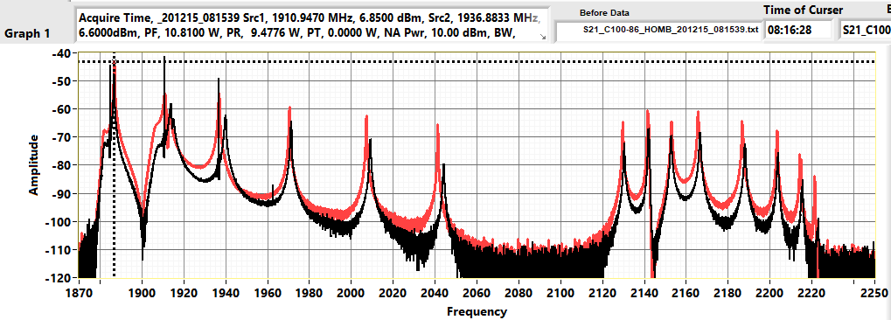

Figure 7‑a: Network Analyzer trace of Cell 4 and 3 ignited

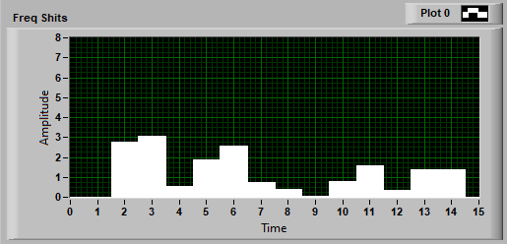

Figure 7‑b: Frequency Shifts for Cell 4 and 3 ignited

# Process Cells 2 and 1

**NOTE:** If unable to ignite plasma in cell 1, the frequency used for cell 1 (0π/7) may need to be adjusted. Review the data collected during the phase shifter determination and select a different frequency for the 0π/7 mode in accordance with PLACLN-PR-CAV-PHASE.

## Disable the RF interlock so that the RF system does not trip off while igniting or making adjustments to the plasma. Disable the RF interlocks by clicking on the In Band Interlock button about half way up the Plasma main screen on the right. Caution - the operator is now the interlock in the event of a coupler breakdown.

## Ignite plasma in cell 2.

### Decrease the power in the cell 4 mode {1911 MHz} to -10 dB and turn off the RF power from that source.

### Decrease the power in cell 3 mode {1937 MHz} until it is approximately 2-3 W.

### Set the other RF source to the cell 2 mode {1971 MHz}. Adjust the amplitude slider to -10 dB and turn on the RF source.

### Slowly increase the power until plasma is ignited in cell 2.

### Slowly decrease cell 3 power to -10 dB or lower and turn off the RF for that channel.

### Adjust the power as needed in cell 2 to approximately 2-3 W.

**CAUTION:**

* Due to the proximity of cell 1 to the HOMs and FP, the probability of a breakdown is increased when igniting plasma in cell 1.
* To decrease the probability of a breakdown:
  + Ensure that cell 1 power slider is -10 dB or lower prior to turning on cell 1.
  + Increase power to cell 1 slowly.
  + Monitor the PF/Pt value for sudden changes in value. A sudden change in the PF/Pt value could indicate that a breakdown will occur if power is increased further.
* Press the RF OFF button immediately if a breakdown is observed in the network analyzer trace.

## Ignite plasma in cell 1.

### Set the other RF source to the Cell 1 mode {1882 MHz}. Adjust the amplitude slider to -10 dB and turn on the RF source.

### Slowly increase the power until plasma is ignited in cell 1. You can tell that it is ignited by observing the knee to the left of the first mode in the network analyzer traces has shifted to the right as shown in Fig. 8-c.

## Adjust power in cell 2 {1971 MHz} to a total of approximately 10 W to the cavity.

## Optional: Increment Freq 1 by 0.1 - 0.4 MHz to increase the plasma density.

## If the interlock value is stable, set the interlock upper and lower values and enable the interlocks:

### On the plasma main program click the button marked “Set RF interlock Plasma ON” to set the upper and lower range of the plasma interlock to plus and minus 1.5 dB. The value of 1.5 dB can be adjusted by changing the value in the Plasma On Offset variable.

### Update the Pf/Pt (dB) graph y-axis to match the Interlock upper and lower values. Verify that the Pf/Pt graph is stable within the interlock band.

### Click on the In Band Interlock Enable button to enable the interlock.

## Process cell 2 and 1 for 1 hour.

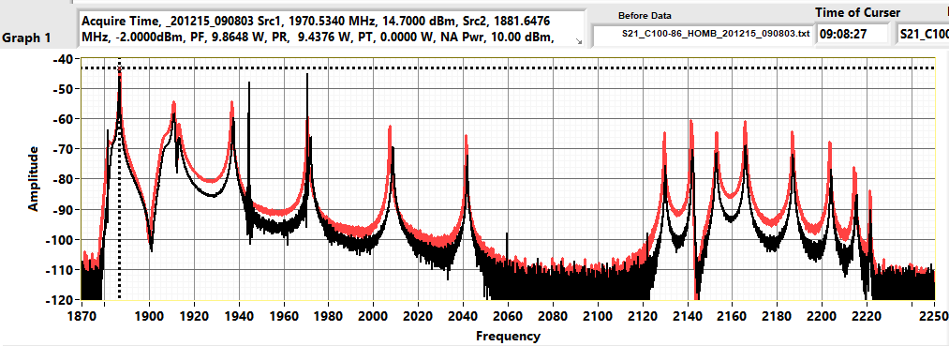

Figure 8‑a: Network Analyzer trace of Cell 2 and 1 ignited

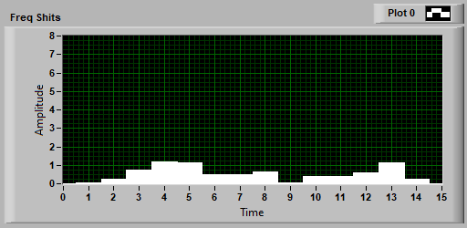

Figure 8‑b: Frequency Shifts for Cell 2 and 1 ignited

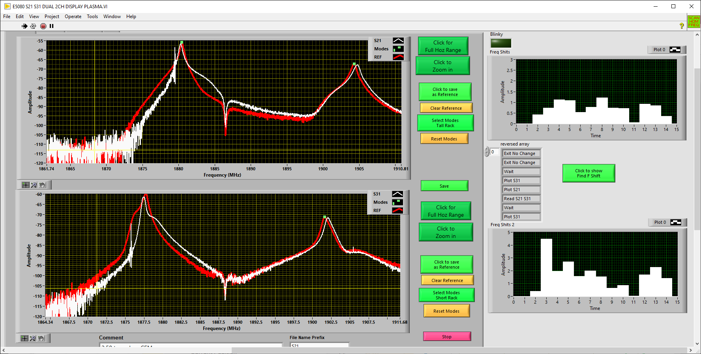

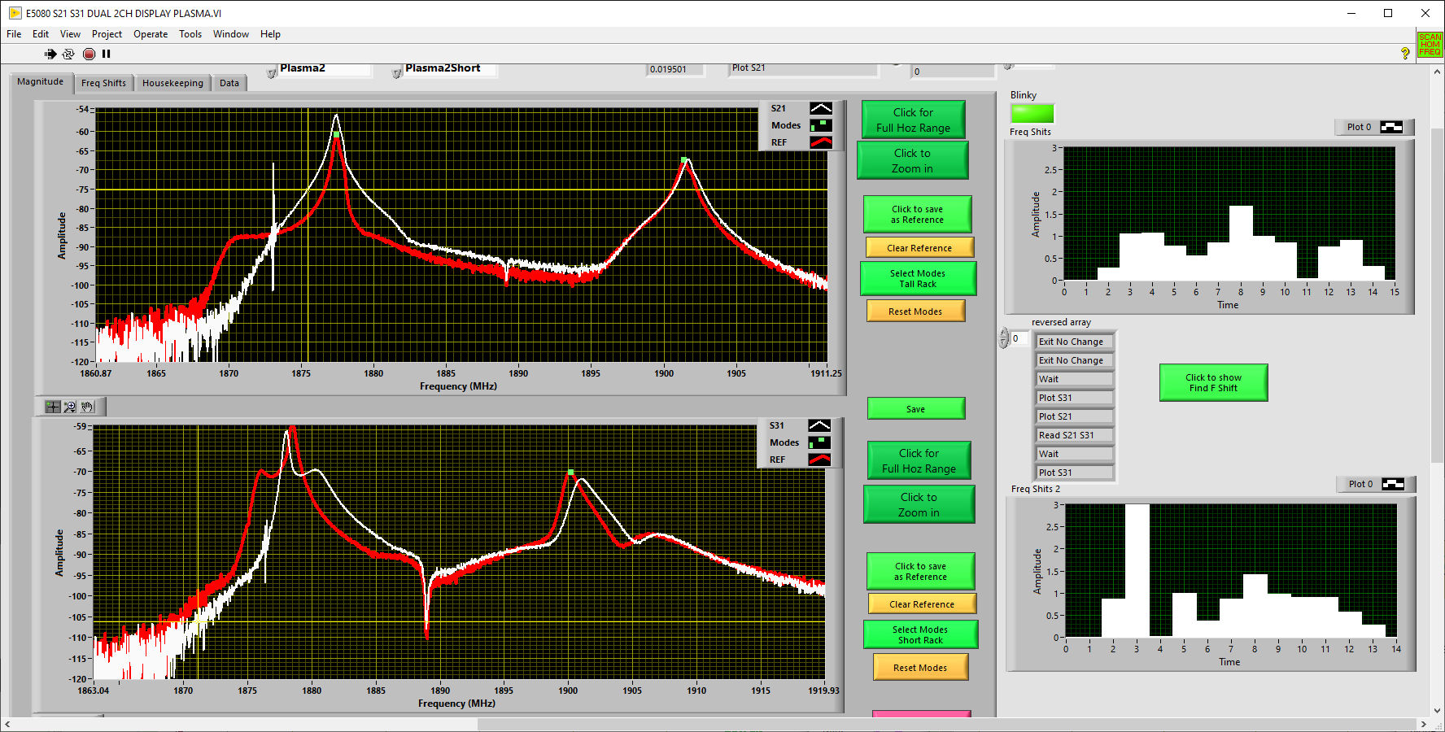

Figure 8-c Zoomed in traces showing the changes in shapes of the S21plots for 4 different cavities when due to Cell 1 being ignited.

# End of a Plasma Processing Day

**At the end of the day, perform the actions in this section to put the system in a safe state until the round will resume.**

## On PlasmaMain, turn all RF off. Set PWR 1 and PWR 2 sliders to -20 dB.

## Turn off amplifier(s).

## Note the MFC setpoint on the PlasmaMain program. Stop gas flow by clicking on the Pressure control on/off button at the top of plasma main towards the center. This will close the MFC valve.

## Close the gas tanks and the valves on the gas cart. Continue pumping the cryomodule with the plasma vacuum cart.

## Close the valve on the plasma manifold between the gas cart and the gas supply manifold. Leave the ion pump valve (VIPXXXXA) open.

## Using the scroll pump on the gas cart, pump out the gas line between the MFC and the gas supply manifold valve by opening the pump valve and the VN2 valve.

## Once the capacitive manometer on the plasma vacuum cart manifold reads in the 0.01 Torr range, fully open the V21 valve on the vacuum cart.

## Backup LabVIEW files and data using either the button on the PlasmaMain Main tab or the standalone software. Verify that the backup file location shows the appropriate file directory based on the computer in use.

## If additional rounds of plasma processing are required, repeat this procedure starting at section 4 when re-starting plasma processing.

## Else if all rounds of plasma processing are complete for the cryomodule, continue to the next section of this procedure.

# End of Cryomodule Plasma Processing

## In accordance with trained clean assembly techniques and PLACLN-PR-CM-DISC, disconnect the plasma carts from the cryomodule / girder. Coordinate the timing of this operation with the test supervisor.

## Disconnect plasma processing RF cables from the cryomodule.

## Click STOP RGA OFF on PlasmaMain to turn off the RGA filament and to stop the PlasmaMain program. PlasmaMain may take several minutes to stop running. Verify the RGA filament is off by checking the green light on the RGA.

## Update the plasma processing traveler for this cryomodule.

# References

|  |  |
| --- | --- |
| **Document No.** | **Title** |
| PLACLN-FM-CM-LIST | Cryomodule Plasma Processing Checklists |
| PLACLN-PR-CM-PREP | Prepare for Vertical Plasma Processing |
| PLACLN-PR-CM-CONN | Connect Plasma Processing Carts to C100 Cryomodule |
| PLACLN-PR-CAV-CCAL | Plasma Processing Cable Calibrations |
| PLACLN-PR-CAV-PHASE | Phase Shift for Plasma Processing C100 Cavities |
| PLACLN-PR-CM-DISC | Disconnect Plasma Processing Carts from Cryomodule |
| PLACLN-CMTF-CM-PLSM | C100 Cryomodule Plasma Processing Traveler |

# Release and Revision History

|  |  |  |
| --- | --- | --- |
| **Rev #** | **Major Changes** | **Approval Date:** |
| 1 | Initial version | 5 Apr 2023 |

# Approvals

|  |  |  |  |
| --- | --- | --- | --- |
| **Approved by:** | **Name:** | **Signature:** | **Date:** |
| Procedure Author | Tiffany Ganey | In DocuShare | |
| Process Owner | Tom Powers | In DocuShare | |