Traveler Title | LCLS-II-HE Cavity String Weldment Upstream Bellows Inspection Traveler
Traveler Abstract | Traveler defines the inspection process for the LCLS-II-HE beam line Upstream Bellows
Traveler ID | L2HE-INSP-BLBU
Traveler Revision | R3
Traveler Author | Michelle Oast
Traveler Date | 4-May-23
NCR Informative Emails | Adamg,lzhao
NCR Dispositioners | weinmann,cheng
D3 Emails | weinmann,cheng,adamg
Approval Names | M. Oast | G. DeKerlegand | A. McEwen | M. Bevins
Approval Signatures
Approval Dates
Approval Title | Author | Reviewer | Group Lead | Project Manager

References | List and Hyperlink all documents related to this traveler. This includes, but is not limited to: safety (THAs, SOPs, etc), drawings, procedures, and facility related documents.
F10075494-D (WELDMENT BELLOWS-US END) | F10023439-B (FLANGE ROTATABLE) | F10023440-B (FLANGE RING) | F10075498 (BELLOWS SHORT-US END) | F10075500-B (FLANGE NR-US END)

Revision Note
R1 | Initial release of this Traveler.
R2 | Initial inspection procedure edit: convolution dents/gouges step changed to include more specific NCR requirements. Added weld inspector requirement and weld inspection step.
R3 | Altered weld inspection requirement, edited approval names and NCR/D3 email names.

Step No. | Instructions |  |  |  |  | Data Input
General handling guidelines: The upstream bellows are fragile and susceptible to denting if dropped or struck. Great care shall be taken to prevent damage during handling. Both end flanges contain sealing faces. Care shall be taken to avoid scratching/gouging this surface and a protective cover shall be installed over this face at all possible times.
1 | Initial Inspection:
 | Technician Name  Date of Inspection  Serial Number of part |  |  |  |  | [[TechName]] <<SRF>>  [[InspectionDate]] <<TIMESTAMP>>  [[BLBUSN]] <<BLBUSN>>
 | Is part clean, free from dust, oil, finger prints or other contaminants? |  |  |  |  | [[PartCleanOK]] <<YESNO>>
 | Visually inspect the bellows assembly convolutions for dings/dents/gouges. Create an NCR for any gouges. Create an NCR for any dents/dings that exceed 1/8". If a single ding or dent is under 1/8" do not create an NCR but leave a comment. For multiple dings or dents an NCR is required. |  |  |  |  | [[ConvolutionsOK]] <<YESNO>>  [[ConvComment]] <<COMMENT>>
 | Visually inspect the assembly for any pitting. |  |  |  |  | [[Pitting]] <<YESNO>>
 | Are welds of good quality? (Smooth ID welds, no undercut, not cold welded/convex, no cracks, no inclusions, no protusions.)  Check weld area for defects similar to the one pictured, if found create NCR.  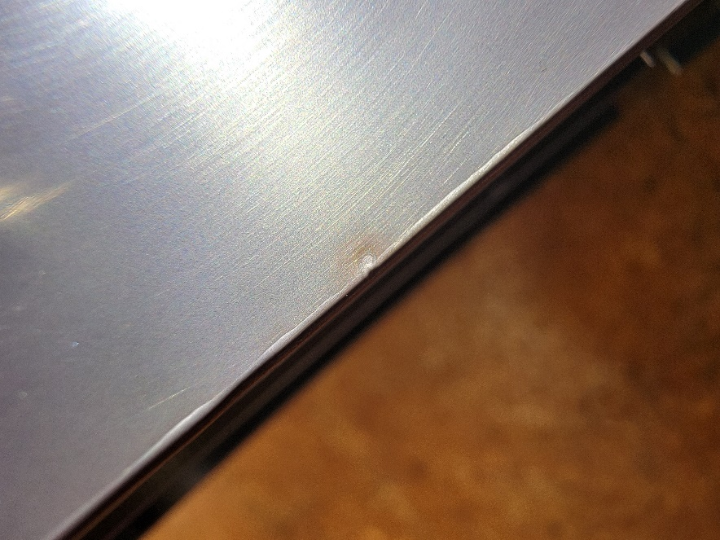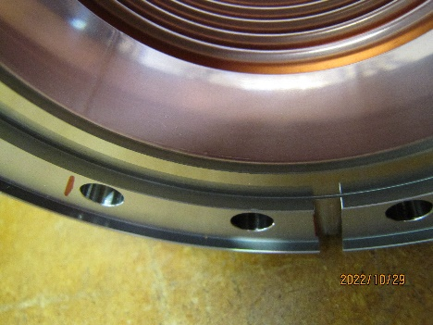 |  |  |  |  | [[WeldsOK]]<<YESNO>>
 | Inspect the flange's sealing surface for scratches/gouges. |  |  |  |  | [[SealingfaceOK]] <<YESNO>>
 | Thread in a M8 x 1.25 silicon bronze screw into the 6 tapped holes of the flange's circumference to verify pitch and ensure threads are undamaged. |  |  |  |  | [[TappedholesOK]] <<YESNO>>
 | Comments:  - Upload photos of the bellows assembly even if no discrepancies are found.  - If discrepancies are found, upload photos of the discrepancy. |  |  | [[VisualInspComment]] <<COMMENT>>  [[VisualInspPhoto]] <<FILEUPLOAD>>
2 | Dimensional Inspection:
 | Dimensionally inspect the bellows assembly against the reference drawings listed above. Only bellows assemblies with serial numbers ending in 001, 004, 007 and and 010 require dimensional inspection. |  |  |  |  | [[DimcheckOk]] <<YESNO>>  [[DimcheckComment]] <<COMMENT>>
Drawing Number |  | Description | Drawing Value |  | Measured Value |  | Within Tolerance
F10075494-C |  | Bellows Length | 66.1 +/- 1.0 mm |  | [[MeasValue1]] <<FLOAT>> |  | [[Tol1]] <<YESNO>>
F10075498 |  | Bellows ID | 78.0 +/- 0.3 mm |  | [[MeasValue2]] <<FLOAT>> |  | [[Tol2]] <<YESNO>>
F10075498 |  | Bellows OD | 98.0 +/- 0.3 mm |  | [[MeasValue3]] <<FLOAT>> |  | [[Tol3]] <<YESNO>>
F10023439-B |  | Flange OD | 145 +/- 0.15 mm |  | [[MeasValue4]] <<FLOAT>> |  | [[Tol4]] <<YESNO>>
F10023439-B |  | Flange hole diameter (Any three randomly selected holes) | 8.8 +/- 0.3 mm |  | [[MeasValue5]] <<FLOAT>> |  | [[Tol5]] <<YESNO>>
F10023439-B |  | Bolt circle diameter (any three holes to establish the BCD) | 120 +/- 0.25 mm |  | [[MeasValue6]] <<FLOAT>> |  | [[Tol6]] <<YESNO>>
F10023439-B |  | Flange pocket diameter | 140.6 +.1/-0 mm |  | [[MeasValue7]] <<FLOAT>> |  | [[Tol7]] <<YESNO>>
F10023440-B |  | Sealing surface OD | 109.2 +/- 0.15 mm |  | [[MeasValue8]] <<FLOAT>> |  | [[Tol8]] <<YESNO>>
F10023440-B |  | Sealing surface ID | 96.0 +/- 0.15 mm |  | [[MeasValue9]] <<FLOAT>> |  | [[Tol9]] <<YESNO>>
3 | Storage:
 | Each bellows assembly shall be re-packaged in its original protective packaging after inspection. |  |  |  |  | [[StorageTech]] <<SRF>>  [[StorageDate]] <<TIMESTAMP>>

