Traveler Title | LCLS-II-HE Cavity Beam Line Bellows PrCM Inspection Traveler
Traveler Abstract | Traveler defines the inspection process for the LCLS-II-HE beam line PrCM Bellows
Traveler ID | L2HE-INSP-BLBP
Traveler Revision | R3
Traveler Author | Michelle Oast
Traveler Date | 4-May-23
NCR Informative Emails | Adamg,lzhao
NCR Dispositioners | weinmann,cheng
D3 Emails | weinmann,cheng,adamg
Approval Names | M. Oast | M. Oast | M. Oast | M. Oast
Approval Signatures
Approval Dates
Approval Title | Author | Author | Author | Author

References | List and Hyperlink all documents related to this traveler. This includes, but is not limited to: safety (THAs, SOPs, etc), drawings, procedures, and facility related documents.
F10041075-H (WELDMENT BELLOWS PrCM) | F10023436 (FLANGE NR) | F10023439 (FLANGE ROTATABLE) | F10023440 (FLANGE RING) | F10041076 (BELLOWS)
Copper Plating Inspection Procedure SRF-MSPR-INSP-CPPL-R1

Revision Note
R1 | Initial release of this Traveler.
R2 | Initial inspection procedure edit: convolution dents/gouges step changed to include more specific NCR requirements. Added weld inspector requirement for weld inspection step.
R3 | Altered weld inspection requirement, edited approval names and NCR/D3 email names.

Step No. | Instructions |  | Data Input
General handling guidelines: The PrCM bellows are fragile and susceptible to denting if dropped or struck. Great care shall be taken to prevent damage during handling. Both end flanges contain sealing surfaces. Care shall be taken to avoid scratching/gouging these surfaces and protective covers shall be installed over these surfaces at all possible times.
1 | Initial Inspection
1 | Technician Name  Date of Inspection  Serial Number of part |  | [[InitInspTech]] <<SRF>>  [[InitInspDate]] <<TIMESTAMP>>  [[BLBPSN]] <<BLBPSN>>
1 | Is part clean, free from dust, oil, finger prints or other contaminants? |  | [[PartCleanOK]] <<YESNO>>
1 | Visually inspect the bellows assembly convolutions for dings/dents/gouges. Create an NCR for any sharp gouges. Create an NCR for any dents/dings that exceed 1/8". If a single ding or dent is under 1/8" do not create an NCR but leave a comment. For multiple dings or dents an NCR is required. |  | [[ConvolutionsOK]]<<YESNO>>  [[ConvComment]] <<COMMENT>>
1 | Visually inspect the assembly for any pitting on internal and external surfaces. (Note shallow pitting in the comments, do not create NCR for shallow pitting.) |  | [[pittingS]]<<YESNO>>
1 | Inspect the flange's sealing surfaces for scratches/gouges. |  | [[SealingfaceOK]]<<YESNO>>
1 | Are welds of good quality? (Smooth ID welds, no undercut, not cold welded/convex, no cracks, no inclusions, no protusions.)  Check weld area for defects similar to the one pictured, if found create NCR.  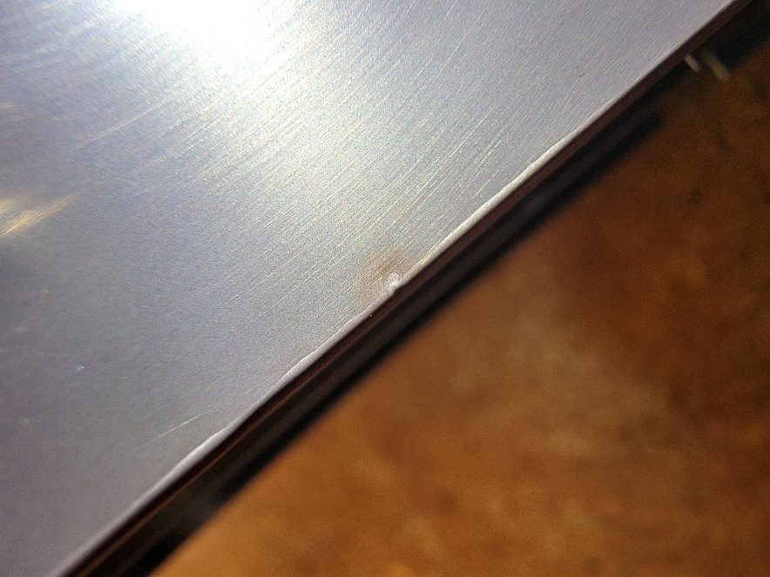  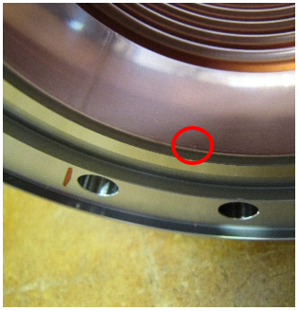 |  | [[WeldsOK]]<<YESNO>>
1 | Measure surface finish of seal groove of rotatable flange. Indicate "no" if roughness is equal to or higher than 0.8 um. |  | [[FinishROk]] <<YESNO>>  [[FinishRComment]] <<COMMENT>>
1 | Measure surface finish of seal groove of non-rotatable flange. Indicate "no" if roughness is equal to or higher than 0.8 um. |  | [[FinishNROk]] <<YESNO>>  [[FinishNRComment]] <<COMMENT>>
1 | Thread a M8 x 1.25 screw into the 6 tapped holes in the flange perimeters by hand to verify the threads are correct and undamaged. Use a silicon bronze screw, do not use a stainless steel screw. |  | [[ThreadsOK]]<<YESNO>>
1 | Comments:  - Upload photos of the bellows assembly even if no discrepancies are found to show the "as received" state. At a minimum, photos should capture the condition of the bellows exterior and interior, sealing surfaces and bellows to flange weld areas.  - If discrepancies are found, upload photos of the discrepancy. |  | [[InitVisInspComment]] <<COMMENT>>  [[InitVisInspPhoto]] <<FILEUPLOAD>>
2 | Plating Inspection
2 | Comment on, but do not create NCRs for the following issues if found:  - Light spots  - Water marks  - Dark spots under 1/8" in diameter  - Small dents under 1/8" in diameter  - Darker shading than is typical of the overall copper plating  - Shallow pitting
2 | Technician Name  Date of Inspection |  | [[PlateInspTech]] <<SRF>>  [[PlateInspDate]] <<TIMESTAMP>>
2 | Does copper plating cover the designated area shown in drawing F10041075? |  | [[platingcoverage]]<<YESNO>>
2 | Plating Inspection with Borescope
2 | There should not be any deep(through plating) pitting in the plating. |  | [[pittingD]]<<YESNO>>
2 | Any flaking of the plating? |  | [[flaking]]<<YESNO>>
2 | Any blistering of the plating? |  | [[blistering]]<<YESNO>>
2 | Any dark spots over 1/8" diameter? |  | [[darkspots]]<<YESNO>>
2 | Any areas larger than 1/8" diameter missing plating? |  | [[barespots]]<<YESNO>>
2 | Comments:  - Upload borescope photos of the plating even if no discrepancies are found. Photos should at a minimum capture the peaks and valleys of the convolutions and weld areas.  - If discrepancies are found, upload photos of the discrepancy. |  | [[PlateVisInspComment]] <<COMMENT>>  [[PlateVisInspPhoto]] <<FILEUPLOAD>>
3 | Dimensional Inspection:
3 | Dimensionally inspect the bellows assembly against the reference drawings listed above. Every 7th bellows inspected requires dimensional inspection. |  | [[DimcheckOk]] <<YESNO>>  [[DimcheckComment]] <<COMMENT>>
Drawing Number | Description | Value | Measured Value | Within Tolerance
F10041075 | Free length | 105.9 +/- 1.0 mm | [[freeL]] <<FLOAT>> | [[TolfreeL]] <<YESNO>>
F10041076 | Bellows ID | 78.0 mm +/- 0.3 mm | [[bellowID]] <<FLOAT>> | [[TolbellowID]] <<YESNO>>
F10041076 | Bellows OD | 98.0 +/- 0.3 mm | [[bellowOD]] <<FLOAT>> | [[TolbellowOD]] <<YESNO>>
F10023436 | Flange OD | 145 +/- 0.15 mm | [[NROD]] <<FLOAT>> | [[TolNROD]] <<YESNO>>
F10023436 | Sealing surface ID | 96 +/- 0.2 mm | [[NRsealID]] <<FLOAT>> | [[TolNRsealID]] <<YESNO>>
F10023436 | Sealing surface OD | 109.2 + 0.15/- 0.0 mm | [[NRsealOD]] <<FLOAT>> | [[TolNRsealOD]] <<YESNO>>
F10023436 | Sealing surface depth | 3.1 +/- 0.1 mm | [[NRsealdepth]] <<FLOAT>> | [[TolNRsealdepth]] <<YESNO>>
F10023436 | Pocket diameter | 140.6 + 0.1/ -0.0 mm | [[NRpockdia]] <<FLOAT>> | [[TolNRpockdia]] <<YESNO>>
F10023436 | Pocket depth | 2.5 +/- 0.3 mm | [[NRpockdepth]] <<FLOAT>> | [[TolNRpockdepth]] <<YESNO>>
F10023436 | Bolt hole diameter (any 3 randomly selected holes) | 8.8 +/- 0.3 mm | [[NRboltdia]] <<FLOAT>> | [[TolNRboltdia]] <<YESNO>>
F10023436 | Bolt hole true position (any three randomly selected holes) | 0.25 mm | [[NRboltTP]] <<FLOAT>> | [[TolNRboltTP]] <<YESNO>>
F10023440 | Sealing surface ID | 96 +/- 0.2 mm | [[RingsealID]] <<FLOAT>> | [[TolRingsealID]] <<YESNO>>
F10023440 | Sealing surface OD | 109.2 + 0.15/- 0.0 mm | [[RingsealOD]] <<FLOAT>> | [[TolRingsealOD]] <<YESNO>>
F10023440 | Sealing surface depth | 3.1 +/- 0.1 mm | [[Ringsealdepth]] <<FLOAT>> | [[TolRingsealdepth]] <<YESNO>>
F10023439 | Flange OD | 145 +/- 0.15 mm | [[ROD]] <<FLOAT>> | [[TolROD]] <<YESNO>>
F10023439 | Pocket diameter | 140.6 + 0.1/ -0.0 mm | [[Rpockdia]] <<FLOAT>> | [[TolRpockdia]] <<YESNO>>
F10023439 | Pocket depth | 2.5 +/- 0.3 mm | [[Rpockdepth]] <<FLOAT>> | [[TolRpockdepth]] <<YESNO>>
F10023439 | Bolt hole diameter (any 3 randomly selected holes) | 8.8 +/- 0.3 mm | [[Rboltdia]] <<FLOAT>> | [[TolRboltdia]] <<YESNO>>
F10023439 | Bolt hole true position (any three randomly selected holes) | 0.25 mm | [[RboltTP]] <<FLOAT>> | [[TolRboltTP]] <<YESNO>>
3 | Storage:
3 | Each bellows assembly shall have any restraints and protective end covers re-installed. They shall be stored in a nitrogen cabinet. |  | [[StorageTech]] <<SRF>>  [[StorageDate]] <<TIMESTAMP>>

