

Traveler Related

Common Procedures

|  |  |  |  |
| --- | --- | --- | --- |
| **Procedure Title** | L2HE Cryomodule Beam Line and Insulating Vacuum Bleed Up & Pump Down Procedure | | |
| **Procedure ID** | **(CP**-L2HE-CM-SLBUP) Need a new ID | | |
| **Procedure Description** | This procedure is for attaching the equipment and performing a slow bleed-up and pump down of a L2HE cryomodule’s beam line and insulating vacuum space. | | |
| **Revision** | R1 | | |
| **Author** | **Sign**: | | **Date**:  26-JUL-23 |
| **Name**: G Cheng | |
| **Reviewer** | **Sign**: | | **Date**:  26-JUL-23 |
| **Name**: Danny Forehand | |
| **Reviewer** | **Sign**: | | **Date**:  26-JUL-23 |
| **Name**: John Fischer | |
| **Reviewer** | **Sign**: | | **Date**:  26-JUL-23 |
| **Name**: John Vennekate | |
| **L2HE CAM** | **Sign**: | | **Date**:  26-JUL-23 |
| **Name**: Adam Grabowski | |
| **L2HE STL** | **Sign**: | | **Date**:  26-JUL-23 |
| **Name**: Mike Bevins | |
| **Revision Notes** | *Describe any changes between revisions here.* | | |
| R1: Initial Release | | |
|  | | |
|  | | |
| **References** | *List and Hyperlink all documents related to this procedure.* | | |
| [JLab 11141S0029-Rev A](https://jlabdoc.jlab.org/docushare/dsweb/Get/Document-76079/11141S0029REV_A-SMALL%20LEAK%20CHECK.pdf)  [Small Leak Check](https://jlabdoc.jlab.org/docushare/dsweb/Get/Document-76079/11141S0029REV_A-SMALL%20LEAK%20CHECK.pdf)  [Procedure](https://jlabdoc.jlab.org/docushare/dsweb/Get/Document-76079/11141S0029REV_A-SMALL%20LEAK%20CHECK.pdf) | [General operation of slow pump cart](https://jlabdoc.jlab.org/docushare/dsweb/Get/Document-136323/CP-L2PRD-CLN-PUMP.docx) | [Large Leak Check Procedure](https://jlabdoc.jlab.org/docushare/dsweb/Get/Document-108753/CP-L2PRO-CST-LKTS-R1.pdf) | |
|  |  |  | |
|  |  |  | |

***Downstream Slow bleed up/pump down installation***

**General:** **This Procedure is for installing the slow bleed up/pump down on an L2HE CM. This Assembly is to be performed using clean assembly practices.**

Gather the following and send in for Degreasing and UHV cleaning. Have all items placed in the pass thru upon completion.

* 2 ¾” CF Blank.
* 4 sets plus spares of 2 ¾” hardware

**HAVE NEW HARDWARE REQUIRED FOR FLOW HOOD WORK CLEANED AND PLACED ON THE PARTS SHELF FOR INSTALLATION.**

1. **PREPARATION** 
   1. Begin setting up laminar flow hood over the downstream end of the Cryomodule.
   2. **During clean beam pipe work the following steps are to be followed!**
   3. Position the laminar flow hood over the work area.
   4. Tape the curtains around the end of the module to eliminate leaks into the hooded area.
   5. Cover all other exposed surfaces in the flow hood with plastic sheeting
   6. Allow the flow hood to run continuously.
   7. Wipe down all surfaces with Alcohol and then blow off the clean room walls and work area with Ionized N2.
   8. Set up the particle counter head unit on the bench in the area in the flow hood. Use the Solair 3100 particle counter to ensure ISO 5 count rate is achieved in the area.
   9. Stage all supplies and tools inside the flow hood, on a pre-cleaned perforated work surface.
   10. Connect the bleed up system to the N2 supply. All isolation valves on system need to be open.
   11. System validation
       1. Verify V1, V2, V9 are fully open.
       2. Verify V3 is closed and under vacuum (should be if V3 is closed).
       3. Turbo controller and ~~block~~ valve assembly switches are set to “auto”.
   12. Bleed up the system to filtered nitrogen.
   13. Verify the Solair 3100 particle count of the work area is stabilized at zero counts on the 0.3 micron scale
   14. Gown up for work.

1. **SLOW PUMP/BLEEDUP SYSTEM HOOK UP #1**

Don **NEW** clean room garments inside the flow hood gowning area.

* 1. Verify cavity string right angle valve is closed
  2. Blow off 2 ¾” assembly hardware, set them aside on clean wipe and cover with secondary pre-wetted wipe.
  3. Remove all except two bolts on the cavity string right angle valve blank where the bleed up system connection will be made and clean to ISO 5 specification.
  4. Check gloves for contamination to ISO 5 spec and change if necessary.
  5. Remove the blanking flange on the right angle valve on the cold gate valve on the string. Clean inside and outside of valve to ISO 5 specification.
  6. Remove the blanking flange on the slow bleed up turbo hose. Clean hose to ISO 5 specification.
  7. Check gloves for contamination to ISO 5 spec and change if necessary.
  8. Install a clean copper gasket, connect the two flanges using two bolts. After the two bolts are hand tight, spinning the nuts only; install the final 4 bolts to hand tight. Torque the 6 bolts down using a star pattern to appropriate uhv standards.
  9. Slow pump down the system to the backside of the right angle valve to 5e-6 torr on G3.
  10. Leak check connection with an RGA
      1. Close V1
      2. Open V3 on the RGA
      3. Open V1
      4. Pump until base pressure is below 2E-7 torr on G4
      5. Perform [JLab 11141S0029-Rev A Small Leak Check Procedure](https://jlabdoc.jlab.org/docushare/dsweb/Get/Document-76079/11141S0029REV_A-SMALL%20LEAK%20CHECK.pdf)
      6. Record results and analog scan.
      7. Shut down the RGA
      8. Close V3

1. **BLEED UP THE STRING** 
   1. Close Turbo isolation valve, V1, Fig 1. And wait for gauge G3 to stabilize.
   2. Turn off the beam line ion pump on the downstream end.
   3. Open the right angle valve on the string slowly (should take about 30 seconds to get to full opening, slower at the beginning during the initial unseating) making a common vacuum. Log the pressure before and after the valve opening on G1 and G3.
   4. Record the piezo gauge reading and the upstream ion pump pressure. Neither reading should go up. If either pressure goes up call SME/supervisor.
   5. Start bleeding up the cavity string using the [General operation of slow pump cart](https://jlabdoc.jlab.org/docushare/dsweb/Get/Document-136323/CP-L2PRD-CLN-PUMP.docx) procedure. Monitor gauging on slow bleed up manifold and stop the slow bleed up at 770 Torr. The setting is 250 SCCM (0.25 liter/min).
   6. Monitor the pressure for the first hour; plotting the pressure vs time every 5 minutes. Calculate the approximate time to 760 torr. If the time is not within normal working hours call SME/supervisor.
   7. Start insulating vacuum bleed up.
   8. Once the piezo on the Slow bleed up filter housing reads 770 Torr (G1), log the pressure.
   9. Close the Right angle valve attached to the gate valve at the bleed up housing.

1. **Perform work on the vented cryomodule as required.** 
   1. Once the required work is complete, continue with next step.
2. **SET UP BEAMLINE SLOW PUMP DOWN SYSTEM**
   1. Verify the system has been returned to the same state as in V1.12, RAV on string is closed to turbo cart
   2. Swap slow bleed-up hose with slow pumpdown hose.
      1. Blow off 2 sets 2 ¾” assembly hardware and one 2 ¾” blank, set them aside on clean wipe and cover with secondary pre-wetted wipe.
      2. Remove all except two bolts on the cavity string right angle valve where the bleed up system connection will be made and clean to ISO 5 specification.
      3. Check gloves for contamination to ISO 5 spec and change if necessary.
      4. Remove slow bleed up filter housing
      5. Install new cleaned blank on slow bleed up system, and verify there is a uniform gap around the new sealed gasket.
      6. Exchange gloves for new ones, make sure they are covering the cotton cuffs on your clean room suit.
      7. Install a clean copper gasket, connect the two flanges using two bolts. After the two bolts are hand tight, spinning the nuts only; install the final 4 bolts to hand tight. Torque the 6 bolts down using a star pattern to appropriate UHV standards
   3. Open the right angle valve on the cold gate valve on the string slowly (should take about 30 seconds to get to full opening, slower at the beginning during the initial unseating). If the pressure on G1 changes by more than 1 torr call SME/supervisor
3. **START PUMPING DOWN THE INSULATING VACUUM**
   1. When insulating vacuum pressure stagnates for at least 30 minutes or reached 1 mbar, proceed to Step 7
4. **SLOW PUMP DOWN OF BEAM LINE**

* 1. Activate slow pump down system using procedure [General operation of slow pump cart,](https://jlabdoc.jlab.org/docushare/dsweb/Get/Document-136323/CP-L2PRD-CLN-PUMP.docx) with a setting of 2.2 torr.
  2. Monitor the pressure for the first hour; plotting the pressure vs. time every 5 minutes. Calculate and log the approximate time to 1torr. If the time is not between 8-10 hours call SME/supervisor.
  3. Leak check connection of right angle valve connection.
     1. Close V1
     2. Open V3 on the RGA
     3. Open V1
     4. Pump until base pressure is below 2E-7 torr on G4 4.12.5. Perform [JLab 11141S0029-Rev A Small Leak Check Procedure](https://jlabdoc.jlab.org/docushare/dsweb/Get/Document-76079/11141S0029REV_A-SMALL%20LEAK%20CHECK.pdf)
     5. Record results and analog scan.
     6. Shut down the RGA
     7. Close V3
  4. Re-establish ion pump.

APPENDIX A

Valve placement on the slow bleed up/pump down equipment. Refer from text.

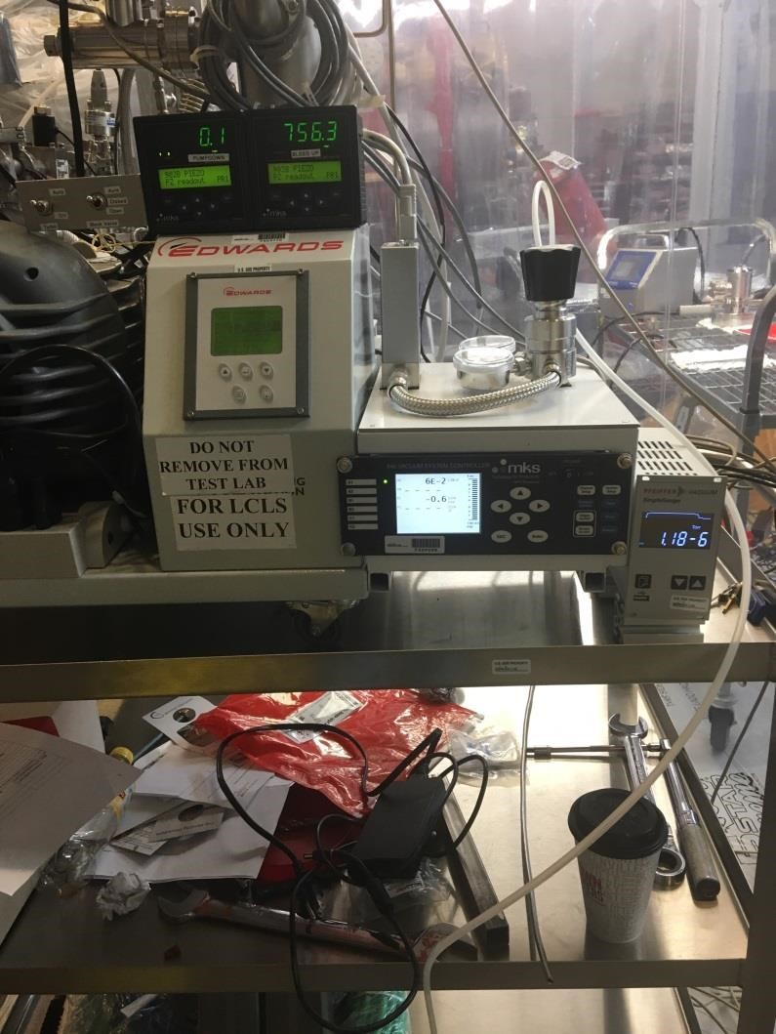

Fig 1. Front view of slow bleed

up/pump down cart

G

2

-

Pressure

gauge Filtered

pump down

manifold

G3

–

System

vacuum full

range gauge

G4

–

Turbo

pump manifold

G

1

–

Bleed up

manifold gauge

Turbo and block

valve switches

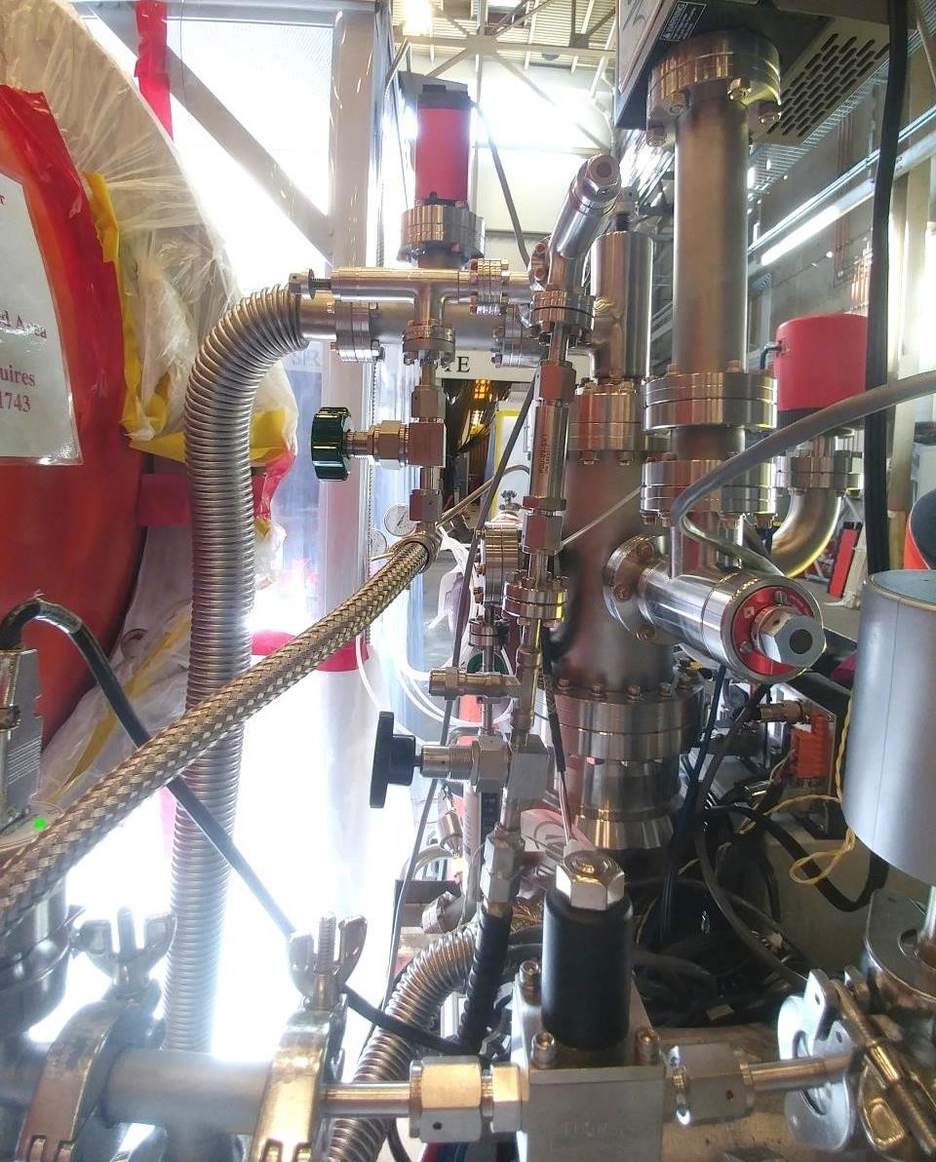

V1

-

Turbo

Isolation Valve

V5

-

Fast Bleed

up Valve (NOT

USED)

Fig 2. View from left side of

Pump down cart

V3

-

RGA

Isolation valve

V2

-

S

low Bleed

up Needle Valve

V4

–

Fast bleed

up relief valve

V8

–

Fast bleed up

isolation valve

V9

–

Slow bleed up

isolation

v

al

ve

)

always open

(

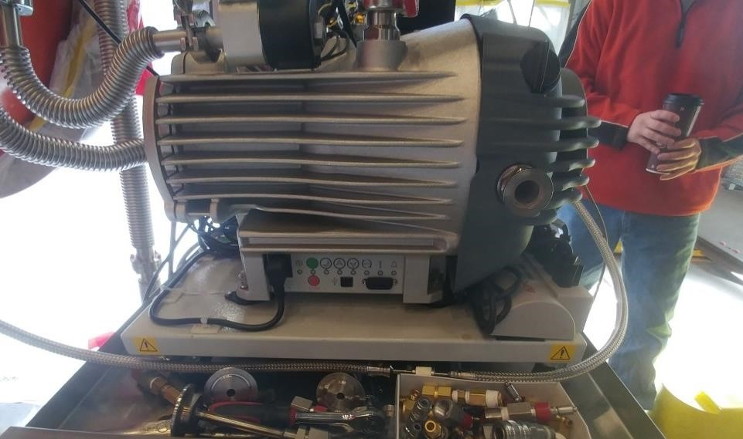

Fig 3. Scroll pump on left side of Pump down cart

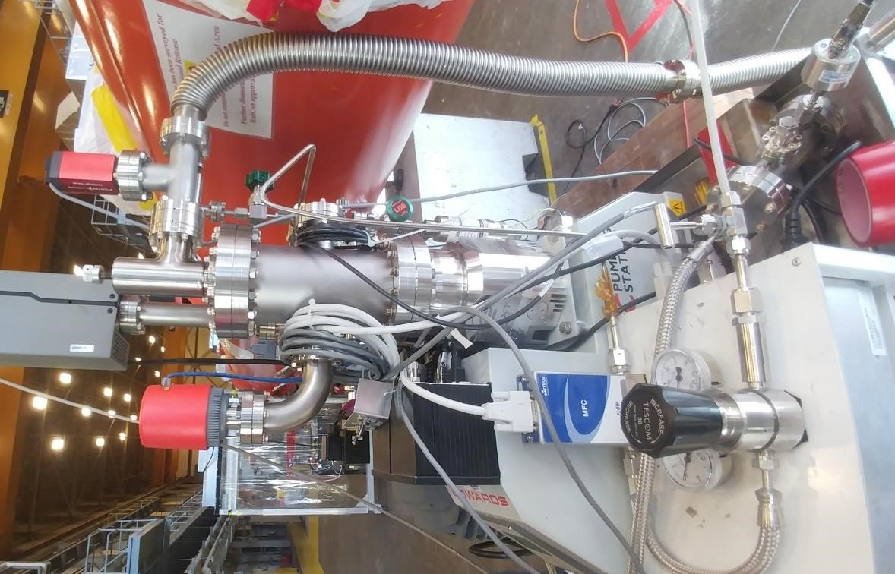

V7

-

Slow Bleed up

N2 Connection

V6

-

Standard

Leak Rate

Fig 4. View from right side of

Pump down cart

G3

–

Full range

vacuum Gauge

G4

–

Turbo

pump manifold

gauge