L2HE Quality Report

Aug 29, 2023

# Open Travelers:

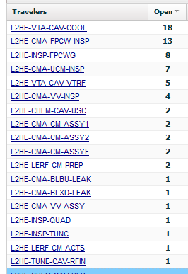 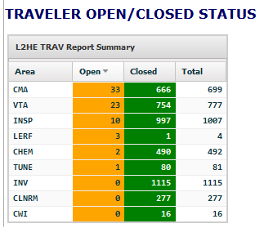

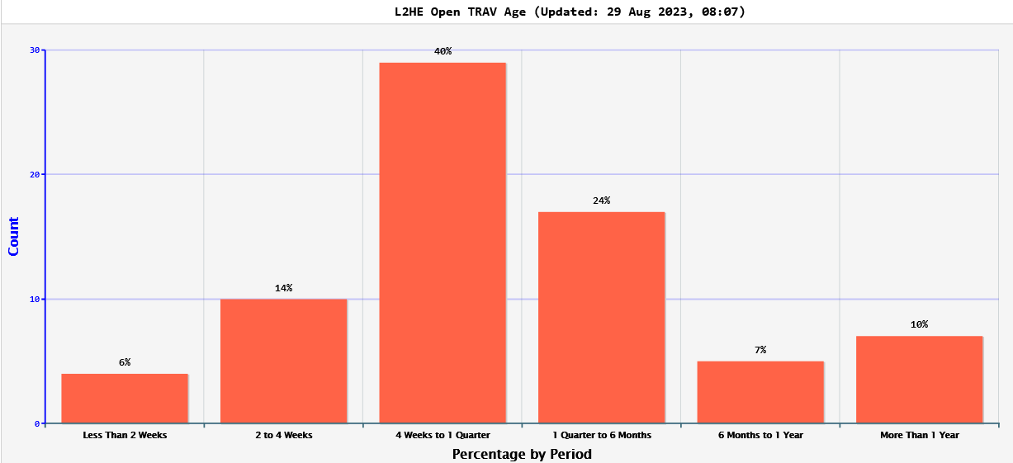

# Open NCRs:

42% over 1 year old

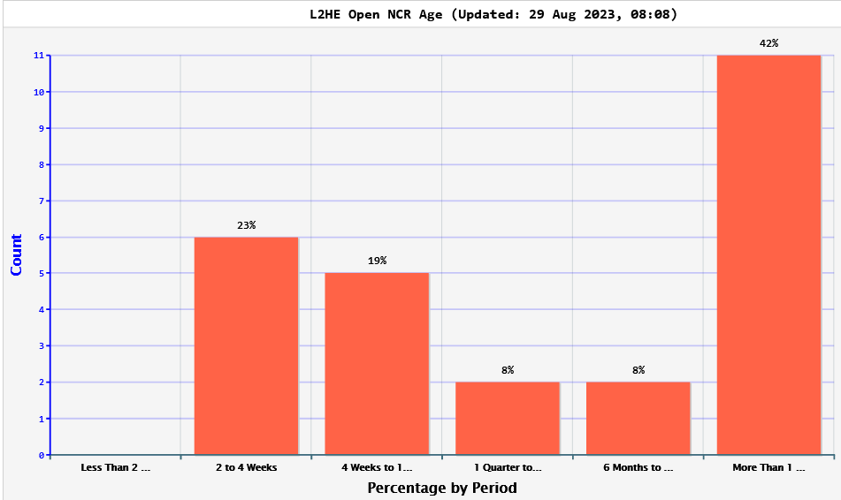

NCR #85 and #104 from 2021 – emailed dispositioners to review.

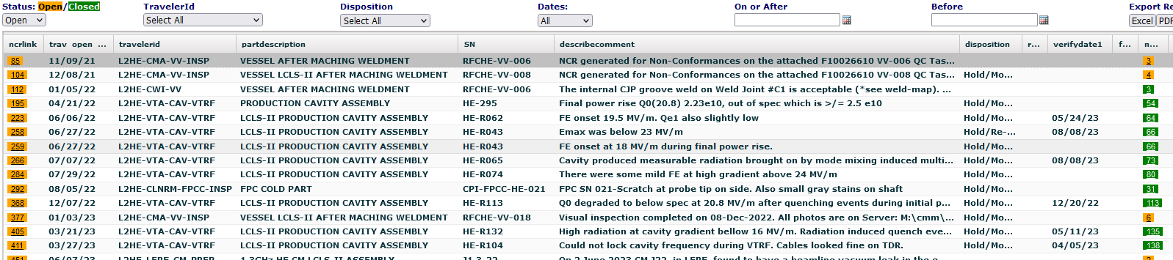

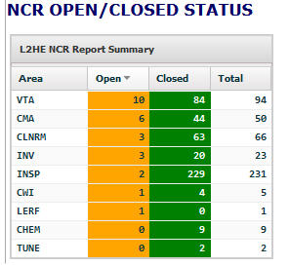

# Open D3s:

Do any of these still need to be open, could they be closed?

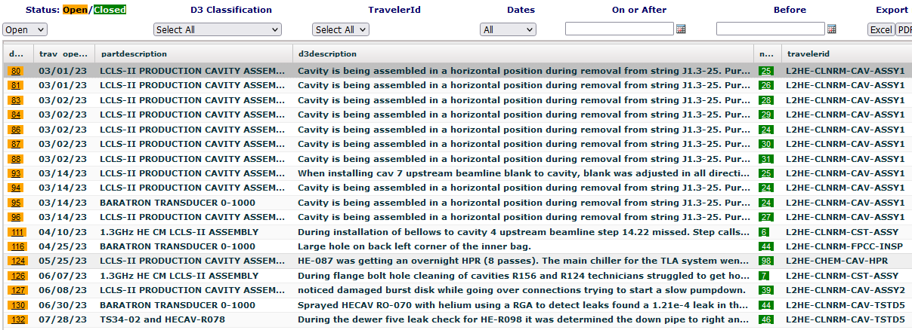

# CAPAs:

CAPA-038 complete, out for final signature to Adam, John, then Tony. Reminder sent this morning.