Traveler Title | Horizontal HOM Damper Fabrication
Traveler Abstract | This traveler defines the steps for fabricating HHOMs for the AUP RFD Cavity
Traveler ID | AUPPS-FAB-HHOM-ASSY
Traveler Revision | R3
Traveler Author | N. HUQUE
Traveler Date | 9-Aug-22
NCR Informative Emails | AREILLY,AOBRIEN,MCEWEN,WILDESON,GROSE
NCR Dispositioners | HUQUE,DOBRENZ
D3 Emails | HUQUE,DOBRENZ,AREILLY,AOBRIEN,MCEWEN,WILDESON,GROSE
Approval Names | Naeem Huque | Adam OBrien | Greg Grose | Tony Reilly
Approval Signatures
Approval Dates
Approval Title | Author | Reviewer | Reviewer | Department Head

References | List and Hyperlink all documents related to this traveler. This includes, but is not limited to: safety (THAs, SOPs, etc), drawings, procedures, and facility related documents.
11141S0029 | AUP-PR-LEAK-CMA-LN2 | CP-AUP-CAV-CHEM-ACID | CP-AUP-CAV-CHEM-DEGR | AUPPS-PR-DAMP-FPREP-ASSY-RF-R1
JL0083868 | JL0086007 | JL0086009 | JL0086010 | JL0086021
JL0086025 | JL0086026 | JL0088266 | JL0088271 | JL0088272
JL0088274 | JL0088326 | JL0088328 | JL0088598 | JL0088600
JL0088602 | JL0093253 | JL0115790

Revision Note
R1 | Initial release of this Traveler.
R2 | Changed HHOOKSN to HOOKSN, incorrect acronym. This R2 did not have a formal approval process as it is only correcting the incorrect acronym.
R3 | Changed reviewer from Scott Williams to Greg Grose. Replaced Scott Williams with Greg Grose for NCR Informative and D3 emails. Added Steps 5b-1 and 9b-1

Step No. | Instructions | Data Input
 | Serial Number of top assembly | [[HHOMSN]] <<HHOMSN>>
PART INSPECTION
1a | Serial number of JL0086021 – Hook  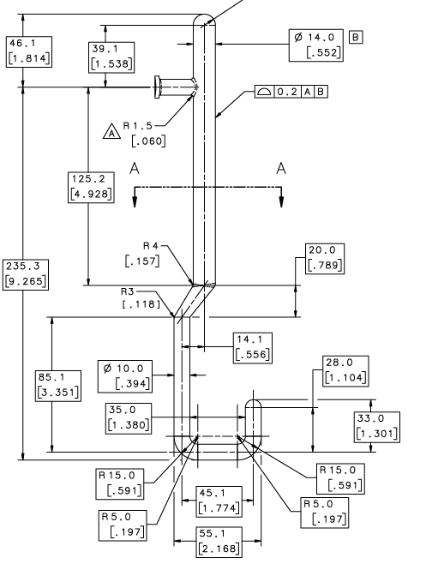 | [[HOOKSN]] <<HOOKSN>>
1b | Upload Material Certificates, along with any relevant photos and/or comments | [[Doc1Tech]] <<SRF>>  [[Doc1Time]] <<TIMESTAMP>>  [[Doc1Comm]] <<COMMENT>>  [[Doc1File]] <<FILEUPLOAD>>
1c | Machine the component as per drawing JL0086021.  Upload any relevant photos and/or comments | [[Mach1Tech]] <<SRF>>  [[Mach1Time]] <<TIMESTAMP>>  [[Mach1Comm]] <<COMMENT>>  [[Mach1File]] <<FILEUPLOAD>>
1d | Verify dimensions on JL0086021  Upload inspection report along with any relevant photos and/or comments. | [[CMM1Tech]] <<SRF>>  [[CMM1Time]] <<TIMESTAMP>>  [[CMM1Comm]] <<COMMENT>>  [[CMM1File]] <<FILEUPLOAD>>
1e | Acid-Etch JL0086021 30 microns as per CP-AUP-CAV-CHEM-ACID. Upload report | [[BCP1Tech]] <<SRF>>  [[BCP1Time]] <<TIMESTAMP>>  [[BCP1Comm]] <<COMMENT>>  [[BCP1File]] <<FILEUPLOAD>>
2a | Serial number of JL0083868 – Tee  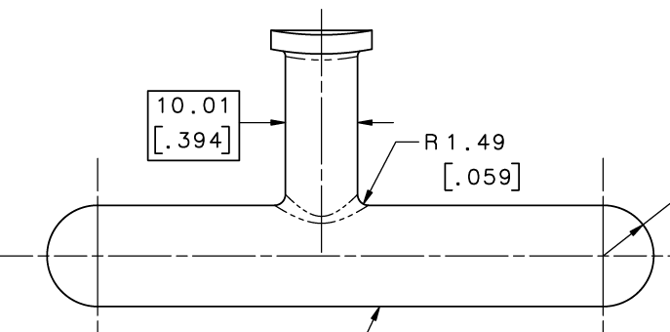 | [[TEESN]] <<TEESN>>
2b | Upload Material Certificates, along with any relevant photos and/or comments | [[Doc2Tech]] <<SRF>>  [[Doc2Time]] <<TIMESTAMP>>  [[Doc2Comm]] <<COMMENT>>  [[Doc2File]] <<FILEUPLOAD>>
2c | Machine the component as per drawing JL0083868.  Upload any relevant photos and/or comments | [[Mach2Tech]] <<SRF>>  [[Mach2Time]] <<TIMESTAMP>>  [[Mach2Comm]] <<COMMENT>>  [[Mach2File]] <<FILEUPLOAD>>
2d | Verify dimensions on JL0083868  Upload inspection report along with any relevant photos and/or comments. | [[CMM2Tech]] <<SRF>>  [[CMM2Time]] <<TIMESTAMP>>  [[CMM2Comm]] <<COMMENT>>  [[CMM2File]] <<FILEUPLOAD>>
2e | Acid-Etch JL0083868 30 microns as per CP-AUP-CAV-CHEM-ACID. Upload report. | [[BCP2Tech]] <<SRF>>  [[BCP2Time]] <<TIMESTAMP>>  [[BCP2Comm]] <<COMMENT>>  [[BCP2File]] <<FILEUPLOAD>>
3a | Serial number of JL0088326 – Nb Can Lid  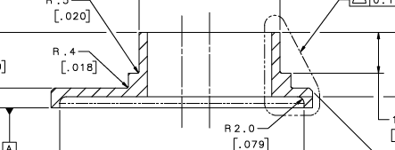 | [[NBLIDSN]] <<NBLIDSN>>
3b | Upload Material Certificates, along with any relevant photos and/or comments | [[Doc3Tech]] <<SRF>>  [[Doc3Time]] <<TIMESTAMP>>  [[Doc3Comm]] <<COMMENT>>  [[Doc3File]] <<FILEUPLOAD>>
3c | Machine the component as per drawing JL0088326.  Upload any relevant photos and/or comments | [[Mach3Tech]] <<SRF>>  [[Mach3Time]] <<TIMESTAMP>>  [[Mach3Comm]] <<COMMENT>>  [[Mach3File]] <<FILEUPLOAD>>
3d | Verify dimensions on JL0088326  Upload inspection report along with any relevant photos and/or comments. | [[CMM3Tech]] <<SRF>>  [[CMM3Time]] <<TIMESTAMP>>  [[CMM3Comm]] <<COMMENT>>  [[CMM3File]] <<FILEUPLOAD>>
3e | Acid-Etch JL0088326 30 microns as per CP-AUP-CAV-CHEM-ACID. Upload report | [[BCP3Tech]] <<SRF>>  [[BCP3Time]] <<TIMESTAMP>>  [[BCP3Comm]] <<COMMENT>>  [[BCP3File]] <<FILEUPLOAD>>
4a | Serial number of JL0088271 – Outer Can Lid  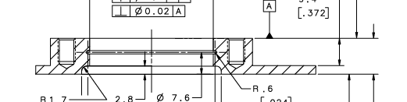 | [[OLIDSN]] <<OLIDSN>>
4b | Upload Material Certificates, along with any relevant photos and/or comments | [[Doc4Tech]] <<SRF>>  [[Doc4Time]] <<TIMESTAMP>>  [[Doc4Comm]] <<COMMENT>>  [[Doc4File]] <<FILEUPLOAD>>
4c | Machine the component as per drawing JL0088271.  Upload any relevant photos and/or comments | [[Mach4Tech]] <<SRF>>  [[Mach4Time]] <<TIMESTAMP>>  [[Mach4Comm]] <<COMMENT>>  [[Mach4File]] <<FILEUPLOAD>>
4d | Verify dimensions on JL0088271  Upload inspection report along with any relevant photos and/or comments. | [[CMM4Tech]] <<SRF>>  [[CMM4Time]] <<TIMESTAMP>>  [[CMM4Comm]] <<COMMENT>>  [[CMM4File]] <<FILEUPLOAD>>

BRAZING
 | Serial Number of Lid Assembly – JL0088328  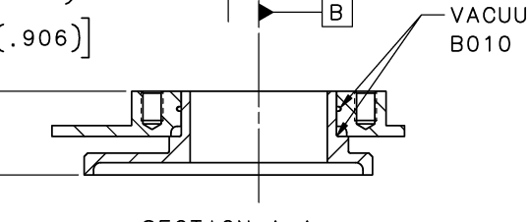 | [[LDBRZSN]] <<LDBRZSN>>
5a | Fabricate sacrificial SS slugs for machining | [[Mach5Tech]] <<SRF>>  [[Mach5Time]] <<TIMESTAMP>>  [[Mach5Comm]] <<COMMENT>>  [[Mach5File]] <<FILEUPLOAD>>
5b | Degrease and Acid-Etch components of JL0088328 as per CP-AUP-CAV-CHEM-ACID and CP-AUP-CAV-CHEM-DEGR | [[Chem1Tech]] <<SRF>>  [[Chem1Time]] <<TIMESTAMP>>  [[Chem1Comm]] <<COMMENT>>  [[Chem1File]] <<FILEUPLOAD>>
5b-1 | Heat treat OUTER CAN LID (JL0088271) at 950C for 2 hours | [[HT1Tech]] <<SRF>>  [[HT1Time]] <<TIMESTAMP>>  [[HT1Comm]] <<COMMENT>>  [[HT1File]] <<FILEUPLOAD>>
5c | Braze assembly as per JL0088328. Upload brazing report and photos. Include any applicable comments | [[Brz1Tech]] <<SRF>>  [[Brz1Time]] <<TIMESTAMP>>  [[Brz1Comm]] <<COMMENT>>  [[Brz1File]] <<FILEUPLOAD>>
5d | Visual Inspection after Brazing. Upload visual inspection report | [[Vis1Tech]] <<SRF>>  [[Vis1Time]] <<TIMESTAMP>>  [[Vis1Comm]] <<COMMENT>>  [[Vis1File]] <<FILEUPLOAD>>
5e | Leak Test the assembly as per 11141S0029. Upload leak test report (PS-7 form) | [[Leak1Tech]] <<SRF>>  [[Leak1Time]] <<TIMESTAMP>>  [[Leak1Comm]] <<COMMENT>>  [[Leak1File]] <<FILEUPLOAD>>
5f | Inform SRF Inventory that the assembly location is the Machine Shop. Machine out the sacrificial SS slugs. Upload images of finished parts and any other notable features | [[Mach6Tech]] <<SRF>>  [[Mach6Time]] <<TIMESTAMP>>  [[Mach6Comm]] <<COMMENT>>  [[Mach6File]] <<FILEUPLOAD>>
5g | Inform SRF Inventory that the assembly will be shipped to the testing vendor. Perform Ultrasonic Testing of the braze. Upload test report.  Does the braze pass? | [[UT1Tech]] <<SRF>>  [[UT1Time]] <<TIMESTAMP>>  [[UT1Comm]] <<COMMENT>>  [[UT1File]] <<FILEUPLOAD>>  [[UT1Pass]] <<YESNO>>
5h | Verify dimensions on JL0088328  Upload inspection report along with any relevant photos and/or comments. | [[CMM5Tech]] <<SRF>>  [[CMM5Time]] <<TIMESTAMP>>  [[CMM5Comm]] <<COMMENT>>  [[CMM5File]] <<FILEUPLOAD>>
6a | Inform SRF Inventory that the assembly location is the Machine Shop. Machine the assembly as per JL0088600. Upload images of finished parts and any other notable features  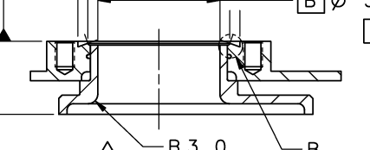 | [[Mach7Tech]] <<SRF>>  [[Mach7Time]] <<TIMESTAMP>>  [[Mach7Comm]] <<COMMENT>>  [[Mach7File]] <<FILEUPLOAD>>
6b | Verify dimensions on JL0088600  Upload inspection report along with any relevant photos and/or comments. | [[CMM6Tech]] <<SRF>>  [[CMM6Time]] <<TIMESTAMP>>  [[CMM6Comm]] <<COMMENT>>  [[CMM6File]] <<FILEUPLOAD>>
6c | Engrave JL0088600-XXX on the OD of the Stainless Steel cylinder, where XXX is the last three digist of the corresponding HHOMSN
6d | Return the assembly to the SRF Inventory

PART INSPECTION
7a | Serial number of JL0086026 – Inner Tube  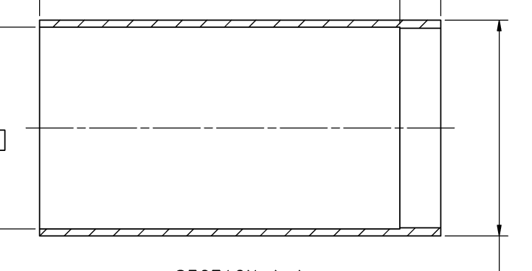 | [[ITUBESN]] <<ITUBESN>>
7b | Upload Material Certificates, along with any relevant photos and/or comments | [[Doc5Tech]] <<SRF>>  [[Doc5Time]] <<TIMESTAMP>>  [[Doc5Comm]] <<COMMENT>>  [[Doc5File]] <<FILEUPLOAD>>
7c | Machine the component as per drawing JL0086026.  Upload any relevant photos and/or comments | [[Mach8Tech]] <<SRF>>  [[Mach8Time]] <<TIMESTAMP>>  [[Mach8Comm]] <<COMMENT>>  [[Mach8File]] <<FILEUPLOAD>>
7d | Acid-Etch JL0086026 30 microns as per CP-AUP-CAV-CHEM-ACID. Upload report | [[BCP4Tech]] <<SRF>>  [[BCP4Time]] <<TIMESTAMP>>  [[BCP4Comm]] <<COMMENT>>  [[BCP4File]] <<FILEUPLOAD>>
7e | Verify dimensions on JL0086026  Upload inspection report along with any relevant photos and/or comments. | [[CMM7Tech]] <<SRF>>  [[CMM7Time]] <<TIMESTAMP>>  [[CMM7Comm]] <<COMMENT>>  [[CMM7File]] <<FILEUPLOAD>>
8a | Serial number of JL0086025 – Flange DN100  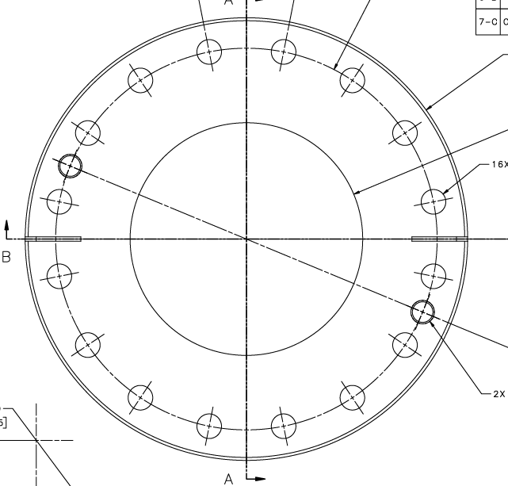 | [[DN100SN]] <<DN100SN>>
8b | Upload Material Certificates, along with any relevant photos and/or comments | [[Doc6Tech]] <<SRF>>  [[Doc6Time]] <<TIMESTAMP>>  [[Doc6Comm]] <<COMMENT>>  [[Doc6File]] <<FILEUPLOAD>>
8c | Machine the component as per drawing JL0086025.  Upload any relevant photos and/or comments | [[Mach9Tech]] <<SRF>>  [[Mach9Time]] <<TIMESTAMP>>  [[Mach9Comm]] <<COMMENT>>  [[Mach9File]] <<FILEUPLOAD>>
8d | Verify dimensions on JL0086025  Upload inspection report along with any relevant photos and/or comments. | [[CMM8Tech]] <<SRF>>  [[CMM8Time]] <<TIMESTAMP>>  [[CMM8Comm]] <<COMMENT>>  [[CMM8File]] <<FILEUPLOAD>>

BRAZING
 | Serial Number of JL0088274 – DN100 Braze Assembly  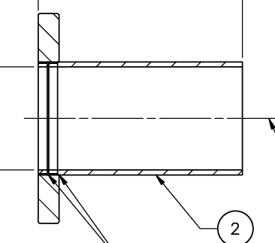 | [[DNBRZSN]] <<DNBRZSN>>
9a | Fabricate sacrificial SS slugs for machining | [[Mach10Tech]] <<SRF>>  [[Mach10Time]] <<TIMESTAMP>>  [[Mach10Comm]] <<COMMENT>>  [[Mach10File]] <<FILEUPLOAD>>
9b | Degrease and Acid-Etch components of JL0088274 as per CP-AUP-CAV-CHEM-ACID and CP-AUP-CAV-CHEM-DEGR | [[Chem2Tech]] <<SRF>>  [[Chem2Time]] <<TIMESTAMP>>  [[Chem2Comm]] <<COMMENT>>  [[Chem2File]] <<FILEUPLOAD>>
9b-1 | Heat treat stainless steel DN100 Flange (JL0086025) at 950C for 2 hours | [[HT2Tech]] <<SRF>>  [[HT2Time]] <<TIMESTAMP>>  [[HT2Comm]] <<COMMENT>>  [[HT2File]] <<FILEUPLOAD>>
9c | Braze assembly as per JL0088274. Upload brazing report and photos. Include any applicable comments | [[Brz2Tech]] <<SRF>>  [[Brz2Time]] <<TIMESTAMP>>  [[Brz2Comm]] <<COMMENT>>  [[Brz2File]] <<FILEUPLOAD>>
9d | Visual Inspection after Brazing. Upload visual inspection report | [[Vis2Tech]] <<SRF>>  [[Vis2Time]] <<TIMESTAMP>>  [[Vis2Comm]] <<COMMENT>>  [[Vis2File]] <<FILEUPLOAD>>
9e | Leak Test the assembly as per 11141S0029. Upload leak test report (PS-7 form) | [[Leak2Tech]] <<SRF>>  [[Leak2Time]] <<TIMESTAMP>>  [[Leak2Comm]] <<COMMENT>>  [[Leak2File]] <<FILEUPLOAD>>
9f | Inform SRF Inventory that the assembly location is the Machine Shop. Machine out the sacrificial SS slugs. Upload images of finished parts and any other notable features | [[Mach11Tech]] <<SRF>>  [[Mach11Time]] <<TIMESTAMP>>  [[Mach11Comm]] <<COMMENT>>  [[Mach11File]] <<FILEUPLOAD>>
9g | Inform SRF Inventory that the assembly will be shipped to the testing vendor. Perform Ultrasonic Testing of the braze. Upload test report.  Does the braze pass? | [[UT2Tech]] <<SRF>>  [[UT2Time]] <<TIMESTAMP>>  [[UT2Comm]] <<COMMENT>>  [[UT2File]] <<FILEUPLOAD>>  [[UT2Pass]] <<YESNO>>
9h | Verify dimensions on JL0088274  Upload inspection report along with any relevant photos and/or comments. | [[CMM9Tech]] <<SRF>>  [[CMM9Time]] <<TIMESTAMP>>  [[CMM9Comm]] <<COMMENT>>  [[CMM9File]] <<FILEUPLOAD>>
10a | Inform SRF Inventory that the assembly location is the Machine Shop. Machine the assembly as per JL0088272. Upload images of finished parts and any other notable features  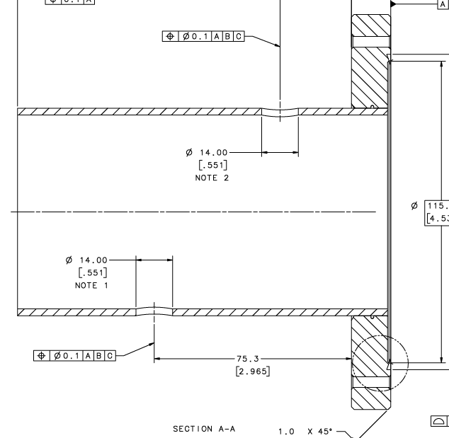 | [[Mach12Tech]] <<SRF>>  [[Mach12Time]] <<TIMESTAMP>>  [[Mach12Comm]] <<COMMENT>>  [[Mach12File]] <<FILEUPLOAD>>
10b | Verify dimensions on JL0088272  Upload inspection report along with any relevant photos and/or comments. | [[CMM10Tech]] <<SRF>>  [[CMM10Time]] <<TIMESTAMP>>  [[CMM10Comm]] <<COMMENT>>  [[CMM10File]] <<FILEUPLOAD>>
10c | Sand off the JL0086025-XXX serial number from the flange OD
10d | Return the assembly to the SRF Inventory

EBW
 | Inform SRF Inventory that the assembly location is EBW (HHOMSN)
11a | Degrease and Acid-Etch components of JL0088266 as per CP-AUP-CAV-CHEM-ACID and CP-AUP-CAV-CHEM-DEGR. Upload BCP report.  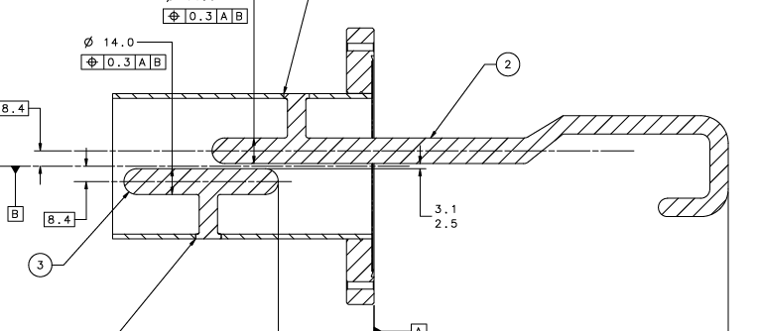 | [[Chem3Tech]] <<SRF>>  [[Chem3Time]] <<TIMESTAMP>>  [[Chem3Comm]] <<COMMENT>>  [[Chem3File]] <<FILEUPLOAD>>
11b | EB weld as per JL0088266 (W010/W020). Upload images | [[EBW1Tech]] <<SRF>>  [[EBW1Time]] <<TIMESTAMP>>  [[EBW1Comm]] <<COMMENT>>  [[EBW1File]] <<FILEUPLOAD>>
11c | Visual Inspection after EBW. Upload visual inspection report | [[Vis3Tech]] <<SRF>>  [[Vis3Time]] <<TIMESTAMP>>  [[Vis3Comm]] <<COMMENT>>  [[Vis3File]] <<FILEUPLOAD>>
11d | Leak Test the assembly as per 11141S0029. Upload leak test report (PS-7 form) | [[Leak3Tech]] <<SRF>>  [[Leak3Time]] <<TIMESTAMP>>  [[Leak3Comm]] <<COMMENT>>  [[Leak3File]] <<FILEUPLOAD>>
11e | Verify dimensions on JL0088266  Upload inspection report along with any relevant photos and/or comments. | [[CMM11Tech]] <<SRF>>  [[CMM11Time]] <<TIMESTAMP>>  [[CMM11Comm]] <<COMMENT>>  [[CMM11File]] <<FILEUPLOAD>>

EBW
 | Inform SRF Inventory that the assembly location is EBW (HHOMSN)
12a | Degrease and Acid-Etch (EBW Prep) components of JL0088602 as per CP-AUP-CAV-CHEM-ACID and CP-AUP-CAV-CHEM-DEGR. Upload BCP report.  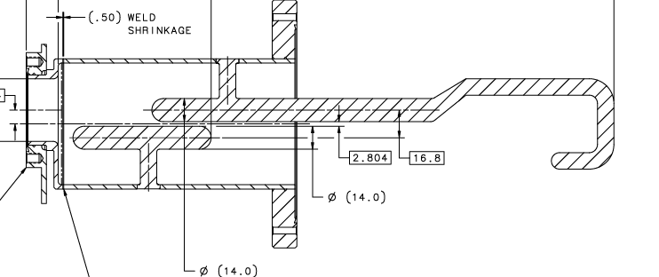 | [[Chem5Tech]] <<SRF>>  [[Chem5Time]] <<TIMESTAMP>>  [[Chem5Comm]] <<COMMENT>>  [[Chem5File]] <<FILEUPLOAD>>
12b | EB weld as per JL0088602 (W030). Upload images | [[EBW2Tech]] <<SRF>>  [[EBW2Time]] <<TIMESTAMP>>  [[EBW2Comm]] <<COMMENT>>  [[EBW2File]] <<FILEUPLOAD>>
12c | Visual Inspection after EBW. Upload visual inspection report | [[Vis4Tech]] <<SRF>>  [[Vis4Time]] <<TIMESTAMP>>  [[Vis4Comm]] <<COMMENT>>  [[Vis4File]] <<FILEUPLOAD>>
12d | Leak Test the assembly as per 11141S0029. Upload leak test report (PS-7 form) | [[Leak4Tech]] <<SRF>>  [[Leak4Time]] <<TIMESTAMP>>  [[Leak4Comm]] <<COMMENT>>  [[Leak4File]] <<FILEUPLOAD>>
12e | Verify dimensions on JL0088602  Upload inspection report along with any relevant photos and/or comments. | [[CMM12Tech]] <<SRF>>  [[CMM12Time]] <<TIMESTAMP>>  [[CMM12Comm]] <<COMMENT>>  [[CMM12File]] <<FILEUPLOAD>>
12f | Sand off the JL0088272-XXX serial number from the flange OD
12g | Inform SRF Inventory that the assembly will be shipped out to the testing vendor. Perform Radiographic testing on JL0088602 EB welds (W030). Upload RT report and films | [[RTTech]] <<SRF>>  [[RTTime]] <<TIMESTAMP>>  [[RTComm]] <<COMMENT>>  [[RTFile]] <<FILEUPLOAD>>
12h | Return the assembly to the SRF Inventory

PART INSPECTION
13a | Serial number of JL0086009 – HHOM External Pipe  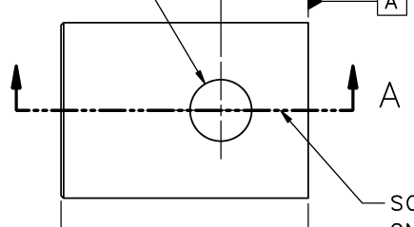 | [[EXPIPSN]] <<EXPIPSN>>
13b | Upload Material Certificates, along with any relevant photos and/or comments | [[Doc7Tech]] <<SRF>>  [[Doc7Time]] <<TIMESTAMP>>  [[Doc7Comm]] <<COMMENT>>  [[Doc7File]] <<FILEUPLOAD>>
13c | Machine the component as per drawing JL0086009.  Upload any relevant photos and/or comments | [[Mach13Tech]] <<SRF>>  [[Mach13Time]] <<TIMESTAMP>>  [[Mach13Comm]] <<COMMENT>>  [[Mach13File]] <<FILEUPLOAD>>
13d | Verify dimensions on JL0086009  Upload inspection report along with any relevant photos and/or comments. | [[CMM13Tech]] <<SRF>>  [[CMM13Time]] <<TIMESTAMP>>  [[CMM13Comm]] <<COMMENT>>  [[CMM13File]] <<FILEUPLOAD>>
14a | Serial number of JL0088598 – Outlet Tube  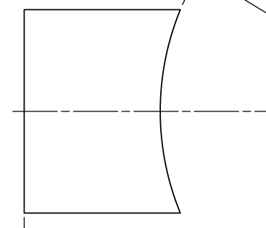 | [[OTUBESN]] <<OTUBESN>>
14b | Upload Material Certificates, along with any relevant photos and/or comments | [[Doc8Tech]] <<SRF>>  [[Doc8Time]] <<TIMESTAMP>>  [[Doc8Comm]] <<COMMENT>>  [[Doc8File]] <<FILEUPLOAD>>
14c | Machine the component as per drawing JL0088598.  Upload any relevant photos and/or comments | [[Mach14Tech]] <<SRF>>  [[Mach14Time]] <<TIMESTAMP>>  [[Mach14Comm]] <<COMMENT>>  [[Mach14File]] <<FILEUPLOAD>>
14d | Verify dimensions on JL0088598.  Upload inspection report along with any relevant photos and/or comments. | [[CMM14Tech]] <<SRF>>  [[CMM14Time]] <<TIMESTAMP>>  [[CMM14Comm]] <<COMMENT>>  [[CMM14File]] <<FILEUPLOAD>>

ASSEMBLY
 | Inform SRF Inventory that the assembly location is Cryomodule Assembly
15a | Clean JL0088602 and components of JL0086007 as per CP-AUP-CAV-CHEM-DEGR  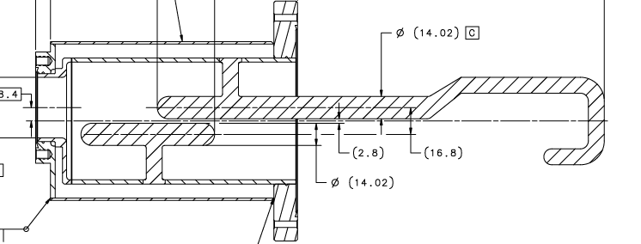 | [[Chem6Tech]] <<SRF>>  [[Chem6Time]] <<TIMESTAMP>>  [[Chem6Comm]] <<COMMENT>>  [[Chem6File]] <<FILEUPLOAD>>
15b | TIG Weld as per JL0086007 (W010/W020/W030) | [[TIGTech]] <<SRF>>  [[TIGTime]] <<TIMESTAMP>>  [[TIGComm]] <<COMMENT>>  [[TIGFile]] <<FILEUPLOAD>>
15c | Visual Inspection after EBW. Upload visual inspection report | [[Vis5Tech]] <<SRF>>  [[Vis5Time]] <<TIMESTAMP>>  [[Vis5Comm]] <<COMMENT>>  [[Vis5File]] <<FILEUPLOAD>>
15d | Pressure test the Stainless Steel space to 38 psig. Upload pressure test report (PS-7 form). | [[PT1Tech]] <<SRF>>  [[PT1Time]] <<TIMESTAMP>>  [[PT1Comm]] <<COMMENT>>  [[PT1File]] <<FILEUPLOAD>>
15e | Leak Test the Stainless Steel space as per 11141S0029. Upload leak test report (PS-7 form) | [[Leak5Tech]] <<SRF>>  [[Leak5Time]] <<TIMESTAMP>>  [[Leak5Comm]] <<COMMENT>>  [[Leak5File]] <<FILEUPLOAD>>
15f | Pressure test the Niobium space to 38 psig. Upload pressure test report (PS-7 form). | [[PT2Tech]] <<SRF>>  [[PT2Time]] <<TIMESTAMP>>  [[PT2Comm]] <<COMMENT>>  [[PT2File]] <<FILEUPLOAD>>
15g | Leak Test the Niobium space as per 11141S0029. Upload leak test report (PS-7 form) | [[Leak6Tech]] <<SRF>>  [[Leak6Time]] <<TIMESTAMP>>  [[Leak6Comm]] <<COMMENT>>  [[Leak6File]] <<FILEUPLOAD>>
15h | Verify dimensions on JL0086007.  Upload inspection report along with any relevant photos and/or comments. | [[CMM15Tech]] <<SRF>>  [[CMM15Time]] <<TIMESTAMP>>  [[CMM15Comm]] <<COMMENT>>  [[CMM15File]] <<FILEUPLOAD>>

RF TESTING AND FINAL ASSEMBLY
 | Inform SRF Inventory that the assembly location is Structures Lab
16a | Assemble JL0086007 and JL0124776 as per JL0093253  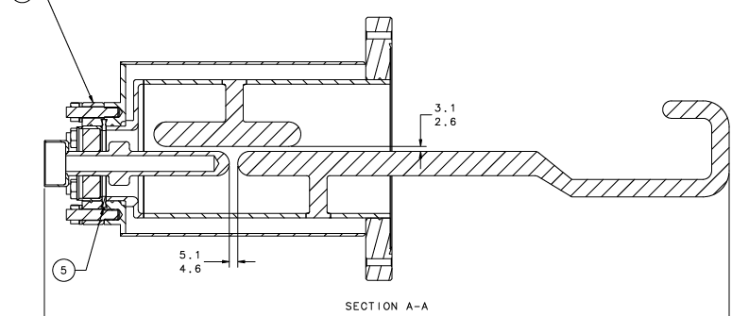 | [[Assy1Tech]] <<SRF>>  [[Assy1Time]] <<TIMESTAMP>>  [[Assy1Comm]] <<COMMENT>>  [[Assy1File]] <<FILEUPLOAD>>
16b | Install the assembly on the RF Test Box and measure the notch as per JL0059276-RF. Upload the test file.  Are the results acceptable? | [[RFTech]] <<SRF>>  [[RFTime]] <<TIMESTAMP>>  [[RFComm1]] <<COMMENT>>  [[RFTest]] <<FILEUPLOAD>>  [[RFOk]] <<YESNO>>
16c | Send the test results to CERN and AUP for concurrence that the assembly has met RF requirements | [[RFHold]] {{huque}} <<HOLDPOINT>>
16d | Disassemble JL0093253 | [[Assy2Tech]] <<SRF>>  [[Assy2Time]] <<TIMESTAMP>>  [[Assy2Comm]] <<COMMENT>>  [[Assy2File]] <<FILEUPLOAD>>

 | Inform SRF Inventory that the assembly location is Chemistry
16e | Degrease and Chemical Polish the Niobium Space of JL0086007 to a depth of 30µm as per CP-AUP-CAV-CHEM-ACID. Degrease the Stainless Steel Space as per CP-AUP-CAV-CHEM-DEGR  Upload any relevant photos and/or comments | [[BCP5Tech]] <<SRF>>  [[BCP5Time]] <<TIMESTAMP>>  [[BCP5Comm]] <<COMMENT>>  [[BCP5File]] <<FILEUPLOAD>>
16f | Degrease the HHOM Feedthrough (JL0124776) as per CP-STP-CAV-CHEM-DEGR | [[Chem7Tech]] <<SRF>>  [[Chem7Time]] <<TIMESTAMP>>  [[Chem7Comm]] <<COMMENT>>  [[Chem7File]] <<FILEUPLOAD>>
16g | Degrease JL0115808, JL0114065 and the hardware shown in JL0115790 as per CP-STP-CAV-CHEM-DEGR | [[Chem8Tech]] <<SRF>>  [[Chem8Time]] <<TIMESTAMP>>  [[Chem8Comm]] <<COMMENT>>  [[Chem8File]] <<FILEUPLOAD>>
16h | Assemble the following parts in the cleanroom as per JL0093253 and JL0115790:  JL0086007  JL0093243  JL0115808  JL0114065  MDC-110025 (6" CF Blank Flange)  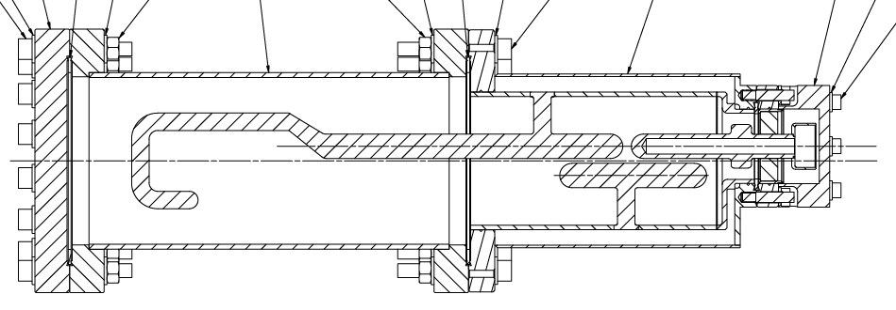 | [[Assy3Tech]] <<SRF>>  [[Assy3Time]] <<TIMESTAMP>>  [[Assy3Comm]] <<COMMENT>>  [[Assy3File]] <<FILEUPLOAD>>
16i | Leak Test the Niobium space as per 11141S0029. Upload leak test report (PS-7 form) | [[Leak7Tech]] <<SRF>>  [[Leak7Time]] <<TIMESTAMP>>  [[Leak7Comm]] <<COMMENT>>  [[Leak7File]] <<FILEUPLOAD>>
16j | Inform FNAL and CERN that the leak check has been completed | [[LCHold]] {{huque}} <<HOLDPOINT>>
16k | Install the assembly into the shipping crate and return to inventory | [[ShipTech]] <<SRF>>  [[ShipTime]] <<TIMESTAMP>>  [[ShipComm]] <<COMMENT>>  [[ShipFile]] <<FILEUPLOAD>>

