|  |  |  |  |
| --- | --- | --- | --- |
| **Downstream Gate Valve / BPM Sub-Assembly**  **and Installation** | | | |
| **Document Number:** | L2HE-PR-CLNRM-GV2SA-ASSY | **Effective Date:** | 09 Nov 2023 |
| **Revision Number:** | 3 | **Periodic Review Date:** | 09 Nov 2026 |
| **Document Owner:** | T. Ganey | **Department Owner:** | SRF Operations |

# Purpose

The purpose of this document is to provide instructions for cleaning and assembling the downstream gate valve sub-assembly (GV2SA), including the BPM and NEG pump assemblies, onto the L2HE mini-rail.

# Scope

Prior to starting this procedure, the NEG Pump should have been assembled and activated in accordance with the L2HE-PR-CLNRM-NEG-PREP.

This procedure assembles the downstream (short) bellows, BPM assembly, spool piece, gate valve, and NEG pump assembly as shown in the L2HE Cavity String Assembly drawing (F10127865). The BPM assembly and spool piece are pre-assembled in the vertical position. The BPM and spool are then installed on the rails and the downstream sub-assembly is completed.

At the end of this procedure, the downstream gate valve sub-assembly (GV2SA) should be fully assembled on the rails and leak checked. GV2SA will be installed on the L2HE cavity string in the L2HE-CLNRM-CST-ASSY.

# Terms and Definitions

The following terms have specific meanings within this procedure.

|  |  |
| --- | --- |
| **Term** | **Definition** |
| BPM | Beam Position Monitor |
| GV2SA | Gate Valve 2 (Downstream) Sub Assembly |
| NEG | Non Evaporable Getter |
| NEG Pump Assembly | The sub-assembly consisting of the NEG pump, nipple, tee, and right angle valve as shown in F10143121. It is installed on the downstream side of the cavity string. Also referred to as the Downstream (Gate Valve) Pump Assembly. |
| Spec 1 | Particle counts are to be zero on all scales except 0.3 µm, which can be zero or 1 in ten seconds. |
| Spec 2 | Particle counts are to be one count per second or less on the 1 µm scale. |

# Roles and Responsibilities

The following roles have responsibilities described in this document.

|  |  |
| --- | --- |
| **Role** | **Responsibility** |
| <Job Title> | <Very short summary of activities this job title performs in this procedure.> |
|  |  |
|  |  |
|  |  |

# Required Equipment and Materials

|  |  |  |
| --- | --- | --- |
| **Description** | **Part Number** | **Quantity** |
| Particle Counter | N/A | As needed |
| Cleanroom (High Purity) Isopropyl Alcohol | N/A | As needed |
| Small Cleanroom Swabs | TX754B | As needed |
| Medium Cleanroom Swab | TX710A | As needed |
| Disposable lint-free Texwipe | TX1008 | As needed |
| Prewet Texwipe (ISO 4 cleanroom) | TX8410 | As needed |
| Beamline HDPF flange cover with SST backing plate | N/A | As needed |
| 2-3/4 HDPF flange cover with SST backing plate | N/A | As needed |
| Alignment blank with short pins | TBD | 1 |
| Gloved Clamps for Beamline flange | N/A | As needed |
| Female Beamline Blank, for bellows to allow for pump down | N/A | 1 |
| Bellows Restraints | TBD | 3 |
| M8 x 1.25" Screws for bellows restraints | TBD | 6 |
| M8 Washers for bellows restraints | TBD | 6 |
| DS Gate Valve Pump Assembly Flange End Adaptor | F10143121, part #1 | 1 |
| M6, 316L SS, EP Washer | F10143121, part #2 | 6 |
| CF Seal, 2.75 CF Flange, Cu | F10143121, part #3 | 1 |
| M6x1x20LGxFT, Si Brz HHCS (hex head cap screw) | F10143121, part #8 | 6 |
| Weldment Extension Downstream (Spool) | F10127865, part #3 | 1 |
| Weldment Bellows Short | F10127865, part # 6 | 1 |
| Seal End Flange (NW78 gasket) | F10127865, part #8 | 5 |
| M8x16x1.4, 316L, EP Washer | F10127865, part #9 | 84 \* |
| M8x1.25x6.5, SiBr Hex Nut | F10127865, part # 10 | 48 \* |
| RF All Metal Gate Valve | F10127865, part # 11 | 1 |
| M8x50 LG RT, 316L, EP Threaded Stud | F10127865, part #12 | 24 \* |
| M8x1.25x40, 316L, EP Set Screw | F10127865, part #13 | 24 |
| DS Gate Valve Pump Assembly (NEG manifold), assembled and activated in accordance with L2HE-PR-CLNRM-NEG-PREP | F10127865, part #37 | 1 |
| Seal for NW40 Flange | F10023160, part #1 | 4 |
| BPM Housing w/ Copper Plating | F10023160, part #2 | 1 |
| Nut Hex, M6x1x5 SS315L | F10023160, part #3 | 32 |
| Washer, M6 | F10023160, part #4 | 32 |
| Beam Position Monitor, Feed Thru ASM | F10023160, part #5 | 4 |
| Stud M6, Ti-GR5 | F10023160, part #6 | 32 |

#### \* Note: these quantities include additional parts to be used for installing the beamline blank to the bellows.

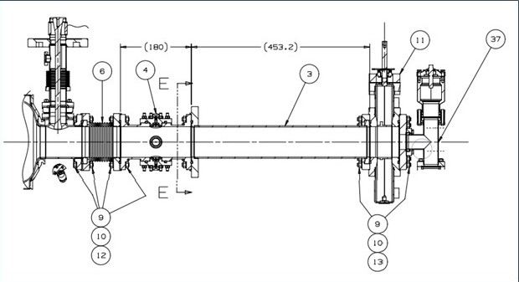

F10127865, Rev. B, Detail D (bottom view)

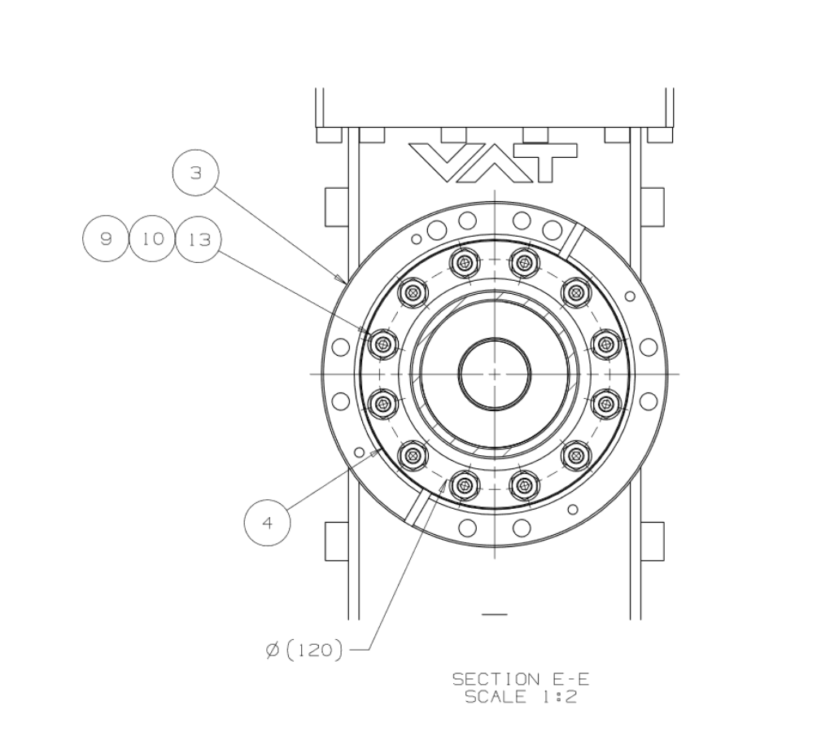

F10127865, Rev. B, Section E-E

# Procedure

## Prepare Hardware

### As per the F10127865, have all the required parts for this procedure cleaned and moved inside the clean room ready for assembly.

### Prepare the gloved clamps in accordance with SRF-MSPR-CLNRM-TOOL-SPCLMP.

#### Verify that the BPM feedthroughs are paired in the BPM Feedthrough Pairing Spreadsheet.

## BPM Housing Assembly Prep

### Spray 32 polished Grade 5 Ti M6 studs (F10023160 #6) with ionized N2 to Spec 2.

### Spray 32 M6 washers (F10023160 #4) and 32 M6 nuts (F10023160 #3) with ionized N2 to Spec 2.

### Gently place studs into the blind threaded holes on all four feed-through flanges (F10023160 #5) until the shoulder stops against the face of the flange.

### Spray the BPM housing (F10023160 #2) to Spec 1.

### Spray four Al NW40 gaskets (F10023160 #1) to Spec 1.

### Place one Al NW40 gasket and feed-through onto housing.

### Place four washers and nuts. Snug with a 10 mm wrench.

### Spray assembly again with ionized N2 until counts are down to Spec 1.

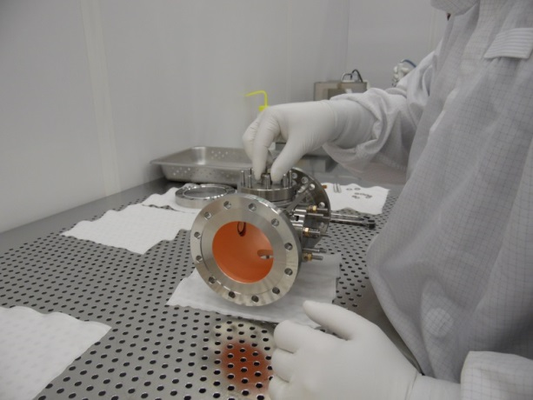

### Repeat this for the remaining three feed-throughs. Assemble the feedthroughs as opposing pairs, in accordance with the BPM Feedthrough Pairing Spreadsheet, onto the BPM housing.

### Place all the remaining nuts and washers on the studs for all flanges. Snug all fasteners with a wrench, using a standard torque pattern as described in Section 6 "BPM Housing Torque Sequence" of this procedure.

### Spray assembly again with ionized N2 until counts are down to Spec 1.

* BPM housing is now ready for installation onto beam tube.

## Beamtube Prep

### Spray the open beam tube (spool piece, F10127865 part #3) in accordance with the Ionized N2 Cleaning Procedure until counts reach Spec 1.

### Spray 12 electro-polished SS M8 set screws (F10127865, part #13) to Spec 1 in accordance with the Ionized N2 Cleaning Procedure. Place on a clean room wipe on work cart.

### Spray one dust cover and head of two clamps to Spec 1 in accordance with the Ionized N2 Cleaning Procedure. Carefully clamp the alignment dust cover on the smaller top flange of the beam-tube and attach the beam tube to the cavity cage with the large flange facing down as shown below.

### Raise the cage with the back-tech to a good working height.

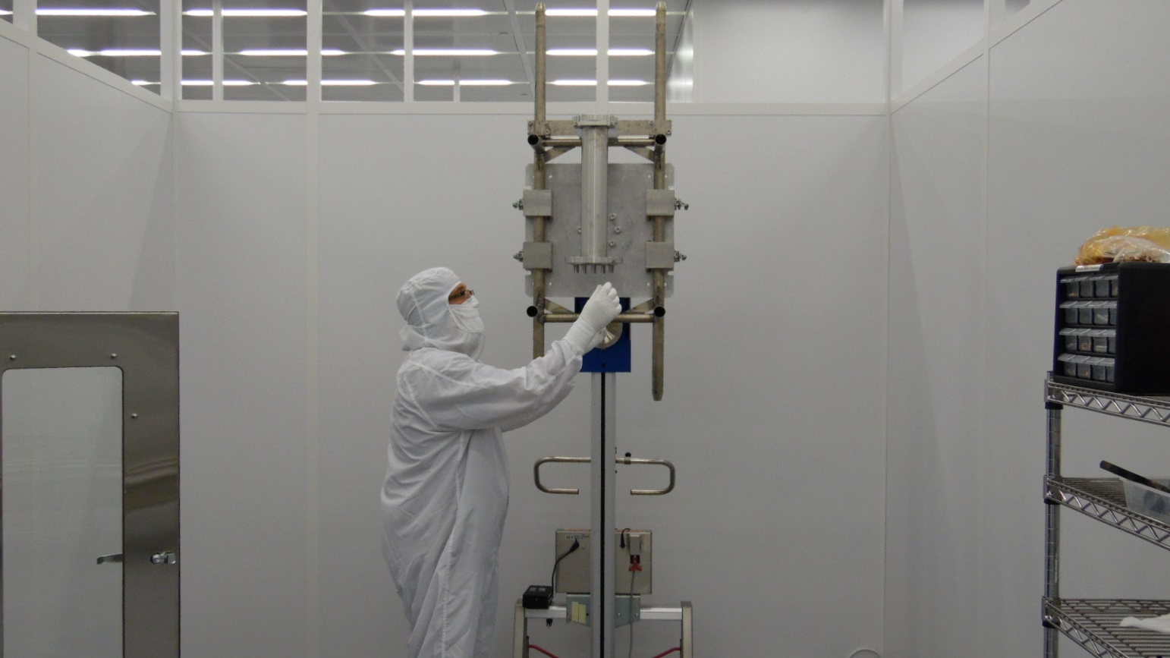

### Carefully thread the set screws with the wrench side accessible into the appropriate threaded holes for attaching the BPM housing.

### Spray ionized N2 across the studs in accordance with the Ionized N2 Cleaning Procedure to Spec 1.

### Spray ionized N2 inside the spool in accordance with the Ionized N2 Cleaning Procedure until Spec 1 is reached.

* Beamtube is now ready for assembly to the BPM.

## BPM Housing to Beamtube Assembly

### Spray two SS M8 washers (F10127865 #9), two M8 SiBr nuts (F10127865 #10), and one Al beamline gasket (F10127865 #8) in accordance with the Ionized N2 Cleaning Procedure until counts reach Spec 1.

### Place gasket into groove on BPM housing flange and slowly approach the beamtube flange.

### Ensure the proper rotation of the BPM body against the magnet.

* For 3 sides, the center pin of the BPM feed-through shall align between the large bolt holes on the spool piece large flange.
* For the side that will be aligned to the gate valve handle, the center pin of the BPM feed-through shall align in the middle of the four large bolt holes.

#### M:\LCLS2-HE\Cavities\string assembly\BPM Alignment\pic5.jpgInkedpic7_LI

### Slowly raise the BPM housing onto the set screws until the flange and gasket make contact as shown below.

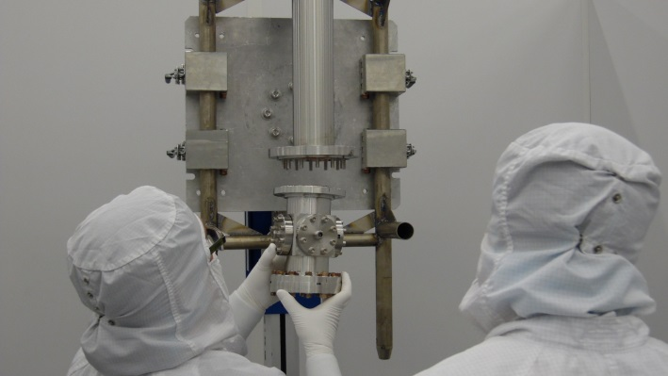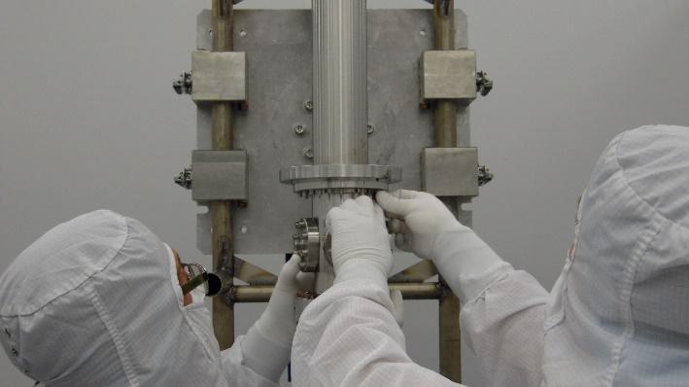

### After full contact is made, a second technician can approach and place the washers and nuts on 2 set screws on opposite sides of the flange. Snug the nuts with a wrench. Do not torque fasteners yet.

## Prepare Bellows

### Spray three bellows restraints, 6 M8 1.25" screws, and 6 M8 washers in accordance with the Ionized N2 Cleaning Procedure until counts reach Spec 1.

### Compress the bellows and install the bellows restraint blocks onto the bellows using 2 bolts per restraint. Spray the bellows in accordance with the Ionized N2 Cleaning Procedure until counts reach Spec 1.

### Spray four SS M8 washers (F10127865 #9), four M8 SiBr nuts (F10127865 #10), two studs (F10127865, #12), and one Al beamline gasket (F10127865 #8) in accordance with the Ionized N2 Cleaning Procedure until counts reach Spec 1.

### Place gasket into groove on rotatable bellows flange. Spray the bellows in accordance with the Ionized N2 Cleaning Procedure until counts reach Spec 1.

### Install a blank on the bellows open (rotatable) bellows flange with 2 clean studs. Spray the bellows in accordance with the Ionized N2 Cleaning Procedure until counts reach Spec 1.

### Spray remaining washers, nuts, and studs for installing the blank to Spec 2.

### Place the remaining nuts and washers on the bellows to beamline blank flange. Snug all the nuts with 13mm wrench.

### Torque the fasteners using the standard star pattern to 15 ft/lbs.

### Set the wrench to 31 ft/lbs and repeat the standard star pattern twice.

### Tighten all nuts in a clockwise rotation a minimum of two times or until there is no movement of any nut.

## Downstream Bellows to BPM Housing

### If needed, raise the cage with the back-tech to a good working height.

### Spray four SS M8 washers, four M8 SiBr nuts two studs (F10127865, #12), and one Al NW78 gasket in accordance with the Ionized N2 Cleaning Procedure until counts reach Spec 1.

### Place gasket into groove on non-rotatable bellows flange. Spray the bellows in accordance with the Ionized N2 Cleaning Procedure until counts reach Spec 1. Take particle counts to verify the bellows is clean.

### Attach the bellow's fixed flange to the BPM using the two sets of cleaned fasteners. Ensure proper rotation of the bellows before installing. One of the stiffeners needs to line up between the two large holes that are 90 degrees from the set of four large holes, in a clockwise rotation. This will place that stiffener at the bottom of the bellows when installed in the string. Snug with a wrench. Spray the flange until counts reach Spec 1.

## Torque Sub-Assembly - Bellows, BPM and Beamtube

### Clean the remaining fasteners for the beamtube, BPM housing, and bellows to Spec 2 in accordance with the Ionized N2 Cleaning Procedure.

### BPM Housing to Bellows

#### Place the remaining nuts and washers on the BPM housing to bellows flange. Snug all the nuts with 13mm wrench.

#### Torque the fasteners using the standard star pattern to 15 ft/lbs.

#### Set the wrench to 31 ft/lbs and repeat the standard star pattern twice.

#### Tighten all nuts in a clockwise rotation a minimum of two times or until there is no movement of any nut.

### Beamtube to BPM Housing

#### Place the remaining nuts and washers on the beamtube to BPM housing flange. Hold the set screws in place with a 6mm Allen wrench. This will prevent them from galling while tightening the nuts. Snug all the nuts with 13mm wrench.

#### Torque the fasteners using the standard star pattern to 15 ft/lbs.

#### Set the wrench to 31 ft/lbs and repeat the standard star pattern twice.

#### Tighten all nuts in a clockwise rotation a minimum of two times or until there is no movement of any nut.

## Gate Valve Prep. (Blow down the gate valve)

### Spray 24 electro-polished M8 SS set screws with ionized N2 until the particle counts reach Spec 1.

### Remove the dust covers from both sides of the valve.

### Spray the bolt holes with the valve in the closed position.

### Place 12 set screws into the gate valve's upstream flange and spray with ionized N2 to Spec 1.

### Place 12 set screws into the gate valve's downstream flange and spray with ionized N2 to Spec 1.

### Spray the valve with ionized N2, with the gate still in the closed position, paying particular attention to the area around the studs. The counts will reach zero without movement, but there will always be some minimal count if the gate is moving.

#### Open the valve halfway and spray the valve with ionized N2 until counts reach Spec 1.

#### Open the valve fully and spray the valve with ionized N2 until count reach Spec 1.

#### Close the valve and spray the valve with ionized N2 until the counts reach Spec 1.

#### Open the valve and spray the valve with ionized N2 until the counts reach Spec 1. Do not continue to cycle the valve. Finish with the gate in the open position.

### Spray the zero-length reducer with ionized N2 until counts reach Spec 1. Spray four sets of M8 SiBr nuts and SS washers with ionized N2. Spray one gasket for the downstream side of the gate valve. Place the NW78 aluminum gasket on the valve and slide the blank on the studs. Install 4 nuts and washers and snug with a 13 mm wrench. Install the remaining nuts and washers and snug all of them in a star pattern. Spray with ionized N2 until the valve reaches Spec 1.

### The valve is now ready to be moved to the valve cradle on the lollipop system.

#### Place the valve in the cradle and level the valve in both directions with the flanges located close to the center of the rail system (the valve stem shall be located on the same side of the string as the cavity FPC). This will allow the connection to the BPM sub-assembly possible without moving the valve.

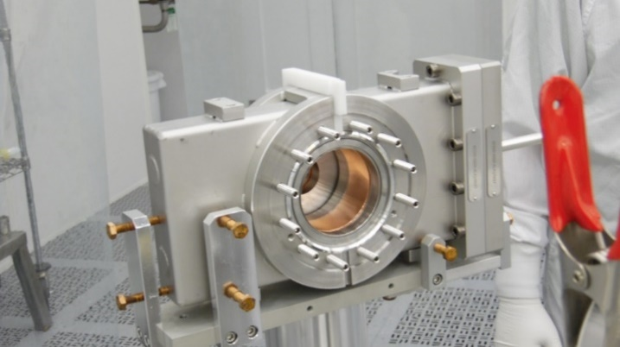

Gate Valve in holding fixture. NEG pump assembly not shown.

#### Prepare a 2 3/4” tee, blank and right angle valve for clean assembly (including fasteners and gaskets) using ionized N2. Place the blank on one end of the tee and blow out again with ionized N2. Place a copper gasket and the tee on the zero-length reducer located on the downstream side of the valve, with the blank facing the bottom of the valve. Spray through the tee and gate valve in both direction with ionized N2 until Spec 1 is achieved.

#### The right angle valve can now be attached to the open end of the tee with the open port on the valve facing straight down. The valve shall remain in the open position to allow spraying of ionized N2 in both directions through the gate valve and right angle valve until Spec 1 is reached. After reaching Spec 1, continue spraying through the gate valve while closing the right angle valve. The open flange on the right angle valve can be covered with a gasketed SS cover and spring clamps.

#### 

#### 

isometric view of downstream gate valve with NEG Pump Manifold

## BPM to Gate Valve Assembly

### Place the BPM housing assembly on the lollipop system.

#### C:\Users\ganey\AppData\Local\Microsoft\Windows\INetCache\Content.Word\InkedSAM_8556_LI.jpgThe large magnet flange has a set of four large holes at one location on the flange. These holes shall be lined up with the gate valve stem.

### Set the roll of the BPM housing assembly with the levelling tool that attaches to the large magnet flange (not pictured).

### Use bridging tool and precision liquid level to set the BPM housing level. Lock assembly to tooling with the V-block.

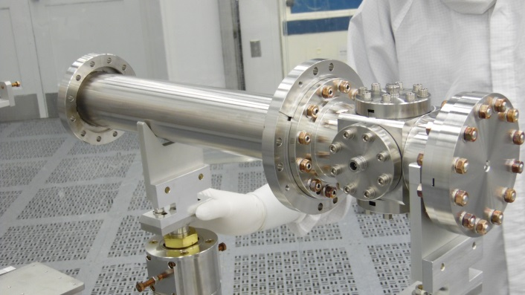 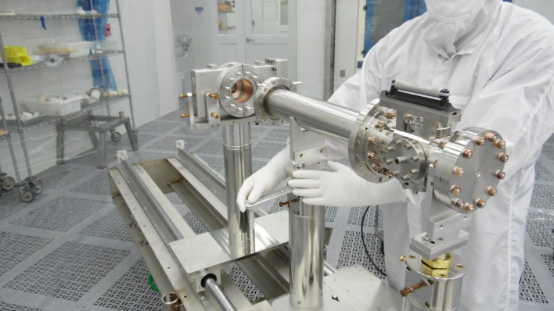

### Spray one NW78 Al gasket, two SS washers and two SiBr nuts with ionized N2 until the particle counts reach Spec 1.

### Place the gasket on the gate valve using the gasket holder.

### The magnet tube on the BPM assembly can be adjusted to the correct height and perpendicularity with the gate valve using the lollipop system.

### Remove the clamped alignment cover and perform the final adjustment. The flange on the tube can be moved out of the way to accommodate alignment process.

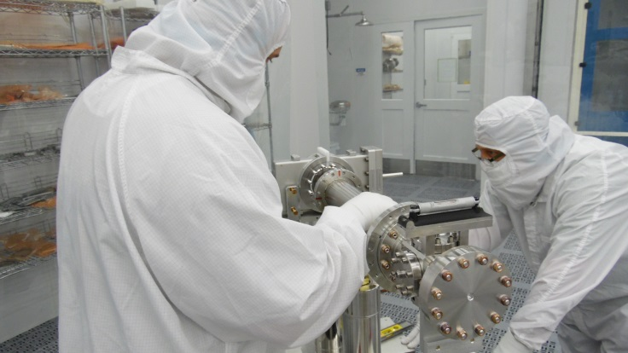

### While holding the magnet tube in place, slide rotatable flange over studs and install two sets of washers and nuts. Snug fasteners with a 13 mm wrench.

## Torque Sub-Assembly - Gate Valve and NEG Pump Assembly

### Spray remaining washers and nuts with ionized N2 until the particle counts reach Spec 2.

### Install remaining fasteners in all locations of the BPM Gate Valve Sub-Assembly

#### Torque all fasteners on beamline flanges to 15 ft/lbs using the standard star pattern.

#### Torque these fasteners to 31 ft/lbs using the standard star pattern twice and the clockwise rotation until there is no movement of any nuts.

#### BPM feed-through fasteners were previously torqued

5.10.2.4 Tighten all conflat fasteners to ensure good seals at these locations

## Leak check the entire downstream gate valve sub-assembly (GV2SA) in accordance with L2HE-PR-CLNRM-AMGV-LEAK.

# BPM Housing Torque Sequence

## Refer to the BPM assembly traveler for additional information and data recording for the BPM housing torque sequence.

## Torque all the fasteners on the four BPM feed-through flanges using the torque pattern pictured below. There shall be three different steps for torquing.

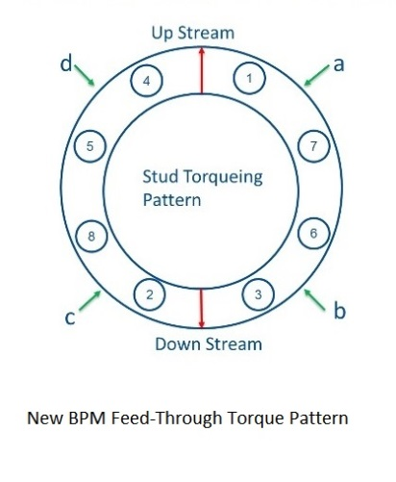

## Measure and record the gap between the face of the BPM housing and the lip of the flange at the four locations a,b,c,d. Torque to 35 inch/lbs using the new star pattern. Repeat star pattern then go around clockwise until no movement is detected for any nut.

## Torque to 71 inch/lbs using the new star pattern. Repeat star pattern then go around clockwise until no movement is detected for any nut.

## Torque to 106 inch/lbs using the new star pattern. Repeat star pattern then go around clockwise until no movement is detected for any nut.

## Re-measure and record the gap between the face of the BPM housing and the lip of the flange at the four locations a,b,c,d.

## Traveler will let you know if the gap is okay. Follow instructions on the traveler based on the gap measurements before and after torquing.

# References

|  |  |
| --- | --- |
| **Document No.** | **Title** |
| [BPM Feedthrough Pairing Spreadsheet](file:///C:\Users\samuels\AppData\Local\Temp\BPM%20Feedthrough%20Pairing%20Spreadsheet) | BPM Feedthrough Pairing Spreadsheet |
| F10023160, Rev. D | Assembly, LCLS-II Cold BPM |
| [F10127865](https://jlabdoc.jlab.org/docushare/dsweb/Get/Document-252521/F10127865_D_DWG1.pdf) | Assembly, Cavity String, 1.3GHz HE CM |
| [F10143121](https://jlabdoc.jlab.org/docushare/dsweb/Get/Document-249262/F10143121-A%20DS%20Gate%20Valve%20Pump%20Assembly.pdf) | DS Gate Valve Pump Assembly |
| [F10170258, Rev -](https://jlabdoc.jlab.org/docushare/dsweb/Get/Document-251075/F10170258___NegManifoldSupportAssembly.pdf) | Assembly, NEG Manifold Support |
| [VAT Drawing 1037707](https://jlabdoc.jlab.org/docushare/dsweb/Get/Document-248682/VAT_1037707_GateValveDrawing.pdf) | RF all-metal gate valve, Series 472 |
| JL00199999 | LCLS-II Clean room assembly tooling |
| [SRF-MSPR-CLNRM-CST-ION](https://jlabdoc.jlab.org/docushare/dsweb/Get/Document-270677/SRF-MSPR-CLNRM-CST-ION-R3.pdf) | Ionized Nitrogen Cleaning Procedure |
| [SRF-MSPR-CLNRM-LEAK](https://jlabdoc.jlab.org/docushare/dsweb/Get/Document-250698/SRF-MSPR-CLNRM-LEAK-R1.pdf) | Leak Testing with a RGA |
| [SRF-MSPR-CLNRM-TOOL-SPCLMP](https://jlabdoc.jlab.org/docushare/dsweb/Get/Document-250845/SRF-MSPR-CLNRM-TOOL-SPCLMP-R1.pdf) | Nitrile Glove Covering of Spring Clamp |
| L2HE-PR-CLNRM-AMGV-LEAK | All-Metal Gate Valve Leak Check Procedure |
| L2HE-PR-CLNRM-NEG-PREP | Downstream Pump Assembly and NEG Pump Initial Activation |

# Release and Revision History

|  |  |  |
| --- | --- | --- |
| **Rev #** | **Major Changes** | **Effective Date:** |
| 1 | Initial version, based on L2PRD BPM Sub Assembly Procedure (CP-L2PRD-ASSY-BPM-SUB-R2) | 09 Dec 2021 |
| 2 | Updated throughout to incorporate lessons learned and process improvements after the first string assembly. | 08 June 2022 |
| 3 | Updated throughout to incorporate lessons learned and process improvements after the several string assemblies. | 11 Nov 2023 |
|  |  |  |

# Approvals

|  |  |  |  |
| --- | --- | --- | --- |
| **Approved by:** | **Name:** | **Signature:** | **Date:** |
| Document Owner | T. Ganey | In DocuShare | |
| Reviewer | C. Dreyfuss | In DocuShare | |
| Cleanroom Lead | D. Forehand | In DocuShare | |
| Project Manager | M. Bevins | In DocuShare | |