

Traveler Related

Common Procedures

|  |  |  |  |
| --- | --- | --- | --- |
| Procedure Title | LCLSII procedure for cold FPC incoming inspection and preparation for assembly onto cavity | | |
| Procedure ID | **CP**-L2PRD-BLA-assy | | |
| Procedure Description | This procedure describes LCLSII BLA clean room assembly, vacuum leak check, controlled bleed up and preparation for shipment. | | |
| Revision | R1 | | |
| Author | **Sign**: | | **Date**: |
| **Name:** Mircea Stirbet | |
| Author | **Sign**: | | **Date**: |
| **Name**: Alex Wildeson | |
| Reviewer | **Sign**: | | **Date**: |
| **Name**: Kirk Davis | |
| Reviewer | **Sign**: | | **Date:** |
| **Name**: Edward Daly | |
| Reviewer | **Sign**: | | **Date:** |
| **Name**: Danny Gabriel Forehand | |
| Revision Notes | *Describe any changes between revisions here.* | | |
| R1: Initial Release | | |
|  | | |
|  | | |
|  | | |
| **References** | *List and Hyperlink all documents related to this procedure.* | | |
| Ionized Nitrogen Parts cleaningCP-L2Q0-IONN2-CLN | **CP-L2BPM-procedure** | Leak testing with an RGA CPL2PRO-CST-LKTS-R1 | |
| Solair 3100 Gen E manual – particulate counter | Vacuum_005_DESY_UHV_guidelines | [L2PRO-CST-SLBUP](https://jlabdoc.jlab.org/docushare/dsweb/Get/Document-104022/Slow%20bleed-up%20procedure.docx) | |
|  |  |  | |

## LCLSII procedure for Beam Line Absorber (BLA) clean room assemble and vacuum leak check

1. Beam Line Absorber (BLA) short description
2. Part preparation for clean room BLA assembly
   * 1. Beam line blanks
     2. Beam line hardware
     3. AlMg diamond gaskets
     4. OFE gaskets
     5. Wrenches
3. Tools and hardware for BLA assembly
   1. Clean room lifting device
   2. BLA beam line supports
   3. BLA absorber clean room support
   4. Torque wrenches
   5. Particulate counter
   6. Stand with vacuum leak check and controlled Nitrogen bleed up system
4. BLA assemble steps
   1. BLA attachment to the clean room lifting device
   2. Attach the first beam line blank
   3. Turn BLA with 180 degree in lifting device
   4. Attach the second beam line blank
   5. Remove BLA from lifting device and position it on two beam line supports
   6. Insert BLA absorber
   7. Attach Al restrains
   8. Secure large bellows with G10 restrains
   9. Assemble VAT valve
   10. Torque beam line blank
5. BLA vacuum leak check and RGA mass spectra
   1. Attach BLA to the pumping system
   2. Place BLA in clean room plastic bag and perform vacuum leak check
   3. Collect RGA mass spectra data
6. BLA slow blead up and once at normal pressure protect VAT port with a blank
7. Insert BLA in double plastic bags
8. **Beam Line Absorber (BLA) short description**

The LCLSII BLA is critical ultra-high vacuum component used to interconnect the beam lines of two cryomodules. Two main components can be identified in BLA:

1. BLA body – stainless steel structure (comer plated inside), with two bellows, one with small diameter on the beam pipe, the other one, larger in diameter over the housing for the absorber. Two UHV and cryo-genic flanges electron beam welded on each side of the BLA.
2. BLA absorber – cylindrical ceramic with controlled RF absorption properties, brazed on a copper bar attached to a CF80 conflat flange.

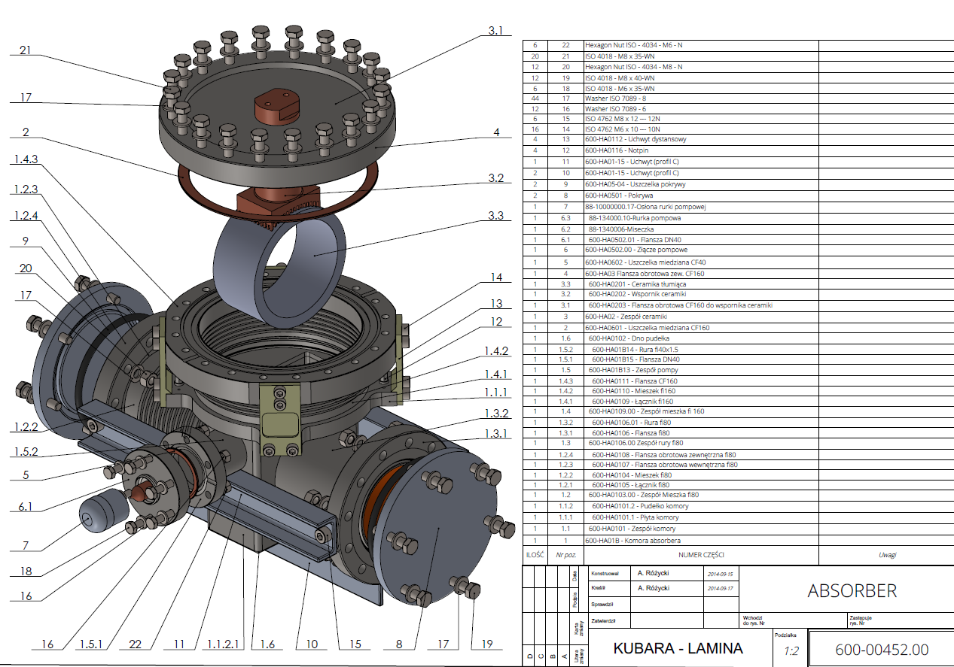

The BLA being used to interconnect two cryo-modules, special requirements related with molecular or particulate contaminates have to be fulfilled. Work is supposed to be done in clean room Class 10 or better by technicians with confirmed skills delivering systems conform to SRF requirements.

Before clean rooms assemble, each Beam Line Absorber is submitted to incoming visual inspection, UHV cleaning, and specific heat treatments (absorber 6 hours at 300 C, BLA body and SS flanges 6 hours at 600C, clean room admission, visual inspection and particulate counts post heat treatment. All hardware needed for BLA assemble is UHV cleaned and transferred in the clean room in plastic bags backfilled with filtered, dry, particulate free Nitrogen.

As a general remark, the BLA is quite fragile and special attention should be done to avoid any dents in bellows, beam line part, scratches of the internal copper plated or of the UHV sealing surfaces.

During clean room assemble, the following parts:

1. Part 8 – beam line transport blanks, VITON gasket and M8 SiBr bolts will be replaced with SS 304 beam line blanks, M8 SS 304 hardware (studs and washers) SiBr nuts and AlMg diamond gaskets.
2. Part 7 – transport protection, VITON gasket and bolts (assembled on pumping port) will be replaced with VAT valve type 34032-GE02-AAN1/0118, CF40 OFE copper gasket and M6 SS304 hardware with SiBr nuts.
3. Part 11 – BLA restrain (3 Al profile) and part 12 (4 G10 fiber glass restrains).
4. See list with hardware for BLA clean room assemble in Annex, item (D).

Remark: for the first two test BLAs, CF40 VAT right angle valve VAT 42132 have been used.

2. **Part preparation for clean room BLA assembly**

After heat treatments, BLA parts are transferred in the clean room and submitted to visual inspection and particulate count checks. Before staring BLA assembly, several steps have to be taken care off:

* 1. Cleaning working area
  2. Install two Al restraints as shown in the photos bellow:

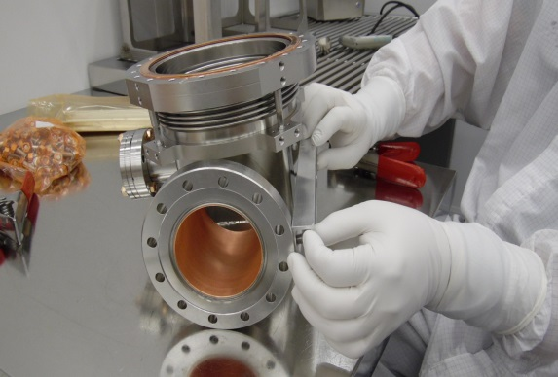 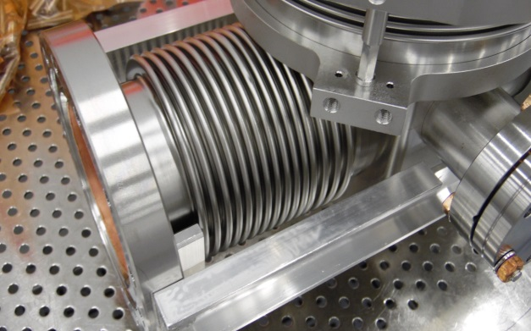

* 1. Position the BLA on two Aluminum supports placed near to the beam line flanges. Pay attention not to generate any dents on bellows or on the beam pipe. See phot bellow:

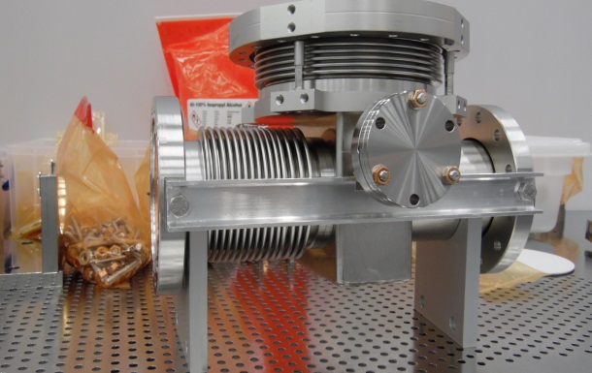 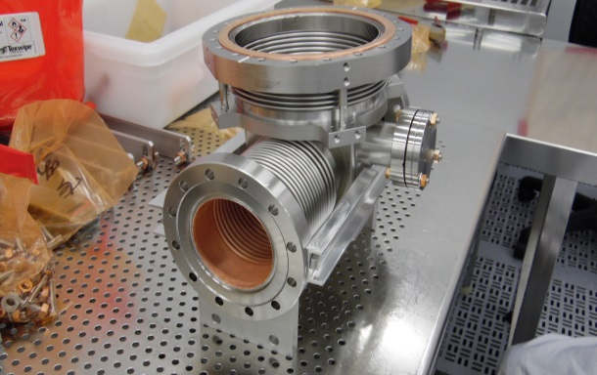

* 1. With the BLA body on supports, check particulate counts inside BLA body. Check particulate counts on BLA absorber placed on a clean room stand. See photos bellow:

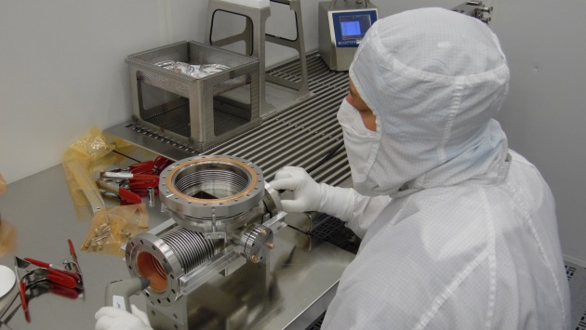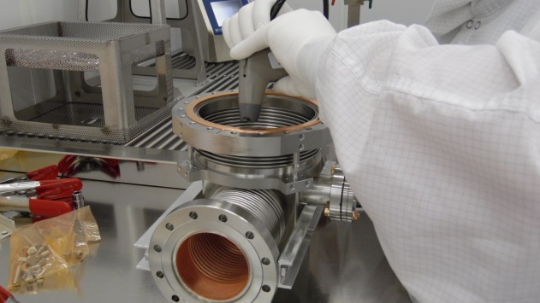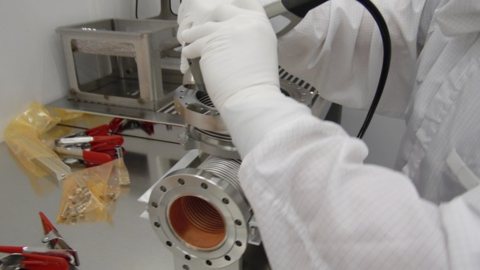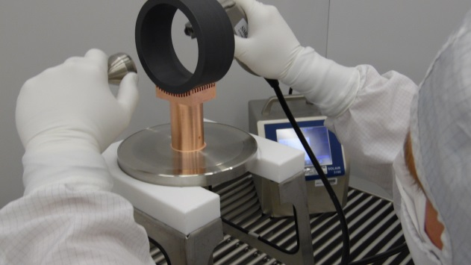

* 1. Prepare (check particulate counts) hardware, blanks and gaskets. See photos bellow:

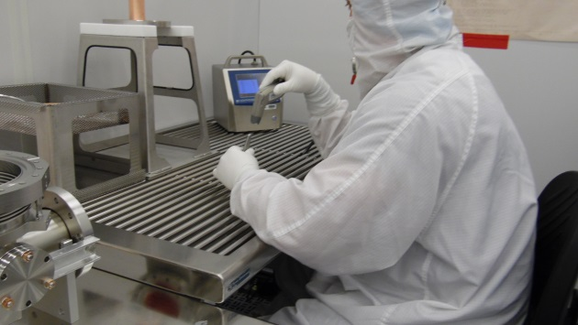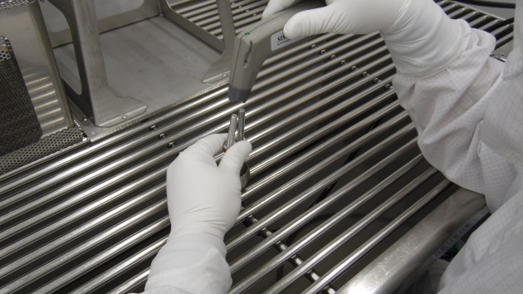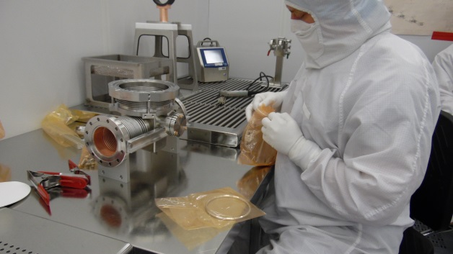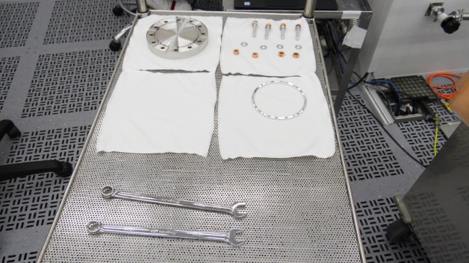

4. **BLA assemble steps**

* 1. BLA attachment to the clean room lifting device

Once the BLA parts and hardware are checked, bring in the assemble area the clean room lifting device with BPM attachment (aluminum plates with cuts and collar to fit the beam line diameter). Attach the BLA on the flange having the beam line pipe without bellows, then secure it with a bride and two bolts (two person task: one technician is supporting the BLA body, the other one is tightening the two bolts, paying attention to have the BLA sitting on the upper beam line flange):

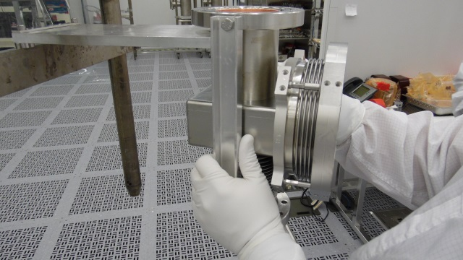 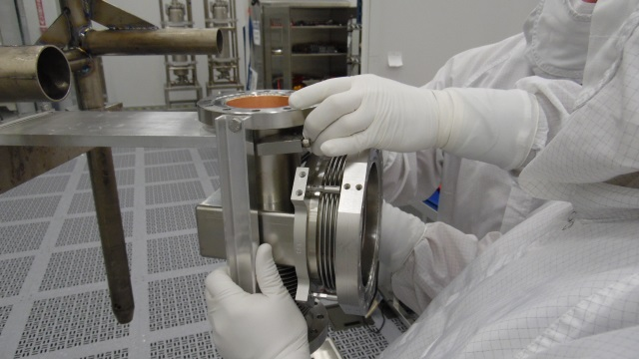

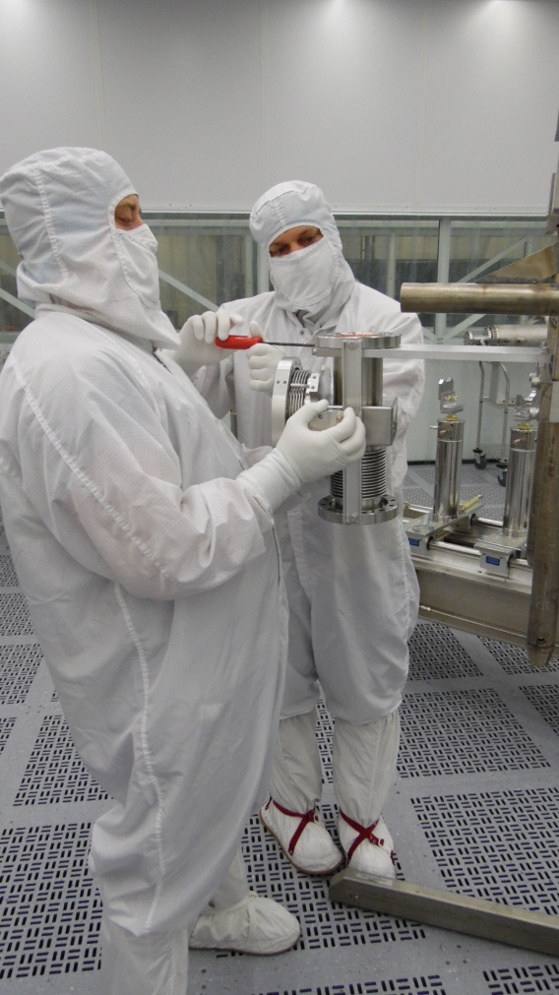 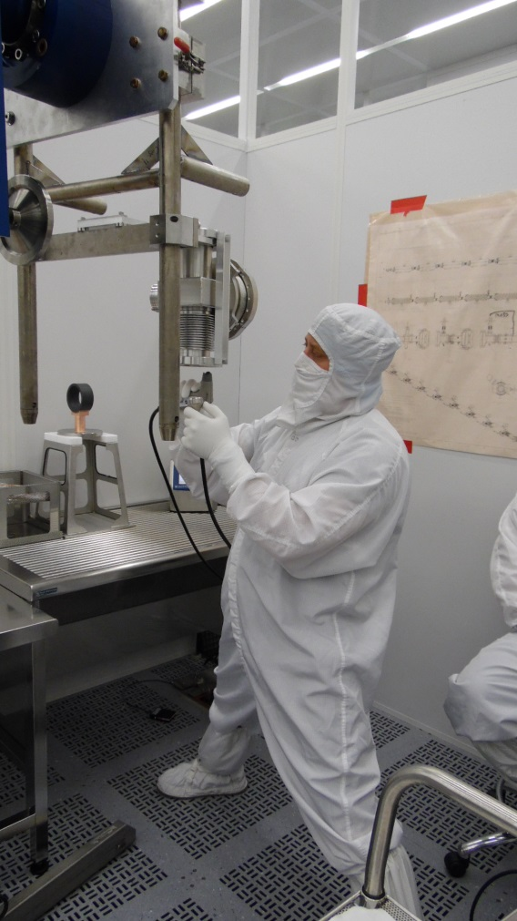

* 1. Attach the first BLA blank conform procedure used for LCLSII BPM:
     1. Change gloves and check if the new gloves are particulate free, eventually blow then with de-ionized nitrogen until the particulate counter records 0 particulate (0.3 um) three time during 10 seconds.

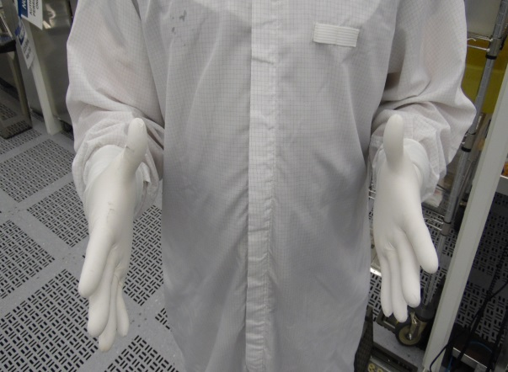

* + 1. Lift the BLA to about 5 ft from the floor and check the BLA flange is parallel with clean room floor.
    2. Using a particulate counter and de-ionized nitrogen gun, check to have particulate counts 0 (0.3um particulate size).
    3. Place the AlMg gasket in the blank groove, two previously clean studs in two holes and slowly bring the blank and gasket to match BLA flange, taking care to minimize the contact/friction between studs and holes on the flanges.

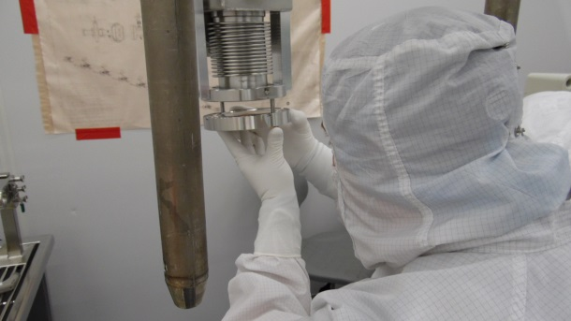 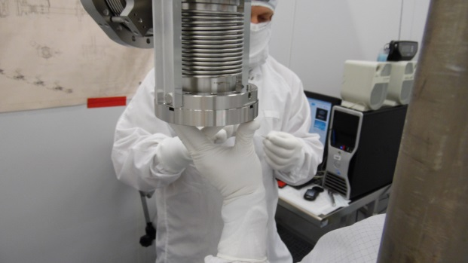

* + 1. Secure the two studs with flat washers and SiBr nuts.
    2. Insert the other 14 studs and snug all SiBr nuts.

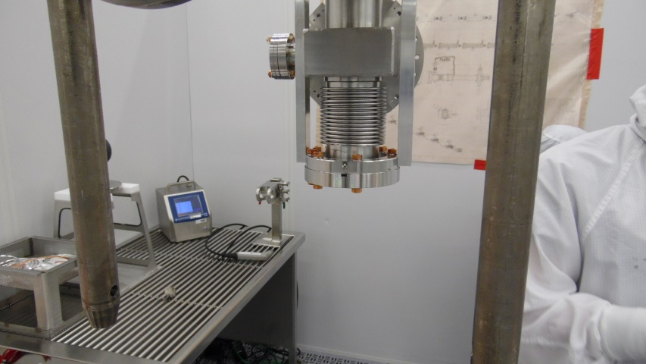

* + 1. Lower the BLA and then slowly rotate it to bring the second flange pointing toward the floor

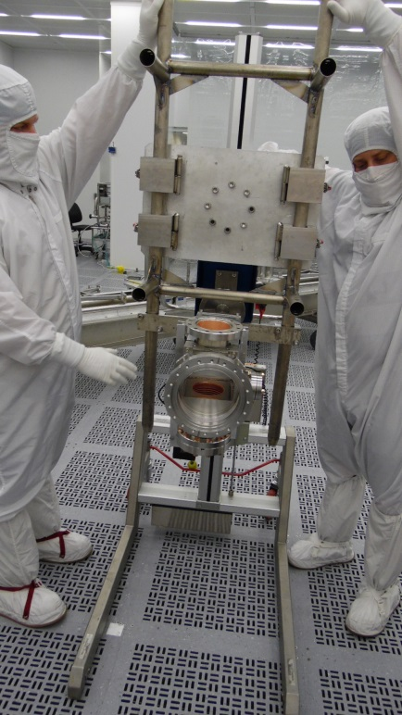 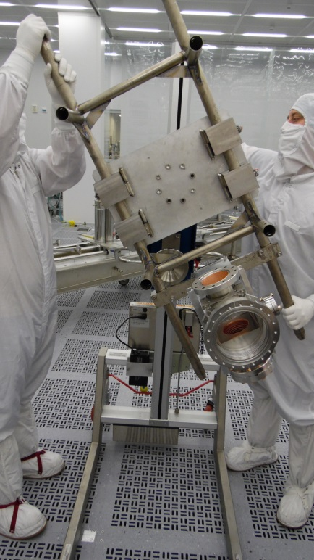 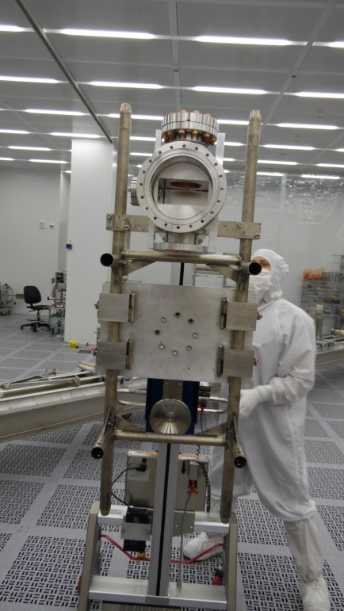

* + 1. Block the lifting device to have the BLA second flange parallel with clean room floor.
    2. Install the blank on the second flange as described at pct. 4.2.1 to 4.2.6.
    3. Once all studs on both BLA beam line flanges are snag, the there is a lower contamination risk, and the flanges can now be torqued to 31 ft.lbs.
    4. Torque is supposed to be done in at least three steps, starting in star pattern, from 20, 25 and 31 ft. lbs. At 31 ft.lbs, using the torque wrench check each bolt individually, one after the other.

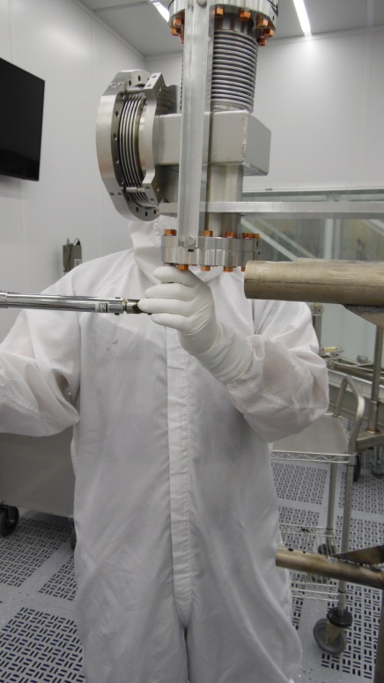 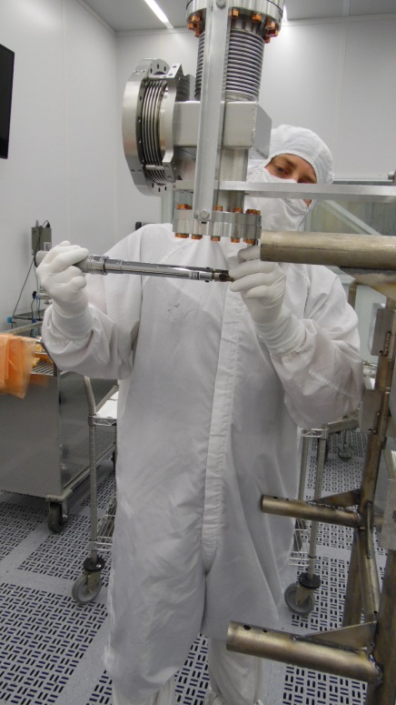

* 1. Remove BLA from lifting device, install the third restrain rail, at 6 o’clock position, then sit the BLA on this third rail with theCF140 flange pointing up.

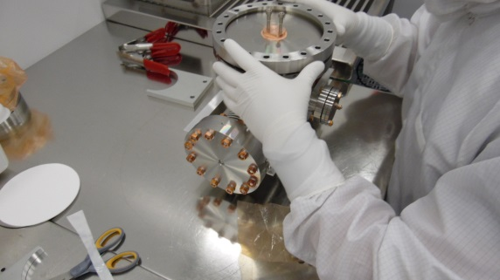 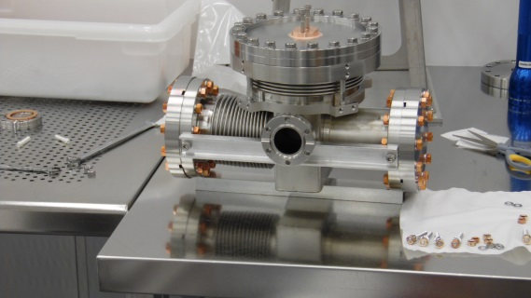

* + 1. Change gloves and check the particulate shadings for these new gloves – see pct.4.2.1.
    2. Check particulate counts on BLA absorber housing as described at pct 2.4 and 4.2.3.
    3. Remove CF140 gasket form the plastic bag, check particulate and place it onto CF140 flange.
    4. Using two M6 stainless steel bolts, take the beam line absorber form the clean room stand and carefully place it in the BLA housing.
    5. Place the CF140 **ring** over CF140 flange carefully aligning the holes.
    6. Insert Nitronic M8 bolts and flat washers in each hole.
    7. Snag tight each M8 Nitronic bolt. Torqueing will be a little bit later.
  1. Using SiBr (Nitronic M6) bolts install the four G10 restrains around CF140 flange.

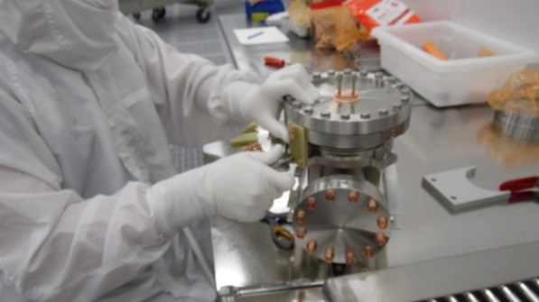 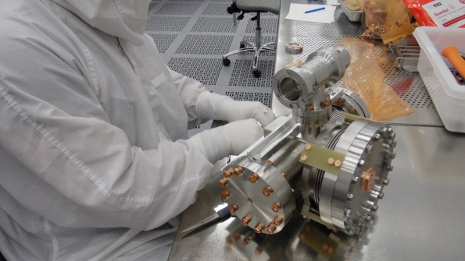

* 1. Install the right angle valve on BLA pumping port.
     1. Snag the bolts on 2 ¾” flange
     2. Torque these bolts to 12 ft.lbs
     3. Protect the right angle valve CF40 flange (not connected to the BLA body) with a blank.
  2. Torque the M8 Nitronic bolts on CF140 flange to 15 ft.lbs, starting in star from 8 ft.lbs, followed by 12 ft.lbs and finish with 15 ft.lbs. After star pattern at 15 ft.lbs, check each bolt, one after the other to have a uniform 15 ft.lbs.
  3. Re- check all M8 nuts on beam line flanges to a final torque value of 31 ft.lbs. This time, with the BLA no more hanging in lifting device.

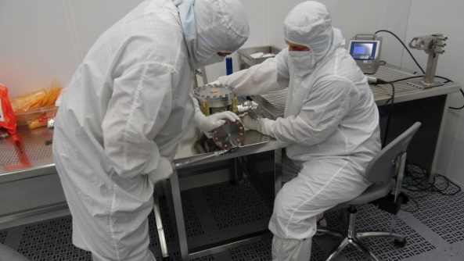 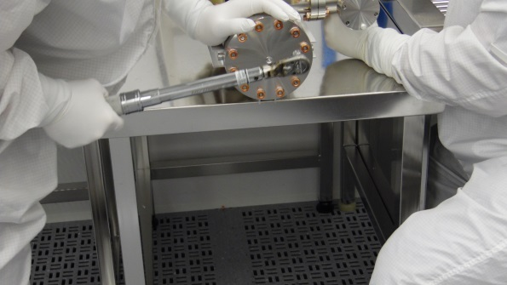

* 1. Place the assembled BLA on a clean room test cart and move it to the vacuum pumping station for vacuum leak check.

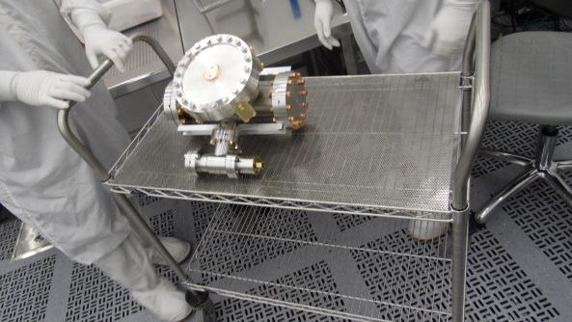 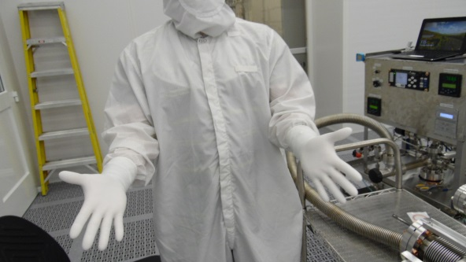

* 1. Change glove, check particulate counts of the new gloves.
  2. Remove the right angle valve blank and connect the BLA to the pumping station.

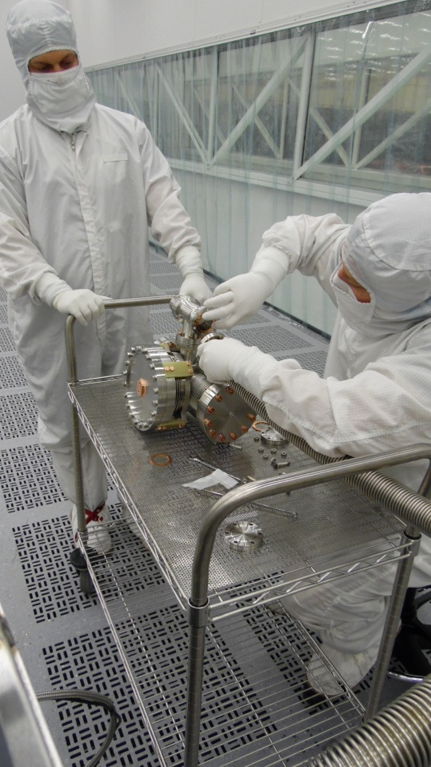 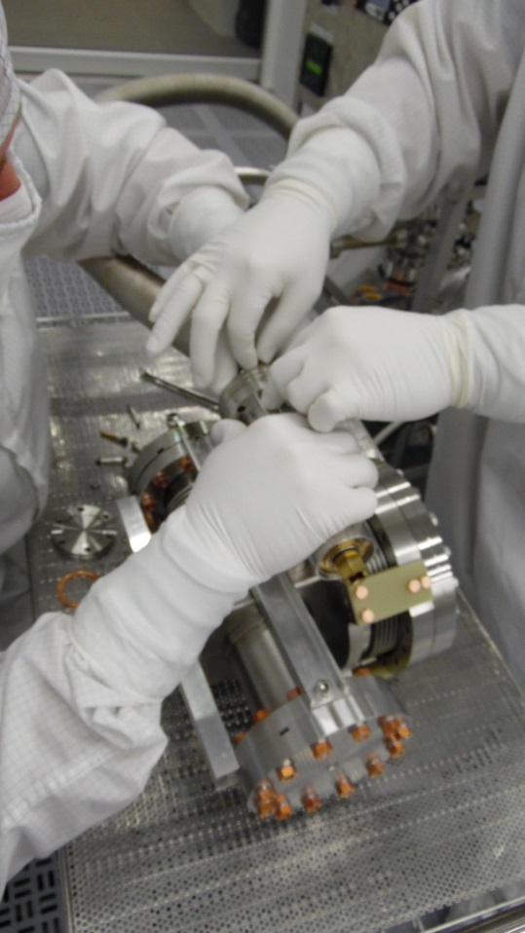

* 1. Torque CF40 flange
  2. With the right angle valve close, start pumping down.
  3. Vacuum leak check the CF40 connection between the BLA and pumping bellows.

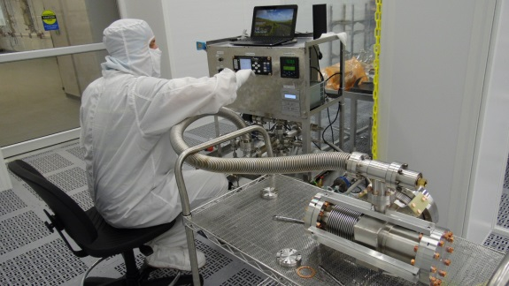 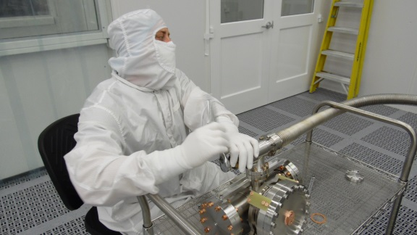

* 1. If CF40 flange is vacuum leak tight, slowly open the right angle valve
  2. Place the BLA in a plastic bag and perform a “plastic bag leak check” once the pressure in the BLA is bellow 5.10-7 mbar ( to be able to turn on the RGA ). Perform vacuum leak check conform procedure: Leak testing with an RGA CPL2PRO-CST-LKTS-R1
  3. Report leak check data as:
     1. BLA_XXX_Leak_Check.rga where XXX stand for BLA serial number i.e. BLA_108_Leak_Check.rga

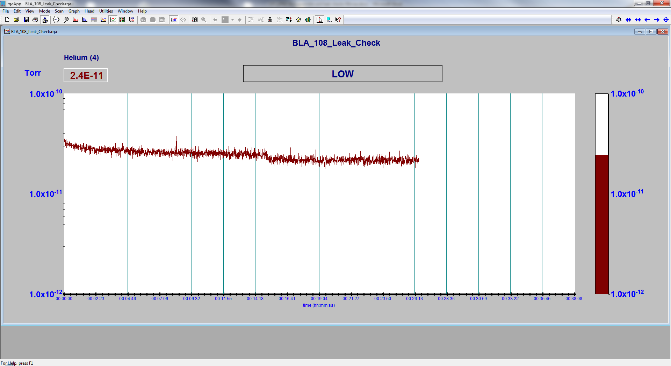

* + 1. BLA_XXX_Analog_Scan.rga and BLA_XXX_Histogram_Scan.rga

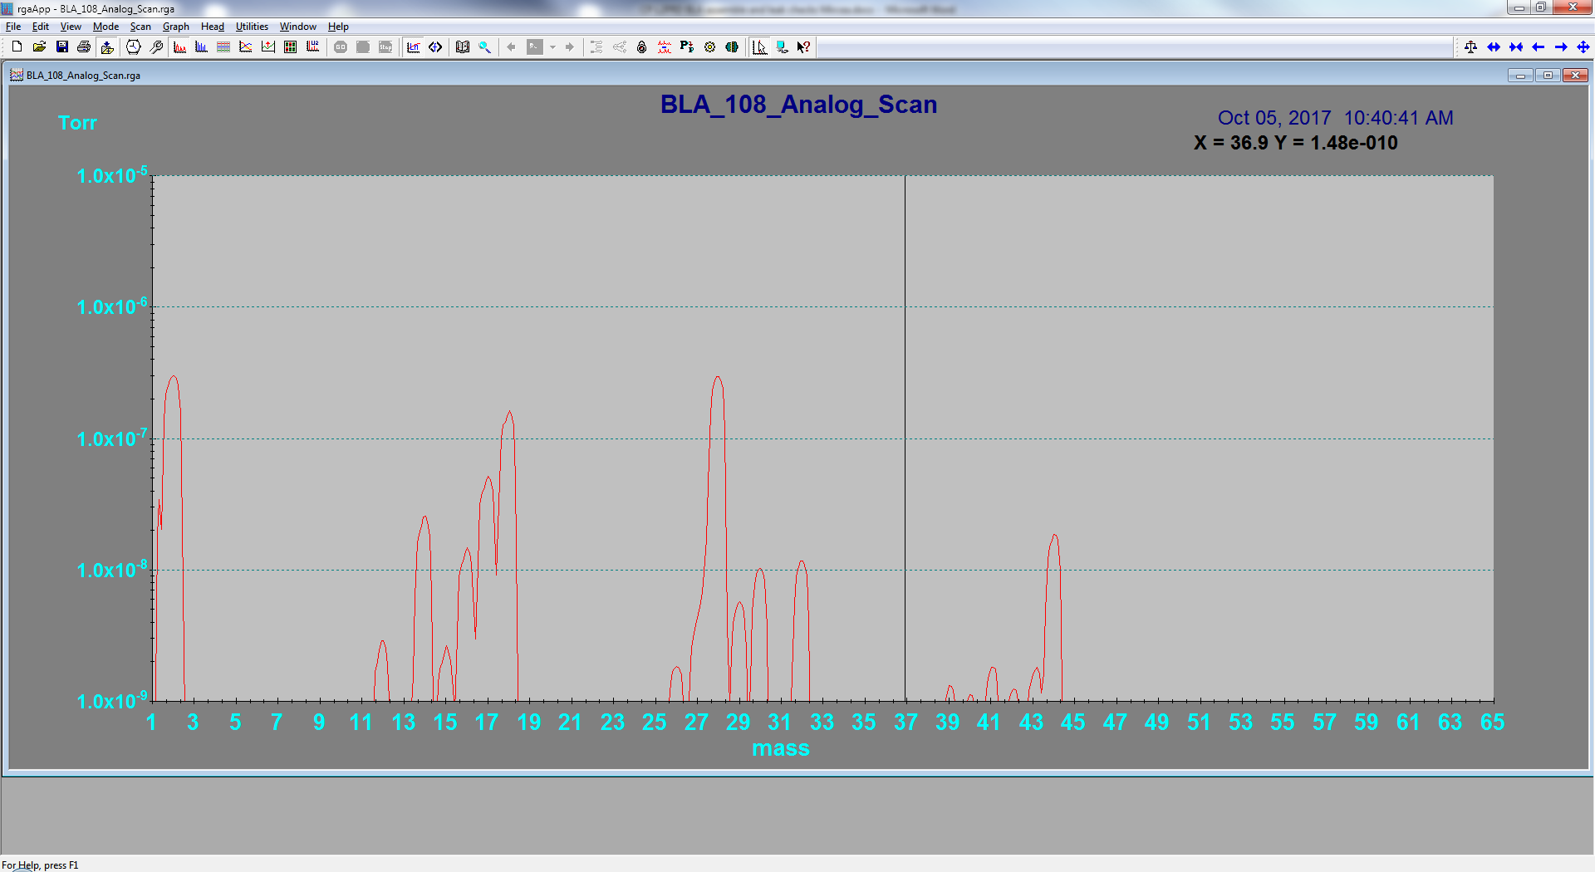 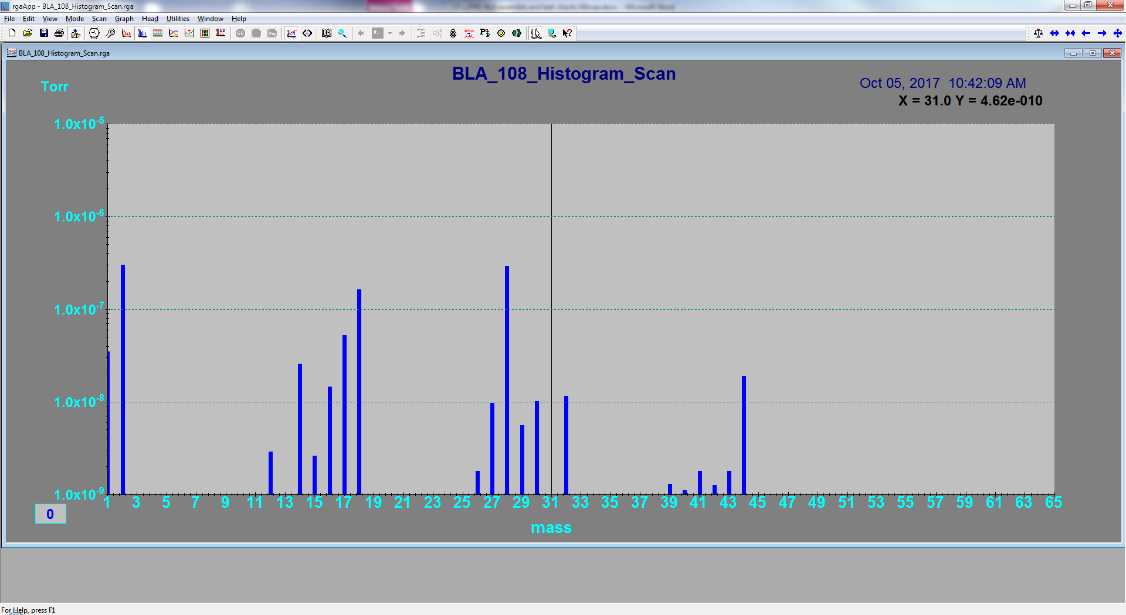

* 1. Slow bleed up the BLA internal volume conform procedure [L2PRO-CST-SLBUP](https://jlabdoc.jlab.org/docushare/dsweb/Get/Document-104022/Slow%20bleed-up%20procedure.docx) .
  2. Close BLA right angle valve
  3. Disconnect the BLA from pumping system
  4. Protect the right angle valve CF40 port with a Copper OFE gasket

1. Insert BLA in double plastic bags
2. Remove the BLA from clean room and place it in a plastic container, with right angle valve pointing to the top, padded with Styrofoam pellets, then the plastic crate is inserted in a wooden crate (padded again with Styrofoam pellets) for shipment.

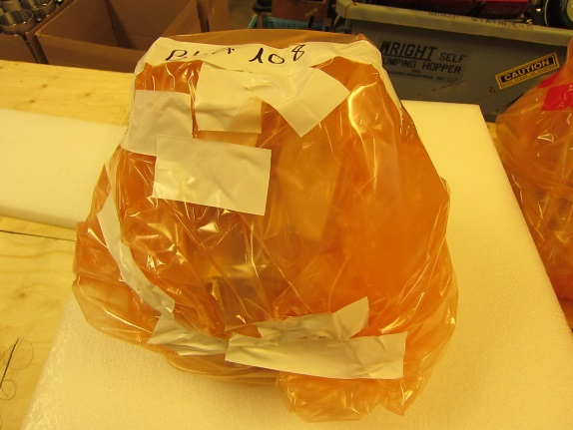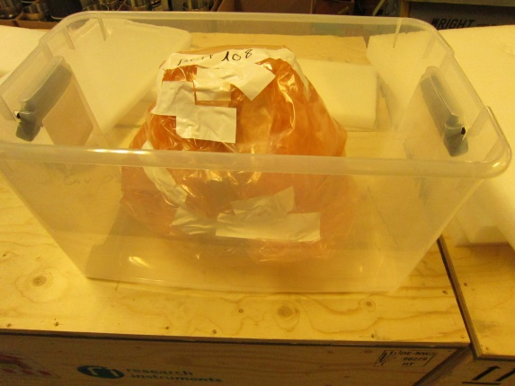

Appendix

1. **Leak Rate Specifications**

All assemblies shall have a total leak rate of less than 2x10-10 mbar-l/sec He as measured with a helium mass spectrometer with a minimum sensitivity less than 1x10-10 mbar-l/sec He. This mass spectrometer shall be calibrated and data recorded as the beginning and ending of each work shift. The leak test shall be carried out with internal vacuum of less than 1x10-4 mbar while the leak check zone is immersed in one atmosphere helium. *Documentation specifying no indicated leak or response to helium is required for all final assemblies.*

1. **RGA Scan Criteria**

This section defines the process and acceptance criteria for the RGA scan of the couplers. After initial pump down, record RGA scans and checks the following:

|  |  |
| --- | --- |
| **Conditions/Criteria** | **Limits** |
| Ration of partial pressures of water vapors (P18 →18 amu) to hydrogen (P2 →2 amu) | P18 < P2/2 |
| Partial pressure P form sum of all peaks > 44 amu | P < 1 x 10-11 Torr |
| Maximum single-peak partial pressure for P >44 amu | P < 5 x 10-12 Torr |

1. **Particle Count Specification**

All internal surfaces of the coupler assembly must meet the particle count specifications as defined in the table below. Particle detection will be performed using boil-off nitrogen or bottled nitrogen (Ultra High Purity 99.9999%). Gas delivery system must have a filter at the dewar and an air ionizer that has a point of use 0.02 μm or better filter. When qualifying all parts, the air ionizer pressure is to be 30psig and the isokinetic sample probe will be positioned no more than 8 inches away from the part being sampled. For Cold and Warm Assemblies, the isokinetic sample probe will be 1 inch way from e-pickup port with nitrogen blowing inside antenna or center conductor area during particle count.

Internal surfaces are defined as all surfaces that are in ultra-high vacuum environment. All internal surfaces must be particle count inspected prior to assembly.

External parts are defined as all parts or surfaces outside the vacuum envelopes. External parts must meet the particle count requirement specified in the table below and with a sampling rate of 10% of the parts.

|  |  |  |  |  |  |  |
| --- | --- | --- | --- | --- | --- | --- |
| Particle size | 0.3 µm | 0.5 µm | 1 µm | 3 µm | 5 µm | 10 µm |
| Internal surface counts | 10 | 5 | 0 | 0 | 0 | 0 |
| External surface counts | 100 | 50 | 10 | 5 | 5 | 2 |

1. BLA hardware

|  |  |  |  |
| --- | --- | --- | --- |
|  | Per BLA | Total loaner tests | Remark |
| VAT valve type 34032-GE02 AAN1/0118 | 1 | 2 |  |
| CF40 OFE gasket | 1 | 2+2 spare |  |
| CF40 blank | 1 | 2 |  |
| ISO 4014 M6 X 40 Hex head bolts | 6 | 12 |  |
| ISO 4032 – M8 Hex nuts (SiBr) | 6 | 12 |  |
| ISO 7089-6-140 HV washers | 12 | 24 |  |
|  |  |  |  |
| CF160 IJP-XFEL-HA-03 blank from CF16- bored flange rotatable | 1 | 2 |  |
| CF160 OFE COPPER gasket | 1 | 2 +2 spare |  |
| ISO 4014 M8 X 35 Hex head bolts | 32 | 64 |  |
| ISO 7089 – 8-140 HV ROUND washer | 64 | 128 |  |
| SS blank (Polish cover) – cavity beam line blank **(dwg F00457202)** | 2 | 4 |  |
| CF80 AlMg gasket | 2 | 4+2 spare |  |
| ISO 4014 M8 X 40 Hex head bolts | 12 | 24 |  |
| ISO 7089 – 8-140 HV round washer | 24 | 48 |  |
| ISO 4032 M8 Hex nuts (SiBr) | 24 | 48 |  |